**Hi!**

**In this document, I would like to describe my done assignment in more detail.**

I did assignment number 3. The point of it was to get the price of Google's shares for the last week.

I did this task using the Python programming language. During the development I needed 4 libraries, such as: requests - to execute requests, alpha_vantage - library to get stock prices, pandas - to format the received stock dates, datetime - to specify the search period for the desired stock days.

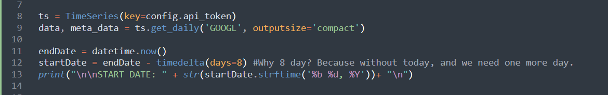

Image 1

In picture 1 (photo of my code) we see on line 8 the connection with API, and on line 9, we get compact information about the company we need (google) and get it by day.

From line 11 to 13 we define the days we need to get the stock prices of the company. We take today's day and from it we subtract 8 days to get the result for a week. We use 8 days, because there is no information about today's day yet, so it is not counted.

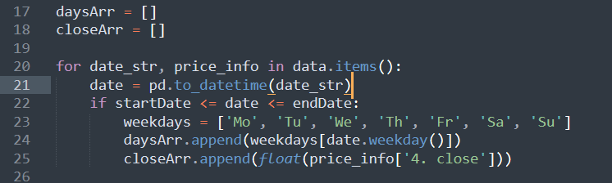

Image 2

In picture 2, on line 17 and 18, I create two empty arrays into which I will write the necessary data, such as the date and the last price for that day.

In line 20 I made a loop to loop through the received data and in line 22 is a check for the required dates. That if the date in the array is greater than or equal to the start date and less than the end date, then it fits and I write this data into the newly created arrays earlier.



Image 3

In picture 3 on line 27 and 28, I format the arrays with dates and last price for easy output to the console.

In line 30 I get the company information and in line 31 I output the final result.

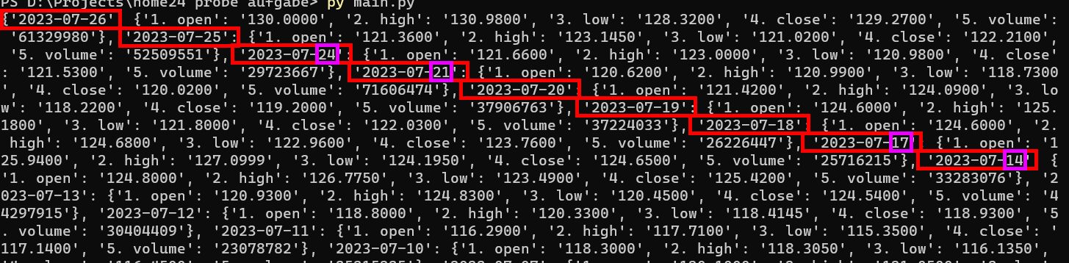

Image 4

I also encountered a problem I don't understand, which you can see in picture 4. Sometimes in the received dates, there could be missing information about some days. I have circled all the dates in red for easy review, and the purple color circles the dates that are out of order, such as July 24 and July 21. That is, there is no information about July 22 and 23. The same problem is observed with July 15 and 16.

Thank you very much, that's all)