Caution fastening screws (3-D printed parts infill should be about 40%)

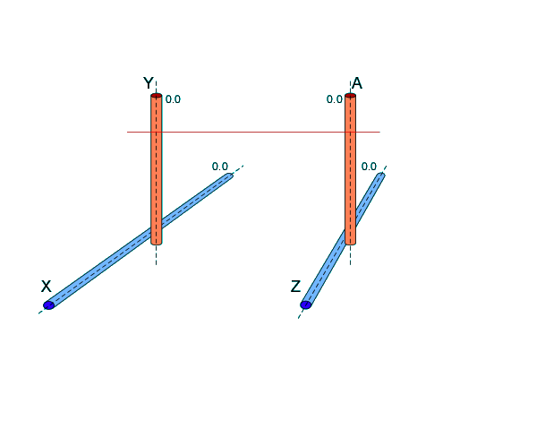

Parts for X/Z – Axis

3-D printed parts

Parts for Y/A - Axis

