**Contents of this file**

---------------------------------------------------

*Introduction.

*How to install visual studio.

*How to load the project on visual studio.

*Corrections

---------------------------------------------------

Introduction

---------------------------------------------------

The purpose of this readme file is to show the user how to install visual studio properly in order to avoid any issues or short comings that may occur before loading the project onto it. Secondly this read me file will describe how to load any application onto visual studio.

---------------------------------------------------

How to install visual studio

---------------------------------------------------

1) 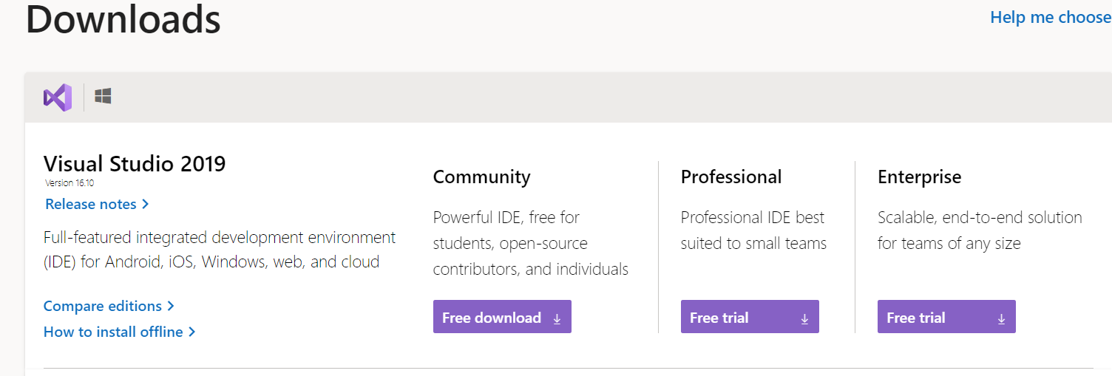

You can download any of these depending on your money and devices, but community is recommended as it is free.

2) 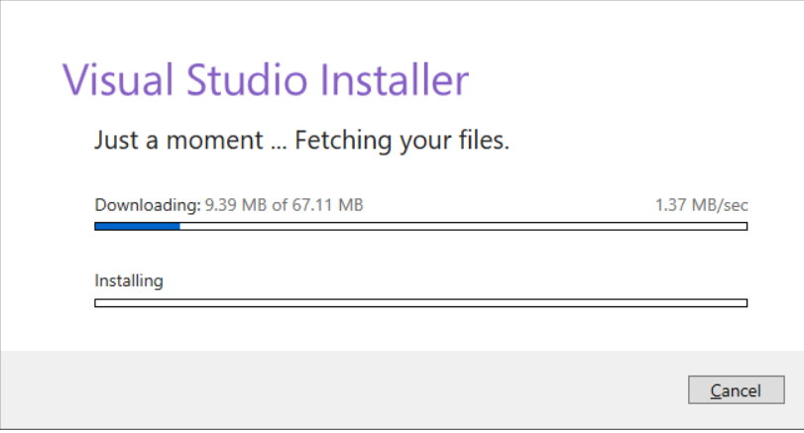

Start the installation of visual studio.

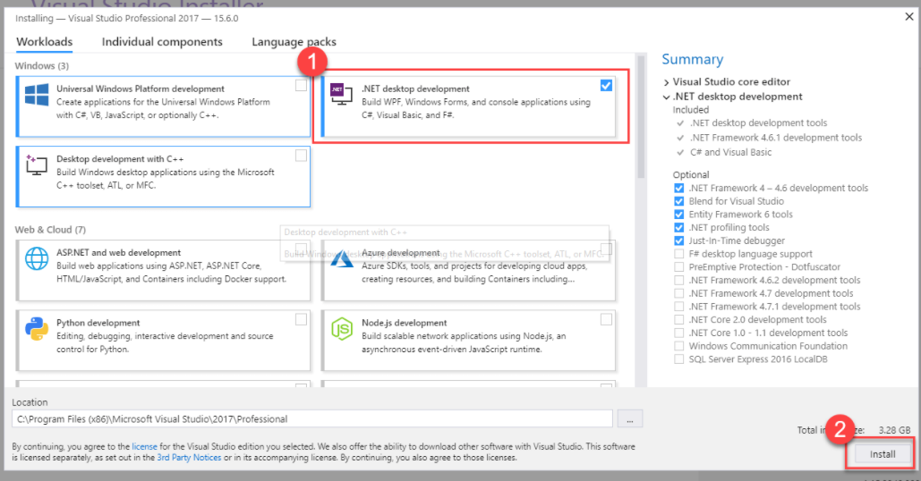3)

Select any extensions that you may want to install with visual studio.

4) 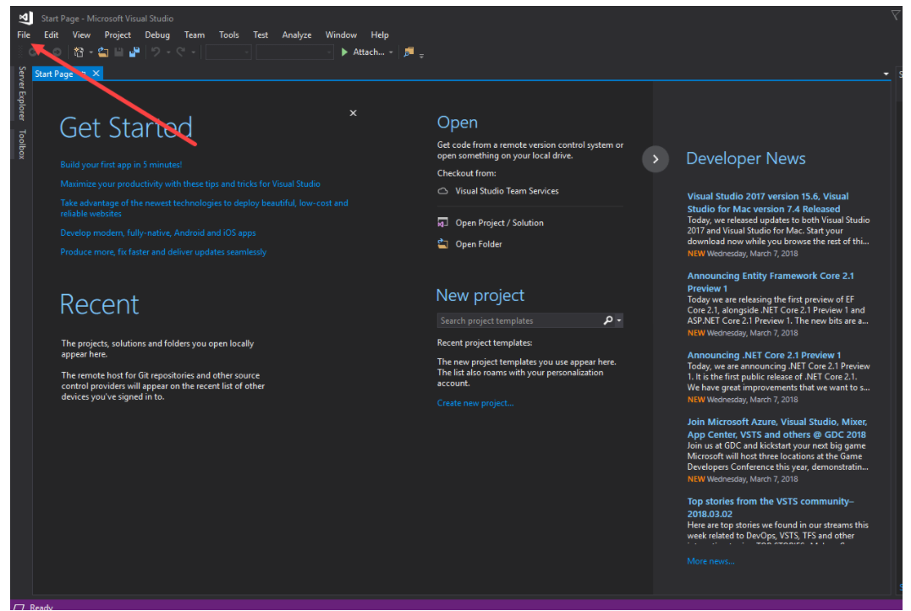

Once you are greeted with the home screen you can navigate to the file icon located top left you can select a project from the files.

---------------------------------------------------

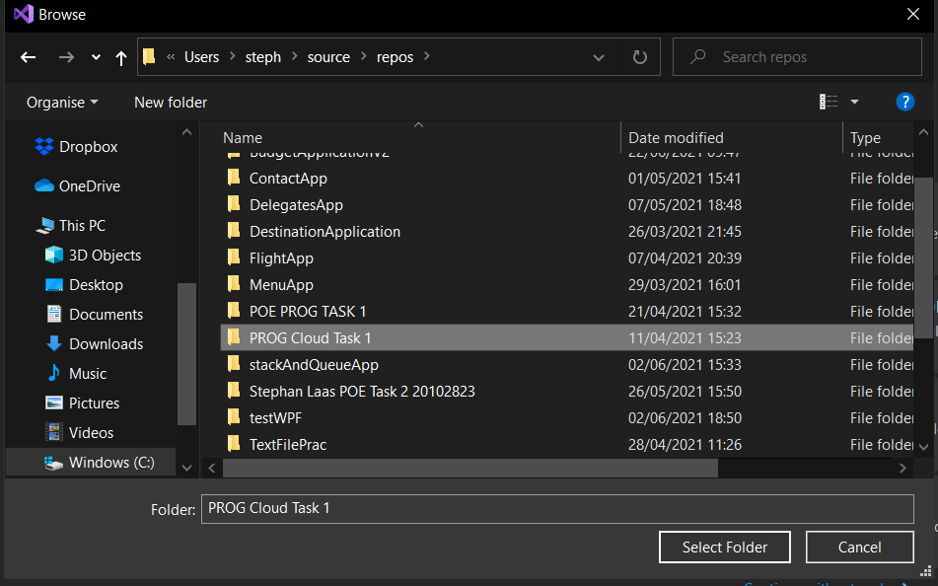1)Select a folder/project you would to load , as soon as you select the folder the project will load

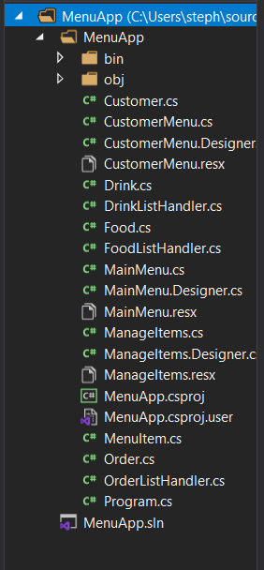2)After selecting the folder the application will open in visual studio and load all the data to be able to run the application.

Corrections

-----------------------------------------------------

1.I display more data to the , I do this by displaying a message box that helps the user guidance through the application.

2.Adding more error handling

3.Submitting to github without a zipFile