# Material Summary: Statistics

## Basic Concepts

**1.1 Descriptive Statistics**

* Numbers which are used to **summarize** and **describe** data
  + We work with **all items of interest** – **statistical population**
  + We don't try to make predictions, just describe what we're seeing
* Not very useful on their own
  + But an important part of other methods
* Example: pet shop sales
  + 100 pets in one month: 40 dogs, 30 cats, 30 other
* What percent of all pets are dogs?
* What's the mean number of cats sold per month?
* We can also represent the information graphically
  + What does the distribution of dog sales per day look like?
  + What does the cumulative distribution of sales look like?
  + How do sales compare?

**1.2 Inferential Statistics**

* In many cases the **population** is too large (or even infinite)
  + We represent the population by a subset – **sample**
  + **The population characteristics can be estimated  
    by using the sample**
    - We have to be extremely careful how to choose the sample
  + In most cases we need **random sampling** of the population
* Examples
  + Voting predictions
    - We ask a small number of people and we draw **inferences** about the entire country
  + Mean salary by age
    - We divide people into age groups (e.g. $20$, $20−25$, $25−30$, $30−35$, …) and ask several people within each age group
    - This also makes the continuous variable "age" easier to work with

**1.3 Sampling**

* The process of selecting a sample from the population
* Steps in the sampling process
  + Define the population
  + Specify the **sampling frame** – a set of items from the population
  + Specify the **sampling method** – how to select items from the frame
  + Determine the sample size
  + Implement the sampling and collect data
* A badly done sampling can induce **biases** and **errors**
  + **Selection bias** – selecting a non-random sample
    - E.g., asking only CEOs of companies when sampling data for salaries   
      by age
  + **Random sampling error** – random variations in the results

**1.4 Sampling Methods**

* Non-random sampling
  + Can be biased
  + **Not representative** of the population
* Random sampling
  + Every member of the population has equal chance of being chosen
  + Example: insect population in trees
    - Trees are numbered 1-200, 10 trees are chosen at random
    - All insects are counted on the 10 random trees
* Stratified sampling
  + Divide the population into categories (subpopulations)
  + For each category, sample at random
  + Example: foot measurement study $→$ male / female; age groups
    - Select samples for each combination { gender; age }

## Properties of Distributions

**2.1 Summarizing Distributions**

* A **histogram** is a **complete description** of the sample distribution
* We often summarize it using a few descriptive statistics
  + **Central tendency**
    - Do the values tend to cluster around a center?
  + **Modes**
    - How many clusters are there? Where are they?
  + **Variance**
    - How much variability is there (how "spread out" is the distribution)?
  + **Tails**
    - How quickly do probabilities drop off as we move away from the center(s)?
  + **Outliers**
    - Are there extreme values, far from the center(s)?
* These are also called **summary statistics**

**2.2 Measures of Central Tendency**

* **Average** – a number which describes a typical data point
  + Can be calculated in many ways
* **Arithmetic mean**
  + A black background with a black square

    Description automatically generated with medium confidenceThe sum of all measurements divided by the number of observations
* **Median**
  + The middle value of the distribution
  + To calculate it, the numbers must be sorted in ascending order
  + Examples:
$$Me\left(\left\{1,2,2,3,4\right\}\right)=2;Me\left(\left\{1,2,2,3,4,10\right\}\right)=2,5$$

* **Mode**
  + The most frequent item
 $$Mo\left(\left\{1,3,2,3,4,3\right\}\right)=3$$

 + Many "most frequent items" $⇒$ multimodal distribution

**2.3 Variance**

* Describes how far away a sample is from the sample mean
  + All differences from the mean $x_{i}−\overline{x}$ can be positive or negative
  + They all sum up to 0 (that's the definition of the mean)
  + A black background with a black square

    Description automatically generated with medium confidenceSo we square them to make them positive
  + Standard deviation: $S\left(x\right)=\sqrt{S^{2}\left(x\right)}$
* In the sample variance formula, there is $n−1$ in the denominator
  + It refers to "degrees of freedom" – how many items we can remove
    - The number of parameters that can vary
  + Because all distances sum up to $0$, if we know $n−1$ of them, we can find the last one
  + Gives us an unbiased estimator (more on that [*here*](http://nebula.deanza.edu/~bloom/math10/m10divideby_nminus1.pdf))
* Why bother to take the standard deviation?
  + Instead of using variance directly
* It's all about units
* Example:
  + Let's say we're measuring length in $m$
  + By definition, the variance will have units of $m^{2}$
  + We want to see how far is a certain point from the center and the units   
    don't match
    - Compare $d=2m,S^{2}=0,25m^{2}$ to $d=\left(2±0,5\right)m$
  + In order to make units match, we take the square root
  + Example
    - If we measure $2,75m$, we can say "This measurement is located at **1,5 standard deviations above the mean**"
    - Comparisons like these are very useful in statistics

**2.4 Population vs. Sample: Measures**

* There are differences between a population and samples from that population $⇒$ we have different statistics
  + Notation
    - Sample statistics – sample mean, sample variance, etc. – Latin letters
    - Population statistics – Greek letters
* Population mean
  + A black background with a black square

    Description automatically generated with medium confidenceAlso called **expected value**
  + $N$– population size
* Population variance
  + A black background with a black square

    Description automatically generated with medium confidenceA black background with a black square

    Description automatically generated with medium confidenceNote how since we know the entire population, there is   
    **no estimation** going on
  + So, there is $N$ in the denominator
* Population standard error

$$σ\left(x\right)=\sqrt{σ^{2}\left(x\right)}$$

**2.5 Example: Snowfall Data**

* You are given data of snowfall in Buffalo, NY in inches for years 1910 – 1972 (**snowfall.csv**)
* Plot a histogram
* Print the mean, standard deviation and modes
* Print the standard deviation
  + Note: If you're using **numpy**, it returns  
    the biased estimator of standard   
    deviation. Pass a parameter **ddof = 1**   
    (difference in degrees of freedom)   
    to calculate the unbiased estimator
* Overlay the mean, median and first mode on the histogram

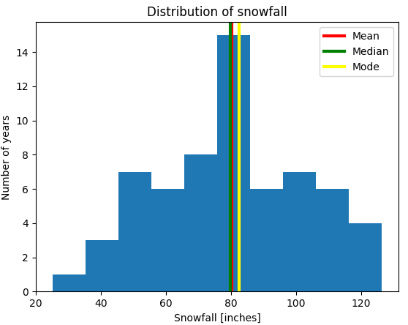

**2.6 Five-Number Summary**

* Conveys similar information to a histogram
  + How many percent of the data are less than or equal to a   
    specified number
    - Minimum (0%); first quartile (25%); median (50%); third quartile (75%); maximum (100%)
      * Generalization: quantiles – divide the frequency   
        distribution into equal groups
      * 100 groups = percentiles
* Visualization: boxplot
  + Middle line – median
  + Box – quartiles
  + Whiskers – largest "non-outliers" – 1.5 times the interquartile range
  + Points – outliers

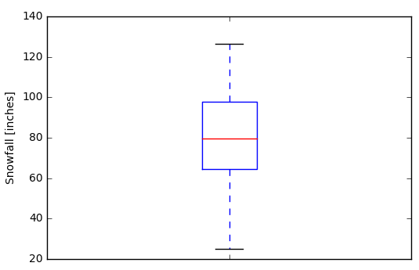

**2.7 Moments of Distributions**

* th central moment:
  + Defined for discrete and continuous variables
  + Measure the shape of the probability distribution
* Zeroth moment: 1 (**total probability**)
* First moment: **arithmetic mean $μ$**
* Second moment: **variance $σ^{2}$**
* Third moment: **skewness $γ$**
  + Asymmetry in the distribution
* Fourth moment: **kurtosis $β$**
  + Heaviness of the "tails"
  + "Normal": $β=3$
    - Excess kurtosis:

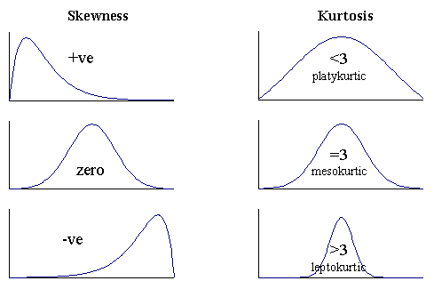

**2.8 Moments of the Gaussian Distribution**

* Generalization of the binomial distribution
* A black background with a black square

  Description automatically generated with medium confidenceProbability density function
* Mean: $μ$
* Median: $μ$
* Mode: $μ$
* Variance: $σ^{2}$
* Skewness: $0$
* Excess kurtosis: $0$
* *"And that, kids, is why I love the Gaussian distribution."*

**2.9 Standard Score**

* In order to compare different Gaussian distributions, we can  
  "normalize" them
  + Change their parameters to get a "standard" Gaussian distribution  
    with $μ=0$ and $σ=1$
  + We need to "shift" the distribution left or right  
    and "squish" or "stretch" to achieve the required standard deviation
  + The shift is denoted by the standard score (or z-score): $Z\left(x\right)=\frac{x−μ}{σ}$
* Example: 50 student scores
  + Normal distribution, mean 60 (out of 100) and standard deviation 15
  + How well did a student perform if they had 70 / 100?
    - Top 25% of the class
  + What marks do the top 10% of the class have?
    - 79 and up

## Many Variables

**3.1 Covariance**

* Up to now, we've been looking at variables on their own
  + But in many cases, they interact with each other
* A black background with a black square

  Description automatically generated with medium confidenceCovariance is a measure of the joint variability of two variables
  + Positive: as one variable increases, the other also increases
  + Negative: as one variable increases, the other decreases
  + Zero: the two variables don't vary together at all
* We can see that $cov\left(X,X\right)=σ^{2}\left(X\right)$
* In higher dimensions, we calculate a covariance matrix
  + The same idea: element $\left(i,j\right)$ is equal to the covariance   
    of the th and th dimensions: $A_{ij}=cov\left(x_{i},x_{j}\right)$

**3.2 Correlation**

* Like the variance, covariance is in "weird" units
  + A black background with a black square

    Description automatically generated with medium confidenceWe divide by the standard deviations to normalize them $⇒$ standard scores (similar to z-scores)
  + A black background with a black square

    Description automatically generated with medium confidenceThe mean value can be calculated as
    - This is called **Pearson's correlation coefficient**
* The correlation coefficient can be in $\left[−1;1\right]$
  + **High absolute value $⇒$ strong correlation**
  + Measures the linearity of a relationship between two variables
  + Cannot express other, more complex relationships

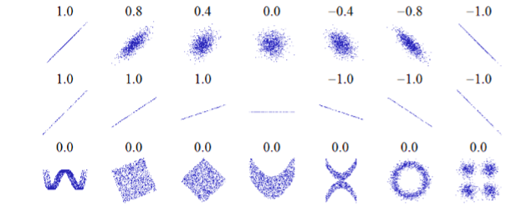

**3.3 Scatter Plots**

* The easiest way to see how two variables are correlated
* Two versions:
  + "Independent" variable – $x$-axis, "dependent" variable – $y$-axis
  + Two correlated variables (we can't say which is "independent")
* Besides, outliers usually become easily visible
* Best practices
  + Label your axes
  + If needed, include a legend
  + Scale / transform the variables if needed
    - Simplifies the relationship
  + Add trendlines if needed
    - You can also plot line charts if that's what your data suggests

**3.4 Example: Birth Rates**

* You are given the number of live births per 10 000 23-year-old women in the US between 1917 and 1975
  + File: birth_rates.csv
* Plot a scatter plot of the birth rates per year
  + What conclusions can you make?
  + This is called "time series analysis" – we are analyzing a process  
    as it evolves with time
* Additionally, you can still inspect the variables   
  one by one
  + Plot a histogram of the birth rates,disregarding   
    the years
  + Are there any "typical" birth rates?
    - Are they distributed normally?

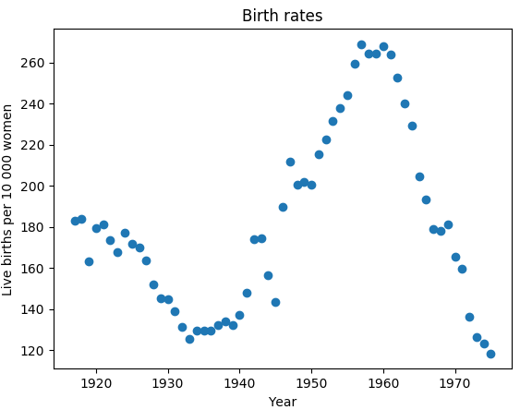

**3.5 Example: Brain and Body Weights**

* File: brain_weight.csv
* Inspect the two variables: body weight [kg], brain weight [g]
  + Plot histograms, even boxplots if needed
* Create a scatterplot
  + The distribution is highly skewed, almost nothing is visible
* Transform the data
  + Take logarithms of both the body weight and the brain weight
  + Plot histograms of the logarithms
  + Create another (log-log) scatterplot
  + Is there any significant relationship?
    - If so, what is the real relationship (between the untransformed variables)?
    - To find it, you have to "reverse" the transformation

## Common Pitfalls

**4.1 Correlation Does Not Imply Causation!**

* If two variables are correlated, this does not mean that  
  necessarily the first causes the second
* Example: height and weight
  + Does a greater weight cause a greater height?
* We can still describe them
* **We can predict** height from weight and vice versa
* But that still does not say anything about one causing the other

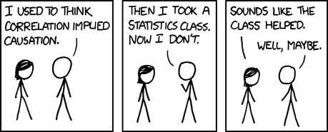

**4.2 Correlation vs. Causation**

* Reverse causation
  + The faster the windmills rotate, the more wind there is $⇒$ Windmills   
    cause wind
* Lurking variable
  + The more firefighters there are to put out a fire, the greater the damage caused $⇒$ Firefighters being present at fires, cause more damage
* Bidirectional relationship
  + Predator numbers affect prey numbers, but prey numbers (amount of food) also affect predator numbers
* Coincidence
  + [*http://tylervigen.com/spurious-correlations*](http://tylervigen.com/spurious-correlations)
* More information about causal relationships: [*minutephysics (YouTube)*](https://www.youtube.com/watch?v=HUti6vGctQM)

**4.3 Anscombe's Quartet**

* Four datasets with similar descriptive statistics which look  
  completely different when plotted
  + More information: [*Wikipedia*](https://en.wikipedia.org/wiki/Anscombe's_quartet)
* Takeaways
  + Plot the data
    - In general, it's important to get to know your data
  + List as many assumptionsand simplifications as possible
  + **Do not rely** simply on a bunch of numbers
    - Even worse, a single number

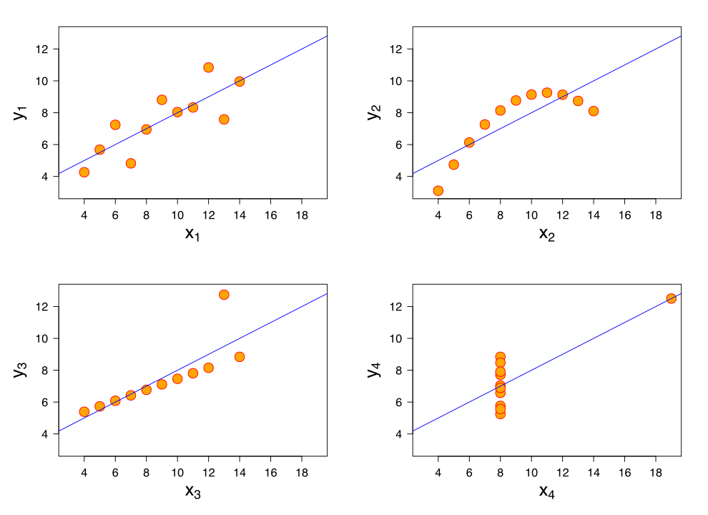

**4.4 Simpson's Paradox**

* 1973, University of California – Berkeley was sued for sex discrimination
  + Accepted 44% male applicants but 35% female applicants
  + When researches dug in, they found it was not so
  + *"****If the data are properly pooled...there is a small but statistically significant bias in favor of women."***
* Simpson's paradox
  + A case of **omitted variable** bias
  + Observed explanatory variable $→$ explained variable
  + **Lurking variable**
  + **Uneven sample sizes (in most cases)**
  + The effect of the observed explanatory variable reverses when we take the lurking variable into account
* When we consider both samples together, it appears that $x$ has a negative effect   
  on $y$
  + When we take color into account, the relationship reverses
* Other example: kidney stone treatment
  + One treatment is better for large stones, and better for small stones; but the other one is better overall
    - Confounders – the severity of the illness + different sample sizes
* An article with [*more info*](http://ftp.cs.ucla.edu/pub/stat_ser/r414.pdf)on the topic

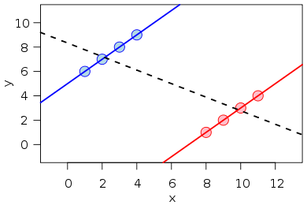

**4.5 UCB Admissions – Explanation**

* The [*research paper*](http://homepage.stat.uiowa.edu/~mbognar/1030/Bickel-Berkeley.pdf)concluded that 6 departments were significantly biased towards men and 4 – towards women
  + The other 75 weren't (significantly) biased at all
* Actually, the overall bias was (slightly) in favor of women
* Women tended to apply to competitive departments with low admission rates
* Men tended to apply to less competitive departments with high admission rates
  + We cannot observe that directly from our dataset
  + **Lurking variable** – competitiveness
    - Students didn't have the same motivations to apply