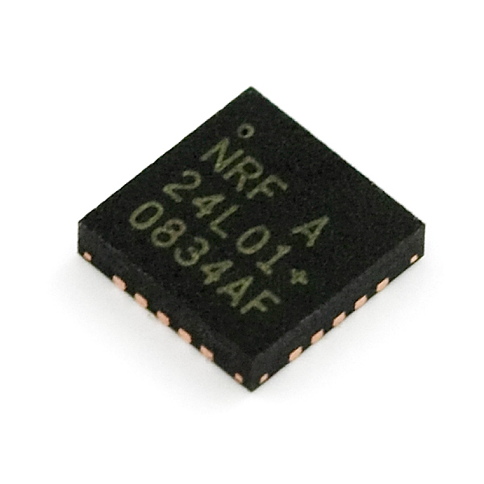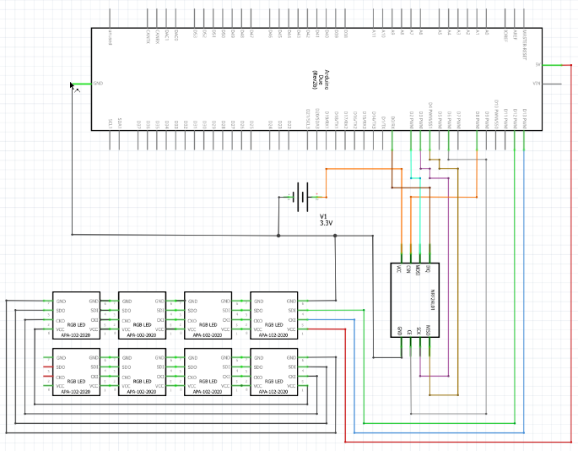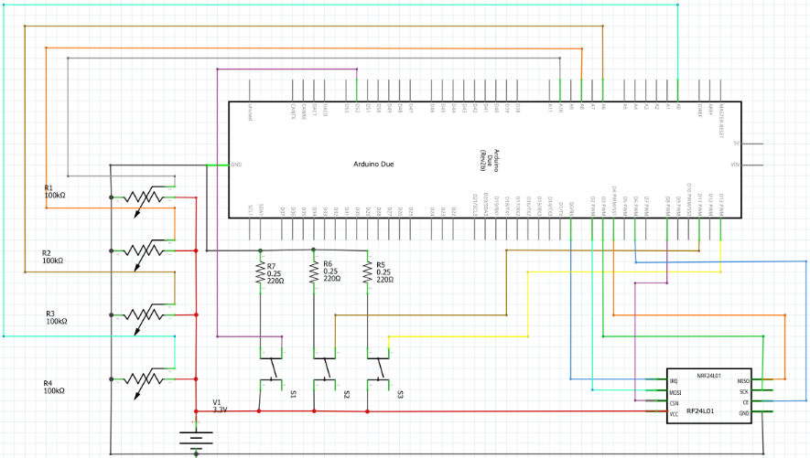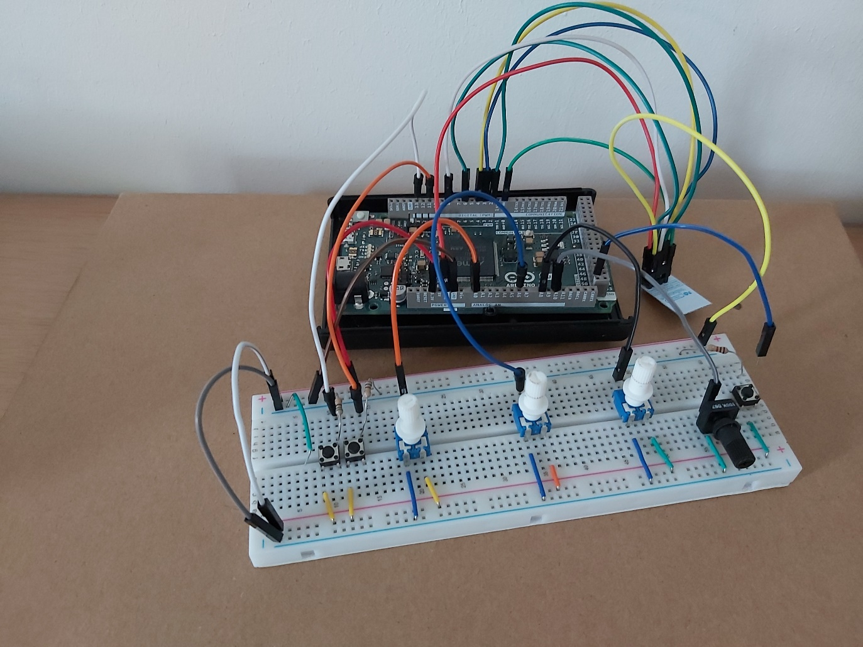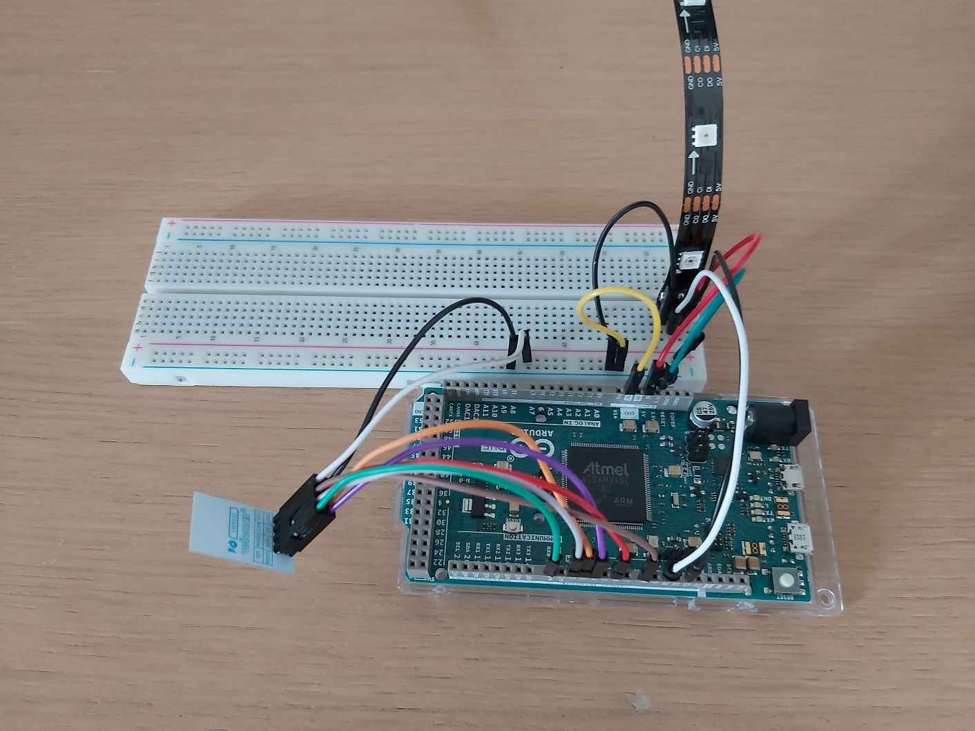

Figuur 1: RF24L01-chip

Figuur 2: Circuit schematic Reciever

Figuur 3: Circuit schematic Transmitter

Figuur 4: Transmitter

Library available at <https://github.com/StephanZaaijer/IPASS>

Documentation available at <https://stephan.zaaijer.net/ipass.html>

***Possible applications***

* Wireless PC periphals
* VoIP headsets
* Game controllers
* Sports watches and sensors
* Home and commercial automation
* Active RFID

Figuur 5: Reciever

***The library***

* The library contains 1 class with 3 subclasses
* In the subclasses are stored the values of the registers, command and the functions of the RF24L01
* In the mainclass are all the functions to read and write data to the RF24L01 and change to specific functions on the RF24L01 by changing the values in the Registers

Made by: Stephan Zaaijer

Date: 28-06-2021

***The RF24L01***

* Send and receive up to 32 on 6 pipes
* 128 rf-channels between 2400 and 2518 MHz.
* Auto-acknowlegde.
* Low-power usage
* 2 datarate modes (1 and 2 Mbps)
* 4 possible rf-outputpower (-18, -12, -6, 0 dBm)

***Used hardware***

* 4 Potentiometers
* 3 pushbuttons
* 2 arduino dues
* 2 Rf24L01-module (vma322)
* 1 APA102
* Resistors

Figuur 6: VMA322 RF-transcievermodule

RF24L01 rf-transceiver