212
Finding Out About Messages and Methods
System Browser

Figure 10.12b
000

tamtflAJMitBrfJilLIE | Interva
Collections-Te t | LinkedL | st | a c c e s s i η q
Collect ions-Array | Ma.ppei | J Collect ion | copying
¹ :ol|Pctions-:-itrpai |  | [pf■] I [=bu ran | adding
'Collect ions-Suppo | Sorted' | Collection | removing
'lira phics-Primitive |  |  | ρ η υ me rat ing
Graphics-Display |  | firstlndexl- | private
5 e q υ e η c e a b 1 e C ο 11 e c t i ο η ν |  |  | lass: # Ordered Coll | 5 C t i 0 Γι
ins tan c e'v'a.ria | bleNarnes: 'first Index last Index '
c la ssVariableNa.mes:
poolDictiona ri | es: "
category: 'Co | llections | - b e q u e η c e | able'

erval
Ο r d e re d υ ο 11 e c t i ο η rn a ke R ο'δνη A t La. s t
Ο rd e re d C ο 11 e c t i ο η fi η d:
Ο rd e re d C ο 11 e c t i ο η re m ο ν e A11S u c h Τ h a t:
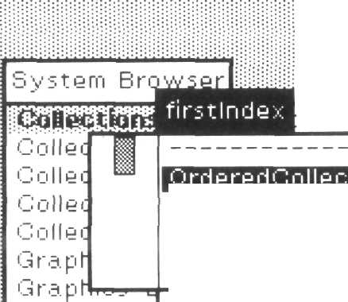
Figure 10.12c
DO
ooo

q ij e η c e ί
in stan
cla.ssV
poolDi
cateqi
before: oldObject
"Answer the element before oldObject. If the
receiver does not contain oldObject
or if the receiver contains no elements before
oldObject, create an error message,"
| index |
index <- self find: oldObject,
if True: [tself errorFirst Object]
ifFalse: [tself basic At: index - 1]

213
10,4 Which Methods Reference a Particular Variable or Literal?

(J ο 11 e c 11 ο η s -
C ο 11 e c t i ο η s - ,·
Collections-ί
C olle c t i ο η s - S
Graphic s-Prii
Graphic s~D is
0 rd e re d C ο 11 e c t i ο η
stlndex '
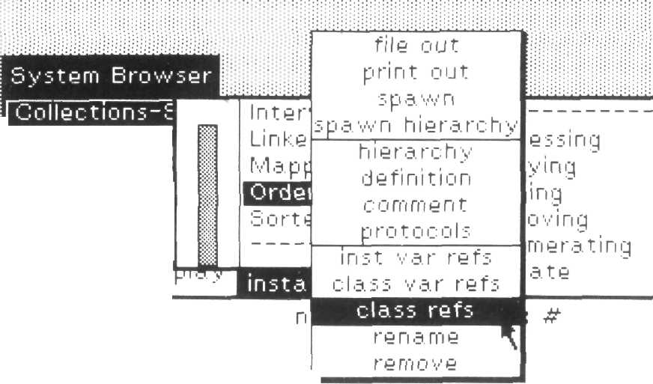
b e q υ θ η c e a b I e υ ο 11 e c t i ο
i η s t a. n c e V a. r i a. b I e Ν a
c I a. s s V aria, b I e Ν a rn e sV
poolDictionaries: "
ca teg ο r y: ' C ο 11 e c t i οηs-Seq ueη c ea b I e'

Figure 10.13a
ioio

by stem Browser

::ollectioM=-
Jollectior Β
Jollectioi
; ο 11 e c t i ο f
ι rap hies ■
Graphics-
ι q u e n c e a b I e
i η s t a n c e V
class Vari;
poolDictio
category:
Users of OrderedCollection
Behavior a 11D y η a. rn i c b u ρ e r c I a s s e s
Β e h a. ν i ο r a 111 n s t a n c e s
Behavior" alllnstVarNames
Β e h a. v i ο r a. 11S u b c I a s s e s
Β e h a v i ο r a 11S u ρ e r c I a. s s e s
alllnstVarNames
"An;wer an Array of the names of the
receiver's instance variables,"
| names
η a. rn e s *~ ^^p^^^^^^^^^^m^Q η e
self a c c υ rn υ I a t e Ι η s t V a r Ν a m e s: η a rn e s
t r a v e r s e d CI a s s e s: S e t η e w,
τ η a. rn e s


Figure 10.13b

Prof. Dr. Oscar Nierstrasz

Smalltalk-

**,,!" Χ, ,

Bits of History, Words of Advice
Glenn Krasner, Editor
Xerox Palo Alto Research Center
Addison-Wesley Publishing Company
Reading, Massachusetts · Menlo Park, California
London · Amsterdam · Don Mills, Ontario · Sydney

Out A
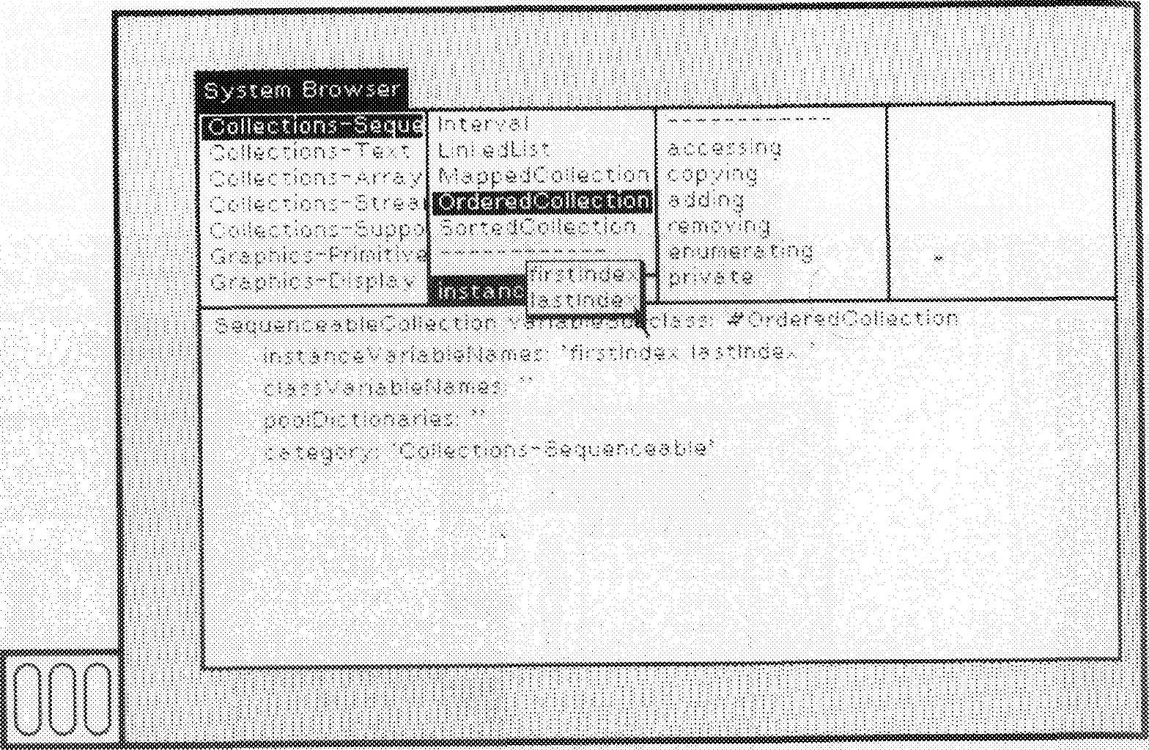
10 12b

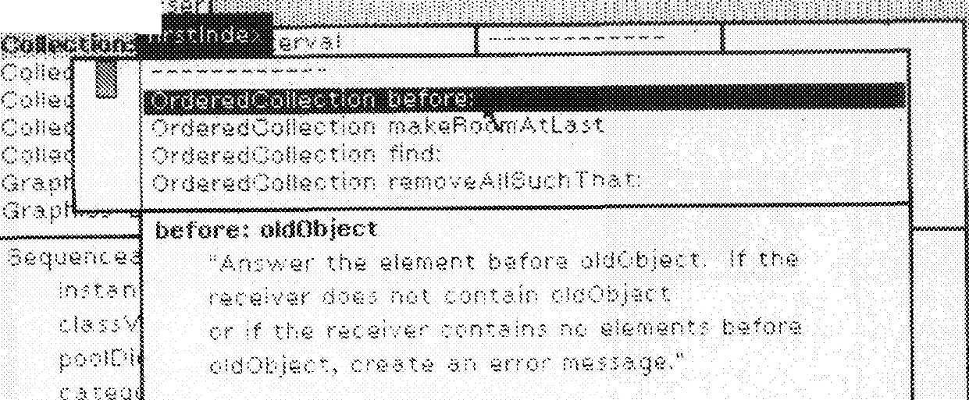
^{Sv}^^{f}:±ji

I!
"I . 1"
f 1 . !:: ''.^■■::,-·

10.12f.

_ 213
.HX4 Which Methods Reference a Particular Variable or Literal?

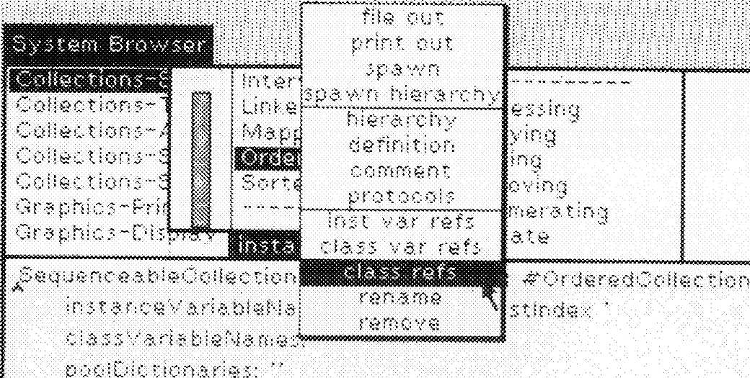

Figure 10J3fcs
III

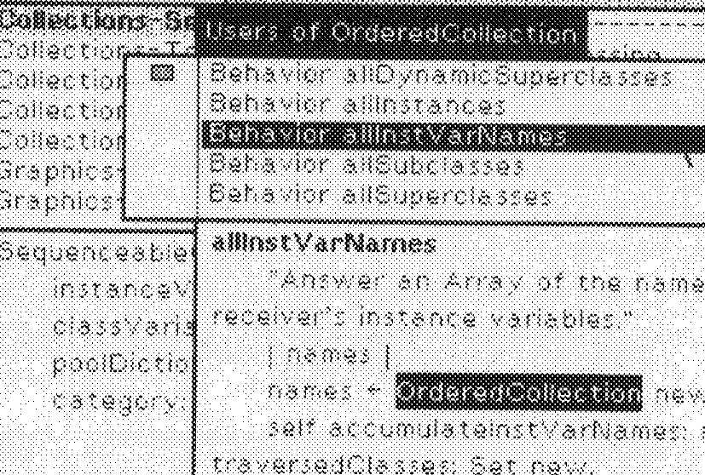

Figure I0.13b
"£f- w>i⁻;'.. .= >>{■

This book is in the
Addison-Wesley series in Computer Science
Michael A. Harrison
CONSULTING EDITOR
Cartoons drawn by Jean Depoian
Library of Congress Cataloging in Publication Data
Main entry under title:
Smalltalk-80 : bits of history, words of advice.
Bibliography: p.
Includes index.
1. Smalltalk-80 (Computer system) I. Krasner,
Glenn. II. Title: Smalltalk-eighty.
QA76.8.S635S58 1983 001.64'.25 83-5985
ISBN 0-201-11669-3
Reprinted with corrections, June 1984
Copyright © 1983 by Xerox Corporation.
All rights reserved. No part of this publication may be reproduced, stored in a retrieval system, or transmitted, in
any form or by any means, electronic, mechanical, photocopying, recording, or otherwise, without the prior written
permission of the publisher. Printed in the United States of America. Published simultaneously in Canada.
ISBN 0-201-11669-3
CDEFGHIJ-AL-8987654
Preface
The Software Concepts Group of Xerox Palo Alto Research Center
(PARC) has been working on the problem of how to give users access to
large amounts of computing power. We have concentrated our efforts
on the study of software systems, rather than on the creation of specific
hardware packages. Our method has been to develop a software system
called Smalltalk, to create applications in that system, and then, based
on our experiences developing the applications, to design the next sys-
tem. We have developed and used three major Smalltalk systems over
the last 10 years, as well as a few minor variations.
We have documented and released the latest of these systems, the
Smalltalk-80 system. We published a description of the system and a
complete specification of its implementation in the book, Smalltalk-80:
The Language and Its Implementation. This first book, however, does
not cover the use of the system or programming style for writing large
applications in the system. These topics are covered in the forthcoming
books Smalltalk-80: The Interactive Programming Environment and
Smalltalk-80: Creating a User Interface and Graphical Applications.
Nor does the first book discuss implementation techniques beyond the
formal specification, which is the subject of this book, Smalltalk-80:
Bits of History, Words of Advice.
To check the accuracy and the clarity of the first book, we invited a
number of groups outside of Xerox to build implementations of the
Smalltalk-80 system. Those groups uncovered problems with the writ-
ten description, and with the system itself, which we then corrected.
They also formed the beginning of a community of Smalltalk
212
Finding Out About Messages and Methods

a. c ο e ss ι η q
copying
adding
removing
en υ me rat ing
private
jf"d.phic5-Pnmitiv
jraphics-Display
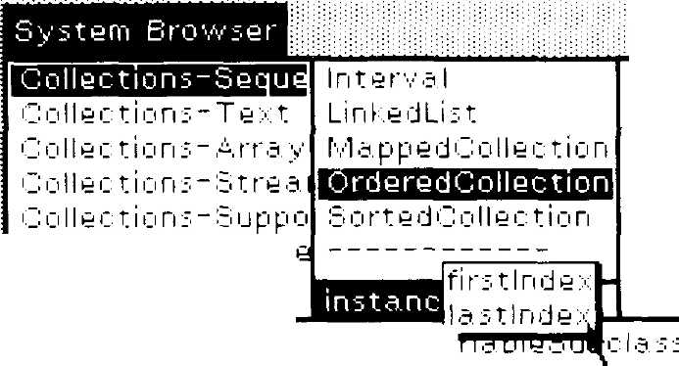

b e q u e η c e a. b I e υ ο 11 e c t i ο η ν 5
Ο r d e f e d C ο 11 e c t i ο η
i η s t a η c e'ν¹ a. r i a. b I e f'·.] a rn 9 s: ' f i r s 11 n d e χ I a. s 11 n d e;
c I a s s V a r i a. b I e Ν a. m e s:
poolDic tin η a ries:
c a. t e g ο r y: ' C ο 11 e c t i ο η s - Si e q u e η c e a. b I e'

Figure 10.12b
000

Figure 10.12c
•00
000

bystern Brc
OoBectfofK |  | DDuSen al j |
Collec  Γ; η 11 ρ ι" | 1
Collec |  | 0 r d e re d Collect! ο η m a. k.9 R ο cVn A t La. 51
Collec |  | 0 rd e re d C ο 11 e c t i ο η find:
Graph |  | 0 rd e re d C ο 119 c t i ο η re rn ο ν θ Α11S u c h Τ h a. t:
 |  | before: oldObject
S e q u e η c e.: |  | "Answer the element before oldObject, If the
ι r s t a n |  | receiver does not contain oldObject
c a. s s ν |  | or if the receiver contains no elements before
poolDi |  | oldObiect, create an error message."
categ.
 |  | | index |
 |  | index - self find: oldObject.
 |  | index = ^^Qj^S
 |  | if True: [tself errorFirst Object]
 |  | if False: [tself basic At: index - 1]

213
10.4 Which Methods Reference a Particular Variable or Literal?

e s sing
ying
inq
oving _
me rat inq
ate
# Ο rd e re d (j die c t i ο η
stIndex '
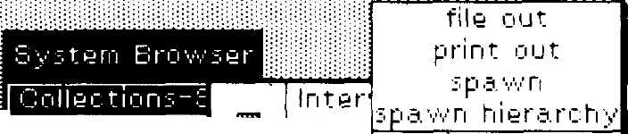

Links
Mapp
Sorts
hierarchy
definition
c ο rn rn e η t
ρ ro t ο c ο I s
ι η ft var refs
class var refs
Collections-
Collections-/
C ο 11 e c t i ο η 5 - i
Collect ions-i
Graphic s-Prii
Graphic s-Dis
rename
remove

^3 e q u e η c e a. b I e C ο 11 e c t i ο η
i η s t a n c e V a r i a b I e Ν a
classV'ariableNarnes
poolDictionaries: "
ca teg οry: 'C ο 11 e c t i οηs-Se q υ e η ce a b I e'

Figure 10.13a
Bio

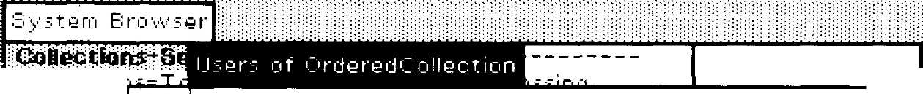
Collect ιοί
Collectioi
Collect io ι
Collect ioi
Graphics
Graphics
Β e h a ν i ο r a. 11D y η a m i c S υ ρ e r c I a s s e s
Β e h a v i ο r a 111 n s t a n c e s
Β e h a ν ι ο r a

Β e h a v i ο r a 11S u b c I a s s e s
Β e h a ν i ο r a 11S u ρ e re I a s s e s

Sequenceable
i η s t a n c e V
classVarii
poolDictio
category;
alllnstVarNarnes
"Answer an Array of the names of the
receiver's instance variables,"
| names |
Γι '3. ΠΊ Q 5 *~ BQBiI3cBPffiufEEBlBuB ri Q '^{i}/¹,¹'.
self a c c u rn u I a t e Ι η s t V a r Ν a. rn e s: η a rn e s
t r a v e r s e d CI a s s e s: S e t η e w,
t η a rn e s

Figure 10.13b
ooo

Preface
implementors with whom we can discuss our ideas, and from whom we
can learn about successful and less successful implementation experi-
ences. Paul McCullough of Tektronix suggested that all the
implementors submit papers describing their experiences to a software
engineering journal or ^to collect papers from each group into book
form. This book, then, is the outcome of that suggestion.
The papers in this book should be of value to other Smalltalk-80
implementors. To implement the Smalltalk-80 system, one has to match
the specification with his or her own hardware environment. Each of
the groups represented in this book had different experiences with this
problem. In addition, some of the groups tested (or speculated about)
various schemes for better Smalltalk-80 virtual machine implementa-
tions.
In addition to Smalltalk-80 implementors, software engineers should
be interested in the papers in this book. Although they are written in
the context of Smalltalk-80 implementations, the papers cover the gen-
eral software engineering topics of managing large software projects,
virtual memory design and implementation, software caching mecha-
nisms, and mapping software needs onto hardware design.
The papers in this book raise more issues than they resolve.
Smalltalk is still quite young—the Smalltalk-80 system is just a snap-
shot of research in progress. There are many other issues that need to
be raised and many ideas that need to be tested before some of the reso-
lutions can be found. It is our hope that this collection of works will get
other implementors thinking about key issues in Smalltalk implemen-
tations.
Part One of this book is a collection of papers that provide some
background and history of the Smalltalk-80 implementation. The first
paper is by Adele Goldberg, manager of the Xerox PARC Software Con-
cepts Group (SCG); it describes the history of releasing the Smalltalk-80
system to the non-Xerox world. Dan Ingalls, who has been the chief ar-
chitect of the many Smalltalk implementations, tells how the previous
systems led up to the Smalltalk-80 system. Glenn Krasner, also of SCG,
presents the design of the format of files that are used for sharing
Smalltalk-80 code among implementations. The last paper in this sec-
tion is by Allen Wirfs-Brock of Tektronix, and explores the various de-
sign decisions that Smalltalk-80 implementors may face.
In Part Two we present papers that describe the experiences four
implementors had in bringing their systems to life. Paul McCullough
writes about the process they went through at Tektronix, including a
step-by-step description taken directly from their logs. His paper points
out how valuable the outside implementors were at discovering prob-
lems with the system and its documentation. Joe Falcone and Jim
Stinger describe the experience they had at Hewlett-Packard bringing
up a couple of implementations. Peter Deutsch, of Xerox SCG, gives

Preface
some details of how he took advantage of hardware architecture to in-
crease the performance of his Smalltalk-80 implementation. Stoney
Ballard and Steve Shirron describe an implementation they made at
Digital Equipment Corp., which differs radically from the suggested im-
plementation of the storage manager, in order to provide improved per-
formance.
Descriptions of implementation experiences help others make their
design choices; actual measurements and analyses provide additional
concrete help. Part Three is a collection of measurements made by the
implementation groups. The first paper, by Kim McCall of Xerox SCG,
describes a set of benchmarks that is provided in the Smalltalk-80 sys-
tem to help measure the performance of an implementation. All the im-
plementation groups were willing to run these benchmarks, and a
comparison of their results is included in the paper. This gives a num-
ber of implementations against which new implementors can measure
their progress. Rick Meyers and Dave Casseres of Apple Computer pro-
vide an interesting set of analyses of their MC68000-based implementa-
tion. David Ungar and David Patterson of the University of California
Berkeley give a before-and-after description of the process of measuring
an implementation, optimizing the time-consuming parts, and measur-
ing the effects of the optimizations. Joe Falcone made measurements of
the Hewlett-Packard implementation that compare static properties
with dynamic properties of the system. Finally, Tom Conroy and Ed
Pelegri-Llopart of UC Berkeley present an analytic model for measur-
ing the potential performance gains of a particular cache scheme for
Smalltalk-80 implementations.
In Part Four we present papers that look toward the future of
Smalltalk systems and propose ideas for extending the Smalltalk-80
system beyond its initial form. The first paper is a description by Ted
Kaehler and Glenn Krasner of Xerox SCG of an object-oriented virtual
memory design. Steve Putz, also of SCG, presents a solution to the prob-
lem of coordinating changes made by many people to an evolving
Smalltalk-80 system. Jason Penney describes his implementation of a
file system at Tektronix, and discusses the use of the Smalltalk-80 sys-
tem for programming. From the University of Washington, Guy Almes,
Alan Borning, and Eli Messinger, present an analysis of the potential
for implementing the Smalltalk-80 system on the Intel ΪΑΡΧ432
microprocessor. Although they did not actually implement the system,
their paper provides a good analysis of how to match an object-oriented
system to object-oriented hardware. Applying compiler technology, Rob-
ert Hagmann of the University of California, Berkeley, proposes ways
to increase the performance of a Smalltalk-80 implementation. The last
paper, by Scott Baden of the University of California, Berkeley, pro-
poses hardware architecture support that would enhance the perfor-
mance of implementations.
213
10.4 Which Methods Reference a Particular Variable or Literal?

CollQctiori:-
iollection:-
iollectionr-
Collectionr-i
Graphic s-Pt
iraphics-Oi:
Ordered Collection
'stlndex '
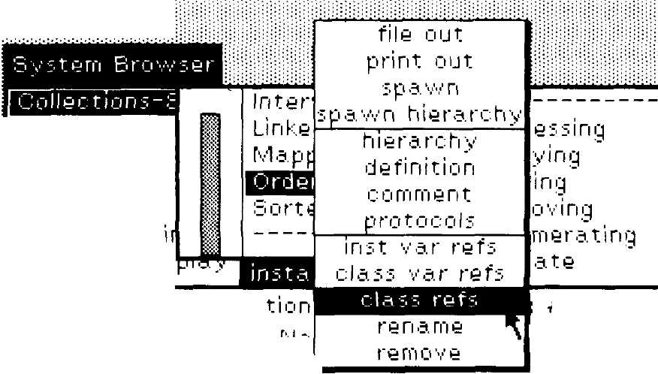
S e q u e η c e a b I e C ο 11 e c
in stance Variable
c I a. s 5 V a ri a b I e Ν a m e ■£·
poolDictionaries

ca teg ο ry: 'Cο 11 e c t iο ηs-S e q ueηc e a b I e'

Figure 10.13a
ΘΪ0

C ο 11 e c t i ο ι
Collect ioi
Collect ior
Collect ί ο r
Graphics-
Graphics
b e q u e η c e a b I e
i η s t a n c e V
class Varii
poolDictio
category:
Β e h a ν i ο r a 11D y η a m i c S u ρ e re I a s s e s
Β e h a. ν i ο r a 111 n s t a n c e s
Β e h a v i ο r a. 11S u b c I a. s s e s
Β e h a v i ο r a 11S u ρ e r c I a s s e s
alllnstVarNarnes
"Answer an Array of the names of th>
receiver's instance variables,"
| names |
η a m e s ^~ Bfl^SCjM^BBttflicMKiBoB η e w,
self a c c u m υ I a t e Ι η s t V a r Ν a rn e s: η a rn e s
t r a v e r s e d CI a s s e s: S e t η e w.
t η a. m e s
1—

Figure 10.13b
Boo

213
10.4 Which Methods Reference a Particular Variable or Literal?

Collections-'
Collections-/
Collect ion:.-'.:
C ο 11 e c t i ο η s - S
Graphic, s-Prii
Graphic s-Dis
Ordered Collection
stlndex '
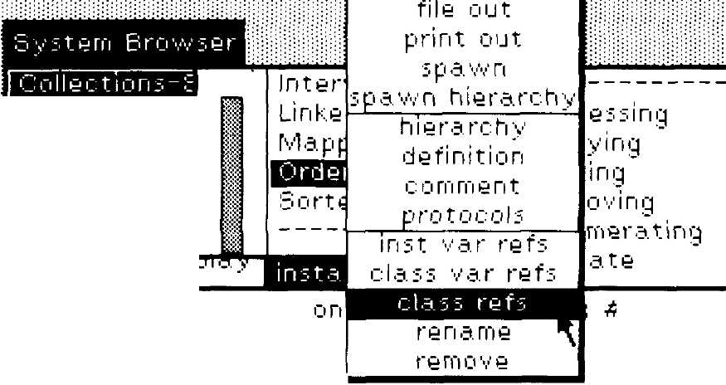
S e q u e η c e a b I e C ο 11 e c t i
inst a n c e V a ή a b I e Ν a.
c I a s s V a ri a b I e Ν a m e -s
poolDictionaries: "
ca teg ο ry: 'Cο 11 ec t i οη s-S e q υ eηc e a b I e'

b ν 5 tern Brow;er
CoBect; fort
C ο II e c t i ο
Collect ioi
Collect! οι
Collect ioi
Graphics-
Graphics·
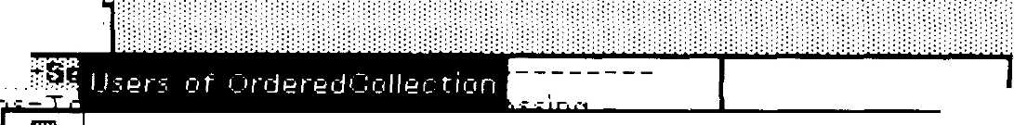
Β e h a ν i ο r a 11D y η a m i c S u ρ e re I a s s e s
Β e h a. ν i ο r a 111 n s t a n c e s

Β e h a v i ο r a 11S u b c I a s s e s
Β e h a v i ο r a 11S u ρ e r c I a s s e s

ο e q u e η c e a b I e
inst a n c e V
class Varic
poolDictio
category:
alllnstVarNarnes
"Answer an Array of the names of the
receiver'.- instance variables,"
| names J
self a. c c υ m u I a t e Ι η s t V a r Ν a m e 5: η a. m e s
t r a v e r s e d CI a ? s e s: S e t η e vv,
t η a m e s

VI
Preface

Acknowledg-
ments
We would like to thank the authors, their co-workers, and their organi-
zations for their contributions to this book, for their diligence during
the release and review process, and for their willingness to be open
about the strengths and weaknesses of their Smalltalk-80 implementa-
tions. We would also like to thank the Xerox Research management for
allowing us to release the Smalltalk-80 system, thus widening the com-
munity of Smalltalk implementors with whom we can share experi-
ences and insights.
Many people contributed to the production of this book. Each author
also acted as an editor of an early draft of another author's paper.
Janet Moreland helped coordinate this swapping with copying and
mailing. Doug Carothers answered legal questions. Ted Kaehler provid-
ed other bits of help, and Frank Zdybel added some words of his own.
Dave Robson built the translator that allowed us to deliver manuscripts
electronically. Eileen Colahan of the International Computaprint Corpo-
ration was extremely cooperative and flexible in turning these electron-
ic manuscripts into print. The cartoons in the book are by Ted Kaehler,
redrawn by Addison-Wesley artist Jean Depoian. Adele Goldberg
merged the images into the cover design with help from Rebecca
Cannara. Particular thanks go to production editor Fran Fulton for her
cooperation and patience, and to Jim DeWolf and Cheryl Wurzbacher of
Addison-Wesley.
Registered trademarks mentioned in this book are: AED-512, Ad-
vanced Electronic Design, Inc.; UNIX, Bell Laboratories; DEC,
DECSYSTEM, DECSYSTEM20, UNIBUS and VAX, Digital Equipment
Corporation; HP-IB, Hewlett-Packard; GPIB, National Instruments;
BitPadOne, Summagraphics Corporation; and Smalltalk-80, Xerox Cor-
poration.

Palo Alto, California
June 1983
G. Ε. Κ.

Contents
PART ONE Background 1
1 The Smalltalk-80 System Release Process
Adele Goldberg 3
- The Evolution of the Smalltalk Virtual Machine
Daniel Η. Η. Ingalls 9
- The Smalltalk-80 Code File Format Glenn Krasner 29
- Design Decisions for Smalltalk-80 Implementors
Allen Wirfs-Brock 41

PART TWO
Experiences Implementing the Smalltalk-80 System
- Implementing the Smalltalk-80 System: The
Tektronix Experience Paul L. McCullough
- The Smalltalk-80 Implementation at Hewlett-
Packard Joseph R. Falcone, James R. Stinger
- The Dorado Smalltalk-80 Implementation: Hard-
ware Architecture's Impact on Software
Architecture L. Peter Deutsch
- The Design and Implementation of
VAX/Smalltalk-80
Stoney Ballard, Stephen Shirron
57
59
79
113
127
vii

213
10.4 Which Methods Reference a Particular Variable or Literal?

ess ing
V ί η ι'4
ing
ο ■·,·■ i η g
m e ra. ting
ate
#OrderedCollection
stlndex '
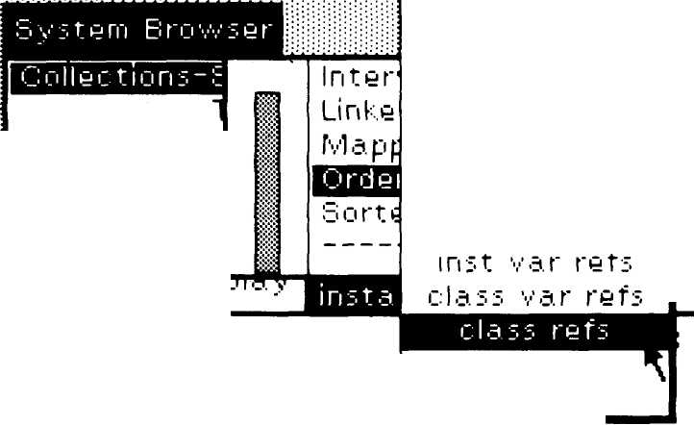
file out
print out
Collections-
Collections-/
Collections
Collections-::
Graphics-Prir
Graphic s-Ois
hierarchy
definition
comment
protocols
5 ρ a w ri
spawn hierarchy
re η a. me
remove
_{A}b e q υ e η c e a. b I e C ο 11 e c tier
instanceVariableNa'
c I a. s s V a ri a. b I e Ν a. rn e sV
poo (Dictionaries: "
c a. teg ο r y: ' C ο 11 e c t i ο η s - S e q u e η c e a. b I e'

Ι Β e h a. ν i ο r a. I i D y η a. m i c S u ρ e r c I a. s s e s
Β e h a ν i ο r a 111 n s t a n c e s
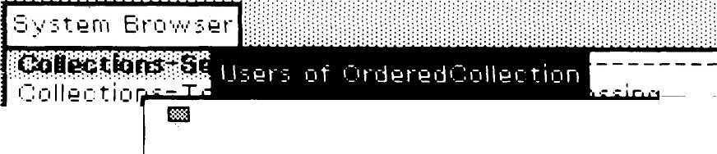
Collectioi
Collectioi
Collectioi
Graphics-
Graphics·

Sequence able
i ri s t a ri c e V
cl &.5 5V an ■:
ρ ο ο ID i c t i ο
category;
Β e h a v i ο r a 11S u b c I a s s e s
Β e h a ν i ο r a 11S u ρ e re I a s s e s
alllnstVarNarnes
"Answer an Array of the names of the
r e c e i ν e r' s in s t a n c e ν a r i a b I e s,"
| names |
ri a. γιί e s *~ ^^^^^^^^^^^^^^^^Q η e w,
self a c c u rn u I a t e Ι η s t V a r Ν a rn e s: η a rn e s
t r a v e r s e d CI a s s e s: S e t η e w.
t η a. rn e s

J

VIII
Contents

PART THREE
Measurements and Analyses of Implementations 151
9 The Smalltalk-80 Benchmarks Kim McCall 153
10 An MC68000-Based Smalltalk-80 System
Richard Meyers, David Casseres 175
- Berkeley Smalltalk: Who Knows Where the Time
Goes? David M. Ungar, David A. Patterson 189
- The Analysis of the Smalltalk-80 System at
Hewlett-Packard Joseph R. Falcone 207
- An Assessment of Method-Lookup Caches for
Smalltalk-80 Implementations
Thomas J. Conroy, Eduardo Pelegri-Llopart 239

PART FOUR
Proposals for the Future of the Smalltalk-80 System
14 LOOM—Large Object-Oriented Memory for
Smalltalk-80 Systems
Ted Kaehler, Glenn Krasner
15
Managing the Evolution of Smalltalk-80 Systems
Steve Putz
16
Implementing a Smalltalk-80 File System and the
Smalltalk-80 System as a Programming Tool
D. Jason Penney
17 Implementing a Smalltalk-80 System on the Intel
432: A Feasibility Study
Guy Almes, Alan Borning, Eli Messinger
- Preferred Classes: A Proposal for Faster
Smalltalk-80 Execution Robert Hagmann
- Low-Overhead Storage Reclamation in the
Smalltalk-80 Virtual Machine Scott B. Baden
Index
249
251
273
287
299
323
331
343

PART ONE

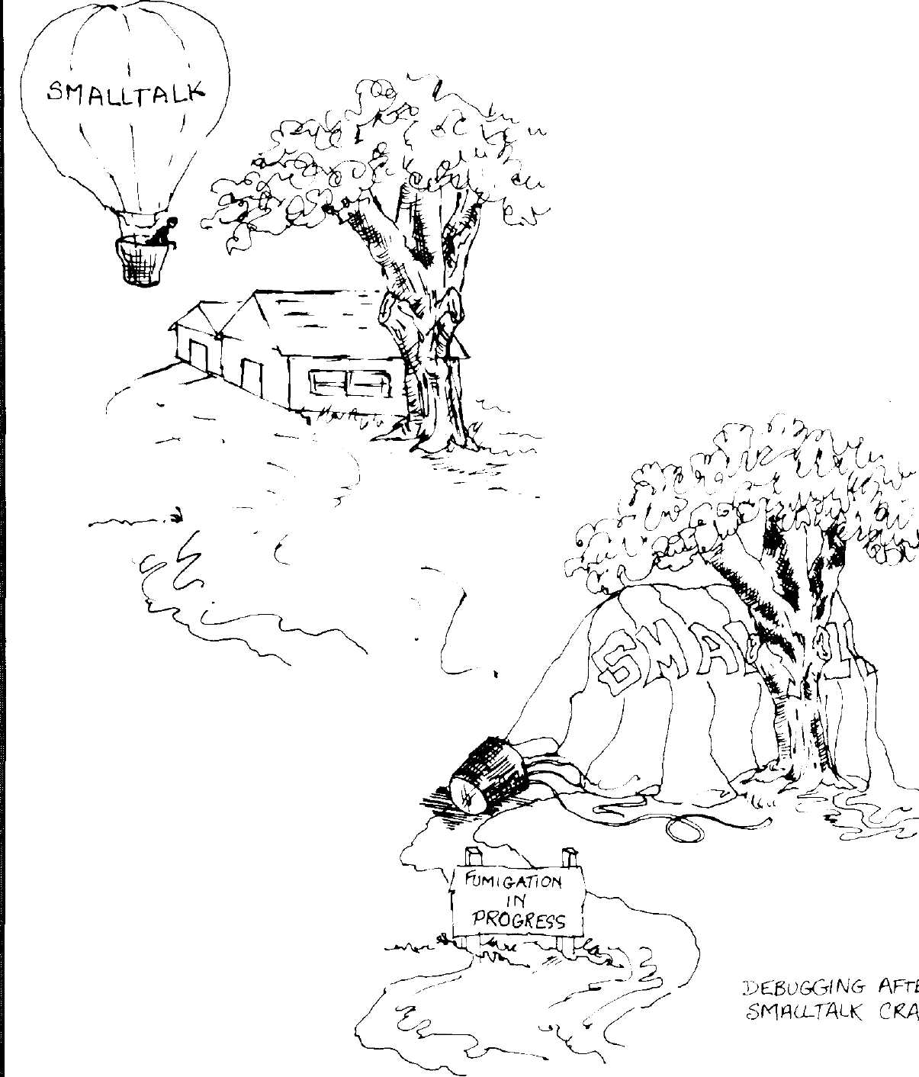
^-u

213
10.4 Which Methods Reference a Particular Variable or Literal?

Inter
#OrderedCollection
stlndex '
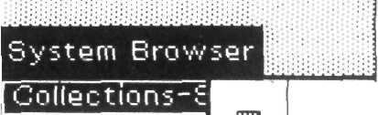

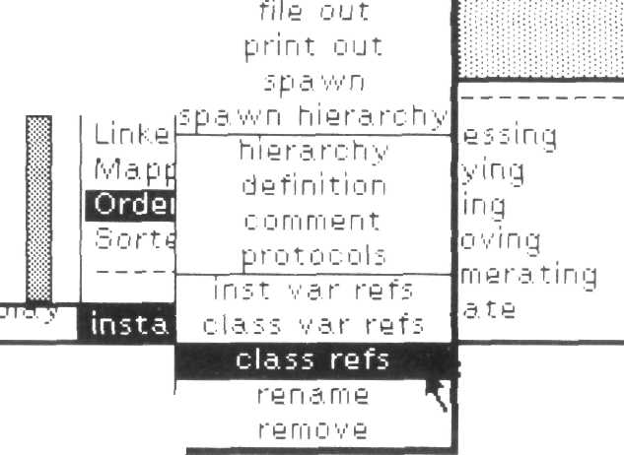
Collect ions-
Collections-/
Collections-?
C ο 11 e c t i ο η s - ■':
Graphics-Prii
Graphics-Dis
ύ e q υ e η c e a. b I e C ο 11 e c t i ο η
i γι s t a. Γι c e V a ri a b I e Ν a'
c I a. s 5 V a r i a b I e Ν a. m e sV
poolDictionaries: "
c a t e g ο r y: ' C ο 11 e c t i ο η 5 - S e q u e η c e a b I e'

oilectio
ollectioi
ollectioi
■•ollectior
raphics-
raphics-
Β e h a. ν ί ο r a. 11D y η a m i c Ό u ρ e r c I a s s e s
Ει e h a ν i ο r a 111 n s t a n c e s
Behavior alllnstVarWames

Ε e h a. ν i ο r a 11S υ b c I a s ί e s
Β e h a. ν ί ο r a. 11S υ per c I a s s e s

; q u e η c e a b I e
ί η :■ t a n c e V
classVarid
poolDictio
c a. t e q ο r y:
alllnstVarNarnes
"Answer an Array of the name.⁷, of thi
r e c e i ν e r' s instance ν a. r i a b I e s,"
| names |
η s. rn e s *~ ^^g^^^u^^^^^^^^^ η e 'vv,
self a c c u rn υ I a t e Ι η s t V ^.r Ν a. rn e s: η a. m e s
traversedCla.sses: Set new,
t η a. rn e s

Intr
The Smalltalk-80 System
Release Process
Adele Goldberg
Manager, Software Concepts Group
Xerox Palo Alto Research Center
Palo Alto, California
'Oduction The Smalltalk-80 system has its roots in the Xerox Palo Alto Research
Center starting more than 10 years ago. During a decade of research,
three major systems were designed, implemented, and tested with a va-
riety of users. The systems were named for the year in which they were
designed. The first two were Smalltalk-72 and Smalltalk-76. The latest
version, called the Smalltalk-80 system, was developed to be adaptable
for implementation on a large number and variety of computers.
The Smalltalk research efforts focus on increasing the support that
computing systems can provide to users who are not computer scientists
by profession. These efforts are centered on the visual impact of
bitmapped graphics, on highly interactive user interfaces, and on in-
creased flexibility in terms of user programmability. Among the out-
comes of this work were the basic concepts of windows, menus (textual
and iconic), and scroll bars. Implementations of these concepts are used
to expand the virtual space of a display screen; they typically empha-
size the use of pointing devices rather than keyboards for selecting ob-
jects (documents, devices) and operations on objects (commands).
In 1979 and 1980, requests and clearances were agreed upon within
the Xerox Corporation to permit the dissemination of the Smalltalk-80
Copyright © Xerox Corporation 1982. All rights reserved.
212
Finding Out About Messages and Methods
System Browser

LinkedLiit
Γνΐ a ρ ρ e d C ο 11 e c t i ο η
accessing
copying
a. d d i ri g
removing
e ri u γιί e r a. t i η g
ρ ri ν a. t e
«lifiragj.wffliiawi.iii
bortedCollection

Collect ions-Text
Collections-A ft" a y
Collect ions-Strea
C ο 11 e c ΐ i ο ri s - S u ρ ρ ο
Graphic s- Ρ ri mi ti
Graphic;-Display
class: #OrderedCollection
b e g υ e ri c e a b I e <j ο 11 e c t i ο η
Ί η s t a η c e V a r Ί a b I e Ν a m e s: ' f i r; 11 η d e χ I a s 11 n d e χ '
classVariableNarnes; "
poolC'ictionaries: "
c a. t e q ο r y; ' C ο II e c t ί ο Γι s - S e q u e η c e a b I e '

Figure 10.12b
000

vstern Br
Ο rd e re d C ο 11 e c t i ο η m a ke R ooVn A t La s t
Ο rd e re d C ο 11 e c t i ο η f i η d:
Ο r d ere d C ο 11 e c t ion re m ο ν e A11S u c h Τ h a t;
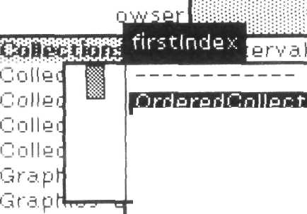

5 e q u e η c e.:
in stan

poolDi
cat eg.
before: oldObject
"Answer the element before oldObject, If the
receiver does not contain oldObject
or if the receiver contains no elements before
oldObject, create an error message."
| index |
i η d e χ <- self find; ο I d Ο b ί e c t,

Figure 10.12c
loo
000
if Τ rue; [tself error First Object]
ifFalse; [tself basic At; index - 1]

213
10.4 Which Methods Reference a Particular Variable or Literal?

collections-!
C ο 11 e c t i ο η s - ,*
C ο 11 e c t i ο η s - S
C ο 11 e c t i ο η s - £
Graphics-Prii
Graphics-Dis
^Ordered collection
stlndex '
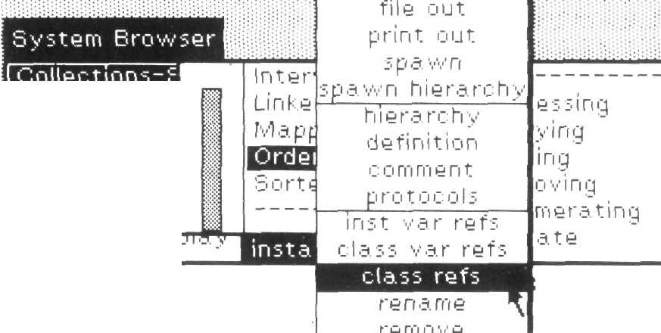
Ό e q u e η c e a b I e C ο 11 e c ΐ i ο η
ί γι s t a. n c e V a r i a b I e Ν a
c I a. s s V an a b I e Ν a m e s¹
poolDictionaries: "
c a t e g ο r y: ' C ο 11 e c t ί ο η ■; - S e q υ e η c e a b I e'

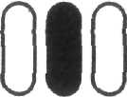
Figure 10.13a

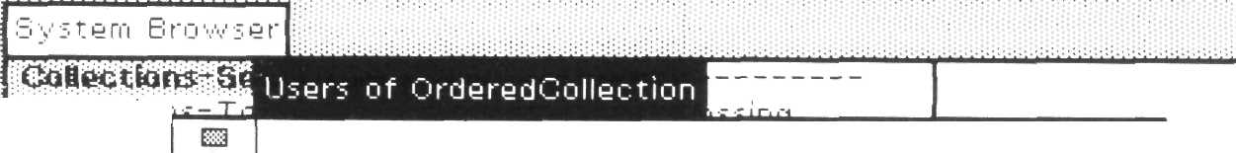
ectior
ollectioi
ollectioi
ο 11 e c t i ο ι
3 rap hies ■
Graphics-
Β e h a v i ο r a 11D y η a rn ι c b υ ρ θ r c la:
Β 9 h a. ν i ο r a 111 n :· t a n c e s
Behavior alllnstVarNames
Β e h a. ν ί ο r a. 11Ό u b c I a. s s e s
Β e h a v ior a 11S υ ρ e r c I a s s e ■■

uequenceable
instance'¹·/
class Van'.:
poolDictio
category:
alllnstVarNarnes
"Answer an Array¹ of the names of th>
receiver's i η s t a. η c 9 ν a r ί a. b I e s."
| names |
fl d Γ0 9 5 *~ ^^U^^^D^^w^^^^^Q Π 9 VV,
self a c c υ m u I a. t e Ι η s ΐ V a. r Ν a. m e s: η a m 9 s
t r a. v e r s e d CI a s s e s: Set η e w,
+ η a γιί 9 s

Figure 10.13b
ra



The Smalltalk-80 System Release Process
system to the non-Xerox world. The stated purposes of this dissemina-
tion were to:
- expand the community of Smalltalk programmers in order to gain
more general experience with how people can use the language;
- expand the community of programming language researchers who
study aspects of the Smalltalk style of programming;
- influence hardware designers to consider ways in which to provide
increased performance for the Smalltalk style of interaction; and
- establish a standard for Smalltalk as an object-oriented program-
ming language and a graphics-based, interactive program develop-
ment environment.
The dissemination was planned in three parts: a series of introductory
articles, a book giving detailed system specifications, and a magnetic
tape containing the system itself. The series of articles would provide
an early and less formal introduction to the Smalltalk-80 system. Ulti-
mately, these articles were published in the August 1981 special issue
of Byte magazine. The system specification was divided into two major
components—the Virtual Machine and the Virtual Image. The Virtual
Machine for a particular hardware system consists of an interpreter, a
storage manager, and primitives for handling the input/output devices.
The Virtual Image is a collection of objects that make up descriptions of
classes providing basic data structures (including numbers), basic
graphics and text, compiler, decompiler, debugger, and viewing and
user interface support. The Virtual Image contains approximately
10,000 objects. The proposed book would contain the formal specifica-
tions for the implementation of the Virtual Machine, as well as a de-
scription of the language and the interfaces to the objects in the Virtual
Image. The proposed tape would contain a digital representation of the
Virtual Image that could be loaded into a hardware system on which
the Virtual Machine had been implemented.
All systems running the Smalltalk-80 system would therefore look
the same; each would have to support bitmapped graphics and a point-
ing device for controlling a cursor on the graphics display. The issue of
protecting the software was resolved by copyrighting the Virtual Image
and publicly disclosing the Virtual Machine; licensing under copyright
grants the licensee the right to reproduce the Image only for incorpora-
tion into a hardware product of the licensee. Any unincorporated repro-
duction and distribution is prohibited. The modular approach to the
Smalltalk design made this form of protection feasible.
Introduction
An initial attempt to produce a book about the Smalltalk system de-
scribed the design of an unfinished system that was to be called
Smalltalk-80. Chapters of the book were written in the spring and sum-
mer of 1979. Since much of this written material described how to im-
plement the system, an appropriate review of the material required
following the specifications and actually implementing the Virtual Ma-
chine. This was accomplished by involving members of software groups
of several computer manufacturers in the process of review and imple-
mentation. Although the Smalltalk systems had received a great deal of
publicity since Smalltalk-72 was first designed, few people outside Xe-
rox's research centers had actually used them before this review.
The cautious invitation issued to six companies was to read the book
material in order to understand the nature of the system. Reviewers
were also invited to visit the Xerox Palo Alto Research Center in order
to see a live demonstration of the system. If they were still interested in
the system after reading the written material and participating in a
demonstration, they were invited to enter the second phase of review—
an actual implementation. A company could only accept the invitation
if it had (1) the required hardware (at least a 16-bit processor, a
bitmapped display, and a way of indicating locations on the display),
and (2) a software team on the project that consisted of regular employ-
ees only.
Only four of those invited were able to enter the second phase of the
review, Apple Computer, Digital Equipment Corporation, Hewlett-
Packard, and Tektronix. These four companies agreed to share in
debugging the formal specification of the Virtual Machine. Problems
encountered and general design advice would be exchanged with all
participants. Besides assisting in completing a book about the system,
this review process would test the ability of these manufacturers to suc-
cessfully create a full implementation of the Smalltalk-80 system based
on the information provided in the book. Success would be measured by
each manufacturer's ability to "read and adopt" the Virtual Image; a
more subjective measurement would be the actual performance of the
system on each manufacturer's hardware.
By 1982, the review process was complete enough that a revision of
the book was possible. Actually, the written material was treated much
the way the Smalltalk software had been treated over the decade of re-
search—it was thrown away, with the exception of the (now debugged)
formal specification of the Virtual Machine. All of the chapters were
rewritten. Because of the volume of material that was to be disseminat-
ed, the book became three books—one for the programmer and lan-
guage designer {Smalltalk-80: The Language and Its Implementation),
one for the user and programming environments designer
{Smalltalk-80: The Interactive Programming Environment), and one for
212
Finding Out About Messages and Methods

Interval
Linked List
Μ a ρ μι e d C ο 11 e c t i ο η
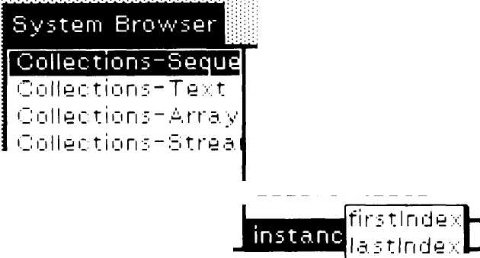

¹ _■ ι j 11 e c t i ο ri s - b u pi ρ ο b ο r t e d <J ο 11 e c t i ο Γι
¹ j ra ρh ic s - Prim i t i ν d
G rδ. ρ h i c s - D i s ρ I a y
a c c 9 s s ι ri q
c ι j μι y i η q
a. d d i ri g
removing
en υ me rat ing
private
b e q υ e η c 9 a. b I e C mile c t i ο η ν .57TOTH57TW c I a. s s: # Ο r d e r e d C ο 11 e c t i ο η
i η s t a ri c 9" v¹ a r i a b 19 Ν a rn 95: ' f i r s 11 η d e χ I a s 11 η ι J 9 χ ^{Ί}
c I a. s s' v¹ a. ri a. b 19 Ν a. rn 9 s:
poolDictionaries: "
c a. teg 0 r y: ' C 0119 c t i ο η s - 3 9 q υ 9 ri c e a b I e'

Figure 10.12b
000

Ο r d e r e d C 011'e c t i ο η m a ke R o'oVn A t La s t
Ο rd e re d C 011 e c t i ο η f i η d:
Ο r d e r e d C 011 e c t i ο η r e rn ο ν e A11S u c h Τ h a. t:
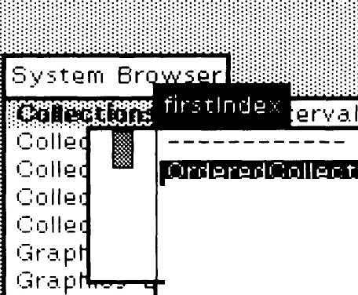
100

b e q u e η c e .=
i η s t a. n
c I a. s s V
ρ ο ο ID i
c a. t e q 1
before: oldObject
"Answer the element before oldObject, If the
receiver does not contain oldObject
or if the receiver contain:- no elements before
oldObject, create an error message."
I index |
index *■ self find: oldObject.
index = μΠΧμ^^Κ
if True: [tself errorFirst Object]
if False: [tself basic At: index - 1]

Figure 10.12c
000

213
10.4 Which Methods Reference a Particular Variable or Literal?

e s s ι η g
y i η g
ing
ο ν i ri g
me rat ing
ate
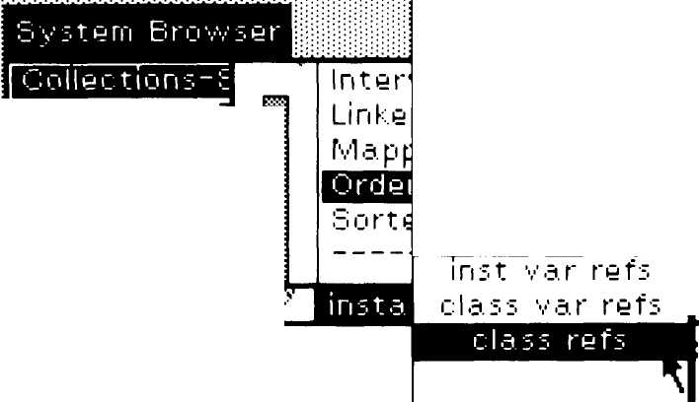
file out
print out

Collections-
Collections-^
Collections-£
Collections-::
Graphic s-Prir
Graphic s-Di
hierarchy
definition
c ο rn m e η t
protocols
s ρ a w η
spawn hierarchy
rename
remove
_{A}S e q u e η c eable'Jollecti ο r
instanceVariableNa
classVariableNamesV
poolC'ic tin π a riy.": "
c a t e g ο ry: 'Collect! ο η s - S e q u e η c e a b I e
# Ordered Collect io η
:tlnde> '

Figure 10.13a
010

Figure 10.13b

 |  | System Β | rows | -^{r}\
 |  | Ooiectior  ι~,'Γι||ΡΓ t ifif | rows
 |  | ■~:ollectioi | m | Β e h a ν i ο r a 11D y η a. rn i c S u ρ e r c 1 a s s 9 s
 |  | Collectior |  | Β 9 h a v i ο r a 111 n s t a n c e s
 |  | ¹ iollectior  Gr.=i ρ hi i ι": ·=: ■ |  | Β e h a ν ί ο r a 11S u b c 1 a s 5 9? ^{x}
 |  | Graphics- |  | Β 9 h a ν i ο r a 11S u ρ 9 r c 1 a s s e s
 |  | S 9 q u 9 η c 9 a b 19 |  | alllnstVarNarnes
 |  | i η s t a ri c 9 V |  | "Answer an Array of thy names of thy
 |  | class Varic |  | receiver's instance variables."
 |  | ρ ο ο 1D i c t i ο |  | | names |
 |  | category: |  | ri a. rn 95 *~ ^^B^^^B^^nl^^u^Q η 9 ν/,
 |  |  |  | self a. c c u rn u 1 a t e Ι η s t V a r Ν a rn 95: η a rn 9 3
 |  |  |  | t r a v 9 r s 9 d C1 a. s s e s: S e t η e w,
 |  |  |  | t η a rn 9 s
uoo

The Smalltalk-80 System Release Process
the applications designer (Smalltalk-80: Creating a User Interface and
Graphical Applications).
For their participation in the review process, each manufacturer re-
ceived a right to use the Smalltalk-80 Virtual Image in their research
and in their developed hardware products. Thus the Virtual Machine
has been provided outside Xerox without obligation, while the Virtual
Image for use in conjunction with the Machine has been licensed under
the auspices of copyright. That is, the reproduction and redistribution of
the Virtual Image or portions of the Virtual Image are permitted only
as incorporated into a product of these manufacturers/licensees.

The Review
Process
The first tape containing a Virtual Image was delivered February 17,
1981. The image file contained 328 records, 512 bytes per record. The
purpose of this tape was to debug the image file format, and to get the
reviewers started loading in and running a version of Smalltalk. The
image had two deficiencies: the source code for the class hierarchy was
primarily a subset of the system, and the primitives called from each
class had only preliminary class/method and number assignments. The
reviewers were also provided a detailed memo instructing them how to
read the image file format and summarizing the information provided
in the book on formats for object pointers, object space, contexts, com-
piled methods, and classes.
As part of the agreement, telephone consultation was available to the
implementors. Any major bugs or discrepancies in the specifications
were reported via telephone and logged. It was possible to monitor each
implementor's progress with respect to their discovery of or compensa-
tion for the bugs. The process of revising the system image itself was
carried out at Xerox with the aid of electronic mail: bug reports, bug
fixes, status reports, and new ideas were typically communicated
electronically. Eventually these communications evolved into a
Smalltalk-80 subsystem called the Version Manager which supported
(re-Configuration of new system releases.
The second tape was delivered on July 24, 1981. In addition to the
image file (this time 589 records long), the tape contained a file of the
source code, a file into which the system writes its "audit trail" of
changes, and three files containing traces generated by the
Smalltalk-80 simulator as it executes the first bytecodes in the Virtual
Image. The traces were made by running the formal specification of the
interpreter written in Smalltalk-80 code (the code is included in the
chapters of the book).

The Review Process
The three traces, provided in all subsequent tape releases, show de-
creasing levels of detail over increasing durations.
- The first trace shows all memory references, allocations,
bytecodes, message transmissions, returns, and primitive invoca-
tions for the first 115 bytecodes executed.
- The second trace shows only the bytecodes, message transmissions,
returns, and primitives for the first 409 bytecodes.
- The third trace shows message transmissions, primitives, and re-
turns for the first 1981 bytecodes.
The traces allow the implementors to compare their system's actual be-
havior with the "expected" behavior.
This second tape contained a full system according to the specifica-
tion of the Smalltalk-80 Virtual Machine. All the source code had ei-
ther been rewritten according to the class hierarchy for Smalltalk-80,
or had been translated from the Smalltalk-76 classes into the
Smalltalk-80 syntax. However, this translated code was not the defini-
tion for the final system.
The third tape was delivered four months later on November 18,
1981. It contained the same kinds of files as were provided on the sec-
ond tape. By this time, however, the system user interface had been
completely rewritten and a great deal of new functionality had been
provided in the program development environment. The image file was
now 977 records long.
Once again, the Virtual Machine had been changed, in particular,
several primitives were added. This time the changes were mostly those
discussed and agreed upon by the implementors who attended the
"First Ever Smalltalk-80 Implementors' Conference" held September
24-25, 1981, in Palo Alto. Much of the discussion at this conference cen-
tered around the uses of reference counting, garbage collecting, and
method caches. The Smalltalk-80 system design separates storage man-
agement from the Virtual Machine specification. The various
implementors were able to try out several storage management
schemes, as well as several different approaches to reference counting.
Source code management was also discussed, notably the solution of
making source code bona fide Smalltalk objects in a virtual memory
system, rather than trying to use external text files. Benchmarks for
comparing system implementations were specified, and agreement was
reached on writing a book on implementation considerations (that is,
the book in which this chapter appears).
A fourth tape was later provided in order to distribute a Virtual Im-
age that had been used for some time and in which many bugs had
been fixed and some new features added. In particular, the fourth im-
8
The Smalltalk-80 System Release Process
age added a model interface to a file system. The image file was now
1011 records long. The implementors who had been successful in run-
ning the third tape were able simply to load and run this fourth tape,
without any changes to their Virtual Machine implementation. The
goal of distributing system releases as Virtual Images was thus reached
and the review process terminated.

Additional
Collaborations
Prior to the delivery of the third image, an additional research license
was given to the University of California at Berkeley in order to pro-
vide material for study by a graduate seminar on computer architecture
(taught by Professors David Patterson, John Ousterhout, and Richard
Fateman). The students in the seminar obtained an early version of the
Hewlett-Packard implementation of the Smalltalk-80 Virtual Machine
on which to run the Virtual Image provided by Xerox. After some ini-
tial use and study, the students wrote their own implementation in the
C language for a VAX/780. The purpose in executing this license was to
establish a close collaboration with a group of researchers experienced
with the application of state-of-the-art hardware architecture technolo-
gy to high-level programming languages.
Once the review process was completed, a special collaboration was
formulated with the Fairchild Laboratory for Artificial Intelligence Re-
search (FLAIR). Several implementations had been carried out on hard-
ware systems consisting of an MC68000 processor, from which several
clever ideas for improving the performance of the interpreter had been
devised. The researchers at Xerox and FLAIR felt that by working to-
gether they could combine these clever ideas into a MC68000-based sys-
tem with better performance than so far demonstrated. At the time
that this chapter was written, this implementation project was still un-
der way.

A Final Word
The book review process, as envisioned by the research team, satisfied
two needs: publication of research results, and setting a standard for a
new form of personal computing. Publication took the form of written
articles; the quantity of material and the integrated presentation of
that material required a full book and a special issue of a magazine.
The published system, however, was best appreciated in its dynamic
form; publication was best served by distribution of the actual system
software. Through this distribution, a shared system base has been cre-
ated.

The Evolution
of the Smalltalk
Virtual Machine
Daniel H. H. Ingalls
Software Concepts Group
Xerox Palo Alto Research Center
Palo Alto, California

Introduction
In this paper we record some history from which the current design of
the Smalltalk-80 Virtual Machine springs. Our work over the past de-
cade follows a two- to four-year cycle that can be seen to parallel the
scientific method and is shown in Fig. 2.1. The paper appears in two
Use
Observe whether the
prediction worked

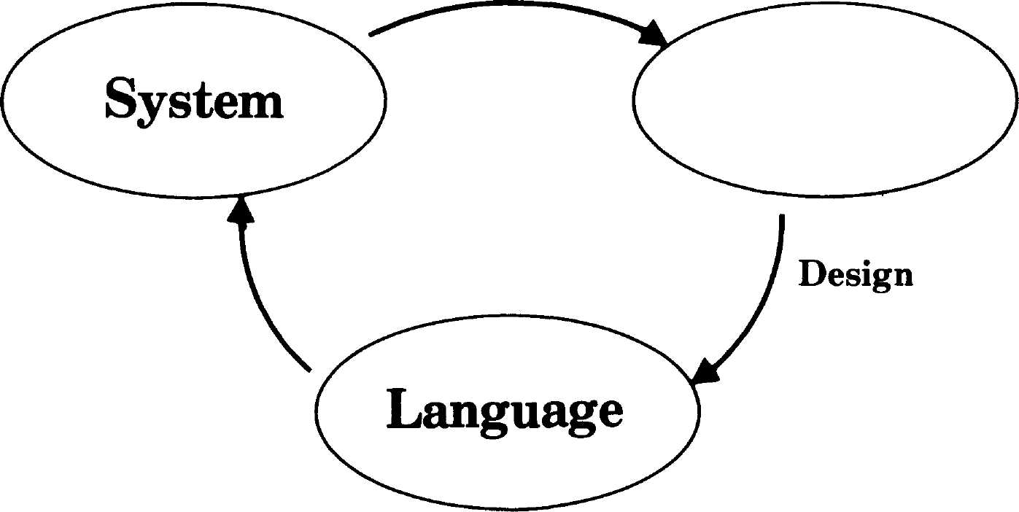
Applications
Implement
Make a prediction
based on theory
Formulate a theory
based on
experience
Figure 2.1

Copyright © Xerox Corporation 1982. All rights reserved.

10
The Evolution of the Smalltalk Virtual Machine
sections that are relatively independent of one another. The first sec-
tion traces the evolution of the current design from the perspective of
form following function. It follows the major implementation challenges
and our solutions to them. The second section relates some of the meth-
odology which evolved in pursuing this cycle of reincarnation. Readers
who are less interested in the details of Smalltalk can skip to the sec-
ond section and interpret our experience relative to other programming
languages and systems.

Form Follows
Function
Smalltalk-72
From the first Smalltalk interpreter to the definition of the
Smalltalk-80 Virtual Machine, the Smalltalk language has been charac-
terized by three principal attributes:
- Data stored as objects which are automatically deallocated,
- Processing effected by sending messages to objects,
- Behavior of objects described in classes.
In spite of other opinions to the contrary, we consider these to be the
hallmarks of the "object-oriented" style of computing. In this section we
shall trace the evolution of the underlying machinery which has sup-
ported language systems in this style over the last ten years. Some of
the changes have augmented the power of the language, and some have
increased its efficiency. Each change can be seen as an attempt to bring
the underlying machinery more into harmony with the day-to-day de-
mands of object-oriented programming.
The very first Smalltalk evaluator was a thousand-line BASIC program
which first evaluated 3 + 4 in October 1972. It was followed in two
months by a Nova assembly code implementation which became known
as the Smalltalk-72 system¹.
□ Storage Management Objects were allocated from a linked list of
free storage using a first-fit strategy. Objects which were no longer ac-
cessible were detected by reference-counting. They were then returned
to the free storage list, with adjacent entries being automatically co-
alesced. Since pointers were direct memory addresses, compaction
would have been complicated, and was not attempted. Contexts, the
suspended stack frames, were managed specially as a stack growing
down from high memory while normal allocation grew up from low
memory. This separation reduced the tendency to leave "sandbars"

π
Form Follows Function
when returning values from deep calls, a problem in the absence of
compaction.
□ Token Representation of Code All code was stored in a single tree
made up of instances of Array (it was called Vector then), a variable-
length array of pointers. The code in this tree represented a pattern de-
scription, similar to Meta. Fig. 2.2 presents the Smalltalk-72 definition
of a class of dotted-pair objects, followed by a few examples of its use.
Responses printed by the system are underlined.

Figure 2.2

to pair
| head tail
(isnew =>
(" head <■ | - :. "tail <
λ. head =>
("head - :)
τ head)
Λ- tail =>
(■^c <— =$>  ("tail | - :)
Τ tail)
Λ- print =>
("[print. | head print
" . print.
tail print. | "] print))
pair
" a «- pair 2 | 5
[2.5]
a tail «- pair | 37
b tail head
3
to is the defining word, as in LOGO.
| declares instance variable names.
isnew is true if an instance is just created.
" means literally the next token, here the
names head and tail.
«- is a message like any other.
: fetches the next value from the incoming.
message stream.
Λ- matches the next literal token
like the Smalltalk-80 message
peekFor:
false =ί> (body) does nothing, but
true => (body) evaluates the body, and
then leaves the outer scope.
In this way several such constructs
work as a CASE statement.
Here a pair is created, called a.
a gets its tail changed.
a's tail (= [3.7]) gets the message head.

The code was viewed by the interpreter as simply a stream of tokens.
The first one encountered was looked up in the dynamic context, to de-
termine the receiver of the subsequent message. The name lookup be-
gan with the class dictionary of the current activation. Failing there, it
moved to the sender of that activation and so on up the sender chain.
When a binding was finally found for the token, its value became the
receiver of a new message, and the interpreter activated the code for
that object's class.

12
The Evolution of the Smalltalk Virtual Machine
In the new context, the interpreter would begin executing the receiv-
er's code, matching it with the token stream which followed the original
occurrence of the receiver. Various matching operators would select a
route through the code which corresponded to the message pattern en-
countered. The matching vocabulary included matching a literal token,
skipping a token, picking up a token literally, and picking up the value
of a token. The latter operation invoked the same dynamic lookup de-
scribed above for the receiver.
Q Classes Most class properties were stored in a single dictionary. In-
stance variable names were denoted by a special code which included
their offset in the instance. Class variables appeared in the same dictio-
nary as normal name/value pairs. Another entry gave the size of in-
stances, and another gave the "code" for the class. When a class was
mentioned in code, it would automatically produce a new instance as a
value. The unfortunate result of this special behavior was to make clas-
ses unable to be treated as ordinary objects.
Q Applications Smalltalk-72 was ported to the Alto² as Soon as the
first machines were built, and it provided a stable environment for ex-
perimentation over the next few years. The Alto provided a large
bitmap display and a pointing device, and thus made an ideal vehicle
for working with graphical user interfaces.
Development of the Smalltalk-72 system began with Textframes and
Turtles. Textframes provided text display with independent composition
and clipping rectangles; Turtles gave us line drawing capability, mod-
eled after Papert's experiments with turtle geometry³. In both cases,
Smalltalk's ability to describe multiple instances added considerable le-
verage to these primitive capabilities. Soon many interesting and useful
applications were written, including a mouse-driven program editor, a
structured graphics editor, an animation system and a music system.
Finally, Smalltalk-72 served as the basis for an experimental curricu-
lum in object-oriented computing for high-school children⁴.
Π Shortcomings The Smalltalk-72 system was used heavily by a
dozen people for four years. The many practical applications gave us a
lot of experience with the power of classes and the message-sending
metaphor. In the course of this work, we also became increasingly
aware of many limitations in the Smalltalk-72 system.
Dynamic lookup of tokens was both inefficient and unmodular. The
dynamic lookup tempted some programmers to write functions which
"knew" about their enclosing context. This code would then cause sub-
tle errors when apparently innocent changes were made in the outer
level.
13
Form Follows Function
The message stream model was complicated and inefficient. One
could not tell what a given piece of code meant in isolation. This be-
came a problem as we attempted to build larger systems in which mod-
ularity was more of an issue. Also, a considerable amount of time was
wasted on execution-time parsing (determining whether the result of a
receiver expression should gobble the next token in the execution
stream).
As mentioned above, classes were not first-class objects. Also, as our
experience increased, we came to realize the need for inheritance. This
was felt first in the commonality of behavior of Arrays, Strings, and
sub-Arrays. For the time being, we referred to common functions from
these similar classes so as to factor the behavior, but it was clear that
some sort of inheritance mechanism was needed.
In 1974 we produced a major redesign of the Smalltalk interpreter with
the aim of cleaning up its semantics and improving its performance.
While the redesign was a mixed success, Smalltalk-74 was the site of
several advances which fed into the later systems.
Q Message Stream Formalism We succeeded in formalizing the oper-
ation of the interpreter, a step in the direction of simplicity and gener-
ality. For instance, we were able to provide a programmer-accessible
object which represented the incoming message stream. Thus, not only
could all the message stream operations be examined in Smalltalk, but
the user could also define his own extensions to the message stream se-
mantics. While this was a local success, it did not solve either of the
real problems: token interpretation overhead, and non-modularity of re-
ceiver-dependent message parsing.
Q Message Dictionaries Classes were given a message dictionary to
allow primary message matching to be done by hashing. This did not do
much for execution speed, since the previous interpreter had tight code
for its linear scan, but it did help compilation a great deal since a single
message could be recompiled without having to recompile all the code
for the class. Unfortunately classes were still not able to be treated as
normal objects.
□ BitBlt Smalltalk-74 was the first Smalltalk to use BitBIt as its
main operation for bitmap graphics. The specification for BitBIt arose
out of earlier experience with Turtle graphics, text display, and other
screen operations such as scrolling and menu overlays. Our specifica-
tion of BitBIt has been used by others under the name RasterOp⁵. While
the general operation was available to the Smalltalk programmer,
much of the system graphics were still done in machine-coded primi-
tives, owing to inadequate performance of the token interpreter.
14
The Evolution of the Smalltalk Virtual Machine

Smalltalk-76
Experience with
Smalltalk-76
Π OOZE Smalltalk-74 was the system in which the OOZE ("Object-
Oriented Zoned Environment")⁶ virtual memory was first implemented.
OOZE provided uniform access to 65K objects, or roughly a million
words of data. Smalltalk-74 served as the development environment for
OOZE, so that when Smalltalk-76 was designed, OOZE was debugged
and ready for use.
□ Applications In addition to the previous applications which we had
developed, Smalltalk-74 served as host to an information retrieval sys-
tem and complete window-oriented display interface. Owing to the vir-
tual memory support, it was possible to integrate many functions in a
convenient and uniform user interface.
In 1976 we carried out a major redesign of the Smalltalk language and
implementation⁷. It addressed most of the problems encountered in the
previous four years of experience with Smalltalk:
- Classes and contexts became real objects;
- A class hierarchy provided inheritance;
- A simple yet flexible syntax for messages was introduced;
- The syntax eliminated message stream side-effects and could be
compiled;
- A compact and efficient byte-encoded instruction set was intro-
duced;
- A microcode emulator for this instruction set ran 4 to 100 times
faster than previous Smalltalks; and
- OOZE provided storage for 65K objects—roughly the capacity of
the Alto hardware.
The design for this system was completed in November of 1976 and sev-
en months later the system was working. This included a full rewrite of
all the system class definitions.
The Smalltalk-76 design stood the test of time well. It was used for four
years by 20 people daily and 100 people occasionally. A large portion of
the design survives unchanged in the Smalltalk-80 system. However,
the Smalltalk-76 design did have some snags which we encountered
during our four-year experience.
□ Block Contexts Smalltalk-76 had to provide a mechanism for pass-
ing unevaluated code which was compatible with a compiled represen-
tation. A syntax was devised which used open-colon keywords for

15
Form Follows Function
passing unevaluated expressions (the semantics were the same as the
square bracket construct in the Smalltalk-80 language). This approach
was supported by block contexts which allowed executing code remote-
ly. Since the Smalltalk-76 design had no experience to draw from, it
was weak in several areas.
One problem which was discovered in the process of supporting error
recovery was that block contexts could not be restarted because they
did not include their initial PC as part of their state. This was not nor-
mally needed for looping, since all such code fragments ended with a
branch back to the beginning. Happily, we were able to fix this by de-
fining a new subclass.
Two other problems were discovered with remote contexts when
users began to store them as local procedures. For one thing, there was
no check in the interpreter to recover gracefully if such a piece of code
executed a return to sender after the originating context had already
returned. Also, the system could crash if remote contexts were made to
call one another recursively, since they depended on their home context
for stack space, rather than having their own stack space.
There were two other weaknesses with remote code. There was an
assymmetry due to use of open-colon keywords. For example one would
write
newCursor showWhile:: [someExpression]
to cause a different cursor to appear during execution of
someExpression. But if the code contained a variable, action, which was
already bound to remote code, one wanted that variable to be passed di-
rectly, as with a closed-colon keyword. The only way to handle this
without needing a pair of messages with and without evaluation was to
write
newCursor showWhile [action eval].
This would do the right thing, but caused an extra remote evaluation
for every level at which this strategy was exercised. Besides being cost-
ly, it was just plain ugly.
Another weakness of remote contexts was that, while they acted
much like nullary functions, there was no way to extend the family to
functions which took arguments.
Finally, there was a question about variable scoping within remote
code blocks. Smalltalk-76 had no scoping, whereas most other languages
with blocks did.
All of these problems with RemoteContexts were addressed one way
or another in the Smalltalk-80 design.
16
The Evolution of the Smalltalk Virtual Machine

Experience with
OOZE
Q Compilation Order The Smalltalk-76 interpreter assumed that the
receiver of a message would be on the top of the execution stack, with
arguments below it. The number of arguments was not specified in the
"send" instruction, but was determined from the method header after
message lookup. From the designer's perspective this seemed natural;
the only other reasonable choice would be for the receiver to lie under-
neath the arguments, as in the Smalltalk-80 system. In this case it
seemed necessary to determine the number of arguments from the se-
lector in order to find the receiver in the stack, and this looked both
complex and costly to do at run time. There were two problems with
having the receiver on the top of the stack. First the compiler had to
save the code for the receiver while it put out the code for the argu-
ments. This was no problem for three of the compilers which we built,
but one particularly simple compiler design foundered on this detail.
The second problem with post-evaluation of receivers was that the or-
der of evaluation differed from the order of appearance in the code. Al-
though one should not write Smalltalk code which depends on such
ordering, it did happen occasionally, and programmers were confused
by the Smalltalk-76 evaluation scheme.
Q Instruction Set Limitations The Smalltalk-76 instruction set was
originally limited to accessing 16 instance variables, 32 temps, and 48
literals. These limits were both a strain on applications and on the in-
struction set. A year later we added extended instructions which re-
lieved these limits. This was important for applications, and it also took
pressure off the future of the instruction set. With extended codes avail-
able, we had the flexibility to change the instruction set to better re-
flect measured usage patterns. For example we found that we could get
rid of the (non-extended) instructions which accessed literals 33-48, be-
cause their usage was so low. Such measurements led us eventually to
the present Smalltalk-80 instruction set.
Q Address Encoding In OOZE, object pointers encoded class informa-
tion in the high 9 bits of each pointer. This had the benefit of saving
one word per object which would have been needed to point to the class
of the object. In fact, it actually saved two words on many objects be-
cause classes contained the length of their instances. Variable length
objects had separate class-parts for common lengths (0 through 8). How-
ever, the address encoding had several weaknesses. It squandered 128
pointers on each class, even though some never had more than a couple
of instances. It also set a limit on the number of classes in the system
(512). This did not turn out to be a problem, although an earlier limit of
128 did have to be changed. Finally, owing to the encoding, it was not
possible to use object pointers as semantic indirection. For this reason,
Smalltalk-76 could not support become: (mutation of objects through
pointer indirection) as in later Smalltalks.

17
Form Follows Function
Q Capacity While the OOZE limitation of 65K objects is small by to-
day's standards, it served well on the Alto. The Alto has a 2.5 megabyte
disk, and with a mean object size of 16 words, OOZE was well matched
to this device.
Q Interpreter Overhead OOZE had a couple of weaknesses in the area
of performance, which only became significant after our appetites had
increased from several years' experience. One was that the object table
required at least one hash probe for every object access, even just to
touch a reference count. Another was a design flaw in the management
of free storage which required going to the disk to create a new tempo-
rary object if its pointer had been previously placed on a free list. We
designed a solution to both of these problems. Temporary objects would
be treated specially with pointers which were direct indexes into their
object table. Freelists would only be consulted when an object "ma-
tured" and needed a permanent pointer assigned. Because temporary
objects account for many accesses, much of the overhead of probing the
permanent object table would be eliminated. Since Smalltalk-76's days
seemed numbered, we did not take the time to implement this solution.

Efficiency and
Portability:
Smalltalk-78
In 1977 we began a project to build a portable computer capable of run-
ning the Smalltalk system. Known internally as NoteTaker, it began as
a hand-held device for taking notes, but ended up as a suitcase-sized
Smalltalk machine. Several factors converged to define this project. We
wanted to be able to bring Smalltalk to conferences and meetings to
break through the abstractions of verbal presentations. With the Intel
8086 and other 16-bit microprocessors (the Z8000 and MC68000 were
coming, but not available yet), we felt that enough computing power
would be available to support Smalltalk, even without microcode. Final-
ly, portability seemed to be an essential ingredient for exploring the
full potential of personal computing.
The design challenge was significant. We were moving to an environ-
ment with less processing power, and the whole system had to fit in 1/4
Mbyte, since there was no swapping medium. Also we faced transport-
ing 32K bytes of machine code which made up the Smalltalk-76 system,
and it seemed a shame not to learn something in the process. The re-
sult of these forces was the design of Smalltalk-78.
Q Cloned Implementation The Smalltalk-78 implementation was sig-
nificant in that it was not built from scratch. We were happy enough
with the basic model that we transported the entire Smalltalk level of
the system from Smalltalk-76. In order to do this, we used the system
tracer (see p. 24) which could write a clone of the entire system onto an
image file. This file could then be loaded and executed by the
Smalltalk-78 interpreter. The tracer had provisions in it for transmut-

18 .
The Evolution of the Smalltalk Virtual Machine
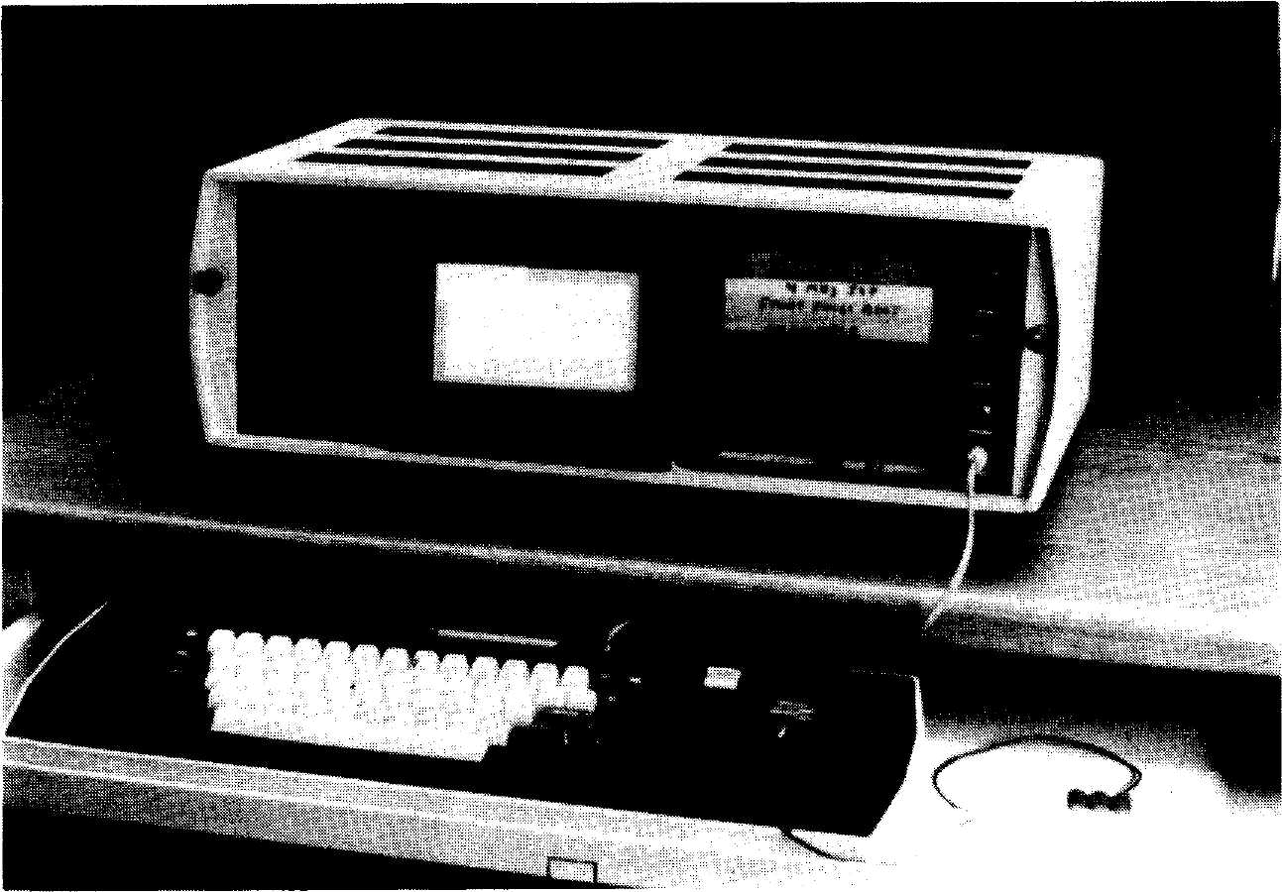
Figure 2.3
ing object formats as necessary, and even for changing the instruction
set used in the methods.
- Indexed OT The Smalltalk-78 design centered around an indexed
object table, which is the same design as in the Smalltalk-80 system.
This greatly simplified object access and yet retained the indirection
which made for easy storage management in Smalltalk-76. Reference
counts were stored as one byte of the 4-byte table entry. Given an ob-
ject pointer in a register, a reference count could be incremented or
decremented with a single add-byte instruction with an overflow check.
- Small Integers Since there would not be room in core for more
than 10K objects or so, it was possible to encode small integers (-16384
to 16383) in part of the pointer space. Since object table indices would
all be even (on the 8086, they were multiples of 4), we encoded small in-
tegers as two's complement integers in the high-order 15 bits, with the
low-order bit turned on. With this design, allocation of integer results
was trivial, integer literals could be stored efficiently, and integer val-
ues did not need to be reference counted.
Q In-line Contexts In order to save time allocating new contexts, and
to take advantage of the stack-oriented instructions available in most
microprocessors, the representation of contexts was redesigned. Instead
of having a separate object for each context, a large object was allocated
for each process, in which contexts could be represented as conventional
19
Form Follows Function
stack frames. This special representation complicated the handling of
blocks and the debugger, requiring an interface which referred to the
process and an offset within the process.
In addition to reduced allocation time, the time to transfer argu-
ments was eliminated by allowing the contexts to overlap; the top of
one context's stack (receiver and arguments) was the base of the next
context's frame.
Q Reduced Kernel— The Leverage of BitBlt We have always sought
to reduce the size of the Smalltalk kernel. This is not only an aesthetic
desideratum; kernel code is inaccessible to the normal user, and we
have always tried to minimize the parts of our system which can not be
examined and altered by the curious user. In this particular case, we
were also moving to a new machine. While writing a certain amount of
machine code seemed inevitable, we did not relish the idea of transcrib-
ing all 32K bytes of code which comprised the Smalltalk-76 kernel. For-
tunately, much of that bulk consisted of various routines to compose
and display text, to draw lines and implement Turtle geometry, and to
provide various interfaces to bitmap graphics such as moving rectan-
gles, and copying bits to buffers as for restoring the background under
menus.
The definition of BitBlt grew out of our experience with text, lines
and other bitmap graphics. Now the constraints of the NoteTaker im-
plementation provided the motivation to implement all these capabili-
ties in Smalltalk, leaving only the one primitive BitBlt operation in the
kernel. This was a great success in reducing the size of the kernel. The
full NoteTaker kernel consisted of around 6K bytes of 8086 code. This
figure did not include Ethernet support, real-time clock, nor any signifi-
cant support for process scheduling.
Q Performance The performance of the NoteTaker was interesting to
compare with the Alto. The Smalltalk instruction rate improved by a
factor of two, and yet the display of text was much slower (being in
Smalltalk, rather than machine code). By adding a small primitive for
the inner loop of text display and line drawing, this decrease was large-
ly compensated. User response for such actions as compiling was signifi-
cantly improved, owing to the faster execution and to the freedom from
the swapping delays of OOZE.
Q Mutability Smalltalk-78 used no encoding of object pointers other
than for small integers. Class pointers and length fields (for variable-
length objects) were stored just as any other fields. It was therefore pos-
sible in this design to allow mutation of objects, and this was made
available as the primitive method for become:.
20
The Evolution of the Smalltalk Virtual Machine

TinyTalk
Smalltalk-80
□ Relevance We learned a great deal from the NoteTaker challenge,
even though only 10 prototypes were built. We made the system much
more portable, and had demonstrated that the new generation of
microprocessors could indeed support Smalltalk. The decision not to
continue the project added motivation to release Smalltalk widely.
At the same time as the NoteTaker implementation, we performed an
experiment⁸ to see if a very simple implementation could run on a con-
ventional microprocessor such as a Z80 or 6502. This implementation
used marking garbage collection instead of reference-counting, and was
able to use simple push and pop operations on the stack as a result. A
method cache largely eliminated the overhead in message lookup and,
since primitive codes were included in the cache, access to primitives
was fast. The system did actually fit in 64K bytes with a little bit of
room to spare. Another experiment which was done in conjunction with
this implementation was to demonstrate that a special case of BitBlt for
characters could run much faster than the general version.
With Smalltalk-78 behind us, few changes were made to the Virtual
Machine to produce the Smalltalk-80 Virtual Machine. The main
change was an increase in power from allowing blocks with arguments.
Beyond this, mostly we cleaned up many details, some of which sup-
ported more extensive cleanups in the Smalltalk level of the system.
Q Contexts Again We felt that the optimized contexts of
Smalltalk-78 did not justify the loss in clarity which they entailed. So
in the Smalltalk-80 language we reverted to Contexts as objects, leaving
such optimizations up to implementors clever enough to hide their
tricks entirely from Smalltalk. In order to simplify the management of
Contexts in the Virtual Machine, we decided to use two sizes of contexts
instead of making them truly variable-length. This meant that, if sepa-
rate free lists were managed for these two lengths, storage for contexts
could be allocated and freed with relatively little fragmentation and co-
alescence overhead.
Q Blocks with Arguments While the syntax changed little in the
Smalltalk-80 language (open colon and other non-ASCII selectors were
banished), our extended discussions of syntax led to the current descrip-
tion for blocks with arguments. In fact, this required no change to the
Virtual Machine, but it had the feel of such a change in the language.
□ BlockContexts We re-engineered BlockContexts in the Small-
talk-80 language. Smalltalk-78 had already handled their recursive ap-
plication by providing independent stack space for each invocation. Be-
yond this, mechanisms were defined for checking and diagnosing such
anomalous conditions as returning to a context which has already re-
turned.

21
Form Follows Function
Q Compilation Order Smalltalk-78 had perpetuated the post-evalua-
tion of receiver expressions so as to avoid delving into the stack to find
the receiver. In the Smalltalk-80 language, however, we encoded the
number of arguments in the send instruction. This enabled strictly left-
to-right evaluation, and no one has since complained about surprising
order of evaluation. We suspect that this change will yield further fruit
in the future when someone tries to build a very simple compiler.
Q Instruction Set In addition to revamping the send instructions, we
made several other improvements to the instruction set. We completed
the branch instructions by adding branch-if-true. We put in 2- and
3-byte extensions to retain reasonable compactness without restricting
functionality. We also added a few compact codes for returning true
and false, and for pop-and-store into temps and fields of the receiver.
Q Methods The encoding of method headers followed the earlier
Smalltalk-78 design. In order to simplify the allocation of contexts, a bit
was included to indicate whether a large frame was necessary to run
the method or not.
While the present Smalltalk design has evolved over a decade now, that
Future Directions does not mean it is finished. As when one climbs a large mountain, the
higher reaches are gradually revealed and it seems there is as much to
do now as when we started.
Q Virtual Memory An obvious shortcoming of the Smalltalk-80 speci-
fication is that it does not include a virtual memory. There are several
reasons for this. Our experience with OOZE suggested that object-ori-
ented approaches might be significantly better than simple paging, and
we did not want to commit ourselves to one or the other. From our ex-
perience with porting the system from one interpreter to another, it
was clear to us that implementors could experiment with the virtual
memory issue fairly easily, while still working from the Smalltalk-80
image specification. The current object formats allow a simple resident
implementation, and yet lend themselves to extension in most of the ob-
vious directions for virtual memory.
□ Reducing Concepts It is always useful to reduce the number of
concepts in a language when possible. Smalltalk distinguishes many
levels of refinement: subclassing, instantiation, blocks and contexts, to
name a few. It is likely that some of these distinctions can be dissolved,
and that a cleaner virtual machine design would result.
Q Typing and Protocols While the Smalltalk-80 language is not a
typed language in the normal sense, there is nonetheless an implicit no-
tion of variable type in the protocol (full set) of messages which must be
20
The Evolution of the Smalltalk Virtual Machine

TinyTalk
Smalltalk-80
□ Relevance We learned a great deal from the NoteTaker challenge,
even though only 10 prototypes were built. We made the system much
more portable, and had demonstrated that the new generation of
microprocessors could indeed support Smalltalk. The decision not to
continue the project added motivation to release Smalltalk widely.
At the same time as the NoteTaker implementation, we performed an
experiment⁸ to see if a very simple implementation could run on a con-
ventional microprocessor such as a Z80 or 6502. This implementation
used marking garbage collection instead of reference-counting, and was
able to use simple push and pop operations on the stack as a result. A
method cache largely eliminated the overhead in message lookup and,
since primitive codes were included in the cache, access to primitives
was fast. The system did actually fit in 64K bytes with a little bit of
room to spare. Another experiment which was done in conjunction with
this implementation was to demonstrate that a special case of BitBlt for
characters could run much faster than the general version.
With Smalltalk-78 behind us, few changes were made to the Virtual
Machine to produce the Smalltalk-80 Virtual Machine. The main
change was an increase in power from allowing blocks with arguments.
Beyond this, mostly we cleaned up many details, some of which sup-
ported more extensive cleanups in the Smalltalk level of the system.
Q Contexts Again We felt that the optimized contexts of
Smalltalk-78 did not justify the loss in clarity which they entailed. So
in the Smalltalk-80 language we reverted to Contexts as objects, leaving
such optimizations up to implementors clever enough to hide their
tricks entirely from Smalltalk. In order to simplify the management of
Contexts in the Virtual Machine, we decided to use two sizes of contexts
instead of making them truly variable-length. This meant that, if sepa-
rate free lists were managed for these two lengths, storage for contexts
could be allocated and freed with relatively little fragmentation and co-
alescence overhead.
□ Blocks with Arguments While the syntax changed little in the
Smalltalk-80 language (open colon and other non-ASCII selectors were
banished), our extended discussions of syntax led to the current descrip-
tion for blocks with arguments. In fact, this required no change to the
Virtual Machine, but it had the feel of such a change in the language.
Q BlockContexts We re-engineered BlockContexts in the Small-
talk-80 language. Smalltalk-78 had already handled their recursive ap-
plication by providing independent stack space for each invocation. Be-
yond this, mechanisms were defined for checking and diagnosing such
anomalous conditions as returning to a context which has already re-
turned.

21
Form Follows Function
Q Compilation Order Smalltalk-78 had perpetuated the post-evalua-
tion of receiver expressions so as to avoid delving into the stack to find
the receiver. In the Smalltalk-80 language, however, we encoded the
number of arguments in the send instruction. This enabled strictly left-
to-right evaluation, and no one has since complained about surprising
order of evaluation. We suspect that this change will yield further fruit
in the future when someone tries to build a very simple compiler.
Q Instruction Set In addition to revamping the send instructions, we
made several other improvements to the instruction set. We completed
the branch instructions by adding branch-if-true. We put in 2- and
3-byte extensions to retain reasonable compactness without restricting
functionality. We also added a few compact codes for returning true
and false, and for pop-and-store into temps and fields of the receiver.
Q Methods The encoding of method headers followed the earlier
Smalltalk-78 design. In order to simplify the allocation of contexts, a bit
was included to indicate whether a large frame was necessary to run
the method or not.
While the present Smalltalk design has evolved over a decade now, that
Future Directions does not mean it is finished. As when one climbs a large mountain, the
higher reaches are gradually revealed and it seems there is as much to
do now as when we started.
Q Virtual Memory An obvious shortcoming of the Smalltalk-80 speci-
fication is that it does not include a virtual memory. There are several
reasons for this. Our experience with OOZE suggested that object-ori-
ented approaches might be significantly better than simple paging, and
we did not want to commit ourselves to one or the other. From our ex-
perience with porting the system from one interpreter to another, it
was clear to us that implementors could experiment with the virtual
memory issue fairly easily, while still working from the Smalltalk-80
image specification. The current object formats allow a simple resident
implementation, and yet lend themselves to extension in most of the ob-
vious directions for virtual memory.
Q Reducing Concepts It is always useful to reduce the number of
concepts in a language when possible. Smalltalk distinguishes many
levels of refinement: subclassing, instantiation, blocks and contexts, to
name a few. It is likely that some of these distinctions can be dissolved,
and that a cleaner virtual machine design would result.
Q Typing and Protocols While the Smalltalk-80 language is not a
typed language in the normal sense, there is nonetheless an implicit no-
tion of variable type in the protocol (full set) of messages which must be
22
The Evolution of the Smalltalk Virtual Machine
understood by a given variable. We have described an experimental sys-
tem based on this notion of type⁹, and a serious treatment of this ap-
proach would likely involve changes to the Virtual Machine.
Q Multiple Inheritance While the Smalltalk-80 system does not pro-
vide for multiple inheritance, we have described an experimental sys-
tem which supports multiple superclasses using the standard Virtual
Machine¹⁰. This is another area in which serious use of the new para-
digm might suggest useful changes to the Virtual Machine.
Q Tiny Implementations While, on one end of the spectrum, we seek
to build vastly larger systems, we should not ignore the role of small
systems. To this end, there is a great deal of room for experimentation
with small systems that provide the essential behavior of the
Smalltalk-80 system. Threaded interpreters offer simplicity and speed,
and it shouldn't be difficult to capture the essence of message sending
in an efficient manner.

Maintaining
an Evolving
Integrated
System
We have had considerable experience maintaining an evolving integrat-
ed system. In this section we cover several of the challenges and our so-
lutions which support the Smalltalk approach to software engineering.

Applying the
Smalltalk
Philosophy
One way of stating the Smalltalk philosophy is to "choose a small num-
ber of general principles and apply them uniformly." This approach
has somewhat of a recursive thrust, for it implies that once you've built
something, you ought to be using it whenever possible. For instance, the
conventional approach to altering such kernel code as the text editor of
a programming system is to use off-line editing tools and then reload
the system with the new code and try it out. By contrast, Smalltalk's
incremental compilation and accessibility of kernel code encourages you
to make the change while the system is running, a bit like performing
an appendectomy on yourself.
The recursive approach offers significant advantages, but it also
poses its own special problems. One of the benefits is that system main-
tainers are always using the system, so they are highly motivated to
produce quality. Another benefit is high productivity, deriving from the
elimination of conventional loading and system generation cycles. Con-
sistent with the Smalltalk philosophy as articulated above, things are

23
Maintaining an Evolving Integrated System
also simpler; the tools and the task are one, so there are fewer versions
to worry about. The complementary side of this characteristic is that if
the only version is compromised, you are "down the creek without a
paddle."
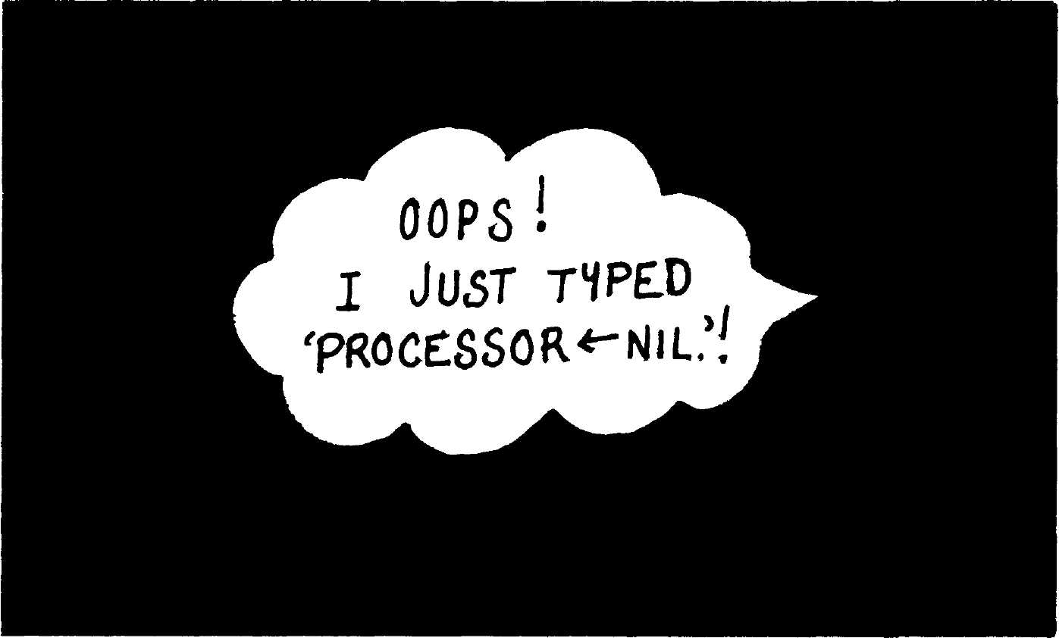
Figure 2.4

The Snapshot
Concept
The Alto had a particularly nice characteristic as a personal machine:
being based on a removable disk pack, once you had installed your per-
sonal pack, any machine you used behaved as your personal machine.
When we built the Smalltalk environment, based on an extensible pro-
gramming language, we arranged the system so that when you termi-
nated a working session, or quit, the entire state of your system was
saved as a snapshot on the disk. This meant that as Smalltalk came to
be a stand-alone environment, containing all the capabilities of most
operating systems as well as the personal extensions of its owner, any
Alto instantly took on that specialized power as soon as you inserted
your disk and resumed your working session. The snapshot also served
as a useful checkpoint in case of fatal errors.
In the later virtual memory systems, OOZE automatically saved a
snapshot from time to time, which could subsequently be resumed fol-
lowing catastrophes such as loss of power or fatal programming errors.
The robustness of OOZE in this respect was remarkable, but owing to
the finite latency period of the checkpointing process, it was necessary
to act quickly when fatal errors were recognized, lest they be enshrined
forever in the mausoleum of a snapshot. In such circumstances, the
alert user would quickly reach around to the rear of the keyboard and
press the "boot" button of the Alto before the next automatic snapshot.

24
The Evolution of the Smalltalk Virtual Machine

Minimum Kernel
for Maximum
Flexibility
The Fear of
Standing A lone
Standing Alone
Without Fear: The
System Tracer
Then he could resume his work from a previous state saved a few min-
utes before. This process was known as "booting and resuming." The
term came to be jokingly applied to other situations in life, such as un-
successful research efforts and other less serious endeavors.
Most systems are built around a kernel of code which cannot easily be
changed. In our Smalltalk systems, the kernel consists of machine code
and microcode necessary to implement a virtual Smalltalk machine.
You clearly want the kernel to be as small as possible, so that you en-
counter barriers to change as infrequently as possible. For example, in
Smalltalk-72 it was a great improvement when the primitive read rou-
tine was supplanted by one written in Smalltalk, since it could then be
easily changed to handle such extensions as floating-point constants.
Speed comes into play here, because if the kernel is not fast enough,
it will not support certain functions being implemented at a higher lev-
el. This was the case for text display in Smalltalk-76. Similarly, gener-
ality is important, for the more general the kernel is, the more kernel-
like functions can be built at a higher level. For example, the one BitBIt
primitive in Smalltalk-80 supports line drawing, text, menus and
freehand graphics.
While Smalltalk-72 and -74 were used as long-lived evolving images,
the systems as released were always generated from scratch, by reading
a set of system definitions into a bootstrap kernel. With the
Smalltalk-76 system, we took a bold step and opted to ignore support
for system generation. The system was built in two parts: a Virtual Ma-
chine was written in microcode and machine code, and a virtual image
was cross-compiled from a simulation done in Smalltalk-74. Although
this paralleled our previous strategy, we knew that we would soon
abandon support for Smalltalk-74, and thus the Smalltalk-76 system
would be truly stand-alone. In other words, if a bit were dropped from
the system image, or if a reference-count error occurred, there would be
no way to recover the state of the system except to backtrack through
whatever earlier versions of the system had been saved. As the system
became more reliable, we went for days and then weeks without start-
ing over, and finally we realized that Smalltalk-76 was on its own. If
this sounds risky to you, think of how we felt!
While the foregoing approach may seem foolhardy, we actually had a
plan: Ted Kaehler said that he would write a Smalltalk program, the
system tracer, which would run inside of Smalltalk and copy the whole
system out to a file while it was running. Considerable attention would
have to be paid to the parts of the system which were changing while
the process ran. Two months after the launch of Smalltalk-76, Ted's
first system tracer ran and produced a clone without errors. While we

25
Maintaining an Evolving Integrated System
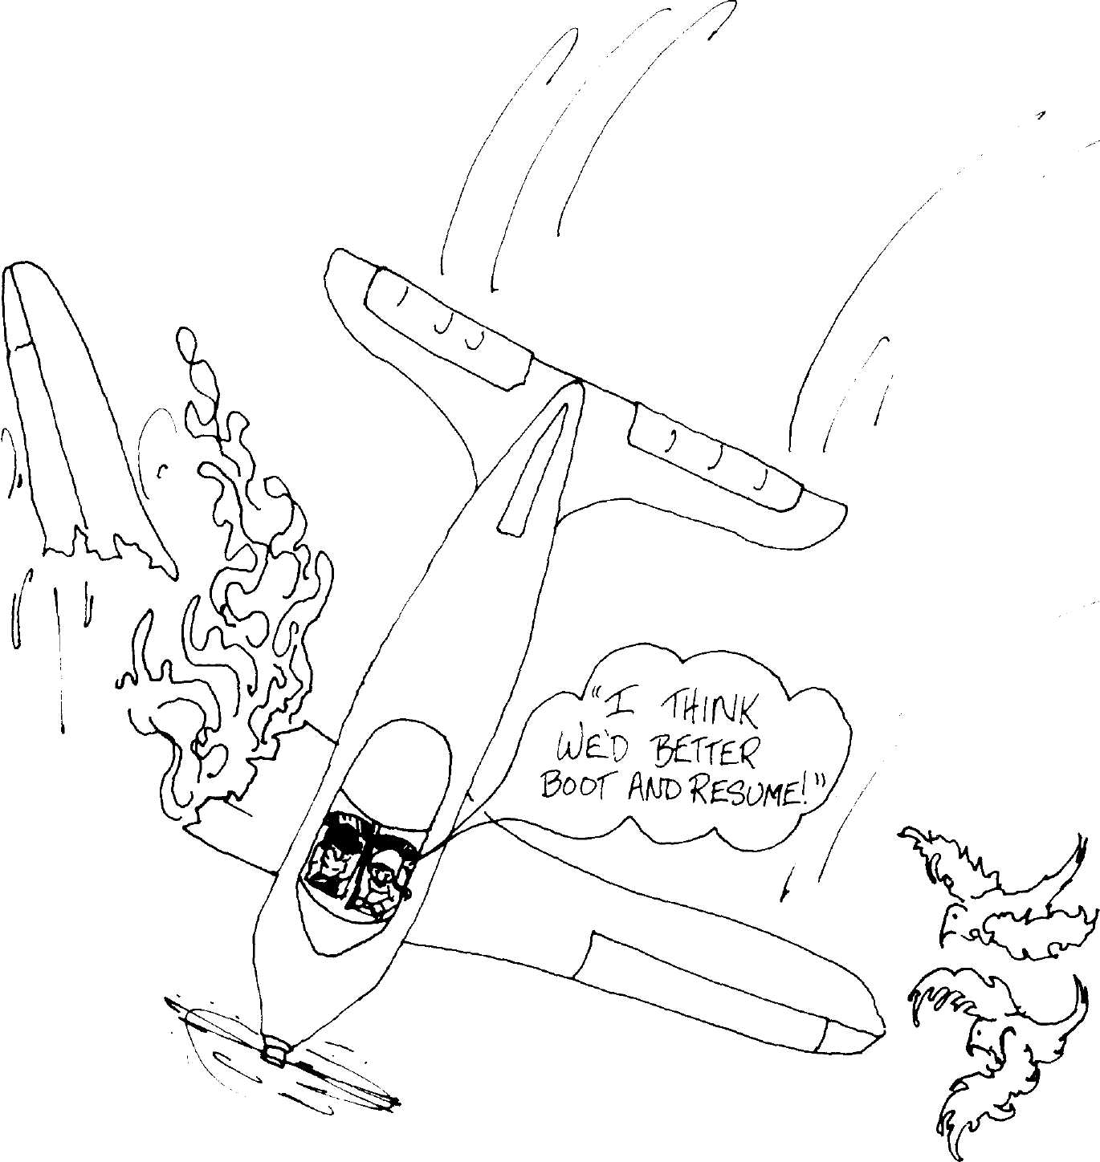
Figure 2.5
all breathed a sigh of relief at this point, the full implications only
dawned on us gradually. This truly marked the beginning of an era:
there are many bits in the Smalltalk-80 release of today which are cop-
ies of those bits first cloned in 1977.
The system tracer solved our most immediate problem of ensuring
the integrity of the system. It caught and diagnosed inaccurate refer-
ence counts, of which there were several during the first few months of
Smalltalk-76. Also, although it took four hours to run, it performed the
function of a garbage collector, reclaiming storage tied up in circular
structures, and reclaiming pointers lost to OOZE's zoning by class. The
essential contribution of the system tracer, however, was to validate our
test-pilot philosophy of living in the system we worked on. From this
point on, we never started from scratch again, but were able to use the
system we knew so well in order to design its follow-ons.
26
The Evolution of the Smalltalk Virtual Machine
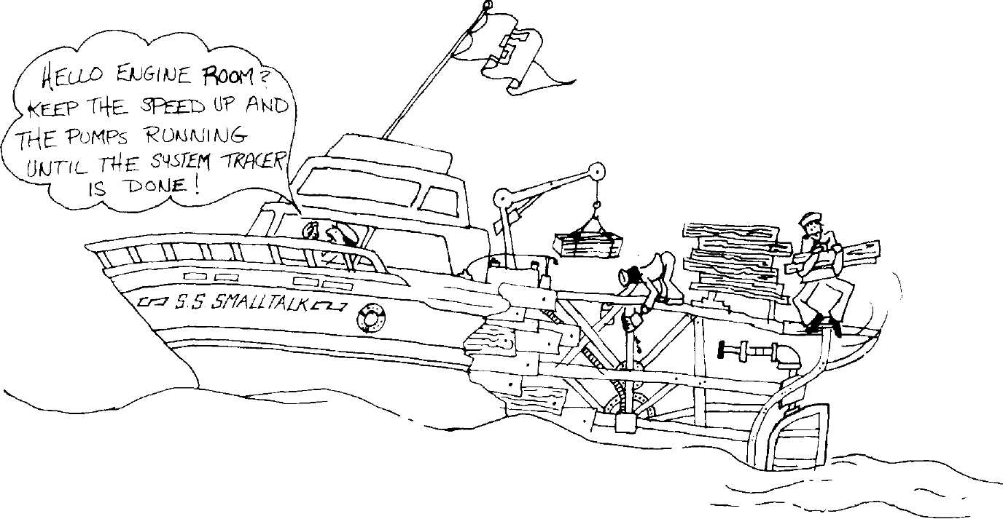
Figure 2.6

Spawning and
Mutation
As time passed we found that the system tracer had even more poten-
tial than we had imagined. For one thing, it offered an answer to the
problem of using a fully integrated system for production applications.
This problem manifests itself in several ways: a fully integrated system
contains many components which are not needed in production, such as
compiler, debugger, and various editing and communications facilities.
Also, at a finer grain, much of the symbolic information which is re-
tained for ease of access may be wasteful, or even objectionable (for se-
curity reasons) in a production release of the system.
The system tracer could be instructed to spawn an application with
all unnecessary information removed. This could be done post facto,
thus freeing application programmers from the integrated/production
dichotomy until the final release of a product. In actual fact, since the
goal of our research is integration, we never pursued the full potential
of the system tracer to drop out such "product" applications. The clos-
est we came was to eliminate unnecessary parts of the system when we
were short of space for certain large projects.
The possibility of using the system tracer to produce mutations be-
came evident soon after its creation, and we took full advantage of this.
For instance, prior to the Smalltalk-80 release, we wanted to convert
from our own private form of floating-point numbers to the standard
IEEE format. In this case, we simply included an appropriate transfor-
mation in the system tracer and wrote out a cloned image which used
the new format. Then we replaced the floating-point routines in the
Virtual Machine and started up the new image. Similar transforma-
tions have been used to change the instruction set of the Virtual Ma-
chine, to change the format of compiled methods, and to change the
encoding of small integers. It was in this manner that Smalltalk-78 and
-80 were built out of Smalltalk-76.

27
Conclusion
It is hard to say how far one should take this approach. Sometimes a
change is so fundamental that it requires starting again from the
ground up, as we did from Smalltalk-74 to -76. Even in such cases
though, it seems easiest to simulate the new environment in the old,
and then use the simulation to produce the actual new system.

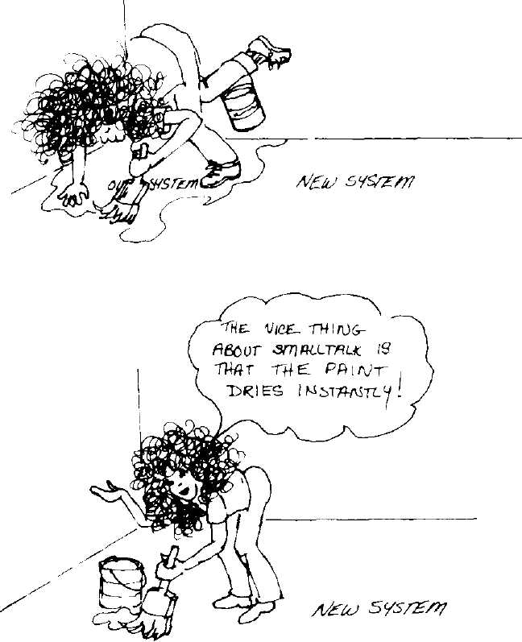
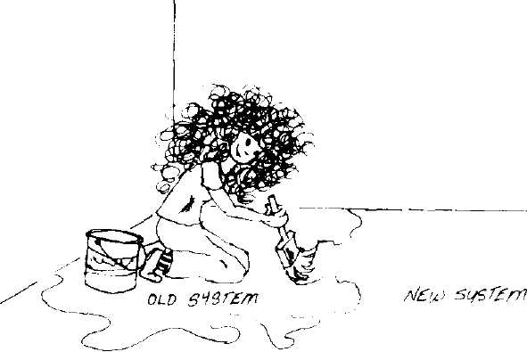
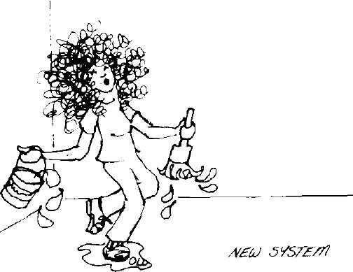
Figure 2.7

The Virtual Image
When we decided to release the Smalltalk-80 system, the question arose
as to what form it should take. From the discussion above, it should be
clear why we chose the virtual image (a fancier term for snapshot) for-
mat. This was the one way in which we could be sure that the release
would set a standard. Any implementation, if it worked at all, would
look and behave identically, at least in its initial version. At the same
time, we tried to decouple the image format as much as possible from
such implementation-related details as reference counting versus gar-
bage collection, machine word size, and pointer size. At the time of this
writing, implementations exist which vary in all of these parameters. It
should be possible to decouple similarly our choice of bitmap display
representation, but this project was not of immediate interest to us.

Conclusion
The evolution of the Smalltalk system is a story of good and bad de-
signs alike. We have learned much from our experiences. Probably the
greatest factor that keeps us moving forward is that we use the system
all the time, and we keep trying to do new things with it. It is this "liv-

28
The Evolution of the Smalltalk Virtual Machine
ing-with" which drives us to root out failures, to clean up
inconsistencies, and which inspires our occasional innovation.
References 1. Goldberg, Adele, and Kay, Alan, Eds., "Smalltalk-72 Instruction
Manual", Xerox PARC Technical Report SSL-76-6, 1976.
- Thacker, C. P., et al., "Alto: A Personal Computer", in Computer
Structures: Readings and Examples, 2nd Edition, Eds. Sieworek,
Bell, and Newell, McGraw-Hill, New York, 1981; (also Xerox
PARC CSL-79-11), Aug. 1979.
- Papert, Seymour, Mindstorms, Basic Books, New York, 1980.
- Goldberg, Adele, and Kay, Alan, "Teaching Smalltalk", Xerox
PARC Technical Report SSL-77-2, June 1977.
- Newman, William, and Sproull, Robert, Principles of Interactive
Computer Graphics, 2nd Edition, McGraw-Hill, New York, 1979.
- Kaehler, Ted, "Virtual Memory for an Object-Oriented Lan-
guage", Byte, vol. 6, no. 8, Aug. 1981.
- Ingalls, Daniel Η. Η., "The Smalltalk-76 Programming System:
Design and Implementation", Conference Record, Fifth Annual
ACM Symposium on Principles of Programming Languages, 1978.
- McCall, Kim, "TinyTalk, a Subset of Smalltalk-76 for 64KB
Microcomputers", Sigsmall Newsletter, Sept. 1980.
- Borning, Alan H., and Ingalls, Daniel Η. Η., "A Type Declaration
and Inference System for Smalltalk", Ninth Symposium on Princi-
ples of Programming Languages, pp. 133-141, Albuquerque, NM,
1982.
10. , "Multiple Inheri-
tance in Smalltalk-80", pp. 234-237, Proceedings at the National
Conference on Artificial Intelligence, Pittsburgh, PA, 1982.

L
The Smalltalk-80 Code
File Format
Glenn Krasner
Software Concepts Group
Xerox Palo Alto Research Center
Palo Alto, California
Introduction In the Smalltalk-80 system, programmers define classes and methods
incrementally by editing in system browsers. At some point, program-
mers may want to share their class descriptions with others using dif-
ferent Smalltalk-80 systems. Some means of communication is therefore
required. We have chosen to use files as the means of communication,
and call such files code files.
Code files for the Smalltalk-80 system allow the programmer to com-
municate source code (class descriptions or parts of class descriptions)
between one Smalltalk-80 system and another (possibly the same sys-
tem, later in time). The format of such files was devised as a result of a
number of design considerations:
- Restrictions on the allowable character set,
- Whether to allow the code to be "readable" when printed on con-
ventional printers,
- Whether to retain/allow more than one emphasis of the text (font
and face changes),
- Whether to include source code in the system image (core) or to
place it on external files,
Copyright © Xerox Corporation 1982. All rights reserved.
29

30
The Smalltalk-80 Code File Format
- Whether to allow for executable expressions in addition to source
code of methods, and
- Whether to provide for system crash recovery.
The Smalltalk-80 code file format is restricted to contain a common set
of characters ("printing" ASCII characters plus a small number of con-
trol characters). It gives up the ability to have multiple emphases of
text in order to be as good (or as bad) on conventional printers as it
would be on more capable printers (raster laser xerographic printers,
for example). The approach taken keeps source methods on file storage
to minimize the amount of core used, includes intermingling of execut-
able expressions with source code for methods, and provides for some
amount of system recovery.

Background
The Smalltalk-80 system is powerful and comprehensible, in part be-
cause everything in the system is treated in a uniform way, as an ob-
ject. However, at the point where the Smalltalk-80 system meets the
external world, this uniformity cannot be maintained. The external
world does not consist of Smalltalk-80 objects, but rather of disk files,
network communication, hardware storage devices, and printers. These
define a much more limited structure of information. For example, disk
files typically consist of collections of 8-bit bytes; networks define a lim-
ited set of data that can be communicated; hardware storage devices de-
fine what kinds and, more importantly, how much information can be
handled; and printers typically are restricted to a small number of
characters as the only data they can handle. If the Smalltalk-80 pro-
grammer never had to meet this external world, there would be no
problem. Everything he or she dealt with would be within the
Smalltalk-80 system. For some programmers, this is sufficient. Most
programmers, however, must meet the external world because they
want to share information with some other system. The Smalltalk-80
code file format is a format for representing code objects (i.e., source
code for methods or expressions), especially for communication via the
media of electronic secondary storage and paper.

Constraints
and Goals
The constraints and goals for the design of the format consisted of:
• Having a format that would serve as a communications protocol
among Smalltalk-80 systems and from a system to paper. We saw

31
The Code File Format
the paper version as being used by people not fortunate enough to
have display-based browsers and, perhaps more importantly, as
one in which algorithms or pieces of code could be published.
Having a format that could be printed without translation on con-
ventional printers. We are interested in first having the world
build Smalltalk engines, with bit-map displays and good pointing
devices and lots of computing power. Later, we expect them to want
to use good printers; we are willing to wait before we require them
to do so.
Having a format that would look satisfactory on paper. Often this
means allowing multiple font and type face information, as well as
formatting information. However, given the first goals, it means
not having extra characters that describe such information clutter-
ing up the printed page.
Having the source code for the more than 4000 methods in the sys-
tem take up as little main memory as possible. We expect that
reasonable Smalltalk-80 machines will have virtual memories,
where space restrictions would not be a problem. However, the
number of bytes taken up by the source code alone (more than a
million) would preclude most current machines from having any
resident implementation. Therefore the file format was to serve as
a somewhat limited form of virtual memory.
Having a format that would include executable expressions. Typi-
cally what people want to communicate between systems includes
method definitions, class descriptions, and class initialization ex-
pressions. By providing for executable expressions, all these desires
can be met.
Minimizing the amount of disk space taken up. For example, one
would not want an entire disk system to become full of text when
only a small percentage of the text is actually needed.
Allowing a certain amount of recovery from system disasters. The
Smalltalk-80 system is one in which it is possible to change almost
anything. This provides great power and flexibility, but has the
danger that a system change could destroy the system itself. It was
desired that code files, since they are somewhat external to the
system itself, could provide recovery from such disasters.
The Code Smalltalk-80 code files are defined as text files that contain only the
File Format "printing" ASCII characters, codes 32 (space) through 127 (DEL), plus
carriage return, line feed, tab and form feed (codes 13, 10, 9 and 12, re-
32
The Smalltalk-80 Code File Format
spectively). The file is broken into chunks, which are sequences of char-
acters terminated by an exclamation point (!), with exclamation points
within a chunk doubled. The meanings of chunks will be described in
the sections to follow.
Exclamation point was chosen for a number of reasons. It is not used
as a Smalltalk-80 selector. It is used in English at the end of sentences,
so it is a reasonable terminator. It tends not to appear in code, so it
rarely has to be doubled. Also, it is thin, so we felt it would not be too
obtrusive on the page.
File Streams The interface between Smalltalk-80 objects and disk files is encapsulat-
ed by the Smalltalk-80 class FileStream. File Streams support sequen-
tial and random access of disk files through the following protocol
class name FileStream
superclass External Stream
opening and closing
openOn: aString
Answer an instance of FileStream representing the disk file named
aString.
close
Close the file.
sequential accessing
next
Answer the character in the file after the current position, and update the
position.
nextPut: aCharacter
Store aCharacter as the character of the file after the current position,
and update the position.
atEnd
Answer true if the current position is at the end of the file, false if it is not.
setToEnd
Set the current position to be the end of the file.
random accessing
position
Answer the current position.
position: anlnteger
Set the current position to be anlnteger.
Two messages were added to FileStream to deal with chunks, one to
read a chunk from the file, and another to write a chunk onto the file
33
Code Files Used for Source Methods
fileln/Out
nextChunk
Answer a string that is the chunk starting at the current position,
undoubling embedded exclamation points, and excluding the terminator.
nextChunkPut: aString
Write aString as a chunk starting at the current position, doubling embed-
ded exclamation points, and terminating it with an exclamation point.

Code Files
Used for
Source
Methods
The Smalltalk-80 system relies on the code file format to read and
write the source methods of the system. In this way, the files are used
to communicate information from the system to itself at a later point in
time. Each CompiledMethod in the system keeps a short (3-byte)
encoding of the location of its source. This encoding includes which of
four file streams contains the chunk of source code for that method and
the position, within that file, of the first character of its chunk. A glob-
al array called SourceFiles points to the four file streams.
The code for getting the source method in class CompiledMethod
could be*
getSource
| sourcelndex sourceFile sourcePosition |
sourcelndex «- self sourcelndex.
sourceFile - SourceFiles at: sourcelndex.
sourcePosition «- self sourcePosition.
sourceFile position: sourcePosition.
tsourceFile nextChunk
Of the four file streams, one, SourceFiles at: 1, is a read-only file
stream of source methods. It is known as the sources file. Periodically
all the source code of the system may be condensed into this file.
The second file stream, SourceFiles at: 2, is a file stream to which ev-
ery change to the system sources is appended. It is known as the chang-
es file. When a method is changed and recompiled, its new source code
is appended to this file (and the encoding bytes of the CompiledMethod
are changed to point at the new source). Periodically, the changes file
may be condensed as well. Since this file grows while a programmer is
working, the changes file may want to be condensed much more often
than the sources file. The third and fourth file streams are currently
unused.
*For implementation efficiency, the code in the Smalltalk-80 system is not actually this,
but provides the same function.

L

34
The Smalltalk-80 Code File Format
The code in class CompiledMethodto store a new source code string
could be
storeSourceString: aString
| sourceFile sourcePosition |
sourceFile — SourceFiles at: 2.
sourceFile setToEnd.
sourcePosition — sourceFile position,
self setSourcelndex: 2
sourcePosition: sourcePosition.
sourceFile nextChunkPut: aString.
Because the changes file is only altered by appending to it, previous
versions can always be found. Periodically, a Smalltalk-80 programmer
will make a snapshot of the state of the system. If the system crashes at
a later time, then, when the system is resumed at the point of snapshot,
the compiled methods in the snapshot of the system will still point to
their place in the files at the time the snapshot was made. The end of
the file will contain changes added between the snapshot and the crash,
and these can be recovered. For example, suppose a programmer
changed the definition of getSource in class CompiledMethod once (ver-
sion A), then made a snapshot, then changed it twice (versions Β and
C), and the system crashed because of an error in C. Then the system
can be restarted at the snapshot point, the source and compiled method
for getSource will be version A, but versions Β and C will be near the
end of the changes file. The programmer could look at the end of the
changes file, copy version Β into the browser for compilation, and ig-
nore C. Then the programmer has recovered to the equivalent of just
before the C change brought down the system.
To improve recovery, the system also records several other things on
the changes file. For example, whenever the user executes an expres-
sion in a code editor, the expression is appended as a chunk on the
changes file. Also, when the user performs a system snapshot, a chunk
consisting of the comment " SNAPSHOT " is appended to the
changes file, marking the occurrence of a snapshot.

Code Files
Used for
Shared Code
Besides storing the system sources, the code file format serves to com-
municate code and expressions between one system and another. For
this we have added a level of syntax and semantics above the chunk
level. The syntax and semantics are defined and implemented by the
message fileln in class FileStream,

35
Code Files Used for Shared Codes
fileln
| aString sawExclamation |
self position: 0.
[self atEnd]
whileFalse:
[sawExclamation <- self peekFor: $!.
aString - self nextChunk.
sawExclamation
ifFalse: [Compiler evaluate: aString]
ifTrue: [(Compiler evaluate: aString) filelnFrom: self]]
peekFor: aCharacter
"Answer true and move past if next = aCharacter"
self next = aCharacter
ifTrue: [Ttrue]
ifFalse: [self position: self position - 1. Tfalse]
That is, when sent the message fileln, a file stream looks for an excla-
mation point. As long as it does not see one, it reads and has class Com-
piler evaluate the next chunk as a Smalltalk-80 expression. If it did see
an exclamation point, then after the expression is evaluated, it hands
the stream (itself) to the object that was returned as the value of the
expression (see example below).
In particular, the methodsFor: aString message sent to a class will re-
turn an instance of ClassCategoryReader that has its instance variable
myClass set to the class, and its instance variable myCategory set to the
string. The class category reader will respond to the filelnFrom: message
by reading chunks from the file stream. Each chunk is presumed to be
the source for a method, and, for each chunk, the class category reader
has the compiler compile it and install the compiled method in the
proper class and category. This continues until an empty chunk is
found.
filelnFrom: aFileStream
| aString |
[aFileStream atEnd or: [(aString «- aFileStream nextChunk) isEmpty]]
whileFalse:
[Compiler compile: aString
forClass: myClass
inCategory: myCategory]
Tself
For example, the code for fileln, peekFor: aCharacter, and filelnFrom:
aFileStream would appear in a code file as

36
The Smalltalk-80 Code File Format
IFileStream methodsFor: ' filel/O '!
fileln
| aString sawExclamation |
self position: 0.
[self atEnd]
whileFalse:
[sawExclamation ^- self peekFor: $"
aString — self nextChunk.
sawExclamation
ifFalse: [Compiler evaluate: aString]
ifTrue: [(Compiler evaluate: aString) filelnFrom: self]]¹
peekFor: aCharacter
"Answer true and move past if next = aCharacter"
self next — aCharacter
ifTrue: [Ttrue]
ifFalse: [self position: self position - 1. Tfalse]!!
ICIassCategoryReader methodsFor: ' filel/O'!
filelnFrom: aFileStream
aString |
[aFileStream atEnd or: [(aString «- aFileStream nextChunk) isEmpty]]
whileFalse:
[Compiler compile: aString
forClass: myClass
inCategory: myCategory]
TselfM
The class category reader created by the expression FileStream
methodsFor: 'filel/O' will read and compile the methods for fileln and
peekFor: aCharacter before returning control to the file stream; the
reader created by ClassCategoryReader methodsFor: 'filel/O' will read
in only the method for filelnFrom: aFileStream.
The example shows a number of visual properties that make it easier
to read code format files when they are printed. Each category is
delimited by a short "methodsFor:" line; it is easy to locate the names
of the class and the category for each. Each method is a visual chunk
with all but its first line indented. This of course, depends on the pro-
grammer keeping the convention of including a tab before each line
other than the message pattern. This convention is supported by the
"format" command in the code editor.
In addition to the source code for methods, the code file format and
its interpretation allow any expression to be saved on a file. In particu-
lar, one may save an entire class description from a Smalltalk-80 sys-
tem. That file will consist of an expression defining the class, followed
by an expression setting the global comment of the class, followed by
L

37
Code File Format for Both Source Methods and Shared Code
the source code for the methods in the class, in the format described
above. When a file stream on such a file, in this or some other system,
is told to fileln, it will recreate the entire class description.
Users could also define their own "readers," objects created with ex-
pressions preceded by an exclamation point, just as
ClassCategoryReaders are created with the "methodsFor:" expressions.
These user-defined readers would be used for creating an object with
special external representation, just as class category readers create
methods whose external representations are strings of characters for-
matted for readability.
Note: In addition to this, since many classes have initialization code
especially for class variables, if the message initialize is defined in the
class, the expression chunk " < class > initialize!" will appear at the end
of the file containing the class definition. Then, when the file is told to
file in, the initialization code will be executed after the methods are
compiled.

Code File
Format for
Both Source
Methods and
Shared Code
The conventions for shared code given in the previous section are also
followed in the two source code files. That is, the sources file is orga-
nized as a sequence of class descriptions in the above format, arranged
alphabetically by class name, with form feeds between them. The com-
piled methods in the system point to the beginning of their chunks. In
this way, printing out the sources file will give an alphabetical listing of
the system sources with page breaks between each class.
The changes file is a collection of chunks of the form
! < class name > methodsFor: ' < category Name > '!
< source method > !!
The compiled methods in the system that point to the changes file also
only point to the beginning of their chunks. The chunks appended to
the changes file when the user evaluates an expression are in the exe-
cutable form
< expression >!
This means that the sources file could be filed in to redefine the system
classes to their state before changes were made, and the changes file
could be filed in to redefine the changes and re-execute the expressions
made since changes were started. The Smalltalk-80 system provides two
ways of looking at the changes file for recovery, to create a view on a
file whose contents are the last few thousand characters of the changes
file and to create a ChangeList browser to view the changes.

38
The Smalltalk-80 Code File Format

Matching the
Goals and
Constraints
The Smalltalk-80 code file format meets most of the goals and satisfies
most of the constraints of its design. It serves as a communications for-
mat between systems. It is used extensively, not only for source code
within a system, but also for exchanging source code between systems.
In addition, because it is restricted to the standard ASCII character set,
it can be printed on conventional printers as well as on more capable
printers.
The code files have a reasonable appearance on paper. Of course, this
is a matter of taste. In a few years we will likely no longer consider its
appearance reasonable because our opinions of "reasonable appearance"
will change. Methods are "chunked" together, and the "methodsFor:"
lines separate categories of methods. Except for the single exclamation
point at the end of each method, there are no characters to distract the
reader. The form feeds between class descriptions also help the read-
ability of the code.
The amount of main memory required to handle sources is quite
small, especially compared with the size of the source code itself. It re-
quires only 3 bytes per compiled method, plus the space taken up by
the interpretation code (outlined in this paper). Compared with over a
million bytes of source code, this is a great savings and considered
worth the added complexity.
The format includes executable expressions. The system currently
uses this feature sparingly—for class descriptions and initialization,
and for recording expressions evaluated by the user. However, the for-
mat provides a generality that can be exploited in the future.
Disk space efficiency is a compromise in our design. Having one
read-only sources file does help meet this goal since multiple systems
can share this file. At Xerox, we often keep this shared file on a remote
server, where multiple systems can access it and where it does not take
up any local disk space. On the other hand, constantly appending to the
changes file consumes disk space. The Smalltalk-80 development style
often involves defining and redefining methods many times. Since each
definition is appended to the changes file, this causes the file to grow.
However, the user can invoke the system's ability to compact the
changes file at any time by sending the message compactChanges to
Smalltalk, an instance of SystemDictionary.
Although using the changes file in this way is wasteful of disk stor-
age, there is the advantage that a considerable amount of recovery from
system crashes is possible. By recording all code changes and many oth-
er user events on the changes file, the programmer can recover should
the system go down. In particular, if a programmer is experimenting
with the user interface code and makes a mistake that renders the in-
terface unusable, there will be a trail of the experiments when the sys-
tem is restarted.

—————39
Other Paths
Other Paths A couple of other directions in the design of the Smalltalk-80 code file
format that we did not take are worth noting. One direction would have
been to invent a standard representation for the Smalltalk-80 virtual
memory, and insist that everyone's system use it. The advantages with
this would have been that the source code would fit in the system and
that no special mechanism would be needed to retain system sources.
However, it would not solve the communication problem, nor the recov-
ery problem.
Another idea we discussed was to store only comments and tempo-
rary variable names on the files; the other pieces of text could be gener-
ated by the system, as is currently done by the Decompiler. The benefits
here are that fewer characters of disk space are needed and that code
would appear in a consistent "pretty-printed" way. We decided that the
disadvantages of this approach outweigh its advantages. Although it
saves disk space in terms of the number of characters, there would be
extra space used (either on disk or in main memory) to describe the
mapping between comments and their place in the methods. This map-
ping would also involve a more complex computation. Another major
disadvantage is that the code files would not be human readable. Also,
we did not want to give up the flexibility of storing and displaying the
code in the way it was typed, rather than in the pretty-printer's format.
Keeping the sources "as is" seemed an easier approach than designing a
more flexible pretty-printer, and even a flexible pretty printer would
not provide that total flexibility.
The Smalltalk-80 system uses only two of the four source file streams
provided; it does not exploit the flexibility that four can provide. One
could imagine ways to use two more files. For example, one of the files
could be used as a read-only version of the condensed changes file, pro-
viding a level of system backup between the sources and changes file.
Another direction that we did not pursue was to allow the text stored
on the files to have multiple emphases (font and face changes) of the
text. The Smalltalk-76 system¹ had two formats that preserved empha-
ses, and produced listings that were easier to read and that allowed pro-
grammers to tailor the visual aspects of their code to suit their tastes.
Since the Smalltalk-80 principles allow such tailoring in other areas of
the system, tailoring source text ought to be allowed as well. Unfortu-
nately, we were unable to design a file format that allowed both em-
phasis description and direct printing of the file on conventional
printers. Solutions to keeping emphasis descriptions always involved us-
ing non-ASCII characters or had extra characters which would clutter
the page if directly printed. We assume that in the future more printers
will be available that print many fonts and faces. When this is the case
(or to help make this be the case), we hope that some other standard
that preserves emphases will emerge.
40
The Smalltalk-80 Code File Format

Conclusion
The Smalltalk-80 code file format was developed to allow communica-
tion between the flexible world of a Smalltalk-80 system and the less
flexible world of disks, networks, storage devices and printers. It is used
by the system to keep the source code for the methods on disk files,
rather than within the memory of a resident system. It is also used to
communicate changes between one system and another, and to provide
a level of recovery from errors. The format is flexible enough to allow
both code (source methods) and executable Smalltalk-80 expressions to
be read in and/or evaluated; it also includes a general mechanism to al-
low objects in the Smalltalk-80 system to read and interpret the files.
The format satisfies its design constraints and leaves the door open for
several useful extensions.

References
1. Ingalls, Daniel Η. Η., "The Smalltalk-76 Programming System:
Design and Implementation", Conference Record, Fifth Annual
ACM Symposium on Principles of Programming Languages, 1978.

Design Decisions for
Smalltalk-80
Implementors
Allen Wirfs-Brock
Tektronix, Inc.
Beaverton, Oregon

Abstract
The Smalltalk-80 virtual machine specification describes the required
behavior of any Smalltalk-80 interpreter. The specification takes the
form of a model implementation of a Smalltalk-80 interpreter. An
implementor of a Smalltalk-80 interpreter is not required to exactly
copy the data structures and algorithms of the model interpreter. The
only requirement is that any Smalltalk-80 interpreter exhibit external
behavior which is identical to that described by the formal specification.
The implementor is free to make design tradeoffs that may increase the
performance of the implementation while preserving the required ex-
ternal behavior. This paper identifies some of the design decisions
which face a Smalltalk-80 implementor and discusses several design
trade-offs.

Introduction
The Smalltalk-80 virtual machine specification as it appears in
Smalltalk-80: The Language and Its Implementation¹ describes the re-
quired low level behavior of any Smalltalk-80 implementation. The

Copyright © Tektronix, Inc. 1982. All rights reserved.
41

42
Design Decisions for Smalltalk-80 Implementors
specification takes the form of a Smalltalk-80 "program" which exhibits
this behavior. One approach to the implementation of a Smalltalk-80
interpreter is to literally translate this program into some appropriate
implementation language. While this approach will result in an inter-
preter which exhibits the required behavior, the performance of the re-
sulting interpreter may be unsatisfactory.
An alternate implementation approach is to construct an interpreter
that uses algorithms and data structures which differ from those used
in the formal specification. These would be chosen to optimize perfor-
mance for the host implementation environment. Such an interpreter
may achieve higher performance but requires greater implementation
effort.
This paper presents an overview of the design decision space which
confronts the implementors of Smalltalk-80 interpreters. Specifically, it
examines some of the potential design trade-offs concerning the host
hardware and implementation language, the interpreter data struc-
tures, the actual execution of Smalltalk-80 instructions, and the cre-
ation and destruction of objects. Even though the design issues are
examined assuming an interpreter implementation utilizing a conven-
tional computer or microprocessor as a host, many of the trade-offs
should be applicable to a microcoded or hardware implementation.
The Formal The first part of the Smalltalk-80 virtual machine specification defines
Specification the virtual machine architecture. This includes the definition of the
primitive data types, the instruction set, and the interface to the object
memory manager. The second part describes the internal operation of
the object memory manager. An implementation of the Smalltalk-80
virtual machin© is commonly referred to as a Smalltalk-80 interpreter.
The formal specification completely defines the required behavior of a
Smalltalk-80 interpreter.
The formal specification takes the form of a collection of
Smalltalk-80 methods which implement a Smalltalk-80 interpreter. It
is, in effect, an implementation of a "model interpreter." Within this
model the "registers" of the virtual machine are represented as
Smalltalk-80 instance variables, the data structures are explicitly de-
fined via constant field offsets and bit masks, and the required seman-
tics of the interpreter are implicit in the behavior of the methods. The
model bytecode interpreter implementation can be viewed as the defini-
tion of the correct behavior of a Smalltalk-80 implementation.
43
The Formal Specification
The specification does not place any particular requirements upon
the internal implementation of the object memory manager. Of course,
it assumes that any implementation will correctly preserve stored data
and that this data will be available to the interpreter when requested.
The memory manager implementation chapter may also be viewed as a
model for how an object memory manager may be implemented.
An implementor of a Smalltalk-80 interpreter must design and con-
struct an interpreter whose behavior conforms to that defined by the
formal specification. One method of accomplishing this is to directly
translate the Smalltalk-80 methods of the model implementation into
an appropriate implementation language. One might even consider us-
ing a program to perform this translation. Figure 4.1 gives an example
of a method from the formal specification and Figure 4.2 shows how it
might be translated into Pascal.
The principal advantage of the direct translation approach is that it is
a simple method of obtaining a semantically correct interpreter. It also
is a very good way for an implementor to learn how the interpreter
works internally. The principal disadvantage associated with this ap-
proach is that the resulting interpreter may exhibit disappointing per-
formance levels. The data structures and algorithms of the book's
interpreter were selected to provide a clear definition of the required be-
havior; they will probably not be optimal for any particular host com-
puter. The challenge for a Smalltalk-80 implementor is to design an
interpreter which will yield acceptable performance within some particu-
lar host environment. At Tektronix, we utilized the direct translation
approach (see Chapter 5) and were able to very quickly build a working
(but slow) Smalltalk-80 implementation. Experience gained from this
initial implementation enabled us to later design a significantly im-
proved second generation interpreter.
initializeGuaranteedPointers
" Undefined Object and Booleans "
nilPointer «- 2.
falsePointer «- 4.
truePointer - 6.
"and so on ... "
pushConstantBytecode
currentBytecode = 113 ifTrue: [Tself push: truePointer].
currentBytecode = 114 ifTrue: [Tself push: falsePointer].
currentBytecode = 115 ifTrue: [Tself push: nilPointer].
currentBytecode = 116 ifTrue: [Tself push: minusOnePointer],
currentBytecode = 117 ifTrue: [Tself push: zeroPointer].
currentBytecode — 118 ifTrue: [Tself push: onePointer],
Figure 4.1 currentBytecode = 119 ifTrue: [Tself push: twoPointer].
44
Design Decisions for Smalltalk-80 Implementors

Figure 4.2
const
(Undefined Object and Booleansj
nilPointer = 2;
falsePointer = 4;
truePointer = 6;
(and so on ...j
procedure pushConstantBytecode;
begin
case currentBytecode of
113: push(truePointer);
114: push(falsePointer);
115: push(nilPointer);
116: push(minusOnePointer);
117: push(zeroPointer);
118: push(onePointer);
119: push(twoPointer);
end jcasej
end (pushConstantBytecode j;

The Host
Processor
The first major design decision which will confront a Smalltalk-80
implementor will be the choice of the hardware which will host the im-
plementation. In many situations the implementor will have little free-
dom in this area. Where the implementor has the freedom to select the
host processor, there are a number of considerations which should enter
into the decision process.
A processor which is to host a Smalltalk-80 interpreter should be
fast. An interpreter which executes 10,000 bytecodes per second may be
perceived by a Smalltalk-80 programmer to be quite slow. The original
Tektronix implementation, which could execute 3500 bytecodes per sec-
ond, was considered to be just barely usable. The Xerox Dolphin imple-
mentation executes 20,000 bytecodes per second and is considered to
have "adequate" performance, while the Xerox Dorado at 400,000
bytecodes per second has excellent performance (see Chapter 9). At
10,000 bytecodes per second the interpreter will have, on the average,
only 100 microseconds in which to fetch, decode, and execute each
bytecode. At a more acceptable performance level of 100,000 bytecodes
per second, the interpreter will have only 10 microseconds for each
bytecode.
A Smalltalk-80 host processor architecture must support a large
amount of main memory (either real or virtual). The standard
Smalltalk-80 virtual image consists of approximately 500,000 bytes of

45
The Implementation Language
Smalltalk-80 objects. To this must be added the space for interpreter,
the interpreter's data structures, the display bitmap, and additional
space to contain objects created dynamically as the system runs. The to-
tal requirements of the system will easily approach one million bytes of
memory with even a modest application. Although it may be possible to
configure a virtual image with fewer features and more modest memory
requirements, this can be most easily done utilizing an operational
Smalltalk-80 system. For this reason, the implementor will need a de-
velopment system with at least 1 megabyte of main memory.
By caching a number of variables which represent the execution
state of a Smalltalk-80 method in internal registers, an implementation
will probably get dramatically improved performance. A good host pro-
cessor should have sufficient internal registers to allow these values to
be cached in its registers. The exact number of registers needed to con-
tain cached values will depend upon the specifics of the interpreter de-
sign. However, as a general rule, 8 is probably not enough while 32 is
probably more than enough. For example, one of our implementations
for the Motorola 68000 processor could have easily made use of several
more than the 15 registers which were available.
Smalltalk-80 interpreters frequently look up values in tables and fol-
low indirect references. For this reason it is desirable that the host pro-
cessor provide good support for indexed addressing and indirection.
Hardware support for the Smalltalk-80 graphics model is another
major consideration. Smalltalk-80 graphics is entirely based upon the
manipulation of bitmaps. Although some implementations have simu-
lated this model using other display technologies (for example, by using
a vector oriented raster terminal), the results have been less than satis-
factory (see Chapter 5). Acceptable results will only be achieved if an
actual hardware bitmapped display is provided. A frequent concern of
new implementors is the performance of BitBIt, the bitmap manipula-
tion operation. One concern is whether specific hardware support will
be required for this operation. Our experience with the 68000 was that
adequate BitBIt performance was easy to achieve with straightforward
coding, while adequate bytecode interpreter performance was very diffi-
cult to achieve. This leads us to believe that a host processor capable of
achieving adequate performance when interpreting bytecodes will prob-
ably perform adequately when BitBlt-ing. In particular, the processor's
ability to perform shifting and masking operations will affect the over-
all performance of BitBIt.
The The choice of an implementation language for a Smalltalk-80 interpret-
Implementation er is typically a trade-off between the ease of implementation of the in-
Language terpreter and the final performance of the system. Implementors should
46
Design Decisions for Smalltalk-80 Implementors
consider using a high-level programming language as the first imple-
mentation tool. A high-level language based interpreter can be quickly
implemented and should be relatively easy to debug. Unfortunately, the
final performance of such implementations may be disappointing. This
may be the case even if a very good optimizing compiler is used.
It is generally accepted that the code generated for a large program
by an optimizing compiler will be "better" than that which a human
assembly language programmer would write for the same problem.
Conversely, for short code sequences, a human programmer can usually
write better code than that generated by an optimizing compiler. Al-
though a Smalltalk-80 interpreter may appear to be a complex piece of
software, it is actually a relatively small program. For example, our as-
sembly language implementation for the Motorola 68000 contains ap-
proximately 5000 instructions. Furthermore, a large portion of the
execution time tends to be spent executing only a few dozen of the in-
structions. These instruction sequences are short enough that carefully
written assembly code can achieve significantly better performance
than optimized compiler generated code. Our 68000 bytecode dispatch
routine consists of five instructions, while the bodies of many of the
push and pop bytecodes consist of only one or two instructions.
A successful Smalltalk-80 interpreter design will consist of an effi-
cient mapping of the virtual machine architecture onto the available
resources of the host processor. Such a mapping will include the global
allocation of processor resources (registers, preferred memory locations,
instruction sequences, etc.) for specific purposes within the interpreter.
An assembly language programmer will have complete freedom to
make these allocations. Such freedom is typically unavailable to a high-
level language programmer who must work within a general purpose
resource allocation model chosen by the designers of the compiler.
Object Pointer The most common form of data manipulated by a Smalltalk-80 inter-
Formats preter are Object Pointers (commonly referred to as Oops). An Oop rep-
resents either an atomic integer value in the range -16,384 to 16,383 or
a reference to some particular Smalltalk-80 object. The formal specifi-
cation uses a standard representation for Oops. This representation de-
fines an Oop to be a 16-bit quantity. The least significant of the 16 bits
is used as a tag which indicates how the rest of the bits are to be
interpreted. If the tag bit is a 0 then the most significant 15 bits are
interpreted as an object reference. If the tag bit is a 1 then the most
significant 15 bits are interpreted as a 2's complement integer value.
47
Object Pointer Formats
Note that the size of an Oop determines both the total number of ob-
jects which may exist at any time (32,768) and the range of integer val-
ues upon which arithmetic is primitively performed.
Because Oops are used so frequently by the interpreter, their format
can have a large impact upon the overall performance of the interpret-
er. The most common operations performed upon Oops by the interpret-
er are testing the tag bit, accessing the object referenced by an Oop,
extracting the integer value from an Oop, and constructing an Oop
from an integer.
Even though the standard Oop format pervades the formal specifica-
tion, use of a different format will not violate the criteria for confor-
mance to the specification. This is possible because the internal format
of an Oop is invisible to the Smalltalk-80 programmer.
There are several possible alternative Oop formats which may offer
varying performance advantages. One alternative is to change the posi-
tion of the tag bit.
Placing the tag bit in the least significant bit position (the position in
the standard Oop format) is most appropriate for a processor which re-
flects the value of this bit in its condition codes. This is the case for the
Xerox processors² upon which the Smalltalk-80 system was originally
developed, and for some common microprocessors. Using such a proces-
sor, the tag bit is automatically "tested" each time an Oop is accessed.
A simple conditional branch instruction can then be used by the inter-
preter to choose between integer and object reference actions. Proces-
sors which lack this feature will require a more complex instruction
sequence, shifting the Oop, a masking operation, and comparison to per-
form the same test.
Placing the tag in the most significant bit position causes the tag to
occupy the sign-bit position for 16-bit 2's complement processors. For a
processor that has condition codes which reflect the value of the sign
bit, a test of the tag becomes a simple branch on positive or negative
value.
Other factors which will affect the tag bit position might include the
relative performance cost of setting the least significant bit as opposed
to the most significant bit (is adding or logical or-ing a 1 less expensive
than the same operation involving 32,768) for converting an integer
into an Oop, and the relative cost of shifts as opposed to adds for con-
verting Oops into table indices.
The standard format uses a tag bit value of 1 to identify an integer
value and a tag bit value of 0 to identify an object identifier. Inverting
this interpretation has potentially useful properties, some of which are
also dependent upon the choice of tag bit position. For example, if a tag
value 0 is used to indicate an integer valued Oop and the tag occupies
the least significant bit position, then Smalllnteger values are, in effect,
2's complement values which have been scaled by a factor of 2. Such

48
Design Decisions for Smalltalk-80 Implementors
Τ

values can be added and subtracted (the most common arithmetic oper-
ations) without requiring a conversion from the Oop format and the re-
sult will also be a valid Small Integer Oop. Only one of the operands of a
multiplication operation will need to be converted from the Oop format
for the operation to yield a valid Small Integer Oop.
If a tag value of 0 is used to indicate object identifier Oops and the
tag occupies the most significant bit position, then object identifier Oops
can serve as direct indices into a table of 8-bit values on byte address-
able processors. This would allow reference counting to be implemented
using an independent table of 8-bit reference-count values which is di-
rectly indexed using Oops. For a word addressed processor, the standard
format allows Oops to be used to directly index a 2 word per entry ob-
ject table.

The Object
Memory
The object memory implementation described in the formal specifica-
tion views the object memory as being physically divided into 16 physi-
cal segments, each containing 64K 16-bit words. Individual objects
occupy space within a single segment. Object reference Oops are trans-
lated into memory addresses using a data structure known as the Ob-
ject Table. The object table contains one 32-bit entry for each of the
32K possible object referencing Oops. Each object table entry has the
following format:

Bits 0-15 (lsb):
Bits 16-19:
Bit 20:
Bit 21:
Bit 22:
Bit 23:
Bits 24-31 (msb):
The word offset of the object within its segment
The number of the segment which contains the object
Reserved
Set if the Oop associated with this entry is unused
Set if the fields of this object contain Oops
Set if object contains an odd number of 8 bit fields
This object's reference count

For each segment there is a set of linked lists which locate all free
space within the segment. In addition there is a single list which links
all unassigned Oops and object table entries. Objects are linked using
Oop references.
The above design includes several implicit assumptions about the
memory organization of the host processor. It assumes that the unit of
memory addressability is a 16-bit word. It assumes that the processor
uses a segmented address space and that each segment contains 64K

49
The Object Memory
words. Finally, it assumes that at most 1024K words (16 segments) are
addressable. This organization may be considerably different from that
of an actual host processor. Many processors support a large, byte ad-
dressable, linear address space. Although the formal specification's de-
sign can be mapped onto such a memory organization, such a mapping
will result in reduced interpreter performance if it is carried out dy-
namically.
An object memory design will consist of two inter-related elements,
the organization of the actual object space and the format of the object
table. The goal of the design will usually be to minimize the time re-
quired to access the fields of an object when given an Oop. However, if
main memory is limited, the goal of the design may be to limit the size
of the object table. A performance oriented object table will usually be
represented as an array which is directly indexed by Oops (or a simple
function on Oops). A hash table might be used for a space efficient ob-
ject table representation³.
The most important component of an object table entry is the field
which contains the actual address of the associated object within the
object space. Ideally this field should contain the physical memory ad-
dress of the object represented so that it may be used without any
masking or shifting operations. Such a format will permit the contents
to be used to directly address the associated object, either by loading
the field into a processor base register or by some type of indirect ad-
dressing mechanism. In this case, the size of the address field will be
the size of a physical processor address.
If the host processor's physical address is larger than the 20-bits used
in the formal specification, the size of an object table entry will have to
be increased beyond 32-bits or the size of the reference count and flag
bits will have to be decreased. Since Oops are typically used as scaled
indexes into the object table, it is desirable that the size of an object ta-
ble entry be a power-of-two multiple of the processor's addressable word
size so that object table offsets may be computed by shifting instead of
multiplication. For most conventional processors, 64-bits (8 bytes, four
16-bit words, two 32-bit words) would be the next available size. Howev-
er, a 64-bit object table entry will require 256K bytes and will probably
contain many unused bits. An alternate approach is to use separate
parallel arrays to hold the address fields and the reference count/flag
fields of each entry. This results in an effective entry size which is
greater than 32-bits without requiring a full 64-bit entry. Decreasing
the size of the reference-count field is another valid alternative. Since
most reference count values are either very small (8 or less) or have
reached the overflow value where they stick⁴, a reference-count field
size of 3 or 4 bits should be adequate. The main consideration will be
whether the host processor can efficiently access such a field.
50
Design Decisions for Smalltalk-80 Implementors
The Bytecode The bytecode interpreter performs the task of fetching and executing
Interpreter individual Smalltalk-80 bytecodes (virtual machine instructions). Before
examining the actual functioning of the bytecode interpreter, we will
consider the general question of time/space trade-offs within Small-
talk-80 implementations. A complete, operational Smalltalk-80 system
requires approximately one million bytes of storage to operate. The ac-
tual interpreter will occupy only a small fraction of this. (Our first im-
plementation, which was very bulky, required approximately 128K
bytes for the interpreter. A later assembly language implementation for
the same host needed less than 25K bytes.) Since Smalltalk-80 inter-
preters seem to strain the computational resources of conventional pro-
cessors, most interpreter designs will tend towards reducing execution
time at the expense of increasing the total size of the implementation.
The model implementation in the formal specification takes an algo-
rithmic approach to interpretation. The interpreter fetches a bytecode,
shifts and masks it to extract the operation code and parameter fields,
and uses conditional statements to select the particular operation to be
performed. While this approach is quite effective for illustrating the
encoding of the bytecodes it is often not suitable for a production inter-
preter because of the computation required to decode each bytecode. A
more efficient implementation technique for the bytecode dispatch oper-
ation may be to use the bytecode as an index into a 256-way dispatch
table which contains the addresses of the individual routines for each
bytecode. For example, rather than using one routine, as in the exam-
ple in Fig. 3.1, there could be seven individual routines, each one opti-
mized for pushing a particular constant value.
The model implementation exhibits a high degree of modularity. This
is particularly true in the area of the interface between the bytecode in-
terpreter and the object memory manager. The bytecode interpreter
makes explicit calls to object memory routines for each memory access.
The performance of a production implementation can, however, be im-
proved by incorporating intimate knowledge of the object memory im-
plementation into the bytecode interpreter. Many object memory
accesses may be performed directly by the interpreter without actually
invoking separate routines within the object memory manager.
As mentioned earlier, the selection of which interpreter state values
to cache is a critical design decision for the bytecode interpreter. The
designer must evaluate the cost of maintaining the cached values (load-
ing the values when a context is activated and storing some of the val-
ues back into the context when it is deactivated) relative to the actual
performance gains from using the cached values. The evaluation should
consider the average duration of an activation. Our observations indi-
cate that most activations span a small number of bytecodes (less than
51
Memory Management
10). Caching too much of the active context can thus lead to situations
where considerable execution time is spent caching values that are not
used over the span of the activation.
The model implementation caches the actual Oop values of several
context fields. This implies that these values must be decoded into real
memory addresses (performing an object table lookup or conversion
from Smalllnteger format) each time they are used. An alternative is to
decode these values when they are fetched from the active context and
to cache the addresses. This means that the cached program counter
would be the actual address of the next bytecode and that the cached
stack pointer would be the actual address of the top element of the ac-
tive context's stack. If this technique is used, care must be taken that
the cached values are correctly updated, e.g., when the memory manag-
er changes the physical location of objects (performs a segment com-
pression). It is also essential that the values of the stack pointer and
program counter field get updated when the active context changes.
The Smalltalk-80 system's required support for multiple processes,
when implemented in an obvious manner, can impose an overhead
upon each bytecode. The formal specification requires that a process
switch may occur before each bytecode is fetched. An obvious way to
implement this requirement is to have a global boolean flag which indi-
cates that a process switch is pending, and to test this flag before fetch-
ing each bytecode. This technique has the disadvantage that the
overhead of testing this flag occurs for each bytecode executed even
though actual process switches are infrequent. Since the number of in-
structions required to implement most bytecodes is relatively small, this
test can be a significant overhead. Alternative implementations tech-
niques can avoid this overhead. For example, the address of the
bytecode dispatcher might be stored in a processor register. Routines
which implement bytecodes would then terminate by branching to the
address contained in the registers. A pending process switch could then
be signaled by changing the address in the register to the address of the
routine which performs process switches. When the current bytecode
finishes, control would therefore be transferred to the process switcher.
Memory The routines of the formal specification's object memory manager may
Management be grouped into two categories. The first category consists of those rou-
tines which support accesses to objects. The second category consists of
those routines which support the allocation and deallocation of objects.
52
Design Decisions for Smalltalk-80 Implementors
The access routines (such as fetchPointer.ofObject: and
storeByte:ofObject:withValue:) are used by the bytecode interpreter to
store and retrieve the information contained in the fields of objects. In
many implementations of the bytecode interpreter, these functions will
not be performed by independent routines, but will be implicitly
performed by inline code sequences within the routines of the interpret-
er. The object allocation and deallocation routines form the bulk of the
memory manager.
Collectively, the memory management routines will probably com-
prise the most complex part of a Smalltalk-80 interpreter implementa-
tion. In addition, unless great care is taken in their design, the
percentage of execution time spent in these routines can easily domi-
nate the time spent in all other parts of the interpreter. Our initial im-
plementation was found to be spending 70% of its time within memory
management routines (see Chapter 5).
The bytecode interpreter normally requests the allocation of an object
Object Allocation in two circumstances. The first circumstance is the execution of a prim-
itive method (most commonly the primitive new or new:) which explicit-
ly calls for the creation of a new object. The second circumstance is the
activation of a new method. This implicitly requires the creation of a
context object to represent the state of the activation. The formal speci-
fication provides a single generalized set of routines which handle both
types of allocation requests. These routines perform the following ac-
tions. First they must assign an Oop which will be used to refer to the
new object. Second they must find an area of free storage within the ob-
ject memory, large enough to contain the requested object. Next they
must initialize any internal data structures (for example an object table
entry or object length field) used to represent the object. Finally, they
must initialize the fields of the object with a null value.
Observation of actual Smalltalk-80 implementations indicates that
the vast majority of allocation requests are for the creation of context
objects (see Chapter 11). In addition, most of these requests are for the
smaller of the two possible context sizes. A memory manager design
which optimizes the creation of a small context object should thus yield
better performance.
There are a number of possible approaches to achieving such an opti-
mization. A memory manager might have a dedicated list of available
contexts. These available contexts might be preinitialized and have pre-
assigned Oops associated with them. If the memory manager attempts
to ensure that this list will not be empty (perhaps by using a back-
ground process to maintain the list), then a context could usually be al-
located by simply removing the first element from the list.
53
Memory Management
A memory manager might choose to dedicate a memory segment to
the allocation of contexts. Since such a segment would only contain ob-
jects of a single size, the actual allocation and deallocation process
should be simplified.
Any scheme to optimize context allocation must, of course, conform
to the formal specification's requirement that a context behaves as a
normal Smalltalk-80 object. The representation of activation records
(contexts) as objects contributes much to the power of Smalltalk-80 (it
allows programs such as the Smalltalk-80 debugger to be implemented)
but requires a large amount of system overhead to support. A major
challenge to Smalltalk-80 implementors is to develop techniques to re-
duce this overhead while preserving the inherent power of context ob-
jects.
—— Storage reclamation is the second major function of the Smalltalk-80
Storage memory manager. While the Smalltalk-80 storage model allows a pro-
Reclamation gram to explicitly request the creation of an object, it does not require a
program to explicitly request that an object be deallocated. Once an ob-
ject has been allocated it must remain in existence as long as it is ac-
cessible from any other object. An object may only be deallocated if no
references to it exist. It is the memory manager's responsibility to auto-
matically deallocate all inaccessible objects. This process is commonly
referred to as garbage collection⁵. The classical method (called mark/
sweep) of performing garbage collection is to periodically halt process-
ing, identify all inaccessible objects, and then deallocate them. This is
commonly done as a two-phase process. First all accessible objects are
marked. This requires starting at some root object and traversing all
accessible pointers in the system. Second, all unmarked objects are
deallocated. With a large object memory, such a process may consume a
considerable period of time (ranging from several seconds to several
minutes). Because of the interactive nature of the Smalltalk-80 system,
such delays are unacceptable. Instead, a garbage collection technique
which distributes the storage reclamation overhead over the entire
computation is required. The most commonly known technique for
achieving this is reference counting. This is the technique used by the
formal specification's model implementation.
Reference counting requires that each object have associated with it
a count of the number of pointers to it which exist in the system. Each
time an Oop is stored into a field the reference count of the object asso-
ciated with the Oop is incremented. Since storing an Oop into a field
must overwrite the previous contents of the field, the reference count
associated with the old value is decremented. When the reference count
of an object reaches zero, the object is deallocated. The deallocation of

54
Design Decisions for Smalltalk-80 Implementors
an object invalidates any object references contained in it and hence
will decrement their reference counts. This may recursively cause other
objects to be deallocated.
Although reference counting eliminates the long delays characteristic
of mark/sweep collection, it introduces considerable overhead into the
normal operations of the system. We have found that for our host pro-
cessor (a Motorola 68000), the code sequences that implement simple
bytecodes such as the push and pop operations using reference counting
are several times longer than the equivalent routines without reference
counting. A Smalltalk-80 interpreter design that can decrease this over-
head should have greatly improved performance.
There are several possible approaches to achieving this improved
performance. One technique which reduces the actual counting over-
head is called deferred reference counting⁶. It is based upon the obser-
vations that the most frequent and most dynamic object references
occur from context objects and that many of these references are quite
transitory. For example, assigning an object to a variable causes the ob-
ject's reference count to be first increased by one as it is pushed onto
the context's stack, then decreased by one as it is popped from the
stack, and finally increased by one as it is stored into the variable. Our
measurements show that "store instance variable" bytecodes (the most
common means of creating an object reference from a non-context ob-
ject) account for less than 4% percent of the dynamically executed
bytecodes. If the need to perform reference counting for references con-
tained within contexts is eliminated, then almost all of the reference
counting overhead will have been eliminated.
A Second The first Tektronix Smalltalk-80 interpreter was implemented in Pas-
Generation cal on a Motorola 68000 (see Chapter 5). Even though the performance
Design of this implementation was so poor that it was only marginally useful,
the experience gained from this effort enabled us to design a new inter-
preter which exhibits much better performance. In developing this sec-
ond generation interpreter we encountered many of the design trade-
offs mentioned in the previous sections of this paper. The new inter-
preter was designed and implemented by the author over a period of
approximately nine months.
We choose to continue using a 68000 as the host for the new inter-
preter but component advances enabled us to use a 10 Mhz processor
with one memory wait state instead of an 8 Mhz processor with two
wait states. We choose to implement the interpreter in assembly Ian-
1

55
Summary and Conclusions
guage. In addition, great care was taken in choosing the code sequences
for all of the frequently executed portions of the interpreter. The com-
mon byte codes are all open coded with separate routines for each possi-
ble instruction parameter.
The active context's stack pointer, instruction pointer, and home con-
text pointer are cached in 68000 base registers as 68000 addresses. The
stack pointer representation was chosen such that 68000 stack-oriented
addressing modes could be used to access the active context stack. Oth-
er registers are dedicated to global resources such as addressing the ob-
ject table and accessing free context objects.
The Oop format chosen requires only a simple add instruction to con-
vert an Oop into an object table index. Object table entries can be di-
rectly loaded into base registers for accessing objects. A separate
reference-count table is used. Deferred reference counting is used to
limit the reference-counting overhead and to streamline the code se-
quences for push/pop bytecodes. Complete context objects are not creat-
ed for leaves of the message send tree. Context objects are only created
if a method references the active context or causes another new context
to be activated.
The initial (before any tuning and without some optional primitives)
performance benchmarks of our second generation interpreter (see
Chapter 9) show that it is between five and eight times faster than our
original implementation. We feel that these results demonstrate that it
is feasible to build usable microprocessor based Smalltalk-80 implemen-
tations.
Summary and For any given host processor, its performance as a Smalltalk-80 host
Conclusions can potentially vary widely depending upon how the Smalltalk-80 inter-
preter is implemented. The goal of a Smalltalk-80 implementor should
be to achieve the best possible mapping of the Smalltalk-80 virtual ma-
chine specification onto the chosen host computer. To accomplish this,
the implementor will need to intimately understand both the internal
dynamic behavior of the Smalltalk-80 virtual machine and the idiosyn-
crasies of the host processor. We would recommend that an
implementor gain an understanding of the behavior of the virtual ma-
chine by first using a high-level language to implement the interpreter
as described by the formal specification. This implementation can then
be used to study the actual behavior of the Smalltalk-80 system and ex-
plore design alternatives. Finally, a new implementation should be
designed which takes maximum advantage of the characteristics of the
56
Design Decisions for Smalltalk-80 Implementors
host processor. We have presented a few of the design alternatives
which should be considered by Smalltalk-80 implementors as they de-
velop their interpreters.
References _{L} _{Goldberg>} _{Adele)} _{and} R_{ODS}on, David, Smalltalk-80: The Language
and Its Implementation, Addison-Wesley, Reading, MA, 1983.
- Lampson, Butler W., "The Dorado: A High Performance Personal
Computer," Xerox PARC Technical Report CSL-81-1, Jan. 1981.
- Kaehler, Ted, "Virtual Memory for an Object-Oriented Lan-
guage," Byte vol. 6, no. 8, pp. 378-387, Aug. 1981.
- Baden, Scott, "Architectural Enhancements for an Object-Based
Memory System," CS-292R Class Report, Computer Science Div.,
Dept. of E.E.C.S., University of California, Berkeley, CA, Fall 1981.
- Cohen, Jacques; "Garbage Collection of Linked Data Structures",
ACM Computing Surveys vol. 13, no. 3, pp. 341-367, Sept. 1981.
- Deutsch, L. Peter, and Bobrow Daniel G., "An Efficient Incremen-
tal Automatic Garbage Collector," Communications of the ACM
vol. 19, no. 9, pp. 522-526, Sept. 1976.
PART TWO
^η,

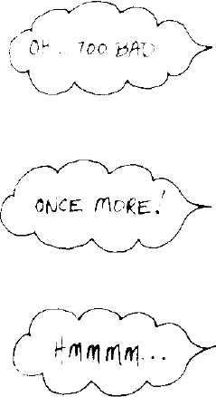


LA"D ComPlLER Toes NO

3+4-


ι
Implementing the
Smalltalk-80 System:
The Tektronix
Experience
Paul L. McCullough *
Tektronix, Inc.
Beaverton, Oregon
Introduction The Tektronix Smalltalk-80 implementation went through a number of
hardware and software phases. Our experience will probably prove to
be similar to that of other research and prototype groups desiring to
implement the Smalltalk-80 system. At best, we will point out some
mistakes to avoid; at the very least we can provide an entertaining view
of our successes and follies.
This paper gives an overview of our initial hardware and software
environments and our initial implementation design. We then present a
fairly detailed account of debugging our first system. Next, we describe
the evolution of our hardware, software, and development tools. We
conclude with some observations and conclusions about the
Smalltalk-80 system and its implications for the future.
Readers should note that we were debugging both our implementa-
tion and the formal specification. Although we detected a number of er-
rors in the formal specification, these errors have since been corrected
and are discussed herein to provide historical perspective.
*Mr. McCullough is currently employed by Xerox Palo Alto Research Center, Palo Alto,
California. Copyright © Tektronix, Inc., 1982. All rights reserved.
59
60
Implementing the Smalltalk-80 System: The Tektronix Experience

Initial Goals
Initially we had four goals for our Smalltalk-80 work:
- Learn about the Smalltalk-80 system, in particular the implemen-
tation of the virtual machine,
- Learn about programming in the Smalltalk-80 language,
- Report on errors in the book draft, and
- Implement the virtual machine, realizing that it would not be our
final implementation.
Tektronix had no previous experience with object-oriented software, so
we were very interested in having a system with which we could
interactively program in the Smalltalk-80 language, and in studying
the Smalltalk-80 virtual machine. As part of our agreement with Xe-
rox, we were to use our implementation as a means to detect errors in
the book draft and to identify ways in which the book might be made
clearer. We realized that our initial implementation would suffer from
performance problems, but felt that a timely implementation was more
desirable than a high performance one.

Initial
Hardware
Our initial hardware consisted of:
- Motorola 68000 processor (8 MHz)
- 4 MHz proprietary bus
- 768 Kbytes of RAM
- Tektronix 4025 terminal
- A microprocessor development system, used as a file server
The choice of hardware was based on the availability of a Tektronix
designed 68000-based system, along with the need for a large, prefera-
bly linear, address space. We also wanted to use a processor amenable
to the construction of personal workstations. The Tektronix 4025 termi-
nal is a raster graphics terminal, primarily oriented toward drawing
vectors. While our bitmapped display was being designed, the 4025
served as an interim display device. Because the initial Smalltalk-80
virtual image did not depend on the use of a file system, we only used
the microprocessor development system as a file server to load and
store virtual images.

61
Initial Software

Software
Development
Environment
Our virtual machine was developed in a cross-compilation environment
using a DECSYSTEM-20. The bulk of the virtual machine was written
in a dialect of the proposed ISO Standard Pascal. This particular dialect
of Pascal supports the independent compilation of modules and pro-
duces assembly language files which are assembled and linked. The re-
sulting executable file is downloaded to the 68000-based system over a
1200 baud serial line. Though the 1200 baud line was an obvious bottle-
neck, the Pascal software already existed on the DECSYSTEM-20 and
we had no desire to port it.

Initial Software
Object Memory
Manager
According to Dan Ingalls: "an operating system is a collection of things
that don't fit into a language. There shouldn't be one"¹. Taking those
words to heart, we chose to implement our virtual machine on a system
that had no operating system. This choice meant that we could not rely
on runtime services normally provided by an operating system and had
to write those portions that we needed, such as routines to handle
input/output to an RS-232 port and perform IEEE 32-bit floating point
arithmetic.
Our software implementation team consisted of three software engi-
neers. We chose to partition the programming task into three distinct
parts:
- Object Memory Manager
- Interpreter and Primitives
- BitBIt
The initial object memory manager was, for the most part, a strict
translation from Smalltalk-80 to Pascal of the methods presented in the
formal specification. During the translation phase, we noted four minor
typographical errors in the draft of the book involving improper bit
masks, or incorrect variable, constant, or method names. We chose to
implement the reference-counting garbage collector. Later, because the
image creates circular garbage, we added a simple, recursive, mark-
sweep collector. The translation process took less than one week and re-
sulted in a working memory manager that maintained a very clear
boundary between itself and the rest of the virtual machine. As dis-
cussed below, this clear differentiation is both a blessing and a curse.
With minor changes due to different dialects of Pascal, we were able
to run programs that tested the object memory manager on the
DECSYSTEM-20 with its more sophisticated debugging and perform-

62
Implementing the Smalltalk-80 System: The Tektronix Experience
ance monitoring software. The test programs read the virtual image,
then made calls to the various entry points in the memory manager.
Then, with Pascal write statements and the debugger, we were able to
examine the state of the object space and determine whether the mem-
ory manager was working correctly. These tests indicated several errors
in the book's methods: for example, the method that determined where
to find the last pointer of an object was incorrect for CompiledMethods,
and the recursive freer needed an extra guard to prevent Small Integers
from being passed off to the pointerBitOf: routine.
At this point, we were able to run test programs that created in-
stances of classes, stored object pointers in other objects, destroyed such
links and thus invoked the deallocation of objects, and performed com-
pactions of the object space. Further testing demonstrated that the
book's method for swapPointersOf:and: was also incorrect.
In order to speed up the performance of the deallocation portions of
the memory manager, we modified the countDown: routine to call
forAIIObjectsAccessibleFrom:suchThatDo: only when the object's refer-
ence count was going to drop to zero, thus saving a procedure activation
that was usually unnecessary.
A few other minor changes provided us with a memory manager that
was tested on the DECSYSTEM-20. Thus, we had a great deal of assur-
ance that the memory manager would perform correctly on the
68000-based system. Also, we felt that when problems were encountered
in our implementation of the virtual machine, we could concentrate on
looking for the problem in the bytecode interpreter or primitives, and
could ignore the memory manager. In actual practice we made many,
many runs of the virtual machine before any problems were found in
the memory manager. We heartily recommend having a trustworthy
memory manager.
In parallel with the development of the object memory manager, we
Interpreter and coded the bytecode interpreter and primitives. The interpreter and
Primitives many of the primitives were written in Pascal. The arithmetic primi-
tives were coded in assembly language in order to simplify the mainte-
nance of the small integer tag bit.
The outer block of the interpreter consists of a call to an initializa-
tion routine and a loop containing a very large case statement that acts
as the bytecode dispatcher. While the memory manager was a fairly lit-
eral translation of the book's methods, much greater care was exercised
in the construction of the interpreter. Code that in the book was several
message sends was often collapsed into a single Pascal statement. We
included in our interpreter the capability of producing traces which du-
plicate those supplied with the virtual image by Xerox.
In order to give the reader a measure of the complexity of
implementing an interpreter (in Pascal), we present the lengths (in
63
Initial Software
printer pages at 60 lines per page) of some of the major routines. These
figures include the length of tracing code:
- Looking up a message, including the perform: primitive: two and
one-half pages
- Sending a message (including cache lookup): one and one-half
pages
- Executing the current method, including the primitives written in
Pascal: twelve pages
- Returning a value from the active context: one and one-half pages
- The scan characters primitive (used for text composition): three
and one-half pages
- Large integer primitives: four pages
- Process primitives: five pages
We strongly recommend that the first implementation of an interpreter
be in a high-level language. By writing the virtual machine in a high-
level language, implementors gain a more thorough understanding of
the virtual machine as well as a much more quickly completed imple-
mentation.
The BitBIt primitive handles all graphics in the Smalltalk-80 system.
BitBlt Due to its importance, we decided to have one person concentrate on its
implementation. The routines to implement BitBIt were written in as-
sembly language and closely reflect the structure of the BitBIt methods
in the book. To assist in the debugging of BitBIt, there are many condi-
tionally assembled calls to the Pascal runtime print routines. The main
BitBIt routine accepts one argument, the address of a Pascal record con-
taining the various BitBIt parameters. When called, the routines per-
form the following actions:
- Clip the source parameters to the physical size of the source form
- Clip the clipping rectangle to the true size of the destination form
- Clip and adjust the source origin
- Compute the masks necessary for the logical operations
- Check for possible overlap of the source and destination forms
- Calculate the offsets for the starting and ending words
- Copy the bits as appropriate
64
Implementing the Smalltalk-80 System: The Tektronix Experience
Certain optimizations are performed for the special cases of clearing,
setting, or complementing the destination forms. BitBIt is approximately
2 Kbytes of assembly code.
We maintained a fairly detailed log of our attempts to get the virtual
Summary of Runs machine up and running. The comments we made for each of these
runs may be helpful to future implementors of the virtual machine.
This summary should provide a sense of the types of errors and prob-
lems one should expect when implementing the virtual machine.
- Reached the first send, then encountered an error in a debugging
routine we had written.
- Reached the first send again, encountered another error in a
debugging routine.
- Encountered a Pascal compiler bug.
- Reached first send of the @ selector, and discovered that we had
transcribed the constant for class Small Integer incorrectly.
- The method specified in the book for initializing the stack pointer
of a new context was incorrect.
- We forgot to initialize the sender field when creating a context.
- In the book, the method returnValue:to: caused the reference count
of the sender context to go to zero (thereby making the sender
garbage) just before returning to that context. We had to explicitly
increase the reference count of the sender context, perform the re-
turn, then explicitly decrement the reference count.
- We had decided to implement the "common selector" bytecodes
using full message lookup. Unfortunately, the method header for
selector = = in class Object did not specify the execution of a
primitive. We patched the image to specify the correct primitive
number.
- The first conditional branch we encountered failed because we did
not advance the instruction pointer past the second byte of the in-
struction.

- We discovered that the source code for Small Integer < did not
specify a primitive, resulting in an infinite recursion. We patched
the image again.
- Discovered that other methods of class Smalllnteger did not have
primitives specified. We retrenched to executing the following se-
lectors without lookup: class, = =, arithmetics, relationals.
65
Initial Software
- Selector at: failed. Our fault, in the routine positive16BitValueOf: a
" > " should have been a " < ".
- Multiply primitive failed due to an assembly language coding er-
ror.
- All relational primitives written in assembly language had an in-
correct (and uninitialized) register specified.
- Made it through the first trace. (Listings of four traces of the in-
terpreter's internal operations were included with the first distri-
bution of the virtual image. Subsequent distributions included
three traces.)
- The book's method for the primitive value: caused the stack to be
off-by-one.
- Once again, we found an error initializing the stack pointer of new
contexts.
- Again, the stack pointer is off. These three errors were caused by
an incorrect constant in the book draft.
- A message selector was not found. Another run is necessary to de-
termine what happened.
- At the beginning of execution for a block, the cached stack pointer
is one too large. In the past, message sends and returns have
worked because the routine that stored the stack pointer
decremented it.
- We had coded the at:put: primitive incorrectly: we forgot to have it
return anything, hence the stack was off-by-one.
- We incorrectly coded the at: put: primitive with an uninitialized
variable.
- The at:put: primitive had a > that should have been a > =.
- The Smalllnteger bitShift: primitive added in the Smalllnteger bit,
but should have Or'ed it in.
- Interpreting lots of bytecodes, unfortunately not the correct ones.
Apparently, we took a bad branch somewhere.
- We found that the book's methods for the bytecode "push self" did
not necessarily work for block contexts.
- Almost through the fourth trace when the Smalllnteger division
primitive failed to clear the high-order half of a register. The er-
ror was detected by a Pascal runtime check.
66
Implementing the Smalltalk-80 System: The Tektronix Experience
- Through the fourth trace when Sensor primMousePoint dies be-
cause of a clash between the interpreter and the Pascal runtimes.
- We are well beyond the fourth trace when we discover that the
method frame:window:para:style:printing: has a MethodHeader ex-
tension that specifies primitive number 0. We had assumed that
an extension always specified a valid primitive number, but find
that it may also be used to specify a method with more than four
arguments.
- We have changed all unimplemented primitives so that they fail,
and now correctly handle primitive 0 in MethodHeader extensions.
By now, we should have something up on the 4025 display, but do
not. Investigating, we find that the book says that the bitmap for
a Form is the first field, whereas the sources say it is the second
field.
- We are halftoning the display. We have to make a few adjust-
ments to prevent overrunning the display. Halftoning will take a
long time, approximately two hours. After a while, a runtime ex-
ception was raised by a Pascal support routine that contained a
bug.
- The "T" for the TopView window title tab is present on the dis-
play. Interpreter stopped after sending copyTo: to a Smalllnteger.
- We have disabled halftoning to the 4025, continuing with the
study of the problem of sending copyTo: to a Smalllnteger.
- The problem is that the BitBIt primitive, copyBits did not return
anything, thus forcing the stack off by one. Similarly, beDisplay,
and beCursor did not return anything. We have added more dis-
play memory to the 4025.
- Hurray! "Top View" window title tab is on the screen. Pascal
runtime checks detected an out-of-range scalar while setting up
arguments for copyBits. We have always assumed that BitBIt argu-
ments are unsigned, but that is not so. We were told that BitBIt
should do source clipping, so we will add that to BitBIt.
- The entire "Top View" window is on the display, then erased. We
eventually crashed because we are out of object space, but unsure
why.
- We are out of object space because the book's methods for super-
class send was incorrect: another level of indirection is necessary.
- We now have "Top View" window, Browser, and Transcript window
on the display. Interpreter stopped when the mouseButtons primi-
tive failed.
67
Initial Software
- We turned on halftoning to see what would happen. This was a
mistake because windows are half toned black and then white. We
decided to reload and try again without halftoning.
- We have reached the idle loop, checking if the mouse is in any
window. We changed the position of the mouse (by altering two
memory locations) and placed it within the browser. The browser
awoke and refreshed four of its panes. The fifth pane (code pane)
caused an interpreter crash with a Pascal out-of-range error due
to a minor bug in the mod primitive.
- Great excitement! We have refreshed the window containing a
"Congratulations!!" message. Eventually we crashed because the
Float < primitive fails. The system tried to put up a Notify win-
dow, but had difficulty because of other primitive failures. Howev-
er, it was able to put up messages in the Transcript window. For a
system that is not yet fully implemented, it is amazingly robust.
We noticed that certain BitBIt operations seem to put up incorrect
information, then erase it. For example, putting up the "Top
View" title tab, the text reads "Top Vijkl" for a short time, and
the incorrect part is then repainted. Investigation showed the
method computeMasks to have a < selector that should have been
a < =, an error carried over from the book.
- Generally poking around with the system. We have found that we
need floating point primitives in order for scroll bars to work, so
we have implemented all but the fractional Part primitive. Rather
than develop an IEEE Floating Point package, we acquired one
from another group at Tektronix. We have also speeded up BitBIt
by using 4010-style graphics commands with the 4025.
- We have implemented object memory statistics to report the num-
ber of fetch Pointers, storePointers, etc. performed. We have also
added a lookup cache for faster message send processing. A cleri-
cal error in the caching routines crashes the virtual machine.
- An uninitialized variable causes the cache to misbehave.
- The cache is functioning well. Our initial algorithm is to exclu-
sive-or the Oops of the receiver's class and the method, then ex-
tract bits 3-7 and index a 256 element array of 8 byte entries. The
interpreter definitely runs faster with the cache. The cache con-
sists of the Oop of the selector, Oop of the receiver's class, Oop of
the method, the most significant byte of the method header, and
one byte indicating either the primitive index or 0.
- Tried a new hash function, shifting two bits to the left before the
exclusive-or because we observed that the Oops of different selec-
68
Implementing the Smalltalk-80 System: The Tektronix Experience
tors in the same class are very similar to one another. Some
speedup was noted.
- Another hash function, this time adding the Oops rather than ex-
clusive-oring them. No noticeable change. We did move the mouse
to the first pane of the Browser and crashed the system when the
interpreter passed a Small Integer to the memory manager.
- Further examination of the previous problem shows that we did
not cut the stack back far enough after a value: message. This bug
was carried over into our code from the book, but only appears
when sending value: within an iterative loop.
- We have fixed value:, now we need to write the perform: primitive.
- We have installed perform:, but get an infinite recursion because
the floating point package is not IEEE format. We will write one
in Pascal.
- With the new floating point code, we can now cut text, pop up
menus, and so on. This is great!
At this point, we added some simple performance monitoring code. We
counted the number and type of object memory references, the number
of bytecodes executed, and information concerning the performance of
the lookup cache. For each bytecode executed, an average of just under
10 object memory references were made. The majority were calls to
fetchPointer:, then storePointer:, fetchByte:, and fetchClass:. The various
lookup cache algorithms were found to perform either fairly well (50 to
70% hit rate) or very poorly (20% or worse hit rate). Evidently, caching
algorithms either perform quite well or miserably.
We feel that we were able to implement a relatively complex piece of
Summary of software in less than six weeks (that is, from nothing to a working sys-
Initial Software tern) in less than 60 runs for several reasons:
- We were fortunate to have very good software engineers.
- We had a well-defined task.
- Because it took so long to load the virtual image (about 10 min-
utes) from the file server and so long (again, 10 minutes) to
download our virtual machine from the host, we were very careful
in coding and in analyzing crashes. We were also sharing the hard-
ware with another group, so we made good use of our time on the
machine.
- The specification, though not without error, was well written.
69
The Second Virtual Image
The Second About this time, we received the second virtual image from Xerox Palo
Virtual Image Alto Research Center (PARC). With this image, the handling of primi-
tive methods was much cleaner, access to BitBIt was improved, the ker-
nel classes were rewritten, and a source code management system was
added. Several significant changes to the virtual machine specification
were made, with the intention that these would be the final modifica-
tions. The second image also made use of the process primitives, while
the first image did not.
Because a general cleanup of our interpreter seemed a good idea, and
because a fair amount of the interpreter needed to be changed to sup-
port processes and new primitive numbers, we rewrote much of it. A
history of our runs for the second virtual image follows:
- We got our "Initializing ..." message, and the system crashed be-
cause we were trying to initialize the cursor frame buffer. Since
our bitmap display was not yet available, the presence of this code
was premature.
- We are through one-third of the first trace, but a conditional
branch bytecode branched the wrong way.
- Several problems noted:

- Metaclass names no longer print properly on our traces.
- We encountered off-by-one errors in stack operations while han-
dling bytecode 187 because we forgot to adjust the stack index.
- We encountered off-by-one errors in stack operation for
Smalllnteger //.
- Our trace does not print operands for Smalllnteger * properly.
- We need to carefully check the code for all stack operations.

- M68000 stack overflow causes parity errors.
- We are through trace 1, and three-quarters through trace 2 when
Pascal detects an out-of-range scalar because the routine
returnValue:to: returned to a deallocated block context. We had
failed to increase a reference count.
- We are almost halfway through trace 3 when we hit an
unimplemented process primitive. We also noticed the primitive
return of an instance variable did not pop the receiver, thus caus-
ing the stack to be off-by-one.

70
Implementing the Smalltalk-80 System: The Tektronix Experience
- We are about 60% through trace 3 when we try to add nil to an
instance of class Rectangle. Caused by our coding error: when a di-
rect execution send fails, we fail to tidy up the stack pointer.
- We find that we need to implement the process primitives.
- BitBIt fails to clear the high-order bits of a register causing a crash
on the 21380th message sent.

- Sending the selector + to an Array fails. Stack is off-by-one be-
cause the copyBits primitive failed to return self.
- We find that the resume: primitive does not work due to an
uninitialized variable.
- More problems with resume:, it fails to set a boolean.
- More problems with the resume: primitive: the process to be re-
sumed has nil as its instruction pointer because the initial instruc-
tion pointer is not set in primitiveBlockCopy.
- The resume: primitive works finally! Unfortunately, the wait prim-
itive does not because of an incorrectly coded branch.
- The wait primitive works, and we are through the third trace cor-
rectly. We forgot to code the setting of the success boolean for
primitive become:, so a notify window is created.
- Fired up the system. We have executed more than 15,000,000
bytecodes and it is still alive!
In order to improve performance, we made many changes to the inter-
preter and the memory manager. Changes to the interpreter included
the caching of absolute addresses in the interpreter, thus employing
considerably fewer calls to the memory manager. For example, to ex-
tract the fields of a source form, rather than a fetchPointer call to the
memory manager for every field, the interpreter merely cached an ab-
solute address and stepped through a range of offsets. Within the mem-
ory manager, many procedure calls were replaced with macro calls that
were expanded by a macro preprocessor. Not only did this save the
overhead of procedure calls, but quite often allowed common
subexpression elimination to occur, thus actually decreasing the
amount of compiler-generated code.
We also sped up certain parts of the interpreter based on where we
believed the interpreter was spending its time. With these optimiza-
tions, performance is approximately 470 bytecodes a second.
An observation: Utilizing a raw computer (that is, one without an
underlying operating system) to implement a Smalltalk-80 system is a
double-edged sword: on the one hand, you can place data structures and
τ

τ\_
Performance Modeling Tool
code anywhere in the system, and you have complete control of the
hardware. On the other hand, the lack of performance monitoring tools
and underlying file systems can be a problem because it takes time to
implement them, rather than just interfacing to them.

Second Version
of the Hardware
At about this time, we added floppy disks to the system, as well as a
utility program that could save and restore arbitrary memory locations
on the disks, thus freeing us from the microprocessor development sys-
tem file server. The 10 minute delay for the loading of a virtual image
was reduced to about 45 seconds. A more dramatic change to the hard-
ware was the addition of our bitmap display. No longer would we have
to translate bitmap operations to vector drawing commands on the
4025, nor wait for a window to be halftoned. We also added a standard
Tektronix keyboard and a mouse. In order for the mouse and keyboard
(as well as portions of the Smalltalk-80 software) to work, we also added
a one millisecond timer interrupt.
As part of another project, a new M68000 processor board was made
available to us. Recall that the bus that we were using ran at 4 MHz,
which introduced wait states into the M68000. The new processor board
used a one longword data cache and a one longword instruction cache
to reduce bus requests. This resulted in a 70% speedup in system per-
formance, to approximately 800 bytecodes per second.

The Third
Virtual Image
At this point, our goal became to build a virtual machine that was
clearly faster (approximately 4000 bytecodes per second), but to do it
quickly and at relatively low expense. The method we chose was to de-
velop a performance analysis tool and, using the results of the measure-
ments, to rewrite time consuming portions of the virtual machine in
assembly language. The following sections summarize our findings and
our techniques for speeding up the virtual machine.

Performance
Modeling Tool
To monitor the execution of the virtual machine, we developed a simple
analysis tool that was called by the one millisecond timer interrupt rou-
tine. Each time it was called, it stored the value of the interrupted

72
Implementing the Smalltalk-80 System: The Tektronix Experience
M68000 program counter. By changing a memory location, a routine
could be activated to print a histogram showing ranges of program
addresses, the number of times the program counter was found to be
within the range, and the percentage of time spent within the range.
The size of the address range for each line of the histogram was
selectable by the user. We mapped routine addresses to these ranges so
that the histogram showed time spent in each routine. This tool proved
to be invaluable in speeding up the virtual machine.
Prior to utilizing this tool, we decided to measure how much time
was spent in the interrupt service routine. The Smalltalk-80 virtual
machine expects a timer interrupt every millisecond and the routine
checks the mouse and keyboard motion registers. If a change has oc-
curred, the routine makes note of the change so that the bytecode dis-
patch loop can create a Smalltalk-80 event. Like much of our virtual
machine, our timer interrupt routine was initially written in Pascal.
Because the interrupt routine has many basic blocks, and the optimizer
of the Pascal compiler operates only upon one basic block at a time, the
interrupt service routine spent a great deal of time reloading registers
with previously loaded values. We discovered that an amazing 30% of
the M68000 cycles were going to the interrupt service routine! One of
the first optimizations that we performed was to take the Pascal com-
piler-generated code and to perform flow analysis on it. The new inter-
rupt service routine consumed 9% of the M68000 cycles. Future plans
call for hardware to track mouse and keyboard events, and for timers to
interrupt the M68000 only when necessary (for example, when an in-
stance of class Delay has finished its wait period).

The Results of
Performance
Monitoring
The performance monitoring tool showed us some statistics that were
surprising to us (the percentage figures presented below do not include
time spent in the interrupt service routine nor the performance moni-
toring tool). Approximately 70% of the M68000 cycles were being spent
in the memory manager, 20% in the interpreter and primitives, and
10% in BitBlt. The bulk of the time in the memory manager was spent
in only a few routines: fetchPointerofObject:, storePointenofObject:-
withValue:, fetchClassOf:, countUp:, countDown:, and two sets of routines
generally referred to as the recursive freer and the niller. Previous sta-
tistics we gathered had indicated that fetchPointenofObject: and store-
Pointer:ofObject:withValue: were popular routines, but they were rela-
tively short and (so it seemed) should consume relatively little processor
time.

i

73
The Results of Performance Monitoring
Looking at the Pascal-generated code, we felt that we could do far
better with assembly language, and we recoded all memory manager
routines that the interpreter and primitives could call directly.
Recoding fetchPointenofObject: resulted in a 4.5% speedup. Next, we
recoded storePointer;ofObject:withValue: and achieved an additional 13%
speedup. The major difference between these two routines is in refer-
ence counting: when storing pointers, reference counts must be updated;
when fetching pointers they do not. Although we had previously con-
cluded that reference counting was an expensive operation, we now had
measurements of just how expensive. After recoding in assembly lan-
guage all the routines callable by the interpreter and primitives, the
system was an aggregate 19% faster.
Next, we considered routines that were private to the memory man-
agement module. From the histograms, it was obvious that we spent a
great deal of time initializing just-instantiated objects to nil pointers (or
zeroes for non-pointer objects). This inefficiency again arose from the
strict basic block analysis of the Pascal compiler. For the price of a pro-
cedure call to an assembly language routine, we were rewarded with a
speedup of nearly 10%.
Another major change to the memory manager came in the area of
the so-called recursive freer. When an object's reference count drops to
zero, this set of routines is activated to decrement the reference counts
of the object's referents and, should their counts drop to zero, recursive-
ly free them. The first attempt at speeding up this process was done in
Pascal and resulted in nearly a 10% speedup. Later on, we rewrote the
recursive freer again in assembly language achieving an additional
speedup.
The instantiation of objects was also expensive because several proce-
dure calls were made. We rewrote this code (still in Pascal), collapsing
several procedures into one. Later, the instantiation routines were re-
written in assembly language.
Changes to the interpreter and primitives were done in an interest-
ing manner. Recall that we had a functioning, albeit slow, interpreter.
With the belief that it is far better to change one thing at a time, rath-
er than everything at once, we modified a small portion of the inter-
preter and tested the change. Once the change was shown to be
satisfactory, we changed another part of the interpreter.
Initially, we rewrote the bytecode dispatch routine, but, in keeping
with our philosophy of small changes, none of the bytecode interpreta-
tion routines. Thus, the assembly language bytecode dispatch routine
set a boolean indicating that the assembly language dispatch had failed
and that the Pascal routine would have to take over. Then we added
bytecode interpretation routines, more or less one at a time. Eventually,
we were able to discard the Pascal dispatch loop and bytecode inter-
preters completely.
74
Implementing the Smalltalk-80 System: The Tektronix Experience
Once all the bytecode interpretation routines were completed, we
turned our attention to the primitive routines. These changes were ac-
complished in a similar manner: initially, all assembly language primi-
tives failed, forcing the Pascal-coded primitives to run. We would then
select a primitive, code it in assembly language, and test it. Once it was
found to be acceptable, we selected another primitive to re-code. Final-
ly, the Pascal primitives were discarded. Rather than call high-frequen-
cy primitive routines, we included many of them in-line.
In order to save some procedure calls to the memory manager when
instantiating objects, the interpreter first tries to directly acquire the
new object off the free lists. If the attempt fails, the interpreter calls
the memory manager. Such "fuzzing" of the line between the pieces of
the virtual machine seem necessary to achieve acceptable performance
on current microprocessors. This demonstrates how a clear boundary
between the memory manager and the rest of the virtual machine is
both a blessing and a curse.
The changes to the memory manager and interpreter eventually re-
sulted in a 3500 bytecode per second system.
The Third and Our technique of making incremental changes to the virtual machine
Fourth Images enabled us to use a working system and to bring up new virtual images
as they were received from Xerox. A log of the attempts to run the
third image follows:
- At Xerox, the display bitmap is simply an object in the object
space. In our implementation, the display bitmap lives at a specif-
ic address, and we encountered a problem because this image
sends the become: primitive to the current display object. We
modified our code in the become: routine.
- We encountered a Pascal subscript-out-of-range error. The routine
that returns instance variables was coded incorrectly, due to an
error in the book's specification.
- There are some new primitives related to the Xerox implementa-
tion in the image. We modified our interpreter to understand
them.
- A bit of Smalltalk folklore: "If 3 + 4 works, everything works."
We typed 3 + 4 into a window and executed it. .It did not work be-
cause the Smalllnteger size message returned the wrong result.
75
Some Observations
- Executing "Circle exampleOne" causes infinite recursion because
the graphics classes were coded incorrectly by Xerox. They had
not noticed this problem because the Xerox implementation of
primitive new: did not comply with the formal specification,
allowing their code to execute.
- The system is up and working.
The fourth image was brought up on the first attempt.
Some If we analyze the coding errors that we encountered in our various im-
Observations plementations, we find that most fall into the following categories:
- Off-by-one errors
- Failing to return the correct object, or failing to return any object
(leading to off-by-one errors)
- Conditional branch reversals
- Errors in the specification
Perhaps the most painful part of debugging a virtual machine is finding
the off-by-one errors. These errors typically arise in primitive handling
and in the stack activation records. Certain primitives may fail, and
Smalltalk-80 methods are expected to take over. During the develop-
ment of the virtual machine, it is quite common to damage the object
references on the stack or to misadjust the stack pointer resulting in
off-by-one errors. When returning from a procedure call in many stack
machines (the M68000 is an example), if the processor's stack has an
extra argument or does not have a return value, the correct return ad-
dress will not be found, and the processor will return to an erroneous
location. The typical result is a system crash. In the Smalltalk-80 virtu-
al machine, the return address (actually the sender field) of the activa-
tion record (an instance of either class MethodContext or class
BlockContext) is always in a known place, and a correct return can al-
ways be made and the machine will definitely not crash. Nonetheless,
the interpreter (or primitives) may have pushed an incorrect result val-
ue or left garbage on the stack. Only later will this type of error mani-
fest itself. These errors can be time-consuming and relatively difficult
to find.
Errors resulting from conditional branch reversals are common, and
are not further discussed here.
76
Implementing the Smalltalk-80 System: The Tektronix Experience
We certainly found our share of errors in the specification of the
Smalltalk-80 virtual machine. This statement should not be taken as an
affront to the Software Concepts Group at Xerox PARC. They were
both developing and documenting two complex software products (the
Smalltalk-80 system itself and the underlying virtual machine), and it
was our job to point out discrepancies. Indeed, they produced an
amazingly well constructed software system, and future implementors
should have fewer problems with their own implementations.
We have programmed very few application programs in the
Smalltalk-80 language. However, we do have one very definite data
point in this area. Our file system (see Chapter 16) was totally devel-
oped in the Smalltalk-80 system and in a relatively short time period.
All debugging was done using the Smalltalk-80 system: we never used
the Pascal or assembly language debugging tools.
A final observation: the routines collectively known as primitives are
about one-third to one-half of the implementation effort. Bear this in
mind when scheduling an implementation.

Conclusions
Our work with the Smalltalk-80 system has shown it to be a robust,
well-engineered piece of software. The initial, albeit incomplete, virtual
machine required six weeks of effort by three software engineers, pri-
marily using a high-level language. This resulted in a slow but useable
system. By monitoring where the virtual machine spent its time, we
were able to construct a system with adequate performance. For first-
time implementors, we heartily recommend a similar approach.
Without question, the Smalltalk-80 system will have a strong impact
on many areas of computer science, including language design, system
architecture, and user interfaces. Perhaps most importantly, the system
and language cause the user to think about problems in new ways.

Acknowledg-
ments
Many people contributed to our Smalltalk-80 effort. Allen Wirfs-Brock
designed and implemented the Pascal-based interpreters and primitives
and the initial assembly language enhancements. Jason Penney
designed and implemented BitBIt, the floating point package, the floppy
disk driver, and the assembly-enhanced interpreters. Joe Eckardt
designed our excellent bitmap display and has made interesting modifi-
cations to the Smalltalk-80 code. Tom Kloos and John Theus designed

L
References
and maintained our M68000 system, as well as the interface to the
mouse, keyboard, and floppy disks. Allen Otis graciously shared his
hardware with us in the early days of the project and made some of the
first measurements of the virtual machine. Larry Katz made many sug-
gestions for the improvement of the book and served as our unofficial
kibitzer during the implementation and provided much food for
thought. We would like to acknowledge the various managers (Jack
Grimes, Don Williams, Dave Heinen, George Rhine, and Sue Grady)
who had the foresight and wisdom to allow us to work on the project.
Glenn Krasner, of Xerox PARC, provided answers to our questions and
provided us with ideas for speeding up our implementation. And, we
would like to thank Adele Goldberg and the Software Concepts Group
of Xerox PARC for including us in the book review and implementation
process. Without them, we would have naught.
References 1. Ingalls, Daniel Η. Η., "Design Principles Behind Smalltalk", Byte
vol. 6, no. 8, pp. 286-298, Aug. 1981.

78
Implementing the Smalltalk-80 System: The Tektronix Experience

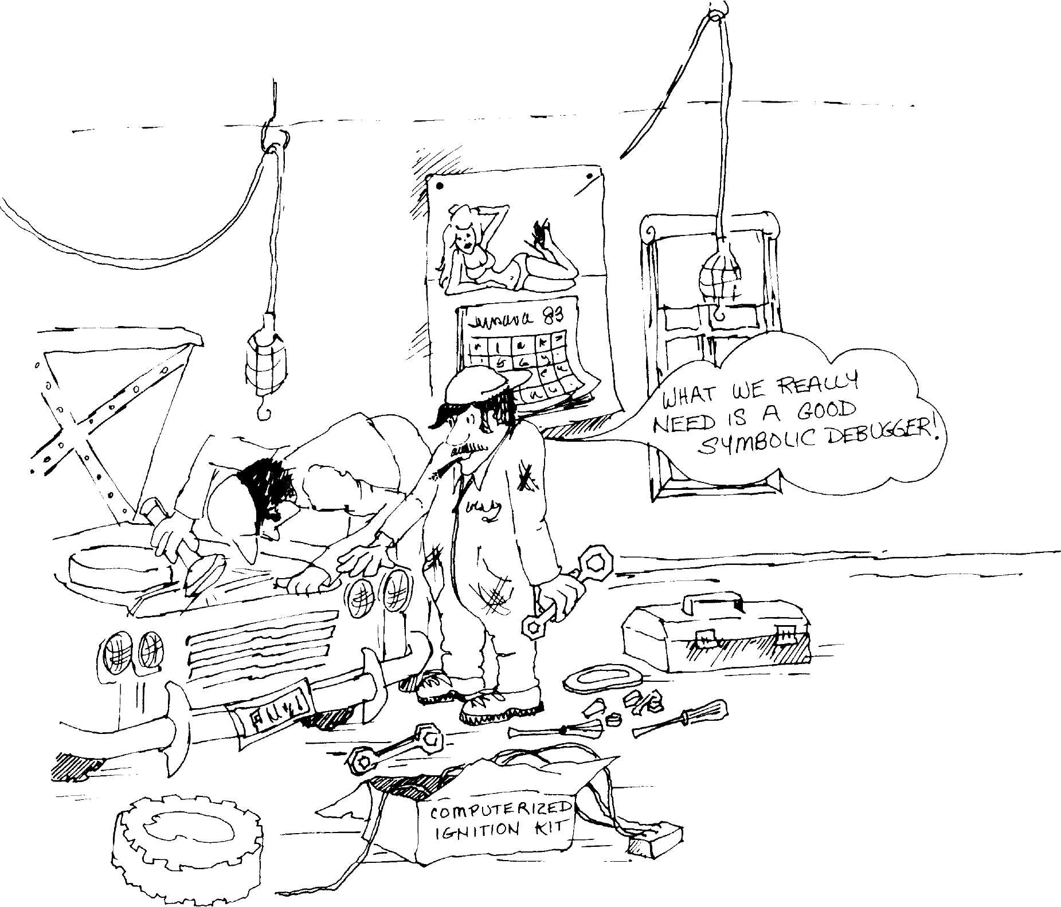

The Smalltalk-80
Implementation at
Hewlett-Packard
Joseph R. Falcone
James R. Stinger*
Computer Research Center
Hewlett-Packard Laboratories
Palo Alto, California

Introduction
This report describes one of the four test sites for the Smalltalk-80 re-
lease process: a personal computing research group at the Computer
Research Center of Hewlett-Packard Laboratories in Palo Alto. The fol-
lowing sections present a history of the work at Hewlett-Packard, an
overview of our implementation, a description of the development envi-
ronment, and some conclusions. A comprehensive analysis of the
Hewlett-Packard implementation is in the companion paper (see Chap-
ter 12).

Smalltalk-80
Project at
Hewlett-
Packard
The Smalltalk project at Hewlett-Packard Laboratories received author-
ization on December 8, 1980. Beginning in November of 1981 the proj-
ect slowed considerably, and the new year found nearly all development
at a halt. The project officially closed on February 22, 1982, though
some independent and academic work on the system continues. The im-
*The views expressed herein are those of the authors, and do not necessarily represent
the position of Hewlett-Packard or any commitment to products or services. Copyright ©
Joseph R. Falcone and James R. Stinger, 1982. All rights reserved.
79

80
The Smalltalk-80 Implementation at Hewlett-Packard
plementation portion of the project produced nine releases on five dis-
tinct host architectures. Documentation review and background work
took one person-year of our group's time. We produced the first release
of HP Smalltalk in two months, and subsequent releases followed coin-
ciding with the availability of new Smalltalk images and new host com-
puters. The analysis of these systems consumed another person-year.
This section describes our experience implementing a Smalltalk-80
system according to the specifications distributed during the test pro-
gram. When the project began, neither the documentation nor the soft-
ware was complete, a fact which profoundly influenced the duration,
scope, and direction of the project.
The first three months of the project involved reviewing chapters of the
Project History Smalltalk-80 implementation guide and selecting the first host machine
for the implementation. The first few chapters covered the underlying
philosophy of Smalltalk and set the ground rules for an implementa-
tion. As time passed, the chapters concerned with the specifics of imple-
mentation began to arrive.
The Smalltalk-80 language itself was the specification language used
to describe the implementation. We felt that this hindered our efforts in
two ways. First, it forced us to learn Smalltalk before we had our own
system, and at a time when Xerox possessed the only Smalltalk-80 en-
gines (and even those were incomplete). Second, it introduced some
unwelcome ambiguity into the specification.
Initially we considered the HP 3000 Series 44 for the implementation
host because of its stack architecture and position as the fastest HP
processor then available (approximately 0.5 MIPS). This strategy
seemed appropriate for the Smalltalk-80 virtual machine architecture
as we understood it. However, after studying the matter further, we be-
came aware of several implementation obstacles. We determined that
Smalltalk would perform significantly better on the Series 44 if we put
it directly on the bare machine, instead of layering it on MPE, the HP
3000 operating system. As there is a tight coupling between MPE and
the microcode on the Series 44, the Smalltalk-80 virtual machine code
on the bare Series 44 would have to satisfy the expectations of the mi-
crocode for MPE structures. We also were not sure how Smalltalk
would behave in an environment with separate code and data segments
(enforced by hardware), as is the case on the Series 44. We explored
changing the microcode of the Series 44, but we felt that the task would
take too much effort, especially since none of the members of the group
had microcoding experience. We also considered modifying the
Smalltalk-80 compiler to produce Series 44 machine code, but Xerox ad-
vised that this would be difficult without a working Smalltalk system
on which to do it. Because of these problems, plus time restrictions, we
decided to postpone putting Smalltalk on the HP 3000 Series 44.
81
Smalltalk-80 Project at Hewlett-Packard
Instead, we decided to implement our first Smalltalk-80 system in
Pascal under TOPS-20 on a DECSYSTEM-20 mainframe. Our selection
of Pascal as the implementation language reflected the investigative
nature of the project. We were not sure that a strongly-typed high-level
language could implement the Smalltalk-80 virtual machine as speci-
fied, and it was an interesting exercise to try to do it and find out for
ourselves.
Around the middle of March we felt we had enough information
about the Smalltalk-80 virtual machine to begin writing the interpret-
er. The first test release Smalltalk-80 image also arrived in March. The
DEC-20 implementation proved sufficient and useful for the early
stages when many subtle implementation points were unclear. In par-
ticular, the type and range checking in Pascal exposed many implemen-
tation problems as we progressed. Such experimentation with the
manner of the implementation continued throughout the project.
By the middle of April, the first version of the object memory manag-
er was operating. This version included dynamic memory management
via reference counts. A month later, the interpreter managed to exe-
cute up to the first invocation of a primitive method. We had included a
monitor which allowed us to observe the operation of the system via a
motion picture display (see p. 103 for more details on the development
environment). Two weeks later, on June 5, 1981, we reached a project
milestone: we ran the first Smalltalk-80 test image successfully. This
system on the DEC-20 became the first HP Smalltalk release.
Although the system ran, we did not have graphics capability until
the middle of the summer. This used an HP 2647 terminal connected to
the DEC-20 system, and unfortunately, it took 50 minutes to display a
single Smalltalk screen. We knew from the start that our DEC-20 did
not have a suitable graphics device, so as early as April we began to ex-
plore different approaches. We had already ordered a Lexidata 3400 bit-
mapped graphics system with an HP-IB (IEEE-488) interface for the
proposed HP 3000 Series 44 implementation. Using a National Instru-
ments GPIB11-2 IEEE-488 interface, we could connect the Lexidata to
the VAX-11/780 UNIX system owned by our department. After much
discussion, we adopted this plan. We gained several advantages by
transferring our efforts to VAX UNIX. First, it allowed us to use our
Lexidata system as the graphics device. Second, it took advantage of the
UNIX and C expertise of a team member. Third, and most importantly,
it would give us a version of Smalltalk which could be portable across
UNIX engines.
In the process of moving from the DEC-20 to the VAX, we converted
the entire system from Pascal to C. We developed editor command
scripts for the code conversion to automate the process as much as pos-
sible. Over the course of the next month, as we completed various parts
of the system on the DEC-20, we moved them to the VAX, so that by
June 19 we had transferred the entire svstem.
82
The Smalltalk-80 Implementation at Hewlett-Packard
The object memory was the first part of the system transferred to
UNIX. Because of its dependence on the memory architecture of the
host machine, the memory manager was almost completely rewritten.
A version of it was running during the first week of May. We eventual-
ly rewrote about half of the original Pascal code as part of the move to
UNIX. The recoding was necessary partly for reasons of efficiency and
partly to take advantage of certain VAX features. In addition to rewrit-
ing the object memory manager, we redesigned the execution monitor,
the memory inspector, and the input/output routines. Most of the
small, frequently-called Pascal procedures became macros. The inter-
preter and primitive routines remained relatively unchanged. We also
integrated the object memory inspector into the execution monitor, so
that one could switch between them to examine objects during
debugging. By the end of the conversion process, the HP Smalltalk-80
system consisted of 7500 lines of C code. Remarkably, it executed a
dozen or so instructions after its first successful compilation on UNIX.
Although some work continued on the DEC-20 Smalltalk-80 system,
particularly with the graphics interface, most of our effort shifted to the
UNIX version. By the end of June we had fast and slow versions of
both the object memory manager and the bytecode interpreter. The fast
versions coded many of the C procedures of the slow versions as macros.
Although the fast versions were indeed faster, they were less useful for
debugging since C debugger breakpoints could only be set on the initia-
tion or completion of a macro, leaving the intermediate steps of the ex-
pansion inaccessible. In addition, the slow version of object memory
performed much error checking which efficiency considerations had
eliminated from the fast version. Once the interpreter stabilized, we
discarded the slow version of it, primarily to simplify version manage-
ment.
A prime reason for moving the Smalltalk system to UNIX was to
take advantage of certain tools, such as the C profiling facility prof. It
showed not only where the system was spending its time, but also how
fast it was running. Using the information gained from the profiles we
were able to improve the performance of the system considerably
through the following techniques:
- We used structure casts overlaying object memory for contexts
and other fixed-size objects to reduce access time. After setting up
the base address, these casts allow direct access of all elements of
the structure.
- We expanded small procedures with few invocations in-line.
- We recoded very small procedures as macros.
- We cached frequently accessed information in special variables,
including the stack and instruction pointers as absolute addresses,
and the current active context and method as base addresses.
83
Smalltalk-80 Project at Hewlett-Packard
When the second image release arrived in June, instead of abandoning
the first image and focusing our attention on converting the system to
run the new release, we decided to work with the first image until it
was fully functional. We felt the effort would pay off when getting the
system to work on subsequent image releases. Unfortunately, the pur-
pose of the first image, as stated by Xerox, was merely to provide a ve-
hicle for debugging the Smalltalk-80 virtual machine interpreter. Thus,
there was, no documentation available on the user interface for this
first image; neither did we have a complete Smalltalk source listing.
Also, the Lexidata graphics system was not available until the end of
June. To help ease the problem of not having any graphics output be-
fore that time, we modified the scanword primitive to display any text
on the session terminal that would normally appear on the graphics de-
vice. Thus, we saw text output a full two weeks before we saw our first
Smalltalk screen.
By the middle of August, keyboard input was working, including an
appropriate mapping of the keys into the Smalltalk character set and a
keyboard polling scheme that did not cause the system to wait for a
character to be typed if none was in the buffer.
In early September we started to convert the system for the second
image while finishing the implementation for the first image. After
solving a number of very elusive problems, everything except floating
point worked. We were able to do 32 factorial in 14 seconds, 100 factorial
in 90 seconds, and 200 factorial in 360 seconds. At this point our chief
concern was simply getting Smalltalk to work, and the slow operation
of the system was the least of our worries.
By the end of September we had recompiled our first method in the
browser, run the Turtle demo successfully, and managed to get the
snapshot facility working. Early in October we discovered how to de-
clare variables which permitted more sophisticated top-level program-
ming. By the middle of October, the floating point primitives were
working. One annoying problem with testing the system was that the
code which executed after loading a Smalltalk snapshot refreshed all
the windows and required some time-consuming reorganization on en-
try to the first browser pane. To get around this, we constructed work
images which were snapshots of the system taken after these tasks had
concluded. We also generated a version of the system which did not in-
corporate the object memory inspector or the execution monitor. We
used this new sleek version for demonstrations and software develop-
ment, while we continued to debug with the original system. By this
time the original system contained over 10,000 lines of C code. These
systems constituted the second release of HP Smalltalk and the first on
VAX UNIX.
We began to make the changes necessary to run the second image in
the beginning of September. By the first week in October the system
executed up to the first invocation of the inputSemaphore primitive.
84
The Smalltalk-80 Implementation at Hewlett-Packard
This was a major accomplishment since the second image had required
a significant restructuring of the system. There were changes in
input/output handling, primitive invocation, and process management
(for multiple processes). We also discovered that some of the class Oops
in the second image differed from those in the previous version. This
was a recurring problem with each new release and the system would
behave somewhat strangely until we remembered to check the class
Oops. By the end of the first week in November the system was 95%
functional with the second image, and only a few unimplemented prim-
itives remained.
At about this time, Dave Patterson, representing the University of
California at Berkeley, obtained a research license from Xerox enabling
him to study the Smalltalk-80 system in his graduate seminar on com-
puter architecture. Dave requested a copy of our UNIX Smalltalk sys-
tem for his studies, and upon receiving clearance from Xerox to do so,
we delivered the second release HP system to him. We expended very
little effort in porting the system to their VAX; it took them considera-
bly longer to interface their graphics terminal to it. The experiences of
the Berkeley Smalltalk group are discussed in Chapter 11.
By early December the system was fully operational with the second
image. This system featured an early version of the new Smalltalk-80
user interface, and it became the third release of HP Smalltalk. We
provided this release to Berkeley for use in their studies, since it dif-
fered significantly from the previous one.
Also in December, Xerox delivered the third Smalltalk-80 image. The
system required only minor modifications for this new image, so it was
running in a few days. However, there were some minor bugs that
needed attention before it was fully functional. More serious were a
number of problems with the Smalltalk code itself which made it neces-
sary to revise this image release (see p. 96).
At this point we were ready to consider enhancements to the system.
We added a more flexible image handler, a garbage collector, an opti-
mized object memory system, and a method lookup cache. In addition,
we implemented the replaceFrom:to:with:startingAt: method as a primi-
tive to speed up string processing. The third image system with these
modifications constituted the fourth release of a HP Smalltalk-80 sys-
tem. The project closed shortly after this release, and there have been
no significant structural changes to the system since. All project mem-
bers went on to new assignments in the research center.
Cancellation was a major, but not fatal, setback as we undauntedly
reached another milestone on March 13, 1982 when the system execut-
ed the testStandardTests benchmark without error. Nagging object
memory allocator problems had thwarted previous attempts to run the
complete benchmark for some time. Unfortunately, as the project had
been closed for nearly a month, we could only spare a few moments
85
Overview of the System
here and there to work on the system. Debugging was usually done in
pairs, and we found it particularly difficult to coordinate our schedules
now that we were all working on different projects. But we were deter-
mined to attain full functionality, and, given our limitations, it was
quite an achievement.
Two weeks later, the fourth Smalltalk-80 image arrived from Xerox.
Again, the modifications for this image were minor and took only a few
days to make. Enhancements to this version of the HP Smalltalk-80
system include an improved object memory inspector, an increase in
the speed of drawing lines by implementing the drawLoopX:Y: primitive,
and a new hard-copy facility for the Printronix line printer and the
Versatec electrostatic plotter. The system also includes a mechanism
for displaying Smalltalk screens on HP graphics terminals, at about
three minutes per image—an improvement over the previous 50 min-
utes in the first release.
On April 28, 1982 we released our fifth version of the Smalltalk-80
system, which we call HP Labs Smalltalk-84 for historical reasons re-
lated to our internal release numbering. This version was the first
made available for use by staff at Hewlett-Packard Laboratories Com-
puter Research Center.
In parallel with the documentation and analysis of the system, we
made a number of modifications to the fifth release. Many of these
modifications were a direct result of having to explain our implementa-
tion in this and other technical reports. Documenting the system in de-
tail exposed many aspects that we had overlooked in our rush for
implementation. In addition, the battery of tests used to generate the
statistics in the companion report suggested many subtle ways to im-
prove performance. In tests this revised version of HP Smalltalk-84 exe-
cutes from 33% to 500% faster than our previous systems. We released
this sixth version on September 13, 1982.
Overview of Smalltalk is similar to other language implementations at Xerox Palo
the System Alto Research Center in that it has its own virtual machine. The
Smalltalk-80 virtual machine consists of a byte-oriented instruction set
or bytecodes together with an associated support environment. Porting
the Smalltalk-80 system to a new machine involves implementing a
Smalltalk-80 virtual machine emulator to execute bytecodes and man-
age resources such as memory, time, files, and graphics. The distribu-
tion format for the Smalltalk-80 system is an image or snapshot,
somewhat analogous to an APL workspace.
86
The Smalltalk-80 Implementation at Hewlett-Packard
The virtual machine is in three parts: the bytecode interpreter, the
primitives, and the object memory. The interpreter dispatches and exe-
cutes the bytecodes. The primitives are the gateway through which the
system makes requests to the underlying resource managers. The mem-
ory manager maintains a dynamic object store for the system.
The interpreter is the core of the Smalltalk-80 virtual machine emula-
Interpreter tor. The Smalltalk-80 virtual machine is an abstract architecture
designed to execute Smalltalk and is similar to the P-machine of Pas-
cal. It is a stack machine with a byte-oriented instruction set encoded
chiefly to conserve space. Its most unusual aspect is the message send
facility, roughly analogous to procedure call in conventional architec-
tures. There are no computational instructions as such because message
sends perform their function, with special cases to expedite the more
popular ones (such as arithmetic and logical operations). The implemen-
tations of most bytecodes are only a few lines of code, but certain types
of message sends require many lines of code for selector lookup and
context activation, since the worst case amounts to a late-binding proce-
dure call.
Our first implementation of the Smalltalk-80 virtual machine inter-
preter was a literal translation of the specification we were reviewing:
each Smalltalk-80 method in the specification became a Pascal proce-
dure in the DEC-20 version. When we moved the system to UNIX, we
converted many of these procedures into C parameterized macros and
consolidated several sets of interrelated procedures. These changes
helped to avoid the substantial overhead of procedure invocation for
most simple operations. In fact, often the consolidated code took less
time than the original with the embedded procedure call. The parame-
terized macro facility gave us the best of both worlds—we moved many
short procedures into in-line code without sacrificing the documentation
value of the calling structure.
We structured the interpreter as a large switch statement encased in
an instruction fetch loop. Early on we made several significant perfor-
mance enhancements:
- We moved most of the simple bytecode emulation into the switch
cases to eliminate procedure call overhead (which is considerable
on some hosts).
- We cached Oops and addresses of the active context and method to
speed up the frequent bytecode fetch and stack push/pop opera-
tions.
- We also cached the Smalltalk-80 virtual machine instruction
pointer (IP) and stack pointer (SP) in the form of C address point-
ers, instead of representing them as integer field offsets.
87
Overview of the System
Since the cached IP and SP values change during execution, occasional-
ly it is necessary to synchronize them with their values in object memo-
ry. Some of these occasions are:
- Change of current active context.
- Access of the current active context (e.g., instVarAt: and
instVarAtput: primitives).
- Certain object memory management operations (e.g., compaction).
The most complex operation in the interpreter is message selector look-
up. A message send enters the interpreter along with the class of its re-
ceiver and a selector. The current class below is initially the class of the
receiver of the message. The algorithm implementing class behavior in-
heritance is as follows:
- Search for the selector in the message dictionary of the current
class.
- If the selector is not found and the superclass of the current class
is not nil, then set the current class to its superclass and go to (1).
- If the selector is not found or the search reaches the end of super-
class chain, then give a message not understood error.
Unfortunately, even though message dictionary access is through a
hash function, the inevitability of selector collisions and the attractive-
ness of behavior inheritance cause a fair amount of both linear diction-
ary searching and superclass chain traversal. We added a simple meth-
od cache which eliminated much of the overhead, especially during
repetitive tasks. The clumping of both selector and class values required
a hash scheme with unusual characteristics. The cache has 509 ele-
ments and the hash function is
((selector bitShift: -1) bitXor: (class bitShift: -1) \\ 509) bitShift: 2
Using a large prime for the cache size distributes hashes more evenly
and gives performance comparable to caches four times the size. Unfor-
tunately, any time the system changes the object pointer of a compiled
method, selector, or class, Smalltalk invalidates the entire cache. A
more sophisticated approach to cache management would be a welcome
addition.
We have recently modified the interpreter to transfer the receiver
and arguments using the fast block move instruction on the VAX. This
has significantly reduced the overhead of context initialization.
88
The Smalltalk-80 Implementation at Hewlett-Packard
The system primitives are the roots of the Smalltalk-80 virtual ma-
Primitives chine. One can view the primitives as a collection of system calls, a li-
brary of procedures, or a set of very important methods. Primitives
exist for two reasons: Smalltalk cannot implement all system functions
(e.g., I/O and basic arithmetic), and more important, Smalltalk code of-
ten cannot perform well enough for certain special functions (e.g.,
graphics).
We implemented most of the non-arithmetic primitives with UNIX
system subroutines, and added additional software layers to handle er-
ror conditions, to interface with other software and hardware compo-
nents, and/or to simulate particularly unusual operations. In all, a
mass of over 100 C procedures implements the more than 80 primitives
included in our system.
While it is not possible to code some primitive operations in
Smalltalk, not all of them have to be implemented underneath the sys-
tem. Indeed, some primitives begin life as Smalltalk methods and enter
native code after careful evaluation of cost and benefit. As a result,
some primitives remain as optional native implementation candidates,
with backup Smalltalk code in place to execute if the associated primi-
tive routine is absent or fails. An example is the set of primitives which
handle arbitrary precision arithmetic, all of which have Smalltalk code
to execute if the primitive invocation balks.
The term primitive does not refer to the complexity of the routine,
though many are simple, straightforward functions. Rather, it describes
the level of implementation—the lowest level possible. Our decision to
develop the system in portable high-level languages was in direct con-
flict with this notion. However, since we could not modify the microcode
on our VAX, we had no alternative for the prototype system and the
performance of the primitives suffered accordingly. We feel that
microcoded Smalltalk-80 virtual machine support could have improved
performance by an order of magnitude over our existing system.
One of the more unwieldy concepts in the implementation was that
of primitive failure: how and where to look for it, and what to do about
it. We implemented most primitives with relatively strict runtime
checking of the classes and value ranges of receivers, arguments and
their fields. The current system probably has too many checks for valid
receivers and arguments, but in some cases these were vitally necessary
and helped us considerably during the debugging phase. In particular,
the copyBits primitive contains a number of such checks. This checking
may be stricter than absolutely necessary given the way the
Smalltalk-80 code actually uses the primitives. However, we did not feel
the specification of the Smalltalk-80 virtual machine was precise
enough to rule out the need for these checks.
The addition of primitives for string processing
(replaceFrom:to:with:startingAt:) and for line drawing (drawLoopX:Y:) re-
89
Overview of the System
suited in impressive performance gains for work in those domains.
However, we did not implement the arbitrary precision arithmetic and
the file system primitives. Currently the arbitrary precision arithmetic
primitives default to backup Smalltalk code which is relatively slow.
This is not a serious problem since most Smalltalk system arithmetic
stays within the signed 15-bit range of immediate small integer objects.
Unfortunately, we will have to redesign most of the Smalltalk file sup-
port code to incorporate a reasonable interface for sophisticated hierar-
chical file systems (like UNIX). The file interface supported by
Smalltalk is very low level, using too much information about physical
disc operation. We do not consider this approach appropriate even for
implementations without an underlying file system.
Currently, we use a Lexidata 3400 graphics system connected to a
VAX UNIBUS via HP-IB. The physical pointing device, a
Summagraphics Bitpad One with a four-button puck, operates through
the Lexidata graphics processor. The routines for graphics device inter-
action shield the Smalltalk-80 system from the details of these lower
levels. The Lexidata display memory is maintained by tracking the
class Bitmap object associated with the current display form. Every
time the bit map of the current display form changes, the graphics driv-
er sends a copy of the altered area to the Lexidata. Since the at:put:
primitive can potentially change the bit map, it recognizes when the
destination is the display bit map and invokes the graphics driver.
The graphics system required much work to get to its present condi-
tion. We began with a 1280 χ 1024 display optimized for white on black
graphics and a track ball with illuminated throw switches. An HP-IB
interface was designed especially for the Lexidata under a special con-
tract and this was our pathway into the host machine. As time passed,
pieces of the system fell into place. We developed microcode to use the
bit pad in place of the track ball. The bit plane logic was reversed to
display a white dot when the corresponding bit is off for black on white
graphics. Other parameters and microcode in the graphics processor
were modified to enhance black on white graphics, but there were lim-
its to this. Regardless of mode, we could not use the system at its maxi-
mum resolution. We compromised for improved readability by using the
graphics processor to double the pixels in both the X and Υ dimensions
so that a 640 χ 480 Smalltalk screen neatly occupies the display. We
even have room at the bottom of the display for system messages. In
short, this experience was a baptism of fire in computer graphics.
We did try to optimize copyBits by implementing the bit copying op-
erations in VAX assembly language. In this experimental version of
copyBits we could copy an entire 640 χ 480 pixel bit map in 0.08 second
(about 10 times faster than the C routine). Unfortunately, the VAX bit
operations work in the opposite direction of that needed for bit map
manipulation. Our priorities prohibited modifying all of the bit map
90
The Smalltalk-80 Implementation at Hewlett-Packard
management code for reverse bit ordering, which now included micro-
code in the Lexidata graphics processor.
The current implementation of copyBits makes little use of the ex-
tended functionality of the graphics processor, such as area fill or poly-
gon moves. The Lexidata system does manage and update the cursor as
it tracks the mouse. In addition, having a screen bit map that is sepa-
rate from CPU memory permits us to continuously display its contents
without regard to processor operation. This is not the case with some
integrated graphics configurations where display refresh consumes a
significant percentage of CPU bandwidth.
The buttons on our mouse conform to the Smalltalk-80 color scheme:
red on left, yellow in middle, blue on right. Because we had four but-
tons, we could attach more functions to our mouse. The fourth one, the
green or HP button, acts as a shift key for the other three buttons. The
following extended functions are available on our system:
- green + red Take a snapshot of the syste
- green + yellow Stop the system.
- green + blue Print the screen.
The HP system offers two flavors of snapshot. Besides the standard
Smalltalk snapshot, we implemented a flash freeze snapshot which
saves the image without executing any Smalltalk code. This avoids the
rather tedious motions of the standard mechanism, including restora-
tion of the display screen. The user may select this alternative snapshot
through a mouse function or a monitor command. Since this facility
permits snapshots at arbitrary bytecode boundaries, we must preserve
more state information than is strictly necessary for saving an image
via the Smalltalk mechanism. For example, the keyboard input buffer
would not need to be kept if we had only the Smalltalk facility. The
state information falls into three categories:

Monitor State
Cached Objects
Bytecode count and current bytecode. Although this infor-
mation is not needed to resume execution, it is nonetheless
useful, especially during debugging. When a system re-
sumes we always know the exact bytecode where it left off.
Oops of the current display form, the current cursor bit
map, the current input semaphore, the clock semaphore,
and any new process waiting to be run. In addition, we
save the Oops of all semaphores that have been signaled
due to the occurrence of an input event. The Oop of the
current active context is saved by storing it in the active
context field of the current active process prior to taking a
snapshot; similarly the cached stack pointer and cached in-

91
Overview of the System
struction pointer are saved by storing their current values
in the current active context.
I/O State Cursor position, mouse position, last mouse buttons
pressed, current sample interval, input polling interval, the
time at which to signal the clock semaphore, the keyboard
input buffer, and various indices and flags including the
state of the link between the mouse and the cursor (linked
or unlinked).
The system can print screen images on Printronix line printers,
Versatec electrostatic plotters, and Hewlett-Packard graphics terminals
in a variety of resolutions and magnifications. Anytime during a session
the user may request a copy of the screen via the mouse buttons or
monitor. The screen image is sent to a general bit map spooler.
We process external events and manage the input word buffer on a
Smalltalk-80 virtual machine bytecode-synchronous basis. The system
recognizes external events by (just before executing the next bytecode)
explicitly polling the devices to determine whether they have changed
state. One UNIX process implements all Smalltalk processes as well as
the switching mechanism. The Smalltalk-80 system does not explicitly
use the UNIX interrupt mechanism to support multiple processes. The
system checks certain I/O queues after executing a fixed number of
bytecodes since the last inspection. The user sets this inspection inter-
val at system initialization.
The object memory itself is a simulator underneath the Smalltalk-80
virtual machine emulator, implementing a small-object dynamic stor-
age manager within the large virtual memory of our host machines. As
mentioned before, there are two versions of our memory system. The
slow or protected version checks field index bounds and operand classes
at the interpreter/object memory interface. The fast version does no
checking and consists mainly of C macros. The protected version was
very useful for detecting memory problems close to their source.
Access to objects in Smalltalk is via object pointers (Oops) which can
be either signed 15-bit immediate integers (small integer objects) or
15-bit indexes into tables of state entries and field addresses (indirect
object pointers). The 15-bit range of the object pointer (the other bit de-
cides between small integer and indirect pointer objects) limits the
number of indirect objects in the system to 32767. This limit was not a
factor in our research.
The final Smalltalk-80 image is by no means small as it contains
over 450 kilobytes of objects and requires at least half a megabyte with
its object table. The suggested Xerox implementation uses a 20 bit ad-
dress into the object space, but our implementation uses 32-bit virtual
addresses. This required a reorganization of the object table into sepa-
92
The Smalltalk-80 Implementation at Hewlett-Packard
rate tables for the state entries and the field addresses, but the results
were favorable.
Table 6.1 Hewlett-Packard SmaIltalk-84 Image Format
Word Entry
0-1 number of entries in the object table
2-3 the length of the object space in 16-bit words
- system state object Oop
- offset to the first entry in the table (the first offset)
- object state header of the first active entry in the object
table
- length in 16-bit words of the first active entry in the ob-
ject table
- Oop of the Class of the first active entry in the object ta-
ble
9 offset to the second entry in the table (the second offset)
10-12 the second active entry in the object table
13 offset to the next entry in the table (the third offset)
14-end of entries the remainder of the object table entries
followed by the fields of the objects in the table
Because of host machine differences and efficiency considerations, the
HP Smalltalk-80 system uses the image format in Table 6.1 which dif-
fers from the standard interchange format. The HP format uses a spe-
cial coding scheme to indicate free entries in the object table, whereas
the interchange format does not eliminate the space wasted by these
entries. This format is also space efficient and easy to load and save.
The first 8 bytes contain the image size parameters as 32-bit unsigned
integers. The number of object table entries is followed by the number
of 16-bit words in the object fields space. Next, is the Oop of the system
state object, used to restore Smalltalk and the support environment to
their exact condition before a snapshot.
The object table follows. It is not stored as an exact image of the sys-
tem object table (that would waste space). Each object table entry in the
image is preceded by a 16-bit offset from which the next table entry lo-
cation is derived. For example: if the first active Oops in the system
were 12, 16, 18, 26, and 56, then the offset values (in brackets) would
be:
[121 > 12 + [4] > 16 + [2] > 18 + [8] > 26 + [30] > 56
The first of these offsets determines the location of the first used object
table entry. Thereafter the offsets are used to skip the unused entries
in between the active ones.
93
Overview of the System
The field pointer portion of the object table entry in memory is ini-
tialized by cumulatively adding the object lengths to the base address of
the memory allocated for the object space. Therefore, each object table
entry in the snapshot consumes 8 bytes: 2 for the offset, 2 for the head-
er, 2 for the length, and 2 for the class. After the object table entries are
read in, a single mass read brings the object field space into memory.
Saving an image is similar, except that the object field space must be
written on an object-by-object basis, since we cannot assume contiguous
allocation on a used system.
We conVert the image from the standard interchange format into the
HP format by the following transformations:
- Convert the interchange format state entries into the HP layout.
- Move the class and length from the fields of each object into the
object table entry.
- Swap the bytes of all non-byte objects (our hosts use low-
byte/high-byte ordering rather than the high/low of the image in-
terchange format).
- Convert objects of class Float in the image from IEEE format to
VAX format. The ranges are slightly different so the conversion
program indicates when it encounters an IEEE floating point
number which has no VAX format correspondent.
- Create the special HP system state objects in which the snapshot
process saves relevant details so that the system may continue lat-
er from the same state.
The conversion process takes less than a minute and includes a consis-
tency check on the interchange format image.
The implementation of our object memory system differs from that
in the Smalltalk-80 virtual machine specification. The system main-
tains two tables of object information: the first table contains the 16-bit
state entries while the second table has the length and class Oops plus
the pointer to the object fields for a size of 64-bits. Since the size of the
entries in each table is a power of two, access is fairly efficient. Previ-
ous single table versions used either 96- or 80-bit entries which re-
quired multiplies by three or five for indexing.
Each state entry contains an 8-bit reference count (used fully), and 6
flag bits for the following conditions:
- Reference-count overflow and exemption.
- Object is permanent.
- Object table entry is available.
94
The Smalltalk-80 Implementation at Hewlett-Packard
- Object contains pointers.
- Byte object is odd length.
- Object has a mark (from garbage collector).
The two remaining bits are for future enhancements, such as a code bit
for compiled method objects. We moved the length and class Oops from
the fields of the object into this table for more efficient access. This
change significantly improved performance for the protected version of
object memory, and also reduced the load on the dynamic memory allo-
cator by two words per request, but in doing so increased static alloca-
tion by 128 kilobytes. With an object table that is three-quarters full,
the actual waste from this is 32 kilobytes, which is negligible in a large
virtual memory system. The length entry contains the actual number of
words allocated to the object fields (not the same plus two for length
and class, as suggested). The pointer to the fields is a 32-bit virtual ad-
dress instead of a 20-bit quantity divided into a 16-bit offset and a 4-bit
segment number.
Early in the implementation, we defined the interface through which
the interpreter and primitives communicate with the object memory.
The strict adherence to this interface permitted an easy transition from
the DEC-20 to the VAX even though their memory systems differed
considerably. The interface consists of:
- Instantiate pointer, word, and byte objects.
- Load and store pointer, word, byte and float values.
- Get object length and class.
- Test and convert small integer and pointer objects.
- Decrement and increment reference counts.
- Find first and next instance of a class.
- Swap object pointers.
- Query memory allocator state.
The memory system initializes all objects upon instantiation. Word and
byte objects need to have their fields set to zero, while pointer objects
require nil values or 2's, which most architectures cannot do efficiently.
The VAX has a block move instruction which, combined with a
predefined array of nil values, is an efficient solution to this problem.
The cost of using standard memory accesses to store nil in every field is
excessive (since the average size is about 18 words).
Reference-count activity dominates the time spent in the memory
system. We implemented a straightforward strategy and attempted to
reduce the amount of checking necessary to determine whether an ob-
95
Overview of the System
ject actually must be reference counted. For example, the shortest path
for the count decrement operation is
check if small integer bit of Oop is set (is object a small integer?).
ifFalse:[ fetch the header of the object pointed to by the Oop.
check if exempt flag is set (is object free, permanent or overflow?),
if False: [ decrement reference count,
check if reference count > zero.
ifFalse: enter deallocation routine. ] ]
The sequence for the count increment operation is
check if small integer bit of Oop is set (is object a small integer?).
ifFalse:[ fetch the header of the object pointed to by the Oop.
check if exempt flag is set (is object free, permanent or overflow?).
ifFalse:[ increment reference count,
check if reference count > zero.
(note: the byte arithmetic wraps around to zero on overflow.)
ifFalse: set exempt flag in header to overflow ] ]
Measurements of our Smalltalk-80 object memory and similar dynamic
memory systems indicate that count maintenance consumes from 20%
to 40% of execution time. The implementors of the M3L machine¹ dem-
onstrated the performance advantages of special reference-count hard-
ware. Reference-count maintenance is expensive because it congests
data paths with extra traffic and requires ALU cycles during every
count function. For example, a store pointer operation includes both a
count down on the Oop at the destination and a count up on the source
Oop. The cost of store pointer was the motivation behind its
reimplementation in assembly language.
The availability of virtual memory on our host machine was an ad-
vantage in the early phases of design. Makeshift memory systems could
run even while wasting a lot of space or thrashing over lists. Thus a
gradual evolution of object memory implementations progressed until
the better ones emerged. The current version implements:
- A set of special allocation pools.
- A mechanism for coalescing blocks on the general free list.
- A marking garbage collector.
The special allocation pools were the most significant addition to the
system, and they differ considerably from the free lists described in the
specification. There are four pools in the system: one for each of the
three most popular sizes of pointer objects and a general pool for the
rest. The three special pools take advantage of the allocation frequency
of small contexts, points, and large contexts. Each special pool is a
96
The Smalltalk-80 Implementation at Hewlett-Packard
linked-list of fixed-length pieces of memory allocated at system initial-
ization and permanently residing in that pool. Only transactions requir-
ing pointer fields of the three sizes can use the special pools so there is
no fragmentation in the pool. In our standard configuration, 16
kilobytes of memory in the special pools satisfies over 97% of all instan-
tiation requests.
The transaction traffic of the memory system is very different from
that of most programming environments. The system allocates,
accesses, and just as quickly deallocates megawords of memory in
chunks typically less than 20 words. Since the special pools handle
nearly all memory traffic, we have fragmentation effects from only 3%
of allocations. Our memory allocator continuously coalesces and recy-
cles this space on the general free list, thus preventing most fragmenta-
tion problems. In view of these facts, we feel that the actual long term
fragmentation is not serious enough to warrant dynamic compaction.
Compaction does happen whenever we save and reload an image. This
scheme suits our view of personal computer usage patterns well—load-
ing an image, working for a while, then saving the results—and since it
takes less than 15 seconds to save and reload an image, we see little ad-
vantage to having a separate compactor.
Cycles of inaccessible objects occur with reference-counting memory
management schemes. Sadly, some of the occasions for cycle creation
involve fundamental concepts in the language, such as sending a mes-
sage with a block as an argument (where the pointer to the block con-
text is in the temporary variable area of the home context). Periodically
we run an auxiliary garbage collector to sweep the object table of all
derelict objects caught in cycles. The cost of such a collector in CPU
time is high, so it is advantageous to avoid running it. Because contexts
are most frequently involved in these cycles, the system invokes the col-
lector when either of the two special allocation pools devoted to con-
texts becomes empty. By setting the sizes of these pools at system boot
we can vary garbage collection frequency. The collector also runs when-
ever the object table becomes full, but this is a far less frequent occur-
rence. We found it necessary to lock out the garbage collector whenever
the reference counts do not accurately reflect the condition of object
memory. The current system requires collector lock-out in only a hand-
ful of situations.
The Smalltalk-80 distribution process proceeded through five test re-
Implementation leases. Each new release posed a variety of problems which we usually
Issues resolved after a month or so of changes and corrections. Smalltalk
proved to be an incredibly robust system—so robust that it could con-
tinue to run after bugs had corrupted major sections of data or code.
For example, in implementing the primitive methods sometimes we did
not push a result on the stack before returning. In spite of this, the sys-
97
Overview of the System
tern was able to execute many bytecodes before giving any indication
that something had gone wrong. Problems such as this were often diffi-
cult to diagnose, even with the sophisticated debugging tools at our dis-
posal.
We list here some of the problems and issues faced in implementing
the Smalltalk-80 system in the hope that future implementors can ben-
efit from our experience. These problems are in six categories: arithme-
tic, primitive methods, input/output, object memory, programming, and
general problems.
Q Arithmetic Problems Many of the problems in the arithmetic area
were with floating point numbers. One problem was that we were not
certain which floating point representation was used in the first test
image. In particular, floating point objects in the first image were three
words or 48-bits, which seemed to contradict the claim that the
Smalltalk-80 system used IEEE standard 32-bit single precision format.
As it turned out, it was IEEE format and the system simply ignored the
third word. But this was bad news—the VAX did not have IEEE stan-
dard floating point arithmetic at that time. We had to convert all ob-
jects of class Float to VAX floating point format and hope that none
would be outside the VAX range. Fortunately, no Smalltalk floating
point numbers have exceeded this limit. And after we went through all
of this, DEC introduced IEEE floating point support for the VAX.
In another situation, the routine that extracted the fields of floating
point numbers treated the fields as small integers (-16384 to 16383),
when in fact they have a range of zero to 65535. This problem occurred
in several places throughout the system and was the source of many
bugs. As a result of these complications, we were well into converting
the system for the second image before the floating point primitives
went into operation.
Another problem involved the initialization of the fields of
LargePositivelnteger objects. When we first installed the special alloca-
tion pools in the memory system, we set the fields of all pool objects to
nil upon deallocation. The only requirement to request memory from a
special pool was to be the appropriate size—there was no pointer object
check. Occasionally a large integer happened to be one of the sizes han-
dled by the special pools, and thus had nils in its fields. If one
performed bit operations such as bitOr: on a large integer, these nil val-
ues could affect the result. Indeed, we found that when one added two
large positive integers of certain values there were extraneous 2's in
some of the lower digits of the result. The solution was to correct the al-
locator to ensure that it only initialized pointer objects with nils.
A third arithmetic problem had to do with the // operation. It was
not clear from the original documentation for the first image just what
the definition of // was. As we began to use the system, occasionally we
98
The Smalltalk-80 Implementation at Hewlett-Packard
would get a mysterious error 'Subscript out of bounds:' which did not
seem to have any relation to what we were doing. We had spent quite
some time searching for the cause when we discovered that the system
was using the // operation to compute the index for a table, and be-
cause it truncated in the wrong direction, it often produced a negative
index. As the corresponding C operator differed from the Smalltalk def-
inition, we had some difficulty implementing the // operation correctly.
Because of this confusion, the specification now includes both variants
of the operation.
Π Problems with Primitive Methods There was confusion over the
extent of error checking to include in the implementation of primitive
methods. Because there were no specific guidelines in the documenta-
tion, we decided to implement comprehensive checking. We checked the
class and range of the receiver and the arguments and their fields.
However, we soon encountered problems with class checking. In some
cases the receiver or argument need only belong to a specified class or
any subclass thereof. The class check in this situation could be time
consuming since it involves a traversal of the superclass chain. Rather
than endure this overhead, we removed the class check in these cases.
In general, we feel that this checking gave us a useful safety net to pro-
tect the system from corrupted code and other problems, but it is not
clear that such checking would be desirable in a production system.
During testing of the system with the slow version of object memory,
we encountered many load word and store word range errors in the
copyBits primitive. Some of these were caused by insufficient clipping of
the source and destination forms. We eliminated them by adding more
checks for clipping based on the sizes and relative positions of the
source and destination forms. Other range errors stemmed from the
way the BitBlt algorithm handled the transition from one row of the bit
map to the next. When doing a preload on the last word of a bit map
row, the next word loaded in computing the destination word comes
from the next bit map row instead of the current row. This did no harm
except when the last word of the last bit map row was at the end of the
bit map. If it was, the next load word generated an error. We fixed this
by checking whether the second load word goes past the end of the bit
map. If it reaches the end of the bit map, we substitute zero for the sec-
ond load word value. This is not the most efficient solution to the prob-
lem, but it preserved our investment in the copyBits primitive (which
no one wanted to rewrite).
Another problem with copyBits on the third test image involved the
coordinate arguments. In some instances, these coordinates contained
floating point numbers instead of small integers. We had to check for
floating point arguments in the makePoint routine. When the argu-
ments to makePoint were instances of class Float, the primitive convert-
99
Overview of the System
ed them to integers before making them into a coordinate point. The
final image does not suffer from this problem.
There was a rather simple problem with the swapPointersOf primi-
tive. An early implementation swapped the reference counts along with
everything else. Since the reference counts must follow the Oop and not
the table entry, the system behaved strangely until we realized what
had happened and repaired the primitive.
Π Input/Output Problems We had many problems with keyboard in-
put and character mapping. With each new Smalltalk-80 test release,
we modified our keyboard input routine to accept numeric ASCII codes
instead of characters in order to determine the appropriate mapping.
This process became easier with each new release and particularly after
the second release which was the first to use the ASCII character set.
With the second release came more problems as we had to find a way
to input control key codes for those not in the ASCII character set (e.g.,
control-0 to control-9). Since the Smalltalk I/O code could handle either
ASCII-encoded or unencoded keyboards, we designated an escape se-
quence to input unencoded control characters (control-Τ followed by the
character). In the final release, the Smalltalk methods for keyboard in-
put interfered with this scheme so we rewrote most of them.
We found it difficult to implement the polling scheme for keyboard
input on the first test image. Often the last character in the buffer
would not appear on the screen until the user typed another character
and it was interminably slow. Finally, after rewriting the keyboard in-
put primitives and maintaining better control of the buffer, the system
improved, although it was still slow. With the second test image, key-
board input was to be interrupt-driven and synchronized with sema-
phores. Initially we simulated this behavior with another polling
scheme. The system checks for keystrokes every η bytecodes, and if any
are waiting, it places the key codes in an input buffer and signals the
input semaphore. Recently we developed a way to eliminate polling for
text input using an interrupt scheme based on UNIX intrinsics. This
has improved overall system performance by eliminating the terminal
buffer count check which was a part of polling.
Our Smalltalk system manages the mouse in a similar manner.
Whenever the system polls the keyboard, it also checks the mouse posi-
tion and mouse buttons for activity since the last poll. If there are any
changes, the system generates appropriate event words, places them in
the input buffer, and then signals the input semaphore. Various
Smalltalk routines also query mouse position directly, posing some
question about the need for our system code to do it as well. A series of
experiments suggested that the system was more responsive with mouse
position polling in both places.

100
The Smalltalk-80 Implementation at Hewlett-Packard
Q Object Memory Problems The problems with the object memory
manager centered around allocation, reference count management, and
garbage collection. At one point there was infrequent trashing of some
of the fields of method and block contexts. Somehow the memory sys-
tem was allocating objects that were overlapping contexts. While we
never discovered the source of the problem, we solved it for a while by
isolating contexts into special allocation pools. The problem reappeared
however, when running the interpreter on the final image. Again we
redesigned the memory allocator, this time using linked lists for the
pools instead of a table of pointers. We have had no problems with ob-
ject memory since.
During testing of the interpreter on the second image we noticed
that the memory system was allocating many small contexts while
deallocating only a few through the reference counting mechanism. We
later discovered that when performing sends we neglected to nil out the
argument fields of the sender after transferring the arguments. This
enabled cycles to develop involving block arguments and contexts. The
correct transfer mechanism eliminated over 90% of these cycles.
Shortly after investigating these cycles in object memory, we decided
to add a marking garbage collector to our system. At the time, our pri-
mary motivation was to reduce the size of the special pools from which
the system allocated contexts. In the process of implementing the gar-
bage collector we had to determine the root objects from which marking
should proceed. We start from all cached object pointers, plus the Oop
of the Smalltalk object. We were then faced with the problem of deciding
when to activate the collector. Activation would certainly be tied to
some sort of low watermark in the allocator, but should the collector
proceed directly from there or be postponed to a safe period or a
bytecode boundary? There are times when the garbage collector could
do much damage, so it is vital to ensure that it cannot run during these
periods. For example, sometimes the system temporarily increases the
reference count of an object to ensure that it remains through a critical
operation. During the interval between the artificial increment and dec-
rement operations the reference count is inconsistent, and intervention
by the collector would discard such an artificially protected object. This
is because the collector chases pointers to determine the number of ref-
erences to an object instead of relying on the reference count in the
state header. To prevent intrusion during such operations, we devised
critical section locks which disable and re-enable the collector. In addi-
tion, we make permanent (via a permanent bit in our object state head-
er) those objects that are not to go away under any circumstances (e.g.,
true).
Once our garbage collector was working, we reduced the small con-
text pool size from 8192 to 256 contexts, a saving of nearly 300
kilobytes of memory. Our investigations have shown that garbage col-
lections are relatively infrequent when browsing or text editing, but
τ

101
Overview of the System
that at least one occurs when compiling or decompiling a method,
reclaiming as many as 500 objects.
Q Programming Problems As with any programming project involv-
ing more than one person, we found ourselves confronted with problems
of version management, communication among the members of the
team, and implications of changes made to the system. We found UNIX
tools to be very useful for managing these situations. In most respects,
the project was a model of modern software management. All of us had
a background of software projects and we placed a heavy emphasis on
software tools and techniques. In fact, we considered managing the soft-
ware effectively to be almost as important as implementing Smalltalk
itself. Some of the management tools are described on p. 103.
We had a resource problem in having to share our host machines
with other projects, some of which involved signal processing. There
were times when the load on the system was so heavy that it was hope-
less to attempt debugging the system. For demonstrations we would get
the machine all to ourselves for acceptable performance.
Global variables, of which there were many, gave us the usual prob-
lems with proper initialization and usage. We tried to localize state
variables as much as possible to only those modules that used them. In
spite of these precautions, global variables were the source of several
bugs in the system.
Macros were also a source of problems in coding the system. Since we
tried to optimize code as much as possible by using macros, we some-
times nested them several levels deep. Upon expansion, these macros
could get quite large—nearly 900 characters for the push macro, for ex-
ample. Increasing the size of these macros could produce complaints
from the C preprocessor in some situations. We also had to parenthesize
macro arguments to ensure the proper order of expansion. A significant
difference between macros and procedures is that macro arguments are
evaluated at each appearance in the definition instead of only once on
procedure entry. For example, a macro may use an argument in a num-
ber of different places in the definition. If we pass it a function which
always returns the same value, the macro will operate properly. How-
ever, if we pass a function like popStack, then at each appearance of
the function in the definition it will return a different result (plus there
will be too many stack pops). We used temporary variables within mac-
ro definitions to ensure that arguments are evaluated only once.
We encountered an optimization problem with printing hard copy of
the Smalltalk screen. The routine for dumping the screen to the printer
worked fine until we ran the system through the C code optimizer. Af-
ter that, the hard copy routine would print only garbage. Later we dis-
covered that the c2 code optimizer for the VAX produced incorrect code
for certain bit operations, and unless it has been changed, it still has
this bug.
102
The Smalltalk-80 Implementation at Hewlett-Packard
Q General Problems The biggest general problem was with the in-
complete and sometimes erroneous details of the implementation given
in the book. The agreement with Xerox made it our task to debug the
documentation and image test releases. As we read through the chap-
ters, we found we had many questions and comments. For example, we
had difficulty getting nested blocks to work. Our system was not prop-
erly initializing the instruction pointer for a nested block. The initial
instruction pointer was coming from the home context instead of the
active context as it should have been. The documentation did not make
this detail clear, and we wasted some time tracking it down.
Another problem was the result of a similar oversight. In early Sep-
tember, many of the methods in the first image were operational, but
some still were not working and others gave 'message not understood'
errors. There was no pattern to the failures and the cause seemed al-
most impossible to isolate. We had just about given up when, in a mar-
athon debugging session, we discovered that the Smalltalk compiler was
using byte stores to set the 16-bit header word of new compiled method
objects. Because byte ordering on our host machines is the opposite of
that on Xerox systems, a method header constructed in this fashion had
the bytes in reverse order. As this header encodes the number of liter-
als and temporaries as well as a special method flag, mere chance dic-
tated whether the byte-reversed header would affect the execution of
the method. The final system avoids this problem by having primitives
for compiled method creation and manipulation.
A fascinating problem cropped up when we ran the Arc example pro-
vided with the third release image. The system mysteriously went into
an infinite loop and eventually ran out of object table space through
the activation of thousands of contexts! By tracing the execution of the
interpreter and looking at the Smalltalk source code, we were able to
determine the cause of the infinite loop. The method for the Arc exam-
ple included the following
anArc «- Arc new.
Since Arc class did not understand the message new, it defaulted to the
new message understood by Path class, the superclass of Arc class. The
method for new in Path class contained the statement
Τ super new initializeCollectionOf Points.
Following the superclass chain, we made the transition from the
metaclass to the class hierarchy by passing through Object class into
Class and eventually ended up in Behavior. Here the method new had a
primitive associated with it. However, since the receiver was an
indexable object, the primitive failed and invoked the backup Smalltalk
code which included
self isVariable ifTrue: [tself new: 0].
103
Development Environment
Since self was Arc class, we now followed a similar path starting at Arc
class looking for a new: message. Again we found it in Path class, and
the associated method contained
Tsuper new initializeCollectionOfPoints: anlnteger.
The infinite loop now begins, since we were again looking for the new
method in the superclass of Path class and so on. This switching back
and forth between new and new: continues until memory is exhausted.
The final image release avoids this problem by having the new and new:
methods in Path class use basicNew instead of new. The method for
basicNew in Behavior has backup Smalltalk code which uses basicNew:
instead of new:. Since Path class does not understand the basicNew:
message, the basicNew: message in class Behavior is executed and it
succeeds, avoiding the infinite loop.
We had problems in making the transition of our system from one
release of a Xerox Smalltalk image to the next. These problems were
generally minor, although annoying. The most extensive changes oc-
curred in going from the first image to the second. In general, there
were differences in some class Oops, and sometimes the structures of
some objects changed. Unfortunately, in most cases we had to discover
these differences ourselves. These should not be problems for future
implementors since the documentation has been rewritten and there
will be only one Smalltalk image to deal with. This image is the fifth or
final one referred to herein.
Development An extensive collection of development tools complements the
Environment Smalltalk system at Hewlett-Packard. These tools compose our software
development environment, which consists of the following layers:
- The Smalltalk-80 system with its debugger.
- The Smalltalk-80 virtual machine execution monitor and object
memory inspector.
- The UNIX operating system², SCCS version controller, make sys-
tem builder, sdb symbolic debugger, and prof execution profiler.
These levels offer access to different aspects of execution. For example,
we have the capability of setting breakpoints at the Smalltalk-80 state-
ment level (Smalltalk debugger), the Smalltalk-80 virtual machine
bytecode level (Smalltalk-80 virtual machine monitor), or the C source
level (sdb). Often we use all three mechanisms to attack a problem from
104
The Smalltalk-80 Implementation at Hewlett-Packard
each particular level of detail. The same goes for performance evalua-
tion as we have the capability to tap in at any level to spy on the activi-
ties of the system.
We structured the first level of our development environment using
the hierarchical file system of UNIX. A read-only copy of the latest sta-
ble version of the system is in a source directory, and each of the proj-
ect members owns a subdirectory under it. Each member can modify,
test, and debug sections of code in his subdirectory without affecting the
other members who may also be debugging. This feature was made pos-
sible by the UNIX make facility for creating, maintaining, and install-
ing software. Someone working in a subdirectory who wants to put
together a system using some changed source files simply asks make to
build it. Make determines whether any source needs to be recompiled,
and then loads the new code from the subdirectory and the rest from
the source directory. Duplication is minimal as there is only one copy of
the master source plus those pieces that people are working on in their
subdirectories.
The Source Code Control System (SCCS) was our primary tool for
dealing with version management issues. Whenever one wants to make
a change to a piece of the system, one asks SCCS for a modifiable copy
of the latest version. If no one else has a copy out, SCCS acquiesces and
places the copy in the subdirectory. After successful testing of the modi-
fications, one sends the modified copy back to SCCS and informs the
system version manager of the change. The version manager asks SCCS
to place a read-only copy of the new files into the source directory, and
then gets make to build a new system. It is important that only well
tested modifications make it to the source directory since all of the
work in the subdirectories depends on the stability of that code. Fig. 6.1
depicts an execution monitor command menu, and Fig. 6.2 shows an ex-
ecution monitor chain of context display.
type ?? for the list of commands
System multiple step ms, single step ss, continue cs, run rs
display state ds, update freq us, breakpoint bs, trace ts
Image load li, inspect ii, save si
Graphics reset rg, print pg
Other monitor me, statistics sc, context chain cc, receiver update ru
Window Help wh, Banner wb, Inspector wi, Smalltalk ws
Context we, Receiver wr, Method wm
Keys TC interrupt, TV quote, TX break, Τ Ζ suspend, i\core dump
Τ upArrow, <- left Arrow, TT ifTrue:, TF if False:, Τ Τ control
ESC select, DEL delete, TW delete Word, Τ Τ [0-9] fonts
* * default radix is Decimal - prefix with 0 for Octal, Ox for Hex
Figure 6.1 ** Shell sh * Help ?? * Exit qq
105
Development Environment
context class method receiver class
 | 7c3a | 16 | 72cc | 238a
 | 7cO6 | 16 | 552e | 8aa
 | 7c3e | 16 | 232c | 7908
 | 7d32 | 16 | 4bae | 7908
 | 7cf6 | 16 | 650 | 7908
 | 7c74 | 16 | 660 | 7908
 | 7abe | 16 | 632 | 7932
 | 7cb2 | 16 | 648 | 7932
 | 7dlO | 16 | Iae8 | 7932
 | 7c96 | 16 | 650 | 7932
 | 7cae | 16 | 660 | 7932
 | 7d5c | 18 | 5606 | 7d6e
 | 79f8 | 18 | 784 | 798c
Figure 6.2 |  | active process: |  | 7c40
la < Point >
66a < InputSensor >
3ef4 < StringHolderController >
3ef4 < StringHolderController >
3ef4 < StringHolderController >
3ef4 < StringHolderController >
1 lfO < StandardSystemController >
1 lfO < StandardSystemController >
1 If0 < StandardSystemController >
1 lfO < StandardSystemController >
1 lfO < StandardSystemController >
16 <MethodContext>
16 < MethodContext >
priority = 4
Central to the multi-level environment is the Smalltalk-80 virtual ma-
chine execution monitor (Fig. 6.1), a runtime facility offering the follow-
ing services:
- Transfer Smalltalk-80 images between object memory and the
UNIX file system.
- Variable step and run modes for the Smalltalk-80 virtual machine
interpreter.
- Manipulate Smalltalk-80 virtual machine-level breakpoints.
- Display the current state of the Smalltalk-80 virtual machine.
- Trace the chain of method and block contexts, as in Fig. 6.2.
- Print the contents of the display bit map on a hardcopy device.
- Enable Smalltalk-80 virtual machine functional tracing.
- Invoke the object memory inspector.
In Fig. 6.3, a memory inspector subsystem command menu is presented.
The last capability links the monitor to this inspector subsystem, a fam-
ily of services concerned with object memory state:
- Examine and change the current state of object memory.
- Create new instances of classes in object memory.
- Verify the current reference-count state of object memory.
- Invoke garbage collection for object memory.
106
The Smalltalk-80 Implementation at Hewlett-Packard
type ?? for the list of commands

Figure 6.3
Load word lw, byte lb, float If, string Is
Store word sw, byte sb, float sf, string ss
Length word wl, byte bl
Show header hs, object os, context cs, method ms
Reference Count display re, verification vc, garbage collection gc
Instantiate Class with Words iw, withBytes ib, withPointers ip
Window Help wh, Banner wb, Inspector wi, Smalltalk ws
Context we, Receiver wr, Method wm
** default radix is Decimal - prefix with 0 for Octal, Ox for Hex
** answer 'y' ^{or} '^{n}' when asked 'more?'
** Shell sh * Help ?? * Exit qq
To diagnose problems in dynamic memory management, we developed a
facility to verify the reference counts of all objects in the system. It
steps through the object table recording the number of pointers to each
object and then checks this against the reference count field of each ob-
ject. The routine produces a listing of objects with reference count dis-

HP Labs Smalltalk-84 System
> > ds
| RS| AC 7cca| 13501316 | Next bO/260 + | Last 76/166 P + l

OTE7cca| lVDfmPe[18 |  |  | OTE7cba| |  | 9VDfmPe[12 | OTE135e| 2VDfmpo[54]
Se | 7c92 | < MethodConte | #00 | 7c7c | < Text > | Hdr | 0519= 05 s 12
PC | 85 |  | #01 | 7ca8 | < TextStyle > | LOO | 0130 A 0010 C< Array
SP | 7 |  | #02 | 7ccO | < Point > | L01 | 0041 32D
Me | 135e | < CompiledMet | #03 | 0002 | Nil | L02 | 0dd6U "height:"
RM 0002 Nil |  |  | #04 | 7ca4 | < Rectangle > | L03 | 1360 U "in:"
Re | 7cba | < Paragraph > | #05 | 7cda | < Rectangle > | L04 | 1362 A 1366 C < Compo
TO | 0061 | 48D | #06 | 0a52 | < DisplayScr | L05 | 1302 U " lineAt:put: "
Tl | 0087 | 67D | #07 | 0007 | 3D | L06 | 1376 U " composeLine
T2 | OOOd | 6D | #08 | 1560 | < Form > | Index:inParagraph
T3 | 0093 | 73D | #09 | 0001 | OD | L07 | Olfe U " max: "
T4 | 7cdc | < Composition | #0a | 7cd8 | < Array > | L08 | 1378 U "rightX"
SI | 006f | 55D | #0b | OOOd | 6D | L09 | OldOU "last"
S2 | 0003 | ID |  |  |  | LOa | 12f4 U " updateCom
S3 | 7cf2 | < TextLinelnt |  |  |  | LOb | 12f6 U " trimLines: "
S4 | OOOd | 6D |  |  |  | #00 | 4021cd820a75820b756
S5 | 0061 | 48D |  |  |  | #10 | 75e287137c768142680
S6 | 7cba | < Paragraph > |  |  |  | #20 | 6cl011b399a41c701214
S7 | 0002 | Nil |  |  |  | #30 | 8714d813e76b0al2c0d
Figure 6.4 |  |  |  |  |  | #40 | 6aa3de70da87701276

107
Development Environment
crepancies as well as those with permanent or overflow bits set. Usually
all objects, except for a handful, have valid reference counts. The few
exceptions are the objects cached by the system (e.g., the active con-
text), and the Smalltalk object (SystemDictionary) which has an artificial-
ly increased reference count to prevent accidental deallocation.
Our system actually uses two displays: a graphics display for
Smalltalk and a CRT terminal for the monitor and UNIX. Smalltalk,
the monitor, and UNIX share the terminal keyboard. The presentation
of information from the monitor facilities posed an interesting problem.
It was impossible to squeeze everything into the 24 χ 80 terminal for-
mat so we took a lesson from Smalltalk itself and implemented seven
overlapping windows for the user interface. The user can select which
windows to view and the system preserves the contents across selec-
tions. General command interaction uses a window consisting of the top
four lines of the screen and the other windows do not overlap this re-
gion. Windows for diagnostic, inspector, and Smalltalk interaction fit
into the other twenty lines. Fig. 6.4 shows the three vertically-over-
lapping 20 χ 40 windows which display the active context, receiver, and
compiled method components of the Smalltalk-80 virtual machine state.
Most of the context and receiver information is in the leftmost 20 col-
umns of their windows, so having those windows overlap was not a
problem. The user can also close the receiver window to get full view of
the context and the method.
Table 6.2 Notation for Displaying Objects
class example description
Small Integer 0205 258D small integer value in decimal
Special Object 0006 True name of object
Symbol 0132 U " Array " (unique strings) U followed by string
String 0664 S " a string" S followed by string
Association 0008 A 6f20 < Arc > A followed by value field
Metaclass 73ea C < File > C followed by class name
Other 72cc < Turtle > class name within angle-brackets
The user can have the context, receiver, and method windows of the
Smalltalk-80 virtual machine state display dynamically updated with
execution. The frequency of update is selectable, and performance is ac-
ceptable even for small granularity updates. One can watch the stack
values, temporaries, and instance variables change, and display en-
hancements indicate the current positions of the stack pointer and pro-
gram counter. We follow a convention for single-line object descriptions
in the window system. In all cases, we display the object pointer in
hexadecimal format, and the additional object-specific information is
108
The Smalltalk-80 Implementation at Hewlett-Packard
described in Table 6.2. The motion-picture Smalltalk-80 virtual ma-
chine state display proved invaluable to the debugging effort. The per-
formance of the system under full display is quite good.
Both the monitor and the inspector can escape to the UNIX shell to
execute commands there. The monitor intercepts certain control char-
acters and will halt execution, kill the system, or dump the core image
to a file on request. As a special feature, the monitor traps all fatal er-
rors and recursively invokes a new copy of itself to hunt for the cause.
Then we can use the inspector to fix wayward values and continue exe-
cution.
Future As Smalltalk enters the real world there is much speculation over fu-
Directions ture directions for the system. Although the Smalltalk-80 distribution
test process was thorough in eliminating problems in the system, many
issues remain unresolved such as network interfacing and multiple in-
heritance, and there has been little time to implement the more ingen-
ious optimizations. Hence there is much room for improvement in the
design.
All of the test site implementations used high-level or assembly lan-
guage to implement an interpreter for the Smalltalk-80 virtual ma-
chine. Unfortunately, this approach produced significantly degraded
performance compared to native mode execution of the processor (a
penalty of 40 to 200 times slower). The elimination of the Smalltalk-80
virtual machine as an intermediate stage could boost performance con-
siderably, but this would necessitate the implementation of a
Smalltalk-80-to-native-code compiler.
Early in our project we had investigated a native compiler strategy.
Our bytecode execution frequency figures indicate that such an ap-
proach would be worthwhile. Over 70% of the Smalltalk-80 virtual ma-
chine bytecodes executed in normal usage (push, pop, store, jump,
return) map to at most a few instructions in an ordinary computer. In
addition, nearly 85% of all bytecodes executed (those above plus the
special sends) translate to in-line sequences of instructions, including a
procedure call escape for the exceptional cases. Only about 15% of
Smalltalk execution requires the message lookup process where proce-
dures perform the late binding. Because the Smalltalk-80 virtual ma-
chine compiler is written in the Smalltalk-80 language, the
development of a native code version requires a stable Smalltalk-80 sys-
tem to begin with.
In spite of the myriad optimizations proposed and implemented, a
Smalltalk-80 system seems doomed to lower performance than more
109
Future Directions
traditional programming systems. There are two areas where Smalltalk
loses to other languages. One is the 15% of execution which requires
message lookup. Message cache schemes lessen the penalty, but speed is
still impaired by the symbol matching and indirection. The other area
involves the automatic memory management provided by reference
counting and/or garbage collection mechanisms. The memory manager
is very expensive to operate and it is not clear that performance prob-
lems in this area can be solved. This may impact the ultimate success
or failure of Smalltalk, as users of traditional programming systems
may be reluctant to give up performance in exchange for Smalltalk.
Alternative implementation hosts also merit consideration. Although
we have yet to implement the system on an HP 3000, we have derived
performance estimates for the Smalltalk-80 virtual machine on the HP
3000 and the HP 1000 A Series minicomputer systems. With its stack-
oriented architecture, an HP 3000 could be capable of 200,000 bytecodes
per second. The HP 1000 A Series is a more attractive candidate be-
cause of its excellent price/performance ratio and compact packaging.
Performance in excess of 100,000 bytecodes per second might be possi-
ble for an A Series processor with writable control store.
Implementations can benefit from special hardware for functions
which do not perform well on general-purpose processors. Xerox solved
this problem by adding special-purpose microcode for such functions to
their general-purpose hardware. We have already commented on how
the performance of our primitives suffered from lack of access to micro-
code or hardware support. This situation is most serious for graphics
operations where microcode or instruction cache support for block
moves would expedite matters by at least a factor of 10.
Since the Smalltalk-80 system is geared toward the personal comput-
ing community, the microprocessor is a natural area for investigation.
However, most microprocessors do not have modifiable control stores
and so special-purpose hardware may be the only efficient option to
achieve acceptable performance. In fact, advances in VLSI design and
fabrication have promoted the development of many such special-pur-
pose chips for graphics control, memory management, and I/O support.
A native code compilation system integrating these chips with one of
the new 16- or 32-bit microprocessors could be an excellent
Smalltalk-80 host.
There is also the issue of having an operating system alongside or
underneath an implementation of the Smalltalk-80 system. The HP im-
plementation runs on top of UNIX, which has significant advantages
and disadvantages over the strategies of other implementors in the test
program. UNIX has many features which assist the development of pro-
totype software. For example, the debugging utilities are key compo-
nents of our development environment. However, there are a few points
where the integration of UNIX into Smalltalk could have helped us,
110
The Smalltalk-80 Implementation at Hewlett-Packard
such as in multiprocess control. As it stands we simulate this feature on
UNIX, thus incurring additional overhead. The file system was another
area where UNIX could have helped. By integrating the UNIX hierar-
chical file system into Smalltalk, we could have structured the system
source into a hierarchical collection of files reflecting class relationships
instead of the single large file currently used.
The Smalltalk-80 language itself is another direction for research.
We find the language to be excellent for systems programming of appli-
cations with superior user interface characteristics. Contrary to popular
belief, we do not feel that it is a programming language for the naive
user community. Instead, it has proven itself to be a very good language
for developing application kits to enable naive users to solve problems
in limited domains, as in ThingLab³. The object orientation lends itself
especially well to the programming of graphics problems. As other lan-
guages incorporate similar graphics capabilities, it will be interesting to
note how their user interfaces compare with Smalltalk's.
There have been proposals to include types in Smalltalk, either
through inference or declaration⁴·⁵. Each approach has its own merits,
but more work needs to be done to determine the best way to integrate
type structure into the system. In particular, we look forward to ways
of using type information to optimize certain operations in the system.
Conclusions The Hewlett-Packard team was curious about Smalltalk and we ap-
proached the task of implementing the Smalltalk-80 system with both
reservations and enthusiasm. And indeed, some of our reservations
were warranted: the Smalltalk-80 language did not prove to be a work-
ingman's programming language and did not perform well enough on
conventional hardware. The mystery surrounding Smalltalk for so
many years had inspired grand expectations in us. In the end we were
disappointed, but our curiosity was sated and we are perhaps better for
it. The concepts embodied in Smalltalk have a heritage which goes back
over 20 years, yet many have not achieved widespread acceptance by
the research or marketing communities. There is little doubt now that
the new economics of VLSI will make many of these concepts standard
features of computing products.
It remains to be seen however, whether Smalltalk itself will succeed
in the marketplace. All during the project we dreamed of a
Smalltalk-80 product. These visions gradually became a nightmare as
we discovered the pitfalls of an environment with the flexibility of
Smalltalk. A Smalltalk-80 user can break the system by changing a sin-
gle method. More important, one can make it incompatible with the
distribution just as easily. From a product support standpoint, this
would be chaos. Software distribution would be difficult to impossible.
111
References
Application software could assume very little about the runtime envi-
ronment, since it might have been modified extensively by the user. In
tracing down system problems, it would be tricky to determine whether
the problem was in the distribution or in the changes made by the user.
One solution would be to restrict what a user can change, but this de-
feats the whole purpose of Smalltalk. We can not see how an organiza-
tion could hope to provide any form of comprehensive support for a
Smalltalk product. The only way we can envision Smalltalk in the mar-
ketplace is as an unsupported package.

Acknowledg-
ments
We would like to acknowledge the tenacious efforts of our fellow mem-
bers of the HPL Smalltalk team in coping with the vagaries of a distri-
bution test program. In particular, Alec Dara-Abrams for stalking the
wild interpreter, Bob Shaw for graphics support beyond the call of duty
on the Lexidata, and Bob Ballance for his work on the interpreter and
primitives, especially in floating point and process control. Our project
leader, Jim Stinger, provided technical arbitration and primitive design.
Joe Falcone contributed in the object memory, development environ-
ment, and performance evaluation areas.
There are others who contributed to the project in advisory and man-
agerial capacities. Ching-Fa Hwang, Dan Conway, and Sam Gebala
helped review the chapters of the Smalltalk book and participated in
the early discussions about target machines. We would also like to
thank our department manager, Ted Laliotis, for his support through-
out and beyond the life cycle of the project. None of this would have
been possible without the work of Jim Duley and Paul Stoft, who were
responsible for bringing the Smalltalk-80 system to Hewlett-Packard.
Finally, we express our appreciation to David Casseres, Ann Falcone,
Karri Kaiser, Glenn Krasner, Rick Meyers, and Steve Muchnick for
their editorial assistance.
All of us involved with the Smalltalk-80 system at Hewlett-Packard
appreciate the efforts of the Xerox Software Concepts Group. We grate-
fully acknowledge their support and tolerance during the test program.

References
1. Sansonnet, J. P., et. al., "Direct Execution of LISP on a List-Di-
rected Architecture", Proceedings at the Symposium on Architec-
tural Support for Programming Languages and Operating
Systems, Palo Alto, CA, pp. 132-139, March 1982.

112
The Smalltalk-80 Implementation at Hewlett-Packard
- Ritchie, Dennis M., and Thompson, Ken, "The UNIX Time-Shar-
ing System" Comm. ACM vol. 17, no. 2, pp. 365-375, July 1974.
- Borning, Alan H., "The Programming Language Aspects of Thing
Lab, A Constraint-Oriented Simulation Laboratory", ACM Trans-
actions of Programming Languages and Systems vol. 3, no. 4, pp.
353-387, Oct. 1981.
- Borning Alan H., and Ingalls, Daniel Η. Η., "A Type Declaration
and Inference System for Smalltalk", Ninth Symposium on Princi-
ples of Programming Languages, pp. 133-141, Albuquerque, NM,
1982.
- Suzuki, Nori, "Inferring Types in Smalltalk", Eighth Symposium
on Principles of Programming Languages, Williamsburg, VA, pp.
187-199, 1981.
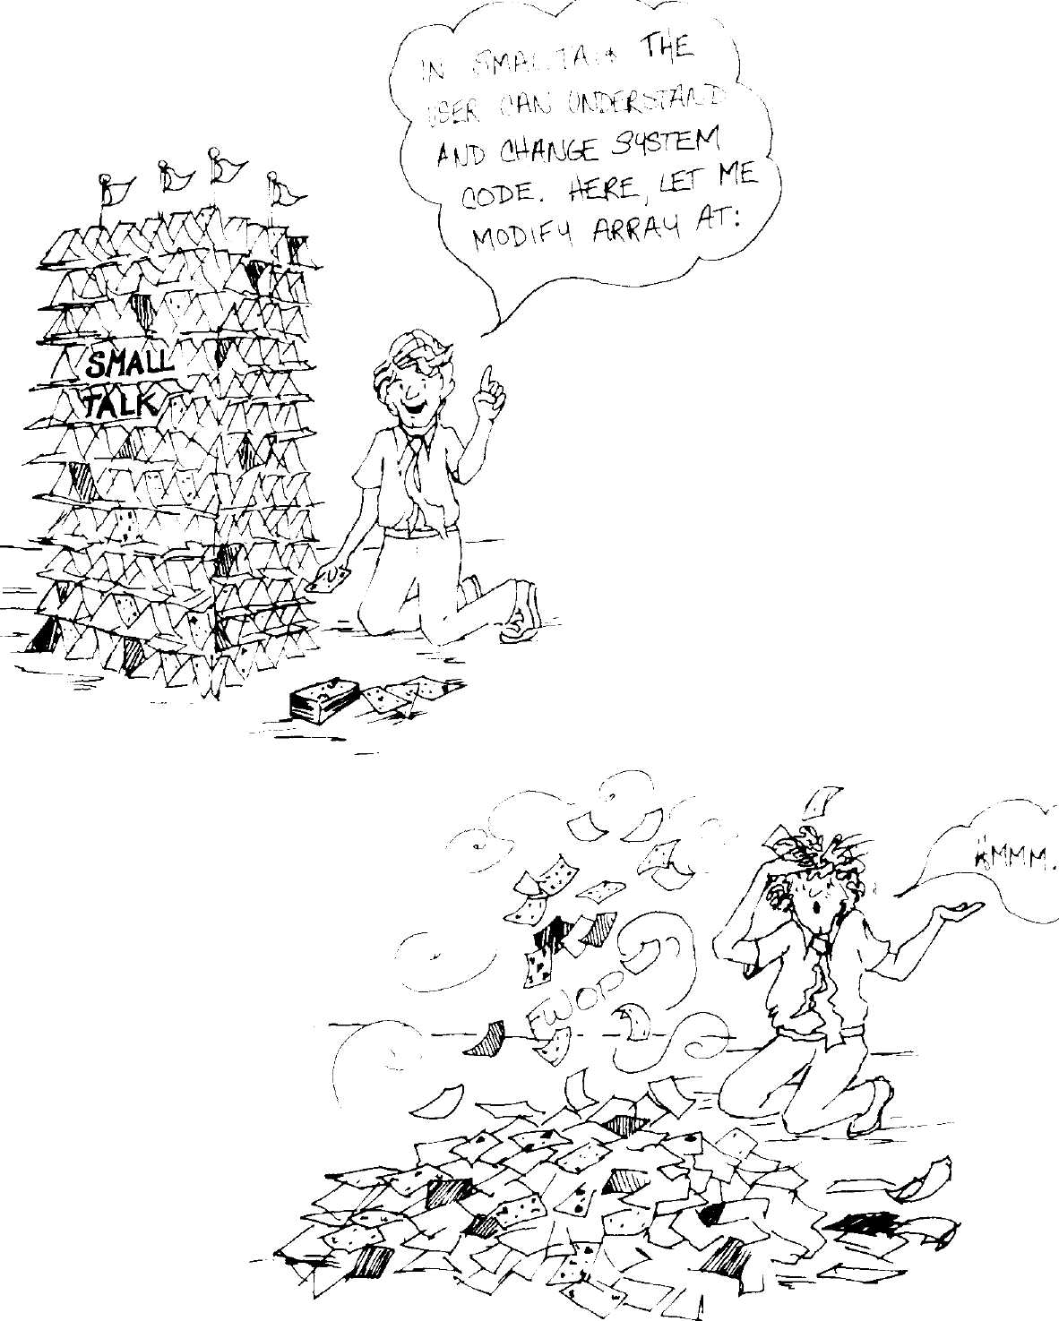
The Dorado Smalltalk-80
Implementation:
Hardware Architecture's
Impact on Software
Architecture
L. Peter Deutsch
Software Concepts Group
Xerox Palo Alto Research Center
Palo Alto, California

Abstract
The implementation of the Smalltalk-80 virtual machine on the Dora-
do, an experimental high-performance microprogrammed personal com-
puter, was strongly influenced by a few attributes of the Dorado
hardware architecture: a large microprogram memory, a hardware in-
struction prefetch and decoding unit, an effective memory cache, and
the use of base registers for memory addressing. Each of these features
substantially reduced the complexity and/or improved the performance
of the Smalltalk implementation.

Introduction
The Dorado is an experimental high-performance microprogrammed
personal computer, the latest and most powerful descendent of the Xe-
rox Alto. Because the Dorado is relatively easy to microprogram, and
because it incorporates many architectural features for aiding
implementors of higher-level languages, the Software Concepts Group
chose the Dorado as the first target machine for implementing the
Smalltalk-80 virtual machine. The first version of the implementation

Copyright © Xerox Corporation 1982. All rights reserved.
113

114
The Dorado Smalltalk-80 Implementation
ran successfully in early 1981, after approximately six months' work by
a single person.
Three excellent papers on the Dorado hardware architecture have
appeared elsewhere¹, so we will only mention the machine's most im-
portant attributes. The Dorado is microprogrammed, with a 70 ns mi-
croinstruction time and a 36-bit microinstruction. The microprogram
memory holds 4K microinstructions, all in RAM. The internal registers
and data paths are 16 bits wide. The processor accesses main memory
through a 4K-word cache, which can accept a reference every microin-
struction and deliver data 1 or 2 microinstructions after a read request.
The processor includes pipelined hardware for prefetching and decoding
macroinstructions. Later we will describe other details of the Dorado
hardware in connection with their impact on the Smalltalk-80 virtual
machine implementation.
Emulator The Dorado microinstruction memory (microstore) holds 4K instruc-
Architecture tions. In the standard Dorado microcode, approximately 1300 microin-
structions implement I/O controllers and 700 microinstructions
implement a simple macroinstruction set inherited from the Alto². (The
I/O control microcode is a consequence of the Dorado's I/O architec-
ture, which emphasizes simple controller hardware and uses microcode
multiprocessing to provide most of the control function.) The remaining
2000 microinstructions are available for implementing other macroin-
struction sets and/or extending the Alto instruction set: normally they
implement an instruction set specialized for Mesa³. The hardware in-
struction fetch unit (IFU, described in more detail below) allows switch-
ing between instruction sets in less than a microsecond, simply by
reloading an IFU register.
In our Smalltalk-80 implementation, we had a number of choices:
- Keep the Alto and/or the Mesa macroinstruction set, and imple-
ment the Smalltalk-80 virtual machine entirely in it/them.
- Keep the Alto macroinstruction set; implement the Smalltalk-80
virtual machine mostly in microcode, and the remainder in Alto
code.
- Discard the Alto microcode; implement the Smalltalk-80 virtual
machine mostly in microcode, and partly in Smalltalk extended
with special primitives for manipulating memory or the I/O de-
vices directly.
115
Emulator Architecture
4. Discard the Alto microcode; implement the Smalltalk-80 virtual
machine entirely in microcode.
We rejected approach 1 for performance reasons: although somewhat
harder to write, microcode is approximately five times as fast as either
Alto code or Mesa for straightforward instructions, and also offered the
opportunity to fully exploit the available processor registers and the
IFU.
It was likely that the microstore was not large enough for 4; 4 would
also have deprived us of the ability to write debugging aids in Alto code
or Mesa, and to use the standard debugger (as opposed to a microcode
debugger) during Smalltalk development.
In finally choosing 2 over 3, we were motivated by several principal
arguments:
- We wanted the parts of the Smalltalk-80 system written in
Smalltalk to be completely portable, i.e. not contain code specific to
any particular storage or I/O system, and were willing to tolerate
a larger non-Smalltalk kernel to achieve this.
- Both the Dorado and the Dolphin, a less powerful machine for
which we also wanted a Smalltalk implementation, already had
Alto emulation microcode. Those parts of the Smalltalk system
written in Alto code could be shared between the two implementa-
tions. We were also considering an implementation on the Alto,
which has less powerful microcode and a smaller microstore. A sys-
tem architecture which allowed us to move small functional units
of code between microcode and Alto code implementations was
likely to be more transportable between the three machines.
- Keeping the Alto emulator, which occupies less than 20% of the
microstore, would relieve us of the 4K limit (by allowing us to
write arbitrarily large fractions of the system in Alto code) without
depriving us of a lot of microstore space.
It is interesting to note that Interlisp-D⁴, where these desires were not
as important, made the opposite choice. Interlisp-D originally adopted
approach 2, later replacing it by 3. The Interlisp-D system now contains
literally thousands of lines of machine-dependent source code written in
Lisp: it has no clear division between a portable virtual machine and an
implementation level, but the instruction set is much closer to the ma-
chine level and is much easier to implement efficiently.
Two features of the hardware architecture helped reduce the cost of
approach 2 compared to 3, specifically by reducing the cost of passing
control and data between the two implementation levels: quick switch-
116
The Dorado Smalltalk-80 Implementation
ing between instruction sets in the IFU, and the fact that the Alto in-
struction set deliberately included a large number of undefined opcodes
to which we could assign our own interpretation. We used these opcodes
to optimize the transfer of information between the microcode and Alto
code implementation levels. The appendix (p. 123) lists these opcodes in
detail; we believe that any Smalltalk-80 implementation that uses a
combination of microcode and an existing macroinstruction set will find
this list a useful guide.
In retrospect, this decision to split the implementation between two
levels worked out extremely well. The decision gave us a great deal of
flexibility to move parts of the Smalltalk kernel between Bcpl (a system
programming language which compiles into Alto code), Alto assembly
language, and microcode as we investigated its performance character-
istics. As it turned out, we only used Bcpl for initialization, since it
could not generate our extended Alto instructions and since its subrou-
tine calling sequence is less efficient than a hand-coded one by a factor
of about 3. Typical Smalltalk-80 benchmarks show between 5% and
15% of the time being spent executing Alto code, and the remainder in
Smalltalk microcode.
In the final implementation, the main part of the system is
implemented entirely in microcode:
- Instruction set interpreter (with assistance from the IFU)
- Process switching
- Reference counting
- Object allocation and deallocation
In addition, the following primitive methods are implemented in micro-
code:
- Small integer arithmetic
- Subscripting and instance variable access: at:, at: put:, size,
characterAt:, characterAt:put:, objectAt:, objectAtput:, instVarAt:,
instVarAt:put:
- Object creation (new, new:)
- Block context creation and execution: blockCopy:, value/value:,
valueWithArguments:
- Process scheduling (signal, wait, resume, suspend)
- BitBlt (copyBits)
117
Instruction Sequencing
• Miscellaneous: asOop, ==, class, flushMessageCache, perform:,
performWithArguments:
The following primitive methods for storage management were original-
ly implemented in microcode, but were later translated into Alto code
for reasons explained below: refct, become:, asObject, somelnstance,
nextlnstance.
The following primitive methods are implemented in Alto code:
- 16-bit large integer arithmetic
- Floating point arithmetic
- All I/O primitives (disk, Ethernet, display, keyboard, mouse) except
BitBIt
- The remaining storage management primitives: newMethod:header:,
core Left
- Snapshot
The following optional primitive methods are not implemented on ei-
ther the Dorado or the Dolphin: next, nextPut:, atEnd.
When the interpreter microcode encounters a Smalltalk method that
includes a call on a primitive, it consults a table stored in main memo-
ry to determine whether the primitive is implemented in microcode (the
table contains a microcode dispatch address) or Alto code (the table con-
tains the address of an Alto code routine). In the latter case, the inter-
preter switches the IFU to Alto emulation, and the machine starts
executing the Alto code that implements the primitive. The Alto code
typically contains some special Smalltalk-specific instructions (described
in the appendix on pg. 123) which allow it to interact with the
Smalltalk world: LDSS instructions to access the receiver of the mes-
sage and its arguments, SETDS and LDFD/STFD instructions to access
the instance variables of the receiver, and finally a PRET instruction to
return the result of the primitive and resume Smalltalk execution. All
these trapped opcodes are of course implemented in microcode. PRET
switches the IFU back to the Smalltalk instruction set and resumes ex-
ecution with the next Smalltalk bytecode.
Instruction The Dorado's Instruction Fetch Unit (IFU)⁵ prefetches and decodes in-
Sequencing structions in a manner almost ideally matched to the Smalltalk instruc-
tion set. In fact the three language-oriented instruction sets designed at
the Palo Alto Research Center (Lisp, Mesa, and Smalltalk) and the Do-
118
The Dorado Smalltalk-80 Implementation
rado design influenced each other considerably. The IFU prefetches up
to 6 bytes, accessing the memory through the same cache the processor
uses, and only when the processor is not accessing it. The first 8-bit
byte of an instruction indexes a 256-entry RAM. The entry in the RAM
gives the address of the microcode that implements the instruction, says
how many additional bytes the instruction uses (0, 1, or 2), and supplies
a 4-bit parameter for any purpose the microcode wants. (For example,
each group of Smalltalk "load" instructions uses the same microcode,
but different parameter values corresponding to the offset of the desired
variable within the context, instance, or literals.) The RAM also con-
tains information which allows the IFU to execute certain uncondition-
al jumps itself. The microcode that implements a given macroinstruc-
tion can read the parameter and the additional bytes from the IFU onto
a convenient bus. The last microinstruction of each macroinstruction
contains a field that informs the processor's control logic that the pro-
cessor should ask the IFU for a new dispatch address for the next mi-
croinstruction; under this arrangement, there is normally no delay at
all between macroinstructions. Thus the overhead of fetching, decoding,
and dispatching on macroinstructions, and returning to a central loop
after a macroinstruction is finished, is reduced essentially to zero. This
overhead may take up as much as 20% of the time in an interpreter
implemented without hardware assistance⁶.
The entire job of instruction sequencing and decoding is handled by
the IFU. The microprogram only intervenes to restart the IFU for
jumps, message sends, and returns, and when switching between the
Smalltalk and Alto instruction sets. The IFU RAM actually holds up to
four instruction sets at once, and the overhead of switching is less than
a microsecond if the first instruction to be executed is in the memory
cache. Only 2.4% of execution time is spent waiting for the IFU to sup-
ply a dispatch address; we cannot determine what fraction of this time
is due to cache misses and what fraction to competition with the proces-
sor for cache cycles. For a deeper discussion of IFU performance, see the
Dorado papers.⁷

Memory
Management
The Dorado provides hardware support for a paged virtual address
space, but the Smalltalk-80 implementation makes no use of it—
Smalltalk initializes the page tables to map virtual addresses one-for-
one into real addresses. Recovering from a page fault at the microcode
level is potentially complicated. A single Smalltalk instruction can
make many memory references, so we would have had to adopt some
combination of resuming execution of a Smalltalk instruction in mid-
flight, arranging all instructions to be restartable, and/or letting the

Memory Cache
page fault handler complete the faulting reference. For this reason, and
because past experience with a paged Smalltalk suggested that it would
perform very badly if the working set exceeded real memory signifi-
cantly, we did not go to the trouble of observing the microcoding re-
strictions which would make recovery from faults possible.
Recursive freeing of objects with zero reference count is implemented
in microcode; the main loops of the compactor, but not the overall con-
trol, are also in microcode. This arrangement has worked out extremely
well. In fact so little time is spent in recursive freeing (1.9%) that we
might be able to move at least some cases of the rather complex recur-
sive freeing algorithm into Alto code as well with relatively little per-
formance penalty. This is partly a result of a minor interpreter change:
when control returns from a context which has no other references to
it, the interpreter essentially "unrolls" the top loop of the recursive fre-
er, i.e., there is a special loop which iterates through the fields of the
context (but only up to the current position of the stack pointer),
decrementing the reference counts and calling the actual recursive fre-
er if needed.
Memory Cache The Dorado's memory cache is nearly as fast as the processor registers.
A memory fetch in microinstruction Ν produces data in a register in
microinstruction N + l which can be used for computation in microin-
struction Ν+2. Memory stores are even faster, taking a single microin-
struction. The cache is pipelined, so a new fetch or store can be started
in every microinstruction. As a result, we decided to implement even
the very highest-bandwidth operations of the Smalltalk-80 implementa-
tion—pushing and popping quantities (particularly variables) on the
stack—using memory references at the microcode level without signifi-
cant time penalty. Thus for example, the microcode that implements
the "load local variable" instruction reads the local variable using the
current context as a base and the parameter supplied by the IFU as the
offset, increments a stack pointer held in a register, and then writes the
value onto the stack (in main memory) using the stack pointer as an
offset from another base register.
In retrospect this decision was almost certainly correct. The memory
references to the stack and the local variables in a context never cause
cache misses. The bookkeeping required to manage a finite-size register
stack (the Dorado has four 64-register stacks in the processor) would
have been relatively complex, especially since Smalltalk does not al-
ways transfer control between contexts in LIFO order. However, this
decision is critically dependent on the speed of the cache. If the cache
120
The Dorado Smalltalk-80 Implementation
had been only half as fast—taking 3 to 4 microinstructions to fulfill a
request—it would probably have been better to store some of the cur-
rent context in registers.
Despite its small size, the Dorado cache works effectively for
Smalltalk. Our measurements show that cache misses account for only
11% of execution time. References to the stack and the current context
never cause misses; most misses are caused by accesses to method dic-
tionaries during message lookup, and to method headers when starting
execution of a method.
Registers The Dorado includes 256 16-bit working registers, organized as 16
groups of 16 registers each. One of the 16 groups is current at any time,
selected by a processor register called RBase. Microinstructions supply
a 4-bit register address within the current group, which is concatenated
with RBase to provide the full register address. The Smalltalk micro-
code uses three groups:
- The "main" group, described in more detail just below
- A group used only by the compactor and recursive freer
- A group used almost exclusively by the process scheduler
Because changing the RBase register ties up a microinstruction field
that is also involved in many other operations (such as memory refer-
ences and constant generation), it is highly valuable to divide the regis-
ters into blocks according to major sections of the microcode control, to
minimize the frequency of group switching. The convention we chose in
the Smalltalk microcode was to define a single "main" group to be cur-
rent throughout the entire microcode, except for local switching to ac-
cess individual registers in other groups, and self-contained routines
like the recursive freer which would restore the "main" group to cur-
rency when they were done.
Since the contents of the "main" group are a valuable indication to
implementors as to what information should be held in machine regis-
ters, we list them here, in approximate order of decreasing utility:
SPR The stack pointer, relative to the base of the current con-
text
9 temporary regis- Also used for passing arguments and results to and from
ters microcode subroutines
NargS The number of arguments to the current method
121
Base Registers
Self The Oop (object identifier) of the current receiver
SI A flag indicating whether the last (or current) primitive is
"fast" (entered directly in response to a special selector) or
"slow" (entered through method lookup)
MyPC The byte PC (relative within the method), saved whenever
control might switch to another context or to Alto code
Context The Oop of the current context
Method The Oop of the current method
Note that direct pointers to the bodies of some of these objects (the re-
ceiver, context, and method) are also held in base registers, as described
in the next section.
The limitation of 16 readable registers was much less of a nuisance
than might be expected. The original Dorado prototype had 32 groups of
8 registers, which was a tremendous nuisance: the microcode shrank by
about 15% from the prototype version simply through elimination of
microinstructions whose main purpose was to switch register groups.
Expansion to direct addressing of all 256 registers would probably elim-
inate only another 20 microinstructions: the figure is small because of
our careful division of registers into meaningful groups. In other words,
our experience indicates that for Smalltalk-80 implementation, there is
a "knee" in the utility curve somewhere between 8 and 16 directly ac-
cessible registers.
The Dorado also includes 4 stacks of 64 registers which can only be
accessed through a pointer register, the processor stack pointer (StkP).
The microinstruction format supports pushing and popping quantities
in the current stack as easily as addressing the current block of 16 ad-
dressable registers. Unfortunately, StkP is awkward to load and read,
and recovering from over- or underflow is even more difficult. For these
reasons, we chose not to use these stacks to model the Smalltalk stack,
but only for temporary storage within the microcode. When a
microcoded primitive fails, or other exceptional condition arises, the mi-
crocode resets StkP to a standard state before continuing with the re-
covery code. As indicated in the earlier section on the memory cache,
we believe this choice is better than using the processor stack for cach-
ing parts of Smalltalk contexts.
Base Registers The Dorado memory system provides 32 base registers which hold full
28-bit virtual addresses; the microinstructions that reference memory
normally provide 16-bit displacements relative to a current base regis-
122
The Dorado Smalltalk-80 Implementation
ter, switched under microprogram control. Consequently, the Smalltalk
microcode dynamically maintains the following addresses in base regis-
ters at all times:
TS The current context for accessing local variables (home
context when executing a block, current context otherwise)
SS The context used for execution and stack — always the cur-
rent context, even when executing in a block
RS The receiver in the current context (self)
CS The currently executing method (code)
In addition, it loads the following addresses at system initialization:
OTBase The base of the object table (OT)
FreeLists The base of the table of free list heads
MCacheBase The base of the message lookup cache
SpecialBase The SpecialSelectors array, used to handle sends of special
selectors (must also be reloaded after memory compactions)
It is interesting to observe that the memory system is so fast, and the
indirect or indexed addressing of registers so awkward, that the system
actually runs (slightly) faster by putting the free list heads in memory
than by putting them in addressable registers.
This choice of base registers is fairly obvious, except for the issue of
whether or not to maintain a pointer to the receiver. Maintaining such
a pointer requires reloading it at each activation or return; not
maintaining such a pointer requires indirect access through the OT at
each reference to an instance variable. (More complicated schemes are
also possible, such as a flag to indicate whether the base register has
been reloaded since the last change of context.) Measurements indicate
that references to instance variables are slightly more common than
context switches, so we come out slightly ahead by always loading the
base register at a context switch.
While the base register model works well for memory references,
loading a base register is awkward for two relatively minor reasons:
Base registers are 28 bits wide, but the Dorado's data paths are
only 16 bits. Thus loading a base register takes at least 3 microin-
structions (one to select the register, and one to load each half).
Because the Dorado implementation packs flag bits into the OT
along with the data address, exactly as described in the Smalltalk
123
Appendix: Extended Alto Instructions
virtual machine documentation, a masking operation is required.
Also, again because of the 16-bit architecture, two memory refer-
ences are required to fetch the OT entry.
As a result of these problems, the standard subroutine which loads a
base register with the address of an object whose Oop is known (essen-
tially the SETDS instruction described in the appendix below) takes 6
microinstructions; over 10% of execution time is spent in this subrou-
tine (and various open-coded copies of it). By using 3 words per OT en-
try instead of 2, we could have eliminated the masking operation,
saving 1 of the 6 microinstructions. However, besides adding 32K to the
system's memory requirements, this design would have increased the
cache working set size (and hence the wait time due to misses) signifi-
cantly, so there might well have been no net speed improvement.

Microcode
Multiprocessing
The Dorado micro-architecture includes multiple processes at the mi-
crocode level. The Smalltalk-80 emulator itself makes no use of this ca-
pability, which is primarily designed to allow a single processor to
function effectively as a controller for multiple high-speed I/O devices.
However, one of these processes can be awakened periodically, at inter-
vals as short as a few microseconds, to collect a histogram of the ad-
dress of the next microinstruction to be executed by the instruction set
emulator. This facility proved invaluable in analyzing performance bot-
tlenecks in the Smalltalk microcode; essentially all the measurements
reported in this paper were obtained from the micro-address histogram.
One particularly interesting number was the amount of time spent
waiting for cache misses; we computed this by looking at the number of
samples at addresses of microinstructions that had to wait for memory
data to arrive, compared to the instructions immediately preceding and
following these.

Appendix:
Extended Alto
Instructions
In the following descriptions of the extensions to the Alto instruction
set, AC0-3 refer to four 16-bit registers which the Alto instruction set
views as central registers, but which are addressable registers at the
microcode level.
Many of these instructions are designed for use only from Altocode
primitives, and consequently can cause "primitive failure" under cer-

124
The Dorado Smalltalk-80 Implementation
tain circumstances. Primitive failure means that the execution of the
primitive code is abandoned, and the Smalltalk method is executed in-
stead.
The instructions are arranged below in groups, with the most heavily
used groups listed first.

Access to
Smalltalk Data
LDSSn
SETDS
LDFD η / LDF1
STFD η / STF1
LDNFD η / LDNF1
STNFD η / STNF1
ACO - word η relative to SS+SPR-Nargs, the location of
receiver and arguments on the stack in the current
context. Ν = 0 is the receiver, η = 1 is the first argument,
etc.
ACO = an Oop. Sets the DS base register to the real
memory address of the object, taken from the OT. Causes
primitive failure if ACO is a small integer rather than an
Oop.
ACO — word η relative to DS; for LDF1, η is taken from
AC1 rather than from the instruction itself. The
parameters .LENGTH, .CLASS, and .FLDS define the
offsets of the length word, class word, and first field of an
object, e.g. the assembly-language instruction to load the
second field of an object would be LDFD .FLDS + 1.
ACO = a new Oop to be stored at word η relative to DS.
This instruction does reference counting (increases the
reference count of the object identified by ACO, decreases
the reference count of the old contents): use STNFD (below)
to store a non-Oop without reference counting.
ACO — word η relative to DS. Meant for use when the data
being loaded are bits rather than Oops. Equivalent to
LDFD in the current system, only provided for symmetry
with STNFD.
ACO = a new value to store into word η relative to DS.
Does not do reference counting (see STFD above).

Conversion
of Integers
IVAL
WRDVAL
MKINT
ACO = a small integer; ACO «- the value of the integer.
Causes primitive failure if ACO is not a small integer.
ACO = an Oop of a Smalltalk LargePositivelnteger, or a
Smalllnteger; ACO «- the value of the number. Causes
primitive failure if the Oop is not a Largelnteger, or if the
value does not fit in one word.
the corresponding
ACO = an unsigned integer; ACO
Smalltalk integer (small or large).

Primitive Control
Access to OT
PRET
PFAIL
READOT
SETOT
125
Appendix: Extended Alto Instructions
A primitive has completed successfully. ACO = the value
to return from the primitive.
Cause primitive failure.
Read the OT entry for a given Oop. ACO = an Oop. ACO -
address word from OT, AC1 «- flag word from OT.
Set the OT entry for a given Oop. ACO = an Oop, AC1 =
address word to store in OT, AC3 = flag word to store in
OT.

Access to
Microcoded
Primitives
SIGNAL
CINST
ACO = a Semaphore. Does a "signal" operation on the
semaphore. Used only by I/O interrupts and the low space
notification mechanism.
ACO = the Oop of a class, ACl = the number of extra
fields (for variable-length classes); ACO — the Oop of a
newly created instance. DS is also set as for SETDS.

Compaction
CLEANSTATE
ACOMPACT
CSEG
CLOOP
CRESUME
Store all of Smalltalk's state into memory in preparation
for a compaction or a snapshot.
Start a compaction. ACO = the Oop of the display bitmap.
Prepare to compact the area of memory starting at ACO/1
and going up to an end marker which is the maximum
legal Oop +3.
Do the main compactor lOop. ACO/1 <- the end of the
occupied area after compaction. AC2/3 «- the end of the
occupied area just below the display bitmap, if the display
bitmap was in the area being compacted.
Resume Smalltalk execution after a compaction.

Miscellaneous
RESUME
SETCNT
READCNT
Resume Smalltalk execution with the next bytecode. Used
only during initialization, and for resuming after an
interrupt. (All hardware interrupts cause control to go
from the Smalltalk interpreter to Alto code.)
Set the low-space trap parameter to ACO.
ACO «- the number of Oops left before a low-space trap
will occur -1.

CONFIG
Initialization and
Post-mortem SETOTBASE
ACO <- the size of (real) memory in units of 32K, e.g. for a
512K Dorado, ACO - 16 decimal.
Initializes the microcode base register that points to the
OT. ACO = low address of OT, ACl = high address of OT.

126
The Dorado Smalltalk-80 Implementation
DEADSTART Initializes the system. AC3 = a pointer to a block of
memory laid out as follows:
- base address of OT (low bits)
- (high bits)
- size of OT (# of OT entries)
- the address of an 8K table for a microcode PC histogram,
or 0 (low bits)
- (high bits).
After initialization is done, Smalltalk execution begins, so control does
not return to the instruction following the DEADSTART.
READOUT ACO = a pointer to a readout area in memory, into which
are stored the following values:
- - Oop of current context (CONTEXT register)
- - current stack pointer (SPR register)
- - byte PC of current instruction (PCX register)
- - unused but reserved for future use
- - micro-PC from which crash occurred (LINK register)
5-19 - unused but reserved for future use.
References 1. Lampson, Butler W., "The Dorado: A High-Performance Personal
Computer", Xerox PARC Technical Report CSL-81-1, Jan. 1981.
- Thacker, C. P., et. al., "Alto: A Personal Computer", in Computer
Structures: Readings and Examples, 2nd Edition, Eds. Sieworek,
Bell, and Newell, McGraw-Hill, New York, 1981; (also Xerox
PARC Report CSL-79-11 Aug. 1979).
- Mitchell, James G., et. al., "Mesa Language Manual," Xerox
PARC Report CSL-79-3, Apr. 1979.
- Burton, Richard R., et. al., (The Interlisp-D Group), "Papers on
Interlisp-D", Xerox PARC CIS-5, July 1981; (a revised version of
Xerox PARC SSL-80-4).
- See reference 1.
- Markoff, John, "Smalltalk: A Language for the 80s", InfoWorld,
cover story, Jan. 24, 1983.
- See reference 1.
The Design and
Implementation of
VAX/Smalltalk-80*
Stoney Ballard
Three Rivers Computer Corporation
Pittsburgh, Pennsylvania
Stephen Shirron
Digital Equipment Corporation
Marlboro, Massachusetts

Introduction
VAX/Smalltalk-80 is an implementation of the Smalltalk-80 system
written for the VAX family of computers running with the VMS oper-
ating system. This version differs from standard Smalltalk-80 imple-
mentations by using a basic word size of 32 bits and an incremental
compacting garbage collector. This paper describes the rationale for
these changes, their implementation, and various tricks that were de-
veloped to enhance the performance of this version of the Smalltalk-80
virtual machine. We also discuss some ideas for future work aimed at
improving the performance of paged virtual object systems.

Some History
Our group at DEC (the Corporate Research Group) was involved in
studying issues relating to personal workstations and graphics. We had
been interested in the Smalltalk-72 and Smalltalk-76 systems for sever-
al years because they were the best examples of powerful personal
workstation environments that we had seen. Consequently, we jumped
at the chance to participate in the Smalltalk-80 review.
The work described in this paper was done at Digital Equipment Corp. Copyright ©
Stoney Ballard and Stephen Shirron 1982. All rights reserved.

127

128
The Design and Implementation of VAX/Smalltalk-80
The VAX Smalltalk-80 implementation was our second, the first hav-
ing been done for the PDP-11/23. The PDP-11 version was implemented
as closely as possible to the virtual machine specification published in
Smalltalk-80: The Language and Its Implementation. This version was
notable primarily for its execution speed, which resembled molasses in
December. By the time we were out of ideas to speed it up, the PDP-11
was executing about 5K bytecodes/second.
The PDP-11 version exhibited three major performance bottlenecks:
the PDP-11 memory manager, the lack of writable microcode hardware,
and the reference counter.
The memory management hardware on the PDP-11/23 was designed
to map a 64Kbyte virtual space into physical space by using eight sepa-
rate 8Kbyte segments. Our problem however, was not to map virtual
space to physical, but rather to directly access the full 256Kbyte physi-
cal space of the PDP-11/23. This involved adjusting the map for every
object access (as well as every object table access) to map it into the
64Kbyte directly addressable range. Since some Smalltalk-80 objects
are larger than 8Kbytes, we had to adjust the map to point at the par-
ticular field we wanted. This was particularly painful since it took
about 30 instructions to adjust the map. By setting up map segments
for the objects commonly used by the interpreter (e.g. the context,
method, self) at context switch and process switch, we eliminated most
of this overhead. Nevertheless, the interpreter spent about half of its
time with map box adjustment.
The PDP-11/23 had no writable microstore, so we wrote the bytecode
interpreter and all the primitives in assembly language. If we had been
able to write microcode, we could have achieved about a factor of two to
four improvement in speed. The PDP-11 is not suitable for microcoding
a Smalltalk-80 interpreter because the hardware is designed specifically
for fetching and decoding its native instruction set.
The reference-counting scheme caused serious performance problems.
Updating the reference counts of objects and tracing objects whose
counts had gone to zero was the primary source of memory manage-
ment overhead. Mapping problems aside, we felt that reference count-
ing was inherently inefficient anyway because of the many places in
the code that were required to update reference counts. Reference
counting is probably the best scheme to use for small machines since it
reclaims space immediately as it becomes garbage. All other garbage
collection schemes leave a relatively large amount of garbage lying
around between collections.
The space compactor was annoying since it caused the system to
pause for several seconds whenever it ran. Our compactor was slow
bqth because we compacted the whole memory at once, and because the
memory map had to be constantly adjusted as it ran.
After playing with the PDP-11 version for a while we came to sever-
al conclusions about the Smalltalk-80 system:
129
Some History
- A maximum of 32K objects is insufficient for a system that sup-
posedly integrates the whole environment into one object space.
We felt that 10 to 100 times that number of objects would be
needed to properly support a rich environment. Even the base
Smalltalk-80 system suffers from the small object name space as
seen in the non-uniform handling of methods. These objects
should be broken into a literal vector and a bytecode vector, but
weren't for performance reasons and because that would have
added about 6K objects to the base system. This non-uniformity
requires a great deal of the code to handle methods specially.
- The performance we achieved was clearly inadequate for real
work. Compilation and browsing were far too slow to support rap-
id development work. Touch typing was virtually impossible since
we could type faster than the input process could accept charac-
ters. We felt that a tenfold increase in speed would be needed be-
fore we would feel comfortable with the system.
- Fifteen-bit Smalllntegers are too small. Although this is somewhat
of a minor problem, it would clean up the array indexing code
substantially if a Small Integer was sufficient to index the largest
possible array.
- The reference-counting scheme should be discarded in favor of an
incremental compacting garbage collector. Not only would this
eliminate the problem of reclaiming circular garbage (which re-
quired us to implement a "separate mark/sweep garbage collector),
but would also reduce the work required when storing object
pointers into other objects, especially contexts. Additionally, an in-
cremental compacting garbage collector eliminates the pauses due
to compacting space.
- Some sort of virtual object storage is necessary to support large
applications or sets of applications where millions of objects would
be needed. Paging systems are commonly available and easy to
use. We were interested in determining the performance of paging
for a system like the Smalltalk-80 system, where the locality of
reference between adjacent objects is much smaller than in tradi-
tional language environments.
These considerations led to our decision to implement a modified ver-
sion of the Smalltalk-80 virtual machine on a VAX-11/780. The VAX
was an obvious choice for us since most groups at DEC had one, and it
would be much easier for people to use the Smalltalk-80 system if it
ran on computers accessible to them. To this end we decided to imple-
ment a portable system that could be used on any VAX running VMS.
We realized, of course, that we would be giving up a fair amount of per-
formance by using a timesharing system. Our plan was to build a ver-
130
The Design and Implementation of VAX/Smalltalk-80
sion for VMS, written in assembly code, and then convert it to run
stand-alone with microcode assist. This latter phase has not yet been
performed.
The following sections give details of the characteristics of our
Smalltalk-80 implementation (which we call VAX/Smalltalk-80) and
some suggestions for future work.
Word Size We reformatted the Smalltalk-80 image to use 31 bit object names and
Changes Smalllntegers, using the 32nd bit as a tag bit to distinguish between
them. Object headers increased from 4 to 8 bytes. Non-Oop fields, such
as those of BitMaps and Strings, were not changed. This reformatting in-
creased the size of the base image by about 50%. After reformatting,
the average object size in the base image was 40 bytes. Fig. 8.1 shows
typical object formats.
A 4 byte size field allows objects up to 2²⁴ bytes long, leaving a byte
for various flags and an age field (described below). Our size field was a
byte count of the object, eliminating the "odd" bit from the object table
entry. Objects were stored on longword (4 byte) boundaries because
longword fetches are faster on the VAX if naturally aligned. Fig. 8.2
shows the layout of the size field.
The object name space is vastly larger than the 32K objects support-
ed by the standard Smalltalk-80 virtual machine. This not only allows
keeping such things as the source code for the methods in the object
space, but also allows us to use an incremental, compacting garbage col-
lector. Unlike reference-counting schemes, an incremental compacting
garbage collector does not reclaim either the names of objects or the
space they take as soon as they become inaccessible. This requires that
the name space be substantially larger than the maximum number of
names otherwise needed. Although we could support two billion objects
with a 31-bit name, we are limited to a much smaller number by the
size of the virtual space allocated by VMS to the Smalltalk-80 process.
Although our version allocates 31 bits in an object reference for the
name space, it is certainly feasible to allocate fewer (say 24) for the
name reference and use the rest for tagging. Having tag bits in a refer-
ence can be useful when one object needs to appear in different guises
depending on who references it. This would allow a "monitor" object to
trap all messages from objects who refer to it as a monitor, but allow its
"owner" to send messages to it directly, bypassing the monitoring.
These tag bits could also be used to mark objects as being, for example,
usable by the interpreter as CompiledMethods even if they are
subclasses of CompiledMethod. Currently, the interpreter does not check
 |  |  |  | 131
MSB |  | Word | Size Changes  LSB
 | Flags | Size |  | 0
Pointer Fields |  | Class |  | 4
Pointer Fields |  | Pointer Field 0 |  | 8
 |  | Pointer Field 1 |  | 12

Word Fields

LSB
MSB
Flags |  |  |  | Size
 |  | Class
Word | 1 |  |  | Word | 0
Word | 3 |  |  | Word | 2
0
4
8
12

Byte Fields

MSB |  |  |  |  | LSB
Flags |  | Size
 |  | Class
Byte 3 | Byte | 2 | Byte 1 | Byte | 0
Byte 7 | Byte | 6 | Byte 5 | Byte | 4
0
4
8
12

L
Figure 8.1

132
The Design and Implementation of VAX/Smalltalk-80
31 30 29 28 27 26 25 24 23 22 21 20 19 18 17 16
 |  | Age | 1 |  | X |  | Ρ |  |  |  | Size | (23:16)
15 | 14 | 13 12 | 11 | 10 | 9 | 8 |  | 7 | 6 | 5 | 4 | 3 | 2 | 1 | 0
 |  |  |  |  |  | Size (15:0)
Age - Age of the object in Flips
P- Set if object has pointer fields"
X - Unused
Size - Size in bytes of the object
The Ρ field is duplicated here so that the scanner need not refer to the OTE (Object Ta-
Figure 8.2 ble Entry) to see if the object has pointer fields.
the class of objects such as CompiledMethods both for reasons of effi-
ciency, and to allow using subclasses of these classes. Having tag bits
that assert the compatibility of such objects with the ones expected
would lead to greater safety in the interpreter.
In the standard virtual machine, only 15 bits are allocated for literal
Small Integers. This is inadequate to index large arrays, so the indexing
code must be able to use LargePositivelntegers as indices. Since a 31-bit
Smalllnteger can index any array, our array primitives are simpler and
faster.
Converting Smalltalk-80 to use 32-bit words was surprisingly pain-
less. We found few places in the Smalltalk-80 code that depended on
the word size. The worst one was that the decompiler found the first
bytecode of a method by taking twice the number of literals and adding
three (for the header and index origin). This prevented us from editing
any of the methods to fix them, especially this one. We fixed this by
creating a primitive that determined the initial PC of a method, and
patching the initialPC method by hand to call this primitive. We recom-
mend that these dependencies be removed from Smalltalk-80 systems
by adding a primitive that returns information about the field size.

Garbage
Collection
This is perhaps the most interesting aspect of our version, it is certainly
where most of our effort went. The PDP-11 version (and prior experi-
ence with Lisp implementations) showed us that it is vitally important

133
The Baker Garbage Collector
to have a reliable garbage collector early in the game. A buggy garbage
collector has a tendency to randomly smash parts of objects in such a
way that the damage does not come to light until much later. This
makes the whole virtual machine rather difficult to debug, as you are
not sure just which piece of code was responsible for the error. Since
mark/sweep collectors can be simple enough to debug easily, we started
out by using one.
After debugging the virtual machine with the simple mark/sweep
collector, we turned our attention to the implementation of an incre-
mental garbage collector. There were two candidates to choose from,
the Baker¹ and the Lieberman-Hewitt². Since the Lieberman-Hewitt
garbage collector was an elaboration of the Baker, and significantly
more complicated, we decided to implement the Baker first.

The Baker
Garbage
Collector
To gain a full understanding of this garbage collector, you should read
Baker's work on the subject³. For those readers unfamiliar with this
garbage collector, we present a brief description of it here.
The Baker garbage collector is an incremental, compacting garbage
collector. By incremental, we mean that the process of collecting gar-
bage is interleaved with the process of allocating space in such a way
that the time required for collecting the garbage and compacting space
is distributed fairly smoothly over time. The individual incremental ex-
ecutions of the collector have an upper bound on their time consump-
tion proportional to the size of the largest object. This corresponds to
the time it takes to move an object from one place to another. Under
normal circumstances, no pauses in execution due to the garbage collec-
tor operating are perceptible.
The Baker garbage collector divides the virtual space into two equal-
sized regions, or semispaces, called Fromspace and Tospace. Objects are
copied from Fromspace to Tospace (hence the names) as they are found
to be accessible. These copied objects are compacted sequentially at one
end of Tospace. A scanning pointer starts at the base of this region, and
moves field by field through the objects that were copied previously to
Tospace, copying objects in Fromspace that are referenced by them. In
this way, the objects in Tospace act like the stack commonly used by a
mark/sweep collector. This scanning and copying continues until the
scanning pointer runs out of objects. Newly created objects are placed
at the far end of Tospace, so that they are not scanned. Fig. 8.3 shows
the layout of Tospace.
In the original Baker scheme, whenever an object is copied, its old lo-
cation (in Fromspace) is marked as a "forwarding pointer," and the new
address is placed there. An access to a copied object is redirected to the
new copy, and the reference is changed to point to the new location.

134
The Design and Implementation of VAX/Smalltalk-80
Roots of the object space
are placed here
when flipping

Next copied object
goes here
Next new object
goes here

\
Free Space

Figure 8.3
Scanning
Pointer
(scans to
the right)

This is necessary for systems (such as Lisp) where objects are referenced
by virtual address.
The whole process is started by an operation called a "flip", which
switches the identity of Fromspace and Tospace, and immediately cop-
ies all the objects known to the interpreter (the "roots" of the world) to
the bottom of the new Tospace. Flips may occur any time after the
scanning pointer has reached the end.
We took the simplistic approach of flipping when there was
insufficent space to satisfy an allocation request. This minimizes the
copying activity at the expense of maximizing page faulting. Flipping
when the scanning pointer runs out of objects to scan will minimize the
number of pages needed for both semispaces by keeping the accessible
objects as compacted as possible. It appears that the optimal time to flip
should be dependent on the average lifetime of newly created objects, so
that a flip will occur when the expected density of accessible objects
falls below a reasonable value. The object of this tradeoff is to minimize
the sum of the page faults due to accessing and creating objects and
those due to copying objects.
Objects that must be copied as roots are those objects that may not
be transitively accessible from any other object copied as a root. It is a

135
The Baker Garbage Collector
good idea to copy all the objects that are "wired into" the virtual ma-
chine to insure that they never get deleted under any circumstances.
The registers of the virtual machine are defined to always be in
Tospace, so any objects referred to by them must also be copied at flip
time. The objects that must be copied include the current context, all
the objects it refers to that are cached by the interpreter (e.g. the meth-
od, receiver, self), any semaphores waiting for external events, the
ProcessorScheduler object, the current DisplayBitMap (if it is not in a
special location), and all the objects used by the interpreter such as nil
and the selector doesNotUnderstand. If a list of these objects other than
those relating to the current context is maintained, the list can be
scanned incrementally to reduce the time required to perform the flip.
It is not necessary to copy the object Smalltalk (the symbol table) at this
time, although it is known to the interpreter, because the interpreter
never uses it. If it is live, then it must be reachable from at least one of
the objects which are actually used by the interpreter.
Whenever a reference to an object in Fromspace is stored into an ob-
ject in Tospace, the Fromspace object must be copied to Tospace. This is
necessary because the scanner may have already passed the Tospace ob-
ject, or it is new. The interpreter registers are considered to always be
in Tospace, since they are the first things scanned, so that object refer-
ences stored in them must be checked and the objects copied if neces-
sary. Although at first glance this seems to require more overhead than
reference counting, it is actually much faster to test a flag than to in-
crement a reference count and handle overflows. In practice, only a
small number of objects need to be copied when their references are
stored, and this copying would have been done by the scanner anyway.
The garbage collector is run (incrementally) every time an object is
allocated. The amount of space to copy whenever a new object is creat-
ed should be adjusted so that the scanning pointer finishes at the time
a flip is desired (as per the above discussion). This will tend to distrib-
ute the copying activity as smoothly as possible. The semispaces must
be large enough so that the probability of running out of room before
the scanning pointer finishes is negligible. In practice, the largest
semispaces possible should be allocated, as the middle pages of the
semispaces will never be used, and will only contribute to page table
overhead. Our implementation was not tuned in this fashion. Our sys-
tem was set to copy four times as much space as we allocated so that
we did not run out of room.
The net effect of this garbage collector is to copy all the objects
which are live by virtue of being accessible (transitively) by the inter-
preter, from one space to another, leaving behind all the garbage. This
old space can then be reused starting at the next flip.
With the Baker garbage collector objects are copied in a breadth-first
order. This ordering has been shown to be substantially better than a
136
The Design and Implementation of VAX/Smalltalk-80
random ordering for reducing page faults, though not as good as depth-
first⁴. This ordering is largely invariant from one flip to the next, so
that the copying will tend to proceed linearly through Fromspace, mini-
mizing the page faulting due to the copying.
It is difficult to compare the performance of this garbage collector
with reference counting schemes. There is no suitable analytical ap-
proach to this problem. We have not directly compared the two schemes
in the same environment, but we can offer some observations based on
our experience:
- Reference counting uses less space (virtual or physical) than any
other incremental scheme, as long as circular garbage is rarely
created.
- Smalltalk-80 systems would generate a fair amount of circular
garbage if the programs did not explicitly unlink circular struc-
tures before deleting them. This manual intervention in what
should be a completely automatic process of garbage collection is
"unclean" because it prohibits easy sharing of circular data struc-
tures.
- The Baker garbage collector is closer to a "real time" process be-
cause the time an activation takes is no more than the time to
copy the largest object. A reference counter may take time that is
proportional to the size of the largest network of objects.
- Reference counting does not compact space incrementally. If ob-
jects are allocated from segments of limited size, the compaction
time of a segment may be small enough to be unnoticeable. Seg-
mentation may make it substantially more difficult to allocate
large objects, such as bitmaps for high-resolution printers.
- Reference counting is not sufficient by itself. An auxiliary
mark/sweep garbage collector is needed to reclaim both circular
garbage and objects whose reference counts have overflowed (if an
overflow table is not used).
- The Baker garbage collector traces accessible objects, while refer-
ence counters trace the inaccessible objects. Which is more effi-
cient depends on the rate of garbage generation and of space
flipping. The Lieberman-Hewitt garbage collector (see below)
promises to radically reduce the amount of accessible storage that
needs to be traced and copied, making it a clear winner in this
category.
- A detailed look at the implementation of both schemes shows that
the virtual machine code has fewer places where the space check-
ing for the Baker scheme must be performed, compared with the
places where reference counts must be updated. In both schemes,
137
The Baker Garbage Collector
storing an object pointer usually requires that the stored pointer
be checked, but reference counters require that the overwritten
pointer be dereferenced, while the Baker does not.
For another comparison, it will be instructive to compare the processing
necessary to perform a "store" with both reference counting and Baker.
This is presented as a pseudo-Pascal code fragment in which the value
of the ith field of object "objA" is stored into the jth field of the object
"objB". The object table is expressed as an array of records containing
the appropriate fields.
First, the reference-counting version.
store: objA intoField: j of: objB
temp := objBfj]; get the old value of objB[j]
if not isSmalllnteger(temp) then
if ot[temp].refCount < > overflow then
begin decrement refCount
ot[temp].refCount := ot[temp].refCount - 1;
if ot[temp].refCount = 0 then
deallocate(temp); if 0 then delete it
recursive deallocation
end;
temp2 := objA[i]; get the object pointer to store
if not isSmalllnteger(temp2) then
Smalllntegers have no reference count
if ot[temp2].refCount < > overflow then
if ref Count hasn't overflowed
ot[temp2].refCount := ot[temp2].refCount + 1;
increment refCount
objB[j] := temp2; then store it
Next, the Baker version.
store: objA intoField: j off: objB
temp :— objA[i]; get the object pointer to store
if otfobjB].space = Tospace then
if the dest is in Tospace
if not isSmalllnteger(temp) then
and the source is not a Smalllnteger
if ot[te.mp],space = FromSpace then
and the source is in Fromspace
moveObject(temp) move source from Fromspace to Tospace
objB[j] := temp; then store it
Note that it is unnecessary to check if the destination object is in
Tospace if it is the current context, since it would have either been cre-
ated there or moved there when it became current.
138 _
The Design and Implementation of VAX/Smalltalk-80

Modifications
to the Baker
Garbage
Collector
One difference between Smalltalk-80 object spaces and those of Lisp-
like systems is that Smalltalk-80 objects are referenced by name,
whereas in Lisp, objects are typically referenced by virtual address.
This allows us to eliminate the forwarding pointers needed in Lisp sys-
tems using the Baker garbage collector, since in Smalltalk-80 systems
the object table is the only place that the actual address of an object is
stored. We also use a flag in the object table entries to note in which
semispace an object is stored. This could be done by comparing the vir-
tual address of the object with the base addresses of the spaces, but
would be slower.
The use of object names rather than virtual addresses is both a bless-
ing and a curse. The elimination of forwarding pointers simplifies the
object accessing code, since no check need be made for a forwarding
pointer, but adds an extra indirection for object accesses (the other be-
ing the virtual to physical mapping), and the difficult problem of
reclaiming the names of objects which have become garbage.
The indirect addressing caused by using object names rather than
virtual addresses is not nearly as expensive as having to handle for-
warding pointers. The use of forwarding pointers requires that the
accessing code test the virtual address pointer to see if it is in
Fromspace, and if so, read the object header to determine if it is a for-
warding pointer. If it is, the source of the reference must be changed to
point to the new location. This is more expensive (without special hard-
ware) than accessing objects indirectly through the object table. Most
object references in Smalltalk-80 systems are to objects whose virtual
address is cached by the interpreter (the context, method, and receiver)
so that indirection through the object table is minimized. "Pure" objects
need never be changed if they reference other objects by name, allowing
them to be stored on read-only media like videodisks. An object table
will take up about 10-20% of the space of the whole world of objects,
but we don't feel that that is excessive given the benefits of naming.
Garbage objects are reclaimed by virtue of not being seen by the gar-
bage collector, so there is no direct way to reclaim their names. One
way to deal with this is to defer name reclamation until some conven-
ient time, such as overnight. Although a 31-bit name space is big
enough to do this, the object table would become quite large and sparse.
This would be difficult to manage, so we looked for a way of incremen-
tally reclaiming names.
At first, we implemented a mechanism whereby a flag was set in the
object table entry for objects that were either newly created or copied
to Tospace. At flip time, we scanned the object table, freed those names
without the flag set, and cleared the flags in those that were set. This
resulted in a pause of several seconds at each flip, due to page faulting

139
The Lieberman-Hewitt Garbage Collector
in the object table. We could have just checked the pointers in the ob-
ject table to find the ones that were still pointing at Fromspace, but we
felt that the flag test was marginally faster.
Eventually, Steve Shirron developed a properly incremental method
of reclaiming names that works in the following way.
Each object table entry has two flags, an "even" flag, and an "odd"
flag. Each flip of the garbage collector alternates between being an
"even" or an "odd" flip. As objects are created or copied to Tospace, the
appropriate flag in the object table entry is set, without touching the
other flag. A name reclaiming process is run incrementally every time
a name is allocated. The name reclaimer scans the object table sequen-
tially, starting over at each flip. For each object table entry, it checks to
see if both flags are clear. If so, the object is dead and the name is
reclaimed. If not, the flag corresponding to the previous cycle is cleared.
In this way, names of objects that died in cycle Ν are reclaimed in cycle
N + l.
The name reclaimer scans some number of entries each time it is ac-
tivated. Since it is not fatal for the name reclaimer to not be done when
a flip occurs (it merely finishes scanning the object table first), the
number of entries to scan each time is not critical. The number of
entries scanned per activation should dynamically depend on the
amount of free space left, the average object allocation size, and the
amount of object table left to scan, so that it will finish just before a
flip occurs.

The
Lieberman-
Hewitt
Garbage
Collector
Lieberman and Hewitt observe that with the Baker garbage collector
the cost of creating objects and garbage collection is not related to the
objects' lifetimes⁵. Traditional environments commonly use stack stor-
age for temporary objects, especially activation records, because stack
management is very inexpensive. Stacks have the nice property that
they are always compacted, so that allocating and deallocating objects
of varying sizes does not cause fragmentation of storage. Language en-
vironments such as C and Pascal follow a strict control hierarchy, and
the lifetimes of their temporary objects (local variables and activation
records) are directly related to this hierarchy. In these environments it
is either illegal or impossible to pass a reference to a stacked object to a
previous level. These restrictions allow traditional languages to manage
space very efficiently.
Most Lisp systems allow only hierarchical control flow so that they
can allocate activation records on a stack. Temporary objects can be de-
clared to the compiler as "local" to a function activation, which allows

140
The Design and Implementation of VAX/Smalltalk-80
them to be deallocated when the function returns. Lisps which allow
multiprocessing, such as Interlisp, use either multiple stacks or a struc-
ture known as a "spaghetti stack"⁶. Multiple stacks are difficult to
manage because they may each grow to a potentially unbounded size.
With spaghetti stacks, activation records are allocated from a heap and
linked together. This facilitates the use of multiprocessing and environ-
ment closures. Even here, the cost of allocating activation records from
a heap is not inordinately expensive because the virtual machine can
deallocate them when they are deactivated.
Smalltalk-80 activation records (contexts) are objects just like any
other object in the environment. Since a method may hand a reference
to its context to any other object in the system, contexts may not be au-
tomatically deallocated when returning from a message send. Contexts
are created at a very high rate, which makes the Smalltalk-80 system
have pretty much the worst space management problems.
The Baker garbage collector is quite inefficient for Smalltalk-80 sys-
tems because the large number of contexts fill up free space rapidly,
causing frequent flips. Since each flip causes all the accessible objects to
be copied to the other semispace, the Baker garbage collector consumes
too much time to be practical.
The Lieberman-Hewitt garbage collector eliminates this problem by
dividing the world into a lot of little Baker spaces. These spaces are set
up so that objects of about the same age are in the same space. Newer
objects are more likely to die than older objects, so newer spaces are
collected more often than older spaces. Garbage collecting a small space
is quite a bit cheaper than garbage collecting the whole world at once.
The individual spaces are collected separately, allowing the use of small
Tospaces. Unfortunately, dealing with references that cross space
boundaries is complex.
This "generation" scheme is ideal for Smalltalk-80 systems. The
newest region will be filled with contexts rapidly, but when flipping the
region, very few of the contexts will survive. This drastically reduces
the amount of copying needed to maintain a compacted region. The
scheme can be arranged so that a new generation is created whenever
the newest region starts filling up with objects that have survived sev-
eral flips.

The Static
Object Region
We have not yet implemented the Lieberman-Hewitt garbage collector.
There are several open questions about the details of this scheme that
we want to answer before we try it. Instead, we implemented a scheme

141
The Static Object Region
that is somewhat halfway between the Baker and the Lieberman-
Hewitt. This scheme involved the use of a separate region called the
static object region.
We noticed that of the approximately 700Kbytes of objects in the
base Smalltalk-80 system, about 600Kbytes of them are relatively per-
manent, and need not be subject to the continual scrutiny of the Baker
garbage collector. By dividing the objects into two groups, static and dy-
namic, we can remove most of the objects from the Baker regions and
compact them together into the static object region. This region is not
garbage collected dynamically because the objects in it are expected to
have very long lifetimes.
The Static Object Region and the Baker region are equivalent to the
oldest and the newest generation in the Lieberman-Hewitt garbage col-
lector. By leaving out all the middle generations, we simplify the
scheme at the expense of causing inefficiencies when running applica-
tions that generate lots of medium lifetime objects.
Static objects are differentiated from dynamic objects by their age.
Each object has a 6 bit (arbitrarily chosen) age field. This field is used
to keep track of how many flips the object had survived. An object older
than 63 flips was placed in the Static Object Region the next time the
region was regenerated. Fig. 8.4 shows the resulting layout of each ob-
ject table entry.
Whenever a snapshot is requested (which already causes a long pause)
we scan through all objects looking for "old" ones. A space is created
that is just big enough to hold them, and then they are copied to it. The
object table entries for these objects are marked to indicate to the
Baker collector that they should be ignored. This space is dumped to
the snapshot file separately from the "dynamic" objects, so that it is
easy to recreate when rolling in a snapshot.
Dynamic objects referred to only by static objects must be saved by
the Baker garbage collector. Instead of scanning all the static objects
for references to dynamics, we use an "exit table." This table is a list
of those static objects which may contain references to dynamic objects.
The static objects referred to by this table are scanned by the Baker
scanner and all dynamic object references found in them are handled
appropriately. Each static object has a flag, which when set indicates
that the static object has an entry in the exit table. Whenever an object
reference is stored in another object, the flags are checked. If they indi-
cate that the destination is a static object without an entry in the exit
table, and that the source is a dynamic object, an entry for that static
object is placed in the table. If later, that static object ceases to have
references to dynamic objects, it is not removed from the exit table.
This does not appear to be the source of any inefficiency. Surprisingly,
the exit table had fewer than 50 entries after running for several
142
The Design and Implementation of VAX/Smalltalk-80
An Object Table Entry is a 32 bit word

31 | 30 | 29 | 28 | 27 | 26 | 25 | 24 | 23 | 22 | 21 20 | 19 | 18 | 17 | 16
ST | NE | W | X | Μ | SO | SE | Ρ |  |  | Location | (23: | 16)
15 | 14 | 13 | 12 | 11 | 10 | 9 | 8 | 7 | 6 | 5 4 | 3 | 2 | 1 | 0
 |  |  |  |  | ] | -.ocation ( |  | 15:2) |  |  |  |  | X | F

Figure 8.4
F-Set if OTEisfree
Ρ - Set if object has pointer fields
SE - Even flag for OTE sweeper
SO - Odd flag for OTE sweeper
Μ - Mark-used by Mark/Sweep GC
W - Set if object has word fields
NE - Set if object is Static and is not in exit table
ST - Set if object is static
X - Unused
Location - Longword virtual address of object.

weeks, indicating that all but about 50 of the static objects only re-
ferred to other static objects.
The become: primitive causes problems because it switches the object
pointers of two objects which may be in different spaces. A static object
converted to a dynamic is the most difficult to manage. Rather than
scan all the statics looking for those which refer to this new dynamic
object (which would take a while), we add the new dynamic to a list
called the "becomelist". This list is scanned by the garbage collector at
flip time so that all the objects referred to by it are copied into Tospace.
This insures that the new dynamic object is not deleted in case it is re-
ferred to only by static objects. It is fairly rare to convert a static object
to a dynamic object, so we are not concerned by the possibility that it
dies but is not seen as garbage. The exhaustive garbage collector that is
run at snapshot time will get rid of it if it has died.
Converting a dynamic object to a static merely requires that the new
static object be scanned for references to dynamic objects. If any are
found, the new static is installed in the exit table. Only one object is
scanned in this case, so no perceptible pause occurs.

143
Virtual Object Space
Eventually, we have to collect the garbage that has accumulated in
the static region. This is accomplished by an exhaustive mark/sweep
garbage collector that is run at snapshot time. This same garbage col-
lector also compacts the dynamic objects so that there is no wasted
space in the snapshot image.
We found that the use of the static region resulted in a significant
improvement in performance, more than doubling the apparent speed.
Removing most of the objects from the Baker regions reduced page
faulting substantially, because there were fewer objects to copy when a
flip happened.
The implementation of this scheme was relatively simple compared
to the full Lieberman-Hewitt. We acquired a lot of useful statistics from
this that should allow us to do a good job of implementing the
Lieberman-Hewitt garbage collector.
Virtual In order to support a very large number of objects, some "virtual ob-
Object Space ject" mechanism must be used. The Software Concepts Group has used
variants of "object swapping" to achieve this with their OOZE and
LOOM virtual object systems⁷. Since the VAX/VMS system supports a
large paged virtual address space, we decided to use it directly to imple-
ment a virtual object scheme. This approach allowed us to defer issues
relating to virtual memory performance until after we got the basic sys-
tem running.
The virtual space is divided into several regions: two IMbyte "Baker"
semispaces, 512Kbytes for the object table (ot), and approximately
600Kbytes for the static object region. The object table is set at 128K
objects. This number was derived by doubling the size until we stopped
running out of room. Although we do not know how much page faulting
is due to accessing the object table, we suspect that it is substantial.
Ted Kaehler's paper (see Chapter 14) discusses the problems with
straightforward paging systems (such as we used) and compares them
with object swapping schemes. The gist of the argument against paging
is that since there is a low locality of reference between adjacent objects
in a page, and objects tend to be much smaller than pages, the majority
of space in physical memory is taken up by useless objects that just
happen to be on the same pages as useful objects. Object swapping
schemes such as OOZE and LOOM compact the active objects into phys-
ical memory so that more active objects can fit at one time. This allows
larger applications to run without faulting than with a paging system.
Object swapping has two problems dealing with disks that like to trans-
144
The Design and Implementation of VAX/Smalltalk-80
fer whole pages at once. First, a faulted-in object must be copied from
the disk page buffer to the object region in core. This is probably not se-
rious compared to the time it takes to access the object on disk in the
first place. The second problem is that when faulting-out an old object
(when it has been modified), the disk page(s) it belongs in must first be
read so that the adjacent objects are not trashed. Although it is possible
to write all the objects you need to fault out compacted together and
appended to the end of the file, this will not only cause problems deal-
ing with the fragmentation of the disk image, but makes for extra work
in updating the directory of the objects on disk.
The VAX/Smalltalk-80 system is more properly thought of as a
"mapped real memory" than a true virtual object memory because of
the excessive paging we encounter when we have less than about
3Mbytes of real core for our use. A proper system should provide ade-
quate performance whenever the set of active objects fits into the avail-
able real memory. There may be more than a 100 to 1 ratio between all
objects and the active objects in a production Smalltalk-80 system. A
virtual object system should be able to support such a system with ease.
Our goal is to design a hybrid of object swapping and paging that
gives us a low faulting rate, yet runs on paged systems. This would al-
low us to use commonly available computers that have hardware to
support paging, as well as allowing Smalltalk-80 systems to co-exist
with other language environments on the same machine.
Our approach is based on the observation that you can create a com-
pact set of active objects in a paged system merely by copying them
from wherever they happen to be in virtual space into a region which is
locked into core. Faulting out objects is accomplished by just copying
them back. The disk activity of the paging system caused by this
scheme is virtually identical to that of the object swappers. In addition,
objects larger than a page need not be copied at all, allowing much
larger objects than would be possible with an object swapper. A large
linear virtual address space is helpful when implementing garbage col-
lectors such as the Baker. With a paged system, when Fromspace is
empty the pages underlying it can be deleted completely. Pages needed
for Tospace can be quickly created by using those released from
Fromspace. If a large amount of garbage is collected in each pass, then
the amount of physical memory required is much less than what both
semispaces would ordinarily require. If you need more space than is
available physically, paging will happen automatically.
The Lieberman-Hewitt garbage collector would be a natural candi-
date for use here. Newer objects are accessed more frequently than
older objects, so by keeping the newest regions in core and copying ob-
jects from older regions into a cache, we would obtain the benefits of
both object swapping and incremental garbage collection.
145
Paging Performance
The cache could be managed by combining the "clock" procedure⁸
with a Baker-like semispace set. The clock procedure would repetitively
scan a list of the cached objects. Those that had not been touched since
the last scan would be copied back to their home (if they had been mod-
ified), those which had been touched would be copied to the other
semispace. This would compact the cache incrementally. It is also possi-
ble to fault-out objects until a big enough hole is created to satisfy a
faulted-in object, but this scheme may cause noticeable pauses whenev-
er a flurry of objects are faulted out, as each will probably cause a page
fault when written back. Fortunately, most of the objects would not
have been modified and therefore need not be copied back. Some experi-
mentation is called for here.
The object table should be implemented as a hash table in order to
eliminate page faulting when accessing active objects. Objects in the
cache, and those in the newer regions would have their names placed in
the hash table.
Paging The straightforward approach we have taken, although easy to imple-
Performance ment, spends most of its time waiting in a page fault state when there
are other users on the system. VMS allocates most unused core for
faulted out pages, so when the Smalltalk-80 system is running by itself
(on Sunday mornings) the performance improves several fold as disk
accesses are usually unnecessary for page faults. A lot of the paging
overhead is due to the Baker garbage collector and the object name
reclaimer scanning their spaces. Since the pages touched by the name
reclaimer, and many of the pages touched by the Baker scanner are
completely predictable, a mechanism whereby the pager could be re-
quested to fault-in a page without suspending the program would have
a substantial impact on the performance. Unfortunately, VMS does not
have such a hook. We are looking into using a separate VMS process,
mapped into the same space as the Smalltalk-80 process, to fault-in
pages so that it would be suspended instead of the Smalltalk-80 process.
Anything that reduces the rate at which garbage is created will have
a favorable impact on paging rates because of the reduced garbage col-
lection activity. Smalltalk-80 systems seem to be much worse than mod-
ern compiled Lisp systems in the rate at which garbage is generated.
This is attributable primarily to contexts, which must be allocated from
the heap, and secondarily to the fact that Smalltalk-80 methods tend to
require arguments packed into objects such as points and rectangles,
which are almost immediately discarded. Editing text also creates a
146
The Design and Implementation of VAX/Smalltalk-80
substantial amount of garbage as new strings are created for each mod-
ification. Some object-based systems allow variable-length objects to
"grow" by allocating space for them that is larger than that actually
needed. When an object such as a string needs more room, it can ex-
pand until it fills the contiguous chunk allocated for it by the memory
system. If it needs more, it is automatically copied to a larger area. It
may be worthwhile to use this technique in a Smalltalk-80 implementa-
tion.

Context
Reclamation
We noticed that we were generating about a megabyte per second of ob-
jects that did not survive even one space flip. We found that these ob-
jects were almost entirely contexts. Some method of reducing this
garbage without compromising the flexibility of the context linkages
had to be found. We could not just reclaim contexts when they were re-
turned from, since a reference to a context could be handed to another
object.
We found that there are only two occasions when a reference to the
active context was handed out: the PushActiveContext bytecode, and
when the context was placed on a process or semaphore queue. We as-
sumed that if either of these events happened, the current context and
all its ancestors could be accessible by any other object, so must be
reclaimed only by the garbage collector. Fortunately, these cases hap-
pen infrequently. If neither of these events occurred, the context could
be reclaimed immediately upon returning. By maintaining a counter
that is incremented every time a non-primitive send happens and
zeroed when either of the special events happens, we reclaim contexts
(small only) whenever we return and the counter is non-zero
(decrementing the counter as we return).
These reclaimed contexts are linked together on a free list, and are
used instead of heap space if there is anything on the list. When the
garbage collector does a space flip, this list is cleared because the con-
texts are then in the wrong space and it would be silly to copy them to
the new Tospace.
This little trick reclaims about 85-90% of the contexts. Occasionally,
it is much worse (40-50%), apparently due to executing tight loops that
perform a lot of blockCopys.

Dealing with a
Timesharing
System
The Smalltalk-80 system as distributed is not designed to either run
background processes or co-exist on a timesharing system. This is due
to the large number of places where the code loops waiting for a mouse

147
The Message Cache
button. The system can be converted to one which is entirely event
driven by inserting wait messages to an "any event" semaphore into
the loops. We found these loops by noticing whenever the idle process
was not running, yet nothing else seemed to be happening. We would
then type control-C to interrupt the Smalltalk-80 system and find out
who was responsible. The debugger was then used to edit and recompile
the offending methods. Converting all the interaction to an event-driv-
en style allowed background Smalltalk-80 processes to run whenever
the user was'not actively interacting with the Smalltalk-80 system.
It is generally considered uncivil to run programs that are not doing
anything worthwhile on a timesharing system. To fix this, we replaced
the Smalltalk-80 idle process with one that called two special primi-
tives. The Smalltalk-80 code for this is as follows.
idleLoop
[true] whileTrue:
[[Smalltalk collectGarbage] whileTrue.
Smalltalk hibernate]
The collectGarbage primitive performed an incremental activation of
the garbage collector, returning false if there was nothing left to do.
The hibernate primitive suspended the Smalltalk-80 VMS process, let-
ting other users run. The hibernate primitive returned whenever an ex-
ternal event happened. Since this loop runs at the lowest priority, it is
preempted by any Smalltalk-80 process with something to do.
This made us more popular with the other users of the VAX, and
also reduced the overhead of the garbage collector when interacting
with the Smalltalk-80 system in a bursty manner (which is usually the
case). The Smalltalk-80 process itself also benefited from this because
the VMS scheduler assigns a lower priority to compute-bound processes.
By hibernating often enough, the Smalltalk-80 process would preempt
other users running compilers and the like, leading to a snappier re-
sponse when browsing or editing.
The Message We implemented a message cache to speed up message lookup as
Cache recommended by the book. We found, however, that using a two-way
set associative scheme was significantly better than the one-probe hash
table described in the book. Our cache used a hash table where every
key (constructed from the receiver's class and the selector Oop) had two
possible locations in the cache, determined by the hash value and its
complement. The location to store a message was determined by a ping-
pong scheme in which a flag was toggled whenever a message was in-
148
The Design and Implementation of VAX/Smalltalk-80
serted into the cache. If the flag was set, the direct hash value was
used, if cleared, the complement was used. This allowed two messages
with the same hash value to co-exist in the cache. More elaborate
caches using 4- and 8-way sets are feasible, but the payoff is less since
all possible locations may have to be checked when looking up a mes-
sage. In this cache we stored the full key for matching, the method's
Oop, the fields of the method header and extension unpacked into bytes,
and the address of the interpreter routine that handled that method.
This latter information proved very helpful in speeding up the process-
ing of message sends. Our hit rate was typically better than 90% with a
256 entry cache (two sets of 128 entries).
The Image The differences in word formats between the Xerox and DEC hardware
Preprocessor forced us to write a program (in C on the VAX) that read the standard
Smalltalk-80 image, massaged it, and wrote out an image in our format.
This was done originally for the PDP-11 version, and was extensively
modified for the VAX version. This preprocessor did the following con-
versions:
- Converted object headers to 32-bit word format.
- Converted the size fields to be bytecounts.
- Initialized the flags in the object header and object table entry.
- Converted all pointer fields to 32-bit words by sign extending
Smalllntegers and zero extending Oops.
- Byte-reversed all the objects with byte fields (e.g.
CompiledMethods) so that we could use the byte-addressing capa-
bility of the VAX directly.
- Bit-reversed all the words in bitmaps (our lsb is on the left of a
scanline).
- Converted the IEEE format floating point numbers to DEC format.
- Converted LargePositivelntegers to Smalllntegers where possible.
- Patched CompiledMethod initialPC to call a primitive.
10. Patched the PCs in all the contexts to reflect the increased storage
taken by the literals.
149
Conclusions
- Reformatted the object table because of the different flags and
addresses.
- Formatted the image header to have the information about the
static region that we needed.
This preprocessor also gathered information about the number and
sizes of the various types of objects.

Performance
Measurements
It is difficult to come up with accurate performance figures for a system
like this. Small changes in such things as the working set size have a
major impact on the performance. Our performance monitoring soft-
ware could not distinguish between time due to page faults and time
due to other users preempting the Smalltalk-80 system (it left them
both out). The page fault rate depended on the long-term history of the
Smalltalk-80 session, and the time it took to handle faults varied ac-
cording to the load on the VAX.
With that in mind, when using a working set of 512, 512 byte pages
(the largest our system let us have), we observed that we were getting
about 250 page faults/second during compiling or browsing. We seemed
to get between 15K and 25K bytecodes/second (on Sunday mornings)
when compiling or browsing.
We found that CPU time spent in the garbage collector code
amounted to about 7% of the total when executing long tasks. Of
course, the real time was substantially larger (except on Sunday morn-
ings) due to page faulting in the garbage collector.

Conclusions
After using this version of Smalltalk-80 implementation for a while, we
can make some useful observations:
- 32 bit fields are the way to go.
- Paging systems are very easy to use, but a lot of work needs to be
done to achieve adequate performance.
- Incremental garbage collection is generally superior to reference
counting, both in ease of implementation and performance.
- The Smalltalk-80 system is marginally usable on a timesharing
system with 40 users.

150
The Design and Implementation of VAX/Smalltalk-80
References 1. Baker, Henry G., "Actor Systems for Real-Time Computation,"
MIT Laboratory for Computer Science, MIT/LCS/TR-197, 1978.
- Lieberman, Henry, and Hewitt, Carl, "A Real Time Garbage Col-
lector Based on the Lifetimes of Objects," MIT AI Memo no. 569,
1981.
- See reference 1.
- Stamos, James W., "A Large Object-Oriented Virtual Memory:
Grouping Strategies, Measurements and Performance," Xerox
PARC Technical Report SCG-82-2, May, 1982.
- See reference 1.
- Bobrow, Daniel G., and Wegbreit, Ben, "A Model and Stack Imple-
mentation of Multiple Environments," Communications of the
ACM, vol. 10, pp. 591-602, 1973.
- Kaehler, Ted, "Virtual Memory for an Object-Oriented Lan-
guage," Byte vol. 6, no. 8, Aug. 1981.
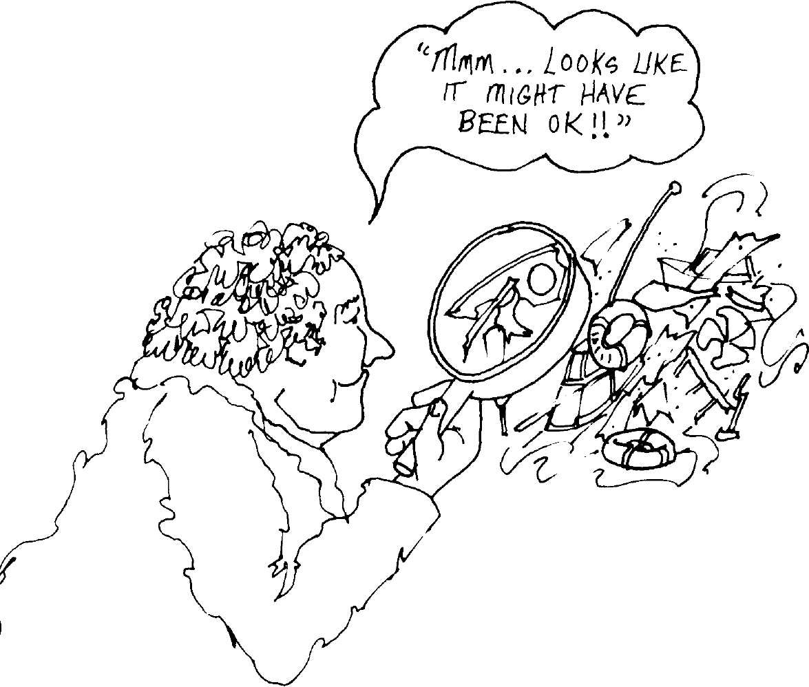

Inti
The Smalltalk-80
Benchmarks
Kim McCall
Software Concepts Group
Xerox Palo Alto Research Cento·
Palo Alto, California
Oduction At the first Smalltalk-80 "implementors meeting" on September 24-25,
1981, several of the groups pursuing implementations expressed a de-
sire for some system facilities to help them measure the efficiency of
their interpreters. Such facilities, which were unavoidably labeled
"benchmarks," would provide an objective means of comparing imple-
mentations, gauging the value of intended performance enhancements,
and tracking the progress of individual implementations over time.
This author was given the responsibility of adding such facilities to
the system, and thus was born the class Benchmark found in the
Smalltalk-80 virtual image.
In this paper I:
- Describe the general framework of the timing and reporting facili-
ties in class Benchmark;
- Describe various individual tests (hereafter referred to as "bench-
marks");
- Explain how to write a new benchmark;
- Suggest ways benchmarks can be used, i.e., how to gain useful in-
formation from them; and
Copyright © Xerox Corporation, 1983. All rights reserved.
153
154
The Smalltalk-80 Benchmarks
5. Present the results of running the standard system benchmarks in
several different implementations.

The
Benchmark
Framework
Class Benchmark contains a simple set of facilities for timing the execu-
tion of some block of code and reporting the result. The central message
is
test: aBlock labeled: label repeated: nTimes.
aBlock must be a BlockContext that contains the code to be timed; and
label should be a string describing this code, i.e., describing the system
behavior that is being timed. Since timings are recorded in milliseconds,
it often happens (e.g., when testing atomic system functions such as
pushing a value onto the stack or popping it off) that a single execution
of aBlock would yield a value so small that it would be dwarfed by the
roundoff error. So the method allows us to specify the number of times
the block should be executed (nTimes).
For example,
Benchmark new
test: [20 factorial]
labeled: 'testing 20 factorial'
repeated: 100
would time 100 executions of the block
[20 factorial]
and report the result, using the label 'testing 20 factorial' for purposes of
identification.

Reporting
Class Benchmark contains various facilities for reporting its results in a
permanent, semi-permanent, or evanescent way.
A report consists of:
- An identification line, giving the label, enclosed in square brack-
ets.
- A total time line, giving the number of times aBlock was executed
and the total time (in seconds).
- If the number of executions of aBlock is greater than one, a single
iteration line, giving the time (in microseconds) taken to execute
aBlock once.

155
The Benchmark Framework
For example, if it took 26133 milliseconds to run 100 repetitions of [20
factorial], the report would read
[testing 20 factorial]
100 repetitions timed at 26.133 seconds
261330.0 microseconds per repetition.
After each benchmark test, some feedback is printed in the
SystemTranscript. The user can choose to print either the full report as
described above or just the identification line. If she or he desires a
more permanent record, the user may also elect to print a report on a
file. For implementations that do not yet include a working file system,
the report may be printed on a Stream.
The default reporting behavior will be to print the full report in the
Transcript. To change the default, the user sends the message
setOutputParameters to the instance of class Benchmark that is going to
perform the test. In response to setOutputParameters, the instance of
Benchmark will invite the user to select among the various reporting
options.
In order to generate a file containing reports for a series of bench-
marks, class Benchmark provides the message testList:. The
setOutputParameters message is sent automatically in response to
testList:. There are built-in facilities in class Benchmark for comparing
two output files in order to chart progress over time or to compare two
different implementations. These facilities are invoked by the message
compareOldTimes:newTimes:outputTo:.
The actual timing is done by the method
Timing
time: aBlock repeated: nTimes
This method times nTimes executions of aBlock and nTimes executions
of an empty block (one that just returns nil), and then computes and re-
turns the difference. This should report the actual time spent executing
aBlock nTimes times, and subtract out the overhead of the counting and
execution control structures. In the code for
time: aBlock repeated: nTimes
some care was taken to insure that the control structures for counting
up to nTimes would not dominate the execution of aBlock. For example,
rather than using timesRepeat: for looping, we use an open coded loop.
We also use a doubly-nested iteration loop when nTimes is large, to in-
sure that all the counting is done using Small Integer arithmetic.
156
The Smalltalk-80 Benchmarks

The Standard
System
Benchmarks
The Smalltalk-80 virtual image includes two different kinds of bench-
marks, those that measure specific parts of an interpreter and those
that measure overall system performance. In order to be able to gauge
the benefit of small changes to restricted parts of the interpreter, or to
isolate specific areas in need of improvement, there is a set of bench-
marks that test the efficiency of each of the most basic, simple opera-
tions of the interpreter. These test the basic bytecodes and the
primitives. There is also a set of more global benchmarks that test the
performance of the system at the higher-level activities invoked by a
typical Smalltalk-80 programmer, such as compiling, decompiling, using
browser facilities, and inserting, formatting, and displaying text. We call
these the micro-benchmarks and the macro-benchmarks respectively.

The Micro-
Benchmarks
Most of the micro-benchmarks consist of several repetitions of the par-
ticular bytecode or primitive to be tested. We need several repetitions of
the very fast bytecodes in order to make the execution time of aBlock
be so much greater than the execution time of the empty block that the
rounded-off results will be meaningful. To keep the stack from
overflowing, and to satisfy the demands of the compiler, the repetitions
of the operation we intend to test are interspersed with pops or quick
sends of the message ==. The micro-benchmarks all end with Τ nil.
This makes aBlock's execution speed more directly comparable to the
execution time of an "empty" block (which just returns nil). In the de-
scriptions of the individual micro-benchmarks below, I generally give
the percentage of bytes in the block (ignoring the Τ nil) that actually exe-
cute the behavior we are trying to test. I will present the standard sys-
tem benchmarks in the order in which they occur in the method for
setStandardTests in class Benchmark class. This list is intended to serve
as a documentation reference, and the casual reader is invited to skip
or skim it.
Please note that the inclusion in the benchmarks of the = = message
or other byte codes that we really didn't want to test may greatly alter
the execution speed of the block and compromise the meaningfulness of
the results. For example, I thought that I had implemented the quick
push of a constant (like 1) onto the stack about as efficiently as possible,
and I was perplexed to learn that a machine-coded MC68000 implemen-
tation performed the testLoadQuickConstant benchmark faster than my
own microcoded implementation. After looking at the code that actually
implements the Smalltalk-80 virtual machine instruction 16r76 (118
decimal), I was even more perplexed, since my implementation looked
considerably more efficient. Finally, I realized that most of the time re-
ported by the benchmark was going into the execution of (and return
from) the = = message which I had included just to satisfy the compil-

. 157
The Standard System Benchmarks
er. (This MC68000 implementation gave better results because it uses a
delayed reference-counting scheme that greatly expedites pushes, pops,
and simple primitive operations.)

testLoadlnstVar
testLoadTempNRef
testLoadTempRef
testLoadQuickConstant
testLoadLiteralNRef
testLoadLiterallndirect
testPopStore I nstVar
This benchmark measures how quickly an in-
stance variable of the receiver can be pushed
onto the stack. Because this variable is set to
1, there is little reference-counting overhead
on the push (although there may be more on
the other operations in the block). 50% of the
bytes in the block are 16rO, a push of the re-
ceiver's first instance variable.
This benchmark measures how quickly a vari-
able that is local to a method can be pushed
onto the stack. Setting this variable to 1
avoids most reference-counting overhead on
the push. 50% of the bytes in the block are
16rlO, a push of the method's first local vari-
able.
This benchmark also measures how quickly a
variable that is local to a method can be
pushed onto the stack, but because the vari-
able is set to some newly created point, the
implementation's reference-counting mecha-
nism (if any) will be fully exercised. Again,
50% of the bytes in the block are 16rlO, a
push of the receiver's first instance variable.
This benchmark measures how quickly one of
the "quick constants" (-1, 0, 1, 2, nil, true, false)
can be pushed onto the stack. There is little
reference-counting overhead on the push. 50%
of the bytes in the block are 16r76, a push of
the constant 1.
This benchmark measures how quickly an or-
dinary literal (a constant generated at compile
time) can be pushed onto the stack. Because
we have used the constant 3, there is little
reference-counting overhead on the push. 50%
of the bytes in the block are 16r21, a push of
the method's second literal.
This benchmark measures how quickly the
contents of an indirectly accessed variable
(such as a class variable or a global variable)
can be pushed onto the stack. Because our
variable refers to class Point, there is little ref-
erence-counting overhead on the push. 50% of
the bytes in the block are 16r41, an indirect
push of the method's second literal.
This benchmark measures how quickly a val-
ue can be popped off the stack and stored in
an instance variable of the receiver. Because
this value is the Smalllnteger 1, there is little
reference-counting overhead on the push or
the store. 50% of the bytes in the block are
16r60, a pop of the top of the stack into the
receiver's first instance variable.

158
The Smalltalk-80 Benchmarks
testPopStoreTemp
test3plus4
test3lessThan4
test3times4
test3div4
testi 6bitArith
testLargelntArith
testActivationReturn
testShortBranch
This benchmark measures how quickly a val-
ue can be popped off the stack and stored in a
local variable of the method. Again, since this
value is 1, there is little reference-counting
overhead. 50% of the bytes in the block are
16r68, a pop of the top of the stack into the
method's first local variable.
This benchmark measures the speed of
Smalllnteger addition. Because all values are
Smalllntegers, there is little reference-count-
ing overhead. 25% of the bytes in the block
are 16rB0, a quick send of the message +.
This benchmark measures the speed of
Smalllnteger comparison. Because all values are
Smalllntegers, there is little reference-counting
overhead. 25% of the bytes in the block are
16rB2, a quick send of the message <.
This benchmark measures the speed of
Smalllnteger multiplication. Because all values
are Smalllntegers, there is little reference-
counting overhead. 25% of the bytes in the
block are 16rB8, a quick send of the message *.
This benchmark measures the speed of
Smalllnteger division. Because all values are
Smalllntegers, there is little reference-count-
ing overhead. 25% of the bytes in the block
are 16rBD, a quick send of the message //.
This benchmark measures the speed of 16-bit
integer arithmetic. Since some implementa-
tions use more than 15 bits to represent
Smalllntegers (see Chapter 8), the reference-
counting overhead will depend on the repre-
sentation chosen for 16-bit integers. 25% of
the bytes in the block are 16rB0, a quick send
of the message +.
This benchmark measures the speed of arith-
metic on integers greater than 2¹⁶. The refer-
ence-counting overhead will depend on the
exact representation chosen for these integers.
25% of the bytes in the block are 16rB0, a
quick send of the message +.
This very important benchmark uses a call on
a doubly-recursive method to measure the
speed of method activation and return. There
is little reference-counting overhead associat-
ed with knowing when to end the recursion,
but there may be a great deal in managing
the Contexts that represent the activations.
About 12.5% of the bytes executed during this
benchmark are 16rE0, a send of the method's
first literal (in this case, the Symbol recur:),
and about 12.5% are returns, split evenly be-
tween 16r78, a quick return of the receiver,
and 16r7C, a return of the value on the top of
the stack.
This benchmark times the short jump to the
false branch of a conditional. Although there

159
The Standard System Benchmarks

testWhileLoop
testArrayAt
testArrayAtPut
testStringAt
testStringAtPut
testSize
testPointCreation
testStreamNext
testStreamNextPut
testEQ
testClass
testBlockCopy
is not much reference-counting overhead, oth-
er operations may be so fast that reference
counting takes a good proportion of the time.
16.7% (1/6) of the bytes in the block are
16r90, a short conditional branch.
This benchmark measures the speed of exe-
cuting a simple "while loop." All loop-count-
ing uses Smalllnteger arithmetic. About 9% of
the bytes in the block are 16rA3, long jump,
and about 9% are 16r9D, a short conditional
branch.
This benchmark measures how quickly a val-
ue can be read from an Array. 25% of the
bytes in the block are 16rC0, a quick send of
the message at:.
This benchmark measures how quickly a val-
ue can be stored into an Array. 20% of the
bytes in the block are 16rCl, a quick send of
the message at:put:.
This benchmark measures how quickly a val-
ue can be read from a String. 25% of the bytes
in the block are 16rC0, a quick send of the
message at:.
This benchmark measures how quickly a val-
ue can be stored into a String. 20% of the
bytes in the block are 16rCl, a quick send of
the message at:put:.
This benchmark measures how quickly a
String can return its size. The String will be
reference counted in reference-counting im-
plementations. 33% of the bytes in the block
are 16rC2, a quick send of the message size.
This benchmark measures how quickly a Point
can be created from two Smalllntegers. 25% of
the bytes in the block are 16rBB, a quick send
of the message @.
This benchmark measures how quickly the
next value can be read from a Stream. About
33% of the bytes in the block are 16rC3, a
quick send of the message next.
This benchmark measures how quickly the
next value can be stored into a Stream. About
25% of the bytes in the block are 16rC4, a
quick send of the message nextPut:.
This benchmark measures how quickly two
objects can be compared for identity. About
50% of the bytes in the block are 16rC6, a
quick send of the message = =.
This benchmark measures how quickly an ob-
ject can return its class. 33% of the bytes in
the block are 16rC7, a quick send of the mes-
sage class.
This benchmark measures how quickly a
BlockContext can be created that has the cur-
rent context as its "home context." 25% of

160
The Smalltalk-80 Benchmarks

testValue
testCreation
testPointX
testLoadThisContext
testBasicAt
testBasicAtPut
testPerform
testStringReplace
testAsFloat
testFloatingPointAddition
testBitBLT
testTextScanning
the bytes in the block are 16rC8, a quick send
of the message blockCopy:.
This benchmark measures how quickly a sim-
ple BlockContext can be evaluated. 33% of the
bytes in the block are 16rC9, a quick send of
the message value.
This benchmark measures how quickly a class
can be instantiated. 33% of the bytes in the
block are 16rCC, a quick send of the message
new.
This benchmark measures how quickly one co-
ordinate can be extracted from a Point. 33% of
the bytes in the block are 16rCE, a quick send
of the message x.
This benchmark measures how quickly the
current context can be pushed onto the stack.
50% of the bytes in the block are 16r89, a
quick push of the current context.
This benchmark measures how quickly the
value can be read from an unnamed (but
indexed) field of a variable-length object. 25%
of the bytes in the block are 16rE4, a send of
the method's fifth literal, in this case the mes-
sage basic At:.
This benchmark measures how quickly a val-
ue can be stored into an unnamed (but
indexed) field of a variable-length object. 20%
of the bytes in the block are 16rF5, a send of
the method's sixth literal, in this case the
message basicAt:put.
This benchmark measures the speed of the
perform: primitive. 20% of the bytes in the
block are 16rFl, a send of the method's second
literal, in this case the message perform:with:.
This benchmark measures the speed of the
String replacement primitive.
This benchmark measures the speed of the
Smalllnteger to Float conversion. 33% of the
bytes in the block are 16rDl, a send of the
method's second literal, in this case the mes-
sage asFloat.
This benchmark measures the speed of the
floating point number arithmetic. 25% of the
bytes in the block are 16rB0, a quick send of
the message + which must be looked up in
class Float.
This benchmark measures the speed of the
BitBIt primitive. 33% of the bytes in the block
are 16rD2, a send of the method's third liter-
al, in this case the message copyBits.
This benchmark measures the speed of the
primitive method that displays characters on
the screen.

161
The Standard System Benchmarks

The Macro-
Benchmarks

testClassOrganizer
testPrintDefinition
testPrintHierarchy
testAIICallsOn
testAlllmplementors
testlnspect
testCompiler
testDecompiler
testKeyboardLookAhead
testKeyboardSingle
testTextDisplay
The macro-benchmarks provide examples of the main activities in
which a Smalltalk programmer is typically engaged. Since the
Smalltalk-80 virtual image does not contain many applications besides
the programming environment as a whole, most of the macro-bench-
marks test system support for programming activities.
This benchmark measures the speed of con-
version between the textual and the structur-
al representations of a class organization. The
example chosen is class Benchmark because its
organization contains many categories.
This benchmark measures how quickly a class
definition, as it appears in the system brows-
er, can be generated. The example chosen is
an instance of class Compiler because it has a
moderate number of instance variables.
This benchmark times the printing of a por-
tion of the Smalltalk-80 class hierarchy. The
example chosen is class InstructionStream be-
cause it has several subclasses.
This benchmark measures how quickly all the
methods in which a given selector is refer-
enced can be found. The example chosen is
the selector printStringRadix: because it has a
moderate number of senders.
This benchmark measures how quickly all the
implementors of a given selector can be found.
The example chosen is the selector next be-
cause it has a moderate number of
implementors.
This benchmark measures how quickly a stan-
dard inspect window can be created. The ex-
ample chosen is an instance of class Compiler
because it has a moderate number of instance
variables.
This benchmark measures the speed of the
compiler on a slightly longer than normal
method, one containing 87 tokens and compil-
ing into 73 bytecodes.
This benchmark measures the speed of the
Decompiler by decompiling all the methods in
class InputSensor.
This benchmark gauges keyboard response,
simulating a typist who is able to type ahead.
This benchmark measures keyboard handling
by simulating a typist who waits until each
keystroke appears on the screen before typing
the next one.
This benchmark measures how quickly a
paragraph can display itself. The paragraph
chosen contains 13 lines with no font or em-
phasis changes.

162
The Smalltalk-80 Benchmarks
testTextFormatting
testTextEditing
This benchmark measures the system facili-
ties required to display a piece of source code
in the system browser. First, the message pat-
tern is discovered and highlighted (by making
it bold). Next, the line breaks are determined
which will allow it to be displayed between
certain margins. Finally, the text is displayed.
This benchmark measures text-editing speed
by repeatedly inserting characters into a
string and redisplaying the string.

Writing
Your Own
Benchmarks
Suppose you want to use the general benchmark facilities to test and
record your system's performance of some tasks that are not already
tested by class Benchmark. This is quite straightforward if you are test-
ing some large system function, such as compilation, that does not re-
quire user interaction. As explained above, you send an instance of
Benchmark the message
test: aBlock labeled: label repeated: nTimes
where aBlock invokes the function whose speed you want to measure.
But if you want to test a more atomic system facility, such as a primi-
tive specific to your implementation or a simple system facility, primi-
tive, or byte code for which I have not included a test (such as the
performance of your low-level disk code), or if you want to test your sys-
tem's behavior at a task that involves user input, I have a few words of
advice.
First, advice for macro-benchmarks that require user input: It should
be obvious that if the benchmark ever has to wait for input, the results
will depend on the behavior of the user rather than that of the system.
This is unacceptable. So unless you can be sure of feeding your bench-
mark all the input you need ahead of time (by "type ahead" for exam-
ple), you will need to figure out a more creative way to discover the
results you want. The implementors at University of California, Berke-
ley, (see Chapter 11), have developed a "script" facility in which the in-
put events required to drive some application can be recorded and then
played back later. This allows a script to drive an application or a
benchmark, and thus avoids uneven waiting.
Next, advice for the designers of new micro-benchmarks: The main
problem in defining a benchmark is being sure that the benchmark ac-
tually tests what you mean it to test. The main problem here is making
sure that that operation is not swamped by other extraneous computa-

163
Writing Your Own Benchmarks
tion. For example, if you want to test the speed of your BitBIt primitive,
you might think of a simple way of getting a BitBIt to occur, such as
Display reverse: (100@100 corner: 400® 400)
which uses BitBIt to complement the bits in a rectangle on the screen.
But this would probably be a mistake, because several (costly) message
sends are required to turn this high-level description of a particular
BitBIt into a completely specified call on the primitive. The Smalltalk-80
"spy" facilities contained in class MessageTally can help you discover
whether your proposed benchmark times primitive or higher-level exe-
cution.
To solve this problem you need to find a much lower-level way of in-
voking the desired behavior. But sometimes you have to be very careful.
For example, consider my original code for testing the speed of
BlockContext creation. Smalltalk methods often call for unevaluated
blocks of code to be passed as arguments. This happens, for example, in
all code of the general form
1 to: 10 do: [:i | array at: i put: true].
When it sees something like this, the compiler realizes that it needs to
create a BlockContext to serve as the second argument of the to:do:
message. So it generates the following sequence of byte codes
pushThisContext pushO (or 1 or 2, etc.) sendMsg: blockCopy:
Now, I was interested in testing the speed of execution of this
blockCopy: message. Since I wanted to follow my general rule of making
sure that this operation was not swamped by other computation, I
thought it would be smart to store the current context in a temporary
variable and thus be able to get it onto the stack by a simple pushTemp
instruction rather than a (at least in some implementation strategies)
potentially more complicated pushThisContext instruction. The problem
is that since the code that the benchmark repeatedly executes is itself
passed as an unevaluated block, by the time this code is executed, my
clever temporary variable no longer points at the current context, but
rather at one further down the stack. This resulted in my benchmark
testing an operation that would literally never be performed in any nor-
mal Smalltalk-80 system and that might go much slower (in certain
very highly optimized implementations) than the behavior I had meant
to test.
The micro-benchmark designer should also be careful to consider the
effect of other "filler" bytes, as discussed above.
The Smalltalk-80 Benchmarks

How to Use
Your Results
What can you learn from the results of your tests? The micro-bench-
marks can, of course, suggest parts of an implementation that need ad-
ditional work. They will often help identify local gross inefficiencies.
They can also serve to confirm that a simple local modification was, in
fact, an improvement. But I think it is a mistake to place a great deal
of emphasis on micro-benchmark performance. It seems that there are
only a few micro-benchmarks whose performance correlates strongly
with global (macro-benchmark) performance. Microcoded machines with
stringent control store limits would be especially ill-advised to spend
micro-instruction space speeding up the relatively insignificant micro-
benchmarks.
The macro-benchmarks appear to be a good measure of overall sys-
tem performance. Improvement in their performance correlates well
with user-perceived system performance. I have found them very useful
in gauging the effect of both small and large changes to my interpreter
and in tracking my progress over time. For example, columns A and Β
of Table 9.1 compare the Dolphin interpreter before and after a change
to the handling of the display that had a significant effect on perfor-
mance. At other times however, testing the macro-benchmarks has
served primarily to quell my enthusiastic anticipation of the value of
some intended enhancement.

A Brief
Analysis of
Early Results
As this book attests, there are now several successful Smalltalk-80 im-
plementations. The standard system benchmarks have been run in each
of these implementations, and the reports are presented below. There
are several interesting lessons to be gleaned from these results, which I
will explore here.
It should be stressed that the figures we will be comparing were
achieved on machines of vastly different speeds and hardware configu-
rations. Some of our figures are very early results. Some come from im-
plementations that were intended to teach the implementors about the
structure of the interpreter and that placed very low priority on execu-
tion speed. Some implementations were written in high-level languages
while others were written in microcode. None of these results is final,
and none indicates the expected performance of any future products.
I include these figures because the fact that they were achieved on
vastly different machines and in pursuit of different goals allows us to
do interesting cross-correlations. We can learn which of the micro-
benchmarks seem to be good predictors of the speed of the macro-

165
A Brief Analysis of Early Results
benchmarks (which is what we really care about). And we can glimpse
the results of various strategies such as reference counting versus gar-
bage collecting.
I will present the results in two tables. Table 9.1 gives raw times for
each of the benchmarks, and Table 9.2 gives times as a proportion of
the average (geometric mean) time across all implementations. The
time reported for each benchmark is the execution time for the entire
benchmark (rather than for a single repetition), i.e., that given in the
report's "total time line."
Table 9.1 The Benchmarks, Raw Times
A B C D Ε F G HI J
Micro Tests
testLoadlnst Var
4.47 3.72 0.28 5.85 27.6 3.85 23.41 10.62 5.89 10.02
testLoadTempNRef
4.37 3.07 0.28 5.97 26.2 2.78 23.3 10.62 5.92 9.71
tes tLoad TempRef
6.42 4.53 0.4 5.85 31.16 2.78 26.7 13.89 7.53 11.1
testLoadQuickConstant
7.31 5.14 0.5 11.7 46.19 5.37 38.58 19.65 11.89 17.9
tes tLoadL i tera INRef
4.46 3.11 0.28 6.03 25.51 2.88 19.22 10.62 6.02 10.9
testLoadLiterallndirect
7.33 5.06 0.49 6.6 29.0 3.92 24.49 15.41 8.13 11.9
testPopStorelnst Var
3.12 2.81 0.18 6.75 27.68 5.62 20.63 7.98 10.49 6.95
tes tPopStore Temp
3.58 2.51 0.18 4.67 27.69 2.48 22.87 7.99 9.79 8.22
test3plus4
3.48 2.42 0.16 7.43 24.56 3.1 25.97 8.7 10.52 8.04
test3lessThan4
3.47 2.41 0.18 7.33 24.84 3.25 26.36 9.34 10.12 12.8
test3times4
6.58 4.59 0.4 8.38 25.43 3.98 28.83 10.22 7.41 10.8
test3div4
4.22 3.08 0.57 1.25 2.67 0.48 3.45 1.29 0.75 1.43
testl6bitArith
5.55 5.57 0.65 0.88 11.75 2.07 405.6 133.45 0.59 135.7
tes tLa rgeln tA ri th
6.38 0.65 0.08 0.08 1.17 0.27 43.1 14.31 0.06 14.3
testActivationReturn
11.07 7.39 1.01 16.2 55.38 8.68 73.41 26.38 16.84 21.5
166
The Smalltalk-80 Benchmarks
Table 9.1 (Cont.)
A B C D Ε F G HI J
testShortBranch
2.04 1.43 0.12 6.65 21.6 2.63 13.82 7.35 6.14 6.74
testWhileLoop
7.04 4.92 0.44 16.3 57.43 7.33 64.95 18.77 12.45 21.4
testArrayAt
2.48 1.7 0.19 4.03 30.71 1.65 13.74 5.73 2.51 5.85
testArrayAtPut
2.93 2.02 0.22 4.63 32.12 2.13 16.1 6.71 3.08 6.94
testStringAt
2.45 1.69 0.19 4.0 11.91 1.6 14.63 5.61 2.65 4.72
testStringAtPut
3.16 2.2 0.23 4.92 14.44 1.92 16.95 6.23 2.8 5.01
testSize
1.79 1.23 0.15 3.03 8.52 1.45 11.14 4.76 2.15 4.59
tes tPoin tCreation
1.66 1.17 0.37 1.67 5.52 1.4 6.29 4.3 1.28 3.37
testStreamNext
10.15 7.17 0.91 4.97 15.67 6.5 21.98 7.2 4.01 8.18
testStreamNextPut
12.32 8.77 1.05 5.88 28.71 7.58 26.26 9.33 5.18 9.84
testEQ
5.71 3.93 0.37 6.75 28.76 3.15 29.51 13.71 7.13 12.2
test Class
1.62 1.11 0.13 0.9 4.79 0.5 3.95 2.23 1.05 1.56
testBlockCopy
15.59 10.8 0.53 13.7 22.54 4.18 20.85 16.57 13.09 11.2
test Value
4.25 2.81 0.25 4.08 23.81 3.4 28.51 8.85 6.91 8.21
testCreation
4.03 2.78 0.35 6.65 32.58 3.82 16.37 11.04 4.13 7.33
testPointX
4.84 3.38 0.35 11.78 35.93 5.03 35.43 17.49 12.24 13.2
testLoadThisContext
6.04 4.19 0.4 5.9 29.76 3.05 33.72 14.21 5.36 10.6
testBasicAt
2.31 1.58 0.19 3.32 19.96 1.62 11.24 5.76 2.65 6.46
testBasicAtPut
2.79 1.91 0.22 3.85 31.89 2.15 13.91 6.44 2.76 6.63
testPerform
2.02 1.39 0.3 6.12 29.5 2.25 18.24 7.43 31.28 7.0
167
A Brief Analysis of Early Results
Table 9.1 (Cont.)
A B C D Ε F G HI J
testStri ngRep la ce
0.88 0.61 1.06 0.17 2.24 0.183 0.62 0.38 19.38 0.23
testAsFloat
2.4 1.68 0.26 0.62 25.13 1.12 1.47 1.44 0.26 0.71
testFloa tingPointAddition
2.81 1.96 0.25 0.73 18.86 0.88 2.57 1.63 0.38 1.04
testBitBLT
2.32 1.65 0.4 209.05 33.69 25.83 194.87 5.24 21.73 57.4
tes t Tex tSca nning
1.65 1.16 0.32 21.78 3.44 4.0 7 17 1.01 2 2 2 29
Macro Tests
testClassOrganizer
12.3 8.51 1.25 16.03 80.79 8.58 65.02 24.53 16.82 27.4
testPrintDefinition
8.49 5.58 0.84 10.43 47.37 6.0 48.21 15.61 11.66 15.9
testPrin tHierarchy
8.28 5.75 1.0 9.82 44.44 5.87 37.69 14.39 12.05 15.5
testAHCallsOn
19.06 13.2 1.57 24.38 92.45 10.73 102.72 33.95 21.41 34.2
test A lllmplemen tors
6.13 4.3 0.61 7.95 34.33 4.22 36.11 12.33 8.55 12.7
testlnspcct
15.55 10.6 1.83 19.08 69.23 10.65 91.81 30 09 19 3? 26 6
testCompiler
19.9 13.7 2.17 27.25 134.09 15.15 127.42 50.54 27.11 58.2
testDecompiler
12.29 8.45 1.34 17.38 68.5 9.8 73.53 24.21 17.4 25.5
testKeyboardLookA head
3.37 2.34 0.49 23.08 13.07 3.7 25.13 5.28 4.85 8.99
test Keyboard Single
10.12 7.0 1.47 116.12 43.92 10.95 76.58 18.55 16.27 42.1
testTextDisplay
9.28 6.5 1.2 41.43 32.8 12.92 47.44 11.95 13.88 23.8
testTex (Format ting
8.64 6.02 1.11 9.0 35.29 4.87 83.81 18.53 10.57 11.2
testTextEditing
24.83 17.3 4.07 135.2 95.23 28.03 186.39 37.1 37.03 60.3
168
The Smalltalk-80 Benchmarks
Table 9.2 The Benchmarks Normalized to the Average

A B
Micro Tests
C
D
Ε
G
Η

tes tLoadlns tVar
0.772 0.642 0.0483 1.01 4.77
testLoadTempNRef
0.801 0.563 0.0514 1.09 4.8
tes tLoad TempRef
0.958 0.676 0.0597 0.873 4.65
testLoadQuickConstant
0.74 0.521 0.0506 1.19 4.68
tes tLoadL i tera INRef
0.819 0.571 0.0514 1.11 4.68
testLoadLiterallndirect
0.989 0.683 0.0661 0.891 3.91
testPopStorelnstVar
0.581 0.523 0.0335 1.26 5.16
tes tPopStore Temp
0.734 0.515 0.0369 0.957 5.68
test3plus4
0.669 0.465 0.0307 1.43 4.72
test3lessThan4
0.624 0.433 0.0324 1.32 4.46
test3times4
0.955 0.666 0.058 1.22 3.69
test3div4
2.82 2.06 0.381 0.835 1.78
testWbitArith
0.657 0.659 0.0769 0.104 1.39
testLargelntArith
5.5 0.56 0.0689 0.0689 1.01
testActivationReturn
0.756 0.505 0.069 1.11 3.78
testShortBranch
0.543 0.381 0.032 1.77 5.75
testWhileLoop
0.623 0.435 0.0389 1.44 5.08
test Array At
0.736 0.504 0.0564 1.2 9.11
testArrayAtPut
0.74 0.51 0.0555 1.17 8.11
testStringAt
0.813 0.561 0.0631 1.33 3.95

0.665 | 4.04 | 1.83 | 1.02 | 1.73
0.51 | 4.27 | 1.95 | 1.09 | 1.78
0.415 | 3.98 | 2.07 | 1.12 | 1.66
0.544 | 3.91 | 1.99 | 1.2 | 1.81
0.529 | 3.53 | 1.95 | 1.1 | 2.0
0.529 | 3.31 | 2.08 | 1.1 | 1.61
1.05 | 3.84 | 1.49 | 1.95 | 1.29
0.508 | 4.69 | 1.64 | 2.01 | 1.69
0.596 | 4.99 | 1.67 | 2.02 | 1.54
0.584 | 4.74 | 1.68 | 1.82 | 2.3
0.578 | 4.18 | 1.48 | 1.08 | 1.57
0.321 | 2.3 | 0.862 | 0.501 | 0.955
0.245 | 48.0 | 15.8 | 0.0698 | 16.1
0.233 | 37.1 | 12.3 | 0.0517 | 12.3
0.593 | 5.02 | 1.8 | 1.15 | 1.47
0.701 | 3.68 | 1.96 | 1.64 | 1.8
0.649 | 5.75 | 1.66 | 1.1 | 1.89
0.49 | 4.08 | 1.7 | 0.745 | 1.74
0.538 | 4.06 | 1.69 | 0.777 | 1.75
0.531 | 4.86 | 1.86 | 0.88 | 1.57

i

169
A Brief Analysis of Early Results
Table 9.2 (Cont.)

A
Β
C
D
Ε
F
G
Η
J

testStringAtPut
0.889 0.619 0.0647 1.38
test Size
0.744 0.511 0.0624 1.26
testPointCreation
0.825 0.582 0.184 0.83
testStreamNext
1.52 1.08 0.136 0.745
testStreamNextPut
1.46 1.04 0.125 0.697
testEQ
0.854 0.588 0.0553 1.01
test Class
1.33 0.91 0.107 0.738
testBlockCopy
1.65 1.14 0.0559 1.45
test Value
0.819 0.542 0.0482 0.786
testCreation
0.759 0.524 0.0659 1.25
test Point X
0.597 0.417 0.0432 1.45
testLoadThisContext
0.921 0.639 0.061 0.899
tesiBaswAt
0.745 0.509 0.0612 1.07
testBasicAtPut
0.75 0.513 0.0591 1.03
test-Perform
0.402 0.277 0.0598 1.22
tes tStn ngReplace
1.21 0.838 1.46 0.234
testAsFloat
1.97 1.38 0.214 0.509
test Floatingpoint Addition
2.02 1.41 0.179 0.524
testBitBLT
0.162 0.115 0.028 14.6
tes t Tex tSca η η ι ng
0.684 0.481 0.133 9.03

4.06 | 0.54 | 4.77 | 1.75 | 0.787 | 1.41
3.54 | 0.603 | 4.63 | 1.98 | 0.894 | 1.91
2.74 | 0.696 | 3.13 | 2.14 | 0.636 | 1.68
2.35 | 0.975 | 3.3 | 1.08 | 0.601 | 1.23
3.41 | 0.899 | 3.11 | 1.11 | 0.614 | 1.17
4.3 | 0.471 | 4.41 | 2.05 | 1.07 | 1.82
3.93 | 0.41 | 3.24 | 1.83 | 0.861 | 1.28
2.38 | 0.441 | 2.2 | 1.75 | 1.38 | 1.18
4.59 | 0.655 | 5.5 | 1.71 | 1.33 | 1.58
6.14 | 0.72 | 3.08 | 2.08 | 0.778 | 1.38
4.43 | 0.621 | 4.37 | 2.16 | 1.51 | 1.63
4.54 | 0.465 | 5.14 | 2:17 | 0.817 | 1.62
6.43 | 0.522 | 3.62 | 1.86 | 0.854 | 2.08
8.57 | 0.578 | 3.74 | 1.73 | 0.742 | 1.78
5.88 | 0.448 | 3.63 | 1.48 | 6.23 | 1.39
3.08 | 0.251 | 0.852 | 0.522 | 26.6 | 0.316
20.6 | 0.92 | 1.21 | 1.18 | 0.214 | 0.583
13.5 | 0.631 | 1.84 | 1.17 | 0.273 | 0.746
2.36 | 1.81 | 13.6 | 0.367 | 1.52 | 4.02
1.43 | 1.66 | 2.97 | 0.419 | 0.912 | 0.949

170
The Smalltalk-80 Benchmarks
Table 9.2 (Cont

A
Β
C
D
Ε
G
Η
J

Macro Tests

testClassOrganizer
0.771 0.533 0.0783
testPrintDefinition
0.808 0.531 0.0799
testPrintHierarchy
0.811 0.563 0.0979
testAUCallsOn
0.874 0.605 0.072
testA lllmplementors
0.78 0.547 0.0776
testlnspect
0.82 0.559 0.0965
testCompiler
0.702 0.484 0.0766
testDecompiler
0.756 0.52 0.0825
tes tKey boa rdLoo kA head
0.614 0.426 0.0892
testKeyboardSingle
0.537 0.371 0.078
tes t Tex tDisp lay
0.676 0.473 0.0874
testTextFormatting
0.822 0.573 0.106
testTextEditing
0.625 0.436 0.103

1.0 | 5.06 | 0.538 | 4.08 | 1.54 | 1.05 | 1 | .72
0.992 | 4.51 | 0.571 | 4.59 | 1.49 | 1.11 | 1 | .51
0.961 | 4.35 | 0.575 | 3.69 | 1.41 | 1.18 | 1 | .52
1.12 | 4.24 | 0.492 | 4.71 | 1.56 | 0.981 | 1 | .57
1.01 | 4.37 | 0.537 | 4.6 | 1.57 | 1.09 | 1 | .62
1.01 | 3.65 | 0.562 | 4.84 | 1.59 | 1.02 | 1 | .4
0.962 | 4.73 | 0.535 | 4.5 | 1.78 | 0.957 | 2 | .05
1.07 | 4.22 | 0.603 | 4.53 | 1.49 | 1.07 | 1 | .57
4.2 | 2.38 | 0.674 | 4.58 | 0.961 | 0.883 | 1 | .64
6.16 | 2.33 | 0.581 | 4.06 | 0.984 | 0.863 | 2 | .23
3.02 | 2.39 | 0.941 | 3.46 | 0.87 | 1.01 | 1 | .73
0.856 | 3.36 | 0.463 | 7.98 | 1.76 | 1.01 | 1 | .07
3.4 | 2.4 | 0.706 | 4.69 | 0.934 | 0.933 | 1 | .52

Here is a brief description of each implementation, with references to
the related chapters in this book.
A. Xerox (see Chapter 7). Implementation written in microcode and
machine code running on a 40Mhz Xerox Dolphin.
B. Xerox (see Chapter 7). Implementation written in microcode and
machine code running on a 44.5Mhz Xerox Dolphin with special
display alignment.
C. Xerox (see Chapter 7). Implementation written in microcode and
machine code running on a Xerox Dorado.
D. U.C. Berkeley (see Chapter 11). Implementation written in C run-

171
A Brief Analysis of Early Results
ning on a DEC VAX-11/780, under 4.1BSD UNIX. Uses AED-512
over a RS-232 link for the display. Uses 32-bit Oops.
E. Tektronix (see Chapter 5). Implementation written in Pascal and
assembly language running on an 8Mhz MC68000.
F. Tektronix (see Chapter 4). Implementation written in assembly
language running on a lOMhz MC68000.
G. Hewlett-Packard (see Chapter 6). Implementation written in high-
level language (C) running on a DEC VAX-11/780 with 4
megabyte main memory running 4.1BSD UNIX. Portable among
UNIX systems. "By the book" implementation; limited optimiza-
tion. 16-bit and Largelnteger arithmetic performed with
Smalltalk-80 code (no primitives); Float arithmetic using VAX for-
mat (not IEEE); some additional class and argument checking in
primitives; standard reference-count management with 8-bit
counts (contexts are reference counted); recursive marking gar-
bage collector.
H. Apple (see Chapter 10). Implementation written in assembly lan-
guage running on a 5Mhz MC68000. Synchronization of CPU
memory accesses and display memory accesses reduces the effec-
tive processor speed to about 4.5Mhz.
I. Digital Equipment Corp. (see Chapter 8). Implementation written
in assembly language, running on a DEC VAX-11/780 with 4
megabyte main memory, under VMS. Small Integer and Float prim-
itives implemented; Largelnteger primitives not implemented. All
primitives do class and argument checking. Incremental compact-
ing garbage collector.
J. Digital Equipment Corp. (see Chapter 8). Implementation written
in Bliss-32, running on a DEC VAX-11/780 with 4 megabyte main
memory, under VMS. "By the book" implementation using refer-
ence counting; moderately optimized. All arithmetic primitives
implemented. All primitives do class and argument checking.
One can see from the above data that some micro-benchmarks matter
very little to overall performance. Performance on the division and
Largelnteger benchmarks for example, does not seem to be a very good
predictor of overall performance. As might be expected, performance on
the String replace benchmark correlates strongly with performance on
the text editing macro-benchmark, but not for example, with compiler
performance.
Another observation is that performance on the micro-benchmarks
varies much more widely than performance on the macro-benchmarks.
While this was to be expected, since the macro-benchmarks test perfor-
172
The Smalltalk-80 Benchmarks
mance over a much broader range of activities than do the micro-
benchmarks (thus smoothing out peaks and valleys), I was surprised at
the magnitude of this difference between the smoothness of the macro-
benchmarks and the variations among the micro-benchmarks. (For the
Dolphin implementation, the standard deviation for the micro-bench-
mark results is 0.86 while the standard deviation for the macro-bench-
marks is only 0.087.) This leads me to the hypothesis that, for any
reasonably efficient interpreter, virtually all macro-level performance is
determined by a very few micro-level factors. This hypothesis is sup-
ported by the observation that while the Dorado performance on most
of the micro-benchmarks is on the order of 15-20 times as fast as the
Dolphin, performance on the macro-benchmarks is only approximately
10 times as fast. This appears to be due primarily to the relative speeds
of activation and return in the two implementations. The
activation/return benchmark correlates much more strongly with mac-
ro-level performance than do most other micro-benchmarks. So it ap-
pears that general system behavior is most strongly influenced by the
speed of method activation and return. (This may be less true of ma-
chines with special stack hardware or other special hardware that
would affect Smalltalk-80 bytecode performance in a non-uniform way.)
From an analytic point of view, this hypothesis, that (within reason-
able bounds) overall system performance is most strongly determined
by the speed of method activation and return, can be supported by two
other general facts: method activation and return are by far the most
expensive atomic operations the interpreter must perform; and a fairly
high proportion of the byte codes encountered by a running interpreter
cause activation or return. Of course, neither of these "facts" is univer-
sally true. The String replacement and BitBIt primitives can be much
more expensive than an activation, so code that is very rich in these,
such as text editing, can be expected to perform more like the relevant
micro-benchmarks. Also, highly optimized code (such as that invoked by
Smalltalk allCallsOn:) will "open code" important message calls rather
than incurring the activation and return overhead and can therefore be
expected to perform closer to the level predicted by the other bench-
marks.
Exceptions to the general rule that macro-behavior is best predicted
by the testActivationRetum benchmark are illustrated by the perform-
ance of implementation D on the testTextEditing and testKeyboardSingle
macro-benchmarks. Most of D's normalized micro-benchmark scores fall
in the range 0.8 to 1.6, but the scores for the display-intensive micro-
benchmarks testBitBLT and testTextScanning are much worse. The dis-
play configuration that D uses is much slower than other
implemenations and accounts for these low scores. While performance
on most macro-benchmarks is very near 1.0, as predicted by the majori-
ty of the micro-benchmarks, the scores for testTextEditing and
T73
Concluding Summary
testKeyboardSingle are much worse (3.4 and 6.16) due to the fact that
these are display-intensive macro-benchmarks. It is also worth noting
that these particular macro-benchmarks seem to correlate strongly
with user satisfaction. While D appears to be computationally accept-
able in other respects, its users are generally not satisfied with its re-
sponsiveness.
Concluding Discoveries and warnings have been sprinkled throughout this paper;
Summary here is my chance to put them in one place.
Many of the micro-benchmarks contain operations that I had not
meant to test, but that I included simply to satisfy the demands of the
compiler or stack management discipline. These operations, although
fairly fast, may be slower than the operations being tested and this may
distort somewhat the meaningfulness of these benchmarks.
In writing your own benchmarks, you must be very careful to make
sure that the operations you are trying to time are not swamped by
other computation. For micro-benchmarks, it is good to look at the com-
piled code to see whether you have created the test you thought you
had.
Most of the micro-benchmarks are not very good predictors of overall
system performance. The speed of certain specialized applications may
correlate well with some specific micro-benchmarks, such as BitBIt or
String replacement, but it appears from our data that the efficiency of
activation and return is the overriding determinant of system perfor-
mance.
Finally, let me stress again that the data I presented in the analysis
section represent early or interim results, designed for very different
purposes, written in different level languages, and running on vastly
different hardware. None of these are final, and none indicate the
expected performance of any future systems. We thank the
implementors for their courage in allowing us to publish such prelimi-
nary measurements.
174
The Smalltalk-80 Benchmarks
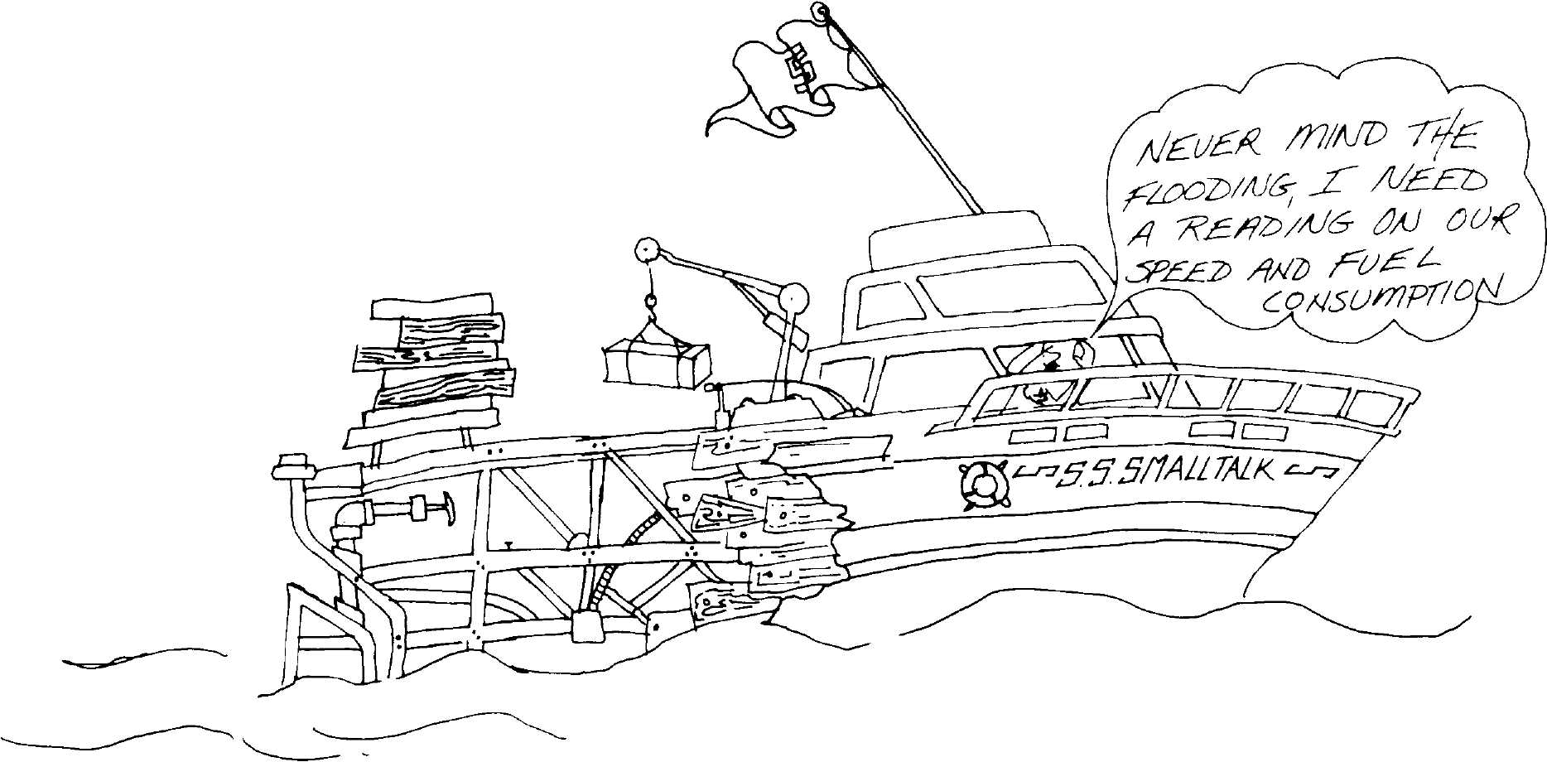
An MC68000-Based
Smalltalk-80 System
Richard Meyers
David Casseres
Apple Computer Inc.
Cupertino, California

Introduction
This paper describes some preliminary results of an MC68000-based im-
plementation of the Smalltalk-80 system. The implementation was con-
ducted as a research project by Apple Computer Inc. Our purpose in
presenting this data is to provide to other implementors some of the in-
formation we wish we had known when we first set out to implement
Smalltalk.

History
Apple Computer began its Smalltalk-80 research project in early Octo-
ber 1980. The project has been staffed by one engineer (Rick Meyers)
and, for about half of the last 18 months, by a technical writer (David
Casseres). Apple has consistently viewed Smalltalk as a research effort,
and has afforded the project the freedom from schedules and from mar-
keting considerations that allows research efforts to thrive.
Our Smalltalk-80 implementation has been running since April 1981
on a series of experimental Motorola MC68000-based computer systems.
The Smalltalk-80 virtual machine described in this paper is a straight-
forward translation of the Xerox virtual machine specification to 68000
assembly language. The bytecode interpreter, object memory system,

Copyright © Apple Computer Inc., 1982. All rights reserved.
175

176
An MC68000-Based Smalltalk-80 System
and primitive routines were written slowly and carefully by a single en-
gineer. Other engineers contributed the BitBIt (screen display), text
scanning (textual display), and floating-point arithmetic routines. To
date, only about three weeks of effort have been devoted specifically to
optimizing the virtual machine, and the only major optimization is the
message lookup cache described later in the paper.
This paper reports on work in progress. The measurements reported
were first made in June 1981 and were repeated in June and July 1982.

Memory
Layout
The measurements were made on a Smalltalk-80 system configured to
use about 793K bytes of memory. Estimates of the sizes of major system
components are shown in Table 10.1. The virtual machine size includes
BitBIt, text scanning, and the floating-point routines. The data does not
include the program development system used to host Smalltalk, the
file system and the device drivers, the system debugger, or the data
areas used by program analysis tools.

Table 10.1 Memory Layout

Area
virtual machine data
virtual machine code
display memory
object table (24K objects)
15K system-supplied objects (60K)
9K user objects (36K)
heap storage (10 heaps, 64K/heap)
system supplied objects (407K)
user objects (233K)
Total
Bytes
4K
21K
32K
96K
640K
793K

Virtual
Machine
Structure
and Size
At the time of this writing, our Smalltalk-80 virtual machine consists of
21,088 bytes of Motorola 68000 assembly-language code. The major sys-
tem components have the following functions:
• Initialization and Utilities: Global initialization, memory image in-
put, I/O operations, utilities

177
Virtual Machine Structure and Size
- Fetch Loop: Bytecode fetch and dispatch
- Bytecode and Primitive Tables: Addresses of bytecode and
primitive routines
- Bytecode Interpreter: Bytecode interpretation, except the major ac-
tivities such as send, return, and memory allocation
- Send/Return: Send and superclass send, primitive dispatch, context
switch, argument transfer and return
- Multiprocessing: Process switch, semaphores, keyboard and time
events
- Memory Management: Memory allocation, reference counting,
heap compaction, and garbage collection
- Primitives: All primitives except for floating-point package, BitBit
and text scanning
- BitBit: Class BitBit, method copyBits
- Text Scanning: Class TextScanner, method scanCharactersFrom:to>
last:in:rightX:stopConditions:displaying:
- Analysis: Reference-count validation, statistics gathering and re-
porting
Table 10.2 shows a breakdown of the virtual machine into its major
components. The file system and device drivers are excluded from these
measurements. The table also indicates time spent in each component
of the virtual machine.

Table 10.2 Virtual | Machine | Structure and | Size
Function | Bytes | Size | % Time \
initialization & utilities | 2,274 | 10.8% | 1.9%
fetch loop | 18 | 0.1% | 10.2%
bytecode & primitive tables | 802 | 3.8% | --
bytecode interpreter | 1,476 | 7.0% | 16.0%
send & return | 1,132 | 5.4% | 39.2%
multiprocessing | 1,338 | 6.3% | -
memory management | 1,650 | 7.8% | 22.6% |
primitives (except those below) | 5,128 | 24.3% | 8.8% ;
floating-point | 3,162 | 15.0% | 0.0% \
BitBit | 1,956 | 9.3% | 0.5%
text scanning | 1,258 | 6.0% | 0.7% ■
analysis | 894 | 4.2% | --

178
An MC68000-Based Smalltalk-80 System

Virtual
Machine Code
Utilization
A sampling technique was used to measure the approximate percentage
of the total time spent executing each instruction of the virtual ma-
chine. The virtual machine program counter was sampled every 10 mil-
liseconds to construct a histogram of relative utilization for each
possible program counter value. It should be noted that this technique
fails to measure periodic activities which are based on interrupts, such
as multiprocessing activity.
The Smalltalk-80 memory image supplied by Xerox Palo Alto Re-
search Center contained a set of 35 benchmarks, included as methods in
class Benchmark. The benchmarks test a number of individual
bytecodes, common primitive operations, and several "macro" opera-
tions such as compilation and text formatting. The results of running
Benchmark testStandardTests are reported in Chapter 9. The results re-
ported in this section were gathered during execution of the Benchmark
"macro" operations

Benchmark new testCompiler
Benchmark new testDecompiler
Benchmark new testlnspect
Benchmark new testTextEditing
Benchmark new testTextFormatting
Each of these tests was run five times in a period of just over 28 min-
utes; 170,922 samples were taken, one every 10 milliseconds. The time
spent in each of the major system components is summarized in Table
10.2 above and in Fig. 10.1.
Several sections of the virtual machine deserve special attention. The
bytecode fetch and dispatch, which usually requires five instructions,
accounts for 10.2% of the total execution time. The relatively small
(1132 bytes, 5.4% of total) send/return component of the system ac-
counts for 39.2% of the execution time. Prior to implementation of a
method lookup cache, this percentage was 52.5%.
The countDownOthers routine, which recursively decrements the ref-
erence counts for the fields of deallocated objects, requires 11.8% of the
execution time. This fact, and the time spent in countDown, suggests
that implementation strategies which avoid reference counting of con-
texts may yield substantial performance improvements.
Overall patterns of utilization indicate the value of time optimization
for send/return and the memory management functions, and space opti-
mization for most of the primitive operations, especially the floating-
point routines. Fig. 10.1 shows the space and time used by each major
system component.

Space Occupied by Code
179
Virtual Machine Code Utilization
Time Spent in Code

Bytecode & Primitive Tables
Send, Execute, & Return
' ;5 li'Mii hi ii
Multiprocessing
* ? i^U4*4l iw4 iy4*l4^ i f έ * ί! # ι ί * 11! I! ι ί ι ί i 11 ? f
fllfilfillfiilfiif
BUBlt, & Text Scanning
..i;jr)l;j.

Text Scanning
BitBlt, & Text Scanning
Analysis

0%
10%
20%
30%
40%
50%
60%
70%
80%
90%
100%

Figure 10.1

180
An MC68000-Based Smalltalk-80 System

Bytecode and
Primitive
Frequencies
The Smalltalk-80 virtual machine implements 256 individual bytecodes
(instructions) and approximately 100 primitive operations. In designing
and optimizing an implementation, it is vital to know which bytecodes
and primitives occur most frequently, and which are rarely used.

 | 0 | 1 | 2 | 3 | 4 | 5 | 6 | 7 | 8 | 9 | A | Β | C | D | Ε | F
0 | Push Instance Variable (0 to F)
1 | Push Temporary Variable (0 to F)
2  3 | Push Literal Constant (0 to IF)
4  5 | Push Literal Variable (0 to IF)
6 | Pop Instance Variable (0 to 7) |  |  |  |  |  |  |  | Pop Temporary Variable (0 to 7)
7 | Push  self | true | false | ι nil | -1 | 0 | 1 | 2 | retur  self | η from  true | messag  false | 'e  nil | ret.  msg. | TOS  block
8 | Push | store | pop | send | send | send  super | ^send  super | pop  stack | dup.  TOS | push  c'txt
9 | Jump (1 to 8) |  |  |  |  |  |  |  | Jump on False (1 to 8)
A | Jump (iii^l)*256+jjjjjjjj |  |  |  |  |  |  |  | Jump on True |  |  |  | Jump on False  ii*256+jjjjjjjj
Β | + | - | < | > | < = | > = | = | ~= | * | / | \\ | @ | bit  Shift: | // | bit  And: | bit  Or:
C | Send Special Selector |  |  |  |  |  | = = | class | block  Copy: | value | value: | Send | Special Selector
D | Send Literal Selector (0 to F) with No Arguments
Ε | Send Literal Selector (0 to F) with 1 Argument
F | Send Literal Selector (0 to F) with 2 Arguments

Notes:
To look up a hex bytecode, find the high-order digit on the left and low-order digit at the top.
indicates a bytecode that is followed by one extension byte,
indicates a bytecode that is followed by two extension bytes,
indicates a bytecode that is not used.

Figure 10.2

181
Bytecode and Primitive Frequencies
Our implementation was instrumented to tally every bytecode and
primitive executed. This instrumentation imposed a time overhead of
about 22%, low enough to allow execution of reasonably large methods
during analysis.
Bytecode and primitive frequencies are both directly dependent on
the methods being executed while data is collected. Two separate meas-
urements are reported here. In the first test we ran each of the Bench-
mark "macro" operations, listed above. Measurements continued
through both the data collection and data reporting phases of the
benchmarks. The second test consisted of browsing as rapidly as possi-
ble for about two minutes; it demonstrates the degree of variation in-
volved.
Figure 10.2 is a bytecode summary matrix to aid in the interpreta-
tion of the bytecode frequency data.
Table 10.3 lists the percentage of total bytecodes executed in each
major bytecode category, while executing the "macro" operations. A to-
tal of 3,750,200 bytecodes were executed while collecting this data.

 | Table 10.3 Bytecode Frequencies by Category in
 | Benchmark Macro Tests
Hex Code | Operation | Percentage
00-0F | push instance variable | 7.3%
10-lF | push temporary variable | 19.1% I
20-3F | push literal constant | 2.3% i
40-5F | push literal variable | 1.1%
50-67 | pop instance variable | 1.9%
68-6F | pop temporary variable | 3.9%
70-77 | push self, true, false, nil, — 1, 0, 1, 2 | 14.4%
78-7B | return from message self, true, false, nil | 1.8%
7C-7D | return TOS from message/block | 4.7%
80 | extended push | 1.3%
81 | extended store | 1.4%
82 | extended pop | 0.9%
83 | extended send | 0.6%
84 | double extended send | 0.0%
85 | superclass send | 0.2%
86 | double extended superclass send | 0.0%
87 | pop stack | 3.7%
88 | duplicate TOS | 0.1%
89 | push context | 0.3%
90-97 | jump (1-8) | 0.2%

182
An MC68000-Based Smalltalk-80 System
Table 10.3 (Cont.)

Hex Code Operation Percentage
98-9F jump on false (1-8) 4.8%
A0-A7 jump (iii-4)*256+jj jjj jjj 2.1%
A8-AB jump on true ii*256+jjjjjjjj 0.0%
AC-AF jump on false ii*256+jjjjjjjj 2.2%
BO-BF send +,-,<,>,<=,>=,=, ~ = , *, /, \\, @,
bitShift:, //, bitAnd:, bitOr: 11.2%
CO-CF send special selector, = = , class, blockCopy.,
value, value: 7.1%
DO-DF send literal selector with no arguments 3.4%
EO-EF send literal selector with 1 argument 2.5%
FO-FF send literal selector with 2 arguments 1.4%
In both of the tests, 18 of the 256 bytecodes accounted for over half of
the bytecodes executed, as shown in Tables 10.4 and 10.5. Simple push
operations (push self, push temporary variable, push 0, push 1) top both
lists and account for over 30% of all bytecodes executed.
Table 10.4 Most Frequent Bytecodes in Benchmark Macro Tests
Hex Code | Operation
70 | push self
10 | push temporary variable 0
11 | push temporary variable 1
12 | push temporary variable 2
76 | push 1
7C | return TOS from message
87 | pop stack top
B0 | send +
01 | push instance variable 1
AC | jump on false (range 0 to 256)
CO | send special selector 0
B6 | send =
Bl | send —
A3 | jump (range —256 to —1)
B4 | send < =
75 | push 0
81 | extended store
78 | return self
 | Total
Percentage
6.7%
6.1%
4.6%
4.5%
4.4%
3.9%
3.7%
3.7%
2.4%
2.2%
2.0%
1.9%
1.7%
1.7%
1.5%
1.4%
1.4%
1.4%
55.2%

183
 | Bytecode and Primitive | Frequencies
 | Table 10.5 Most Frequent Bytecodes in Browsing Test
Hex Code | Operation | Percentage
10 | push temporary variable 0 | 6.9%
70 | push self | 5.4%
7C | return TOS from message | 5.4%
11 | push temporary variable 1 | 4.9%
12 | push temporary variable 2 | 3.3%
BO | send + | 3.3%
76 | push 1 | 2.9%
00 | push instance variable 0 | 2.4%
01 | push instance variable 1 | 2.4%
87 | pop stack top | 2.3%
Bl | send — | 2.2%
DO | send literal selector 0 (no arguments) | 2.1%
80 | extended push | 1.9%
CO | send special selector 0 | 1.8%
78 | return self | 1.6%
75 | push 0 | 1.5%
AC | jump on false (range 0 to 256) | 1.5%
82 | extended pop and store- | 1.5%
 | Total | 53.3%
Primitive executions were tallied during execution of the Benchmark
"macro" operations. Primitive executions resulting from "send special
selector" bytecodes and those resulting from n-jrmal send operations
are included in the tally. Primitive failures are also included. The 20
most frequent primitives are listed in Table 10.6. The top five primi-
tives account for over 50% of all primitive executions, and the top 20
account for almost 95%. As expected, all of the most common primi-
tives are invoked directly from "send special selector" bytecodes.

Table 10.6 Most Frequent Primitives in Benchmark Macro Tests
Method

Decimal # | Class
1 | Smalllnteger
7 | Smalllnteger
60 | Object
2 | Smalllnteger
5 | Smalllnteger
110 | Object
at:

Count | Percentage
138,803 | 18.2%
73,339 | 9.7%
72,429 | 9.5%
65,399 | 8.5%
58,746 | 7.7%
48,784 | 6.4%

184
An MC68000-Based Smalltalk-80 System

 |  | Table 10.6 < Con t.)
Decimal 3? | Class | Method | Count | Percentage
61 | Object | at.put: | 38,657 | 5.0%
62 | Object | size | 36,075 | 4.7%
81 | BlockContext | value/value: | 35,092 | 4.6%
4 | Smalllnteger | > | 34,170 | 4.4%
63 | String | at: | 27,256 | 3.3%
66 | ReadStream | next | 25,259 | 3.3%
6 | Smalllnteger | > — | 13,010 | 1.7%
3 | Smalllnteger | < | 11,724 | 1.5%
80 | ContextPart | blockCopy: | 9,894 | 1.3%
70 | Behavior | new | 8,695 | 1.1%
111 | Object | class | 8,402 | 1.1%
71 | Behavior | new. | 7,781 | 1.0%
11 | Smalllnteger |  | 6,039 | 0.7%
12 | Smalllnteger | // | 5,594 | 0.7%
 | Total |  |  | 94.4%

Send
Characteristics
Message sends play a key role conceptually in the Smalltalk-80 lan-
guage, and have a major impact on the performance of Smalltalk-80
implementations. Three categories of bytecodes initiate send operations.
- Integer and common primitive bytecodes
- Special selector bytecodes
- Send and superclass-send bytecodes.
The final action taken as the result of a send can be any of the follow-
ing:
- Primitive return of self
- Primitive return of an instance variable
- Successful execution of a primitive
- Activation of a CompiledMethod.
Sends involving primitives can either succeed or fail (usually because of
improper argument classes). Our interpreter was modified to tally the
various attributes of sends. The data in Table 10.7 was collected while
executing the Benchmark "macro" operations.

185
Number of Arguments
Table 10.7 Analysis of Send Characteristics

Bytecode Initiating Send
Integer & common primitive bytecodes
Special selector bytecodes
Send and superclass-send bytecodes
Final Action Taken
Primitive return of self
Primitive return of an instance variable
Successful execution of a primitive
Activation of a CompiledMethod
Primitives
Primitive successes
Primitive failures

Counts | Percent
515,099 | 51.9%
173,164 | 17.4%
305,065 | 30.7%
1,673 | 0.2%
40,585 | 4.1%
733,779 | 73.9%
217,291 | 21.9%
733,779 | 96.8%
23,969 | 3.2%

Number of
Arguments
In optimizing the activation code within the virtual machine, it may be
helpful to know the distribution of the number of arguments passed by
sends. The virtual machine was instrumented to construct the histo-
gram shown in Fig. 10.3. Only sends resulting in activation of a
CompiledMethod were considered. The data below is for the Benchmark
"macro" operations. Zero-argument and one-argument sends occur with
nearly equal frequency, and account for over 80% of all reported mes-
sages.

Figure 10.3

Arguments | Sends
0 | 96,130
1 | 79,858
2 | 23,823
3 | 10,518
4 | 4,455
5 | 308
6 | 1,462
7 | 72
8 | 270
% of Total
0 10 20 30 40
I I I I
50

186
An MC68000-Based Smalltalk-80 System

Message
Lookup
Chaining
The message lookup routines begin their search in the class of the re-
ceiver. If the message being sent is not in this class, the search contin-
ues up the superclass chain until an inherited message is found. Our
interpreter was modified to gather statistics on the depth of search re-
quired. The method lookup cache was not in use when these statistics
were collected. The data in Fig. 10.4 was gathered while executing the
"macro" operations in class Benchmark.
About half of all sends are to methods defined in the class of the re-
ceiver, requiring 0 depth of search. Searches of depth 1, 2, 3, and 4 oc-
cur with roughly equal frequencies of about 7.5% to 15%. Relatively
few messages require a search of depth 5 or more, but one search of
depth 9 did occur.

Depth Sends
 | 0 | 242,792
 | 1 | 56,771
 | 2 | 38,024
 | 3 | 75,968
 | 4 | 64,234
 | 5 | 12,455
 | 6 | 4,404
 | 7 | 7,892
 | 8 | 20
 | 9 | 1
Figure 10.4
10
% of Total
20

30
40
50

Performance
Measurements
Performance measurements are included here to allow comparisons
with other Smalltalk-80 implementations. These measurements were
made on a single-user Motorola MC68000-based system with the system
clock running at 5 MHz. (A 4-byte register-to-register add takes 1.6 mi-
croseconds. A 4-byte move from an absolute memory location to a regis-
ter takes 3.2 microseconds. CPU memory accesses and display memory
accesses are synchronized, slowing the CPU by 10-15%). The measure-

. 187
Acknowledgments
ments are a snapshot of work in progress as of July 1982. The only ma-
jor optimization in use was a 256-entry message lookup cache. The
uninterpreted results of running Benchmark testStandardTests are re-
ported in Chapter 9.
A traditional test of system performance is the number of bytecodes
per second the system can execute. Bytecodes vary tremendously in
complexity, from simple operations such as pushing a literal zero on the
stack or branching to another bytecode to very complex primitive oper-
ations such as floating-point divide, string-to-string copy, or BitBIt oper-
ations. Therefore, bytecode-per-second measurements are extremely
dependent on the methods being executed. We had no trouble collecting
measurements ranging from 5000 to about 30,000 bytecodes per second.
Our analysis was done by modifying the virtual machine to count the
actual number of bytecodes executed. This introduced an overhead of
about 5%, which is compensated for in the final column of Table 10.8.
Class Benchmark, method test:labeled:repeated: was also modified to al-
low collection of the bytecode counts. We have chosen to report data
collected for each of the "macro" operations in class Benchmark. Mea-
surements reported are the average of three trials. The message lookup
cache was in use when these measurements were taken.

Table 10.8 Bytecodes/Second for Benchmark Macro Tests
Activity | Counts | ms Elapsed | Bytecodes/sec | + 5%
compile dummy method | 550,061 | 49,440 | 11,126 | 11,682
decompile Form & Class | 2,391,154 | 203,440 | 11,753 | 12,341
create an Inspector | 33,959 | 3,430 | 9,901 | 10,396
format a bunch of text | 258,750 | 20,880 | 12,396 | 13,012
replace & redisplay test | 350,985 | 38,580 | 9,098 | 9,552

Acknowledg-
ments
The authors wish to thank the management of Apple Computer, and es-
pecially John Couch, Wayne Rosing, Nellie Connors, and Ron Johnston
for providing the equipment, the environment and the freedom needed
to implement the Smalltalk-80 system successfully on the MC68000.
Thanks also go to Bill Atkinson and David Hough, who helped with the
engineering effort.

Abstract
Berkeley Smalltalk:
Who Knows Where
the Time Goes?
David M. Ungar
David A. Patterson
Computer Science Division
Department of Electrical Engineering
and Computer Sciences
University of California, Berkeley
Sad deserted shore,
Your fickle friends are leaving.
Ah but then you know
It's time for them to go.
But I will still be here
I have no thought of leaving.
I do not count the time.
Who knows where the time goes?
Who knows where the time goes?
"Who Knows Where the Time Goes"*
We have implemented the Smalltalk-80 virtual machine in the C pro-
gramming language for the Digital Equipment Corp. VAX-11/780 un-
der Berkeley Unix. We call this system Berkeley Smalltalk (BS). An
AED-512 terminal connected over a 9600-baud serial link serves as the
display device. In four months one person wrote BS in about 9000 lines
* [Denny, Sandy, "Who Knows Where the Time Goes?" (BMI) Winckler Music, Judy
Collins (BMI), Irving Music, used by permission]
Copyright © David M. Ungar, David A. Patterson, 1982. All rights reserved.
189
190
Berkeley Smalltalk: Who Knows Where the Time Goes?
of source code. Other Smalltalk-80 implementations on non-micropro-
grammable computers have suffered from poor performance. We believe
that a straightforward, literal implementation of the specification can-
not achieve acceptable performance. This paper explains how the opti-
mizations in BS have increased performance fourfold.

Introduction
The Smalltalk-80 book¹ includes a clear and intelligible definition of
the Smalltalk-80 virtual machine. To learn about the performance con-
sequences of following this definition, we have measured key compo-
nents of:
- An interpreter that follows the book exactly; and
- Berkeley Smalltalk (BS), which meets the specification but does
not mimic the definition in the book.
The results of this study are shown in Table 11.1 below. Berkeley
Smalltalk is 4.8 times faster than a straight-forward implementation.
The rest of this paper details the steps behind this result.

Tabl< | ϊ 11.1 Summary of | All Optimizations
(all times are in microseconds per bytecode)
Activity | By-the-book | BS | By-the-book/BS
reference counting | 50 (12%) | 9.5 (11%) | 5.3
dispatching bytecodes | 124 (31%) | 10 (12%) | 12
BitBIt | 0—100(0—25%) | 0—8.3 (0—10%) | 12
allocation and freeing | 19 (5%) | 5.2 (6%) | 3.7
OT indirection | 29 (7%) | 2.4 (3%) | 12
method lookup | 36 (9%) | 3.8 (5%) | 9.4
Subtotal | 358 (89%) | 39 (47%)
other activities | 44 (11%) | 44 (53%)
Total | 402μβ (100%) | 83μβ (100%) | 4.8

Methodology
First, we identified the activities or operations that distinguish a
Smalltalk-80 system from a conventional non-interpreted language.
These include:

191
Methodology
- Automatic free space reclamation (realized with reference counts),
- Bytecode decoding,
- Bitmap manipulation (BitBIt)²,
- Allocating and freeing objects,
- Object table (OT) indirections, and
- Method lookup.
We measured the cost of each activity by writing test programs in C³
that simply looped and performed the operations as defined by the
book. The CPU execution times of these programs were compared with
dummy programs that looped without performing the measured opera-
tion. Although we never implemented a complete interpreter by-the-
book, we coded these key operations with as much ingenuity as those in
BS. In this way, we hoped to measure only differences caused by under-
lying data structures rather than those attributable to clever "hacks"
in the code.
Next, we derived a bytecode mix from a profile of a typical interac-
tive session of seven million bytecodes⁴. This mix is shown in Table 11.2
below.

Table 11.2 | A Typical | Dynamic Bytecode Distribution
Instruction Type | Frequency | Explanation
push | 43% | typically instance or temporary variable
full sends | 11% | causes context switch
direct arith prims | 8% | successful; another 2% fail
short circuit sends | 5%
direct special prims | 3% | successful
primitives | 3% | 0.3% fail
return stack top | 9% | assume 1 entry on stack
other returns | 2% | assume 1 entry on stack
pop and store | 5% | typically instance or temporary variable
pop | 2%
jump conditional | 6% | from Baden's measurements⁵
jump unconditional | 2% | from Baden's measurements⁶
store | 1%
unaccounted | 1%
Total | 100%
The Smalltalk-80 book and the BS source code gave us the types and
numbers of key operations for each type of bytecode. Finally, we calcu-
192
Berkeley Smalltalk: Who Knows Where the Time Goes?
lated a weighted average for the mean number of key operations per
bytecode.
Multiplying the time per operation by the number of operations per
bytecode gave us the time spent per bytecode on each operation (except
BitBIt). To measure individual optimizations, we also computed the time
spent by an implementation that performed all the optimizations but
the one in question. Table 11.1 summarizes effects of optimizing these
areas. We'll examine these areas individually in the following sections,
discuss other optimizations, and draw some conclusions.
Reference Smalltalk-80 implementations, including BS, reclaim space by
Counting maintaining a reference count for every object. Two reference-count op-
erations are required when the virtual machine stores an object pointer
(Oop): one to account for the destruction of the word's former contents,
and one to account for the creation of a new reference. Each reference-
count operation must first verify that its operand represents a refer-
ence-counted object and not a small integer. Then it must increment or
decrement the appropriate count and check for over- and underflow.
When an object's reference count diminishes to zero, all of its refer-
ences must be destroyed by recursively decrementing the counts of the
referenced objects. Only then can the virtual machine reuse the space.
Although each reference-count operation is not expensive, the cumula-
tive time counting references threatens to throttle by-the-book imple-
mentations.
We designed the Oop and OT structures to speed up reference count-
ing. We enlarged the book's reference-count variables from 8 to 32 bits
to obviate overflow checking. The object table was split into separate
arrays of reference counts, addresses, and flags to eliminate the multi-
plication needed to index an array whose elements are not a power of 2
long. The Small Integer tag bit was moved to the high order bit of the
Oop from the low order bit to avoid the right shift required to convert
an Oop to an array index.
Oops by-the-book.
15 ... 1 0
<OT Index > 0
< Integer > 1
Berkeley Oops
15 14 ... 0
0 <OTIndex >
1 < Integer >
193
Reference Counting
The Berkeley Oop format also reduced the overhead of reference count-
ing by hastening the check to decide whether an object must be refer-
ence counted. Since the integers all have negative Oops, and the Oops
not needing reference counting (invalid Oop, nil, true, false) have values
0 through 3; a single signed comparison can ferret out nonreference-
counted Oops. A typical BS count operation became 25% faster—8.2μ8
to 6.3ju,s.

Reference-
Counting
Operations Per
Bytecode
BS incorporated many strategies from the Xerox Dorado⁷ and Dolphin
implementations⁸ that reduce the number of reference-count operations.
For example, when returning the top of stack, the result's Oop must be
pushed onto the caller's stack. A straightforward implementation would
copy the Oop into the new context and increment its reference count.
Later, when freeing the callee's context, the implementation would dec-
rement the result's reference count. Instead, destructively moving the
Oop obviates these two reference-count operations. After storing the
Oop in the caller's context, BS destroys the old reference from the
callee's context by nilling it out. Since the net number of references
does not change, the reference count stays the same. An implementa-
tion can also avoid a decrement operation when it can guarantee that
the target field contains a nonreference-counted object (e.g. nil). If the
implementation can count on the new contexts of a field to be
nonreference counted, it can avoid the increment.
Perhaps the single most significant trick for optimizing reference
counting is the stack management strategy we adopted from the Dorado
implementation. A Smalltalk-80 interpreter must free a context on al-
most every return. Since the context may contain references to objects,
a conventional implementation must sweep the entire context to free it.
The stack occupies two-thirds of a context; most of the stack is never
used. BS avoids sweeping the area above the top of the stack (TOS) by
banishing references to objects from that area. Only nil, Smalllntegers,
true, and false may reside there. Performing context freeing as part of
the return operation whenever possible is another important optimiza-
tion. In addition to saving the overhead of invoking the recursive free-
ing routine, many other fields in a context are sure to be nonreference
counted and are thus ignored. With these changes, recursive freeing ac-
counts for less than 2%⁹ of the execution time. Moving the sender Oop
and result Oop instead of copying them saved four more count opera-
tions in the return bytecode. Tables 11.3 and 11.4 enumerate the refer-
ence-count operations required for a full send and return.
Be warned: explicitly altering either the stack pointer or the fields
above the top of stack (both pointless actions) can compromise the in-
tegrity of an implementation with this optimization. This hazard has
not posed a problem for BS or the Dorado implementation.

194
Berkeley Smalltalk: Who Knows Where the Time Goes?

Table 11.3 Reference-Count Operations for Full Sends
By-the-book | Bi
1 | 0
1 | 0
1 | 0
1 | 1
1 | 0
1 | 0
1 | 0
1 | 0
1 | 0
1 | 0
1 | 1
1 | 0
1 | 0
1 | 0
1 | 0
15 | 2
Operation
decrement sender in new context
increment new sender
decrement old active context
increment new active context
decrement IP in old context
increment IP in old context
decrement SP in old context
increment SP in old context
increment context class
decrement method in new context
increment method in new context
decrement receiver in new context
increment receiver in new context
decrement argument in new context
increment argument in new context
Total for full send

Table 11.4 Reference-Count | Operations for | Returns
Operation | By-the-book | BS
decrement old active context | 1 | 1
increment new active context | 1 | 0
increment result | 1 | 0
decrement result | 1 | 0
increment old IP | 1 | 0
increment old SP | 1 | 0
Total to switch contexts | 6 | 1
decrement old sender | 1 | 0
decrement old IP | 1 | 0
decrement old SP | 1 | 0
decrement old unused field | 1 | ο !
decrement old receiver | 1 | 1
decrement old method | 1 | 1
decrement old stack contents | 12 | 1
decrement context class | 1 | 0
Total to free old context | 19 | 3
Grand total for return | 25 | 4

195
Reference Counting
This stack management strategy also reduced the number of refer-
ence-count operations for pushes and pops. It saved a decrement for
each push and saved two reference-count operations per pop and store.
It did force pop operations to nil out the old Oop. Three reference-count
operations were saved for each integer primitive since they can succeed
only with nonreference-counted Oops. Table 11.5 lists the number of
counts for each type of bytecode. The optimizations removed 70% of the
reference counting.

Table 11.5 | Reference-Count Operations by Bytecode
Instruction type | By-the-book | BS | By-the-book/BS
push | 2 | 1 | 2.0
full sends | 15 | 2 | 7.5
direct arith prims | 4 | 0 | (infinite)
special primitives | 4 | 3 | .67
short circuit sends | 2 | 2 | 1.0
primitives | 4 | 4 | 1.0
return stack top | 25 | 4 | 6.3
other returns | 26 | 5 | 5.2
pop and store | 2 | 1 | 2
pop | 0 | 1 | 0
jump conditional | 0 | 0
jump unconditional | 0 | 0
store | 3 | 2 | 1.5
Mean counts per
bytecode | 6.1 | 1.5 | 4.1
Multiplying the time per count by the number of counts per bytecode
gave us the total time spent for each bytecode on reference counting.
Table 11.6 presents these data and reinforces the importance of the ref-
erence-count optimizations; if BS did not include them, it would run 1.5
times slower.
Table 11.6 Cost of Reference Counting

Measurement | By-the-book | BS | By-the-book/BS
mean counts per bytecode | 6.1 | 1.5 | 4.1
mean time per count | 8.2με | 6.3μβ | 1.3
mean count time per bytecode | δΟμβ | 9.5μβ | 5.3
mean time per bytecode | 124μβ | 83μβ | 1.5
Fraction spent counting | 40% | 11% | 3.6

196
Berkeley Smalltalk: Who Knows Where the Time Goes?

Bytecode
Decoding
The definition of bytecode decoding encompasses the computation
performed identically for each bytecode. Both Dolphin and Dorado con-
tain fast hardware to decode bytecodes, a luxury absent from a conven-
tional computer like our VAX. In addition to the decoding itself, we
included checking for process switches, fetching bytecodes, updating the
virtual instruction pointer, and for BS, counting bytecodes. BS uses a
256-way branch table to decode single-byte bytecodes completely. We
combined the check for process switching and input polling into a single
counter that is decremented and tested for each bytecode executed. Al-
though we did not measure this optimization by itself, we did duplicate
the code for the directly executed primitives so they could be executed
in-line. Open coding minimizes the number of subroutine calls; the most
common bytecodes and primitives use none. We timed bytecode
decoding for both BS and a by-the-book implementation. As Table 11.7
shows, fast dispatching is critical—BS would be 2.5 times slower with-
out it.

Table 11.7 Bytecode |  | Dispatching
Measurement | By-the-book | BS | By-the-book/BS
time to dispatch one
bytecode | 124jus | ΙΟμβ | 12
mean time per bytecode | 207μβ | 83μ8 | 2.5
% of time spent dispatching 60% |  | 12% | 5

BitBlt
Coping With an
External Display
BitBlt¹⁰ is the workhorse of the Smalltalk-80 graphics system. It per-
forms all bitmap manipulation and text composition. The large amount
of computation for this operation makes it a prime target for optimiza-
tion. BS uses an external display, and must pay communication costs
for bitmaps as well as the computation costs.
We found three techniques to cut communication costs to our external
display: fill recognition, delayed output, and reordered output.
Q Fill Recognition The bulk of the computation on bitmaps fills a
rectangular area with all ones or all zeroes¹¹. These area fill operations
involve 21 times more bits than other, more complex copying opera-
tions. BS determines which invocations of BitBlt merely fill areas and
sends rectangle fill commands to the display for them. (BitBlt itself is
optimized for this case with special-purpose routines.)

197
BitBlt

Measuring the
BitBlt Optimization
Q Delayed Output Second, borrowing an idea from an HP version of
Smalltalk¹², when displaying text, our output routine does not send in-
dividual character-sized blocks of pixels until the completion of an invo-
cation of the text composition primitive, scanCharacters. At that point
BS sends a complete word-sized block.
□ Reordered Output Third, when sending a bitmap to the display de-
vice, the middle goes separately from the left and right edges. Since the
middle is an integral number of bytes, no shifting is needed to align the
pixels for the display device. Each row in the middle of the bitmap is
sent as bytes, not bits.
The only display optimization that can be easily compared to the speci-
fication in the book is the special purpose code for area fill. We meas-
ured the time to fill a 1000 by 1000 bitmap with the slow, general code,
and the time to fill the same bitmap with the fast code for zero and one
fill. The data in¹³ supplied the proportion of work done by BitBlt (num-
ber of bits) that could be done with the special-purpose fast code. A
weighted average of the times then yields the mean time to fill a 1000
by 1000 bitmap. Profile data supplied the midpoint proportion of total
time spent per bytecode on BitBlt. To derive the time spent in BitBlt per
bytecode for BS, we multiplied the time per bytecode by this percent-
age. We obtained the BitBlt time per bytecode of the unoptimized ver-
sion by multiplying this time by the ratio of the unoptimized time to fill
a megabit to the BS time to fill a megabit. Table 11.8 shows the results
of this calculation. We conclude that this optimization is important for
sessions that involve graphics and text composition, it doubled the
speed of the interpreter.

Table 11.8 | BitBlt Area Fill | Optimization
Measurement | By-the-book | BS | By-the-book/BS
time to fill 1000 χ 1000
zeroes | 2100ms | 92ms | 23
time to fill 1000 χ 1000
ones | 2100ms | 97ms | 22
time to fill 1000 χ 1000
mixed bits | 2100ms | 2100ms | 1
ratio of zero/one fill to
mixed bits | 21 | 21 | 1
avg. time per 1M bits | 2100ms | 180ms | 12
% time copying | 0—57% | 0—10% | 1—5.7
copybits time per
bytecode | 0—ΙΟΟμβ | 0 —8.3μβ | 1 — 12
Mean time per bytecode | 75μβ—175μβ | 83μ8 | 1—2.1

198
Berkeley Smalltalk: Who Knows Where the Time Goes?
Allocation and Unix includes a library package for allocating and freeing areas of
Freeing memory¹⁴, but it might be too general to be fast enough for a
Smalltalk-80 system. The proliferation of dynamic objects in a
Smalltalk-80 environment strains conventional memory allocators. In
particular, every message send and return pair results in allocating and
freeing a context object. Many Points are created and discarded in the
graphics routines. The popularity of these two classes is shown in Table
11.9, the percentage of allocation frequency by size based on measure-
ments¹⁵.
Table 11.9 Sizes of Frequently Allocated Objects

Size | Allocation Frequency | Comments
18 | 84% | size of small context
2 | 9% | size of point object
28 | 1% | size of large context
other | 6%
BS exploits this pattern with an algorithm outlined in the specification¹⁶.
We observed that when a small object such as a context is freed, the
probability of an allocation request for an object of the same size in the
near future is high. The obvious strategy then is to hold onto the space
and OT entry for the freed object, and to recycle it for the expected al-
location. Although the specification defines a small object as one with
20 or fewer fields, we extended it to 40 to cover large contexts as
suggested by Peter Deutsch. For each size of small object (0-40), BS
maintains a pool of free objects on a linked list. Thus BS can allocate a
small object by removing one from the appropriate list, setting its class
and reference count, and nilling out the object's fields. If a pool runs
dry, the Unix storage allocator is invoked to obtain a chunk of memory
10 times the desired size. BS then divides the chunk into 10 free objects,
and tosses them into the pool. If too many objects end up in the free
pools, it is possible to run out of available OT slots. When this happens,
OT entries must be released from the free objects. The memory space
for large objects is obtained from the Unix allocator.
We measured the cost of an allocation with a test program that re-
peatedly allocated and freed 100 context-sized objects with a LIFO disci-
pline. Both the Unix allocator and the BS allocator were measured. It
will be useful for the analysis to trichotomize sends:
1. We call sends to methods that simply return self or an instance
variable short-circuit sends. The method header names the field to
be returned.
. 199
Object Table Indirection
- Other sends result in the invocation of runtime interpreter sub-
routines. These are the primitives.
- The longest sends activate a new context and transfer control to
the target method. We call these full sends.
The frequency of full sends provided the context allocation frequency,
and the total allocation frequency was obtained by dividing the number
of contexts allocated per bytecode by the fraction of context allocations.
The allocate, free, and nilling out time is just the product of the alloca-
tions per bytecode and the time per allocation. Table 11.10 shows this
calculation. Our object allocation strategy bought only a modest im-
provement in overall performance. The Unix allocator is well-tuned,
and the time allocating and freeing objects is amortized over the time
spent using the objects.

Table 11.10 Cost | to Allocate and | Free Object
Measurement | Unix allocator | BS allocator | Unix/BS
time to allocate and free | 130μβ | 21μβ | 6.2
time to nil out object | 19μβ | 19μβ | 1.0
Total | 149μβ | 40μβ | 3.7
allocations per bytecode | .13 | .13 | 1
alloc/free/nil time per bytecode | 19μβ | 5.2μ8 | 3.7
mean time per bytecode | 97μβ | 83μβ | 1.2
Fraction of time spent
allocating | 20% | 6% | 3.2
There are more tasks involved in storage management than just allo-
cating and freeing, but the large address space and physical memory of
the VAX reduce the importance of most of them. BS usually needs
about half a megabyte of physical memory, and fits comfortably on our
4 megabyte time-shared VAX. In particular, we have not observed any
thrashing, and thus have ignored dynamic compaction. Garbage collec-
tion flashes by so quickly on a 32-bit computer with plentiful memory
that it can be hidden in the time needed to save an image on disk.
Object Table To read or write a field of an object, the Smalltalk-80 virtual machine
Indirection must first determine the object's memory address from the Object Ta-
ble. We optimized this object table indirection just as we optimized ref-
erence counting. Addresses, like counts, are stored in a separate array,
200
Berkeley Smalltalk: Who Knows Where the Time Goes?
and the same Oop format that facilitates indexing the reference array
speeds accesses to the object address array. We used test programs to
time the cost of an indirection. Indirection is so simple that the array
access costs dominates; the data structures in the book would double
the time for each object table indirection on a VAX.
Close scrutiny of the book and the BS source code yielded the num-
ber of indirections. BS avoids object table indirections by saving memo-
ry addresses of some objects in registers. In particular, it keeps the
current receiver, active and home contexts, current method, top of
stack, and next bytecode addresses in registers or local variables. Those
primitives and bytecodes that do multiword transfers or read-modify-
write operations also keep addresses in registers. Scattering addresses
around in registers complicates compaction, but except for garbage col-
lection, BS does not compact. Tables 11.11 and 11.12 enumerate the in-
directions performed for a full send and a return, respectively. The
need to recursively free the old context increases the number of indirec-
tions for a by-the-book return.
Table 11.11 Object Table Indirections for Full Sends

Operation | By-the-book | Β
fetch send | 1 | 0
copy receiver and argument | 4 | 0
initialize new context | 5 | 0
store old IP | 1 | 0
store old SP | 1 | 0
store new IP | 1 | 0
store new SP | 1 | 0
get address of new context | 0 | 1
get address of new method | 0 | 2
get address of new receiver | 0 | 1
Total | 14 | 4
Computing the indirections for the other operations was straightfor-
ward, except for the nonarithmetic primitives, where we cheated by as-
suming three indirections each. (These are only 6% of the bytecodes
executed.) Table 11.13 gives the number of indirections required for
each type of bytecode. A by-the-book implementation performs an indi-
rection for every bytecode simply to fetch it; caching this address of the
next bytecode is every implementor's favorite optimization. The optimi-
zations are successful, they remove three-quarters of the indirections.
201
Object Table Indirection
Table 11.12 Object Table Indirections for Returns

Operation
fetch bytecode
pop result
push result
store old IP
store old SP
load new SP
load new IP
load new method register
load new receiver register
load active context
get address of new method
get address of new context
get address of new receiver
free context
recursive free of context
Total

By-the-book | R
1 | 0
1 | 0
1 | 0
1 | 0
1 | 0
1 | 0
1 | 0
1 | 0
1 | 0
1 | 0
0 | 1
0 | 1
0 | 1
2 | 2
18 | 0
30 | 5

Table 11.13 Object Table Indirections per Bytecode

Instruction Type | By-the-book
push | 3
full sends | 14
arith prim | 4
special prim | 4
primitives | 5
short circuit sends | 3
return stack top | 28
other returns | 30
pop and store | 3
pop | 2
jump conditional | 2
jump unconditional | 1
store | 3
Mean indirections per
bytecode | 7.0
BS
0
4
0
1.5
3
0
5
5
0
0
0
0
0
1.2
By-the-book/BS
(infinite)
3,5
(infinite)
2.6
1.7
(infinite)
5.6
6.0
(infinite)
(infinite)
(infinite)
(infinite)
(infinite)
5.8

Finally, to obtain the time spent on object table indirection per
bytecode, we multiplied by the number of indirections per bytecode. Ta-
ble 11.14 shows these results. These optimizations reduce indirection

202
Berkeley Smalltalk: Who Knows Where the Time Goes?
from a major cost of the interpreter to merely 4% of the total cost.
There have been proposals to use 32-bit Oops and eliminate the object
table. Table 11.14 implies that eliminating the speed penalty of the in-
direction is a poor justification for abolishing the object table. There
may of course, be other, more compelling reasons.

Table 11.14 Cost | of Object Table Indirection
Measurement | By-the-book | BS | By-the-book/BS
mean indirections per bytecode | 7.0 | 1.2 | 5.8
time per indirection | 4.2μδ | 2.0μ8 | 1.2
mean indirection time per
bytecode | 29μδ | 2.4μδ | 12
mean time per bytecode | ΙΙΟμβ | 83μδ | 1.3
Fraction spent indirecting | 26% | 3% | 9.0

Method
Lookup
Runtime type checking is a fundamental innovation of the Smalltalk-80
language. Every message send (procedure call) looks up the message's
selector in the method dictionaries for the receiver's class (and
superclasses). The Smalltalk-80 book recommends reducing the time
spent for lookups with a cache. BS incorporates such a method lookup
cache with 1024 entries. The cache slot is computed from the low-order
10 bits of the result of performing an exclusive-or (the book uses and) of
the receiver's class and the selector. Conroy and Pelegri (see Chapter
13) have conducted a thorough study of Smalltalk-80 method cache be-
havior; Table 11.15 merely summarizes their findings for BS. The
wisdom in the book is borne out, as BS would be 40% slower without
the cache.

Table 11.15 Method Caching

 | Without | With
Measurement | Cache | Cache | Ra
measured hit time |  | 4.4μδ
measured miss time | 187 μδ | 284με
measured hit % | 0% | 94%
mean lookup time | 187μ8 | 20μβ | 9.4
mean lookups per bytecode | .19 | .19 | 1.0
mean lookup time per bytecode | 36μ8 | 3.8μ8 | 9.4
mean time per bytecode | 115μβ | 83μ8 | 1.4
Fraction of time for lookup | 31% | 5% | 6.2

203
Comparative Execution Times

Other
Optimizations
Many other optimizations exist in BS. Standard programming tricks
speed recursive freeing and garbage collection for certain popular clas-
ses. Subroutine calls and other overhead are trimmed in sends and re-
turns. Floating point arithmetic is performed in hardware. Most of
these optimizations are easily discovered and are unrelated to the
distinguishing characteristics of the Smalltalk-80 system.

Other As Table 11.1 shows, the activities we measured account for a total of
Interpreter 40μβ per bytecode in BS. BS has been instrumented to measure the
Activities bytecodes executed per CPU-second; this is about 12000 for typical in-
teractive sessions of browsing, editing, compiling, and so forth. Thus, BS
spends 1/12000 second or 83μβ per bytecode. That leaves 43jas unac-
counted for. This represents the "useful work", in the sense that it con-
tains no easy targets for optimization. It includes the execution of
bytecodes and primitives.
Although we have optimized these activities in the obvious ways (e.g.
open coding), these are the least interesting optimizations. We therefore
made the conservative assumption that the unoptimized interpreter
would be no slower.

Comparative
Execution
Times
How close is BS to an optimal Smalltalk-80 implementation? The
fastest Smalltalk-80 implementation is Deutsch's Dorado interpreter.
The Dorado is a powerful personal computer¹⁷ with a microcycle time
three times faster than the VAX-11/780. The Dolphin is a more modest
machine; it is considered to be adequate but not comfortable. We decid-
ed to examine two test cases: our typical interactive session and Baden's
Towers of Hanoi benchmark¹⁸. Peter Deutsch measured the perfor-
mance of the Xerox implementations on the Hanoi benchmark. The
numbers for the Xerox implementations for the typical interactive ses-
sion reflect the best estimates of the Software Concepts Group. The exe-
cution rate for BS was measured as described above. Table 11.16

Table 11.16 Relative | Performance | (kilobytecodes | per second)
Case | BS | Dolphin | Dorado
Interactive use | 12 | 30 | 400
Towers of Hanoi | 23 | 33 | 420

204
Berkeley Smalltalk: Who Knows Where the Time Goes?
compares BS execution speed for the two test cases. Although BS per-
forms well for a conventional machine, it suffers in comparison to the
Xerox personal computers.

Conclusions
We have several minor reservations about the results in this paper.
First, our methods yielded only rough approximations. We ignored the
effects of the VAX hardware cache hit rate on the running times of our
test programs. Bytecode frequencies can be expected to vary. Second,
major optimizations often have synergistic effects on code complexity
and execution time. Finally, we did not explore some important areas
(e.g. context changing overhead). The intended value of this work lies in
ranking the different optimizable areas and in quantifying the benefits
of optimization. For instance, it clearly shows that reference counting
remains a more promising target than allocation and freeing. These
measurements and calculations do however, reinforce the need to opti-
mize carefully and tune implementations of Smalltalk-80 virtual ma-
chines. When our optimizations in the measured areas were combined,
they resulted in a fourfold improvement in performance.

Acknowledg-
ments
We would like to thank the Software Concepts Group for creating the
Smalltalk-80 system and bringing it out into the light of day. In partic-
ular, we owe our gratitude to Peter Deutsch who has offered both
quintessential and patient technical guidance, and to Adele Goldberg
who issued our entry visa onto the "Isle of Smalltalk". We thank the
students here at Berkeley involved with the Smalltalk project: Scott Ba-
den, Ricki Blau, Dan Conde, Tom Conroy, Dan Halbert, Ed Pelegri,
Richard Probst, and Steve Sargent have contributed hard work, data,
and insight to the task of understanding where the time goes. We owe a
debt of thanks to Jim Stinger, Ted Laliottis, Bob Ballance, and the rest
of the Smalltalk-80 group at HP Labs, who by permitting us to study
their unfinished implementation, furnished us with a working model to
study. Paul McCullough provided thoughtful and constructive com-
ments to help smooth out the rough spots in this paper.
This effort was funded in part by Apple Computer and the State of
California through the Microelectronics Innovation and Computer Re-
search Opportunities program, and sponsored by Defense Advance Re-
search Projects Agency, Department of Defense, Order No. 3803,

205
References
monitored by Naval Electronic System Command under Contract No.
N00039-81-K-0251.
- Goldberg, Adele, and Robson, David, Smalltalk-80: The Language
and Its Implementation, Addison-Wesley, Reading, Mass., 1983.
- Ingalls, Daniel Η. Η., "The Smalltalk Graphics Kernel", Byte vol.
6, no. 8, pp. 168-194, Aug. 1981.
- Ritchie, Dennis M., Johnson, Stephen C, Lesk, Michael E., and
Kernigham, Brian W., "UNIX Time-Sharing System: The C Pro-
gramming Language", Bell System Technical Journal vol. 57, no.
6, pp. 1991-2019, 1978.
- Conroy, Tom, and Pelegri—Llopart, Eduardo, "CPU Time Profile
of Long Interactive BS Session", Private Communication, May
1982.
- Baden, Scott, "High Performance Storage Reclamation in an Ob-
ject-Based Memory System", Master's Report, Computer Science
Div., Dept. of E.E.C.S., Univ. of California, Berkeley, CA, June 9,
1982.
- Ibid.
- Lampson, Butler, "The Dorado: A High-Performance Personal
Computer", Xerox PARC Technical Report CSL-81-1, Jan. 1981.
- Deutsch, L. Peter, Berkeley Computer Systems Seminar, Fall
1981.
- See reference 4.

- See reference 2.
- Cole, Clement T., Pelegri-Llopart, Eduardo, Ungar, David M., and
Wayman, Russel J., "Limits to Speed: A Case Study of a Smalltalk
Implementation Under VM/UNIX", Class Report CS-292R, Com-
puter Science Div., Dept. of E.E.C.S., Univ. of California, Berkeley,
CA, Fall 1981.
- Stinger, Jim, et. al., Private Communications, 1981.
- See reference 11.
- Joy, William N., and Babaoglu, Ozalp, UNIX Programmers Manu-
al, Computer Science Div., Dept. of E.E.C.S., Univ. of California,
Berkeley, CA, Nov. 7, 1979.
206
Berkeley Smalltalk: Who Knows Where the Time Goes?
- See reference 5.
- See reference 1.
- See reference 7.
- See reference 5.

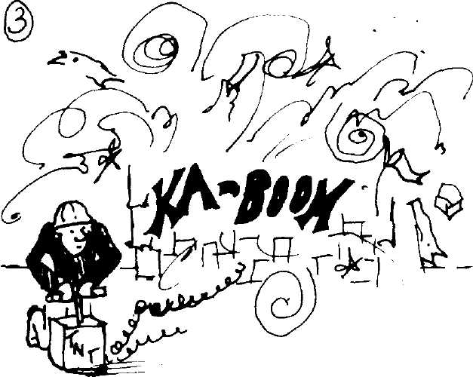

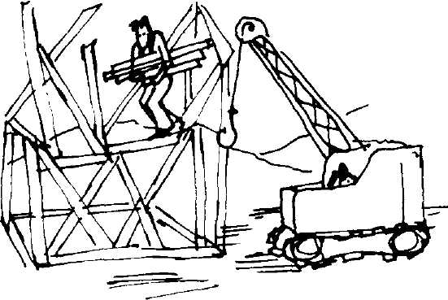
e

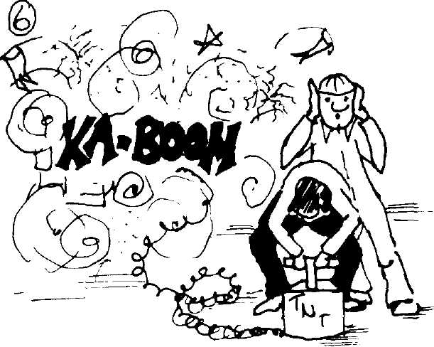
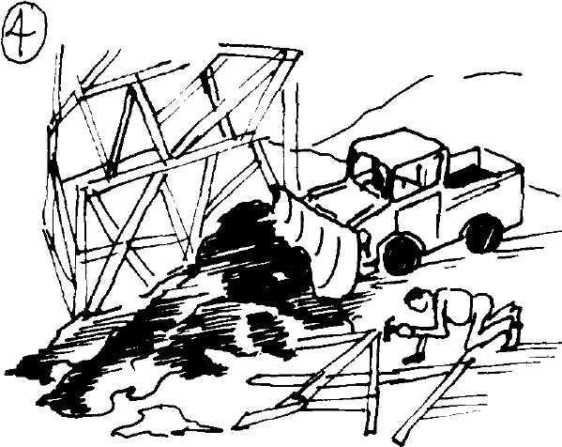

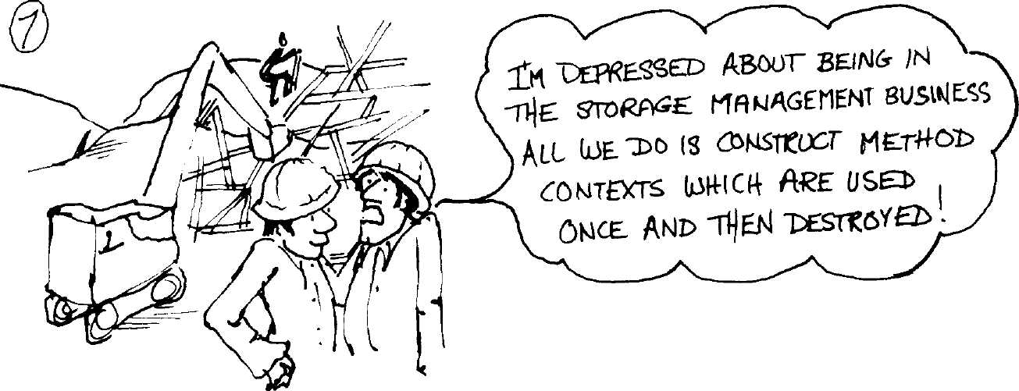

The Analysis of the
Smalltalk-80 System at
Hewlett-Packard *
Joseph R. Falcone
Computer Research Center
Hewlett-Packard Laboratories
Palo Alto, California

Introduction
The implementation of Smalltalk at Hewlett-Packard Laboratories was
the principal component of an investigation into personal computing
environments. As we developed the implementation, we continually an-
alyzed its performance to achieve a better understanding of the system.
This program began in earnest in March of 1981 when we embarked on
the first implementation. By November, the entire project was winding
down and we placed more emphasis on performance analysis to com-
plete it before the end. When the project closed in February of 1982, we
had developed a vast body of performance data, collected by both pro-
grams and people. Since then only the performance analysis has contin-
ued (as an unofficial part-time activity). The HP Smalltalk project is
described in more detail in Chapter 6.

Approach
The Smalltalk-80 system is difficult to measure, given the variability of
user interaction which is fundamental to it. Repeating the identical test
twice was nearly impossible so we designated a general collection of
The views expressed herein are those of the author, and do not necessarily represent the
position of Hewlett-Packard or any commitment to products or services. Copyright ©
Joseph R. Falcone, 1982. All rights reserved.

208
The Analysis of the Smalltalk-80 System at Hewlett-Packard
tasks as the basic test, touching all of the capabilities of the system at
least once according to our view of personal computer usage patterns.
During this test, the browser, compiler, decompiler, and window system
are exercised in every conceivable way. With full performance monitor-
ing, the test covers millions of bytecodes and takes over six hours. Our
test should not be confused with the testStandardTests benchmarks.
Early investigative work on our system used the testStandardTests
benchmarks until we noticed that the results bore little relation to sta-
tistics gathered from normal usage. Hence we felt that it was not useful
as a personal computing performance test.
In the following sections, we present measurements of the system
compiled from many basic test experiments. The measurements cover a
wide variety of system functions, from bytecode frequencies to memory
access. These figures are probably accurate to within 10% for different
mixes of Smalltalk-80 code. We conducted these tests on a pre-release
version of the Smalltalk-80 system.

Bytecode
Measurements
Table 12.1 Smalltalk-80 Virtual Machine Bytecode Frequency

Static %
SVM Bytecode
push temporary variable 0
push self (receiver)
return stack top from message
push temporary variable 1
send +
push temporary variable 2
push constant 1
send literal 0 with no args
pop stack top
send at:
jump on false 0*256 + next
push receiver variable 1
push receiver variable 0
send = =
send —
extended pop and store (all)
push constant nil
return self (receiver)
send < =
Dynamic % Cumulative

6.25% | 6.48% | 6.48%
6.28% | 5.73% | 12.21%
3.22% | 4.94% | 17.15%
3.39% | 4.74% | 21.89%
1.19% | 3.65% | 25.54%
2.12% | 3.46% | 29.00%
2.61% | 3.26% | 32.26%
1.66% | 2.57% | 34.83%
7.03% | 2.42% | 37.25%
0.77% | 2.06% | 39.31%
0.86% | 1.93% | 41.24%
0.97% | 1.72% | 42.96%
0.97% | 1.70% | 44.66%
0.90% | 1.62% | 46.28%
0.83% | 1.61% | 47.89%
1.09% | 1.51% | 49.40%
1.33% | 1.48% | 50.88%
2.55% | 1.43% | 52.31%
0.18% | 1.32% | 53.63%

209
 |  | Bytecode | Measurements
 | Table 12.1 (Cont.)
SVM Bytecode | Static % | Dynamic % | Cumulative
extended push (all) | 0.68% | 1.32% | 54.95%
jump -1*256 + next | 0.27% | 1.29% | 56.24%
pop and store temporary 1 | 0.87% | 1.27% | 57.51%
push constant 0 | 1.87% | 1.26% | 58.77%
push temporary variable 3 | 1.27% | 1.18% | 59.95%
extended store (all) | 0.81% | 1.17% | 61.12%
pop and branch on false 2 | 0.76% | 1.15% | 62.27%
push temporary variable 6 | 0.42% | 1.10% | 63.37%
send literal 1 with no args | 1.21% | 1.05% | 64.42%
push receiver variable 14 | 0.20% | 1.05% | 65.47%
pop and store temporary 2 | 0.71% | 1.03% | 66.50%
send > | 0.32% | 0.96% | 67.46%
send = | 0.91% | 0.94% | 68.40%
push temporary variable 4 | 0.82% | 0.88% | 69.28%
send literal 0 with 1 arg | 1.63% | 0.85% | 70.13%
all others (213) | 41.91% | 29.87% | 100.00%
Table 12.1 lists the static and dynamic frequencies of the Smalltalk-80
virtual machine instruction set. This distribution is remarkably uni-
form. Most dynamic instruction frequencies show at least one instruc-
tion at over 10%\ but the highest in the Smalltalk-80 virtual machine
is only 6.48% for pushing a temporary onto the stack, usually
performed to work on an argument passed through the temporary vari-
able area. However, as the following section will show, there is some
regularity by category of bytecodes. The top 17 bytecodes consume more
than 50% of execution and the top 34 are over 70% out of 247 designat-
ed bytecodes.
Pop stack top had the highest static frequency even though it was
ninth in execution. The top three bytecodes in static frequency comprise
one-fifth of all generated code. After that there is a steep drop and no
bytecode rises above 3.39%. The less popular instructions tend to have
higher static frequencies. Outside of the top 30, the bytecodes have a
static/dynamic frequency ratio of 4 to 3.
There are 9 unused bytecodes in the Smalltalk-80 virtual machine
instruction set, and the system never executed 18 other bytecodes in
our tests. Twelve of these instructions were long jumps, and all were
the longer varieties. The current Smalltalk compiler does not generate
the pop and jump on true instructions. This is apparently to simplify
the task of the decompiler. The other six untouched instructions were
pushes and sends concerned with somewhat rare circumstances.
210
The Analysis of the Smalltalk-80 System at Hewlett-Packard
Table 12.2 Bytecode Frequency by Category

Bytecode Category Static % Dynamic % Cumulative
44.01% | 44.37% | 44.37%
29.00% | 28.63% | 73.00%
13.32% | 10.80% | 83.80%
6.50% | 8.59% | 92.39%
stack push
message send
stack pop and store
branch and jump
return 7.17% 7.61% 100.00%
Table 12.2 groups the bytecodes into five categories for static and dy-
namic frequencies. The importance of message sends in Smalltalk is ev-
ident, but this can be misleading. The percentage of sends is so large
because it includes both procedure calls and arithmetic and logical op-
erations (note the absence of a computational instruction category).
Also, because many of the sends are special or primitive operations
which do not result in the execution of Smalltalk code, the percentage
of return instructions is much lower.
Stack operations account for 55.17% of instructions executed, and
71.37% are instructions other than sends. The frequency of stack push
and pop instructions points out the necessity of having an optimized in-
dependent path to the stack frame of the active context.
Although the message send is perhaps the most important part of
Send Bytecodes Smalltalk, it comprises only about one-quarter of execution time. More
importantly, nearly half are special sends which do not require a diction-
ary lookup for their selector. These special sends perform functions
which are typically in the instruction set of a processor, such as arith-
metic and logical operations for small integers.
Approximately every third instruction is a message send and sends
requiring dictionary lookups occur every 6.67 bytecodes. Of the sends
needing dictionary searches, 36.64% invoked primitives, and the rest
resulted in the execution of a Smalltalk method which, along with pro-
cess switches, accounted for a context switch every 6.50 bytecodes.
Of the special sends, 78.92% are arithmetic and logical operations.
The remaining special sends fell further into the minority by a change
in the third test image release which required 11 of the 16 cases to look
up the selector in a special messages array rather than invoking a
primitive directly. As a result, some of these special sends actually re-
sult in the execution of Smalltalk code if the selector in the array does
not bind to a primitive for the receiver in question. Of course this al-
lows one to dynamically modify system behavior or to change this set of
primitives if future requirements should dictate. These other special
sends include high level operations such as instantiation, indexing,
length and class query, block evaluation, and point coordinates.

1

Bytecode Measurements

Table 12.3 Frequency of Message Sends by Flavor
Flavor of Send Percentage Cumulative Percentage
66.86% | 66.86%
21.42% | 88.28%
11.72% | 100.00%
primitive
method
pseudo-primitive
There are three flavors of message sends:
Primitive Those which invoke C or machine code routines.
Method Those which activate Smalltalk code.
Pseudo-primitive Those which return directly after performing an operation
encoded in the header of the compiled method.
The method sends are the best known of those in Table 12.3. At about
one-fifth of all sends executed, this indicates the amount of optimization
possible through the proper choice of the set of primitives. The pseudo-
primitives, which offer an inexpensive way to access instance fields, ex-
ecute half as frequently as traditional method sends. In all, 78.58% of
sends do not immediately result in the execution of Smalltalk code. This
does not take into account those primitives which fail and then activate
Smalltalk backup code (discussed later).
Table 12.4 Frequency of Primitive Method Invocations by Type

Type of Primitive | Percentage | Cumulative Percentage
arithmetic | 56.30% | 56.30%
selector | 28.66% | 84.96%
common | 15.04% | 100.00%
Primitive invocations also break down into three categories:
Arithmetic Arithmetic and logical operations invoked with no lookup.
Common Operations invoked without lookup in the special messages
array.
Selector Those sends where selector lookup associated a primitive
with the method.
As one might expect, the arithmetic primitive invocations dominate the
statistics in Table 12.4. Overall, 71.34% of primitive invocations are di-
rect from bytecode dispatch and require no special handling.

212
The Analysis of the Smalltalk-80 System at Hewlett-Packard
Table 12.5 Failures of Primitive Methods by Type
Type of Primitive Percentage Cumulative Percentage
arithmetic 81.36% 81.36%
selector 15.93% 97.29%
common 2.71% 100.00%
Several interesting figures arise from Table 12.5 which shows primitive
failures by type. Only 4.49% of primitive operations fail, and most of
these are the result of small integer arithmetic range violations. In fact,
arithmetic primitives are 2.6 times more likely to fail than selector
primitives and 8 times more likely than common primitives. The true
figure for arithmetic failures is probably even higher because we did
not implement certain primitives in the selector category (e.g., large in-
teger arithmetic) and an invocation of one of them leads directly to a
primitive failure. Still the failure rate for arithmetic primitives is only
6.49%, a testament to the utility of signed 15-bit arithmetic.
Table 12.6 Frequency of Message Sends by Flavor
(adjusted for primitive failures)
Flavor of Send Percentage Cumulative Percentage
successful primitive 63.86% 63.86%
method and primitive backup 24.42% 88.28%
pseudo-primitive 11.72% 100.00%
Comparing Table 12.6 with Table 12.3, we see that primitive failures
account for only a three percent increase in the number of Smalltalk
methods activated. This is a very small price to pay for significantly
better performance than equivalent Smalltalk routines.
Table 12.7 Send Bytecode Frequency by Category

Send Category | Static % | Dynamic % | Cumulative
special arithmetic | 19.00% | 37.65% | 37.65%
selector send | 53.81% | 32.71% | 70.36%
common send | 19.74% | 27.21% | 97.57%
extended selector | 7.45% | 2.43% | 100.00%
The SVM send instructions fall into the four categories listed in Table
12.7.
________ 213
Bytecode Measurements
- Special Arithmetic. Arithmetic and logical operations invoked
with no selector lookup. Their dynamic frequency is twice the stat-
ic, indicating the popularity of these operations. Together with the
common send instructions, these dominate dynamic frequency at
over 64%.
- Common Send. Special operations which either execute directly
(five cases) or indirectly through the lookup of a selector in the
special messages array. Although these bytecodes have a higher
static frequency than special arithmetic sends, they execute 10%
less of the time.
- Selector Send. An instruction specifying where the selector is
found in the literal frame of the compiled method. These sends
can access the first 16 literal selectors in the compiled method,
and they take 0, 1, or 2 arguments. The static frequency concurs
with our flavor analysis as selector send bytecodes constitute more
than 50% of all sends in methods, but less than one-third of exe-
cution.
- Extended Selector. These are 2- and 3-byte extended versions of
the regular selector sends for greater literal access range and/or
larger numbers of arguments. They come in two flavors: one is an
ordinary message send to receiver; the other starts message look-
up in the superclass of the receiver. The 2-byte version can access
the first 16 selectors with 0 to 7 arguments. The 3-byte version al-
locates a byte to the selector index and the argument count, with
a range of 0 to 255 for each. These are rarely executed so their
static frequency is triple the execution rate.
Table 12.8 Send Bytecode Frequency

Send Bytecode | Static % | Dynamic % | Cumulative
+ | 4.10% | 12.14% | 12.74%
selector 0, no args | 5.84% | 9.01% | 21.75%
at: | 2.67% | 7.18% | 28.93%
= = | 3.11% | 5.66% | 34.59%
— | 2.87% | 5.64% | 40.23%
< ₌ | 0.64% | 4.61% | 44.84%
selector 1, no args | 4.16% | 3.66% | 48.50%
> | 1.09% | 3.38% | 51.88%
= | 3.13% | 3.28% | 55.16%
selector 0, 1 arg | 5.61% | 2.97% | 58.13%
X | 0.56% | 2.73% | 60.86%
y | 0.45% | 2.71% | 63.57%
selector 0, 2 args | 1.93% | 2.42% | 65.99%

214
The Analysis of the Smalltalk-80 System at Hewlett-Packard

 | Table 12.8 (Cont.)
Send Bytecode | Static % | Dynamic % | Cumulative
selector 1, 1 arg | 3.10% | 2.17% | 68.16%
@ | 2.11% | 2.07% | 70.23%
all others (66) | 58.63% | 29.77% | 100.00%
Table 12.8 is a closer look at the send bytecodes. Addition ( + ) is the
most popular message sent, executing at triple its static frequency.
However, a selector send follows closely revealing the importance of the
more flexible versions in spite of all the special cases. The next two
entries in the table are primitive sends for array access (at:) and object
equivalence (= =). The three other primitive sends in the table all deal
with points—creation and access. The graphical nature of the
Smalltalk-80 user interface increases the use of the coordinate point so
that messages for point handling account for over 7.5% of all messages
sent. Overall, the selector sends have much higher static frequencies
than the rest.
Table 12.9 Special Arithmetic Send Bytecode Frequency

Bytecode
bitAnd:
bitShift:
II
bitOr:
/
Static %
21.56%
15.11%
3.35%
5.74%
16.47%
11.12%
4.92%
2.01%
1.96%
1.94%
1.53%
3.35%
6.24%
2.68%
0.29%
1.75%
Dynamic % Cumulative
33.85%
14.96%
12.26%
8.96%
8.71%
5.50%
4.53%
2.62%
2.42%
1.79%
1.57%
1.06%
0.86%
0.63%
0.26%
0.02%
33.85%
48.81%
61.07%
70.03%
78.74%
84.24%
88.77%
91.39%
93.81%
95.60%
97.17%
98.23%
99.09%
99.72%
99.98%
100.00%

The statistics for special arithmetic sends in Table 12.9 are comparable
to those for the computational instructions of conventional languages
and architectures². Additions occur over one-third of the time, and to-

215
Bytecode Measurements
gether with subtractions, comprise nearly half of arithmetic send execu-
tion. The sixth entry is a bit unusual—an instruction for creating a
point from the receiver as the X value and the argument as the Υ val-
ue. Multiplication and division account for only about 3.5% of special
arithmetic sends. The static and dynamic frequencies show interesting
differences. The execution frequency of < = is four times the static,
while the opposite is true for @ and = where the static frequencies are
twice the dynamic. The multiplication bytecode is fifth in static fre-
quency with a rate eight times its execution percentage.
Table 12.10 Common Send Bytecode Frequency

Bytecode
at:
y
value:*
size
blockCopy:"
new
at:put:
class*
nextPut:
value*
new:
next
atEnd

Static % | Dynamic % | Cumulative
13.51% | 26.41% | 26.41%
15.77% | 20.81% | 47.22%
2.85% | 10.02% | 57.24%
2.26% | 9.95% | 67.19%
2.09% | 6.86% | 74.05%
9.71% | 4.91% | 78.96%
19.29% | 4.75% | 83.71%
10.59% | 4.57% | 88.28%
7.18% | 3.38% | 91.66%
2.90% | 3.05% | 94.71%
4.95% | 1.87% | 96.58%
2.67% | 1.48% | 98.06%
4.40% | 1.47% | 99.53%
1.77% | 0.47% | 100.00%
0.00% | 0.00% | 100.00%

Table 12.10 lists the frequencies for common send bytecodes. The selec-
tors marked by an asterisk in the table are those messages which do
not require any dictionary lookup before invoking a primitive. Those
without the asterisk get their selectors from a special messages array
and then proceed via the normal send process. Array access (at:) and ob-
ject equivalence (= =) constitute nearly one half of common send exe-
cution. Although array element loads (at:) are eight times more
frequent than array element stores (at:put:), the opposite is true for
streams. Writes on streams (nextPut:) are four times more frequent than
reads (next). Nearly all of the common send instructions show signifi-
cant differences between static and dynamic frequencies, ranging as
high as a 4 to 1 ratio in both directions.

216
The Analysis of the Smalltalk-80 System at Hewlett-Packard
Table 12.11 Primitive Method Invocation Frequency
(excluding arithmetic primitives)

Class & Primitive | Percentage | Cumulative Percentage
< Object > at: | 25.89% | 25.89%
< Object > = = | 19.91% | 45.80%
< BlockContext > value | 8.10% | 53.90%
< Object > size | 7.78% | 61.68%
< String > at: | 5.76% | 67.44%
< Object > at:put: | 5.75% | 73.19%
< BlockContext > blockCopy: | 4.38% | 77.57%
< Behavior > new | 4.25% | 81.82%
< Object > class | 2.81% | 84.63%
<BitBlt> copyBits | 2.47% | 87.10%
all others (31) | 12.90% | 100.00%
The 10 primitive methods in Table 12.11 total nearly 90% of all invoca-
tions. Array, string, and stream access account for nearly 40% of these.
With a few exceptions, the leading non-arithmetic primitives perform
very simple functions. The most notable exception is copyBits, a very
complex primitive made even more so because of our external graphics
display system. Two of the primitives manage block execution and ac-
count for over 12% by themselves.
Table 12.12 Superclass Chain Traversals by Length

Length of Traversal
- (receiver)
- (superclass)
2
3
4
5
7
6
8, 9 & 10
Percentage Cumulative Percentage

56.20% | 56.20%
17.36% | 73.56%
6.72% | 80.28%
6.18% | 86.46%
5.33% | 91.79%
4.32% | 96.11%
2.11% | 98.22%
1.67% | 99.89%
0.11% | 100.00%

Table 12.12 gives the number of links traversed to look up messages in
the dictionaries of superclasses. The zero category corresponds to mes-
sages understood by the class of their receiver and therefore no links
are traversed. The average traversal distance is 1.18, but the majority
of messages never go to the superclass. Nearly 14% search four or more
dictionaries, thus skewing the figures in that direction.

Table 12.13 Message Dictionary Probes by Number

Number of Probes
1 (direct hit)
2
4
3
5
9
8
12
23
6
all others (31)
Percentage Cumulative Percentage
61.16%
11.97%
4.71%
4.08%
2.54%
1.45%
1.41%
1.34%
1.28%
1.19%
8.87%
61.16%
73.13%
77.84%
81.92%
84.46%
85.91%
87.32%
88.66%
89.94%
91.13%
100.00%

The statistics in Table 12.13 for message lookup are for method cache
misses. Our method cache hit rate is 93% for a 509 element cache.
There is an average of 3.89 probes into each message dictionary after a
cache miss. Combined with the superclass chain traversals, each send
missing the cache requires an average of 8.48 probes of message diction-
aries, searching the message dictionaries of the class and superclass of
the receiver in the typical case. The appearance of figures over 10 in
the table is the result of very long hash collision chains. If a message
dictionary is nearly full this will happen, but it is more likely that the
very simple hash function used by Smalltalk is causing many collisions.

Push Category
temporary variable
special
receiver variable
extended (all)
literal variable
literal constant
Push and Pop
Bytecodes
Table 12.14 Push Bytecode Frequency by Category

Static % | Dynamic % | Cumulative
35.45% |  | 44.45%
33.95% | 29.57% | 74.02%
11.30% | 17.19% | 91.21%
1.54% | 2.97% | 94.18%
8.97% | 2.96% | 97.14%
8.79% | 2.86% | 100.00%

Push instructions can access four different memory areas in the
Smalltalk-80 execution environment:
1. Temporary Variable. The area just above the stack in a method
context is the temporary frame where the Smalltalk-80 language
passes arguments and allocates local and temporary variables.

Γ
The Analysis of the Smalltalk^) System aTHe^Te^Packai
- Receiver Variable. The instance variables of the receiver of the
message.
- Literal Variable. A variable accessed through a pointer to an asso-
ciation in the literal frame of a compiled method.
- Literal Constant. A constant value in the literal frame of a com-
piled method.
Table 12.14 lists the frequencies of these plus the special push instruc-
tions for frequently used constants and environment values, such as self
(the receiver of the current message). The extended category includes
all four flavors of push instructions. The static frequencies for literal
access are triple the execution rate, which is less than 6%. Literal con-
stant access is particularly low because of the push constant instruc-
tions for 2, 1, 0, —1, false, true, and nil. These seven bytecodes alone
constitute 15.71% of all pushes.
The access ranges of push instructions vary. The standard temporary
and receiver variable push instructions can access the first 16 entries,
while the literal frame pushes have a range of 32. The extended push
instructions can access up to 64 entries. When this range is not enough,
other tactics are necessary. For example, to access instance variable
number 73 of the receiver, we can do the following:
- Push self [the Oop of the receiver]
- Push literal constant η [73]
- Send at:
This takes two pushes and a primitive invocation, so one can appreciate
the value of the extended push instructions.
Table 12.15 Push Bytecode Frequency

Push Bytecode
temporary variable 0
self (receiver)
temporary variable 1
temporary variable 2
constant 1
receiver variable 1
receiver variable 0
constant nil
extended (all)
constant 0

Static % | Dynamic % | Cumulative
14.19% | 14.61% | 14.61%
14.26% | 12.92% | 27.53%
7.70% | 10.70% | 38.23%
4.81% | 7.79% | 46.02%
5.92% | 7.34% | 53.36%
2.20% | 3.88% | 57.24%
2.19% | 3.82% | 61.06%
3.03% | 3.33% | 64.39%
1.54% | 2.96% | 67.35%
4.24% | 2.84% | 70.19%

Push Bytecode
temporary variable 3
temporary variable 6
receiver variable 14
temporary variable 4
receiver variable 2
temporary variable 7
temporary variable 5
literal variable 2
all others (85)

tatic % | Dynamic % | Cwnulath
2.89% | 2.67% | 72.86%
0.95% | 2.48% | 75.34%
0.46% | 2.35% | 77.69%
1.87% | 1.99% | 79.68%
1.75% | 1.65% | 81.33%
0.59% | 1.62% | 82.95%
1.40% | 1.49% | 84.44%
2.10% | 1.30% | 85.74%
27.91% | 14.26% | 100.00%

Pushes involving the receiver and the first three temporary slots ac-
count for nearly half of execution in Table 12.15. These top four entries
correspond roughly to usage of the first four parameters or local vari-
ables in an ordinary language subroutine. After the special push of con-
stant 1, there is a steep drop in execution percentage. There is little
disagreement between static and dynamic frequencies for these instruc-
tions.
Table 12.16 Special Push Bytecode Frequency

Special Push Bytecode
self (receiver)
constant 1
constant nil
constant 0
constant 2
active context
constant false
constant true
constant —1
stack top

Static % | Dynamic % | Cumulative
42.00% | 43.70% | 43.70%
17.45% | 24.82% | 68.52%
8.92% | 11.26% | 79.78%
12.50% | 9.61% | 89.39%
4.02% | 3.98% | 93.37%
7.59% | 3.13% | 96.50%
3.11% | 1.91% | 98.41%
1.97% | 1.45% | 99.86%
0.53% | 0.09% | 99.95%
1.91% | 0.05% | 100.00%

The special pushes offer a shortcut for popular push operations. When
it determines a value to be constant, the compiler can use the special
push instructions to avoid additional memory accesses and to conserve
space in the literal frame where it usually puts constants. However, in
some cases the special pushes are the only mechanism for reaching cer-

220
The Analysis of the Smalltalk-80 System at Hewlett-Packard
tain environment values, such as the receiver of the current message
and the active context. In Table 12.16, push self accounts for over 40%
of special push execution, and the top four comprise nearly 90%. Both
push —1 and duplicate stack top have a combined static frequency of
nearly 2.5% (0.83% overall), but execute only once every 2400 pushes
(or 5400 bytecodes).

Table 12.17 Pop and Store | Bytecode Frequency by |  | Category
Pop & Store Category | Static % | Dynamic °/ | Ό Cumulative
pop and store temporary variable | 25.16% | 36.51% | 36.51%
pop stack top | 52.77% | 22.36% | 58.87%
pop and store receiver variable | 7.84% | 16.30% | 75.17%
extended pop and store (all) | 8.15% | 13.96% | 89.13%
extended store (all) | 6.08% | 10.87% | 100.00%
The pop and store instructions in Table 12.17 roughly parallel the push
operations, with a few differences. The SVM prohibits storing directly
into the literal frame of compiled methods, but one can modify literal
variables through their association in the literal frame via the extended
pop and store instructions. In addition, the range of the regular pop and
store instructions for temporary and receiver variables is 8 entries in-
stead of 16. Because of these factors, the extended versions of the in-
structions total nearly 25% of all pop and stores executed. The pop
stack top bytecode is also almost one-quarter, leaving regular tempo-
rary and receiver variable access at a little over half. The story is dif-
ferent for static frequencies where pop stack top leads at over 50%,
more than double its dynamic rate. The other categories show dynamic
frequencies from 40% to 100% higher than their static figures.
The difference in execution between loads and stores on this system
is interesting. The figures for temporary and receiver variable opera-
tions are very similar. However, the extended pop and store instruc-
tions execute over eight times more frequently than extended pushes
(24.83% vs. 2.97%). This is because the only way to modify literal vari-
ables is through the extended pop and store instructions, whereas there
is a separate regular bytecode for pushing literal variables. In addition,
as noted, the range of pop and store instructions is more limited, hence
forcing the use of extended instructions more frequently. Finally, pop-
ping the stack top is almost 500 times more frequent than duplicating it
(22.36% vs. 0.05%).
221
 |  | Bytecode Measurements
Table 12.18 Pop | and Store Bytecode Frequency
Pop & Store Bytecode | Static % | Dynamic % | Cumulative
pop stack top | 52.77% | 22.36% | 22.36%
extended pop and store (all) | 8.15% | 13.96% | 36.32%
temporary variable 1 | 6.53% | 11.76% | 48.08%
extended store (all) | 6.08% | 10.87% | 58.95%
temporary variable 2 | 5.36% | 9.53% | 68.48%
receiver variable 1 | 1.57% | 4.36% | 72.84%
receiver variable 0 | 1.61% | 3.99% | 76.83%
receiver variable 4 | 0.87% | 3.44% | 80.27%
temporary variable 6 | 1.50% | 3.26% | 83.53%
temporary variable 4 | 2.22% | 3.11% | 86.64%
temporary variable 3 | 3.23% | 2.89% | 89.53%
temporary variable 7 | 0.82% | 2.82% | 92.35%
all others (7) | 9.29% | 7.65% | 100.00%

Return, Branch,
and Jump
Bytecodes
Table 12.18 provides a more detailed look at the pop and store
bytecodes. Temporary variable 0 is not among the top 12, and in gener-
al, the frequency of variable access is not in numeric sequence. In fact,
pop and store operations on temporary variable 1 are six times more
frequent than those on variable 0 (11.76% vs. 1.82%). This indicates
that methods manipulate temporary variables more than arguments,
since temporary slot 0 is usually occupied by the first message parame-
ter.
The system spends nearly one-sixth of execution on these transfer of
control instructions. The return bytecodes are the most sophisticated of
them, having to reset the sender as the active context upon leaving a
method. The special case sends have diminished the importance of re-
turns by relegating their use to the relatively small percentage of meth-
od sends. We divide the other control transfer bytecodes into branches
for the single-byte short versions and jumps for the multiple-byte long
ones. These are not very significant either because the tiny size of
Smalltalk methods leaves precious little space for much transfer of con-
trol.

Table | 12.19 Return Bytecode | Frequency
Return Bytecode | Static % | Dynamic % | Cumulative
stack top from Method | 44.90% | 64.83% | 64.83%
self | 35.54% | 18.82% | 83.65%
stack top from Block | 14.08% | 8.10% | 91.75%

222
The Analysis of the Smalltalk-80 System at Hewlett-Packard
Table 12.19 (Cont.)
Return Bytecode Static % Dynamic % Cumulative

false
true
nil

2.30% | 5.59% | 97.34%
1.78% | 2.63% | 99.97%
1.40% | 0.03% | 100.00%

Nearly three-quarters of all methods and blocks return top of stack as
shown in Table 12.19. Most of the rest return self, while a very tiny
portion return nil. Although the default return for Smalltalk-80 code is
self, such returns account for less than 20%. The static frequencies of
return self and stack top from block are nearly double their execution.
At the other end, only one of every 3300 methods returns nil, raising
doubts as to the value of this variant, which is executed once every
43,802 bytecodes on average.

Table 12.20 Branch | and Jump Bytecode | Frequency by | Category
Branch & Jump Category | Static % | Dynamic % | Cumulative
pop and branch on false | 40.71% | 49.50% | 49.50%
pop and jump on false | 13.21% | 22.56% | 72.06%
jump | 27.46% | 21.42% | 93.48%
branch | 18.62% | 6.52% | 100.00%
pop and jump on true | 0.00% | 0.00% | 100.00%
Because Smalltalk-80 methods tend to be very short, one expects to find
low execution frequencies for long jumps, and the data in Table 12.20
concurs. However, the most frequent unconditional transfers are the
long jumps, outnumbering short branches by more than three to one.
Overall, the conditional and unconditional short branches account for
57.02% of transfers. The conditional branches and jumps execute over
two and a half times more frequently than the unconditional ones. As
noted before, the current compiler does not use the pop and jump on
true instruction.
Table 12.21 Branch and Jump Bytecode Frequency
Branch & Jump Bytecode Static % Dynamic % Cumulative
jump 0*256 + next 13.21% 22.56% 22.56%
jump -1*256 + next 4.21% 15.01% 37.57%
pop and branch on false 2 11.63% 13.38% 50.95%

Table 12.21 (Cont.)

Branch & Jump Bytecode
pop and branch on false 4
pop and branch on false 3
pop and branch on false 6
jump 0*256 + next
pop and branch on false 1
pop and branch on false 5
branch 1
pop and branch on false 8
all others (9)

itatic % | Dynamic % | Cumulative
7.76% | 8.53% | 59.48%
6.65% | 7.33% | 66.81%
2.78% | 6.59% | 73.40%
23.20% | 6.39% | 79.79%
3.16% | 5.10% | 84.89%
4.60% | 4.77% | 89.66%
8.15% | 3.44% | 93.10%
1.74% | 2.81% | 95.91%
12.91% | 4.09% | 100.00%

The first two entries in Table 12.21 comprise nearly 90% of all long
jumps executed. The rest of the table is dominated by the short condi-
tional branch instruction. There is little consistency to the static and
dynamic measurements. For the two unconditional long jumps in the
table, the backward jump executes at more than three times its static
frequency while the forward jump has a greater static frequency by
nearly four to one. The branches and jumps in the others category have
a low execution frequency but appear statically more than three times
as often.

Memory
System
Measurements
The performance of the object memory system is vital to a Smalltalk-80
implementation. We recognized this early, and we were able to improve
memory system performance substantially through regular analyses of
profile data. The following tables are the culmination of this effort.

Object/Class
Distribution
Class of Objects
CompiledMethod
Symbol
Array
String
Association
Point
ClassOrganizer
MethodDictionary

stem by Number ot Instances
Percentage | Cumulative Percentage
25.83% | 25.83%
21.84% | 47.67%
15.45% | 63.12%
9.11% | 72.23%
3.81% | 76.04%
2.91% | 78.95%
2.80% | 81.75%
2.80% | 84.55%

224
The Analysis of the Smalltalk-80 System at Hewlett-Packard
Table 12.22 (Cont.)

Class of Objects
Character
LargePositivel nteger
RemoteString
Metaclass
Float
TextLinelnterval
all others (296)

Percentage | Cumulative Percentage
1.66% | 86.21%
1.44% | 87.65%
1.40% | 89.05%
1.40% | 90.45%
1.33% | 91.78%
1.09% | 92.87%
7.13% | 100.00%

Table 12.22 ranks the classes in the system according to the number of
extant instances of each. Compiled methods and symbols (selectors)
comprise nearly half of the objects in the system, and over 75% of the
objects are instances of the top five classes. With over 200 classes in the
system, this indicates that many have very few instances. In fact,
56.48% of classes (excluding metaclasses) have no instances at all and
exist mainly for the behavior inherited by their subclasses; 26.38%
have exactly one instance (a system controller, object, or dictionary). In
all, 76.38% of all classes have fewer than 10 instances. This is a result
of a particular style of Smalltalk programming making extensive use of
an existing set of basic classes and certain paradigms.

Table 12.23 Classes in the System by Memory Usage
Class of Objects Percentage Cumulative Percentage
34.69% | 34.69%
13.19% | 47.88%
11.72% | 59.60%
9.76% | 69.36%
9.74% | 79.10%
8.62% | 87.72%
4.18% | 91.90%
0.88% | 92.78%
0.77% | 93.55%
0.62% | 94.17%
0.60% | 94.77%
5.23% | 100.00%
CompiledMethod
Array
Symbol
DisplayBitmap
String
Bitmap
MethodDictionary
ClassOrganizer
Metaclass
Dictionary
Association
all others (296)
Table 12.23 lists the classes by the amount of memory used by their in-
stances. Compiled methods and symbols occupy nearly half the object
space. The percentage for DisplayBitmap depends on the size of the dis-
play screen currently in use. In our case, a 640 χ 480 pixel bit map was

Type of Access
load pointer
store pointer
load word
store word
load byte
store byte
Object Memory
Access
active. The leading classes result from code (CompiledMethod Arrav
Symbol, MethodDictionary and Metaclass) at 64.55% and '
(DisplayBitmap and Bitmap) at 18.38% for a total of 82.93%.
Table 12.24 Object Memory Accesses by Type

Percentage | Cumulative Perc
72.45% | 72.45%
14.84% | 87.29%
7.59% | 94.88%
4.82% | 99.70%
0.23% | 99.93%
0.07% | 100.00%

The load pointer and store pointer routines fetch and store object point-
ers in memory. The word and byte routines deal only with non-pointer
16- and 8-bit quantities. Because our interpreter caches the instruction
and stack pointers, the memory access figures in Table 12.24 include
neither stack push/pop operations nor bytecode instruction fetch. How-
ever, those aspects of execution have well-defined behavior and are - iry
easy to monitor. The bias introduced by such factors can be significant.
For example, if we include bytecode fetches with the other memory
accesses, the share of load byte operations increases from 0.23% to
16.90%. This bias tends to cloud the real issues (bytecode fetch, like
death and taxes, is inevitable).
These figures show load pointer dominating the memory accesses.
This is not surprising in an object-oriented memory system. Pointer ob-
ject accesses accounted for over 87% of all memory traffic. The memory
system must endure nearly five accesses per bytecode, a figure which is
due partly to the experimental nature of the system. A better imple-
mentation of the interpreter could reduce the number of accesses, but
that was not our goal.
Load and store operations occur 40 times more frequently for words
than for bytes. At 12.41% word accesses seem relatively high since they
are not used by the system for any common operations. Instead, the in-
frequent but massive bit map operations are responsible for this rate of
access.
Table 12.25 Load Pointer Operations by Class

Percentage
Class of Object
MethodContext
MethodDictionary
CompiledMethod
Array
Cumulative Percentage

27.55% | 27.55%
25.06% | 52.61%
15.70% | 68.31%
7.00% | 75.31%

226
The Analysis of the Smalltalk-80 System at Hewlett-Packard

 | Table 12.25 (Cont.)
Class of Object | Percentage | Cumulative Percentage
Class Array | 4.95% | 80.26%
BlockContext | 3.11% | 83.37%
Class String | 1.29% | 84.66%
Class LargePositivelnteger | 1.25% | 85.91%
all others (258) | 14.09% | 100.00%

The breakdown of load pointer operations by classes in Table 12.25
points out the memory intensive nature of some operations. The meth-
od and block context loads are for receiver and argument passing as
well as operations occurring while they are neither the active nor the
home context (since access to those are through a cache). The hash
probes to the selector portion of message dictionaries comprise part of
the method dictionary figure. The compiled method loads are from the
literal frame for constants, pointers, and selectors. The array accesses
correspond to the method pointer portion of the message dictionary—in
other words, the method Oop fetch after a successful cache hit or
search.
Table 12.26 Store Pointer Operations by Class
Class of Object Percentage Cumulative Percentage
MethodContext 81.96% 81.96%
BlockContext 8.43% 90.39%
Point 1.95% 92.34%
CompositionScanner 1.85% 94.19%
DisplayScanner 1.23% 95.42%
all others (102) 4.58% 100.00%
Context initialization, including receiver and argument passing, domi-
nates store pointer operations in Table 12.26. Again this does not in-
clude operations on home or active contexts. Graphics and text
manipulation consumes the remainder of the stores.
Table 12.27 Load Word Operations by Class
Class of Object Percentage Cumulative Percentage
69.30% | 69.30%
30.22% | 99.52%
0.40% | 99.92%
0.08% | 100.00%
DisplayBitmap
Bitmap
Float
Array

Bit map access constitutes over 99% of word object loads and stores
These bit maps come in two flavors: the bit map associated with the dis-
play and subsidiary bit maps used as graphics workspaces to prepare
material for BitBIt to the display bit map. In Table 12.27 the relatively
high percentage for Bitmap loads results from the transfer of their con-
tents to the display bit map. Accordingly, Table 12.28 shows that store
word operations are almost completely devoted to the display bit map,
the eventual recipient of all words loaded. This indicates that the ma-
jority of graphics operations do not warrant the use of subsidiary bit
maps, but rather operate directly on the display bit map.

Table 12.28 Store Word Operations by Class
Class of Object Percentage Cumulative Percentage
97.41% | 97.41%
2.06% | 99.47%
0.31% | 99.78%
0.11% | 99.89%
0.11% | 100.00%
DisplayBitmap
Bitmap
Float
Array
LargePositivelnteger
String processing accounts for nearly 75% of all byte loads in Table
- This is a result of the actions of the compiler, decompiler, and
text editor. For byte stores, string processing declines by one-third as
operations on large integer objects double their share to lead Table
- Compiled methods are rarely the subject of byte accesses, and in
general, byte accesses account for a tiny fraction of all types, mainly be-
cause the bytecode instruction fetches have direct access to the current
compiled method.

Table 12.29 Load Byte Operations by Class
Class of Object Percentage Cumulative Percentage
67.96% | 67.96%
25.46% | 93.42%
6.50% | 99.92%
0.08% | 100.00%
String
LargePositivelnteger
Symbol
CompiledMethod

228
The Analysis of the Smalltalk-80 System at Hewlett-Packard
Table 12.30 Store Byte Operations by Class

Class of Object Percentage Cumulative Percentage
52.26% | 52.26%
46.69% | 98.95%
0.66% | 99.61%
0.39% | 99.92%
LargePositivel nteger
String
CompiledMethod
Symbol

Table 12.31 Object Instantiation Types by Number
Allocation and
Instantiation Type of Instantiation Percentage Cumulative Percentage

pointer object
byte object
word object

98.34% | 98.34%
1.20% | 99.54%
0.46% | 100.00%

Pointer objects dominate the instantiation statistics in Table 12.31. Byte
objects show a relatively higher rate of instantiation than word objects,
probably because of the fine granularity of string processing. Such ex-
tremely lopsided statistics lead one to seriously question the need for
type distinctions between pointer and non-pointer objects.
Table 12.32 Object Instantiation Types by Amount
Type of Instantiation Percentage Cumulative Percentage
pointer object 99.11% 99.11%
word object 0.49% 99.60%
byte object 0.40% 100.00%
Table 12.32 shows the percentage of memory allocated to the three ob-
ject types. Pointer objects lead this category by an overwhelming mar-
gin with an even greater share than in Table 12.31. The next places are
reversed, with word objects taking second. Though the system instanti-
ates byte objects more frequently than word objects, the average word
object is more than three times larger. A breakdown by classes and
sizes will further clarify this situation.

229
Memory System Measurements

Table 12.33 Object Instantiations by Size in Words
Size of Instantiation Percentage Cumulative Percentage
83.86% | 83.86%
11.47% | 95.33%
1.90% | 97.23%
0.88% | 98.11%
1.89% | 100.00%
18 words
2 words
38 words
1 word
all others (98)
Instantiations are listed by object field size in Table 12.33. The three
most popular sizes exceed 97% of all instantiations, suggesting a corre-
lation with the preceding type figures. These sizes are those chiefly
used for small contexts, points, and large contexts, respectively.
Table 12.34 Average Instantiation Size by Type
Type of Instantiation Average Size in Words
pointer object 16.50 words
word object 14.53 words
byte object 6.67 words
all objects 16.38 words
From Table 12.34, the average allocation size is less than 17 words. The
memory system actually stores byte objects in words, sometimes wast-
ing an odd byte, as a relic from Xerox word-addressed memory architec-
tures. However, there are so few byte objects in the system that this
waste is not significant. The system averages about one instantiation
for every dozen bytecodes executed. This makes for an allocation rate of
1.4 words per bytecode.

Table 12.35 Pointer Object Instantiations by Class
Class of Object Percentage Cumulative Percentage
83.02% | 83.02%
8.32% | 91.34%
4.18% | 95.52%
2.25% | 97.77%
2.23% | 100.00%
MethodContext
Point
BlockContext
Rectangle
all others (79)

230 .
The Analysis of the Smalltalk-80 System at Hewlett-Packard
Method and block contexts comprise over 87% of pointer object instan-
tiations (Table 12.35). In Smalltalk, the system creates and activates a
method context for every non-primitive send, thus leading to their
prominent position in these statistics. Over 10% of instantiations are
for points and rectangles. Applications use points for screen manage-
ment, since they are the fundamental reference for graphics operations.

Table 12.36 Pointer Object Instantiations by Size
Size of Object Percentage Cumulative Percentage
85.28% | 85.28%
10.99% | 96.27%
1.93% | 98.20%
1.80% | 100.00%
18 words
2 words
38 words
all others (37)
In Table 12.36 note that point size objects (2 words) are more prevalent
than the large context size (38 words). The typically short methods of
Smalltalk rarely require the deep stack provided by a large context.
The preceding tables actually underestimate the dominance of con-
texts in memory allocation. Context instantiations consume nearly 97
out of every 100 words allocated by the system. This is because the av-
erage context size (18.44 words) exceeds the mean size for all other ob-
jects by 14.52 words, thus boosting the context share from 87% to 97%.
For pointer objects alone, if we exclude contexts the average object size
drops to 3.28 words.
Even though bit maps are the most frequently accessed word objects,
the system creates very few of them (only 3.69% of word object instan-
tiations). Floating point objects are the most frequently instantiated
word objects and their size (2) is the most popular, both at 96.31%. Most
bit maps were at least 100 words, but so few were created that there
was little impact on the average size of word objects. As evidence, the
average size of word objects instantiated, excluding those of size 2, was
341.72 words.

Table 12.37 Byte Object Instantiations by Class
Class of Object Percentage Cumulative Percentage
87.12% | 87.12%
12.59% | 99.71%
0.17% | 99.88%
0.12% | 100.00%
LargePositivel nteger
String
CompiledMethod
Symbol

Large integers lead byte object instantiations by a substantial
(Table 12.37), and together with strings, they encompass nearlyalTS
them. Smalltalk does create many large integers because certain system
functions use numbers greater than those small integer objects can con-
tain. A number of solutions are possible: redesign those system func-
tions to stay within the small integer range, implement the arbitrary
precision arithmetic primitives in firmware or hardware, or increase
the range of small integers through an implementation with 32-bit ob-
ject pointers.
Table 12.38 Byte Object Instantiations by Size in Bytes

Size of Object
- bytes
1 byte
4 bytes
0 bytes
- bytes
16 bytes
200 bytes
9 bytes
all others (94)

Percentage | Cumulative Percentage
37.91% | 37.91%
22.94% | 60.85%
16.39% | 77.24%
8.59% | 85.83%
2.46% | 88.29%
1.88% | 90.17%
1.10% | 91.27%
0.91% | 92.18%
7.82% | 100.00%

Memory
Reclamation
As one might expect, the byte object instantiations exhibited a more
uniform distribution of sizes than the other types (Table 12.38). This re-
flects the fact that text varies greatly even within an application, and
could vary with choice of identifiers, different user interfaces, or foreign
language systems.
Table 12.39 Reference Count Size by Amount of Memory Reclaimed
Size of Count Field
- bits
- bits
- bits
- bits
- bits
- bits

Percent of Memory Reclaimed
65.21%
83.34%
92.42%
95.67%
97.31%
99.87%

The number of bits necessary for reference counts can be important, es-
pecially for those considering hardware implementations of count
caches and managers (see Chapter 19). Table 12.39 shows that 4 bits

232
The Analysis of the Smalltalk-80 System at Hewlett-Packard
can reclaim over 90% of memory, while 6 bits can manage over 97%.
Because of the availability of fast byte access and arithmetic on our
host machines, our system uses an 8 bit reference count field in a 16-bit
header with additional separate permanent object and count overflow
or exemption flag bits. Using our reference-count verifier, we have
found only a few non-permanent object counts over 255, while some of
the permanent kernel objects have hundreds of references.
Table 12.40 Pointer Chasing for Count Down Operations by Depth

 | Percentage of | Cumulative
Count Down Extent | Count Downs | Percentage
exempt | 75.42% | 75.42%
decremented, > zero | 20.55% | 95.97%
sons exempt | 0.06% | 96.03%
son decremented, > zero | 3.52% | 99.55%
grandsons exempt | 0.20% | 99.75%
grandson decremented, > zero | 0.18% | 99.93%
deeper levels (12) | 0.07% | 100.00%
The most expensive side of the dynamic memory management scheme
involves reference count decrement and the possible pointer chasing
and object deallocation. There are nearly two reference count decre-
ments for every bytecode executed. Table 12.40 shows to what depth the
associated pointer chasing went during experiments with the system.
Objects with active reference counts accounted for 24.58% of count
down invocations and the other 75.42% were on small integers or ob-
jects exempt from count management (either permanent or count over-
flow). Only 4.03% of count down invocations resulted in a decrement to
zero and a subsequent deallocation for a rate of one every 13.61
bytecodes. Nearly all of these deallocations caused some pointer chasing
to decrement the counts of objects referenced from the fields of the now
dead object; the average depth of such pointer chases was 1.13 levels.
Table 12.41 Objects Disposed through Garbage Collection by Class

Class of Object
MethodContext
Process
BlockContext
Percentage of
Disposed
49.61%
18.74%
13.49%
Cumulative
Percentage
49.61%
68.35%
81.84%

233
System Specifications
Table 12.41 (Cont.)

Percentage of Cumulative
Class of Object _{Disposed} _{Percentage}
Disposed
String 3.83%
85.67%
f. , ^{241%} 88.08%
Association 2.06% ₉₀ _{U9}
all others (28) 9^ 10Q.oo% _
Table 12.41 lists the trouble makers: the objects which compose inacces-
sible cycles. The high ranking of contexts has to do with the problem of
passing a block context as an argument to a message and then having
it passed down the line a few levels of sends. When it is all over there
is usually a three or four context cycle (almost invariably with at least
one block context).

System The size of our implementation varies with the modules included in the
Specifications compilation. Table 12.42 lists the major system modules and their speci-
fications. The primitive methods use over four times as much code as
the bytecode interpreter itself. Although the memory and interpreter
modules contain only about one-quarter of the code, they contain al-
most all of the macros and over half of the procedures in the system.
We designed many of these procedures and macros as part of an imple-
mentation palette which we drew upon to build the system. As a result
of this approach, some of them actually are never used. The extent of
our development environment is apparent from its sheer size. The local
routine module contains implementation-dependent code for the graph-
ics device among other things.
Table 12.42 Module Specifications in the Hewlett-Packard Smalltalk-84
System
Module # of Macros # of Procedures # of Statements

primitive methods | 5 | 109 | 4600
development environment | 18 | 34 | 2300
object memory | 103 | 54 | 2000
local routines | 0 | 50 | 1300
bytecode interpreter | 88 | 22 | 1000
Totals | 214 | 269 | 11,200

234
The Analysis of the Smalltalk-80 System at Hewlett-Packard
The code size of our system ranges from 50 kilobytes in an optimized
version using procedures to 100 kilobytes for the multi-level debug ver-
sion using in-line macros. The static data area ranges from 300 to 500
kilobytes, and the dynamic allocation from 400 to 500 kilobytes. Total
memory usage falls between 750 kilobytes and 1 megabyte. The system
installed at HP Labs has 80 kilobytes of code, 350 kilobytes of static
data, and 400 kilobytes of dynamic data.
Throughout the implementation process, the execution profile of the
system changed continually. At the beginning of July, the system was
spending most of its time in the management of object memory. The top
14 procedures consumed 90% of execution time, and object memory
management accounted for over half of that. As the implementation
progressed, we steadily improved the performance of the most expen-
sive routines. For example, we were able to reduce the overhead of ob-
ject memory allocation and freeing to less than 6%. In our latest
version, the top 14 procedures consume less than two-thirds of the time
and one must add up the first 31 routines to reach 90%. One-quarter of
the time is spent in bytecode fetch, event recognition, and the execution
of all bytecodes except sends. The major object memory operations of al-
location, garbage collection, and reference count management consume
another 25%. The message send process takes 25% of the time, includ-
ing message binding and context initialization. Finally, primitive func-
tions use the final quarter of execution time.
Table 12.43 VAX Instructions Executed for Each Bytecode Category

Bytecode Category | Minimum | Maximum | Average
stack push | 11 | 33 | 16
stack pop and store | 2 | 47 | 28
return | 43 | 81 | 46
branch and jump | 3 | 13 | 11
message send | 33 | >1000 | 120
Recently we investigated the VAX assembly code generated from our C
modules. The main interpreter loop is 12 instructions long. Table 12.43
lists the additional instructions executed for each instruction category.
The cost of maintaining contexts as separate objects plus the message
lookup process contributed heavily to the relatively high figures for
sends and returns. The 15-bit signed arithmetic required for small inte-
ger objects was also very expensive to implement on the VAX.
The performance of the system also changed substantially over the
course of several months. By the first week in July 1981, our system

was executing around 500 bytecodes per CPU second
memory, and over 1000 bytecodes per CPU second with
week later we were at 750/1500 bytecodes per CPU se
memory versions). By early September, the interpreter
better than 2000 bytecodes per CPU second (fast memory ν^ΙοηΓίνο
weeks later it had increased to 2800 bytecodes per CPU a tv«
fifth version of HP Smalltalk boosted this to 4000 bytecodes d η
per
The final version of HP Smalltalk-84 performs at 5000
second on the average, with a peak rate around 25,000.

Table 12.44 Hewlett-Packard Smalltalk-84 testStandardTests Benchmark
Results

Test | Description | Iterations | Seconds | Speed
LoadlnstVar | load instance variable | 20,000 | 3.183 | 12,570
LoadLiterallndirect | load literal indirect | 20,000 | 3.500 | 11,430
LoadLiteralNRef | load literal constant | 20,000 | 3.350 | 11,940
LoadQuickConstant | load | 100,000 | 15.950 | 12,540
LoadTempNRef | load 1 as a temp | 20,000 | 3.384 | 11,820
LoadTempRef | load 0@0 | 20,000 | 3.851 | 10,390
PopStorelnstVar | store 1 in an inst. var. | 200,000 | 24.083 | 16,610
PopStoreTemp | store 1 in a temp | 200,000 | 23.600 | 16,950
16bitArith | add 20000 plus 20000 | 10,000 | 442.783 | 3730
3div4 | divide 3 by 4 | 100,000 | 36.320 | 11,010
3plus4 | add 3 plus 4 | 100,000 | 27.752 | 14,410
3times4 | multiply 3 times 4 | 100,000 | 30.884 | 12,950
LargelntArith | add 80000 plus 80000 | 1000 | 47.034 | 4000
ActivationReturn | activations and returns | 16,383 | 42.084 | 4090
ShortBranch | short branch on false | 100,000 | 14.850 | 26,940
WhileLoop | simple while loop | 10,000 | 7.800 | 11,540
ArrayAt | send at: to an array | 20,000 | 15.000 | 5330
ArrayAtPut | send at.put: to an array | 20,000 | 17.884 | 5590
Size | send size to a string | 20,000 | 11.367 | 5280
StringAt | send at: to a string | 20,000 | 17.284 | 4630
StringAtPut | send at:put: to a string | 20,000 | 18.983 | 5270
StringReplace | replace part of a string | 5000 | 67.385 | 4630
BlockCopy | send blockCopy: 0 | 20,000 | 22.000 | 3640
Class | send class to a point | 20,000 | 4.334 | 13,840
Creation | send new to Point | 20,000 | 16.608 | 3610
LoadThisContext | load a context | 20,000 | 4.620 | 8660
PointX | send χ to a point | 20,000 | 7.867 | 7630
StreamNext | send next to a stream | 20,000 | 23.934 | 2510

236
The Analysis of the Smalltalk-80 System at Hewlett-Packard

 | Table 12.44 (Cont. | )
Test | Description | Iterations | Seconds | Speed
StreamNextPut | send nextPut: to a stream | 20,000 | 28.534 | 2800
Value | send value to a block | 20,000 | 31.433 | 1910
Compiler | compile dummy method | 5 | 140.932 | 3890
Decompiler | decompile Form and Class | 1 | 645.200 | 3710
Inspect | create an inspector | 1 | 10.500 | 3540
TextFormatting | format a bunch of text | 5 | 63.633 | 4030
TextEditing | text replacement | 20 | 215.667 | 3120
Table 12.44 gives the results of running the testStandardTests set of
benchmarks on the HP Smalltalk-84 system. Note that this is an earli-
er version of the benchmarks than the one in the current Smalltalk-80
image. The table includes the time in seconds reported by Smalltalk for
running each entire test, and the speed of execution in bytecodes per
second. We ran the tests on a single-user VAX-11/780 with 4
megabytes main memory under 4.1BSD UNIX. The system was in a
normal configuration with display, keyboard, and mouse active. Clearly,
the primitive method situation is the most serious. The benchmarks for
primitive methods averaged about 5000 bytecodes per second, seriously
limiting opportunities for greater speed.

Conclusion
Our curiosity about the Smalltalk-80 system had lead us down a prim-
rose path. When the termination of the project washed away the path,
we traded in our programming language robes for the lab coats of the
pathologist. The result of our post mortem was simple: there was little
hope for performance high enough to lure users away from traditional
programming systems. Although we did not have the luxury of iterat-
ing and refining our implementation, the experience of those who did is
very discouraging. No one in the test program was able to achieve per-
formance considerably above 25 KIPS. Even with microcode assist, it is
difficult to imagine an implementation performing at better than 50%
of native mode operation. In our experience, though users like the
functionality of a Smalltalk system, they are unwilling to accept a sig-
nificant loss in performance.

237
References
Acknowledg- The analysis of the Smalltalk-80 system at Hewlett-Packard Laborato-
ments ries was basically a post-mortem. Nearly all of the work described in
this report happened after the project terminated. I appreciate the pa-
tience and understanding of my management during the period when I
spent my spare time generating and analyzing the body of statistics.
References _{L} _{Clark>} _{D} _{w} _{an(J} _{Leyy>} _{H} _{M} "Measurement and Analysis of In-
struction Use in the VAX-11/780", Proceedings of the Ninth An-
nual Symposium on Computer Architecture, pp. 9-17, Austin, TX,
1982.
2. Ibid.
Abstract
An Assessment of
Method-Lookup Caches
for Smalltalk-80
Implementations
Thomas J. Conroy
Eduardo Pelegri-Llopart
Computer Science Division
Department of Electrical Engineering and
Computer Sciences
University of California, Berkeley
A unique feature of the Smalltalk-80 language is the dynamic binding
of methods to a message based on the class of its receiver. This binding
requires a lookup of the selector in the message dictionaries of the su-
perclass chain for the receiver. A way to avoid this time-consuming pro-
cess is to cache the most frequently used information. In this paper, we
present an assessment of the cost effectiveness of this mechanism. A
theoretical analysis characterizes the behavior of the cache in terms of
variables dependent on both the particular implementation and on the
Smalltalk code being executed. One result is that the benefits of the
cache heavily depend on the relation of the speed of the implementa-
tion to the speed of the cache accesses, and also on the instruction mix
being executed. For software implementations of virtual machines, a
method-cache can greatly enhance performance. We then present the
implementation of the software method-cache in BS, the Smalltalk-80
implementation at UC Berkeley (see Chapter 11). Measurements from
this implementation show that the cache increased execution speed by
37%.
Copyright © Thomas J. Conroy and Eduardo Pelegri-Llopart 1982. All rights reserved.
239
240
An Assessment of Method-Lookup Caches for Smalltalk-80 Implementations

Introduction
A unique feature of the Smalltalk-80 language is the dynamic binding
of methods based on the class of the receiver. Conceptually, given a re-
ceiver and a message selector, the actions to perform are¹·²:
- Determine the class of the receiver,
- Search for the message selector in the message dictionaries of the
receiver's superclass chain, and
- Retrieve the method associated with the message selector in the
dictionary where the search succeeded.
A direct implementation of this lookup process is time-consuming since
a large number of bytecodes involve method-lookup. A solution to this
problem is to cache³ the result of the whole lookup process. A cache can
provide a fast by-pass of the lengthy search.
A method cache stores combinations of receivers and message selec-
tors, allowing look-ups to be retrieved quickly when the combinations
needed for the look-up are in the cache. For those combinations not
found in the cache, a full look-up has to be done. An additional over-
head present in caching is the cost of trying to keep the more frequent-
ly required combinations on the cache. Clearly, the feasibility of this
technique depends on how often the bypass succeeds and the relative
cost of each alternative.
The effect of the technique on the performance of an implementation
is related to the cost of look-ups, the cost of the remaining components
and the relative occurrence of each part. In this short paper we present
an assessment of this cache mechanism using a simple theoretical anal-
ysis and measurements from a software implementation of the
Smalltalk-80 virtual machine, (see Chapter 11).

Analysis
This analysis compares the behavior of a straightforward implementa-
tion of a Smalltalk-80 virtual machine to an implementation with a
method-cache. Subscripted capital letters represent virtual machine im-
plementation-dependent quantities, while greek letters represent
Smalltalk-80 code-dependent quantities. Specifically,
- A with a subscript represents the time for completing a method
look-up,
- S represents the number of bytecodes/second (speed), and

241
Analysis
• F represents the fraction of total time spent in doing method-look-
ups.
We stress the distinction between Smalltalk-80 code-dependent and im-
plementation-dependent quantities because the former are constants in-
dependent of the implementation. For example, implementations may
differ drastically in the number of bytecodes executed per second, but
for the same Smalltalk-80 code, the number of method-lookups per
bytecode would be identical. The following table lists the variables used
and their definitions.
Table 13.1 Parameters and Definitions
Implementation Dependent Values
A method lookup time for a cache miss*
miss "
A_{n} method lookup time without a cache
A_{hit} method lookup time for a cache hit
Implementation and Smalltalk Code Dependent Values
Α_{χΚ} average method lookup time for an xK entry method cache
S_{nc} number of bytecodes/sec without a cache
S_{xK} number of bytecodes/sec with an xK entry method cache
S _{f} ι the number of bytecodes/sec possible
optimal ** ^{l}
assuming zero access time for method lookup
F fraction of total time spent in lookup without a cache
F_{xK} fraction of total time spent in lookup with an entry xK cache
φ hit ratio (also depends on cache characteristics)
Smalltalk Code Dependent Values
β number of lookups/bytecode
* Strictly speaking, A_{miss} and A_{nc} also depend on the length of the superclass chain, and
hence on the Smalltalk code being executed.
An implementation will be characterized by: A and A,... S and A ,
* ^ miss nit' nc nc'
and ψ and β. These values, together with the equations shown below,
are used to obtain the remaining values of interest.
The fraction of time spent doing method lookups is related to the
number of lookups per bytecode, the lookup access time, and the num-
ber of bytecodes per second by the relationship F =Sy8A. Applying this
relationship to a cache and a non-cache implementation gives
F_{ne} = fiAJS_{nc} and F_{xK} = fiA_{xK}S_{xK}.
The average cache access is given by the usual relation
A_{xK} = <pA_{hit} + (l-<e)A_{miss}.
242
An Assessment of Method-Lookup Caches for Smalltalk-80 Implementations
The speed (bytecodes per second) depends partly on how much time is
spent in method lookup. S_{optimal} assumes the time to be zere.
If T_{optimal} and T_{nc} are the times required to execute Ν bytecodes at
speeds S_{optimal} and S_{nc}, then we have
Ν S Τ
ο __ ^{1V} °nc ^{J} nc
" optimal m
■imai T_{nc}-total lookup time
where total lookp time =Ny8A_{nc}.
Replacing total lookup time by its value, and simplifying, we obtain
ο " nc "nc
" optimal ^, ^ ~ο~Λ "ϊ Ε^ '
-*- " nc P**· nc -*■ " nc
Similarly, the speed of the cache implementation, S_{xK} is derived. The
difference is that the cache's average method lookup access time is used
instead of the non-cache access time.
If T_{nc} and T_{xK} are the times required to execute Ν bytecodes at
speeds S_{nc} and S_{xK} we have
AT Ο Τ¹
^{lv} " nc *- nc
ι? — ~~ — ~
T_{xk} T_{nc}— total time gained by caching
where total time gained by caching = Νβ{Α_{χΗ}—Α_{η(}.).
obtaining,
C _ "nc "nc
Using the equations above, the ratio S_{xK}/S_{optimal} is computed. This ratio
expresses how close the implementation comes to the theoretical lower
limit of zero access time for method lookups, and may be expressed as
ο _{K} 1 — ο _{nc} β A _{nc} 1
^optimal 1 ~ *^ nc β (A _{nc} — Α _{χΚ}) 1 + &_{optimal} β Α _{χΚ}
Furthermore, the ratio S_{xK}/S_{nc} gives the factor increase in execution
speed of a cache implementation compared to a non-cache implementa-
tion. This ratio can be written as
S_{xK} 1
S^ l-S_{nc}fi(A_{nc}-A_{xK})
If we consider a given cache organization, and a fixed program behav-
ior, the speed increase has the form 1 /(l-KS_{nc}), where Κ =/3(A_{nc}-A_{xK}).
One use of this formula is to determine the speed increase that a
non-cache-implementation will get by using a caching scheme. In the
. 243
The Implementation in Berkeley Smalltalk
next section we present a particular Smalltalk-80 implementation, and
on p. 245 we present some measurements on its behavior. Implementors
can use these measurements as guidelines to obtain for their particular
case, approximations to the expected gains.

The
Implementation
in Berkeley
Smalltalk
Currently, Smalltalk-80 virtual machines are being implemented on
general purpose computers. Smalltalk-80 implementors should consider
adding a software cache for method-lookup. As an example of the con-
siderations involved, we now present, in some detail, the implementa-
tion used in BS. BS executes on the VAX-11 family of computers, under
the UNIX operating system. The programming language used is C. The
algorithms were coded with extreme care (sometimes checking the code
produced by the C compiler), and macros were used whenever possible.

Cache Structure
The implemented cache is of the direct-mapped variety. The underlying
data structure consists of four arrays, each with IK entries. The first
three arrays have entries 2 bytes long (one VAX-11 word); the last one
1 byte long. The first two arrays (CacheSel and CacheClass) contain the
Oops of the combinations for selector and class that are cached. The re-
maining two (CacheMethod and CachePrimitive) contain the actual in-
formation: the method Oop, and an indication of whether it is a primi-
tive or not.
The organization as separate arrays allows the use of the VAX-11 in-
dex mode to access all desired information. Thanks to a careful man-
agement of the available registers on the hardware, most of the time
the fastest modes can be employed. Thus, to access CacheSel[i], if i is in
register rO, we can simply use
movw CacheSelfrO],
Note that an implementation as a field in an array of records would
produce much longer code, including shifts (or divides) to access the ap-
propriate entry in the array, plus additional code to access the field.
Recently BS has been extended to include a playback facility. With
this facility, a script of all the bytecodes executed in a session can be
obtained, and later replayed to reproduce the session. In this way we
have been able to study the effect of different cache sizes on the hit ra-
tio. For a particular interactive session of about 2M bytecodes, using as
a hash function a simple EX-OR the hit ratios found were:

244
An Assessment of Method-Lookup Caches for Smalltalk-80 Implementations
Table 13.2 Hit Ratio and Cache Size
entries 64 128 256 512 1024 2048 4096
hit ratio 65.3% 77.0% 86.1% 90.4% 93.1% 95.0% 95.4%
This makes a cache of size IK or 2K the more adequate for most situa-
tions.
Q The lookup algorithm The lookup algorithm is simple. An entry on
the cache is selected using some function of the class and selector Oops.
Then a comparison is done to check the validity of the information as-
sociated to the entry. On a hit, the required information is already
obtained. On a miss we have to go through the complete lookup search;
when the correct binding is found, the entries in the cache are updated
with the appropriate information.
Clearly, the selection of the hashing function is important. Three
simple functions are:
- hash(class,selector) <- (class EXOR selector) AND cacheSize
- hash(class,selector) — (class AND selector) AND cacheSize
- hash(class,selector) <- (class ADD selector) AND cacheSize
As the difference in speed between an EXOR and an ADD is small, on
the order of .07 us (approximate value for the 2 register versions of
these instructions on a VAX-11/780), 1 and 3 have similar qualities. Al-
though AND requires two instructions on the VAX-11, it also has a
similar speed. The total access time in the case of a hit, A_{hit} is reason-
ably small because of the explicit handling of registers done in C.
The playback facility of BS has allowed us to compare the different
functions. The results for the same sample as mentioned above are as
follows:
Table 13.3 Hit Ratio and Hash Function

Function | Hit Ratio | ^{A}hit | A IK
1. | 93.1% | 4.4 | 23.6
2. | 61.6% | 4.5 | 111.82
3. | 94.8% | 4.5 | 19.08
It is clear that 2 is a loser and its use is discouraged. The function origi-
nally used in BS was 1; its performance is acceptable. The best choice is
245
Measurements in BS
3, the hashing function currently being used in BS (and also in the Dol-
phin and Dorado implementations⁴).
Measurements We now present some measurements of the BS implementation. They
in BS show a 32-37% increase in the execution speed of the implementation.
When these measurements were made, the hashing function used
was the one referred to as 1 above; otherwise the implementation is the
one presented there. Two different Smalltalk-80 programs were execut-
ed to obtain representative samples. One program was an interactive
session of editing, browsing, and short arithmetic computations com-
prising 6.8 million bytecodes. The other was the Tower of Hanoi prob-
lem, a computation intensive problem, comprising 1.5 million bytecodes.
On a VAX-11/780, the constants for cache accesses for BS are
A_{hlt} 4.4
A_{nc} 187
A_{miss} 284
The data from the two programs and the computed results are summa-
rized in the table below.

Table | 13.4 Berkeley Smalltalk Results
Parameter | Interactive | Tower of Hanoi
φ (hit ratio) | 0.943 | 0.996
β lookup/bytecode | 0.186 | 0.078
A_{1K} μββο | 20.4 | 5.52
S_{nc} bytecodes/sec | 8,750 | 17,350
^{S}opt_{ima}i bytecodes/sec | 12,570 | 23,230
S_{1K} bytecodes/sec | 12,000 | 23,000
^{F}nc | 0.304 | 0.253
F_{1K} | 0.046 | 0.010
°1Κ' ^optimal | 0.955 | 0.990
s_{1K}/s_{nc} | 1.372 | 1.326
The numeric values for the parameters and values were obtained using
various mechanisms. A_{hit} was obtained from the VAX-11 code that
accesses the cache. The exact time used by the sequence of instructions
is difficult to measure because of the effect of the VAX-11/780 cache;
timing the instruction loop gives an overly optimistic value since all the
246
An Assessment of Method-Lookup Caches for Smalltalk-80 Implementations
code ends up in the cache. A_{nc} and A_{miss} were obtained by profiling the
execution of the updating routines⁵. The difference between the A_{nc} val-
ue and the A_{miss} is the time required to update the cache. The cache is
updated every time there is a cache miss. The profile tool also gave the
number of lookups and the number of bytecodes executed, used to de-
termine β, and the number of misses, used to determine φ. Finally, S_{1K}
was obtained from the user time it took to execute the programs. The
remaining values were obtained from the equations.
There are several important points to make. The software cache
achieves an average method access time of 20.4 microseconds for the in-
teractive session. The Tower of Hanoi problem is atypical and tends to
give a best case result since the small amount of code generates few
cache misses. Nevertheless note that both hit ratios are high, 94% and
99%. The cache of IK entries increases execution speed by 37.2 percent
(interactive), and 32.6 percent (Hanoi). Execution speed is slower than
^optimal by only 4.5 percent (interactive) and 1.0 percent (Hanoi). (Note
that, since the two execution profiles are different, we cannot compare
the two executions directly.)

Conclusions
Fast method access is important in achieving better Smalltalk-80 per-
formance. We have presented the main parameters and relations in-
volved in the method lookup process. From these it has been shown
that the benefits of adding a method cache depend on the relation of
the overall speed of the implementation to the speed of the cache
accesses, as well as on the more traditional considerations of hit ratio
and miss/hit access speeds.
On an optimized VAX-11/780 implementation, the addition of a soft-
ware-supported method cache produced a nine-fold reduction of the
time required by the lookup process. This by itself, increased the overall
speed of the Berkeley Smalltalk-80 implementation by 37%.

Acknowledg-
ments
We heartily thank all the people on the Smalltalk island, both at
Berkeley and at Xerox Palo Alto Research Center. We especially thank
the two Daves, Dave Ungar for making BS a reality, and Dave
Patterson for encouraging us to write this paper. Without them this
work would have never existed. We also want to thank all the review-
ers, their comments largely increased the readability of this paper.

247
References
References 1. Goldberg, Adele, and Robson, David, Smalltalk-80: The Language
and Its Implementation, Addison-Wesley, Reading, Mass., 1983.
- Krasner, Glenn, "The Smalltalk-80 Virtual Machine", Byte vol. 6,
no. 8, pp. 300-320, Aug. 1981.
- Lipway, J. S. "The Structural Aspects of the System/360 Model 85
II: The Cache", IBM Systems Journal vol. 7, no. 1, pp. 15-21, 1968.
- Deutsch, L. Peter, Private Communication, 1982.
- Graham, Susan L., Kessler, Peter B., and McKursick, Marshall K.,
"Gprof: A Profiler Using Call Graphs", in Proceedings of the
Sigplan Conference on Compiler Construction, June 1982.
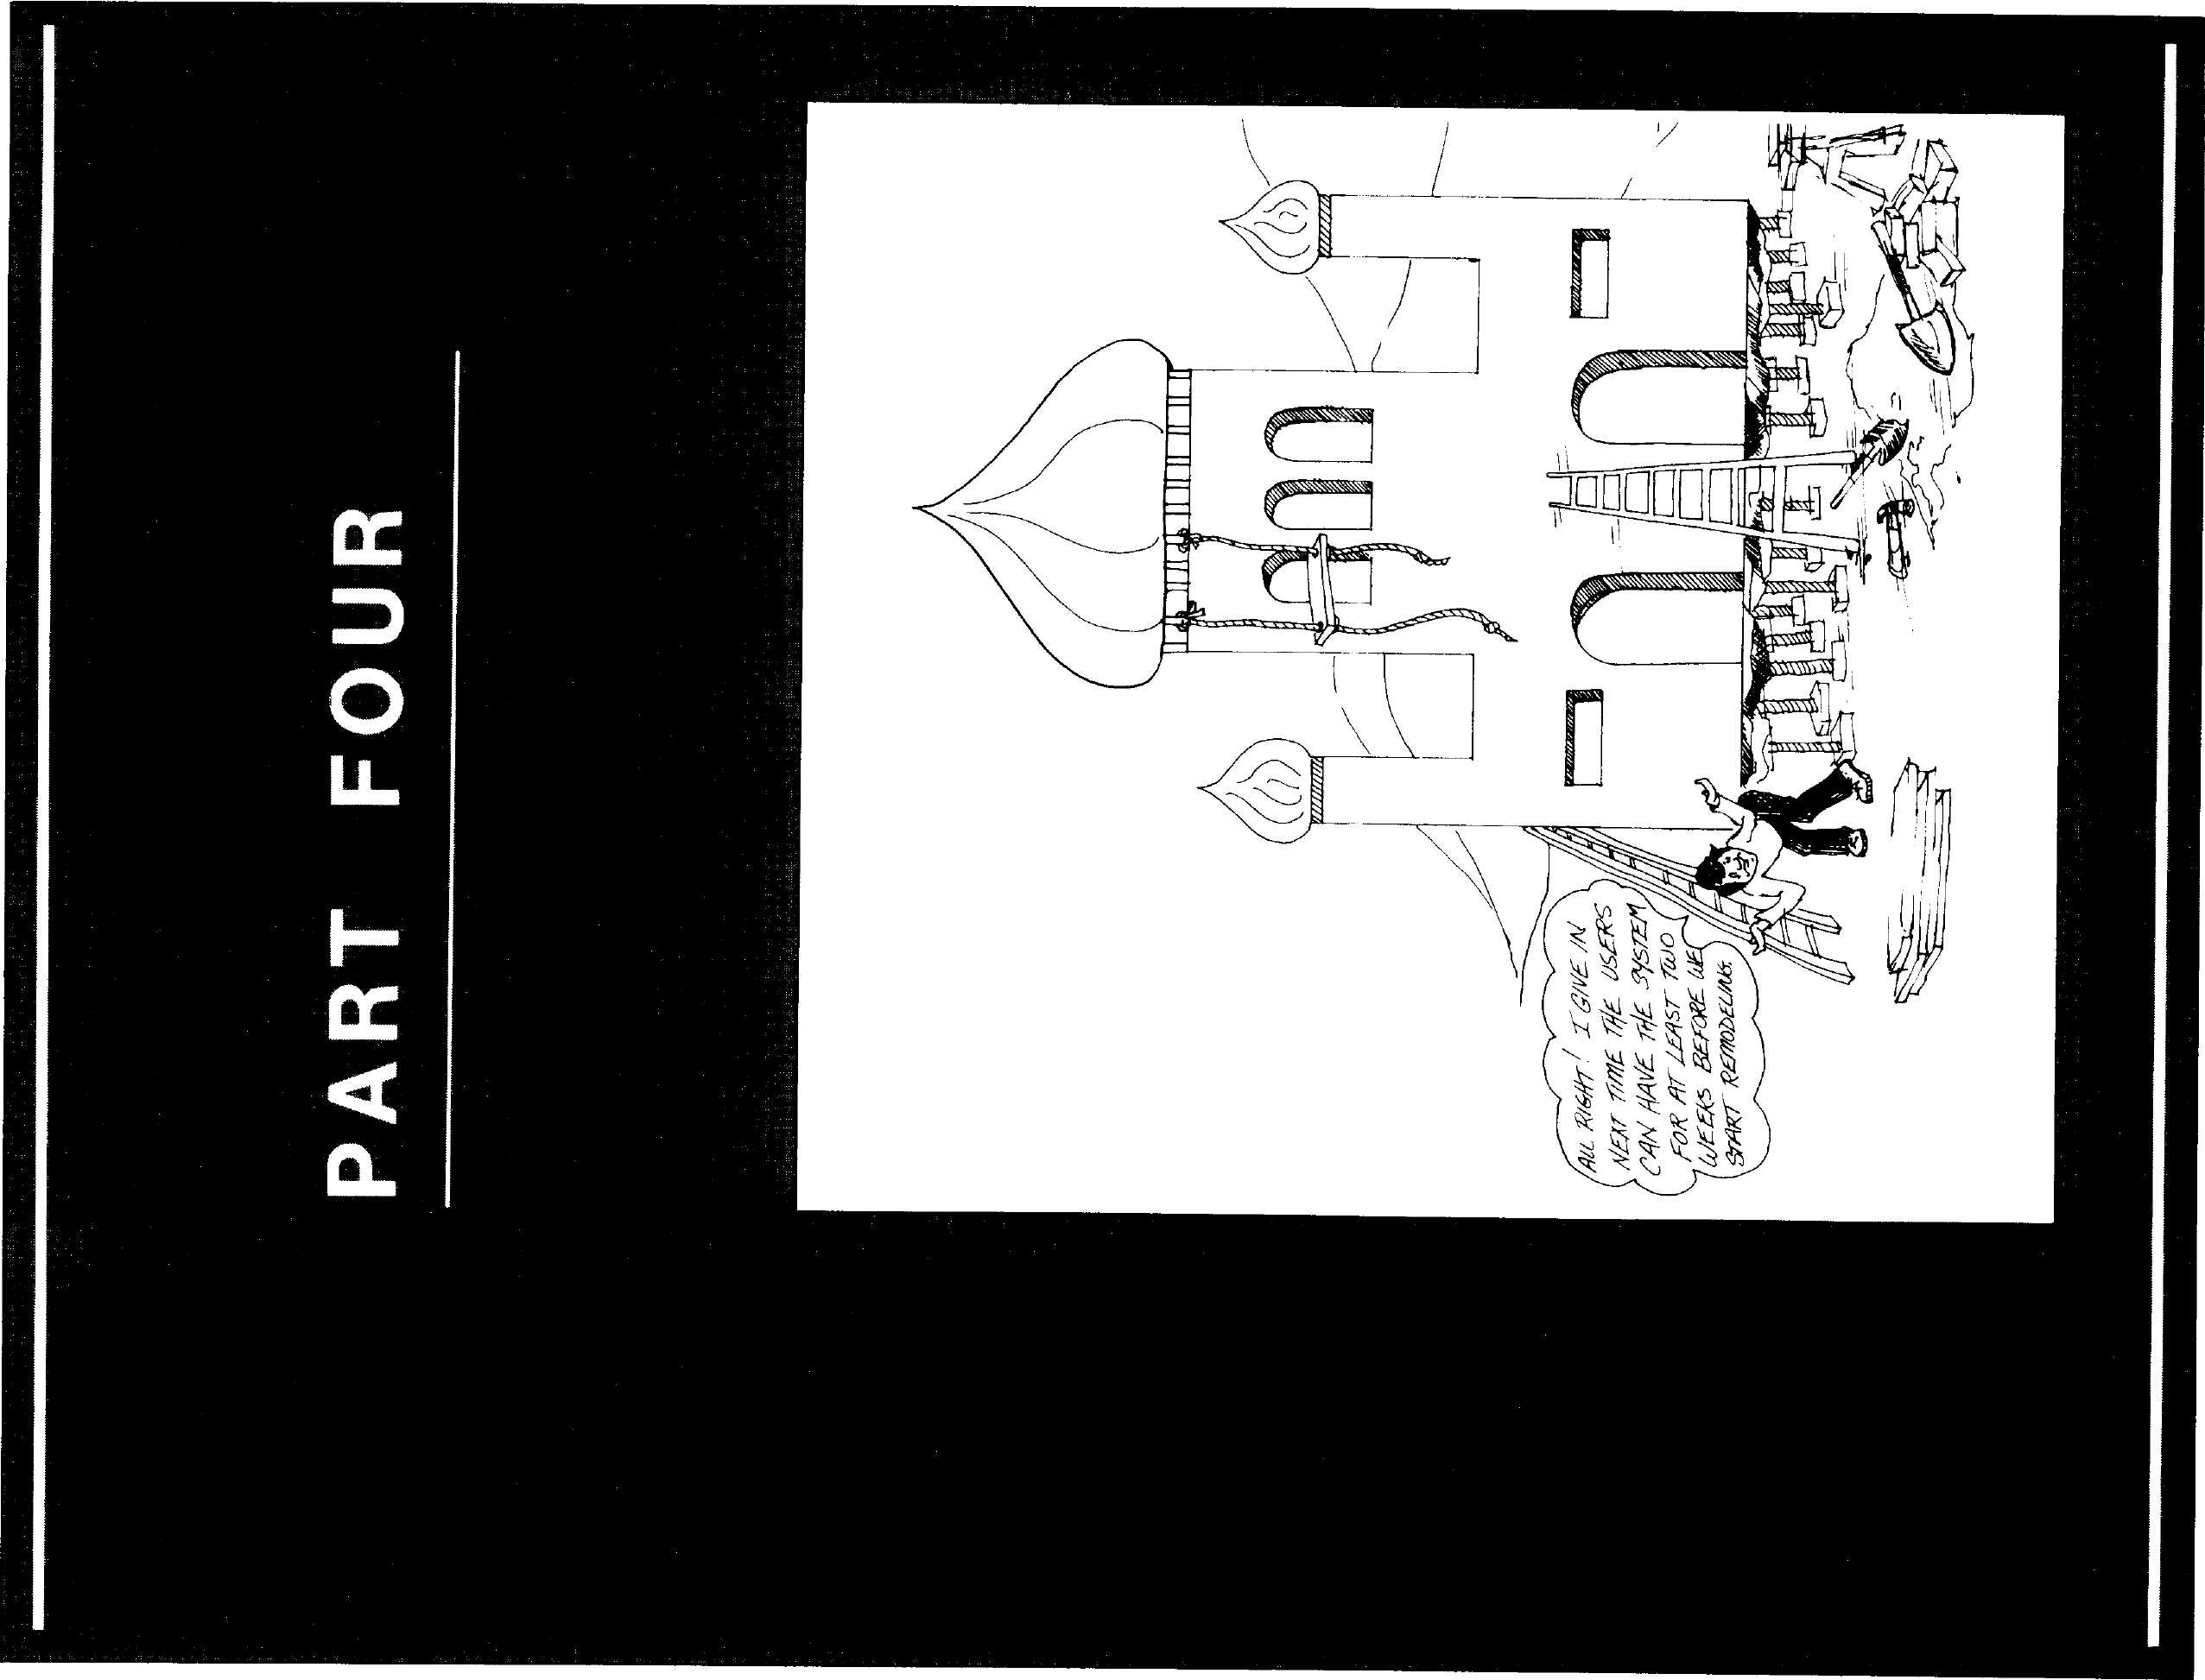

Int
LOOM—Large Object
Oriented Memory for
Smalltalk-80 Systems
Ted Kaehler
Glenn Krasner
Software Concepts Group
Xerox Palo Alto Research Center
Palo Alto, California
roduction The Smalltalk-80 virtual machine is specified as a memory-resident sys-
tem containing up to 2¹⁵ objects. When full, it typically occupies about
2M bytes of memory. Unfortunately, many machines do not have this
capacity in main memory, and many applications require, or will re-
quire, more than this capacity. To solve this space problem, one typical-
ly uses a virtual memory system in which the resident, "real" memory
is used as a cache for the larger mass storage, "virtual" memory.
LOOM, Large Object-Oriented Memory, is a virtual memory system
designed and implemented for the Smalltalk-80 system. The most im-
portant feature of the LOOM design is that it provides virtual addresses
that are much wider than either the word size or the memory address
size of the computer on which it runs.
LOOM is a single-user virtual memory system that swaps objects and
operates without assistance from the programmer. Virtual memory sys-
tems may be characterized by the amount of attention that the pro-
grammer must pay to the transfers between virtual and real memories,
by the extent to which the memory is shared among users, and by the
granularity of transfer between memory levels. Overlay mechanisms
are an example of systems that require much programmer attention,
while all common paging systems require none¹. Databases may be
Copyright © Xerox Corporation, 1982. All rights reserved.
251
252
LOOM — Large Object-Oriented Memory for Smalltalk-80 Systems
viewed as the extreme in allowing sharing; the virtual memory for
Interlisp-D² is one example of a single-user virtual memory. Most over-
lay systems transfer program segments, while paging systems transfer
disk pages, and a few systems such as the OOZE virtual memory for
Smalltalk-76³ transfer objects.
The LOOM We view virtual memory design as a process of trying to determine
Design what happens most often, making it go fast, and hoping that it will con-
tinue to be what happens most often. Our experience with previous
Smalltalk systems gave us three major assumptions on which we based
the LOOM design: programmers and users have a large appetite for
memory, object-swapping is an efficient and effective scheme, and the
Smalltalk-80 design for handling resident objects is worth keeping.
From these assumptions and the desire to provide a large number of ob-
jects on a machine with a narrow word width, we created the major de-
sign decisions.
- LOOM assumes that the object is the unit of locality of reference.
It swaps individual objects between primary and secondary memo-
ry, and allows into main memory only those objects actually need-
ed by the interpreter. Unlike paging systems, LOOM packs objects
in main memory at maximum density.
- LOOM is designed for machines with 16-bit words. Fields of objects
in main memory are 16 bits wide.
- The address space of the secondary memory is large. LOOM allows
as many as 2³¹ objects.
- The interpreter accesses objects in main memory exactly as it does
in a resident Smalltalk-80 interpreter. When the necessary objects
are already in main memory, the interpreter runs as fast as it did
in the resident system.
In order to allow the large number of possible objects, and yet treat the
resident objects in the same way they are treated in a non-LOOM
Smalltalk-80 implementation, we decided to create two different name
spaces. The same object is identified by names from different spaces
when it resides in different parts of the system, as shown in Fig. 14.1.
The identifier of an object is called an Oop, which stands for "object
pointer." An object in secondary storage has a 32-bit Oop (a long Oop),
and each of its fields containing a pointer to another object holds that
253
The LOOM Design


Main Memory
16-bit object pointers
(short Oops)
16-bit values in fields of objects.
Smalltalk-80
Interpreter

To the interpreter, objects
look very much like they did
in resident Smalltalk-80
Object Swapping



Secondary Memory
32-bit object pointers
(long Oops)
32-bit values in fields
Figure 14.1
To the large secondary
memory, main memory
looks like a cache.

pointer as a 32-bit Oop. An object cached in main memory has a 16-bit
Oop (a short Oop) and 16-bit fields. As in the resident Smalltalk-80 im-
plementation, main memory has a resident object table {ROT or some-
times called an OT), which contains the actual main memory address of
each resident object. An object's short Oop is an index into the ROT, so
that the object's address can be determined from its Oop with a single
addition and memory reference. When an object is brought into main
memory from disk, it is assigned a short Oop, and those of its fields that
refer to other objects in main memory are assigned the appropriate
short Oop. Fields pointing to objects that are not resident are handled
specially, the details of which make up the crux of LOOM.
Thus, when all objects in the working set are in main memory,
LOOM behaves just like a resident Smalltalk-80 implementation—all
objects have short Oops that index the ROT, providing their actual core
address. When an object in core must access one of its fields that refers
to an object that is not in core, something special must happen. LOOM
brings that object into core, assigns it a short Oop, and resumes normal
Smalltalk execution. The main memory resident space of 2¹⁵ objects acts
as a cache for up to 2³¹ objects on the disk.

254
LOOM—Large Object-Oriented Memory for Smalltalk-80 Systems

The LOOM
Details
The
Representation of
Resident Objects
The important issues in the LOOM design implementation are:
- The representation of resident objects,
- The representation of objects in secondary memory,
- The translation between representations, and
- The identification of times when the translations must occur.
Resident objects are represented in a manner similar to their represen-
tation in a resident Smalltalk-80 system. Each object has as its name in
main memory, a short (16-bit) Oop. The Oop indexes the ROT in order
to provide the starting address of the object's body, as shown in Fig.
14.2. The ROT entry also has reference-count bits, and a few other bits,
described later. The body of each object contains a word for the length
of the body, a pointer to the object's class, and the object's fields. Each
field is either a pointer to another object or a collection of "bits", in the
same manner as resident Smalltalk-80 fields. We will only deal with
pointer fields here. Each field (as well as the class pointer) that refers

Format of Objects in Main Memory
Resident Object Table Body of an Object
(ROT)

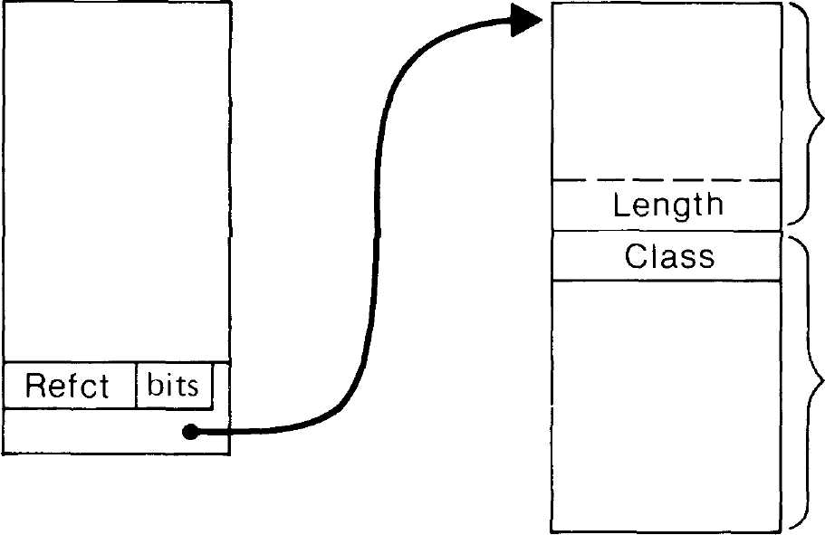
Indexed by
short Oop
(16-bits)
ROT entry
of an object
Main Memory
address of an
Object Body
■16-bits-
Object
Header
Fields of
the Object

Figure 14.2
- 16-bits-

J?55
The LOOM Details
to another resident object contains the short Oop of that object Fields
that refer to non-resident objects (objects on secondary storage) contain
a short Oop of one of two types, a leaf or a lambda.
In addition to these fields, resident objects in a LOOM system have
three extra words. Two of these words contain the long (32-bit) Oop of
that object. The third word, known as the delta word, contains a delta
reference count and some other bits. The short Oop of an object is not
only an index into the ROT for that object's address, but is also the re-
sult of a hash function applied to that object's long Oop. See Fig 14.3,
p. 256. The algorithm for translating an object's short Oop to its long
Oop is:
- Index the ROT with the short Oop to get the body address
- Load the long Oop from the first two words of the body
The algorithm for translating an object's long Oop to its short Oop is:
- Convert the long Oop into a short Oop by applying the hash func-
tion
- Index the ROT with this short Oop to get a body address
- Look at the first two words of the body
- If they match the long Oop, then the short Oop is correct
- If not, create a new short Oop from the current one with a
reprobe function (e.g., add 1), and go to step 2

The
Representation of
Objects in
Secondary Memory
Secondary memory is addressed as a linear space of 32-bit words. Ob-
jects start with a header word that contains 16 bits of length and some
status bits. Each pointer field in the object is 32 bits wide. Non-pointer
fields (such as the bytes in Strings) are packed, with 4 bytes in each
32-bit word. Resident Smalltalk-80 Smalllntegers are rather short to be
occupying a full word on the disk. However, since they represent legiti-
mate object pointers, their 15 significant bits are stored along with a
flag value in a 32-bit pointer field on the disk. The long Oops in pointer
fields are 31-bit disk pointers, addressing as many objects as will fit into
2³¹ disk words (32-bit words). Fields of objects on secondary storage al-
ways refer to objects in secondary storage and do not change when the
object to which they point is currently cached in main memory. As
shown in Fig. 14.4, no information about primary memory is ever
stored in secondary memory. Information such as an object's short Oop,
its location in primary memory, or whether it is currently cached in
primary memory are never recorded in secondary memory.

256
LOOM — Large Object-Oriented Memory for Smalltalk-80 Systems
Finding an Object's Long Oop from Its Short Oop
ROT Object Body
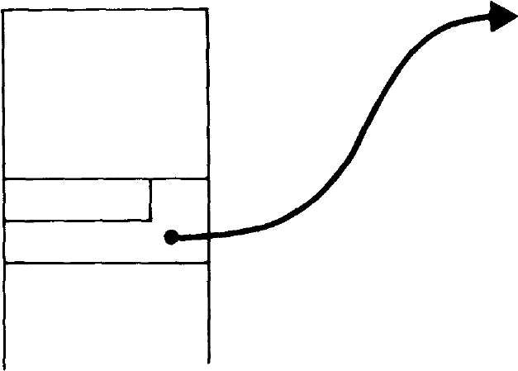
Short Oop
Delta
Length
Class
Fields
Long Oop

Finding an Object's Short Oop from Its Long Oop
ROT


Apply hash
function to
long Oop
This long Oop is not equal to ours.

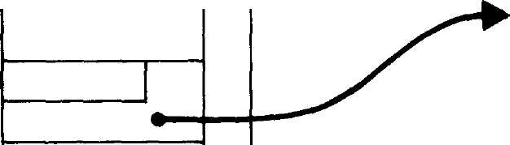
Probe
Short Oop
Likewise, a miss.


This long Oop is the one we are
looking for. This object's short
Oop is the answer.
Figure 14.3

j?57
The LOOM Details
How Objects in Primary and Secondary Memory
Refer to Other Objects.
Hash a long Oop into the ROT and see
if the object is cached in primary memory

A Short Oop-
The object
(in Primary Memory)
A Long Oop.
The object
(in Secondary Memory)

The object's
own long Oop
The object's
fields

The object's
fields

Primary Memory
Figure 14.4
Secondary Memory
Objects here do not know if they
are currently cached in main memory.

When an object on secondary storage is brought into main memory, its
fields must be translated from the long form to short form. The object is
assigned an appropriate short Oop (one to which its long Oop hashes), a
block of memory is reserved for it, and all of its fields are translated
from long Oops to short Oops. Those fields that point to objects already
in main memory are given the short Oops of those objects; those that
point to objects not in main memory are handled in one of two ways,
with leaves or with lambdas.
Q Leaves Leaves are pseudo-objects that represent an object on sec-
ondary storage. They have a short Oop hashed by that object's long Oop
and a ROT entry, but their image in memory only contains a length
word, disk address words, and the delta word. Their image contains no
class word or fields, as shown in Fig. 14.5. Leaves therefore, only take
up 4 words of memory, whereas the average object takes up 13. Leaves
are created without looking at that object's image on secondary storage.

258
LOOM — Large Object-Oriented Memory for Smalltalk-80 Systems
This is very important, since a major cost in virtual memories is the
number of disk accesses. The short Oop of the leaf may be treated as if
it were the short Oop of the object; it may be pushed and popped on the
stack, stored into fields of other objects, without ever needing the actual
contents of that object. Its reference count can be incremented and
decremented (see p. 262).
A Leaf

ROT
Primary Memory
Secondary Memory

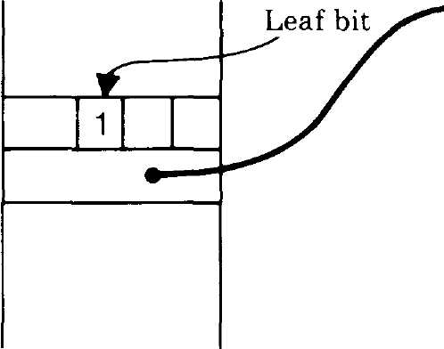

Long
Oop
Delta
Length (4)
The object in
Secondary Memory

Figure 14.5
An object is always in one of three states. Either the entire object is in
main memory, a leaf for the object is in main memory, or the object ex-
ists only on the disk. See Fig. 14.6. When the interpreter needs a field
from an object which is represented by a leaf, the entire object with its
fields must be brought into main memory from disk. Since the leaf con-
tains the disk Oop, the body is easy to find. After the body is translated
into main memory form, its core address is stored into the leaf's OT en-
try, and the leaf body is discarded. Short Oop references to the object
remain the same, but now the full object is actually there. Since a leaf
can be substituted for an object body and vice versa with no effect on
pointers to the object, LOOM is always free to make more room in main
memory by turning resident objects into leaves.
□ Lambdas Lambdas are the second way to represent fields of resi-
dent objects that refer to objects on secondary storage. Lambda is a
place holder for a pointer to an object which has not been assigned a
short Oop. Its purpose is to reduce the number of leaves in the system.
Lambda is a pseudo-Oop, a reserved short Oop (the Oop 0) which is not
the name of any resident object. Consider an object which has a lambda
in one of its fields. To discover the actual value of that field, LOOM
must go back to the object's image on secondary storage, look in that

259
The LOOM Details
States of an Object in LOOM

The entire object is
in main memory
A leaf for this
object is in
main memory
The object exists
only in secondary
storage

Expand a leaf
Resolve a long Oop
(Assign a short Oop)

Figure 14.6

The entire object is  in main memory |  | A leaf for this object  is in main memory |  | The object exists only  in secondary storage
Contract  to a leaf |  | * \ | Retire a  short Oop

field for a long pointer, and create a leaf or resident object. This means
that the cost of fetching a lambda field is an extra disk reference. How-
ever, unlike leaves, lambdas do not take up ROT entries (they all use
the single pseudo-ROT entry at 0) and they do not take up any main
memory storage. Since the number of ROT entries is limited to 2¹⁵, and
main memory is a somewhat scarce resource, this saving can be impor-
tant. During an object's typical stay in main memory, some of its fields
will not be referenced. If leaves are created for the values in those
fields when the object is swapped in, and then destroyed again when
the object is thrown out, much work is wasted. Putting lambdas into
fields which will not be referenced during the object's current stay in
primary memory saves both the space and the time needed to create
and destroy many leaves.
Determining whether to make the fields of an object be leaves or
lambdas when the object is brought into main memory is a tricky busi-
ness. The choice of strategy strongly affects the performance of a
LOOM system. Creating a leaf takes more time and uses up more mem-
ory and a ROT entry, but does not cause any extra disk accesses. A
lambda will cause an extra disk access if the field it occupies happens
to be referenced, but a lambda is faster to create. One way to make the
decision between leaf and lambda is to rely on history; if a field was a
lambda when this object was written to the disk one time, it is likely to
remain a lambda during its next trip into main memory. Each pointer
field of the disk contains a hint, the noLambda bit, and the object
faulting code follows the advice of the hint.

260
LOOM — Large Object-Oriented Memory for Smalltalk-80 Systems

The Translation
Between Object
Representations
When to Translate
Translating between the memory-resident and secondary-storage repre-
sentations of an object is straightforward. For those fields that contain
short Oops, the Oop refers to an object or a leaf. The corresponding long
Oop can be found in the header of the object or leaf. If the field refers
to an object which has not yet been assigned a long pointer, a long
pointer is assigned to the object and a copy is installed in the field. For
those fields that contain lambdas, the field is guaranteed not to be
changed from the object's previous disk image. (The object's disk image
is read before it is written). If the object being translated still has some
short pointers to it (has a positive in-core reference count), then it must
be converted to a leaf instead of being deleted completely from core.
We have already mentioned when the translation between representa-
tions must occur. When a field of an object being brought into main
memory has the noLambda bit set, and that field refers to a non-resi-
dent object, then a leaf is created. A leaf is also created when a field of
a resident object containing a lambda is accessed. When the interpreter
needs to access a field in a leaf, the flow of control in LOOM begins (see
Fig. 14.7). The leaf is expanded into a resident object; its fields are
translated from long form to short form. This is called an object fault
(because the similar situation in paging virtual memory systems, trying
to access a page that is not resident, is called a page fault). The inverse
operation, contracting an object into a leaf, may be done at any time.
The final part of an object's journey into primary memory consists of
destroying the leaf and reusing its short Oop and memory space. This
can only be done when there are no longer any fields in any resident
objects pointing to the leaf.
Lambdas may be resolved into leaves and leaves may be expanded
into full objects before they are needed, and this is called a prefetch.
The complementary operations of contraction and prefetch of objects
can both be done in the background. The exact order and mix of objects
to prefetch or contract can be adjusted at run-time to optimize the per-
formance of secondary storage (disk head movement or network traffic).

LOOM In this section, we provide some details of how LOOM may be
Implementation implemented. In particular we discuss the discovery of object faults, ref-
Details erence-counting, and the assignment of the extra bits in the ROT entry
and the delta word.

Object Faults
Object faults occur when the interpreter tries to access a field in a leaf
or a field in an object whose value is lambda. By the time the interpret-
er scrutinizes them, all objects must be full resident objects. How can
leaves and lambdas be discovered without greatly slowing the speed of
the interpreter?

261
LOOM Implementation Details
The Flow of Control in LOOM

The entire object
is in main memory
A leaf for this object
is in main memory
The object exists only
in secondary storage



Expand
the object
f
Resolve a
long Oop

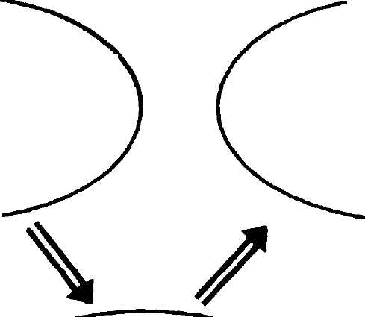
The interpreter needs a
field from an object
which is a leaf
Expand needs to con-
vert long Oop in each
field to a short Oop
May have to contract
some objects to get
space in main memory
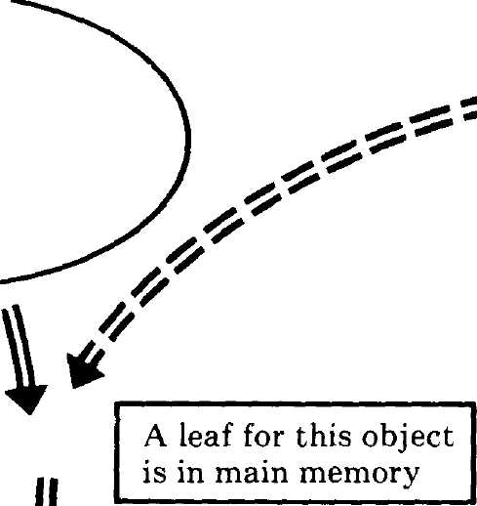

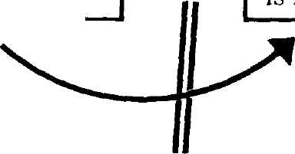
The entire object
is in main memory
Contract an object
to a leaf If
In the very rare case
that there is no empty
ROT entry with the
proper hash, contract
objects until such an
entry is freed
The object exists only
in secondary storage
Retire a short Oop
(Destroy the leaf)

Contract converts \
many short Oops to
long Oops
The last short Oop \
pointing to a leaf is
destroyed

Figure 14.7

262
LOOM — Large Object-Oriented Memory for Smalltalk-80 Systems
It has been our experience that implementations tend to have a sin-
gle subroutine (or expanded macro) that takes an Oop and sets up some
base register to point to the actual address of that object. We call this
subroutine "Otmap." It corresponds roughly to the ot:bits: method of the
memory manager in the formal specification of the Smalltalk-80 virtual
machine, in Smalltalk-80: The Language and its Implementation⁴.
Otmap is called if and only if you want to fetch or store a field of an ob-
ject. Note that this is exactly the condition where you must test for the
object being a leaf. (Otmap may sometimes be used for other purposes—
for example a compaction routine may call Otmap to get the main
memory address of the object in order to move it, but it wants to treat
leaves and objects the same. These cases tend to be rare, so it is worth
having a second subroutine for them.) We reserve one bit of the ROT
entry to say whether the entry is for an object or a leaf. The Otmap
subroutine tests this bit and calls the LOOM routines when the entry is
a leaf. Since both words of the ROT entry are fetched anyway, this ex-
tra test usually only costs one or two extra instruction executions.
Testing for lambda however, must be done on every field reference. In
the worst case, this would mean testing occurs every time a field is
fetched from an object and every time an object is pushed onto the
stack. To decrease the number of tests, we include one bit in each resi-
dent object called "holds lambda." It is set by the LOOM routines
whenever that object has a field that is a lambda. The interpreter guar-
antees that the current context, the home context, the current method,
and the receiver all have no lambdas in them. If any of them does con-
tain a lambda, then the LOOM routines are called to make those fields
into leaves. In this way, the most common fields fetched and all stack
operations can work without testing for lambda. Note that these objects
must be cleared of lambdas only when the active context changes. This
occurs during message sends, returns, process switches, and during the
execution of BlockContext value and value:.
It is useful to note that the LOOM design actually will work with
leaves alone, and without lambdas. When the expand routine brings an
object into main memory, it turns all the fields into leaves and never
creates a lambda. This approach tends to use more short Oops and
main memory than the full LOOM design, but could be an intermediate
stage in the implementation; providing a working virtual memory sys-
tem with only the modification to the Otmap subroutine.
Although some Smalltalk-80 implementations use mark/sweeping gar-
Reference bage collection, most implementations so far, including ours, use refer-
Counting ence counting to identify garbage. Therefore we will describe the
reference-counting scheme as it applies to LOOM. Reference counting
serves two different purposes. One purpose is to detect when the total
count of any object goes to zero. The other is to detect when the last
short pointer to any object disappears so that the short pointer may be
263
LOOM Implementation Details

Other Data
LOOM Holds for
Each Object
reused. The resident Smalltalk-80 interpreter keeps reference counts of
short pointers. This count is kept in the ROT. LOOM uses the ROT ref-
erence count to keep the number of short pointers to an object. In addi-
tion, every object on the disk contains a reference count which is the
number of long pointers to the object. The total count is the sum of the
number of short and long pointers to an object. Whenever a long Oop is
converted to a short Oop and installed in a field in main memory, both
counts for the object pointed at must change. To avoid a disk access to
find and modify the long Oop count every time a field is converted,
LOOM keeps a "delta" or running change in the long Oop reference
count for each object in main memory. The true long pointer reference
count of any object is the count found on the disk in the object's header
plus the count found in the "delta" part of the object's delta word in
main memory. Fig. 14.8 shows the ROT entry, object body, and disk im-
age of an object. The object has three short Oops pointing at it. It used
to have pointers from 6 long Oops, but two were destroyed recently
(they were probably converted to short Oops). The total number of ref-
erences to the object is seven.
There are three sources of reference-count changes. One pointer can
be stored over another, a long pointer can be converted to a short point-
er, and a short pointer can be converted back. Since the interpreter
only deals with short Oops, every store consists of a short pointer re-
placing another short pointer. This high-bandwidth operation touches
only the short pointer reference counts, so the existing code in the in-
terpreter does not need modification. When a leaf expands to a normal
object, pointers in its fields change from long Oops to short ones. The
expand-a-leaf routine increments the short count of that object and dec-
rements the delta of its long count. The inverse happens when the rou-
tine which shrinks objects into leaves converts short Oops to long ones.
Consider the case when the short Oop count of an object goes to zero.
The reference-count routine then looks at the object's long Oop count to
see if the total count of the object is zero. If it is zero, the object is truly
free, and its storage can be recycled. If not, the object is still held by
some long pointers. When the short Oop reference count goes to zero,
and the delta reference count is zero, then the object's long Oop count
on disk need not change. Thus if the ultimate long pointer count of a
leaf can be guessed correctly when the leaf is created, the disk count
and delta count can be adjusted so that the leaf disappears from main
memory without further disk references.
As a help to the LOOM system, two other bits are added to the ROT en-
try for any object—"clean" and "unTouched." Clean is cleared when-
ever a field of the object is changed; unTouched is cleared whenever a
field of the object is read or changed. Clean tells the LOOM system that
it need not rewrite the object's image on disk (unless of course, its true
reference count changed). Clean is set when the object is newly created

264
LOOM — Large Object-Oriented Memory for Smalltalk-80 Systems
The Three Types of Reference Counts

ROT
Main Memory
Secondary Memory

ROT Count

f »
Γ
/
/
Di?k
Count

Figure 14.8
Example Reference Counts
There are a total of seven references to this object.
Three are from short Oops and
(6 Λ—2) = 4 are from long Oops.
-2
or swapped in. UnTouched is set by a routine that sweeps core whenev-
er space is needed. Any object that the routine finds with unTouched
still set has not been touched in an entire pass through memory, and is
thus a candidate for being contracted (turned into a leaf).
The activity which is most likely to cause LOOM to thrash is the res-
olution of lambdas. When a lambda needs to be resolved (turned into a
leaf or discovered to be an existing short Oop), LOOM must first look at
the disk image of the parent object. If the pattern of computation is

265
LOOM Implemented in the Smalltalk-80 Language
such that the noLambda hint does not correctly predict which fields are
needed by the interpreter, lambdas would have to be resolved often.
Even so, lambda resolution is likely to happen soon after the parent
was expanded, so keeping the most recently fetched disk pages in a
cache relieves the need to go to the disk. When a lambda needs to be
resolved, the LOOM procedure looks first in the cache of pages that is
called the disk buffer. If it finds the object in the buffer, it can directly
retrieve the long Oop for the lambda, saving one disk access.

LOOM
Implemented
in the
Smalltalk-80
Language
The LOOM design, though based on only a couple of simple principles,
has a number of reasonably complex algorithms that require a substan-
tial amount of code. We were faced with the problem of whether to im-
plement LOOM's object swapping algorithms in a low-level language or
a high-level language. Low-level implementations typically provide bet-
ter performance at the cost of some flexibility.
We opted to implement the LOOM system in our favorite high-level
system, the Smalltalk-80 system. A number of factors influenced this
choice. The overriding factor was that for us, the Smalltalk-80 language
was the most natural way to express and understand complex algo-
rithms. We are implementing LOOM on the Xerox Dorado computer⁵
(see also Chapter 7). We believe that the Dorado has sufficient perfor-
mance and memory space so that the LOOM system will not be called
very often. When LOOM is called, it will run with acceptable perfor-
mance. Also, once the system is up and running, we will have a com-
plete, debugged high-level description of the algorithms. Should we
decide to reimplement LOOM on the Dorado or another machine in a
lower-level language, only a translation of the code would be required.
In addition, we designed LOOM not only as a working virtual memory
system for our Smalltalk-80 work, but also as a test-bed for virtual
memory techniques. Jim Stamos' master's thesis⁶ is an example of one
experimental technique based on simulation. We want further studies
to use a real virtual memory system.
Deciding to implement LOOM in the Smalltalk-80 language itself led
to problems that might not be encountered in a low-level language im-
plementation. In particular, the amount of "machine state" that needs
to be saved when switching between running the Smalltalk-80 inter-
preter for "user" and for LOOM was quite large. The amount is much
larger than the amount of Smalltalk-80 virtual machine state that
would have to be saved to run the LOOM code written in machine lan-
guage. Also, to avoid a fault on the faulting code, all of the code and
other objects which comprise the implementation of LOOM must be
guaranteed to stay in main memory at all times.

266 _^___
LOOM Large Object-Oriented Memory for Smalltalk-80 Systems
We handled the first problem, saving state, by reworking our inter-
preter. It now obeys the convention that within the execution of a
bytecode, an object fault is possible only before any "destructive" opera-
tions occur. In other words, before the interpreter writes into a field of
any object or changes the reference count of any object, it reads fields
from all objects needed by the current bytecode. In this way, the state
we needed to save was only the "permanent" state that exists between
bytecodes. Temporary state within a bytecode is not saved. In our sys-
tem then, if an object fault occurs, we back up the Smalltalk program
counter, switch the interpreter to the LOOM system, handle the fault,
and then restart the bytecode.
The second problem, insuring that no object faults occur during the
execution of the LOOM algorithms themselves, went through a couple
of different designs. The first method we tried was to have the LOOM
objects and the user's objects in the same Smalltalk-80 space, but to
mark all the objects LOOM would ever need "unpurgable", and to guar-
antee that free space never went below a certain level. We made an al-
most-complete implementation of LOOM using this method on the
Xerox Alto computer⁷ before moving onto the Dorado. The problem with
LOOM and the user sharing the same Smalltalk is retaining the marks
on objects that LOOM needs. If the user adds many methods to class
Small Integer and its method dictionary grows, how does the new array
in the dictionary get marked "unpurgable"? There are many similar
cases.
The LOOM implementation on the Dorado has two separate
Smalltalk-80 systems in the same machine: a full-size system for user's
programs, and a smaller one for LOOM. The LOOM system has some
primitives that enable it to manipulate the bits inside of objects in the
user system. (Note that because they use the same interpreter, the user
system has these primitives also. However, they make no sense in the
user system, so are never used.) Because the LOOM system uses only a
small subset of the Smalltalk-80 system, it can be much smaller, and
can be guaranteed to fit entirely within its portion of main memory and
never cause an object fault. Fig. 14.9 provides a view of the communica-
tion between the systems.

Alternative
Smalltalk
Virtual
Memory
Designs
The LOOM virtual memory design is only one of many ways to imple-
ment a virtual memory for a Smalltalk-80 system. The advantages of
the LOOM design are:
1. It runs as fast as a resident Smalltalk-80 interpreter when the
working set is in core,

267
Alternative Smalltalk Virtual Memory Designs
Two Separate Smalltalks in the Same Machine
User's Smalltalk

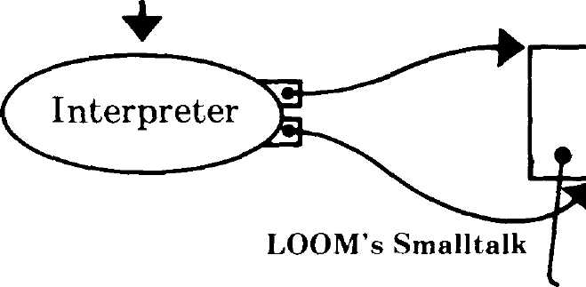
(Really, these are the same
interpreter. Only pointers to the
interpreter state and location
of the ROT change)
Interpreter requests to LOOM:
Expand a leaf
Fix a lambda
Make more space
Make more ROT space
Handle overflow
reference counts
ROT
Interpreter
State
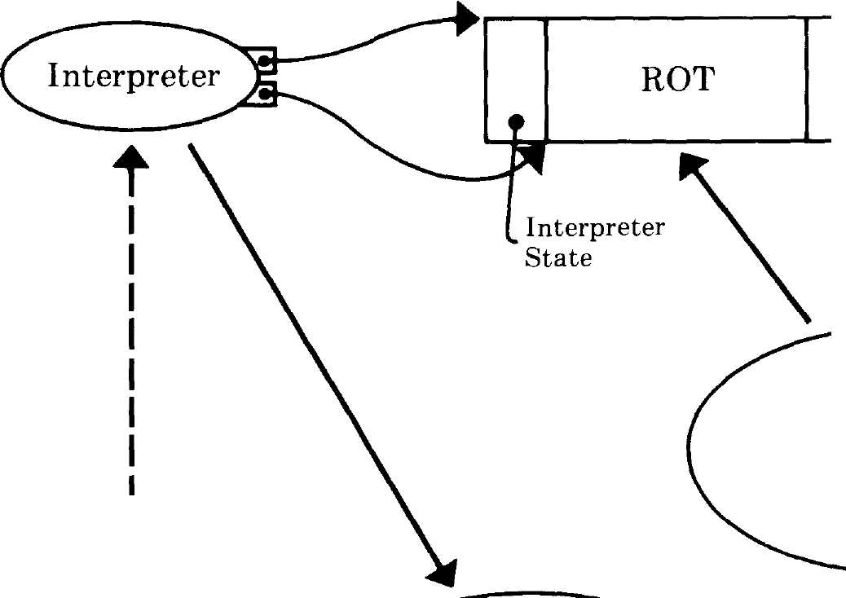


Resident Objects
Loom manipulation of
bits in user's ROT and
resident object space

Objects on I
Secondary ι
Storage
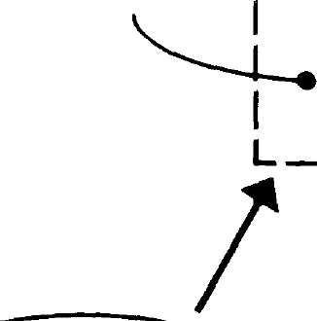

Loom manipulation of
user's objects in
secondary storage using
normal Smalltalk file
and ethernet code
4 Primitives
Resident Objects

Figure 14.9

268
LOOM — Large Object-Oriented Memory for Smalltalk-80 Systems
- It uses 16-bit fields in core to conserve space,
- It allows the interpreter to avoid handling 32-bit Oops, which
makes the interpreter smaller and faster on 16-bit machines,
- It only uses memory for objects that are actually referenced, and
- It provides a large, 32-bit virtual address space.
Its major disadvantages are:
- It relies on fairly complicated algorithms to translate between the
address spaces,
- It takes no advantage of current hardware technology for memory
fault detection, and
- It must move objects between disk buffers and their place in mem-
ory.
There are alternatives to many of the design decisions within LOOM
and to using the LOOM design itself.
LOOM was designed specifically to experiment with various methods
of "grouping" objects on disk pages. If objects which are likely to be
faulted on at the same time live on the same disk page, only the first
fault actually has to wait for the disk. Static grouping restructures the
arrangement of objects on disk pages while the system is quiescent. It
reduces the number of disk accesses for both paged virtual memories
and object swapping systems. Stamos extensively studied the advan-
tages of static grouping and compared LOOM to paged virtual memo-
ries⁸. LOOM is also designed for experiments in dynamic grouping. We
have several algorithms in mind for moving objects on the disk while
Smalltalk is running. These algorithms will endeavor to reduce faulting
by dynamically placing related objects on the same disk page.
We also mentioned that a LOOM system can be built that only uses
leaves and not lambdas. Another alternative that we did not pursue is
to use a marking garbage collection scheme for resident objects and ref-
erence counting for disk references. This should be possible using the
delta reference-count scheme.
LOOM is currently intended for use over a local area network. The
design could be extended to bring many users, many machines, and
large quantities of immutable data into the same large address space. If
32-bit long Oops are not big enough, objects in secondary memory could
be quad-word aligned, giving 2³⁶ bytes of address space. The LOOM al-
gorithms are parameterized for the width of long pointers, so that a
change to 48-bit wide long Oops would not be difficult to do.
The LOOM design may be used for non-Smalltalk systems. In partic-
ular, we have proposed a LOOM-like design to extend the address space
of Interlisp-D. The design adds another level of virtual memory to the
269
Acknowledgments
existing Interlisp-D paging system by treating a page as a single object
and an existing page address as a short pointer.

Learning from
LOOM
Our LOOM virtual memory system is in its infancy. We are only begin-
ning to make measurements on its performance. The design choices of
the LOOM system are based on the belief that the way to design good
virtual memory systems is to determine what happens most of the time,
make it go fast, and hope it continues to happen most of the time.
Many trade-offs were made to meet this goal. Some of the design
choices we made apply to almost all Smalltalk-80 implementations and
some were determined by our hardware/software environment. For ex-
ample, the general idea that object swapping saves main memory over
paging applies to all Smalltalk-80 systems, but the relative cost of ob-
ject swapping versus paging can be heavily influenced by hardware sup-
port for one or the other. Since we know of no current hardware that
supports object swapping, but we do know that a great deal of current
hardware supports paging, paging has a tremendous advantage. Many
of the costs of paging are hidden, such as the address computation on
every memory reference, and the "built in" paging hardware on many
machines. If those costs were brought into the open, and the same
amount were spent on assisting object references, object oriented virtu-
al memories might have better cost-performance than paging systems.
The LOOM design uses two levels of object addressing and translates
between address spaces when necessary. Up to 2³¹ objects residing on
secondary storage are represented by a cache of 2¹⁵ objects in main
memory. These behave almost identically to resident Smalltalk-80 ob-
jects. When a reference from an object in main memory to one in sec-
ondary memory is made, an object fault occurs, the latter is brought
into main memory, and processing continues. This design allows for a
large virtual address space and a space- and speed-efficient resident
space. Because the major algorithms in LOOM are written in Smalltalk
itself, LOOM will be a major test-bed for new swapping algorithms and
for new ways of reducing page faults by grouping objects in secondary
storage.

Acknowledg-
ments
The design of LOOM was a true group effort. Jim Althoff and Steve
Weyer proposed an early version to improve the speed of their work on
programmer directed object overlays. Peter Deutsch worked out a de-
sign for an early version of the dual name spaces (short and long Oops).

270
LOOM — Large Object-Oriented Memory for Smalltalk-80 Systems
Dan Ingalls, Glenn, and Ted designed the three kinds of reference
counts. Danny Bobrow said that leaves were not enough, and Larry
Tesler suggested lambdas from the design of his operating system called
Caravan. Ted, Dan, and Glenn worked out the final system design, and
Ted and Diana Merry built a test version of the LOOM algorithms. Ted
and Glenn did the Alto and Dorado implementations.
References 1. Denning, Peter J., "Virtual Memory", Computing Surveys vol. 2,
no. 3, Sept. 1970.
- Burton, Richard R., et al., (The Interlisp-D Group), Papers on
Interlisp-D, Xerox PARC CIS-5, July 1981; (a revised version of
Xerox PARC SSL-80-4).
- Kaehler, Ted, "Virtual Memory for an Object-Oriented Lan-
guage", Byte vol. 6, no. 8, Aug. 1981.
- Goldberg, Adele, and Robson, David, Smalltalk-80: The Language
and Its Implementation, Addison-Wesley, Reading, Mass., 1983.
- Lampson, Butler W., and Pier, Kenneth Α., "A Processor for a
High-Peformance Personal Computer", Seventh International
Symposium on Computer Architecture, SigArch/IEEE, La Baule,
France, May 1980; (also in Xerox PARC CSL-81-1, Jan. 1981.)
- Stamos, James W., "A Large Object-Oriented Virtual Memory:
Grouping Strategies, Measurements, and Performance," Xerox
PARC SCG-82-2, May 1982.
- Thacker, C. P., et al., "Alto: A Personal Computer", in Computer
Structures: Readings and Examples, 2nd Edition, Eds. Sieworek,
Bell, and Newell, McGraw-Hill, New York, 1981; (also Xerox
PARC CSL-79-11, Aug. 1979.
- See reference 6.
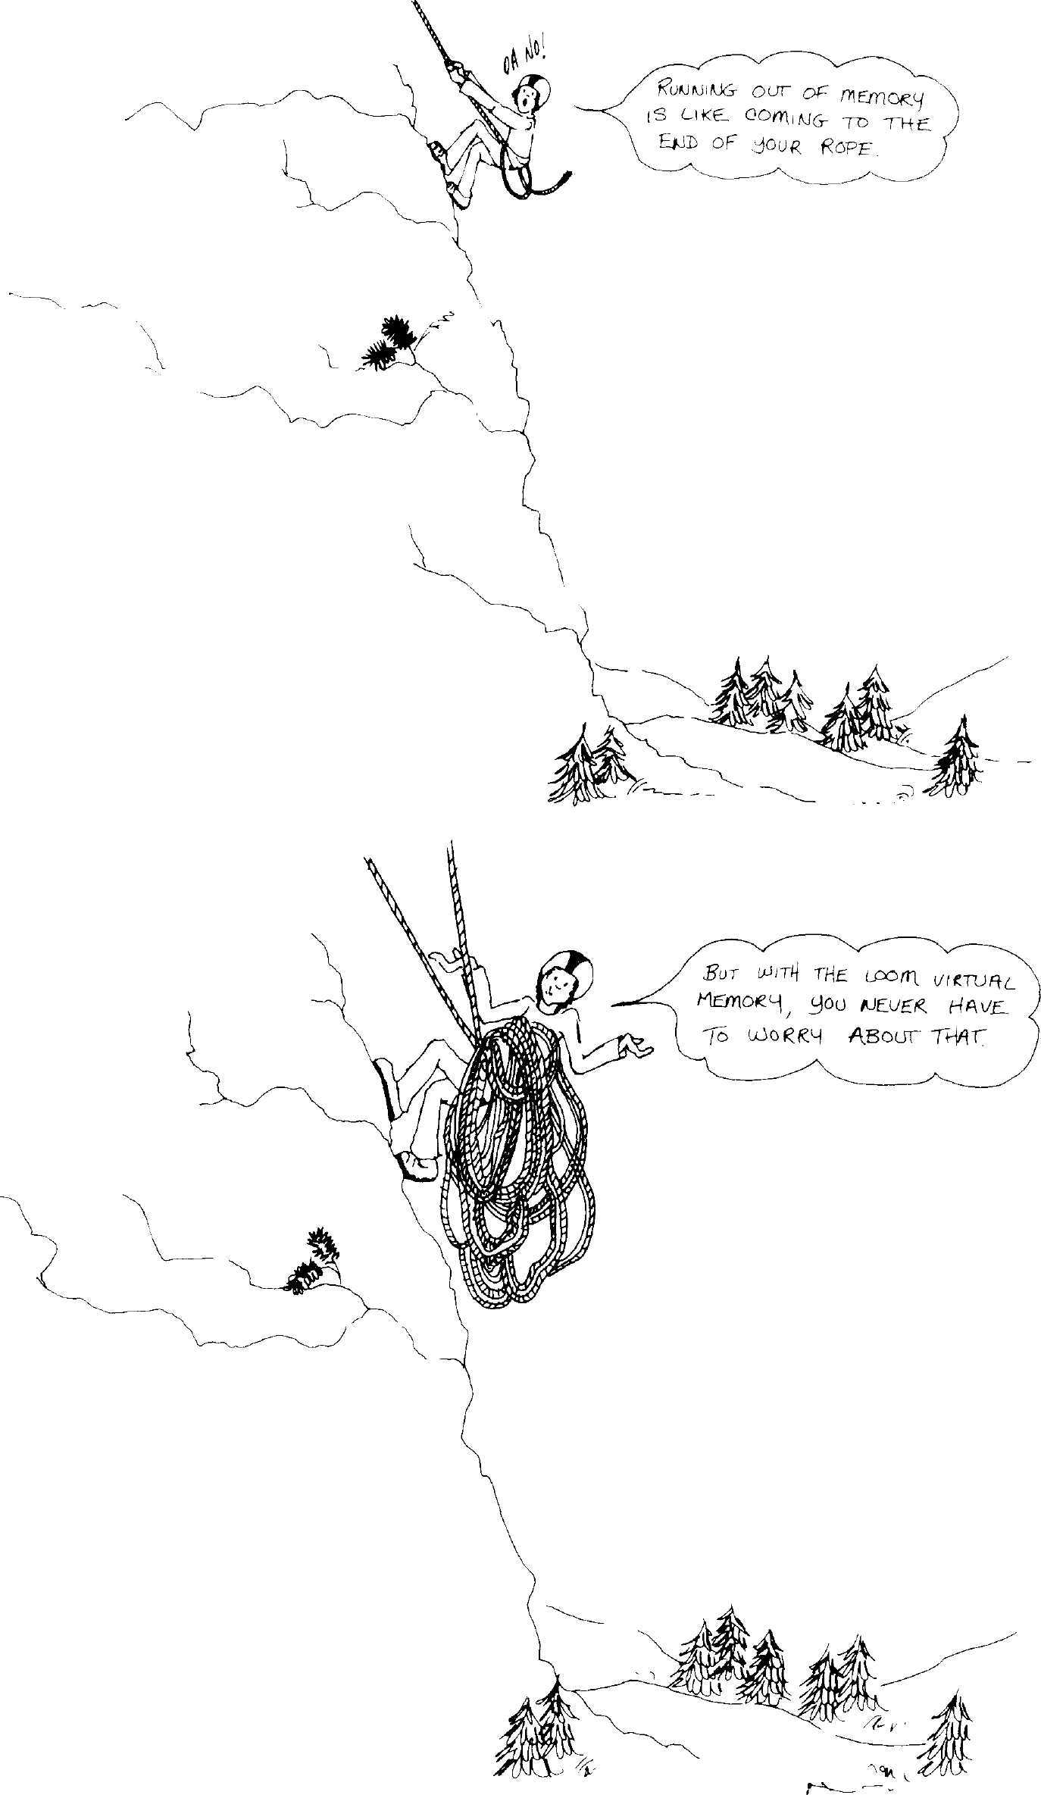
271

Managing the Evolution
of Smalltalk-80 Systems
Steve Putz
Software Concepts Group
Xerox Palo Alto Research Center
Palo Alto, California

Introduction
This paper describes a software system currently being used by the
Software Concepts Group (SCG) to help facilitate and document our de-
velopment of the Smalltalk-80 system. The central feature of this devel-
opment support system is a remote database containing information
about past and proposed changes to the Smalltalk-80 system, as well as
bug reports and an informal library of application programs. We call
the present program which maintains this database the Smalltalk-80
version handler.
Three kinds of documentation which we have found to be important
in the development of the Smalltalk-80 system are:
- Documentation of system changes and system release versions,
- Documentation of known bugs and other problems, and
- Maintenance of a software applications library.

A Research
Programming
Environment
The SCG Smalltalk-80 programming environment is used as an experi-
mental basis for the development of new concepts in user interfaces,
language, and system development tools. The system is modified in or-
der to repair bugs, to enhance existing functions, and to introduce new

Copyright © Xerox Corporation 1982. All rights reserved.
273

274
Managing the Evolution of Smalltalk-80 Systems
functionality. New versions of the system are released for use within
the group frequently. Since different people are often working on the
system at the same time, it is important to coordinate and document
changes to the system, so that inconsistencies are not introduced and
new bugs are kept to a minimum. Since each user has their own copy of
the system, those who are using the Smalltalk-80 system for creating
independent applications also need to know about changes to the sys-
tem, so they can maintain compatibility and take advantage of new fea-
tures. Documentation of problems found by users of the system can help
to warn other users, as well as serving as a list of "things to fix." It is
therefore very desirable to have a well maintained bug list which is
easy to update and access.
In addition to fixing and improving the Smalltalk-80 system itself,
SCG and other users often create small software applications or en-
hancements which may be of interest to others. We call these programs
and enhancements "goodies." It is useful to have easy availability and
documentation for these goodies in the form of a software applications
library. If popular, goodies may be incorporated into a later version of
the system.
Past Practices In the early development of the Smalltalk-80 system, as with its precur-
sors, we had only some ad hoc and informal mechanisms for
maintaining the three kinds of system documentation mentioned earli-
er. At any given time, our current Smalltalk system would be more or
less stable depending on the current focus of activity. During a period of
rapid change and development, many people are doing systems pro-
gramming and new versions of the system may be created as often as
several times a day. Eventually this is followed by a more stable period
in which more people are doing applications and other independent ex-
periments; new versions of the system, with minimal changes, are then
released every few months or so.
During the periods of rapid system development, changes were fre-
quently made directly to the current system image, which was then
written out to become the new, current system. Although old versions
were always maintained for reference and recovery, no systematic docu-
mentation was kept of the changes made, other than verbal communi-
cation and some notes (written by the programmer) kept within the
system itself. Bugs were either communicated verbally or sometimes
listed on a whiteboard until fixed.
275
An Interim Development Support Mechanism
During more stable periods, changes were collected in Smalltalk-80
code files and later applied to the system all at once. A more or less de-
tailed message would be distributed (via electronic mail) outlining the
changes in the new version. Problems and bugs were usually communi-
cated verbally and not necessarily written down.
An informal applications ("goodie") library evolved where users
placed Smalltalk-80 code files on a special file directory and announced
the new goodie via electronic mail. Usually little or no documentation
accompanied the announcement. The announcements were not system-
atically collected, so unfortunately there was not a satisfactory index of
what was available.
These informal methods worked reasonably well due to the small
number of people involved, and the relative simplicity of the changes
being made. One of the disadvantages was that less urgent information,
such as a small bug, was often forgotten. Another disadvantage was
that no detailed record was kept of why a particular change or fix was
made, and why it was done the way it was. Often the programmer is
not even fully aware of his implicit design decisions. As a result, some-
times an important part of a change would be accidentally undone or
interfered with by a later change.

An Interim
Development
Support
Mechanism
During one period of especially frantic development, we decided that
some more formal mechanisms for dealing with documentation and sys-
tem software were required in order to better support our needs for
communication about our changing Smalltalk-80 system. One reason
for this is that the Smalltalk-80 system is significantly larger and more
complex than earlier Smalltalk systems. Software tools for manipulat-
ing this information would be very helpful and would be much less te-
dious than the corresponding manual methods.
Although we planned to create software within the Smalltalk-80 sys-
tem itself for system development support, we started with a simple
mechanism consisting of a minimum of automation in order to gain
some preliminary experience. Fig. 15.1 is a diagram of the components
of the interim support system, outlining as an example the submission
of a bug fix report.
Initially we used an electronic mail system that was not part of the
Smalltalk-80 system in order to enter and collect messages about the
Smalltalk-80 system. Standard forms were used to send messages to a
special "mailbox" (called "Smalltalk80Support") regarding bug reports,

276
Managing the Evolution of Smalltalk-80 Systems

/user fixes a bug and Λ
( places the code file I ■
\on a remote file server/
/user sends an electron ic\
( message describing the )
\ bug fix /
( maintainer appends the Λ
( message to the appropriate )
V. remote mail file J

(
user opens a mail browser
and may inspect or incorporate
the code files mentioned

( Smalltalk-80 System)
( Mail System f
(Mail System )
^Smalltalk-80 System)

Mail Server
File Server
Figure 15.1
bug fixes, system changes, "goodies," or miscellaneous comments about
the Smalltalk-80 system. Copies of these messages were also sent to a
Smalltalk-80 users' group called "Smalltalk80Users." Fig. 15.2 shows
the form used for submitting bug fixes. These messages were collected
daily by a system maintainer in a number of mail files on a remote file
server.

Figure 15.2
Subject: Smalltalk-80 Bug Fix: ShortDescription
To: Smalltalk80Support.PA
cc: Smalltalk80Userst.PA
Source-File: [Phylum] < Smalltalk80Support > FileName .st
From-Version: VersionDate
Bug: DescriptionOfBug
Fix: DescriptionOfFix
Methods Affected:
ListMethodsAffected
Reviewer: NameOfReviewer

Messages regarding software submissions (e.g., bug fixes or goodies) con-
tained the field Source-File indicating the name of a centrally-located
file containing the source code. Periodically new versions of the system
would be created based on the messages received. An electronic mes-
sage would then be sent documenting the new version.
A simple user interface was created for browsing the message files
from within the Smalltalk-80 system. The mail browser window shown
in Fig. 15.3 has two parts. The top part is a menu containing the titles
of the messages in the file. When the user selects a title, the corre-
sponding message is displayed in the lower part, Fig. 15.4.

271
Detecting Conflicts Between Software Submissions

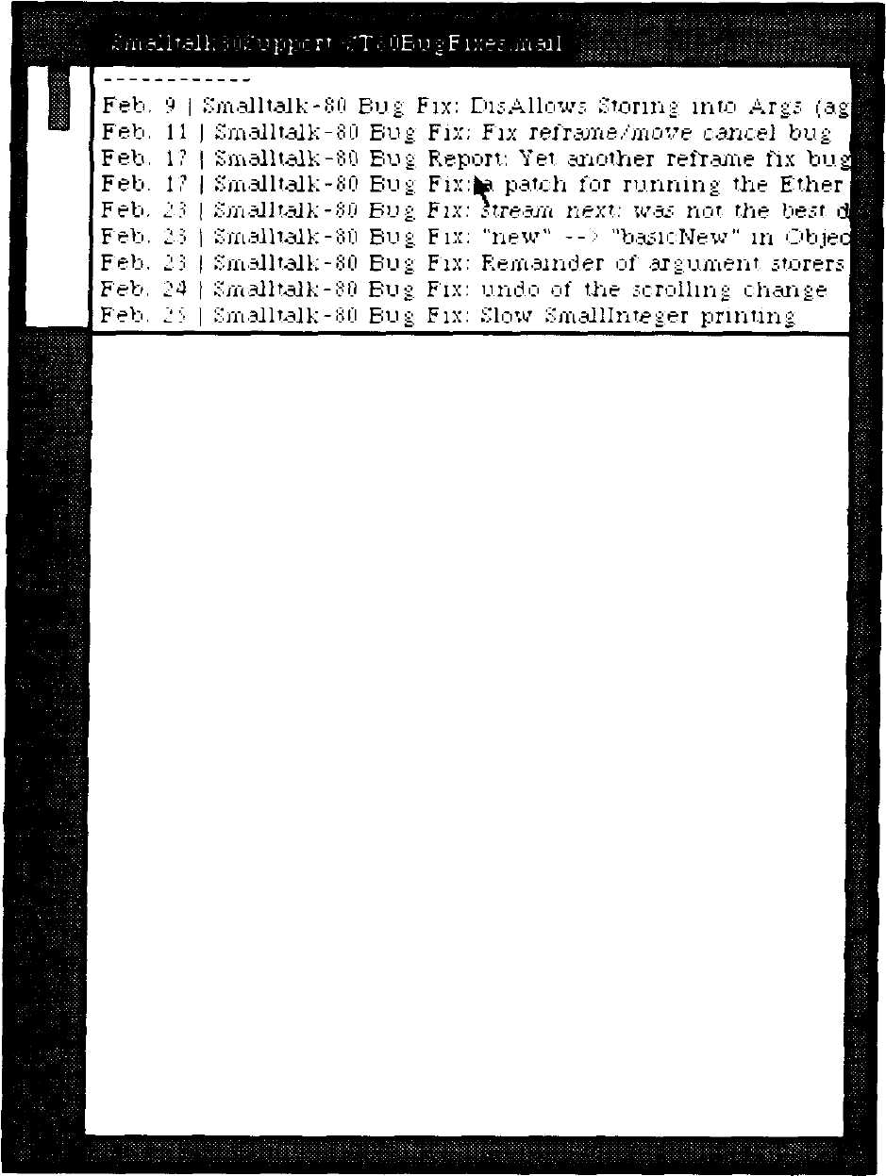
Feb. ? I Smalltalk-80 Bug Fix; DisAllows Stnnn- mtn δ_{γ}<- μ·>
Feb. 11 | Smalltalk-fin Bug Fix; Fix retra/ae/move cancefbu* "'
Feb. 1? | Smalltalk-80 Bug Report: Yet .another reframe fix Vm
Feb. 17 | Smalltalk-80 Bug Fix: a patch for runnini the Ethej'
Feb. Ji | Smalltalk-80 Bug Fix: stream next: was ηώ the hf-st"
Feb. :? | Smalltalk-80 Bug Fix: "new" -- ■ "basicNew" m Obie
Feb. 2 3 | Smalltalk-80 Bug Fix: Remainder of .argument s'oi '
[Feb. 24 | Smalltalk-80 Bug, Fix; undo of the scrolling change
From: Deutsch.pa
alllnteger printing
Subject: Smalltalk-80 Bug Fix: Slo^{T}.
To: SmalltalkSOSupport.PA
cc: Smalltalk i'OUsers t .PA
Source-File: [Phylum]· Smalltalk80Support ■lpdlntPrint.st
From-Version: Febjj
Bug: The method for Smslllmeger prmtC'n:base: did many
pointless conversions between characters and digit values.
The method had obviously been fixed up several times, by
people who didn't have the time to read it carefully, in
order to survive through the various juntas.
Fix: The digit buffer in Smalllnteger was changed from a
Stung to an Array, and .all the unnecessary conversions
were removed. This fix speeds up Smalllnteger printing on
the Dolphin by about ίθ%
Methods Affected:
Smalllnte ger prmtOn :base:
Smalllnteger class initialize
Reviewer: Adele

Figure 15.3
Figure 15.4

This user interface also allows the Smalltalk-80 source code referenced
by a message to be inspected or incorporated into the user's
Smalltalk-80 system via additional pop-up menu commands. Fig. 15.5
shows the user invoking the browseSource command for the bug fix en-
try being viewed; Fig. 15.6 shows the file window obtained as a result.
The user is not allowed to modify the message text or the source code.

Detecting
Conflicts
Between
Software
Submissions
One of the problems encountered with this distributed approach to sys-
tem development and maintenance is avoiding (or at least detecting)
conflicts in work done by different people in parallel. The longer the
time span between system releases, the more likely that incompatible
conflicts will arise between system changes submitted by different

278
Managing the Evolution of Smalltalk-80 Systems

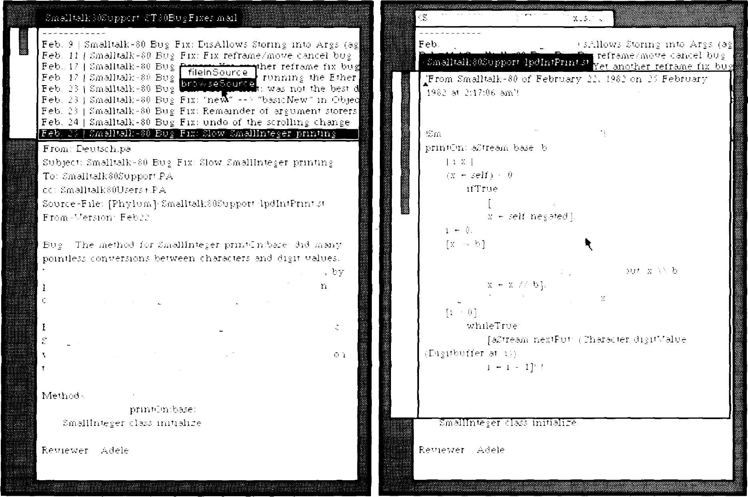
mallt.alKijUuupport ΐ l si.tbu gt ι ■=■ m=al
9 I Smalltalk-SO Bus Fix; Ε ι -
alllntejer method it or "printing;
aStream nextPut: f-
whileTrue.
[E'lgnbut'fer at ii - ι + 1) j
rhe method had ob'.nouily been fixed up ;everaJ timei
neople who didn't have the tune to read it carefully, i
,rder to ;uri:i'.re throijsh the '..'anou; lunt.ai
Diil'buiter at: ,1 - ι + ρ put
^{r}ix: The digit buffer in iVnaJUnfeier w.aj: chajijed from -.
■ tiini to an Array, and all the unnece;i.aTy con'..^{T}er;iun;
u^{T}ere remoT.'ed Thi; fix ;peedi up i'maillntejer printing ι
he E'olphin by about 30%
.- Affected
SffiallInteger
Figure 15.5
Figure 15.6

users. In the Smalltalk-80 system, this usually occurs when two pro-
grammers have modified the same Smalltalk method definition.
In order to help solve this problem, we developed a program for ana-
lyzing Smalltalk-80 code files and reporting the ways in which they
conflict, i.e., by modifying the same method definition or other
Smalltalk object. This approach works very well since most Smalltalk
method definitions are very short and perform a very specific function.
Whenever two or more submissions define the same method, all con-
flicting definitions are appended to a "conflict report" file. It is then up
to the programmers involved to determine how to resolve the conflicts.
Often one of the definitions can be chosen over the others. Otherwise a

279
An On-Line System Development Database
new method must be written which merges or resolves the functionality
of the conflicting definitions. No automatic conflicts resolution was
attempted.
Although this tool is fairly crude, it has proven very useful for
detecting and resolving at least some conflicts which otherwise would
have gone undetected or surfaced later as annoying bugs.

An On-Line
System
Development
Database
After using the interim support mechanism for several months, we
were ready to create a development support system within the
Smalltalk-80 system itself. Since the Smalltalk-80 system did not then
interface with the Xerox internal electronic mail system, one of the
main disadvantages of the interim mechanism was that users were not
able to submit reports directly from the Smalltalk-80 system. In addi-
tion to allowing users to submit bug reports and software submissions
directly from within the Smalltalk-80 system, we wanted the new sys-
tem to provide a Smalltalk-style user interface for browsing, adding to,
and editing the system development database. Fig. 15.7 shows the com-
ponents of the current support system involved in submitting a bug fix.
The new database, like the mail files of the interim system, resides
in a number of data files on a remote file server, accessible to any run-
ning Smalltalk-80 system. Since the database is accessed by
Smalltalk-80 systems rather than standard mail programs, we were
able to automatically include additional information, such as cross ref-
erences between related entries in the database.

user fixes a bug and Λ
places the code file )
^ona remote file server/
(user submits a bug fix Λ
* I report describing the ) '
\^ bug fix y
/the VersionHandler adds Λ
( an entry to the appropriate )
V^ remote database file J
Jj
f user opens a changes browser
ί and may inspect, modify, or
\incorporate database entries

Figure 15.7
( Smalltalk-80 System]
I
File Server
(smalltalk-80 System)

280
Managing the Evolution of Smalltalk-80 Systems

Structure of
the Database
The current version handler database is patterned strongly after the
mail files used in the interim system. The database contains three
kinds of entries: system versions, bug reports, and system changes (in-
cluding bug fixes and "goodies"). Each entry has a unique ID, and a
user supplied title and message body describing the entry. The system
adds fields specifying the date and the version of the Smalltalk-80 sys-
tem from which the entry has been generated. Additional fields may
contain various status conditions of the entry. Most fields are stored as
text in the header portion of the message; some special fields (e.g.,
whether an entry is new or old or has been deleted) are hidden from
the user.
System version entries also contain the ID's of the system changes
which differentiate the version from its predecessor. Thus a new version
can be generated from some previous version by automatically incorpo-
rating the appropriate changes into the user's Smalltalk-80 image. Ver-
sion entries also contain the ID's of all bug reports which apply to that
version.
In addition to containing a description of the bug, bug report entries
contain the ID's of available system changes that fix the bug.
System change entries contain the names of one or more remote files
containing Smalltalk-80 source code. If the change fixes a reported bug,
the change entry also contains the ID of the corresponding bug report
entry. No firm distinction is made between submissions which are actu-
ally changes or fixes to the Smalltalk-80 system and arbitrary user ap-
plications (i.e., goodies). Some changes get incorporated into later
versions of the system while others simply remain in the database for
optional retrieval.
The database is maintained by a special object, named
VersionHandler, which is in every Smalltalk-80 system. The
VersionHandler object acts as an interface to the actual database stored
on a remote file server. It is responsible for reading and writing por-
tions of the database and coordinating access among multiple
Smalltalk-80 systems.

A Browser
Style User
Interface
The user creates Smalltalk windows for accessing the database by send-
ing Smalltalk messages to the VersionHandler. The top level commands
available to the user for accessing the database include:
• Open a version browser

281
A Browser Style User Interface
- Submit a bug report
- Submit a bug fix
- Submit a software goodie
- Create a new system version
Fig. 15.8 shows a workspace containing the Smalltalk messages used to
invoke these commands.

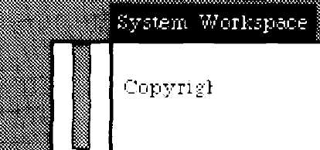
Smalltalk-80 of I - ■ ,
μ ι l'J 1, 1^{IJ}.-.J :>rn·: i"Vir{i
.-.11 n^iiK rr.er-eJ

System Support
iHandle
iHaricUe
iHandle
iHandle
iHandle.
browseRecent'-'ersiorji
browseVeisioris
b r ο w s e Ν e w G ο ο d ι e s
browseGoodies
browseBus.s
a q a
υ Για·.
ρ as
ΒΟΗ
rin -Ρ

V e r s ι ο η Η an d 1 e r b u g R e ρ ο r t

Figure 15.8
VersionHandler submitGoodie

Each of these commands causes a new window to be created. There are
three kinds of database browsers for the three kinds of database
records: version browsers, change browsers and bug report browsers.
These browsers differ only in their contents and the command menus
they provide. Fig. 15.9 shows a version browser in which the user is
selecting the browse changes command. Fig. 15.10 shows the changes
browser created as a result of the selection.
Fig. 15.11 shows the command menus provided by each kind of brows-
er. Selecting browse changes creates a browser on the changes which
make up the version. The browse goodies command creates a browser
on all changes which are not included in the current version. This is
equivalent to searching an applications library of user programs and op-
tional system enhancements. The retrieve version command is useful if
the version of the Smalltalk-80 system one is running is not the most re-
cent. By selecting retrieve version, the user can upgrade the system. The
system then automatically retrieves all the required changes.
The browse source files and file in changes commands in the changes
browser are similar to the special commands provided by the interim
mail browser. File in changes allows a user to incorporate a bug fix or
other change into the Smalltalk-80 system.

282
Managing the Evolution of Smalltalk-80 Systems

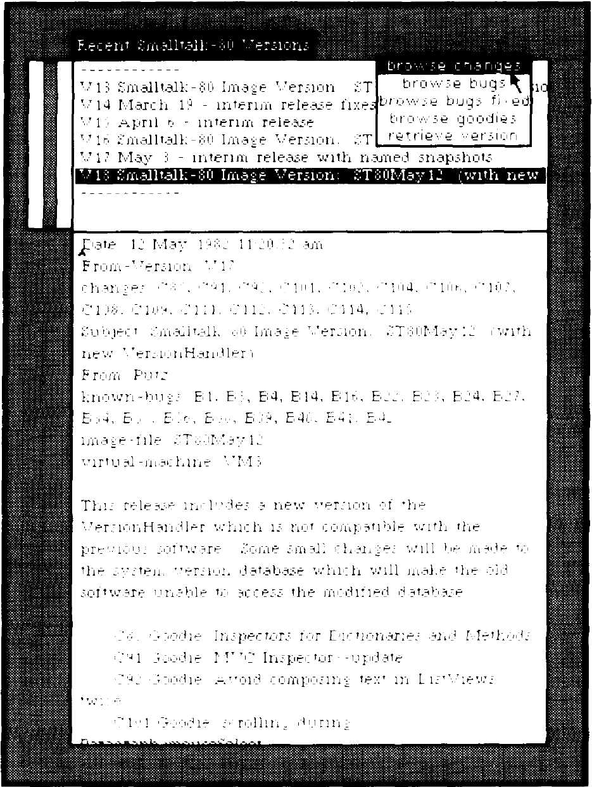

 | ρ | m  m |  | BliiiiiL-™.-. |  | .v> -
 |  | 1 | Jl I
I
I |  |  | I | I r-T
1 |  |  | I r | γ-
1 | 1 |  | 1 | 1
1 | 1 |  | 1 | r-T Γ
I VIS SewlltaEkSO tnage Versaer» |  |  |  |  |  | (yntb
1 |  |  | h ι- | ρ
 |  | F | F | 1 " J f |  | 1
 |  |  |  | 1i 1 ι
1 |  |  | t r | r
1 | r- |  | 1 | 4
t
t
 |  | V |  | 1
 | 1 |  |  | F |  |  | : -τ ·!^
 |  |  |  | 1 ]
I? |  |  | ».,... .»
i | I |  | 1

Figure 15.9
Figure 15.10

Fig. 15.12 shows the window obtained by selecting the browse bugs
command. Unlike the interim mail browser, the text description associ-
ated with an entry may be modified by simply editing the text which
appears in the database browser. Fig. 15.13 shows the user selecting the
file in changes command in order to try out an experimental change to
the Smalltalk-80 system. The goodie browser shown was obtained by
selecting the browse goodies command in the version browser.

browse chang θ 5
browse bugs
browse bugs fixed
browse goodies
retrieve version
Figure 15.11
browse source file;
browse bucjs fixed
file in changes
|browse fixesj

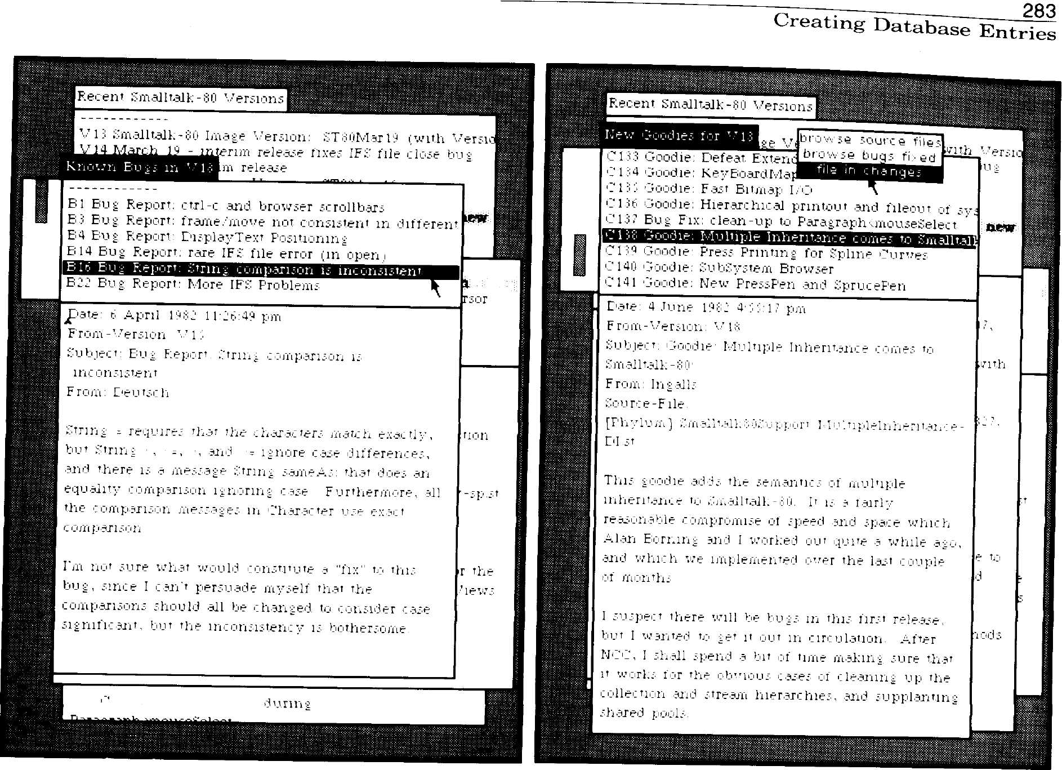
- 10 1 'hoodie: scrolling
Figure 15.12
Figure 15.13

Creating
Database
Entries
There is also a special window used for creating each kind of database
record. The user sends a Smalltalk message to the VersionHandler re-
questing to submit a bug report, bug fix, goodie or new system version.
In response, a new window is created that contains a form for the user
to fill in. The entry is added to the database when the user selects the
accept command.
Figure 15.14 shows the window for creating a system change entry
which fixes some known bug. The lower half of the window contains a
bug report browser. The user selects the titles of the bug reports which
he has fixed. Before selecting accept, the user also fills in a title, his
name, and the name of the Smalltalk-80 code file he has already created.

284
Managing the Evolution of Smalltalk-80 Systems
The user can submit changes or goodies which are not bug fixes us-
ing a window which resembles just the top half of the bug fix window.
Bug reports are also submitted using a similar window.

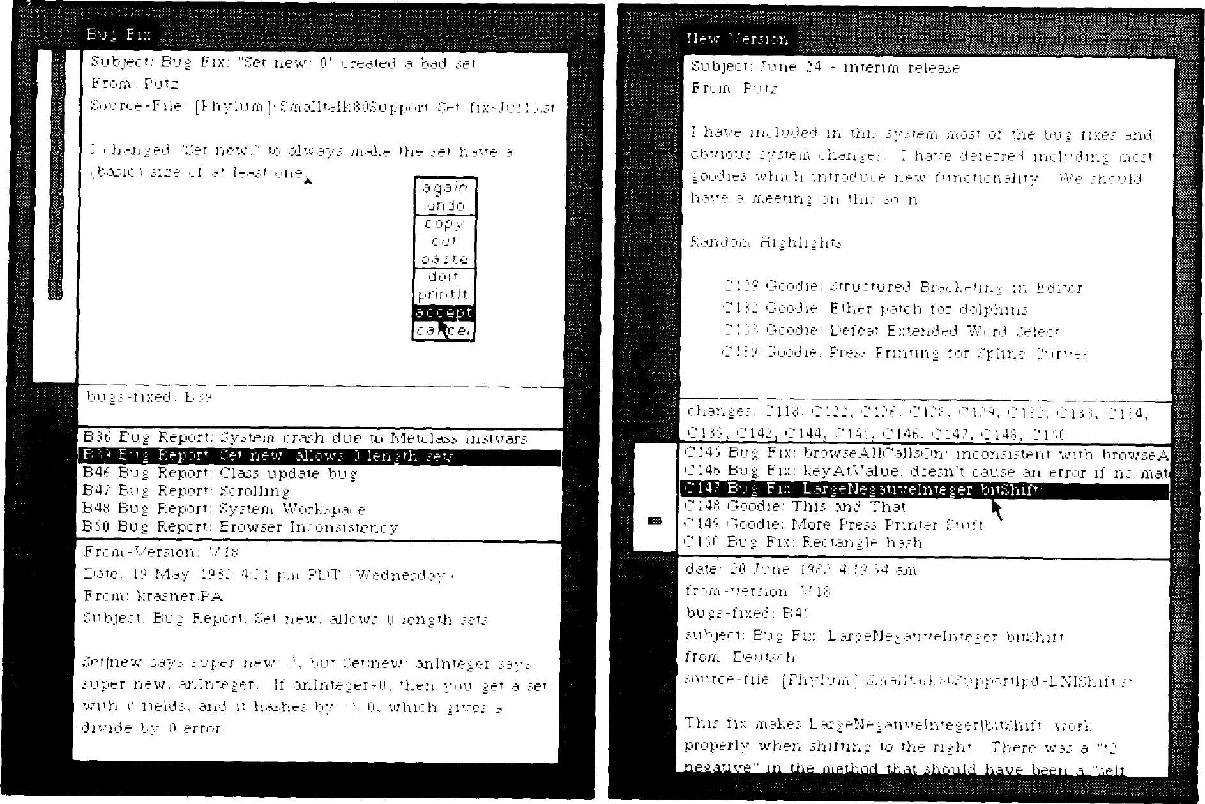
Figure 15.14
Figure 15.15

Fig. 15.15 shows a new system version being created. This is done by
selecting from a menu of the system changes (goodies) submitted since
the last version. A conflict detection program can then point out possi-
ble conflicts between the selected changes. (This is currently not done
automatically.) The ID's of any bugs which have not been fixed by the
selected changes are inherited and included in the new version. When-
ever a new version is created, the source files involved are automatical-
ly copied to a new sub-directory on the file server to freeze and
preserve the integrity of the new Smalltalk-80 system. The new system
may be released as a new image file, or, due to the large overhead of

285
Creating Database Entries
generating an entire system, it may be left as an interim release which
can be quickly generated from a previous image version each time it is
used.
Fig. 15.16 is a diagram of a portion of the database. Bug reports are
shown in the first column with lines connecting them with entries for
corresponding fixes, if any. The second column shows the changes (in-
cluding bug fixes) which have not yet been incorporated into any ver-
sion; these make up the "goodies" application library. The third column
shows changes entries connected by lines to the versions in which they
have been incorporated. The rectangular boxes denote image versions,
while the large ovals are interim release versions. The links between
version entries and bug reports are not shown. When the next version,
V9, is created, the changes C21, C22, and C23 will no longer be consid-
ered "goodies."

Bug
Reports
Incorporated
Changes
System Versions

"Goodies"

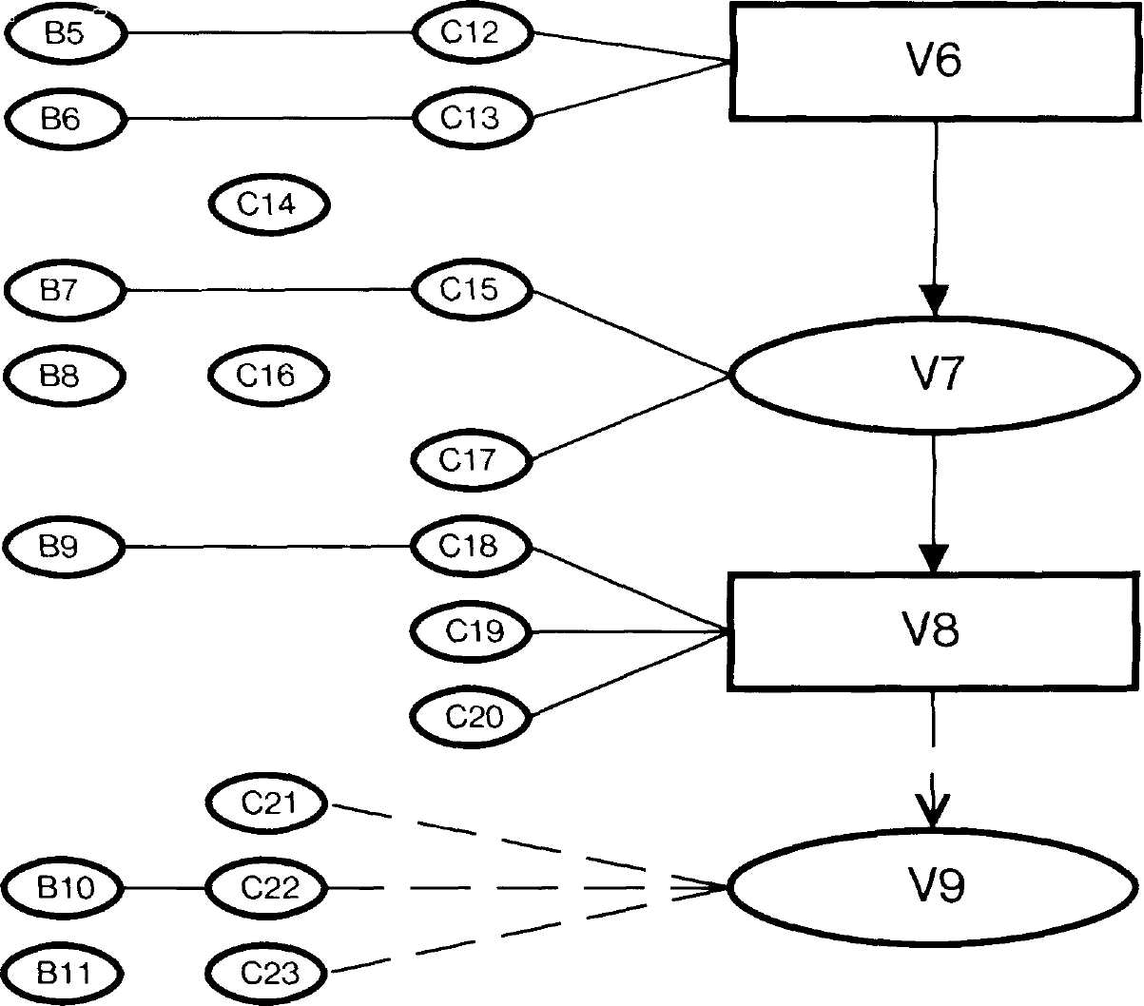
Figure 15.16
image
version
interim
version
image
version
next
version

286
Managing the Evolution of Smalltalk-80 Systems

Conclusion
The system version database has proved to be a very useful software
tool for managing and maintaining our Smalltalk-80 research system. It
has provided us with a convenient mechanism for documenting versions
of the Smalltalk-80 system. Each change made to the system has a cor-
responding entry in the database. This provides a complete history of
the system's evolution. The most popular feature is that users may sub-
mit or browse bug reports directly from their Smalltalk-80 system. The
database also provides a software applications library which may be
easily accessed and augmented.

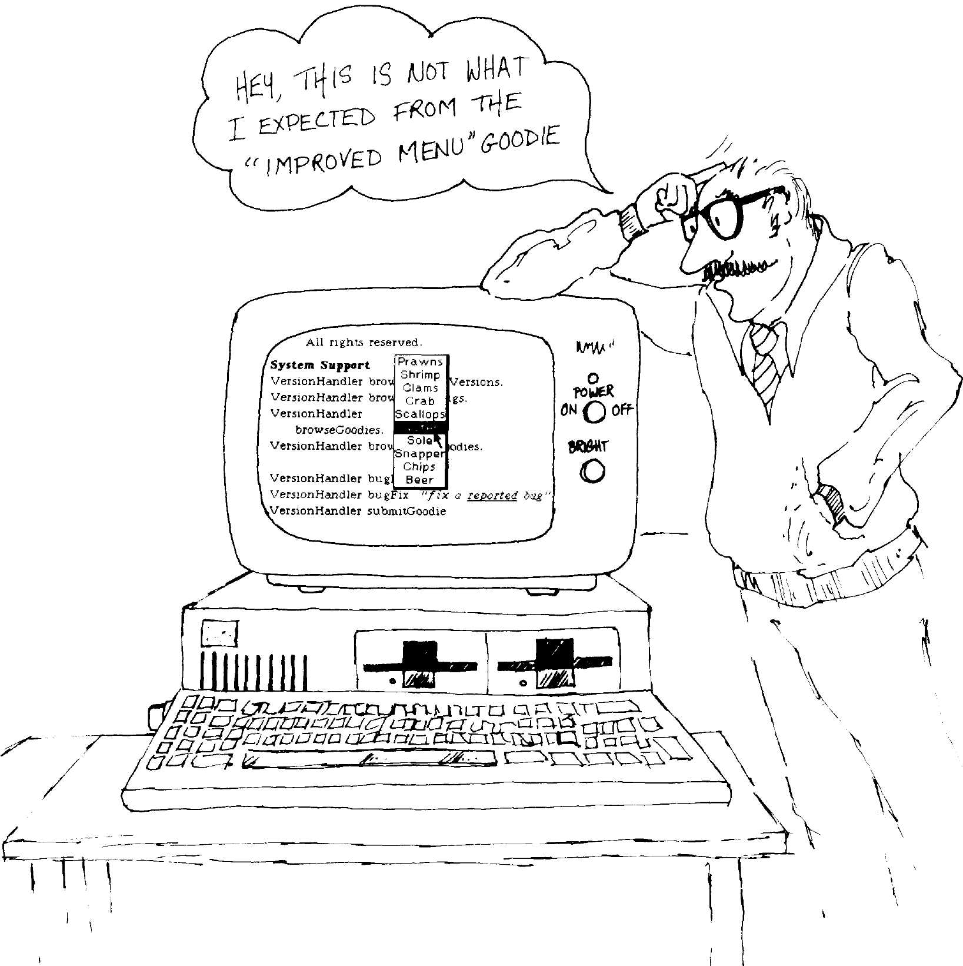

Implementing a
Smalltalk-80 File System
and the Smalltalk-80
System as a
Programming Tool
D. Jason Penney*
Tektronix, Inc.
Beaverton, Oregon

Abstract
The Smalltalk-80 system may be used without any file system, but a
number of its features presuppose a working file system. Work must be
done to effect a file system on a new Smalltalk-80 implementation. This
paper describes the design and implementation of the file system for a
Tektronix Smalltalk-80 implementation and concludes with some reflec
tions on the use of Smalltalk-80 as a programming tool.

Background
The Smalltalk-80 system is designed to be host machine independent.
The system uses files, but file systems tend to rely on the idiosyncrasies
of a particular host. Thus the Smalltalk-80 virtual image can support
files for a new implementation in an abstract manner. Higher-level
methods in the system usually deal with files through FileStream, a
subclass of ReadWriteStream. Files themselves have their functionality
partially separated out into abstract classes File, FileDirectory, and
FilePage. Fig. 16.1 shows the superclass relationships of these classes.

*Mr. Penney is currently employed by Servio Logic Corp., Portland, Oregon.
Copyright © Tektronix, Inc. 1982. All rights reserved.
287

288
Implementing a Smalltalk-80 File System

Figure 16.1
Object ()
File ( 'fileDirectory' 'fileName' 'pageCache¹ 'serialNumber'
'lastPageNumber' 'binary' 'readWrite' 'error')
TekFile ('pageCacheOffset' 'lastPageAddress' 'creationDate'
'creationTime' 'modificationDate' 'modificationTime'
'firstPageMap')
Object ()
FileDirectory ( 'directoryName' 'closed')
TekFileDirectory ( 'nextSerialNumber' 'medium' 'freeListFile'
'directoryFile' 'directoryStream')
Object ()
FilePage ('file' 'page' 'binary')
TekFilePage ( 'address')

The virtual image contains the details of one implementation in the
"concrete" subclasses of File, FileDirectory, and FilePage; to wit, AltoFile,
AltoFileDirectory, and AltoFilePage.
Implementors could implement the primitives these classes require,
reimplement subclasses of the abstract classes, or start from scratch.
The Alto classes presuppose a particular kind of disk and disk control-
ler, as well as the existence of system utilities to manage the disk.
Starting from scratch would require reimplementing FileStream, which
is the interface class for all file manipulation in the system. We eventu-
ally chose the second approach, creating TekFile, TekFileDirectory, and
TekFilePage.

Description of
Chosen
Problem
Class FileStream divides files into fixed-length chunks of bytes, called a
FilePage. FilePage is intended to map directly to page-oriented media. A
FilePage is associated with a File, and has additional state such as the
page's pageNumber in the file, actual number of bytes used on the page,
and a hardware-related address.
A File contains such things as where to find its FilePages and the
String that represents the file's name. When the file is open, some of its
state is cached in the File instance.
A FileDirectory contains the necessary information to access all the
files within a given directory. It responds to some Stream messages such
as reset and next (but not atEnd). A FileDirectory can iterate over all of
its files (with do: but not reverseDo:). A FileDirectory keeps some of its
state in object memory when it is open, hence it responds to state-cach-
ing messages (open, close, and flush).

Alternate
Programming
Approaches
289
Description of Chosen Problem
At Tektronix we did not have the luxury of an existing file system on
our Smalltalk-80 hardware. Thus it was not appropriate for us to try to
emulate the Alto file system or to make another existing file system
work on our hardware and map into the Smalltalk-80 FileStream class.
Since our virtual machine was originally implemented in Pascal, we
briefly considered writing the file system itself in Pascal and providing
a minimal interface in the Smalltalk-80 system. The disadvantage in
this approach is that the resulting file system would be largely opaque
to Smalltalk-80 inspectors and debuggers. Instead we chose to design,
implement, and test the file system using Smalltalk and a small num-
ber of disk primitives.

Design Constraints
Our primary constraint was that the file system had to be simple,
debuggable, and maintainable, so that we could use the file system in a
short amount of time.
The Alto file system puts enough redundant information on file data
pages so that a "scavenger" can recover significant amounts of a disk
after a disk crash. We felt that this should be in our own file system.
Since the Smalltalk-80 source file system manipulates one very large
file, it is necessary to be able to find the address of a specified page
number in the file with relatively little effort. In other words, the file
system should have reasonable performance for random access as well
as sequential access.

Design Approach
Abstract class FilePage allows a chunk of data bytes to be sandwiched
between a non-data header and trailer of a specified (possibly zero)
length. We use a header in TekFilePage to describe the data bytes on
the page. Since our disk driver does address checking and data
checksumming, we did not include these in the page header. The page
header does however, have redundant information (file serialNumber,
file pageNumber, previous page's address, next page's address) as well
as necessary state (size of data in bytes). Fig. 16.2 shows the organiza-
tion of a TekFilePage.
Instances of a concrete subclass of File are suppose to "open" them-
selves when issued the message findLastPageNumber. Since the last
page number (and the address of the last page) are quite useful for
appending a new page to the end of a file and truncating a page from
the end of an existing file, our concrete instances of TekFile have
lastPageNumber and lastPageAddress as additional information for an
open file.

290
Implementing a Smalltalk-80 File System
backPointer
thisPageNumber

nextPointer
serialNumber
\ header (24 bytes)

size
(unused)

Figure 16.2
data (1000 bytes)

The Smalltalk-80
System's Role
in Initial
Design Effort
Our first descriptions of file system design presupposed using Pascal,
Pascal will handle certain types of data structures (such as 32-bit ma-
chine integers) more gracefully than the Smalltalk-80 system will. Pas-
cal encourages fixed-length data typing. Sometimes this is acceptable,
since FilePage pages are fixed length. On the other hand, a file name is
merely a String of arbitrary length, which is not convenient at all with
Pascal data structures. For this and other reasons, we chose to use Pas-
cal for only the disk primitives.

Directory Design
Figure 16.3
Since we were free to design the directory in any way, we chose to im-
plement it as a sequential file in the format shown in Fig. 16.3. This
format allows the directory to be human readable as well as readable
by Smalltalk-80 classes. Many Smalltalk-80 classes support a self-de-
scription facility through the selectors readFrom: and storeOn:. These
selectors do their work on an accompanying Stream in a human-read-
able as well as Smalltalk-80-readable form. Since a FileDirectory is
expected to deliver up a sequence of files in a Stream-like fashion, a
Smalltalk-80 directory can be naturally envisioned as a FileStream that
has a sequence of file definitions.
('Directory',1,1,12,2567462400,41166,2567462400,41166,11)
CFreeList',0,1188,1260,2567462400,41166,2567462400,41166,1)
('Smalltalk80.sources',2,1242,1259,2567462400,41242,2567462400,
60378,13)
Items for each file are in order:
- fileName, a String
- serialNumber, an Integer
- lastPageNumber, an Integer
- firstPageMap, an Integer
- creationDate, seconds since 1 Jan 1901
- creationTime, seconds since midnight
- modificationDate, seconds since 1 Jan 1901
- modificationTime, seconds since midnight
- lastPageAddress, an integer

291
Description of Chosen Problem

Design Details
Our hardware provides random access to a variable number of "sectors"
1024 bytes long. There is exactly one TekFileDirectory for a medium.
The exact number of sectors available for each medium is available
through a primitive.
Each "medium" may have bad sectors—i.e., ones that the device
drivers will not handle without raising error conditions. One sector at a
fixed address is presupposed to be good. This sector with its prespecified
address is called a "leader"; it provides information about the medium
as a whole.
Each sector on a medium (including the leader) is treated as a
TekFilePage. A TekFilePage has a 24-byte "header" and 1000 bytes of
data. "Data" refers to bytes that are handled by Stream messages next
and nextPut:.
The header on a TekFilePage contains a back pointer to the previous
TekFilePage within a file (or a nil-address if none), a pointer to the next
TekFilePage within a file (or nil), the serial number of the page's file,
the ordinal page number of this page in its file (i.e., "1" for the first
page in a file), and the number of data bytes that are actually in use on
this page (the size). All pages in a file except the last one are guaran-
teed to be full.
The header information in a TekFilePage is, strictly speaking, suffi-
cient to completely recover files on a crashed disk. Exceptions to this
are lost sectors containing file data and some information in the direc-
tory file such as creation/modification date and the String used for the
file name. On the other hand this is not enough information to allow
rapid nonhomogeneous access to a file, such as is required by the
Smalltalk-80 browser. To accomplish this an extra data structure is
written with each file in the system: pageMap pages. Fig. 16.4 shows
the organization of secondary structures on a meduim.
leader

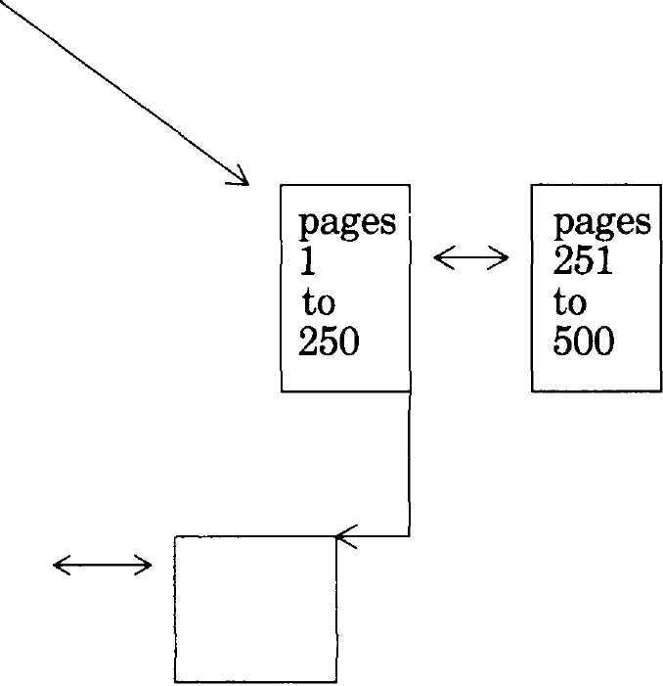
pageMap for Directory
data pages
Figure 16.4
<-> (other pageMaps)

292 __
Implementing a Smalltalk-80 File System
The directory entry for a file specifies the address for the first pageMap
for that file. A file always has at least one pageMap page. A pageMap is
forward- and reverse-linked with other pageMaps. Its serialNumber is
the same as the one used for the FreeList file, so that a disk scavenger
will not confuse it with data. The pageNumber field of a pageMap page
is not used in practice. A pageMap contains 250 4-byte addresses in its
data section, each address corresponding to the appropriate page in a
file. For instance, if one wished to read the 300th page in a file, one
would read the first pageMap for the file, use the forward-link in that
pageMap to read another pageMap, and read the 50th address in that
pageMap to determine the correct address for the 300th page in the file.
As files are created on a given media, they must be given unique
serialNumbers. The next available serialNumber is written on the lead-
er page, using Integer storeOn:. The leader page's forward-link points to
the first pageMap page of the file which is the Directory file.
The first two file definitions in a directory file are special: The first is
the directory file itself (named "Directory") and the second is a relative-
ly large file that occupies all the unused pages in the system (named
"FreeList"). Both of these files are bona fide in the sense that they have
a serialNumber and a complete set of pageMaps. The serialNumber of
FreeList is zero, which signifies non-data. For the sake of consistency,
FreeList's "data" pages are fully linked just like all other files in the
system.
Implementation There is a bootstrap problem involved with implementing a file system.
Approach The source code for the new classes must be typed in by hand. The
physical media must be formatted with a Directory and a FreeList.
Once the file system is up and running, the very large file that contains
the commented sources for the system must be converted to reside on
the new format. Finally, one must recompile the file system methods,
adding comments and regenerating variable names.
Typing in the new classes was irritating but not difficult on our imple-
mentation. If one's interpreter runs at 3500 bytecodes per second, key-
board echo requires three to five seconds. Our virtual image had a built-
in performance problem that additionally delayed keyboard echo. Since
there is no source code system, all the new and untested methods lack
argument variable names, temporary variable names, and comments.
None of the file system could be tested until all necessary methods
were typed in and initialization code written to properly initialize a
new media. The debugging itself will be described later.
293
Implementation Approach
Converting the source code to the file system format turned out to be
easy but time consuming. Our system already has software for saving
and restoring memory images on our disk media. We split the source
file into manageable chunks, converted the ASCII text to a
downloadable image (as if the text were executable processor code), and
saved the resulting memory-images on floppies using the existing non-
file system format. A small bit of code in a workspace was necessary to
read bytes off of a bogus TekFilePage onto a legitimate FileStream, and
a very large amount of time was necessary for the conversion (about 11
hours).
Before implementing the file system, we were familiar with the
Managing Smalltalk-80 user interface, but we had only superficial experience with
Windows it- Each of us had his favorite snapshot with his windows placed just
the way he liked it, but our interaction with the system was casual. We
typically would execute selected examples to show to visitors or com-
pose short methods to answer specific questions.
When we started the file system project, our placement of windows
underwent metamorphosis. The old arrangements changed as new
things came to light. For instance, the only kind of browser that we
ever had at first was a full five-pane System Browser. These are useful
because of their full generality. Unfortunately five panes take up a lot
of room on our 512 χ 512 display, which in turn means that less of each
method ends up visible in the code pane. Since all of the code that we
were entering belonged in a single class category, "Files-Tektronix," we
quickly collapsed the System Browser and kept a Class Category Brows-
er instead, which has proportionately more room in the code part of the
browser.
Our typical display had a System Category Browser and a Workspace
to do development work in. A System Transcript, a collapsed System
Brower, and a collapsed System Workspace were kept off to the side. At
first we did not overlap the Category Browser and the Workspace. After
a little bit of use we reframed these two windows so that they did over-
lap substantially. Since we typically moved between the two windows,
making changes in one window and testing the changes in the other, it
was not necessary to see all of both windows at the same time. This was
a significantly better use of display space on our system.
The Browser worked pretty much as advertised. We added our classes
Using the Browser without any difficulty, but when we finished, we discovered that we had
misspelled an instance variable name. Several methods later in that
class, we decided to change the class definition. Much to our surprise,
when we changed the spelling of the instance variable, we did not get
any syntax error messages while the class was being recompiled. If we
had attempted to change the order of the instance variables, the actual
294
Implementing a Smalltalk-80 File System
roles of the instance variables would have reversed. This is because the
decompiler used the new instance variable names rather than the old.
The method category pane of the browser, which provides categories
of methods within a given class, was originally a nuisance. We chose to
ignore it initially. An odd thing was that as long as we added methods
to a new class, the selection in this pane read "no messages" but if we
switched to another class and back, the selection would then change to
"As yet unclassified".
In general the text editor was a joy to use: all basic editing operations
Using the Editor conform nicely with user intuition. Some features are not intuitive, but
neither are they difficult to learn. For example, using control-F for
"ifFalse:" or control-[ for inserting "[]".
We used a full-ASCII keyboard on our implementation, which caused
a special set of problems using the editor. Some of us were initially per-
plexed about how to type the back-arrow assignment symbol which is
pervasive in Smalltalk-80 code: it turns out that this maps into the
ASCII underscore character. A more serious problem was presented by
the unencoded keyboard interface. Xerox uses an unencoded keyboard
for their own Smalltalk-80 systems. An unencoded keyboard reports
only key-up and key-down activity on the keyboard. An unencoded key-
board is closer functionally to a piano than a typewriter.
Whereas an unencoded typewriter keyboard provides greater flexibil-
ity than a conventional encoded-ASCII keyboard, they are less common.
Our Smalltalk-80 hardware uses a readily available encoded-ASCII key-
board. The way Xerox has written InputSensor and InputState gave us a
little grief. We were unable to force a user interrupt with the control-C
character simply because no one at Xerox thought it would be possible
for a keyboard to generate a control-C character without causing a con-
trol-key event. Thus when one types a control-C on an untuned
Smalltalk-80 system with an encoded keyboard, one gets a garbage
character instead of the expected Notifier. The unencoded keyboard
also manifests itself as a problem with such things as control-0 through
control-9 (used for changing fonts), and control-[ (which is different
from ASCII ESCAPE). Although the encoded keyboard was suitable for
use with the Smalltalk-80 system, the control-C problem caused us grief
when we were debugging the file system.
The debugger has done more to spoil us than any other single feature
Using the in the user interface. All aspects are fully integrated. It was never nec-
Debugger essary for us to go to machine-level debuggers or anything else in order
for us to fully debug the file system.
The interpreter simulator, invoked whenever one selects "step" or
"send", runs about 1000 times slower than the machine interpreter. On
our system this meant that the simulator ran at an effective 3 or 4
bytecodes per second. On at least one occasion we accidentally started
295
Typical Programming Problems
the simulator only to determine afterward that we would have to wait
longer than the MTBF of our hardware to allow the simulation to com-
plete.

Typical
Programming
Problems
Syntax Errors
During the course of "accepting" methods into the system and testing
our resulting code, we ran into a series of problems familiar to every
programmer. In our estimation, this is the part of the Smalltalk-80 sys-
tem that must distinguish itself: from a productivity standpoint, the
amount of time that it takes to effect an application and the resulting
reliability are paramount indices into a workbench's success.
Syntax errors on any system have a fairly limited number of causes, in-
cluding user unfamiliarity and "cockpit errors". Those of us accustomed
to higher level languages such as Pascal or Modula-II are familiar with
a definite syntax phase when entering new program text. Such strongly
typed languages attempt to limit certain kinds of errors by making a
large number of static checks on the program text. The Smalltalk-80
compiler makes relatively few static checks. It does little or no semantic
checking. Abnormal conditions are left to the objects involved during
execution to report. This is all right in principle, but there are some se-
mantic checks that the compiler does not do which could theoretically
be done.
One syntax error that occurred early on is worth mentioning. When
one writes a Smalltalk-80 conditional expression, it will look something
like
3 frob ifTrue: [T1]
ifFalse: [12].
However, if one wishes to code a whileFalse:, one might be tempted to
type
3 frob " creates syntax error"
whileFalse: [4 frob].
This latter construct gives a syntax error because the compiler requires
the receiver of a whileFalse: to be a literal block. Thus the correct syn-
tax for a whileFalse: using the previous example would be
[3 frob] whileFalse: [4 frob].
Once the novice user has discovered this, he may be tempted to write

296
Implementing a Smalltalk-80 File System

Off-by-One Errors
Learning Curve
[3 frob] " gets by compiler but doesn't work "
ifTrue: [T1]
ifFalse: [T 2].
The compiler will accept this without complaint because it makes no re-
quirements on the receiver of an ifTrue:ifFalse:. However, when this
method is executed the response is a mustBeBoolean notifier, because
the receiver is a block instead of a boolean.
Programming languages that allow indexing data structures open
themselves up to off-by-one errors. Smalltalk-80 is such a language. The
first item in a Smalltalk-80 indexable collection is indexed by one in-
stead of zero. Some of us have grown accustomed to programming with
adjustable-offset indexes, which resulted in three off-by-one errors in
our initial attempts.
As with any problem, there is a "learning curve" involved with ap-
proaching a novel situation. In implementing the file system, we tra-
versed learning curves involved with file systems, disk hardware, and
the Smalltalk-80 system itself.
Familiarization with the abstract and concrete implementations of
File took a significant amount of the time necessary to implement the
file system. After that, there was a certain amount of raw familiariza-
tion that had to take place. For instance, is the correct selector to ap-
pend an object to an OrderedCollection addLast: or lastAdd:? (The
former is correct). Also, several times we discovered that we had made
inefficient use of existing methods.
Once we discovered that although we could add and update files
properly, we could not delete them from the directory. Closer examina-
tion revealed that close-ing a FileStream does not necessarily entail
shorten-ing a FileStream. In other words, there were indeed occasions
where hidden functionality of the supplied building blocks caused prob-
lems.
After we had corrected most of the rudimentary syntax and design
errors, a peculiar snag came to light. The system returns self from a
message in absence of some particular result that is expected. This is
reminiscent of the difference between procedures and functions in more
traditional languages. Unfortunately, unlike functions, a Smalltalk-80
method can rely on "self" being returned from a message. This caused a
problem for us when the documentation for the abstract file classes
specified no particular result for TekFile read:. It turns out that this se-
lector is supposed to return the TekFilePage that it reads, not self. The
error that resulted from this misunderstanding was a doesNot-
Understand: message quite removed in time and execution from the ac-
tual source of the error.

Design Errors
297
Summary /Conclusions
After the first several hours of debugging, the remaining errors in the
system were all in our design. There were such things as Disk (a
TekFileDirectory) telling itself to close in the midst of closing itself.
There were some problems involving managing the pageMaps, particu-
larly on larger files.
Since problems in this category go directly back to the definition and
solution of the actual problem to be solved, these problems must reflect
the programmer/analyst more than the system itself. The impressive
part of the Smalltalk-80 system's performance in this regard is that the
turnaround from clerical, syntactic, and learning curve errors back to
design errors occurred quickly, even though the system itself was slow.

Summary/
Conclusions
Design and implementation of concrete subclasses for the file system
took 43 hours over the space of two and a half weeks. A large part of
this time reflects the speed of our implementation as opposed to pro-
grammer time.
At the end of this time all of the higher file-related functions in the
system worked perfectly. Most debugging problems were due to our in-
complete understanding of the Smalltalk-80 system.
One measure of success of a workbench is the quality and applicabili-
ty of the tools that it offers. Our experience with workbenches in gener-
al is that if a tool indeed exists for the problem at hand, its interface is
poorly documented and its behavior erratic if not outright destructive.
This is the first workbench we have ever used in which we are willing
—albeit reluctantly—to use new and unfamiliar tools that are already
available. The integration of tools in the system is so complete that the
apparent reliability of higher level system components (such as brows-
ers and debuggers) is enhanced.
Like any large software system, the Smalltalk-80 system has its
share of bugs. By and large, bugs tend to remain isolated, although a
bug in a widely used component will have significant repercussions
throughout the system. To this extent the full integration of the system
is a double-edged sword: although compactness and ultimate reliability
are aided, one is also able to make changes that blow up the system.
Then again, the system uses snapshots and transaction files to help a
user regain his work in the event of a system crash.
Our final judgment is that yes, the Smalltalk-80 system is a good
programming tool. It would be simplistic to cite a single reason for our
decision, but one of the salient strengths of the system is its high reli-
ability and useability.

Abstract
Implementing a
Smalltalk-80 System
on the Intel 432:
A Feasibility Study
Guy Almes
Alan Borning
Eli Messinger
Department of Computer Science
University of Washington
Seattle, Washington
During autumn 1981, the authors carried out a feasibility study on the
implementation of the Smalltalk-80 language on the Intel iAPX 432.
This report presents the conclusions of that study, together with sup-
porting technical material.
Briefly, a Smalltalk implementation on the 432 would result in sev-
eral important advantages over Smalltalk on conventional computers.
These advantages include support for multilingual systems and for par-
allelism, including parallel garbage collection. There are also however,
some corresponding disadvantages that could prevent a Smalltalk im-
plementation on the 432 from being competitive with implementations
on conventional computers. These disadvantages include large storage
overhead per object, very heavy loading of the parallel garbage collec-
tor, and the possibility of insufficient microcode space. These difficulties
can probably be surmounted; some approaches to dealing with them are
discussed below.
Copyright © Guy Almes, Alan Borning, and Eli Messinger, 1982. All rights reserved.
299
300
Implementing a Smalltalk-80 System on the Intel 432

Introduction
This report describes an effort to study the feasibility of a Smalltalk-80
implementation on the Intel 432. The main body of the report is divided
into three parts:
- The potential benefits of a Smalltalk-432 system.
- The principal threats to the feasibility of Smalltalk-432.
- A sketch of an implementation of Smalltalk-432.
A final section presents some conclusions and recommendations for fur-
ther study.

Background
We assume that readers of this report are acquainted with the
Smalltalk-80 system. However, not all readers will know about the
Intel 432 processor, so in this section we give a brief description of the
features of the 432 that are particularly relevant to the task at hand.
The Intel iAPX 432 is a 32-bit microprocessor. It is designed to be a
processor for Ada; however, as we shall see, with suitable modifications
it may be an effective Smalltalk engine as well. Physically, the 432 con-
sists of a two-chip general data processor (GDP) and a single-chip inter-
face processor (IP). Standard I/O functions are handled separately by
one or more attached processors, which will typically be Intel 8086s.
The basic clock rate is 8 MHz. The 432 chips include microcode in read-
only memory; there is no user-modifiable microcode.
The 432 supports an object-oriented environment (although the
meaning of "object" is not the same as in Smalltalk). A 432 object is a
contiguous segment of memory, up to 64K bytes in length, containing
data and addresses. There can be up to 2²⁴ segments in a system. Each
segment has a type, which determines the operations that can be
performed on it. Addresses for these segments are called access descrip-
tors, and are protected addresses very similar to capabilities on systems
such as Hydra¹·²·³. Two fields totaling 24 bits contain the unique identi-
fier for the object, 1 bit indicates whether the 32 bits in fact constitute
a valid access descriptor, and each of the remaining 7 bits indicates
whether the owner of the access descriptor has a given right for the
segment in question. These rights include "read rights" (can parts of
the segment be examined?), "write rights" (can the segment be modi-
fied?), and "delete rights" (can the access descriptor be deleted or over-
written?). Every access to a segment is checked automatically to see

301
Approaches to Running Smalltalk on the 432
that the possessor of the access descriptor has the required rights, and
that the access is within the bounds of the segment? The hardware and
microcode makes a distinction between data and access descriptors, so
that it is not possible to inadvertently treat 32 bits of data as an access
descriptor or vice versa.
The 432 is designed for multiprocessing. Many 432s can be connected
to a common memory, the maximum being determined by electrical
rather than logical characteristics. Within the common memory, process
objects represent tasks requiring servicing, and processor objects are the
representatives of the physical processors. This representation makes it
easy to add new processors without the need for making software modi-
fications.
Interprocess communication is handled by a port mechanism. A given
process can send an access descriptor for a message segment to a port
object, which can be received by any process with an access descriptor
for that port.
Objects can be allocated from a global heap or on a local stack. Par-
allel garbage collection for heap-allocated objects is supported. Using
Dijkstra's parallel garbage collection algorithm, objects are marked as
"white" (possibly inaccessible), "black" (accessible and traversed), or
"gray" (accessible but not traversed). The hardware supports parallel
garbage collection by marking each white object as gray when a pointer
to it is copied. A software garbage collector, running as a 432 process in
parallel with other processes, handles the rest of the work.
Papers on the 432 architecture have recently appeared in the litera-
ture. These include papers describing the port system⁴, the structured
address space⁵, and the structure of the operating system⁶.

Approaches to
Running
Smalltalk on
the 432
There are a number of possible ways to run Smalltalk on the 432. The
best approach is probably to make a Smalltalk object be the same as a
432 object (in general), and to modify the microcode of the 432 to allow
it to execute Smalltalk bytecodes directly. A system that used this chip
would include both Smalltalk processors (STPs) and ordinary Ada
GDPs.
In the remainder of this section, we describe some of the alternatives
and indicate why the above approach was selected.
It would be very convenient to run Smalltalk on the 432 without
modification to the chip. One way of doing this would be to allocate a
set of 64K-byte 432 data segments to hold Smalltalk objects, and to
handle Smalltalk object allocation and deallocation independently of
the facilities provided by the 432. This may in fact be the best way to
run Smalltalk on the 432 as it exists. However, if this is the case, then

302
Implementing a Smalltalk-80 System on the Intel 432
the 432 is just being used as a rather slow conventional processor, with
no use being made of its special properties. If this is the best that can
be done, it would be better to select another processor.
A more attractive alternative, still using an unmodified 432, would
be to identify Smalltalk objects and 432 objects. There are two possibili-
ties for storing Smalltalk code: writing an interpreter for the present
bytecode set, or changing the Smalltalk compiler to emit mixed native
432 code and subroutine calls. We suspect that a software interpreter
for the present bytecode set would be quite slow. Nevertheless, such an
interpreter should be developed for at least two reasons:
- It might turn out to be acceptably fast.
- Even if it is too slow, it will yield valuable experience that will in-
form the eventual Smalltalk processor design. Specifically, it will
show how well the Smalltalk object to 432 object mapping works.
Once this interpreter is built, its designers will be able to judge the ex-
tent to which such an implementation is competitive with other
Smalltalk-80 systems.
Another alternative would be to mix native 432 code and subroutine
calls. A severe disadvantage of doing this is that there will be an enor-
mous expansion in code size, probably by 5 to 10 times. This expansion
would be acceptable only if done for those methods most frequently exe-
cuted. If a small set of very frequently executed methods can be identi-
fied, either statically or dynamically, then this set might be a candidate
for such expansion.
We are thus led to consider producing an additional 432 processor
type. In addition to the present Ada GDP and IP processors, there
would be a new Smalltalk processor (STP) designed as a modification of
the present Ada GDP processor. Our approach is to try to modify only
one of the two chips, by making changes to the microcode stored in its
ROM and in its PLAs. Again, we make Smalltalk objects and 432 ob-
jects be the same, since not doing so would lose whatever advantages
the 432 has over a conventional chip. The advantage of this approach is
that it is faster than other approaches; a disadvantage is that it does
not allow its implementors to change the interpreter or bytecode format
without replacing the processor chips.
Benefits Of The implementation of Smalltalk on a 432 would yield many benefits.
Smalltalk-432 Some of these benefits improve the performance of the system, while
others make a Smalltalk system on the 432 qualitatively better than
Smalltalk systems on conventional machines.
303
Benefits of Smalltalk-432

Support for Large
Numbers of
Smalltalk Objects
Support for
Communication
with non-
Smalltalk
Programs
Support for
Parallelism
One of the most important benefits of implementing Smalltalk on the
432 would be its ability to handle systems of more than 32,000 objects.
Most existing Smalltalk implementations use 16-bit words for pointers,
and one bit is effectively lost in implementing Small Integers. It should
also be pointed out that a 432 implementation would share this benefit
with any other implementation with a large address space; an imple-
mentation on the Digital Equipment Corp. VAX, for example, can sup-
port similarly large numbers of objects.
Since the Smalltalk system moreover, is well suited for large ad-
vanced applications, this benefit could be crucial.
The design of the 432 system seems to lend itself particularly well to
the idea of a multi-lingual system. With Smalltalk and, for example,
Ada processes agreeing on the "432 protocol," communication between
them can be done.
A Smalltalk processor and a general Ada processor would have the
same notion of what 432 objects and messages are. Thus processes run-
ning concurrently in different languages would be able to share memo-
ry, and send messages to each other through 432 ports. No existing
Smalltalk implementations support such a multi-lingual system. The
Dolphin and Dorado systems at Xerox PARC, for example, run either
Smalltalk or Mesa, but never both within the same processor. This is
due in part to conflicting technical requirements of Mesa and Smalltalk
runtime environments.
One of the primary advantages of a 432-based Smalltalk system would
be support for parallelism. As described in the introduction, the 432 en-
vironment includes process and processor objects. Instances of the
Smalltalk class Process can be mapped in a straightforward way onto
the 432 process objects, so that in a system with multiple STPs,
Smalltalk processes could be executed in parallel.
There are a number of relatively simple ways of exploiting this par-
allelism:
- When filing in a class definition, each method is compiled sepa-
rately. It would be easy to make each of these compilations a
separate process, thus speeding up filing in considerably. The only
synchronization needed would be a lock on the method dictionary
when a new method was being inserted.
- There are a number of messages to dictionaries for doing searches
for example, to find all classes that implement a method for some
selector, to find all methods that invoke a given selector, to find all
references to a symbol, and so forth. All these searches could prof-
itably employ parallelism.
- Parallelism could also be used in graphics. When displaying a
paned window, or updating several windows, each pane or window

304
Implementing a Smalltalk-80 System on the Intel 432
could have a separate process to display it. When displaying an
elaborate image, the display method could divide the work among
several processes. In general some synchronization between the
subprocesses would be necessary, but in many cases (e.g., when the
subimages were nonintersecting, or when they were or'd together
to form the entire image) the subprocesses could proceed asynchro-
nously.
There are other applications for which parallelism would be valuable,
but its use would require more sophisticated synchronization tech-
niques. In simulations for example, it is sometimes useful to have one
process perform the simulation, and a separate viewing process to dis-
play snapshots of the simulation's state.

Support for
Virtual Memory
Because a virtual memory scheme is in the design of the 432 system, it
will automatically accrue as a benefit to the Smalltalk system. This will
be especially important for applications with large numbers of objects.
The quality of the iMax virtual memory mechanism will be very impor-
tant for the quality of the Smalltalk implementation.

Support for
Parallel Garbage
Collection
Similarly the parallel garbage collector, which is to be part of the stan-
dard 432 system, will also benefit the 432 Smalltalk implementation.
Because a storage manager will not have to be written anew for the
Smalltalk virtual machine, the task of implementation will be simpli-
fied. Also, because the garbage collector—as opposed to reference
counting techniques—will be able to collect circular structures,
Smalltalk users will not have to break loops explicitly to deallocate
them. (An anomaly of the Smalltalk object representation called "soft
fields" requires modification to the garbage collector. The soft field
technique is used to add a pseudo field to instances of some class. Soft
fields are implemented through the use of a global dictionary whose
entries contain a pointer to an object, paired with that object's soft
field. The problem then is that an object whose sole reference is from
the soft field dictionary is in fact garbage. Given the large overhead per
object already present, one might prefer to add a real field to Object to
point to a list of backpointers. This would remove this special case in
the garbage collector, at the cost of 4 more bytes per object.)

Support for
Object Filing
A scheme is planned for iMax that would allow 432 objects to be filed
away in an archival format, onto external memory⁷. Thus Smalltalk ob-
jects could be stored and later retrieved from secondary memory after
an arbitrary amount of time. This scheme would allow Smalltalk pro-
grammers a more flexible facility than the saving of entire work-spaces.

305
Threats to Smalltalk-432

Threats to
Smalltalk-432
The Smalltalk-80 implementation on the 432 seems to be feasible, and
due to the advantages cited above would result in a qualitatively better
facility. There are several potential problems however, with the map-
ping of Smalltalk onto the 432 which could make the performance of
the resulting implementation unacceptable. At this point we do not be-
lieve that any of these threats is fatal, but they do serve to focus our at-
tention on the real issues in the rest of the study.

Storage Overhead
Release Three of the 432's architecture incurs an average storage over-
head of approximately 24 bytes per object. This breaks down as 16 bytes
for the object descriptor, and a minimum of 8 bytes for the "memory
image." On the other hand, in the model implementation of the
Smalltalk-80 system, there is only an 8-byte overhead per object; simi-
larly, the LOOM implementation has 14 bytes of overhead per object
(see Chapter 14).
Statistics show that the initial Xerox Smalltalk virtual memory con-
tains approximately 20K objects (including 4K method objects), with a
mean size of 20 bytes. However, since the 432 implementation would
use 32-bit object pointers (as opposed to 16-bit pointers on the Xerox
systems), the average object size would increase. At one extreme, where
no Smalltalk object contains a pointer to another object (e.g., strings),
the average size would remain at 20 bytes; at the other extreme, where
all Smalltalk objects are composed solely of pointers to other objects,
the average size would double to 40 bytes. Clearly the true average lies
somewhere in between. For the basic Smalltalk system, Ballard (see
Chapter 8) found that its size increased by 50% when going from 16 to
32 bit pointers, implying that the average object size increased to 30
bytes. For a big application program with more data than code, the av-
erage number of bytes per object might be somewhat larger.
Regardless of the average object size, the overhead remains 24 bytes
per object. Thus a system of 20K objects would incur approximately 0.5
Mbytes of overhead for about 0.6 Mbytes of objects. (Assuming here an
average object size of 30 bytes.) Also note that the 20K objects figure is
only for the Smalltalk s^tem itself. A reasonably large application,
which takes advantage of the 432's ability to support more than 32K
objects, might use upwards of 100K objects, thus making the overhead
about 2.5 Mbytes for 3.0 Mbytes of objects.
It is thus clear that the Smalltalk-80 system on the 432 is practical
only with a virtual memory system; otherwise the number of objects
that could be used would be so restricted that one would lose all the ad-
vantages of moving from 16-bit to 32-bit pointers.
Also, even with virtual memory, the large per object storage over-
head will increase the amount of real memory required to support a

306
Implementing a Smalltalk-80 System on the Intel 432
given working set of Smalltalk objects. This increases both the cost of a
given hardware configuration and the amount of disk traffic due to
swapping. The user should certainly not be forced into a constrained
style of programming where she or he becomes wary of using too many
objects; this would be very destructive of good Smalltalk programming
style. Any way that is found to reduce the storage overhead of 432 ob-
ject descriptors or memory images would certainly benefit Smalltalk.
However, even if the 24 bytes/object overhead is regarded as a fixed pa-
rameter of the 432, there are other things that can be done to reduce
the total overhead in a Smalltalk system.
One technique would be to represent some Smalltalk objects in other
ways than as full-fledged 432 objects, for example, by embedding their
representation in a pointer rather than storing it separately as a 432
object. Small integers are a prime candidate for such a representation,
but other objects could be so represented as well. This topic is discussed
on p. 316 below.
Experience with the Xerox Smalltalk system has shown the value of
Insufficient implementing a good portion of the Smalltalk virtual machine in the
Microcode Space host system's micro-architecture. At a minimum, the bytecode inter-
preter, plus some critical primitives, must be implemented in microcode
if reasonable performance is to be achieved on the 432.
Clearly the size of the 432's microcode store is much smaller than
any of the Xerox systems. For example, the Xerox Alto has a 32-bit mi-
croinstruction, in comparison to the 432's 16-bit word. Further, the Alto
has IK of ROM and 3K of RAM available to the Smalltalk
implementor; the 432 has much less. In speaking of the microcode re-
quirements of the Smalltalk-80 system, Glenn Krasner⁸ says:
For the systems that we have implemented at Xerox, the
Smalltalk-80 Virtual Image consists of about 300K bytes of objects.
Our typical implementation of the Smalltalk-80 virtual machine is 6
to 12K bytes of assembly code, or 2K microcode instructions plus 10K
bytes of assembly code. Of this, about 40% is in the storage manager,
20% in the interpreter, and 40% in the primitive subroutines.
The 432 has a total of 4K microwords, of which a certain amount will
be left devoted to 432 system primitives (e.g., ports and object tables). A
rough guess would estimate this at 2K, thus leaving 2K for the
Smalltalk implementor. It is difficult to evaluate the extent to which
the PLAs and special-purpose data paths of the 432 microengine will
offset the smaller amount of microcode space.
There are several functions which should be implemented within the
microcode of the 432 in order to achieve reasonable performance. We
list them here in decreasing order of importance:
307
Threats to Smalltalk-432
The standard object table functions—necessary. In order for
Smalltalk programs and Ada programs to be able to share the
same memory space, it is necessary that both have the same notion
of object table and access descriptor.
The standard port functions—necessary. In order for Smalltalk
programs and Ada programs to be able to engage in interprocess
communication, it is necessary that both have the same notion of
port and carrier.
The standard process and processor functions—necessary. In order
for Smalltalk processes to be dispatched in a uniform manner, it is
necessary that Smalltalk processes share the same structure and
dispatching functions as Ada processes. (Note that these three re-
quirements, taken together, require that the Smalltalk processor
support the standard 432 Carrier, Communication Segment, De-
scriptor Control, Object Table, Port, Process, Processor, Refinement
Control, and Type Definition Objects. It is not however, necessary
to support the standard 432 Context, Domain, Instruction, or Stor-
age Resource Objects.)
The bytecode interpreter—necessary. The bytecode set of the
Smalltalk machine is a relatively simple set of instructions. Most
of them are simple push, store, and jump instructions. The others
are more complex instructions for sending a message to an object
and returning from such a send; these functions are similar both in
nature and complexity to the call-context and return instructions
on the standard GDP.
The Smalltalk primitives—varying. The Smalltalk bytecodes do
not for example, include add or compare instructions per se. Rath-
er these functions are handled by invoking special methods, called
primitive methods, known to the Smalltalk virtual machine imple-
mentation. These methods are primitive for either of two reasons:
- Intrinsic. Some primitives would be impossible or at least very
hard, to express as ordinary methods coded with ordinary
bytecodes. Examples are the Process Resume and BitBIt meth-
ods for process synchronization and icon manipulation, respec-
tively. Most of these primitives could be supported by sending a
request message to an Ada program executing on a standard
GDP, then receiving a reply from it.
- Performance. Some primitives are invoked so frequently that
the system would be slower if they were handled by the stan-
dard message-sending scheme. Examples are the methods for
stream operations next, nextPut:, and atEnd. (Note that these
308
Implementing a Smalltalk-80 System on the Intel 432
two motivations for making a method primitive are not mutual-
ly exclusive. Consider, for example, the at: and at:put: methods
for indexing into objects. They would be hard to implement as
ordinary methods both for intrinsic and performance reasons.
Those methods that are primitive only for intrinsic reasons can
often be implemented by auxiliary processes running either on
Ada GDPs or on attached processors. Those that are primitive
only for mild performance reasons might best be implemented
by means of standard Smalltalk methods or by auxiliary pro-
cesses as above. Many however, will best be implemented di-
rectly in the microcode. Various techniques for implementing
primitives other than directly in the microcode will be discussed
on p. 317 below.)
- Object creation—optional. We may decide to have actual allocation
of segments from Storage Resource objects be performed by an
auxiliary Ada process. It should be put into microcode only if there
is plenty of microcode to spare. Allocation of Smalltalk objects is
discussed in more detail in the implementation sketch.
- Large integer and floating point—optional. The primitives for
large integers and floating point numbers may also be handled by
an auxiliary Ada process. Since the floating-point microcode in the
standard 432 uses considerable space, there would be substantial
benefit in performing floating-point arithmetic using an auxiliary
Ada process.
Thus just what can be fit into microcode is bound to be a central issue.
However, a partial solution can be effected by implementing some of
the Smalltalk primitives "off board." Here, low-overhead linkage to
primitives will be very important. Possible implementation techniques
include using an attached processor (AP), an Ada co-process, or inter-
processor communication (IPC). We would expect that some combina-
tion of these techniques would be used in an eventual system. These
techniques are discussed in more detail in the implementation sketch.
A final major threat is the overloading of the garbage collector, since
Overloading of the Smalltalk will put a much heavier load on it than does Ada. In the 432
Garbage Collector implementation of Ada, contexts and local variables for procedure calls
are not stored in the global heap, and so don't need to be reclaimed by
the parallel garbage collector. However, in the book implementation of
Smalltalk, all objects are allocated from a global heap.
If the garbage collector can keep up, then all is well. However, if
Smalltalk processes spend a significant amount of time blocked, waiting
309
Threats to Smalltalk-432
for the garbage collector to free up some storage, or if the garbage col-
lector consumes a large amount of processor or memory resources, then
performance will be improved if ways can be found to reduce the num-
ber of objects that need to be garbage collected. This could be done ei-
ther by reducing the number of real 432 objects created in the first
place, or by reclaiming some objects by means other than the parallel
garbage collector.
One place to look is contexts. In general, contexts must be allocated
from the heap, since it is possible, for example, to obtain a pointer to
the current context and store it into a global variable. However, in
most cases, contexts will be allocated and deallocated in a stack-like
fashion, and probably advantage could be taken of this fact. (The pres-
ence of block contexts, used for many control structures, complicates
the situation. Each block context includes a pointer to its "home con-
text", which will be some method context. When used to implement
such standard control structures as iterations through the elements of a
collection, the block context is only passed up the stack, and the meth-
od contexts still obey a stack discipline. However, there is no guarantee
that a pointer to the block context won't be bound to an instance or
global variable. Hence the presence of block contexts makes it more dif-
ficult to keep track of all the pointers into the stack.)
Another place to look is short-lived objects in general, that is objects
that are created, bound to temporary variables, and used in the course
of executing a method, but which are not returned or bound to an in-
stance or global variable.
For Ada, the 432 uses "level numbers" to help with this situation.
Each context object, along with that context's local variables/objects,
contains a level number that is one greater than that of the calling con-
text. Upon termination of a context (i.e., a return instruction), the run-
time stack is popped by deallocating all objects whose level number
matches that of the terminating context. We devoted some effort to
studying whether modifications to the level-number scheme could be
used with Smalltalk, for example, just using level numbers for method
and block contexts. Unfortunately, none of the techniques we devised
had satisfactory characteristics. Generally, these techniques suffered ei-
ther from too much complexity, too little applicability, or too great an
overhead. We believe however, that reasonable solutions to this prob-
lem can be found with additional work. For example, in Ballard's VAX
implementation, which uses a garbage collector together with a limited
reference count scheme, only about 5% of the contexts needed to be
garbage collected (see Chapter 8).
This is an area that will require further investigation if in fact the
garbage collector threat materializes. Intelligent responses to this
threat will be based on detailed experience with running Smalltalk sys-
tems (for example, what is the rate of creation of method contexts,
310
Implementing a Smalltalk-80 System on the Intel 432
block contexts, and other objects, and how frequently do they exhibit
stack-like behavior?) with the iMax Garbage Collector, and a detailed
review of current garbage collection literature. (See for example, the
October 1981 issue of Computing Surveys. This area is very active, part-
ly due to work on various kinds of Lisp machines.) If this area is pur-
sued, benefits will accrue not only to Smalltalk programmers, but also
to Ada programmers who desire to use the heap heavily.

Implementation
Sketch
Representation of
Smalltalk Objects
System Types for
Smalltalk
This section presents approaches to several aspects of Smalltalk imple-
mentation. Areas discussed include the representation of Smalltalk ob-
jects, special system types for Smalltalk, allocation of Smalltalk objects,
ways of reducing storage overhead, execution of primitive methods,
communication between Smalltalk and Ada programs, and interfacing
to the display.
Smalltalk objects would be represented directly as 432-objects, each
with an object descriptor and a memory image. The object descriptor
would include the object's length and its system type, if any. The few
system types needed specifically for Smalltalk will be presented in a fol-
lowing section. The Smalltalk notion of class would be mapped directly
onto the Release Three 432 extended type notion. Thus Smalltalk ob-
jects that are not of some system type would contain an access descrip-
tor to a Type Definition Object, which would take the form of a
Smalltalk Class object.
With the exception of Smalltalk methods, all Smalltalk objects are
either pure data objects, e.g., strings, or pure access objects, e.g., dictio-
naries. In the case of pure data objects, they may be byte-addressed or
(16-bit) word-addressed, depending on the characteristics of the
Smalltalk class. In the case of pure access objects, they will use the re-
lease three notion of embedded values (see p. 316).
The Smalltalk system makes heavy use of several system types. Ordi-
nary Ada GDPs need only be able to access these types as generic ob-
jects, i.e., be able to access their fields, but not their peculiar operations.
Π Class The first type is Class. Each object of this type describes
some Smalltalk Class, and includes the following kinds of information:
- How to create a new object of this Class, and
- Methods to be executed when a message is sent to an instance of
this Class.

311
Implementation Sketch
The format of this type is shown in Fig. 17.1. The first pointer leads to
another Class object, which is the Superclass of this Class. The second
leads to a Message Dictionary, which contains the Methods for all mes-
sages defined directly on this Class. The third pointer is actually an em-
bedded value, which includes:
- The number of fixed fields in an instance of this Class,
- Whether the instance's representation contains pointers or numer-
ic data,
- If data, whether it is organized as bytes or words, and
- Whether the object is indexable.

Figure 17.1
AD 2:
AD 1:
ADO:
Creation Parameters
Message Dictionary
Superclass

Q Message Dictionary Just as in the model implementation, we re-
quire a Message Dictionary to be an array of pointers to Symbols with a
parallel array of pointers to Methods. This Message Dictionary is used
by the microcode which implements Message Send bytecodes.
Q Method Another system-defined type is the Method, an analogue
of the Ada Instruction Segment. This type is the only Smalltalk class to
contain both data and pointers. The format of these objects is shown in
Fig. 17.2. The byte-organized data, shown below the thick line, contain
the bytecodes for the Method. (A nice property of the 432 implementa-
tion is that the initial instruction address is always zero!) All but the
first pointers are literals, i.e., pointers to constants or global variable
objects. The first pointer is the Method Header, packed within an em-
bedded value. The representation for the Header is:
- Temporary Frame Size: 5 bits
- Argument Count: 5 bits

312
Implementing a Smalltalk-80 System on the Intel 432
- IsPrimitive: 2 bits
- Context Size: 1 bit
- Primitive Index: 8 bits

Figure 17.2

 |  |  |  |  | —>
AD 1... : |  |  |  |  | —>
ADO: |  |  |  | 0 | —>
Bytes 0... :
Literals
Method Header
Bytecodes

The alignment of these data should be designed to simplify the
microcoding of the Send bytecodes. The IsPrimitive field has the follow-
ing four values:
- Not a primitive Method.
- The special primitive "return pointer to Self".

- The special primitive "return a field from within Self". In
this case the primitive index can be used to indicate which
field.
- An ordinary primitive. In this case the primitive index
tells which one.
□ Contexts The other two system-types are Method Context and
Block Context. The Smalltalk Method Context is the activation record
that results from a message being sent to a receiving object, and corre-
sponds to the standard Ada Context object. Unlike the Ada Context ob-
ject however, Smalltalk Method Contexts are allocated from a global
heap and can persist after they return. The format of a Method Context
is shown in Fig. 17.3.

313
Implementation Sketch

Figure 17.3
AD 3:
AD 2:
AD 1:
ADO:

 |  |  |  | ---->
 |  | Υ | 0
Stack
Temporaries
Arguments
Receiver (Self)
Method
IP&SP
Sender

The fields in a Method Context are as follows:
- Pointer to the Sender, i.e., the Context that issued the Send in-
struction that caused this Context to be created. On the 432, this
pointer would lack DeleteRights.
- The Instruction Pointer and Stack Pointer embedded in one pseu-
do-access descriptor. The IP is a byte offset into the Method's
bytecode part. The SP is a pointer offset into the Context itself,
and indicates the top of the stack region of the Method Context.
- Pointer to the Method of which this Context is an invocation. This
pointer would also lack DeleteRights on the 432.

• Pointer to the receiving object
lack DeleteRights on the 432.
Self). This pointer would also

- Next come zero or more arguments. These are the values pushed
on the stack by the sender prior to issuing the Send bytecode. The
number of these is specified by the Method Header, Fig. 17.2.
- Next come zero or more Temporaries, or local variables. The num-
ber of these is also specified by the Method Header, Fig. 17.2.
- Finally, there is room for the expression stack for this context.
This stack is initially empty, so the initial value of the SP must be
determined from the size of the Argument and Temporary frames.

314
Implementing a Smalltalk-80 System on the Intel 432
The Block Context system type is very much like the Method Context,
and is used to implement control structures other than ordinary Mes-
sage Sending. Like the Method Context and all other Smalltalk objects,
it is logically allocated from a heap. The format of the Block Context is
shown in Fig. 17.4.

Figure 17.4
AD 3:
AD 2:
AD 1:
ADO:
Home Meth Context
Initial IP & Arg
Comments
IP&SP
Caller

Three fields of the Block Context differ from those in the Method Con-
text:
- The caller field of the Block Context points to the (Block or Meth-
od) Context that called this Block Context. Note that this may
differ from the Context that created the Block Context.
- An embedded value storing the initial IP and argument count re-
places the Method pointer of the Method Context. These values al-
low the interpreter to initialize the Block Context for a new call.
(The Method can be found via the Home Method Context pointer.)
- The Home Method Context points to the Method Context that cre-
ated the Block Context. It is used for locating the receiver and
temporaries of the Method.

Allocation/
Deallocation
of Objects
315
Implementation Sketch
The allocation and deallocation of Smalltalk objects poses several diffi-
culties:
Smalltalk objects are allocated from global heaps. Their
deallocation cannot therefore, be performed simply because some
method has executed a return instruction. As mentioned earlier,
this threatens to overload the parallel garbage collector.
Microcode space on the processor chip is at a premium. It would
conserve microcode sp ace if object allocation, including mainte-
nance of Storage Resource Objects and Object Tables, could be re-
moved from the microcode.

One consequence of the first point is that any implementation of
Smalltalk on the 432 (or any other machine) must pay serious attention
to efficient garbage collection of Smalltalk objects. This topic is dis-
cussed fully on p. 308.
The allocation of objects, on the other hand, is easier and gives us an
opportunity both to speed allocation and to save microcode space. We
propose that an Ada auxiliary process be assigned to maintain a data
structure that contains pointers to well-formed, unallocated segments.
This data structure would take the form of an access segment, with one
access descriptor for each of several commonly used sizes of segments.
(Since most Smalltalk objects are small, and since object images in the
432 come in chunks of 8 bytes, the sizes 8, 16, 24, 32, 40, 48, 56, 64
would take care of the vast majority of cases.) Each access descriptor in
this structure would be the head of a singly-linked list of unallocated
segments of a certain size. If the Smalltalk processor wants to "create"
a new Smalltalk object, it need only pull a segment of the right size off
the appropriate list. No carving of storage from heap SROs or allocation
of entries from object tables is needed. Also, the auxiliary process could
ensure that the segments it places in the list are all zeroed out. The
Smalltalk processor would only have to adjust the object descriptor to
indicate the proper actual size and type, and would have to put the
class access descriptor in the object.
This way of allocating objects should in fact be faster than doing the
actual manipulation of SROs and object tables required of the Ada 432.
In addition to entries in the list for each of the most common sizes,
there should also be a port for use in making requests for odd sizes.
(Handling this case by having a request-reply protocol via ports would
not be very fast, but it is general and simple and would only be used
rarely.) Another set of lists should be maintained specifically for the
two sizes of method contexts; here there would not even be any need for
setting the class/type in the object. One elegant possibility is to use
ports as the heads of the linked lists—pulling a segment off a list then

316
Implementing a Smalltalk-80 System on the Intel 432
becomes the ordinary Receive Port primitive, synchronized access to the
list is taken care of, and the auxiliary process could use surrogate sends
to find out when certain sizes of segments are being used up. Further-
more, this auxiliary process could coordinate closely with the parallel
garbage collector to effectively recycle objects, rather than going
through the overhead deallocating objects by putting their storage back
into an SRO and deallocating their object table entries.
As discussed on p. 305, one of the threats to a 432 Smalltalk implemen-
Reducing Storage tation is excessive storage overhead per object.
Overhead
Q Embedded Values One technique for reducing this overhead would
be to represent some Smalltalk objects in other ways than as full-
fledged 432 objects, for example, by embedding their representation in a
pointer rather than storing it separately as a 432 object. Note that any
object stored this way must be of an immutable class, since one isn't
sharing pointers to a mutable piece of storage. (The model implementa-
tion uses this technique to represent small integers. Instead of small in-
tegers being represented as an object pointer to an integer object, the
value of the integer is encoded directly into the object pointer.)
On the 432, if the "valid bit" of an access descriptor is turned off,
that access descriptor is not regarded as referencing any 432 object, and
the remaining 31 bits can be used to store the representation of some
object. Since we would have more bits available than in 16-bit imple-
mentations, more things than just small integers can be encoded. A rea-
sonable set of objects to be encoded in the access descriptor is as follows.
(We assume that bits 29-30 are used to disambiguate the different sorts
of objects so encoded, so that bits 0-28 are available for storing data. If
it were important, another bit could be squeezed out for representing
some of the classes by a more clever encoding.)
small integers These are integers between -2²⁸ and 2²⁸-l. Note
that this is much larger than the maximum
small integer in the 16-bit implementations,
and should mean that large integers would be
used even less frequently.
the constants true, There would in fact be only a trivial space sav-
false, and nil ing due to encoding these constants as embed-
ded values, since there is only one instance of
each. However, this will make life much sim-
pler for the garbage collector, since it will be
able to ignore these oft-encountered values.
characters There are exactly 256 distinct instances of this
class, representing the ASCII characters. As
with the above constants, there would only be
317
Implementation Sketch
a trivial space saving due to this encoding; the
garbage collector would be the primary benefi-
ciary.
In the current version of the Smalltalk-80 system, points are mutable
objects. However, it would take a relatively small amount of work to
make them immutable. If this were done, small points would be anoth-
er good candidate for representation as embedded values. (Making
points be immutable would also eliminate some annoying sorts of bugs
arising from accidental sharing.) The χ and y values of a small point
could be stored in 2's complement in the low-order 28 bits of the access
descriptor, 14 bits each. This is sufficient to hold points arising in near-
ly all graphics applications, save perhaps the generation of very high
resolution hardcopy images. There would also be a class LargePoint to
hold points with floating point values or large integer values, in analo-
gy with the Smalltalk classes LargePositivelnteger and LargeNegative-
Integer.
Floating point numbers are another possible candidate for this repre-
sentation. They are stored in 32-bit fields on the 432, so if one is willing
to give up 2 bits of precision, they could be represented as embedded
values. However, as described on p. 306, it is likely that floating point
arithmetic will be handled by an auxiliarly Ada process running on an-
other chip, rather than on the Smalltalk chip. In this case, it would be
better to let floating point numbers be ordinary 432 objects, making it
easier to send them to the Ada process.
Q Other Techniques for Reducing Storage Overhead Another—more
problematic—possibility for reducing the number of objects is to merge
some collections of objects into a single object. This sort of merging
should be used in only a few critical places, if at all; certainly the aver-
age programmer shouldn't need to think about it. As an example of this
technique, rather than maintaining each method object as a separate
segment, all the methods for a given class could be stored in a single
object, with 432 refinements being used to refer to individual methods.
There are about 4000 methods in the Smalltalk virtual image, so this
would reduce the number of objects by close to 4000, since most classes
have many methods. Making this modification might also improve
swapping behavior, but would have the disadvantage that all the code
for a given class would need to be in main memory at one time, rather
than just the methods being used.

Techniques for
Executing
Primitives
As discussed on p. 306, several time-critical primitives will be directly
executed on the processor chip. Other primitives are best executed off
the chip. This section discusses several different ways of executing these
primitives.

318
Implementing a Smalltalk-80 System on the Intel 432
Π Execution of Primitives on an Attached Processor One alternative
is to send requests for primitives to a port served by an attached proces-
sor. In the 432, this is the natural technique to use for i/o primitives. It
may also be important for non-i/o primitives handled better by an at-
tached processor than by another 432 GDP. If BitBIt is not implemented
on the Smalltalk processor, it may be an example of this.
Q Execution of Primitives by an Ada Process Here we devote an Ada
process to be a Smalltalk primitive server. Then, using inter-process
communication (i.e., ports), the Smalltalk system sends requests to the
Ada co-process to execute primitives. Again, this is a natural technique
to use on the 432, and if it works well, is the method of choice for most
non-i/o primitives handled off-board. The speed, and therefore the val-
ue, of this idea will hinge on both the execution speed of Ada programs,
and the speed of inter-process communications. Preliminary statistics
give an overhead of approximately 300 microseconds for such inter-pro-
cess communications.
One advantage of this technique is that the primitives will be coded
in Ada; this should simplify the implementation. Also, with this tech-
nique, the Ada co-process is not locked onto a particular GDP as it is
with the inter-processor communication technique discussed below.
Note that in both of these first two techniques, a message is sent to a
port, and a reply is received on another port. This means that the
implementors of Smalltalk can postpone or change the decision as to
whether a given primitive is implemented by an attached processor or
by an Ada process, and that no change to the microcode would be re-
quired. This flexibility would be achieved by having an access segment,
indexed by the primitive index, that mapped a primitive to a port. This
would make the first two techniques indistinguishable at the microcode
level.
Q Execution of Primitives by a Dedicated GDP This technique de-
votes one GDP exclusively to the Ada primitive handler. Thus when
Smalltalk needs an off-board primitive executed, it sends a wake-up sig-
nal to the GDP and then sends its request. When the GDP is finished
handling the request, it sends itself a stop processor signal. Thus the
GDP is either working for the Smalltalk system, or it is blocked, wait-
ing for a wake-up signal from Smalltalk. The Intel 432 Architecture
Group suggested implementing this approach via the Lock instruction
on the standard GDP.
The advantage here is that we make use of the faster inter-processor
communications facilities of the 432. The disadvantage is that the sys-
tem becomes less general, since the Ada process must be resident on
the GDP whenever the Smalltalk processor is active. This alternative is
attractive only if the improved overhead is worth the reduced generali-
ty and dedicated processor.
319
Implementation Sketch

Communication
between Smalltalk
and Ada Programs
As described in the introduction, one of the potential benefits of a 432
implementation of Smalltalk would be support for multi-lingual sys-
tems. In this section we outline how communication between Smalltalk
and Ada programs might take place.
Within the Smalltalk image, there would be "local representatives"
of Ada tasks with which the Smalltalk program could communicate.
These would be full-fledged Smalltalk objects to which one would send
messages in the usual way. Internally, these representatives would have
an access descriptor for a 432 port. The Smalltalk invocation messages
would thus run methods that would in turn send 432 messages to the
Ada task. There should be a Smalltalk class AdaTask that holds this
general sort of information, with subclasses of AdaTask used to repre-
sent particular Ada tasks.
Smalltalk and Ada will have different ideas about how data is to be
represented. For example, Smalltalk integers will be represented either
as embedded values or as large integers; Ada integers will be stored
simply as 32-bit quantities. To convert between these representations,
the class AdaTask should have a set of conversion messages that accept
certain Smalltalk objects as arguments and encode them on a byte
stream for eventual transmission to the Ada task. For example, the
message encodelnteger would take a (Smalltalk) integer argument and
a stream of bytes, and put out the 4 bytes representing the integer as a
32-bit quantity. An analogous set of messages would be used to convert
values returned by the Ada task back to Smalltalk objects.

Interface to
the Display
A critical factor in the performance of a Smalltalk system, particularly
the user's perception of its performance, is the speed of the graphics.
There are a number of plausible ways in which the display can be con-
nected to the processor, as discussed below. In regard to the production
of a new version of the 432, the relevant question is whether BitBIt
should be supported on the chip; other decisions regarding the display
can be made independently. We conclude that to ensure flexibility,
BitBIt should indeed be supported on the 432, unless there is a severe
shortage of microcode space. While the 432 hardware doesn't have any
special facilities to support BitBIt, its performance would still be quite
adequate if it were implemented in microcode.
One way of connecting the bitmap display to the processor, used in
the Xerox machines, is to make the memory for the bitmap display be
simply part of the machine's main memory. This approach gives maxi-
mum flexibility. An unfortunate problem is that the maximum size of a
432 object is just short of what would be needed to represent the bitmap
as a single 432 object. The maximum size of a 432 object is 64K bytes. A
600x800 display would just fit, but a more generous size (1000x1000)
would not; such a limitation shouldn't be built into the system. With
some additional software complexity, the problem can be overcome by

320
Implementing a Smalltalk-8O System on the Intel 432
mapping the display memory onto several 432 objects. The 432 would
write some data into these objects, which would be reflected on the dis-
play. This approach clearly requires that BitBIt be implemented on the
432.
Another approach is to have the display memory be separate from
the machine's main memory, and to send messages to a separate dis-
play processor to make changes to it. For this approach to have accept-
able performance, there should be some high-level requests that can be
made of the display processor, for example, to display a paragraph or to
replicate a bit pattern along a given path. For flexibility and complete-
ness, low-level BitBIt requests should be supported as well. There would
need to be facilities for swapping fonts and the like into display memo-
ry. Even with this approach, there may well be occasions on which
BitBIt on the 432 itself would be valuable. For example, the programmer
might create an image in main memory—not displayed at all—and
only later show this image on the display.
Thus for maximum flexibility, we recommend that BitBIt be included
in the primitives supported by the 432 microcode, unless there is a se-
vere shortage of microcode space.

Conclusions
Our study of Smalltalk and the 432 leads us to conclude that the imple-
mentation we have described here is feasible. We have pointed to what
we believe to be the three chief technical threats, but we believe them
to be surmountable. The potential qualitative advantages of Smalltalk
on the 432 present real motivations to attempt its implementation.

References

- Wulf, William Α., Cohen, Ellis; Corwin, William, Jones, Anita,
Levin, Roy, Pierson, Charles, and Pollack, Frederick, "Hydra: The
Kernel of a Multiprocessor Operating System", Comm. of the
Assoc. for Computing Machinery vol. 17, no. 6, pp. 337-345, June
1974.
- Wulf, William Α., Levin, Roy, and Pierson, Charles, "Overview of
the Hydra Operating System Development", in Proceedings of the
Fifth Symposium on Operating Principles, Assoc. for Computing
Machinery, pp. 122-131, Austin, TX, Nov. 1975.
- Wulf, William Α., Levin, Roy, and Harbison, Samuel P.,
Hydra/C.mmp: An Experimental Computer System, McGraw-Hill,
New York, 1980.

321
References
- Cox, George W., Corwin, William M., Lai, Konrad K., and Pollack,
Fred J., "A Unified Model and Implementation for Interprocess
Communication in a Multiprocessor Environment", Presented at
the Eighth ACM Symposium on Operating Systems Principles,
1981; (to be published).
- Pollack, Fred J., Cox, George W., Hammerstram, Dan W., Kahn,
Kevin C, Lai, Konrad K., and Rattner, Justin R., "Supporting Ada
Memory Management in the iAPX-432", in Proceedings of the
Symposium on Architectural Support for Programming Languages
and Operating Systems, Assoc. for Comp. Machinery, pp. 117-131,
March 1982; (also distributed as SigArch Computer Architecture
News vol. 10, no. 2, and as SigPlan Notices vol. 17, no. 4).
- Kahn, Kevin C, Corwin, William M., Dennis, T. Don, D'Hooge,
Herman, Hubka, David E., Hutchins, Linda Α., Montague, John
T., and Pollack, Fred J., "iMAX: A Multiprocessor Operating Sys-
tem for an Object-Based Computer", in Proceedings of the Eighth
Symposium on Operating Systems Principles, Assoc. for Comp. Ma-
chinery, pp. 127-136, Dec. 1981; (also distributed as SigOps Review
vol. 15, no. 5).
- Pollack, Fred J., Kahn, Kevin C, and Wilkinson, Roy M., "The
iMAX-432 Object Filing System", in Proceedings of the Eighth
Symposium on Operating Systems Principles, Assoc. for Comp. Ma-
chinery, pp. 137-147, Dec. 1981; (also SigOps Review vol. 15, no. 5).
- Krasner, Glenn, "The Smalltalk-80 Virtual Machine", Byte vol. 6,
no. 8, pp. 300-320, Aug. 1981.
Abstra
Introdi
Preferred Classes: A
Proposal for Faster
Smalltalk-80 Execution
Robert Hagmann
Computer Science Division
Department of Electrical Engineering and
Computer Sciences
University of California, Berkeley
A straightforward implementation of a Smalltalk-80 interpreter has
two main bottlenecks: memory management and message send/return
overhead. In addition, since Smalltalk-80 is a typeless language, it is
harder to compile than to interpret. This proposal addresses both the
send/return bottleneck and the difficulty of compilation by introducing
an optional limited typing mechanism for the Smalltalk-80 language.
The typing mechanism does not change the Smalltalk-80 semantics in
any way. Its sole purpose is to allow for a more efficient execution.
This proposal is for a Smalltalk-80 implementation strategy¹ that is dif-
ferent from conventional interpreters. Where existing implementations
typically try to gain performance through caching and special casing of
high probability cases (see Chapter 11), this proposal explores the gains
made possible by using compiler technology. This strategy has not been
implemented, nor have all of the performance data needed to validate
the effectiveness of this proposal been collected. This paper presents
only one way to apply compiler technology to Smalltalk-80 implementa-
Copyright © Robert Hagmann 1982. All rights reserved.
323
324
Preferred Classes: A Proposal for Faster Smalltalk-80 Execution
tions. The author hopes that by illustrating one technique that other
researchers will be motivated to explore alternate strategies.
Briefly, the idea is to "fix" the class of arguments and variables to
selected Smalltalk-80 methods by explicit declaration. By making the
"fixed" classes be only hints, the semantics would not change. Several
benefits could then occur. First, the target methods of some sends could
be identified at compile time. Second, translation to machine code in-
stead of bytecodes would be made easier since the class of all objects
used in some methods would be known at compile time. Finally, some
methods could be compiled in-line.
The proposals in this paper have some similarity to those of Borning
and Ingalls². Where their proposal deals with compile time type check-
ing, this proposal addresses the issue of performance.
Assumptions There are three assumptions that are necessary for this technique to be
efficient in speeding up Smalltalk-80 execution.
- The overhead associated with the send and return bytecodes is
high.
- A Smalltalk-80 application spends a large fraction of its time at or
near the leaves of the message-send tree: that is, in methods that
send no other messages other than to primitive methods.
- A significant portion of methods executed dynamically do not ex-
ploit the polymorphic nature of the Smalltalk-80 language: that is,
the classes of the arguments and variables used by the method re-
main nearly constant over some relatively long time period.
The assumption that message sends and returns are a bottleneck was
confirmed by measuring several implementations. The percentage of ex-
ecution time attributable to send/return, excluding memory manage-
ment, for the Dorado and Dolphin are 38% and 34%³. For Berkeley
Smalltalk, the same statistic is about 30%⁴. Since memory management
during message send/return is also a bottleneck for the Dorado and
Dolphin⁵, for these implementations about half of the execution time is
directly attributable to message-send and return bytecodes.
The second assumption has also been verified. In measurements of a
Smalltalk-80 interpreter⁶, it was found that 55% of all non-primitive
message sends go to methods that do no further non-primitive sends.
That is, 55% of all methods executed dynamically are at the leaves of
the message send tree. A second interesting result is that the leaf nodes
325
The Technique
tend to be extremely short: 70% of the leaf nodes executed 5 or fewer
bytecodes before returning. The conclusion is that most methods exe-
cute at the leaves of the message-send tree and they tend to be small.
The final assumption is that a significant portion of the methods do
not exploit the polymorphic nature of the Smalltalk-80 language. In
particular, a large fraction of methods are executed with "fixed" classes
for the arguments and variables. That is, for many methods, the classes
of the arguments and variables nearly always are the same from call to
call. No direct evidence has been collected to verify this assumption.
However, one measurement has been made that makes this seem plau-
sible. As measured dynamically, for a given send bytecode in a given
method, the probability is 95% that the receiver is of the same class as
the last time this particular bytecode was executed⁷. This indicates a
strong lack of polymorphism for a large part of the system.
Of course, this measurement does not directly validate the third as-
sumption. Even though the class of the receiver was often the same, the
classes of the arguments and variables (if any) were not measured.
However, it is unlikely that the 5% of variability in receiver is distrib-
uted evenly over the system. Probably, many sends almost always have
the same receiver as the last time. It is also likely that similar results
hold for arguments and variables in methods.
For this final assumption to be true, there must be dynamically a
significant number of methods that are almost always presented with
the same classes for the arguments and variables as the last time.
While the number of methods for which this holds is unknown, it is cer-
tainly true for some methods. For example, some graphics methods
most certainly expect only to be passed an instance of class Point.
The Technique The proposal is to augment the Smalltalk-80 language with an optional
declaration of the class of arguments, instance variables and class vari-
ables. In addition, some methods would have optional declarations of
the class of the value returned from the method and/or the class of the
receiver. These declarations would define the preferred class of the ar-
gument, variable, return value, or receiver. This preferred class is the
class expected to match the actual class used in the method in the vast
majority of activations of the method. The receiver and arguments are
not forced to match: if at run time the actual class did not match the
preferred class, then the method would be executed by a conventional
interpreter. If however, the preferred classes match the actual classes
for all arguments and variables, then a more efficient method of execu-
tion could be performed.
326
Preferred Classes: A Proposal for Faster Smalltalk-80 Execution
At least two other techniques for introducing the notion of types to
Smalltalk languages have been documented. One⁸ uses type inferencing,
and the other⁹ uses type declarations. This proposal is somewhat differ-
ent from either of these.
For the purpose of this paper, the use of pool dictionaries or the
Smalltalk-80 dictionary in a method would make it ineligible for this
technique. The problems involved in incorporating these dictionaries
appear not to be insurmountable, but they confuse the concept being
presented here.
Since the system would always interpret bytecodes when the actual
and preferred classes did not match, the Smalltalk-80 semantics would
not change. The only effect of the preferred classes would be that some
methods would run more efficiently.
The idea behind all of this is that the upper portions (near the root)
of the message-send tree are likely to be polymorphic. However, to per-
form some low level function, only a small locus of methods is used.
Many sends and much looping occur inside of this locus. If the bound-
ary of this locus can be identified and the classes passing over this
boundary checked, then the class of objects inside the locus might be
predicted. This would lead to faster execution of this small part of the
computation. The rule of thumb in conventional programming lan-
guages is that 10% of the code accounts for 90% of the execution. Typi-
cally most of this 90% is found in inner loops. If this conjecture is also
accepted for the Smalltalk-80 language, then this technique could effect
the vast majority of execution.
There is a danger in this approach: by having two execution strate-
gies for methods, the more efficient one with preferred classes might
tend to encourage programmers not to exploit the polymorphic nature
of the language. Programmers might tend to use the more restrictive
but more efficient style of programming rather than the fuller and
more powerful nature of the Smalltalk-80 language. If however, the ad-
dition of preferred classes to a collection of methods is viewed as an op-
timization step performed by the applications programmer after initial
system test, then the polymorphic nature of the Smalltalk-80 language
will be effectively preserved.
Implementation The implementation technique is to compile methods to machine code
as much as possible. For methods where the preferred classes are de-
clared, two types of compiled methods are produced: the existing com-
piled method and a new machine code compiled method. It is assumed
that a conventional interpreter is available to execute methods where
327
Implementation
there are no preferred classes and for use when the preferred classes do
not match the actual classes.
For methods where the preferred classes of all arguments, instance
variables, and class variables are declared, a variant of the message dic-
tionary will be used. This will be set up at compile time. The message
dictionary entry will be flagged to indicate machine code is to be exe-
cuted. The machine code for the method will be divided into two sec-
tions. The first section, called the prologue, will validate the class of the
arguments and variables. To do so, only a few instructions are executed
for each argument and variable. Variables will only be checked if they
are used in the method (unused instance and class variables need not
be checked). If the method explicitly uses self, the class of the receiver
will also be checked. If any of these tests fail, the method will be run by
the standard interpreter. If all these tests succeed, the second part of
the machine code, called the body, will be executed. The body is the ma-
chine code program to perform the method. The body would be all that
would be executed from other machine code methods when the classes
matched. That is, there will really be two entries to the machine code: a
checked (prologue) and an unchecked (body) entry. The first is used
when the classes of the arguments and variables cannot be predicted at
compile time. The second will be used when this prediction is possible.
More optimizations could occur during compilation. If the class of the
receiver of a send can be predicted at compile time and the target
method is short, then it could be compiled in-line. If the target method
is not short and the classes match, the send could be bound to the
unchecked entry. Finally, if the target method can be predicted, a hard
pointer to this method can be used instead of a lookup at execution
time. Primitives are prime candidates for these optimizations.
Additional information must be kept to allow the debugger to oper-
ate as usual. In case of an error, it must be possible to map from ma-
chine code and expanded in-line machine code to a more conventional
representation. This could be done with an auxiliary table for each ma-
chine code method that would set up the correspondence of program
counter values between the two types of methods. Code would be gener-
ated such that at each potential error point, the execution would clean-
ly map into the conventional representation. Dependency lists could be
kept to detect what methods need to be recompiled after another meth-
od is changed¹⁰.
Sometimes during the execution of a method in machine code, the
class of the value returned by some message might not match the pre-
ferred class. In this case, the machine code form of the execution would
also need to be converted to interpreter form (i.e., compute the effective
program counter for the interpreter). The interpreter would then start
executing as usual.
328
Preferred Classes: A Proposal for Faster Smalltalk-80 Execution
For example, suppose the + primitive when called with a receiver
and argument of class Smalllnteger, returns either a Smalllnteger or
Largelnteger. The normal case is for a Smalllnteger to be returned. If a
Large Integer is to be returned (possibly detected by testing the overflow
bit in machine code), the system would invoke full fault recovery to
convert the executing machine code form to the normal interpreter for-
mat. Once this is done, the interpreter would continue to execute the
method. It is hoped that this type of fault is a low probability event, so
that it would not add significant overhead.
By insuring the class of the receiver, arguments, and variables at
method entry, the class of all objects relevant to the computation at the
start of the method are known at compile time. By checking the class of
all objects returned by message sends where needed, the class of all ob-
jects would be known at compile time for the whole method.
The checking of the preferred class at method entry need not be too
time consuming. For class variables, checking could occur when they
are changed. If the setting did not match the preferred class, then the
object table could be flagged to not execute the machine code for those
methods that depend on this class variable. Conversely, the setting of a
class variable to the preferred class would re-enable the execution of
machine code. By doing the checking of class variables when they are
set, normal method execution would do no class variable checking. This
would be faster since it is presumed that variables are read more often
than they are written. The instance variables would have to be checked,
but this could also be reduced to checking a flag in the object if the set-
ting of the instance variables by the standard interpreter also caused a
check of the preferred class. Note that changing an instance or class
variable might involve converting existing suspended methods from the
machine to the bytecode form of execution. Finally, the arguments
would have to be checked. Since dynamically, most methods have few
arguments (an average of 1.3 has been reported¹¹), this would take only
a few instructions. The number of machine instructions to check the
classes might be about six. This would make the checking be about
three times faster than executing a single bytecode in a conventional
interpreter. If the tests succeeded in the clear majority of the cases,
then this overhead would be acceptable.
The final question is that of execution efficiency. Will anything be
gained or lost by the use of this technique? Certainly there will be add-
ed complexity during compilation, debugging, and error handling. Addi-
tional space will be consumed with machine instructions, mappings
from bytecodes to machine instructions, and dependency lists. Addition-
al overhead will be incurred when sending messages to methods with
preferred classes when the actual classes do not match the preferred
classes. The interpreter must also do extra work when setting instance
and class variables that have preferred classes. But what savings can be
329
Acknowledgments
obtained from running part of the system in machine code instead of
using a standard bytecode interpreter? If we assume:
- Executing machine instructions is five times faster than interpre-
tation,
- Half of all executed bytecodes are compiled to machine mode, and
- Half of all messages sends are eliminated by compilation in-line or
direct calls without method lookup,
then the savings would be that half the execution would run five times
as fast, while the other half would run at nearly the same speed. This
means that a savings of about 40% could be obtained. Of course this
number is approximate and depends on the selection of the preferred
classes to be nearly correct. However, this shows that there is potential-
ly a large gain possible by using techniques like the one proposed here.

Conclusions
A technique to augment a conventional Smalltalk-80 interpreter has
been proposed. This technique uses the concept of a preferred class to
gain efficiency in those methods that do not use the polymorphic nature
of the Smalltalk-80 language. This technique allows for more efficient
compilation to machine code. Since the receiver class can sometimes be
identified at compile time, either the method lookup can be done at
compile time, or the method can be expanded in-line.
With the assumptions stated in the body of this paper, it seems possi-
ble that some form of optimizing compiler techniques can be used to
gain efficiency. Although only one technique was presented here (ex-
plicit declaration), many variations on this theme are possible. Type de-
duction, where the type is inferred from dynamic usage, seems equally
viable but requires more compiler sophistication¹².

Acknowledg-
ments
Professor David Patterson provided overall motivation, help, and guid-
ance for this work. Hewlett-Packard allowed Berkeley to run an early
version of their interpreter that was helpful in understanding
Smalltalk-80 implementations and allowed certain statistics to be ac-
quired. Xerox granted Berkeley access to documentation as well as
many personal discussions. In particular, L. Peter Deutsch was most

330
Preferred Classes: A Proposal for Faster Smalltalk-80 Execution
helpful in providing statistics and discussing alternate implementation
strategies. L. Peter Deutsch, Adele Goldberg, Glenn Krasner, and D. Ja-
son Penny also served as reviewers for this paper. Their comments were
most helpful and greatly improved the quality of this paper.
References 1. Goldberg, Adele, and Robson, David, Smalltalk-80: The Language
and Its Implementation, Addison-Wesley, Reading, Mass., 1983.
- Borning, Alan H., and Ingalls, Daniel Η. Η., "A Type Declaration
and Inference System for Smalltalk"; Ninth Symposium on Princi-
ples of Programming Languages, pp. 133-141, Albuquerque, NM,
1982.
- Deutsch, L. Peter, Berkeley Computer Systems Seminar, Fall
1981.
- Ungar, David M., Private Communication, 1982.
- See reference 3.
- Hagmann, Robert, "Some Smalltalk Performance Measurements
Emphasizing Compiler Performance and/or Context Windows",
Unpublished Class Paper for CS292R, Computer Science Div.,
Dept. of E.E.C.S., Univ. of California, Berkeley, Fall 1981.
- Deutsch, L. Peter, Private Communication, 1982.
- Suzuki, Nori, "Inferring Types in Smalltalk", Eighth Symposium
on Principles of Programming Languages, pp. 187-199,
Williamsburg, VA, 1981.
- See reference 2.

- Mitchell, James Α., "The Design and Construction of Flexible and
Efficient Interactive Programming Systems", Garland, N.Y., 1979;
(A Monograph of Mitchell's 1970 thesis at Carnegie-Mellon Uni-
versity).
- See reference 7.
- See reference 10.
Low-Overhead Storage
Reclamation in the
Smalltalk-80
Virtual Machine
Scott B. Baden
Computer Science Division
Department of Electrical Engineering and
Computer Sciences
University of California, Berkeley

Abstract
Measurements of the Smalltalk-80 virtual machine indicate that 20%
to 30% of the time is spent managing storage. Following the work of
Deutsch, Bobrow, and Snyder¹'²-³-⁴, we introduce a strategy that reduces
the overhead of storage reclamation by more than 80%. We also discuss
the design of simple hardware to support this strategy, and compare
our approach to one using only software. We conclude by suggesting di-
rections for future research.

Introduction
Last fall, Smalltalk came to Berkeley. Under the direction of Professor
David Patterson, students in the Computer Science department ported
the Smalltalk-80 virtual machine (SVM), generously provided by
Hewlett-Packard Laboratories, to a research VAX-11/780, and analyzed
several aspects of its performance⁵·⁶⁷.
As a result of these studies, we discovered that a large percentage of
SVM execution time was spent managing storage—20% to 30%⁸-⁹. Most

Copyright © Scott B. Baden 1982. All rights reserved.
331

332
Low-Overhead Storage Reclamation in the Smalltalk-80 Virtual Machine
of this overhead is due to management of activation contexts. According
to our statistics, context objects account for 82% of all object allocations
and deallocations, and references from the evaluation stack and from
local variables (both of which are contained by contexts) cause 91% of
all reference-count operations.
These findings are encouraging: if the SVM could treat context ob-
jects as special objects, then it would save considerable time managing
them. Consistent with this reasoning we show how to reduce storage
reclamation overhead by a factor of five.

Assumptions
SVM Changes
Hardware
Our assumptions deal with changes to the SVM, both to its specification
and implementation, and to the processor that executes it.
An invariant of the SVM specification states that "the reference count
of an object must equal the number of references to that object"¹⁰. In
our implementation we will relax this invariant; the reference count of
an object will usually not include the references made from the η most
recent context activations. We call those contexts whose fields are not
reference counted volatile contexts¹¹.
Owing to the presence of volatile contexts, an object might not be
free when its reference count reaches zero. This condition prevents the
SVM from reclaiming storage incrementally. Instead it reclaims storage
periodically, accounting for all the volatile references before freeing any
storage (we must ensure that the Smalltalk-80 virtual machine never
runs out of storage between reclamation phases).
In addition to relaxing the reference-count invariant we also relax
one other: that "all objects must be assigned an Oop"¹². Usually, the
proposed SVM does not assign Oops to method contexts nor does it allo-
cate space in the object memory for them. Instead, the system stores
the contexts in FIFO order from a fixed region of physical memory.
Occasionally, nonlinearities in the context nesting sequence or other
exceptions will arise, causing the system to momentarily enforce
previously relaxed invariants. Later, we will show that these conditions
arise infrequently enough so that they do not degrade performance sig-
nificantly.
Although volatile contexts can be stored in main memory, they are
used like registers in a conventional CPU, so we provide a small regis-
ter cache, called the context cache.
Two registers, the Top Window Pointer and the Bottom Window
Pointer, mark the physical memory bounds of the volatile contexts. The

333
Assumptions
system uses these pointers, as in RISC-I¹³, to resolve references to con-
texts (e.g., is the context volatile—in the registers—or not?). All the
contexts between the two markers are volatile, while all the contexts
below the Bottom Window Pointer are stable (i.e., their fields are refer-
ence countable). In our implementation, the storePointer operation will
not do any reference counting if the destination field is volatile. To sim-
plify the cache design we assume that all contexts are 32 words deep.
To speed up storage reclamation, we provide a special memory, called
the Zero Count Table (ZCT), that indicates all the objects with a zero
reference count. The ZCT has 32K entries and is 1 bit wide (the depth
of the ZCT will always equal the number of possible Oops in the sys-
tem). It is capable of operating in both random access and content asso-
ciative modes. The system accesses the ZCT over its memory data and
address busses, using a special request line to distinguish the ZCT from
the object memory. The ZCT will behave like a Content Associative
Memory (CAM) when the system searches it for free objects—this be-
havior speeds up the search time considerably (compare with queues
elsewhere¹⁴·¹⁵¹⁶). At all other times it behaves like a RAM. When an ob-
ject's reference count reaches zero the CPU sends the object's Oop over
the memory address bus and tells the ZCT to mark the appropriate en-
try (owing to possible volatile references to the object, it might not be
free).
The CPU suspends normal execution during the storage reclamation
Reclamation phase. First, it accounts for the volatile references—a process we call
stabilization¹¹. To stabilize a register, the CPU increments the reference
count of its contents (a re/7 operation). During the stabilization phase, a
reference count may get incremented from zero to one—we call such a
zero reference count a spurious zero reference count. To prevent the
Smalltalk-80 virtual machine from freeing an object that had a spuri-
ous zero count, the CPU clears the ZCT entry on a zero to one reference
count transition.
After stabilizing the registers, the CPU frees any object marked in
the ZCT. During the reclamation phase further storage may become
free and so new ZCT entries will be set. When reclamation finishes, the
system volatilizes the registers by decrementing the reference count of
their contents (we call a reference-count decrement a refD).
The difference between our scheme and that of its predecessors lies
in the structure of the ZCT (Others used a queue.). Our implementation
of the ZCT is preferable to a queue for two reasons:
- The table will not overflow.
- The search time will depend on the number of free objects, and
not on the number of possible objects (i.e., there is no need to ex-
amine spurious zero counts).
334
Low-Overhead Storage Reclamation in the Smalltalk-80 Virtual Machine

Overhead
There are three potential causes of overhead in a volatilizing system:
- Window underflows and overflows.
- Periodic stabilizations and revolatilizations.
- Special case treatment of volatile contexts.
Since the depth of the stack is bounded, some sends will cause a win-
dow overflow and some returns will cause a window underflow. The sys-
tem must stabilize the bottom window in the cache on an overflow and
volatilize the top window in memory on an underflow. For an 8 deep
context cache, we found that only 3% of all message sends and returns
caused an overflow or an underflow; these conditions result in negligi-
ble overhead¹⁸.
There are certain cases where improper treatment of volatile con-
texts could cause the system to fail: non-linearities in the context nest-
ing sequence, caused by blocks (e.g., a message may return a block as a
result), and sending messages to contexts (e.g., sending a thisContext
message). We assume that these activities have a negligible cost. We
have observed that only 6% of all activations are due to blocks¹⁹, and it
is well known that messages to contexts happen much less frequently
than method activations and messages to other types of objects²⁰.
Although we have provided a fixed region of memory devoted to con-
texts, this does not mean that we have imposed a hardwired limit on
the maximum context nesting depth. When the system overflows the
fixed region, it migrates least-recently used contexts into the object
memory²¹. We believe that this exceptional case can be ignored—we
have observed a maximum context nesting depth of only 40 contexts in
an execution trace of 559K bytecodes²². Assuming that the sample is
representative, it would be reasonable to allocate a fixed region of, say,
64 contexts.

Experiments
and Their
Interpretation
General Method
Experimental evidence shows that our scheme improves storage recla-
mation overhead by at least 80%. First we will discuss our general
method for gathering statistics; next, the experiments; and finally, our
conclusions.
We monitored a session involving the execution of system code and appli-
cation code—browsing, compiling, and execution of simple messages—
a total of 559K bytecodes were executed. To collect a more representa-

The Experiment
Figures of Merit
335
Experiments and Their Interpretation
tive sample we started the measurements after system initialization
had completed.
The H-P code was written exactly as specified in the Smalltalk speci-
fication²³, hence it was highly modular and easy to change. We modified
the code by inserting non-invasive calls to special auditing routines. Ap-
propriate Oops, method headers, and other data were written onto disk.
Owing to its size (17 megabytes), the audit file was copied onto magnetic
tape. A context cache simulator was written and ran directly from the
magnetic tape audit files. Complete documentation for the audit tape
format appears in our previous work²⁴.
Several activities were audited:
- Bytecode Execution
- Reference Counting
- Deallocations and Allocations
- Method Lookups
- Context Activations and Returns
- Primitive Successes and Failures
We measured the effects of volatilization in a non-volatilizing system.
There are two experimental variables: stabilization period (in bytecodes)
and context stack depth (in 32-word windows). First we introduce a set
of criteria for assessing the validity of our approach. Then we present
the numbers to support our claims.
We had to adjust our figures to account for four optimizations not
present in the Smalltalk-80 specification, that reduce reference-count-
ing activity by 50%²⁵²⁶²⁷. These optimizations include: nilling the top of
stack on a pop, not reference counting explicit use of distinguished val-
ues (nil, true, false) in the push and return bytecodes, and not reference
counting when moving Oops (e.g., return top of stack).
Since we did not have access to a volatilizing Smalltalk-80 system,
we could not measure certain fine-grained activities such as spurious
zero counts, or overflowed queues. Hence, we could not quantify our
choice of ZCT implementation over that in the literature. However, we
can justify our choice from an analytic standpoint since it allows us to
place an upper bound on the cost of scanning for free objects. Resolu-
tion of this issue is a topic for future research.
We evaluate our results by reporting the net savings in:
- Reference Counting,
- Allocation Activities, and

336
Low-Overhead Storage Reclamation in the Smalltalk-80 Virtual Machine
3. Deallocation Activities.
The savings in 2 and 3 equal the number of allocated and deallocated
method contexts. We do not include block contexts owing to the difficul-
ties with handling blocks (see p. 332). This omission will not affect our
results significantly because we observed that only 7% of all contexts
allocated are block contexts (in contrast to 6% of all activated con-
texts). The savings in 1 equals the number of reference counts of cached
method context fields (e.g., in active and deactivated contexts, also in
initialized, but inactive, contexts) minus a small overhead.
The Smalltaik-80 system has three types of reference-count opera-
tions, listed here in order of increasing time complexity:
- Reference-count requests that cannot be satisfied (the object can-
not be reference counted).
- Reference-count increment (re/7).
- Reference-count decrement (refD).
1 is decided by a simple check of the object table. 2 or 3 occur
depending on the outcome of the check in 1, and 3 is accompanied by a
check for zero, since the object might be free.

Experimental
Results—The
Effects of
Volatilization
We simplify the analysis of reference-count savings by ignoring refer-
ences from block contexts (they account for only 5% of all references²⁸)
and by assuming a minimum cache depth of two windows. This latter
simplification forces most references contained by method contexts to
always be in the cache:

- The home context.
- The sender (the caller context for blocks) context.
- A newly created context.
Only two of these three contexts need be cached at one time since the
SVM disposes of the sender context when activating a new one. To de-
termine the savings owing to volatilization we maintained separate
tallies for reference-count operations of volatile fields (as mentioned in
1 through 3 above) and nonvolatile fields. The tallies were broken down
further into refl's and refD's. Table 19.1 summarizes these data—it
shows that volatilization of contexts reduces reference counting by 91%.

337
Experiments and Their Interpretation
Table 19.1 Savings Owing to Volatilization
Object refi's refD's Totals

Volatile Contexts | 492890 | 847979 | 1340869
Other Objects | 65747 | 66789 | 132536
Savings (%) | 88 | 93 | 91
Two events reduce these savings:
- Window underflows and overflows.
- Periodic stabilization.
To measure these reductions we simulate a register cache. The simula-
tor stacks the active contexts (in memory and in the registers) and
maintains the bounds of the cached contexts to keep track of
underflows and overflows.
On an overflow the SVM writes out part of the bottom window to
memory: the stack, header, and temporaries. When done writing it also
reference counts these fields. Owing to linear context nesting the SVM
can infer the sender from the top of stack pointer so the context header
is shortened to four fields.
On an underflow the SVM restores the top window in memory into
the registers and then it refD's the cached fields. The cost of an
underflow is the same as an overflow. Table 19.2 shows that for an 8
window cache, the additional reference-count operations caused by
underflows and overflows offsets the gains (of 91%) by no more than
2%.
Table 19.2 Cost of Overflows and Underflows
Activity Cache Depth (# of Windows)

 | 4 | 8 | 16
% overflows | 19 | 3.0 | 0.0
% underflows | 20 | 3.0 | 0.0
% degradation | 6 | 2.0 | 1.4
During reclamation the Smalltalk-80 virtual machine accounts for all
reference-countable cached references, so it does not reference count the
ip and sp fields of volatile contexts. When done it revolatilizes these
fields. Table 19.3 shows that this overhead degrades the savings (by
causing extra reference-count operations) by less than 1%.
338
Low-Overhead Storage Reclamation in the Smalltalk-80 Virtual Machine
Table 19.3 Losses Owing to Periodic Stabilization and Volatilization

 |  |  | Cache Depth
 | 4 Windows |  | 8 Windows
Period | Loss | Loss | Loss | Loss
(Bytecodes) | (Ops) | (%) | (Ops) | (%)
8000 | 3354 | 0.2 | 6707 | 0.4
16,000 | 1676 | 0.1 | 3354 | 0.2
32,000 | 838 | 0.1 | 1676 | 0.1
64,000 | 419 | 0.0 | 838 | 0.1
128.000 | 210 | 0.0 | 419 | 0.0

16 Windows
Loss | Loss
(Ops) | (%)
13414 | 0.8
6707 | 0.4
3354 | 0.2
1676 | 0.1
838 | 0.1

Besides register examination, reclamation includes pointer chasing
(number of recursive refD's done), exclusive of those done to method
contexts, plus object deallocations. Since this work is also done incre-
mentally in a non-volatilizing system it does not affect reference-count-
ing activity but it does affect reclamation latency time. To calculate the
reclamation latency we assume that the SVM executes 128K
bytecodes/second and that it takes 400ns to execute an instruction or to
locate a free object in the ZCT. The Appendix shows that it takes 2.8jas
to free an object and 2.7jus, on average, to "chase a pointer". Table 19.4
shows the latency period for different combinations of the experimental
variables. The latency time is always less than 41ms (the time spent
stabilizing and volatilizing the cache is insignificant compared to the
time spent reclaiming²⁹), so it does not slow down the system's response
time appreciably. Table 19.4 provides the information needed by an
implementor to adjust the reclamation period to suit any response time
constraints.

 | Table 19.4 Reclamation Latency |  | Time
Reclamation | Execution |  | Fields | Reclamation
Period (K BC) | Time (ms) | Frees | Chased | Time (ms)
8 | 63 | 136 | 811 | 3
16 | 125 | 271 | 1622 | 5
32 | 250 | 543 | 3245 | 10
64 | 500 | 1085 | 6489 | 21
128 | 1000 | 2170 | 12978 | 41

339
Acknowledgments

Evaluation
For interactive use, we recommend 128K bytecode reclamation periods.
At this interval the accumulation of unusable storage is reasonable,
10K words³⁰, and the latency time is short, 41ms. We recommend an 8
window cache. Eight windows are far superior to four, but we appear to
reach a diminishing rate of return at 8; 16 windows do not improve per-
formance (i.e. overflow and underflow rates) significantly.
Our scheme reduces storage reclamation time by at least 80%—it
rarely allocates method contexts, avoiding 82% of the object allocations
and deallocations, and does 89% fewer reference-count operations than
a non-volatilizing implementation. Reclamation overhead is reduced to
4% to 5%, and generally, the SVM performance is improved by
22%-27%³¹.
Although we have not considered the speedup due to the caching of
contexts in fast registers, we feel that it will be significant. We base our
choice of fast registers over slower memory on current trends which fa-
vor the inclusion of more processor registers³².
Our results were based on a 400ns processor cycle time. If a faster or
slower one is available, then an implementor will adjust the reclama-
tion period to suit any response time requirements.

Conclusions
A Smalltalk-80 system can save considerable time managing dynamic
storage if it treats context objects as special objects. The hardware is in-
expensive and a 20% general improvement in performance is realizable.
The savings could be as high as 30%, depending on the implementation³³.
Although the strategy looks attractive, we must caution the reader
that we have not dealt with two significant issues: how to reclaim cyclic
garbage, and how to handle the special cases mentioned on p. 332. In
the first case, we must resort to garbage collection or develop a scheme
to keep track of cycles³⁴. In the second case, the system implementor
must weigh the technique's benefits against its complexity. The special
cases are not straightforward and their complexity may make our
scheme appear less attractive, i.e., we may want to replace the refer-
ence-count technique by garbage collection. No clear-cut answer has
been found.

Acknowledg-
ments
I'd like to thank my colleagues here at Berkeley: Ricki Blau, Clem Cole,
John Foderaro, Robert Hagmann, Peter Kessler, Ed Pelegri, Richard
Probst, Russell Wayman, and especially David Ungar, with whom I

340
Low-Overhead Storage Reclamation in the Smalltalk-80 Virtual Machine
spent many enjoyable evenings discussing Smalltalk. At Xerox: Adele
Goldberg, Dan Ingalls, Ted Kaehler, Glenn Krasner; also Peter Deutsch,
who has shared with me and my colleagues a good deal of his insight
into the Smalltalk-80 system. At Hewlett-Packard, I'd like to thank Bob
Ballance, Ted Laliotis, and Jim Stinger. Without their help this work
would never have been possible.
Two faculty members have been instrumental in the execution of
this project: Yale Patt and my advisor David Patterson. Yale kindly of-
fered his time as second reader. Dave made Smalltalk a reality at
Berkeley. He provided a good deal of moral support—I am grateful for
his time and for his consideration throughout the project.

Appendix—
Analysis of
Storage
Reclamation
Times
Reclamation consists of two activities: marking the entry as "free" in
the object table, and chasing its pointers. We present both algorithms,
assuming one 400ns machine instruction per step. We include branch-
ing probabilites at all decision steps (they are enclosed in square brack-
ets, e.g. "[0.24]"). These probabilities were reported in³⁵.
The freeing algorithm involves seven steps totaling 2.8μ8:
- Read and clear a ZCT entry.
- Shift the Oop (to remove the tag bit).
- Read the OT entry.
- Set the "free" bit.
- Write the OT entry back.
- Thread the free object (in the object memory) into the free list.
- Update the head-of-free-list pointer.
The pointer chasing algorithm involves 12 steps totaling 2.7μβ:
- Read the field.
- Nil the field.
- Was the field a Smalllnteger? If so, exit [0.10].
- Shift the Oop to remove the tag bit.
- Read the OT entry.
- Extract the Permanent bit.

341
References
- Is the object Permanent? If so, exit [0.80].
- Read the reference count.
- Decrement the count.

- Write back the count.
- Is the count zero? If not, exit [0.97].
- Toggle the ZCT entry.
References 1. Deutsch, L. Peter, and Bobrow, Daniel G., "An Efficient Incremen-
tal Automatic Garbage Collector", Communications of the ACM
vol. 19, no. 9, pp. 522-526, Sept. 1976.
2. Deutsch, L. Peter, Lecture given to the Berkeley Smalltalk Semi-
nar, Feb. 5, 1982.
3. , Private Communication, 1982.
- Snyder, Alan, "A Machine Architecture to Support an Object-Ori-
ented Language", Ph.D. Dissertation, MIT Laboratory for Comput-
er Science, MIT/LCS/TR-209, March 1979.
- Baden, Scott, "Architectural Enhancements for an Object-Based
Memory System", CS292R Class Report, Computer Science Div.,
Dept. of E.E.C.S., Univ. of California, Berkeley, CA, Fall 1981.
- Cole, Clement T., Pelegri-Llopart, Eduardo, Ungar, David M., and
Wayman, Russell J., "Limits to Speed: A Case Study of a
Smalltalk Implementation under VM/UNIX", CS-292R Class Re-
port, Computer Science Div., Dept. of E.E.C.S., Univ. of California,
Berkeley, CA, Fall 1981.
- Hagmann, Robert, "Some Smalltalk Performance Measurements
Emphasizing Compiler Performance and/or Context Windows",
Unpublished Class Paper for CS292R, Computer Science Div.,
Dept. of E.E.C.S., Univ. of California, Berkeley, Fall 1981.
- Cole, Clement T., Pelegri-Llopart, Eduardo, Ungar, David M.,
Wayman, Russell J., "Limits to Speed: A Case Study of a
Smalltalk Implementation Under VM/UNIX", CS-292R Class Re-
port, Computer Science Div., Dept. of E.E.C.S., Univ. of California,
Berkeley, Fall 1981.
- See reference 2.
342
Low-Overhead Storage Reclamation in the Smalltalk-80 Virtual Machine
- Ibid.
- Ibid.
- Ibid.
- Patterson, David Α., Sequin, Carlo H., "RISC I: A Restricted In-
struction Set VLSI Computer", Eighth Symposium on Computer
Architecture, Minneapolis, Minn., May 1981.
- See reference 1.
- See reference 4.
- See reference 2.
- Ibid.
- Baden, Scott, "High Performance Storage Reclamation in an Ob-
ject-Based Memory System", Master's Report, Computer Science
Div., Dept. of E.E.C.S, Univ. of California, Berkeley, June 9, 1982.
X9_. Ibid.
- See reference 3.
- Ibid.
- See reference 18.
- Goldberg, Adele, and Robson, David, Smalltalk-80: The Language
and Its Implementation, Addison-Wesley, Reading, Mass., 1983.
- See reference 18.
- See reference 3.
- Ungar, David, Private Communication, 1982.
- See reference 18.
- Ibid.
- Ibid.
- Ibid.
- Ibid.
- See reference 13.
- See reference 18.
- See reference 3.
- See reference 18.
Index

Applications 12, 14, 76, 273-286, 287-297
Benchmarks 153-173, 187, 203, 208, 235-236
Cached interpreter state 45, 51, 55, 86, 120-
123
Code files 29-40, 275
Code representation 11, 14, 16, 21, 108
Contexts 10, 14-16. 18, 20, 100, 147, 312-314,
332
Display subsystems 60, 71, 81, 88-91, 189,
196 197, 319 320
File systems 8, 32, 76, 287-297
Graphics
BitBlt 13, 18, 45, 61, 63, 88-91, 98, 196
197, 319
Turtles (Pens) 12
Hardware considerations 45, 113 126
Image format 92, 149
Implementation languages 46. 63, 114 117,
302
Assembler 46, 114-117, 171
Bliss-32 171
C 81, 82, 170, 171
Pascal 43-44, 54, 61-62, 81, 171
Smalltalk-80 41-44, 265-266
Implementors
Apple Computer Inc. 5, 171, 175-187
Digital Equipment Corp. 5, 127-150, 171
Fairchild Laboratory for Artificial
Intelligence Research 8
Hewlett-Packard 5, 79-112, 171, 207-
237, 331
Tektronix Inc. 5, 45, 54-55, 59-78, 171,
287-297
University of California, Berkeley 8, 84,
170, 189-206, 239, 243, 245, 324, 331
Xerox Corp. 113-126, 170
Inheritance 22
Interpreter organization 114-117, 176-179,
233-234, 306-308
Measurements
BitBlt 197
Bytecode characteristics 181 184, 190
191, 196, 208-210, 217 223
Send characteristics 184-186, 210-217
Storage management 198-202. 223 233
Method lookup cache 87, 148, 202, 239-247
Multiple processes 51, 303-304
Mutation (Become) 19, 143
Operating system 70, 81, 109, 147-148
UNIX 82, 107-108, 109, 171
VMS 130, 171
Smalltalk systems
Smalltalk-72 3, 5, 10-13
Smalltalk-74 13-14

343

Smalltalk-76 3, 7, 14-17
Smalltalk-78 17-20
TinyTalk 20
Smalltalk-80 Implementor's Conference 7,
153
Snapshot/Crash recovery 23, 37, 90
Software development environment 61, 68,
71, 72, 82, 101, 103-108, 149, 181
Storage Management 10, 48-50, 52-54, 61-
62, 70, 91, 118-119, 128, 176, 194-195, 305-
306, 315-317
Object Pointer formats 16, 18, 46-48, 55,
91, 129, 130-132, 252-253, 303
Object table formats 93, 146, 253
Storage reclamation 53-54, 55, 95, 96,
100, 102, 128-129, 130, 133-144 147, 192-
193, 262-263, 304, 308-310, 331-342
Virtual Memory 21, 129, 144-146, 251-
271, 304
LOOM 144, 251-271
Ooze 14, 17, 25, 144
Word size/Object body format 93, 130,
254-257, 310-314, 327-328
System cloning 17, 24, 26
Target Machines 80-81
Alto 12
DECSYSTEM-20 61-62, 81
Dolphin 44, 170, 172, 324
Dorado 44, 113-126, 170, 324
iAPX-432 299-321
MC68000 45, 46, 54, 60-62, 171, 175-187
NoteTaker 17-20
PDP-11/23 128-129
VAX/11-780 81, 127-150, 171, 189, 201
Variable Typing 21, 323-330
Version management 6, 273-286
Virtual Image Traces 6-7
Virtual Images
First Image 6, 64, 81
Fourth Image 7, 74, 85
Second Image 6, 69, 83
Third Image 7, 71, 74, 84

344



Smalltalk-80: Bits of History, Words of Advice provides insights into
the implementation of the Smalltalk-80 system — a personal, inte-
grated, interactive programming environment. It will be of value to
Smalltalk-80 system implementors, as well as to system program-
mers in general.
This book is organized into four sections. The first section contains
papers discussing the history of the Smalltalk-80 system, and in par-
ticular the development of the Smalltalk-80 Virtual Machine. In the
second section the authors discuss their implementation experi-
ences, The third section provides measurements of key parts of the
implementations The papers in the fourth section describe the
future paths that Smalltalk-80 implementors may take.
The authors of these papers are affiliated with five different corpo-
rations and two universities Glenn Krasner, the editor, is a member
of the Software Concepts Group at the Xerox Palo Alto Research
Center (PARC). This book of implementation considerations is the
second in a series of four books on the Smalltalk-80 programming
environment.
Other books in the Addison-Wesley Smalltalk-80 Series:
Smalltalk-80: The Language and Its Implementation (11371-6)
Smalltalk-80: The Interactive Programming Environment (11372-4)
Smalltalk-80: Creating a User Interface and Graphical Applications
(11370-8)
ADWSON-WESIEY PUBLISHING COMPANY ISBN Ο-


