Modified Prompts:
- “Explain linear regression in simple terms for a beginner studying data analytics. Describe the components of what linear regression is and provide one example. Include a five row sample data set as well with clear labels.”
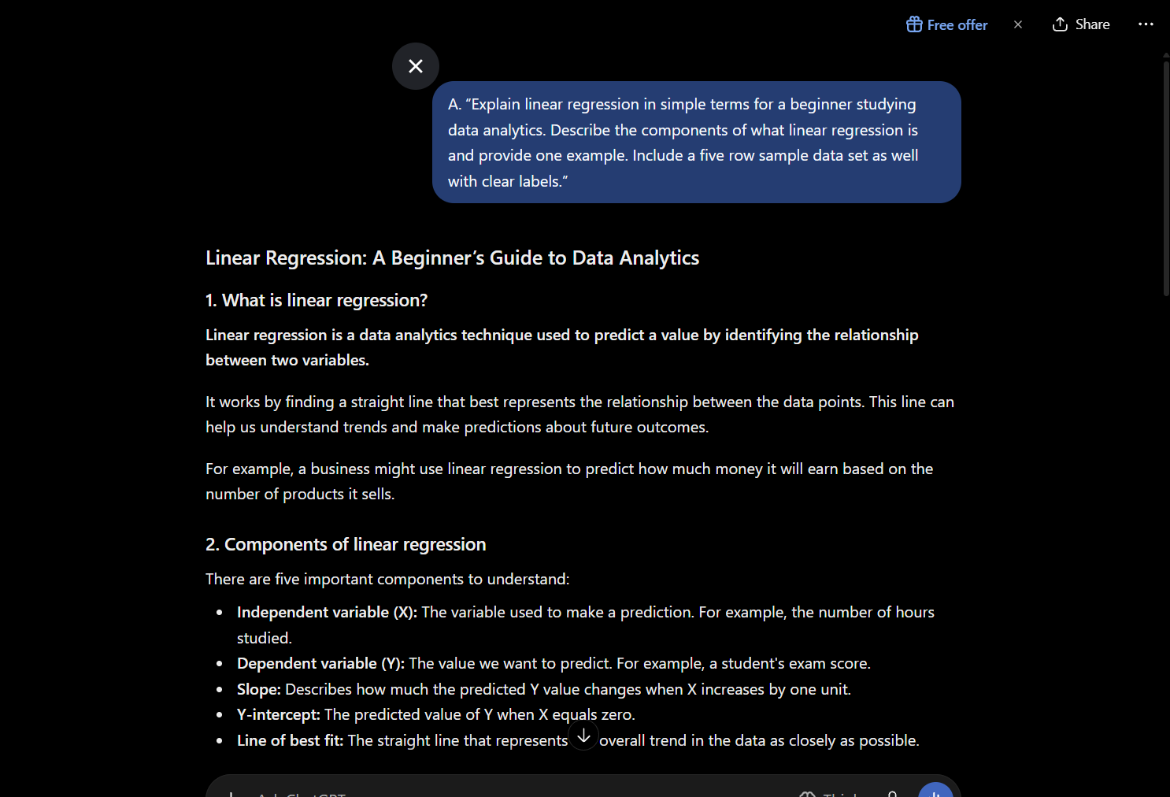
Explanation: My prompt here provides the key word “beginner” so that AI knows my level of knowledge on linear regression and will thus, provide accord wording and examples to my level. I was also specific on the amount of data required in the data set.

- “Teach me the basics of SQL as a beginner learning data analytics. Explain to me what SQL is, how it is used, and what apps are most common for this programming language. Provide me with a simple example with five rows of employee information records. Use beginner friendly language and clear categorization.”
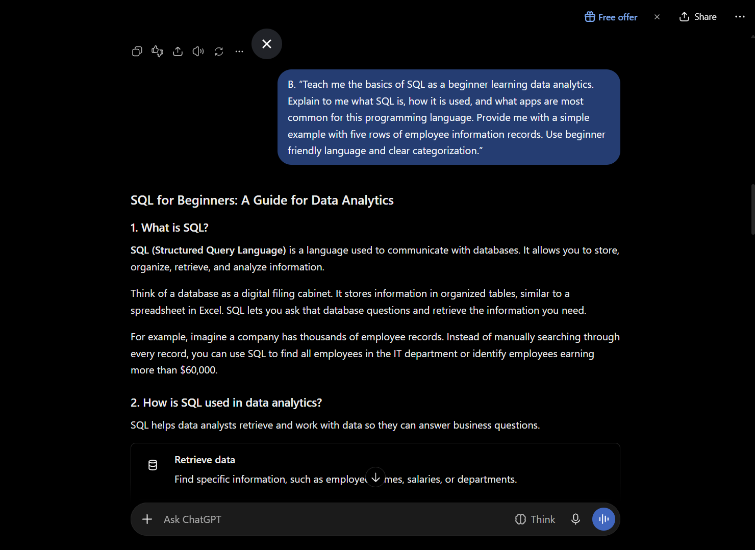
Explanation: Again, I was specific with my level of knowledge on the topic and provided the key word “beginner”. I also provided key points I wanted brought up in the explanation I would be provided; And was specific with the amount of data I required in an example again.

- “Create a dataset with 15 rows and five columns based on typically employee provided information when needing to sign up for payroll as a new hire. Format the table as a clean result so I am able to copy it into Microsoft Excel. After creating the table, please provide me with additional collum ideas in order to expand the table.”
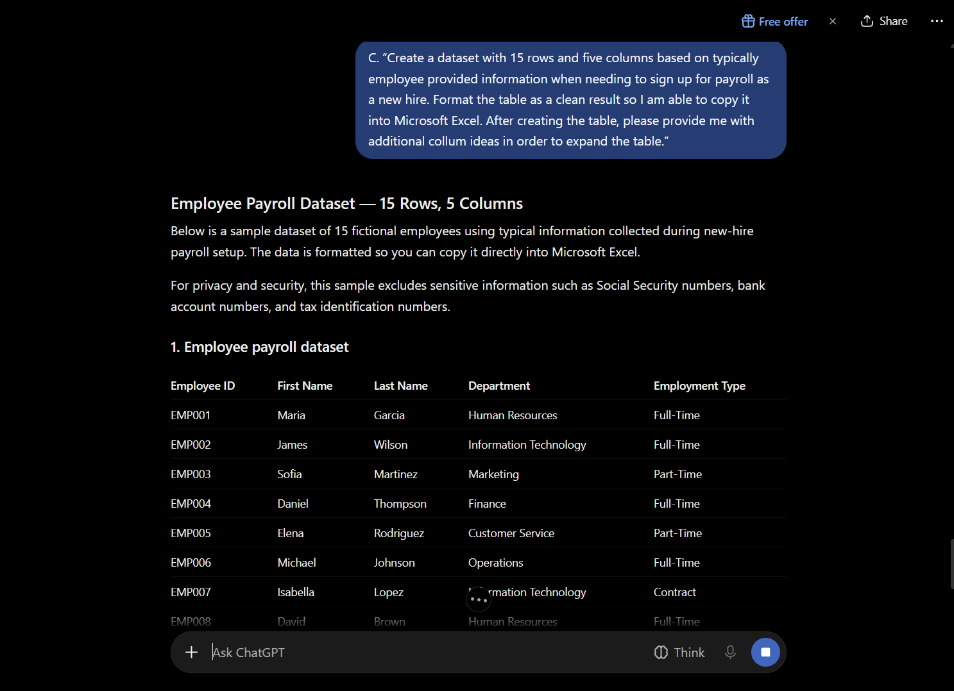
Explanation: I was specific on what topic I wanted my dataset to be based on in order to obtain more personalized results. I was also specific about the number of rows and columns I wanted and asked at the end for additional ideas in order if I would like to add in a bit more information.

