**GROUP X**

**COURSE: EDM1142**

**SPECIALITY: SWE 1**

**Lab 3**

**THE VOTING SYSTEM IN CAMEROON**

Cameroon’s voting system is done manually with electors coming to the polls to deposit their votes. This method has a lot of disadvantages as the case of fraud and carelessness from our supervisors which lead to the missing of some cards and counting errors hence disadvantaging some parties and advantaging the others which lead to other distortions in the political system.

I propose a biometric voting system which involves the use of our finger prints. Each and every valid elector will have a unique identification number on their cards that will keep records of his/her data and the process should be made available online.

**DRAWBACKS**

Some voters can vote more than once due to the lack of good security and poor management of the system. This system brings about a lot of fraud and bribery. Also, counting errors are common and a lot of time is wasted and the carelessness of the staff in charge contribute to the drawbacks of this system. Hence resulting to the winning or selection of an underserving party, thus leading to a retrogress in the development of the community and their activities and other social problems.

Ignoring this situation will lead to a high increase in fraud which may increase strikes in some zones of the country or other social problems. Due to this, it may lead to death cases, famine, lack of shelter, increase in the number of emigrants who may tend to be refuges in host countries and maybe underpopulation. It affects the citizens who might find the new system difficult to manage with and the community development may be halted or it may even retrogress.

Also, problems are observed at the level of the polls and at the administration office where the votes are classified according to the party chosen. Also observed are instances of double voting (fraud)

This problem is faced every time there is a vote going on in the country and the results take up a lot of time before getting released. The voting takes place mostly at the polls in specific areas, causing the voters to go there and follow a long line which causes them a lot time and transportation fare.

Going back to the voting problem in the country it is evident that as unemployment increases and as strikes are ongoing in some zones with an increase in the death case these recent years, it is advisable as said above that voting should be made available online so that people will not risk their lives going out or standing in crowds .

**ACHIEVEMENTS**

* By voting using finger prints it shall be very difficult for someone to vote more than once hence reducing the fraud level in the country.
* It will be difficult to change the voting number of a candidate. It will lead to a fast and more secure release of the results.
* This system will help each and everyone save time and money.

**UML DIAGRAM**

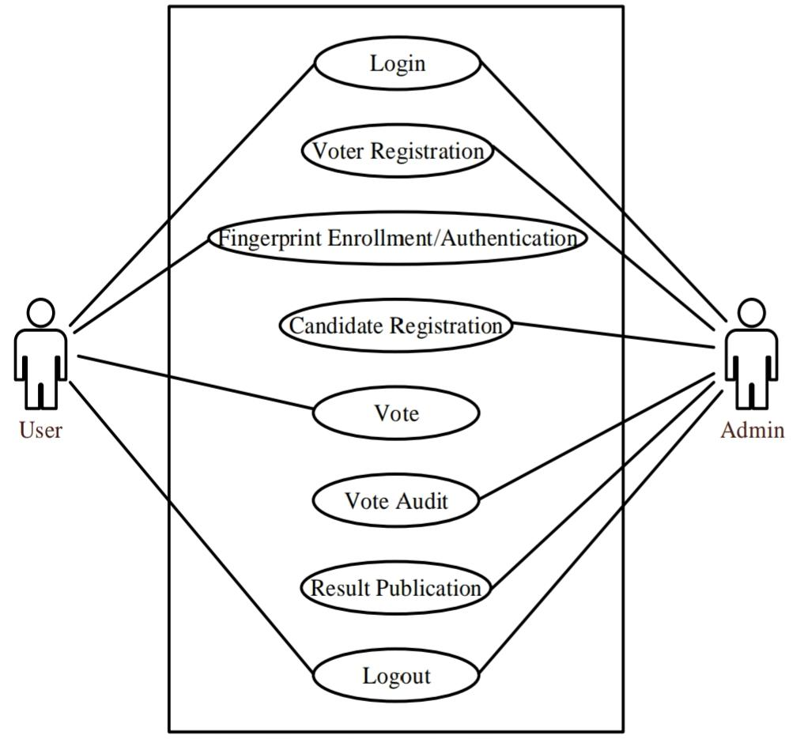

Diagrammatic representation of the system using the case system

**Source:google**