
Smart Parking Platform Project Management Plan

PREPARED FOR
$oftware ¢orp

PREPARED BY
Stephanie Martinez

PROJECT

OVERVIEW

$oftware ¢orp is a software development studio specialised in designing and developing software solutions that address real-world problems through modern web and mobile technologies. We were asked to develop a smart parking platform, acquired after conducting an extensive research, identifying a need for a more efficient way to manage and find parking spots in busy areas from both drivers and parking garage operators.

This project involves the planning and managing the development of this real-time parking platform, aiming to create a seamless connection between drivers and parking operators, making parking faster, more convenient, and more efficient. We plan for the system to allow drivers to locate available parking spaces, reserve them in advance, and pay in real time through web and mobile applications; at the same time, allow parking operators to have access to management tools for monitoring availability, occupancy, pricing, and overall garage performance.

For this project to be successful, the project management will include requirement gathering, stakeholder management, project scheduling, budgeting, risk management, team coordination, software development, testing, and implementation of the final system.

1. Competitive Research
After analysing the current market landscape regarding parking services, these are the solutions suggested by competitors:


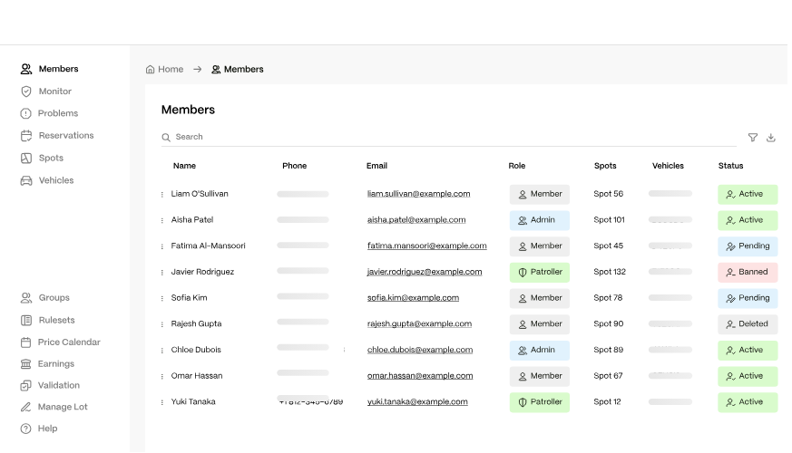
Parkade

Overview: A mobile parking management software for multifamily residential properties, renting parking spots, integrating visitor payments and property management systems.
Strengths:
- Strong all-in-one parking management system, including visitors parking, payments, enforcement, gate access revenue optimization, and 24/7 support
- Compatibility with a variety of residential properties like apartments, offices, residential neighbourhoods, etc.
- Integration with existing property management softwares like Yardu, Entrata, RealPage, and others.
- All manageable within their mobile app.
Weaknesses:
- Overpriced Subscription-based tiers, extra fees and charges.
- Only available for private residential properties, not public spaces
- Some users have reported poor customer service and inconvenient use for visitors and guests, making them download the app.
https://parkade.com

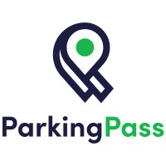
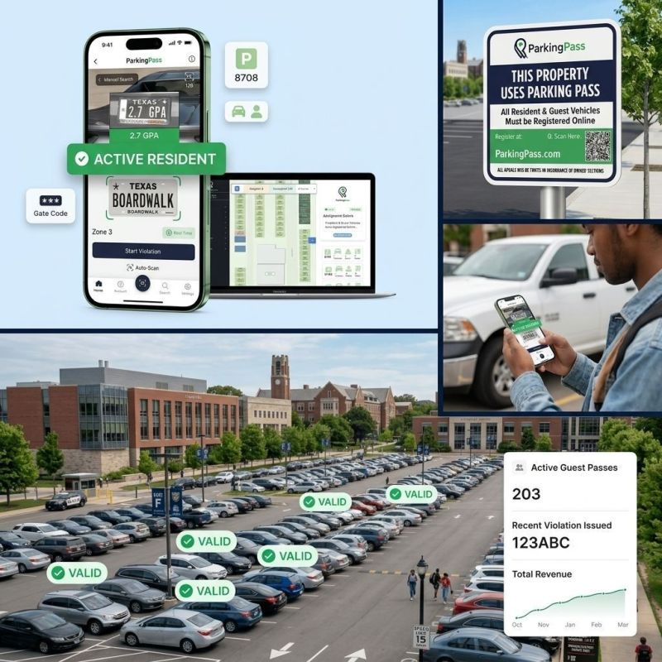
Parking Pass

Overview: A parking management software focuses on residential and community parking management with integrated LPR, guest systems, and digital enforcement tools.
Strengths:
- Provides a paperless parking management platform with digital permits, assigned spaces, citations, payments, reporting and messaging tools.
- It serves a huge range of properties, including apartments, HOAs, municipalities, schools, and commercial properties.
- Offers customers huge customization system tools like choosing from more than 60 features and configuring guest limits, paid passes, enforcement rules, and other policies depending on each property’s needs.
Weaknesses:
- The registration process can be very frustrating and take too long for approval (Up to 10 days according to some sources).
- Lack of pricing transparency due that permits costs may not appear until the registration process and fees vary according to the property’s policies.
https://www.parkingpass.com/


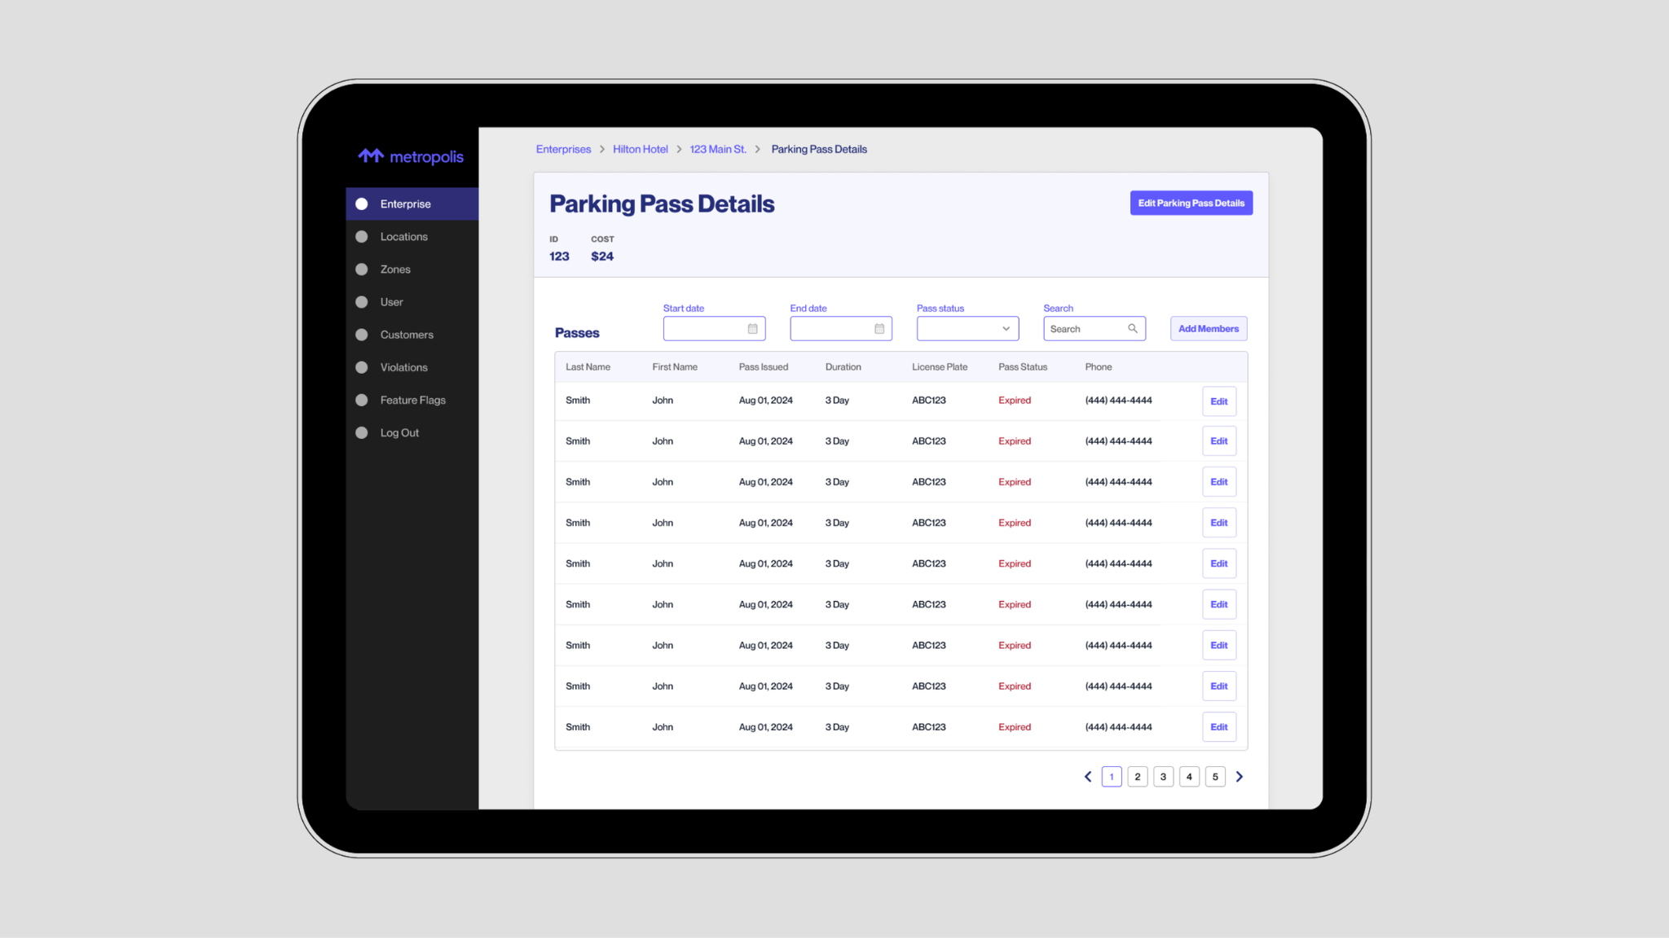
Metropolis
Overview: An AI-powered parking management platform that uses computer vision to automatically recognize vehicles, manage access, and enable ticketless checkout parking and drive-in/drive-out parking operations.
Strengths:
- Its system is designed to reduce traditional parking hardware by using AI and computer-vision approaches and improve operational efficiency.
- Serves a wide audience by signing up for a membership, including drivers, local businesses, local operators, property managers, aviation and more.
- Metropolis offers actionable data analysis for improving revenue, traffic flow and customer experience.
Weaknesses:
- Some users report mistakes on the system including wrong plate recognition, wrong payments assigned to wrong accounts, plate-matching errors, and difficulties resolving billing issues. (https://apps.apple.com/us/app/metropolis-remarkable-parking/id1556970037?see-all=reviews&platform=iphone)
- Heavily reliance on LPR and automated billing, without offering other viable verification methods.
https://www.metropolis.io/product

Opportunities for Differentiation
- Price transparency and accessibility in public garages, avoid unfair overpricing and billing errors
- Accessibility in multiple devices/platforms (web, app, desktop, etc)
- Open to multiple verification methods, not heavily relying on LPR
- No subscription, no memberships. Account-based registration
- Faster and more efficient plate registration system
- No hidden fees and chargers
- Stronger integration of property management, access control, and security enforcement.
- More accessible contact between drivers and parking operators
- Stronger and more capacitated 24/7 customer service.

2. Software Requirements Specification (SRS) [Draft]

Project: Smart Parking Platform Project Management Plan
Version: 1.0
Date: September 10, 2026

Introduction
  - Purpose
    - Planning and managing the development of this real-time smart parking platform, aiming to create a seamless connection between drivers and parking operators, making parking faster, more convenient, and more efficient in public garages.

Scope
    - The project management for this software requires a big scope for success, which will include requirement gathering, stakeholder management, project scheduling, budgeting, risk management, team coordination, software development, testing, and implementation of the final system. We are provided with unlimited resources and budgeting for the management and development of this project.

Overall Description
  - Users: Common drivers, Parking garage operators
  - System Environment: Web-based, desktop, mobile application
  - Constraints: Software must be used in all Houston’s garages. Universal system.
  - Assumptions: customers will use phones and plate numbers to register in certain garages. Must own a vehicle to register. The application has internet access. Software runs in all devices.

Functional Requirements
  - The system must allow users to register their vehicles and log in to their accounts safely.
  - The system must allow users to register and assign a parking spot to their vehicles within 5 steps.
  - The system must allow users to pay their parking time correctly 99.99% of the time.
  - The system should allow parking operators to manage parking registration and updates within 5 dashboard buttons.
  - The system should allow users to contact customer service via phone call, email address or office address.
  - The system should allow users to pay for parking using multiple payment methods such as credit cards, debit cards, digital wallets and/or cash.
  - The system should allow parking managers to customise parking prices depending on the area.

Non-Functional Requirements
  - The system should display available parking spots in all garages available around the driver’s nearest area
  - The system should update available parking spots 99.99% of the time
  - The system’s dashboard should update every 1 second
  - The system should able to register 1 vehicle per person
  - The system should process payment transitions within 3 seconds.
  - Customer service should answer calls within 3 minutes.
  - The system must display all possible fees and charges in a designated area before payment.

Use Cases (Draft)
Title | Actor | Pre-condition | Steps | Post-condition
Register a vehicle in a garage | Regular driver | User scans  QR code to register | 1. User inserts personal information (ex. Name)  2. User driver’s licence number  3. User provides contact information (email + phone number)  4. User provides vehicle’s plate number  5. User saves the information provided and proceeds to the dashboard | Vehicle is registered in the garage’s system
Assigning a parking  spot for vehicle | Regular  driver | User is logged in, vehicle already registered | 1. User selects “assign parking spot” button  2. User selects available parking spot in the garage  3. User confirm Name and plate number | The vehicle has an assigned parking spot.
Parking Payment | Regular  driver | User wants to leave the parking  garage | 1. User selects “payment” button  2. User confirms parking time and amount  3. User selects payment method  4. User provided payment method information  5. System proceeds payment | Parking has been paid for the day
Requesting customer service | Regular user (Driver/  operator) | User is  logged in | 1. User select “Settings” button  2. User scrolls down until finding “Help Center button”  3. Select preferred contact method (phone, email, message, etc.) | User is in contact with customer service
Report an error | Regular user (driver/operator) | User is logged in to the system | 1. User selects “settings” button  2. User scrolls down until finding “report an error” button  3. User selects to report a specific issue  (payment error, wrong plate number, etc.)  4. User is given the option to solve issue within the system  5. If further assistance is needed, user is directed to customer service | User’s problem was resolved or directed to customer service.

