
Smart Parking Platform Project Management Plan

PREPARED FOR
$oftware ¢orp

PREPARED BY
Stephanie Martinez

PROJECT

OVERVIEW

$oftware ¢orp is a software development studio specialised in designing and developing software solutions that address real-world problems through modern web and mobile technologies. We were asked to develop a smart parking platform, acquired after conducting extensive research, identifying a need for a more efficient way to manage and find parking spots in busy areas from both drivers and parking garage operators.

This project involves the planning and managing the development of this real-time parking platform, aiming to create a seamless connection between drivers and parking operators, making parking faster, more convenient, and more efficient. We plan for the system to allow drivers to locate available parking spaces, reserve them in advance, and pay in real time through web and mobile applications; at the same time, allow parking operators to have access to management tools for monitoring availability, occupancy, pricing, and overall garage performance.

For this project to be successful, the project management will include requirement gathering, stakeholder management, project scheduling, budgeting, risk management, team coordination, software development, testing, and implementation of the final system.

1. Competitive Research
After analysing the current market landscape regarding parking services, these are the solutions suggested by competitors:


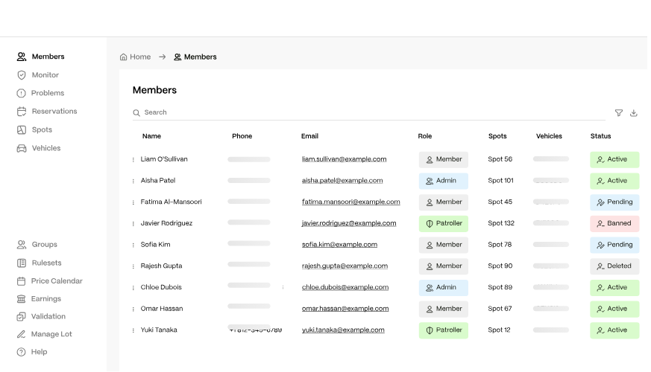
Parkade

Overview: A mobile parking management software for multifamily residential properties, renting parking spots, integrating visitor payments and property management systems.
Strengths:
- Strong all-in-one parking management system, including visitors parking, payments, enforcement, gate access revenue optimization, and 24/7 support.
- Compatibility with a variety of residential properties like apartments, offices, residential neighbourhoods, etc.
- Integration with existing property management softwares like Yardu, Entrata, RealPage, and others.
- All manageable within their mobile app.
Weaknesses:
- Overpriced Subscription-based tiers, extra fees and charges.
- Only available for private residential properties, not public spaces
- Some users have reported poor customer service and inconvenient use for visitors and guests, making them download the app.
https://parkade.com


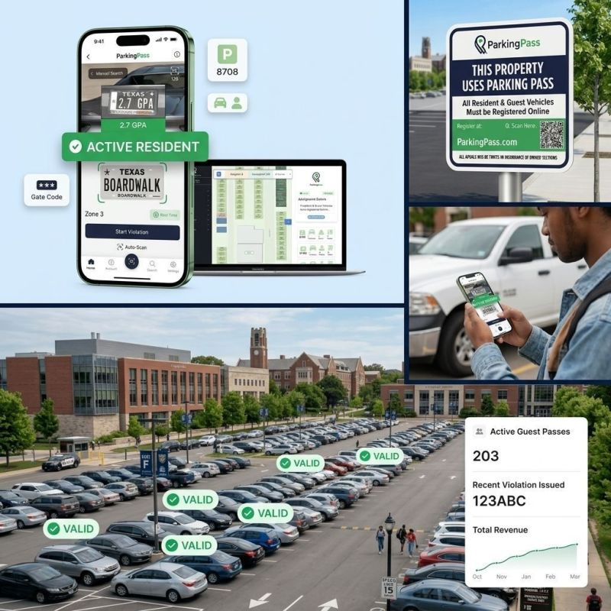
Parking Pass

Overview: A parking management software focuses on residential and community parking management with integrated LPR, guest systems, and digital enforcement tools.
Strengths:
- Provides a paperless parking management platform with digital permits, assigned spaces, citations, payments, reporting and messaging tools.
- It serves a vast range of properties, including apartments, HOAs, municipalities, schools, and commercial properties.
- Offers customers huge customization system tools like choosing from more than 60 features and configuring guest limits, paid passes, enforcement rules, and other policies depending on each property’s needs.
Weaknesses:
- The registration process can be very frustrating and take too long for approval (Up to 10 days according to some sources).
- Lack of pricing transparency due that permits costs may not appear until the registration process and fees vary according to the property’s policies.
https://www.parkingpass.com/


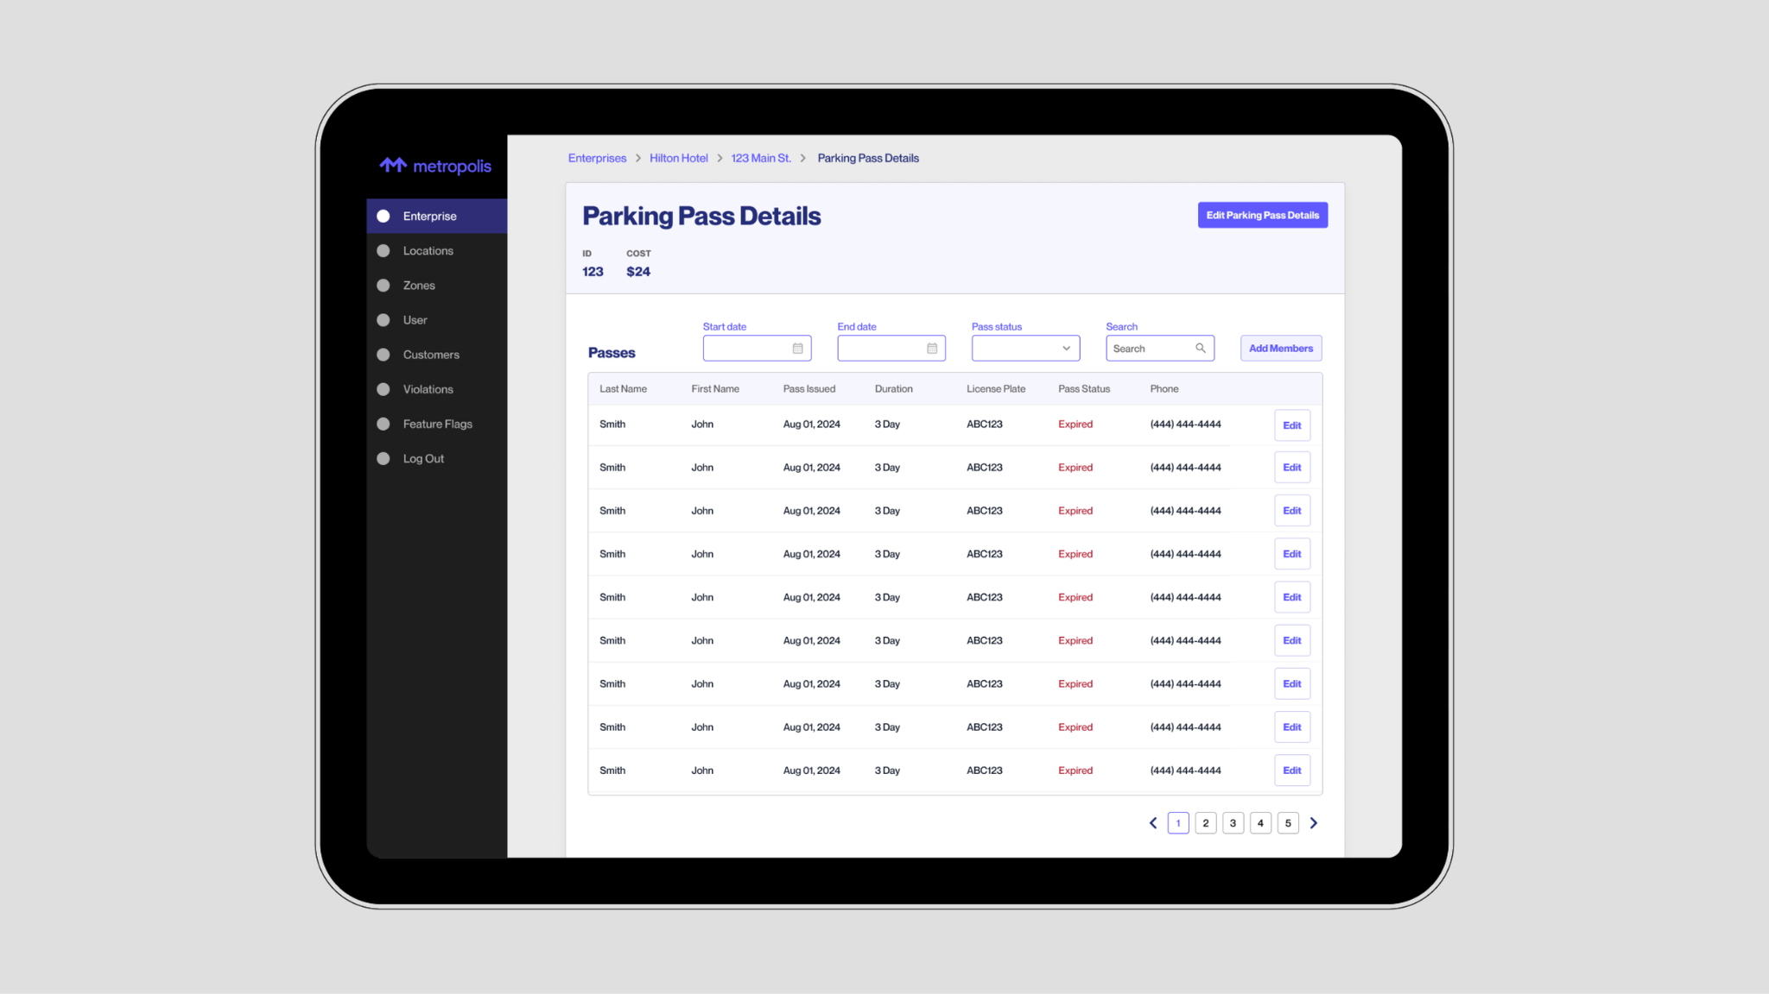
Metropolis
Overview: An AI-powered parking management platform that uses computer vision to automatically recognize vehicles, manage access, and enable ticketless checkout parking and drive-in/drive-out parking operations.
Strengths:
- Its system is designed to reduce traditional parking hardware by using AI and computer-vision approaches and improve operational efficiency.
- Serves a wide audience by signing up for a membership, including drivers, local businesses, local operators, property managers, aviation and more.
- Metropolis offers actionable data analysis for improving revenue, traffic flow and customer experience.
Weaknesses:
- Some users report mistakes on the system including wrong plate recognition, wrong payments assigned to wrong accounts, plate-matching errors, and difficulties resolving billing issues. (https://apps.apple.com/us/app/metropolis-remarkable-parking/id1556970037?see-all=reviews&platform=iphone)
- Heavily reliance on LPR and automated billing, without offering other viable verification methods.
https://www.metropolis.io/product

Opportunities for Differentiation
- Price transparency and accessibility in public garages, avoid unfair overpricing and billing errors.
- Accessibility in multiple devices/platforms (web, app, desktop, etc)
- Open to multiple verification methods, not heavily relying on LPR.
- No subscription, no memberships. Account-based registration.
- Faster and more efficient plate registration system
- No hidden fees and chargers
- Stronger integration of property management, access control, and security enforcement.
- More accessible contact between drivers and parking operators
- Stronger and more capacitated 24/7 customer service.

2. Software Requirements Specification (SRS)

Project: Smart Parking Platform Project Management Plan
Version: 1.0
Date: October 15, 2026

Introduction
  - Purpose
    - Planning and managing the development of this real-time smart parking platform, aiming to create a seamless connection between drivers and parking operators, making parking faster, more convenient, and more efficient in public garages.

Scope
    - The project management for this software requires a big scope for success, which will include requirement gathering, stakeholder management, project scheduling, budgeting, risk management, team coordination, software development, testing, and implementation of the final system. We are provided with unlimited resources and budgeting for the management and development of this project.

Overall Description
  - Users: Common drivers, Parking garage operators
  - System Environment: Web-based, desktop, mobile application
  - Constraints: Software must be used in all Houston’s garages. Universal system.
  - Assumptions: customers will use phones and plate numbers to register in certain garages. Must own a vehicle to register. The application has internet access. Software runs in all devices.

Functional Requirements
  - The system must allow users to register their vehicles and log in to their accounts safely.
  - The system must allow users to register and assign a parking spot to their vehicles within 5 steps.
  - The system must allow users to pay their parking time correctly 99.99% of the time.
  - The system should allow parking operators to manage parking registration and updates within 5 dashboard buttons.
  - The system should allow users to contact customer service via phone call, email address or office address.
  - The system should allow users to pay for parking using multiple payment methods such as credit cards, debit cards, digital wallets and/or cash.
  - The system should allow parking managers to customise parking prices depending on the area.

Non-Functional Requirements
  - The system should display available parking spots in all garages available around the driver’s nearest area.
  - The system should update available parking spots 99.99% of the time.
  - The system’s dashboard should update every 1 second.
  - The system should be able to register 1 vehicle per person.
  - The system should process payment transitions within 3 seconds.
  - Customer service should answer calls within 3 minutes.
  - The system must display all possible fees and charges in a designated area before payment.

Use Cases
Title | Actor | Pre-condition | Steps | Post-condition
Register a vehicle in a garage | Regular  driver | User scans  QR code to  register | 1. User inserts personal information (ex. Name)  2. User driver’s licence number  3. User provides contact information (email + phone number)  4. User provides vehicle’s plate number  5. User saves the information provided and proceeds to the dashboard | Vehicle is registered in the garage’s system
Assigning a parking  spot for  vehicle | Regular  driver | User is logged in, vehicle already registered | 1. User selects “assign parking spot” button  2. User selects available parking spot in the garage  3. User confirm Name and plate number | The vehicle has an assigned parking spot.
Parking Payment | Regular  driver | User wants to  leave the parking garage | 1. User selects “payment” button  2. User confirms parking time and amount  3. User selects payment method  4. User provided payment method information  5. System proceeds payment | Parking has been paid for the day
Requesting customer service | Regular user (Driver/ operator) | User is logged in | 1. User select “Settings” button  2. User scrolls down until finding “Help Center button”.  3. Select preferred contact method (phone, email, message, etc.) | User is in contact with customer service
Report an  error | Regular user (driver/  operator) | User is logged in.  to the system | 1. User selects “settings” button  2. User scrolls down until finding “report  an error” button  3. User selects to report a specific issue  (payment error, wrong plate number, etc.)  4. User is given the option to solve issue within the system  5. If further assistance is needed, user is directed to customer service | User’s problem was resolved or directed to customer service.
Create Driver Account | Regular driver | User wants to create an account.  to the parking app | 1. User downloads app  2. Interface indicates user to enter name, email, phone, and password  3. System validates information | The account was created successfully
Password Recovery | Regular user (driver/  operator) | User forgets password and wants to reset it | 1. User selects “Forgot Password”.  2. Verification Link is sent  3. User writes down new password securely | New password was created successfully
Nearby Garage Search and Availability | Regular driver | Driver wants to search nearby garages and available spaces | 1. User searches through app’s GPS map  2. Garages pins show by proximity  3. Available spots displayed  4. Garages status refreshes automatically | User finds available garage to park
Secure User Login | Regular user (driver/  operator) | User wants to securely log into  my account from different devices | 1. Email/username and password is accepted in phone, desktop or web  2. Incorrect credentials are rejected and try again  3. Secure session created | User logs in into  account with the right credentials
Account Management | Regular driver | User wants to manage account and active sessions | 1. User goes to Settings tab  2. User can update contact information, log out, review active devices and terminate sessions | User has control over account management
Operator Main Dashboard | Parking operator | Operators want to view garage activity from one.  dashboard | 1. User logs in into account  2. Shows occupancy, available spaces, active sessions, revenue summary and alerts | Operator has intuitive tools to manage parking garage
Driver Home Dashboard | Regular driver | Driver wants a simple dashboard so that I can quickly access parking functions | 1. User logs in into account  2. Dashboard shows Find Parking, My Vehicle, Parking Session, Payment and  Help  3. System responses on supported devices | Driver has an intuitive dashboard to access parking functions
Driver Support & Communication Center | Parking operator | Operator wants to communicate with drivers who need assistance | 1. User gets notification from a driver that needs assistance  2. Operator can see driver requests, respond to cases and view issue status/history  3. They can communicate with driver via phone or message | Operator goes to attend driver’s needs
Vehicle and Plate Lookup | Parking operator | Operator wants to find registered vehicles without relying only on LPR | 1. User goes to Registration tab  2. User searches vehicle by plate, phone, account, QR code or registration ID filters  3. Matching user information returned. | The operator identifies the correct registered vehicle.
Parking Price Management | Parking operator | Operator wants to customize pricing.  by location or parking area | 1. User goes to Pricing tab  2. Authorized operators can edit rates  3. Future pricing can be scheduled  4. Changes are confirmed before publication | Operator sets authorized and fair prices for customers

3. Work Breakdown Structure (WBS) for Parking App (≥3 levels deep)

1. Smart Parking Platform

1.1 User Account & Login System
1.1.1 Account Registration
1.1.1.1 Create driver account.
1.1.1.2 Collect user contact information.
1.1.1.3 Validate account information.
1.1.1.4 Create account confirmation process.
1.1.2 Authentication & Access
1.1.2.1 Implement secure user login.
1.1.2.2 Separate driver and operator access
1.1.2.3 Implement password recovery
1.1.2.4 Implement logout and session management
1.1.3 Vehicle Registration
1.1.3.1 Register vehicles per user
1.1.3.2 Capture vehicle plate number
1.1.3.3 Associate vehicle with driver account
1.1.3.4 Complete vehicle registration within five steps

1.2 Driver User Interface
1.2.1 Driver Dashboard
1.2.1.1 Display vehicle information
1.2.1.2 Display active parking session
1.2.1.3 Provide payment access.
1.2.1.4 Provide customer support access.
1.2.2 Parking Search & Availability
1.2.2.1 Display nearby parking garages
1.2.2.2 Display available parking spaces
1.2.2.3 Refresh parking availability information
1.2.2.4 Display parking availability across participating garages
1.2.3 Parking Spot Assignment
1.2.3.1 Display available parking spots
1.2.3.2 Allow driver to select parking spot.
1.2.3.3 Confirm driver and plate information.
1.2.3.4 Complete parking assignment within five steps
1.2.4 Parking Session Interface
1.2.4.1 Display garage information
1.2.4.2 Display assigned parking spot.
1.2.4.3 Display parking entry time
1.2.4.4 Display current parking duration
1.2.4.5 Display estimated parking charge
1.2.5 Parking Payment Interface
1.2.5.1 Display parking time and amount due.
1.2.5.2 Display all fees and charges before payment.
1.2.5.3 Allow payment-method selection.
1.2.5.4 Confirm payment before processing.
1.2.6 Multiple Payment Methods
1.2.6.1 Support credit-card payment
1.2.6.2 Support debit-card payment
1.2.6.3 Support digital-wallet payment
1.2.6.4 Support cash payment where applicable
1.2.7 Customer Support Interface
1.2.7.1 Provide customer-service phone information.
1.2.7.2 Provide customer-service email information.
1.2.7.3 Provide customer-service office-address information.
1.2.7.4 Provide access to error reporting.

1.3 Parking Operator User Interface
1.3.1 Operator Dashboard
1.3.1.1 Display garage occupancy information
1.3.1.2 Display available parking spaces
1.3.1.3 Display active parking sessions
1.3.1.4 Display parking-related alerts
1.3.1.5 Provide parking-management functions within five dashboard buttons.
1.3.2 Parking Space Management
1.3.2.1 View parking-space status
1.3.2.2 Update parking-space status
1.3.2.3 Manage assigned parking spaces.
1.3.2.4 Manage available parking spaces.
1.3.3 Vehicle & Registration Management
1.3.3.1 Search vehicle by plate number
1.3.3.2 Review registered vehicle information
1.3.3.3 Correct vehicle registration information
1.3.3.4 Record registration updates
1.3.4 Parking Price Management
1.3.4.1 View current parking rates
1.3.4.2 Customize parking price by area.
1.3.4.3 Confirm pricing updates.
1.3.4.4 Make updated prices available to drivers.
1.3.5 Driver Support Management
1.3.5.1 View driver support requests
1.3.5.2 Review reported parking issues.
1.3.5.3 Respond to driver issues.
1.3.5.4 Track issue status

1.4 Reporting
1.4.1 Operator Parking Reports
1.4.1.1 Generate parking occupancy report.
1.4.1.2 Report occupied and available spaces.
1.4.1.3 Report parking utilization information
1.4.2 Operator Payment Reports
1.4.2.1 Generate parking revenue report.
1.4.2.2 Report completed payments.
1.4.2.3 Report payment errors or exceptions
1.4.2.4 Report parking fees and charges
1.4.3 Operator Registration & Support Reports
1.4.3.1 Report vehicle registration activity
1.4.3.2 Report registration corrections
1.4.3.3 Report customer-service cases
1.4.3.4 Report issue-resolution status
1.4.4 Driver Parking Reports
1.4.4.1 Display parking history
1.4.4.2 Display previous garage information
1.4.4.3 Display parking duration
1.4.4.4 Display amount paid.
1.4.5 Driver Payment & Issue Reports
1.4.5.1 Display payment history
1.4.5.2 Display parking receipts
1.4.5.3 Display fee breakdown
1.4.5.4 Display reported issue and dispute history.

4. Gantt chart Timeline

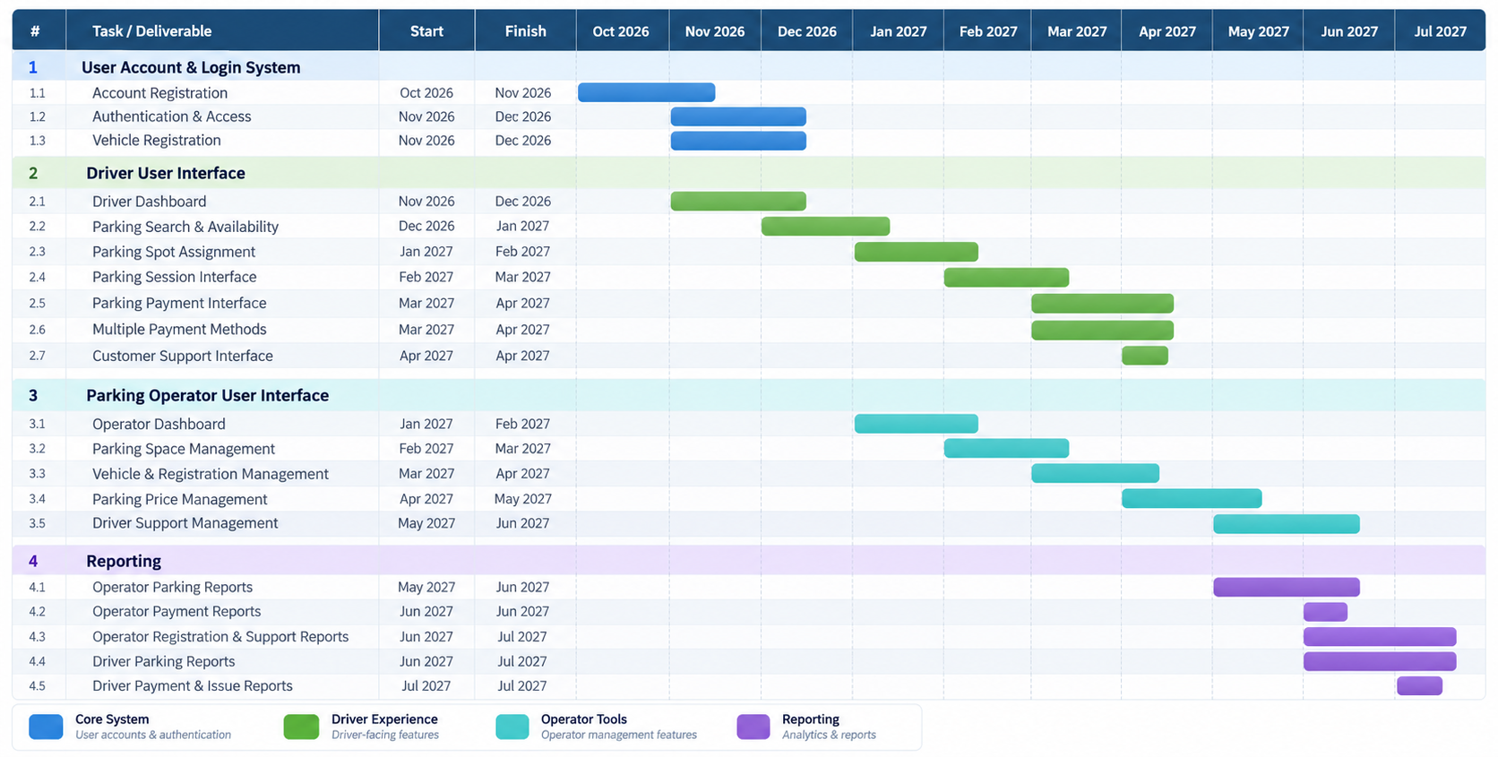
Development Period: October 2026 - July 2027 (10 months)

5. Trello Backlog
Trello link: https://trello.com/invite/b/6ab5c7dd19cf604b6f403c9e/ATTI9f809a0028367148787d6af425abb15aF72DE7D7/tlim3355-parking-app
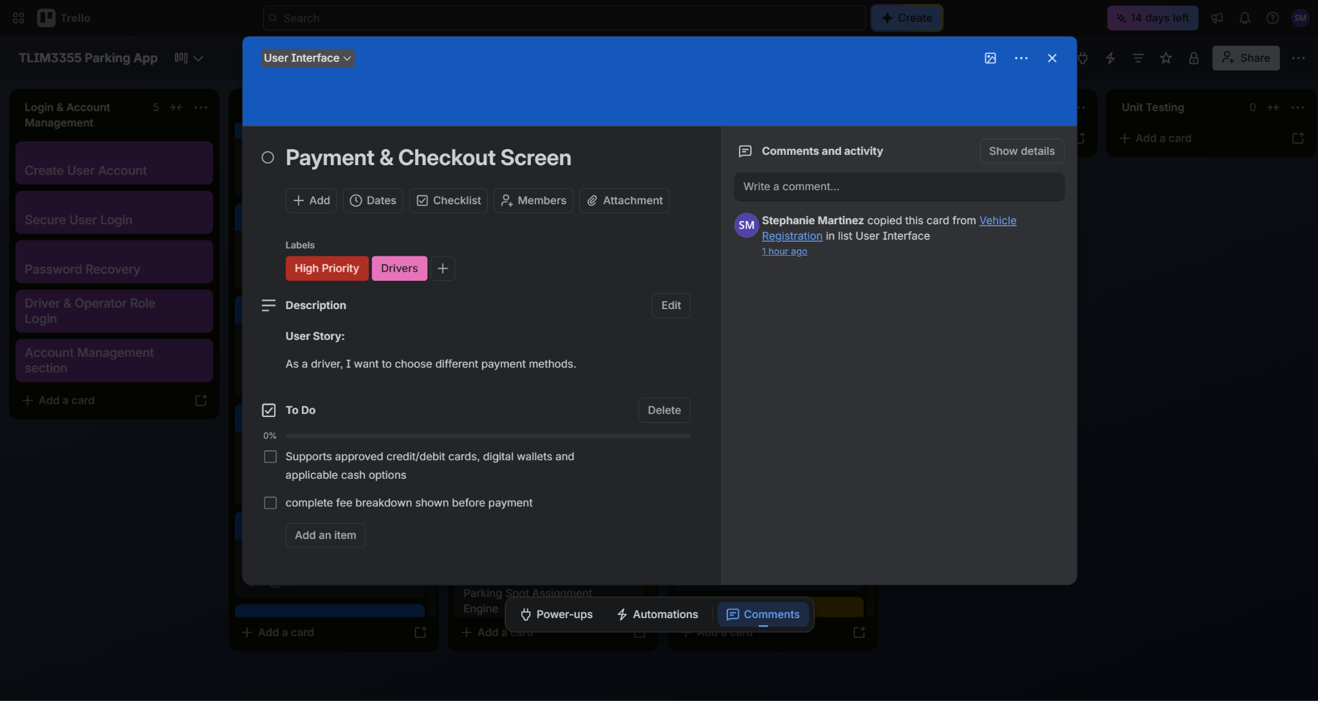
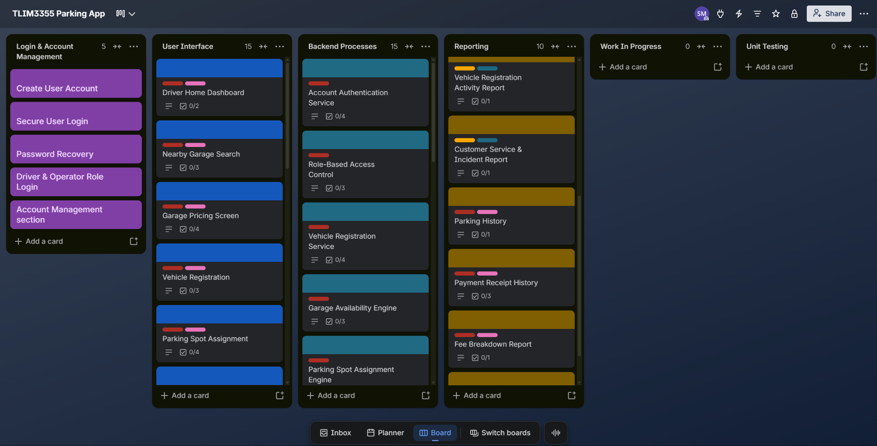

6. Risks & Risk Register

Risks
Technical:
- Synchronization failure: Delays or synchronization errors could show incorrect space availability or create conflicting assignments.
- Payment processing failure: problems with payment gateways could cause failed transactions, incorrect charges, or delays beyond the processing target. |
- Cross-platform compatibility issues: differences between devices, browsers, and operating systems could result in inconsistent behavior or interface problems. |
- Incorrect parking availability bugs: bugs in the availability or parking assignment engine could allow two drivers to select the same space or display unavailable spaces as available.
- Security or privacy vulnerability: weak security could expose sensitive information or allow unauthorized access.
Schedule:
- Integration delays: delays in one system can prevent dependent components from being completed on time.
- Testing takes longer than planned: defects discovered during integration or cross-platform testing could extend the schedule.
- Third-party vendor delays: mapping, payment, or external access-control services may require approvals, technical support, credentials, or integration changes that the project team cannot fully control.
- Scope expansion during development: because the platform is intended to become a universal parking system for Houston garages, additional garage/operator requirements may be requested during development and increase the workload.
- Rework caused by requirement changes: changes to registration, pricing, parking assignments, reporting, or operator workflows after development begins may require completed work to be redesigned or rebuilt.
Financial:
- Development cost overrun even though the project assumes an unlimited budget and resources, rework could exceed the planned bottom-up estimate.
- Cloud infrastructure costs exceed estimates: real-time availability, one-second dashboard refreshes, transaction processing, and synchronization across many garages could require substantially more computing and database capacity than originally estimated.
- Unexpected testing and security costs: may require more resources than initially budgeted.
- Rework costs from defects or requirement changes: major changes discovered after development can require additional developer, designer, tester, and project management hours.
- Garage implementation costs vary by location: different Houston garages may have different equipment, access systems, operational processes, or infrastructure, increasing implementation and integration costs.
People:
- Poor coordination between teams: weak communication could create incompatible components or duplicate work.
- Loss or unavailability of key technical staff: senior backend specialists may become bottlenecks if knowledge is concentrated in one person and delaying critical work.
- Conflicting stakeholder requirements: conflicting needs from different stakeholders can make requirements difficult to finalize.
- Insufficient operator training: parking operators may struggle to use the system if training and documentation are inadequate.
- Resistance to adopting the new system: garage operators or users accustomed to existing parking systems may resist changing their processes, especially if the new platform introduces unfamiliar registration or management procedures.

Risk Register
Probability: 1 = Very Low, 5 = Very High
Impact: 1 = Minor, 5 = Severe

Category | Risk | Probability | Impact | Rating | Risk Response | Contingency Action | Risk Owner
Technical | Synchronization failure across operational systems. | 4 | 5 | Critical | Use centralized availability logic, transaction controls, automated synchronization testing, and monitoring. | Temporarily disable affected space assignments and refresh availability from the authoritative database. | Backend/API  Lead
Technical | Vehicle  assignment  bugs. | 3 | 5 | High | Use atomic database transactions and lock a space immediately during assignment. | Cancel the conflicting assignment, provide an alternative spot, and log the incident. | Backend/API  Lead
Technical | Payment processing  error | 3 | 5 | High | Perform load testing, optimize payment APIs, provide retry handling, and test every supported payment method. | Mark transaction as pending, prevent duplicate charging, and allow a secure retry. | Payment  Integration  Engineer
Technical | Cross-platform compatibility problems | 4 | 4 | Critical | Establish supported-device standards and conduct continuous cross-platform QA throughout development. | Prioritize defects affecting critical functions and release platform-specific patches. | QA Lead / Development Leads
Technical | Security or  privacy breach  exposed | 3 | 5 | Critical | Use secure authentication, encryption, role-based access, vulnerability testing, logging, and security reviews. | Isolate affected services, revoke compromised sessions, investigate incidents, patch vulnerability, and follow incident-response procedures. | Security & Privacy Engineer
Schedule | Integration between  systems take.  longer than planned. | 4 | 5 | Critical | Define APIs early, use integration milestones, conduct continuous integration rather than waiting until final development stages. | Reassign resources to critical integrations and defer lower-priority functionality if necessary. | Project Manager / Technical Lead
Schedule | Testing and  defect correction requires more.  time than  allocated. | 4 | 4 | Critical | Begin QA during development, automate repetitive tests, and reserve sufficient time for integration/regression testing. | Extend defect-resolution work, prioritize critical defects, and postpone nonessential enhancements. | QA Lead / Project Manager
Schedule | Scope increases  During development  time | 4 | 4 | Critical | Maintain a controlled product backlog and require formal evaluation of new requirements before acceptance. | Move noncritical additions to a future release while protecting the agreed baseline scope. | Project Manager / Product Owner
Financial | Cloud  infrastructure  costs  exceed the bottom-up.  estimate | 3 | 4 | High | Monitor infrastructure consumption, conduct load simulations, optimize database queries, and establish usage alerts. | Increase infrastructure budget from contingency and optimize high-consumption services. | DevOps Engineer / Project Manager
Financial | Third-party  API and  transaction  costs exceed estimates | 3 | 3 | Medium | Model API consumption, track usage, negotiate service agreements, and monitor transaction volumes. | Use contingency funding and evaluate lower-cost service configurations or alternative providers. | Project Manager / Finance
Financial | Unexpected  rework  significantly increases labor cost. | 4 | 4 | Critical | Validate requirements and designs before implementation, perform code reviews, prototype high-risk functions, and test continuously. | Use contingency reserve, reprioritize backlog, and reduce lower-value scope if required. | Project Manager
Financial | Different Houston parking garages require additional integration or implementation work. | 3 | 4 | High | Define a standard garage integration model and identify garage-specific differences early. | Create adapters or configuration packages for incompatible garages and implement them in phases. | Technical Lead / Project Manager
People | Poor communication between teams | 4 | 4 | Critical | Hold regular coordination meetings, define interface responsibilities, maintain shared technical documentation, and use common development standards. | Assign technical leads to resolve conflicts and conduct focused integration sessions. | Project Manager
People | A key specialist becomes unavailable. | 3 | 4 | High | Require documentation, peer reviews, shared repositories, knowledge transfer, and backup ownership for critical components. | Reassign a qualified team member and temporarily prioritize essential work only. | Project Manager / Team Leads
People | Stakeholders  have  conflicting expectations | 3 | 4 | High | Conduct stakeholder reviews and define acceptance criteria for both driver and operator workflows. | Escalate unresolved conflicts to the Product Owner and prioritize requirements according to approved project objectives. | Product Owner / Business Analyst
People | Parking operators have difficulty adopting the system due to inadequate training or unfamiliar workflows. | 3 | 3 | Medium | Provide training materials, user documentation, demonstrations, and operator usability testing before deployment. | Provide additional training and customer support during rollout. | Training Specialist / Product Owner

7. Communication Plan
The purpose of this communication plan is to ensure that project information is delivered to the correct stakeholders at the appropriate frequency and level of detail throughout the 10-month development period.
The communication strategy will focus on five objectives: maintaining alignment with requirements, identifying risks and blockers early, coordinating dependencies between development teams, reporting project performance against the schedule and budget, and maintaining documented decisions throughout the project lifecycle.

Meeting Cadence
- Core meetings:
Meeting | Participants | Cadence | Duration | Purpose | Owner | Communication Method
Project  Leadership  Meeting | PM, Product Owner, Technical Lead, QA Lead, DevOps/Security Lead | Weekly | 45–60min | Review overall schedule, budget, major risks, dependencies, and decisions | Project Manager | Video/in-person meeting + meeting notes
Project Team Stand-Up | PM, development leads, QA, UX/UI, specialists | 3 times per week | 15 min | Identify current work, immediate priorities, and blockers | Project Manager | Video meeting
Sprint  Planning | PM, Product Owner, developers, QA | Every 2 weeks | 60–90min | Select backlog items for the next development cycle | Product Owner /  PM | Meeting + Trello
Sprint  Review/Demo | Development teams, PM, Product Owner, QA, selected stakeholders | Every 2 weeks | 60 min | Demonstrate completed features and obtain feedback | Product Owner | Live demonstration + meeting notes
Sprint  Retrospective | Internal project team | Every 2 weeks | 30–45min | Review what worked, what did not, and process improvements | Project Manager | Internal meeting

- Development-Team Communication Cadence:
Team | Internal Meeting Cadence | Cross-Team Communication | Main Topics
Mobile Application Team | Daily 15-minute stand-up | Twice-weekly integration sync | Mobile UI, login, vehicle registration, parking sessions, payments, notifications
Web Application  Team | Daily 15-minute stand-up | Twice-weekly integration sync | Driver web interface, operator dashboard, reporting interfaces
Backend/API Team | Daily 15-minute stand-up | Twice-weekly architecture/integration meeting | Authentication, APIs, availability engine, assignments, payments, synchronization
UX/UI Team | 2 meetings per week during design-heavy phases | Weekly design review with Mobile/Web/Product Owner | Wireframes, user flows, driver experience, operator experience
Mapping &  Location Team | Weekly | Weekly API/integration meeting with backend/mobile teams | Garage search, nearby locations, mapping APIs, availability display
Payment Integration  Team | Weekly; twice weekly during payment integration phase | Payment integration review with backend, QA, and security | Transaction flow, multiple payment methods, fee display, processing time
QA & Testing  Team | Daily during major testing phases; 3 times weekly otherwise | Weekly defect review with development leads | Test cases, defects, regression tests, requirement validation
DevOps /  Cloud Team | Weekly | Weekly deployment/infrastructure sync | Environments, CI/CD, uptime, monitoring, infrastructure usage
Security &  Privacy Team | Weekly during development; twice weekly during security testing | Security review with backend, DevOps, payments, PM | Authentication, permissions, privacy, vulnerabilities, remediation
Technical  Writing /  Training | Weekly during Months 8–10 | Weekly coordination with PM and operator stakeholders | Documentation, operator instructions, training materials

Reporting Methods
Report / Method | Audience | Frequency | Contents | Owner
Trello Product  Backlog | Product Owner, developers, QA, PM | Updated continuously | User stories, priorities, task status, blockers, sprint work | Product Owner
Weekly Project  Status Report | PM, team leads, stakeholders | Weekly | Work completed, upcoming tasks, schedule status, major issues, risks | Project Manager
Gantt Chart | PM, stakeholders, team leads | Updated biweekly or after major schedule changes | Planned vs. actual schedule,  task dependencies, milestone progress | Project Manager
Risk Register | PM, team leads, project sponsor | Reviewed weekly; formal update monthly | Probability, impact, score, mitigation, contingency, risk  owner | Project Manager
Issue / Blocker Log | Development teams, PM | Updated continuously | Active blockers, severity, owner, expected resolution | Team Leads
QA Defect Report | Developers, QA, PM | Weekly; daily before releases | Open defects, severity, new  defects, resolved defects,  regression status | QA Lead
Budget / Cost Report | PM, sponsor, finance | Monthly | Actual labor/infrastructure costs, forecast, contingency usage | Project Manager
Sprint Report | Development teams and PM | Every 2 weeks | Planned stories, completed.  stories, incomplete work,  blockers | Product Owner
Security Report | PM, technical leads, DevOps | Monthly; additionally, after security testing | Vulnerabilities, severity, status, remediation | Security Engineer
Performance Report | Technical leads, QA, PM | At performance-testing milestones | Payment response times, synchronization performance, dashboard updates | QA / DevOps
Release Readiness Report | PM, technical leads, stakeholders | Before each major release | Testing status, security status, critical defects, deployment approval | QA Lead
Monthly Executive Summary | Sponsor / senior stakeholders | Monthly | Overall progress, budget, major risks, milestone status, decisions required | Project Manager

8. Roles & Resources
Team  Member | Project Role | Skill Level | Main Responsibilities | Allocation  %
Elena  Ramirez | Project Manager | Senior,  10+ years | Schedule, budget, risks, stakeholder coordination, sprint oversight, vendor/API coordination | 75%
Marcus  Lee | Business Analyst/ Product Owner | Senior,  7+ years | Requirements, backlog, user stories, acceptance criteria, stakeholder interviews | 51%
Sofia  Patel | UX/UI Designer | Senior,  6+ years | Driver and operator UX, wireframes, prototypes, responsive interface design | 38.5%
Daniel  Kim | Mobile Developer | Senior,  7 years | iOS/Android driver application, notifications,  parking workflows | 70%
Priya Shah | Mobile Developer | Mid/Senior,  5 years | Mobile UI, authentication, vehicle registration, payments | 70%
Jordan  Brooks | Web Developer | Senior,  7 years | Driver web application and responsive web architecture | 70%
Luis  Hernandez | Web Developer | Mid-level,  5 years | Operator dashboard, reporting UI, account management | 70%
Omar  Hassan | Backend/API Lead | Senior,  10 years | System architecture, APIs, parking-session logic, availability engine | 85%
Maya Chen | Backend Developer | Senior,  8 years | Database logic, account services, reporting APIs, synchronization | 85%
Nina Alvarez | Mapping & Location Engineer | Senior,  7 years | Garage location, maps, navigation APIs, proximity search | 40%
Victor  Nguyen | Payment Integration Engineer | Senior,  8 years | Payment gateway, wallets, transaction security, receipts/refunds | 30%
Grace  Wilson | QA/Test Engineer | Senior,  7 years | Functional, integration, regression and cross-platform testing | 60%
Ethan Park | QA/Test Engineer | Mid-level,  5 years | Mobile/web testing, test cases, defect verification | 60%
Noah  Thompson | DevOps/Cloud Engineer | Senior,  8 years | CI/CD, cloud infrastructure, environments,  monitoring, deployment | 50%
Aisha  Rahman | Security & Privacy Engineer | Senior,  9 years | Authentication security, payment/security review, privacy, access control | 43.5%
Chloe  Martin | Technical Writer/ Training Specialist | Mid-level,  5 years | System documentation, operator guides, deployment/training materials | 20%

9. Resource & Cost Plan
We decided to go with a bottom-up estimate, which calculates the cost of each individual resource and component, then adds them together to determine the total project budget. Additionally, we based cost within Texas prices:

A. Labor Cost Plan:
Job | Category | Quantity (Hrs) | Unit Cost | Duration | Total
Project Manager | Labor | 1,200 hrs | $85/hr | 10 months | $102,000
Business Analyst/  Product Owner | Labor | 816 hrs | $70/hr | 10 months | $57,120
UX/UI Designer | Labor | 616 hrs | $65/hr | 8 months active | $40,040
Mobile Developers – 2 | Labor | 2,240 hrs | $70/hr | ~9 months active | $156,800
Web Developers – 2 | Labor | 2,240 hrs | $65/hr | ~9 months active | $145,600
Backend/API Developers – 2 | Labor | 2,720 hrs | $80/hr | 10 months | $217,600
Mapping & Location Engineer | Labor | 640 hrs | $80/hr | ~8 months active | $51,200
Payment Integration Engineer | Labor | 480 hrs | $85/hr | ~6 months active | $40,800
QA/Test Engineers – 2 | Labor | 1,920 hrs | $55/hr | ~8 months active | $105,600
DevOps / Cloud Engineer | Labor | 800 hrs | $80/hr | 10 months | $64,000
Security & Privacy Engineer | Labor | 696 hrs | $90/hr | 10 months | $62,640
Technical Writer / Training | Labor | 320 hrs | $50/hr | 4 months active | $16,000
Total Labor |  |  |  |  | $1,059,400

B. Infrastructure, Tools & Integration Costs
Item | Category | Qty/  Months | Unit Cost/  Basis | Duration | Total | Notes
Cloud hosting & environments | Infrastructure | 10  months | Variable  usage | 10 | $80,000 | Development, staging,  testing and production
Mapping/location  API services | Infrastructure/  API | 10  months | Usage-  based | 10 | $54,500 | Garage search,  geolocation, routing/navigation
Development &  QA licenses | Tools | Project  team | Blended | 10 | $24,000 | IDEs, design, testing,  monitoring tools
Security/privacy  testing | Security | Project | Specialized services/  tools | N/A | $35,000 | Vulnerability, penetration  and privacy testing
Test devices & garage integration equipment | Hardware | Project | One-time | N/A | $30,000 | Phones, tablets, access-control integration test equipment
Pilot garage/access  control integration | Infrastructure | Pilot | One-time | Final  phases | $50,000 | Gate/access testing  and garage pilot equipment
Total non-Labor |  |  |  |  | $273,500

Base project subtotal
- Labor: $1,059,400
- Infrastructure/tools/integration: $273,500
- Base cost: $1,332,900
- Contingency reserve: 10%

Total Estimated Project Budget: $1,466,190

10. RACI matrix

Legend:
R — Responsible: performs the work.
A — Accountable: ultimately owns the result and approves it.
C — Consulted: provides expertise or feedback.
I — Informed: receives progress/results.

Task / Role | PM | BA/ Product Owner | UX/UI | Development Teams | Mapping/Payment Specialists | QA | DevOps /  Security
Requirements  Gathering | A | R | C | C | C | C | I
Product Backlog/  User Stories | A | R | C | C | C | C | I
System Architecture | C | C | I | A/R | C | C | C
Driver & Operator  UI Design | A | C | R | C | I | C | I
Authentication &  Account System | I | C | C | A/R | I | C | C
Vehicle Registration Development | I | C | C | A/R | I | C | C
Parking Availability  Engine | I | C | C | A/R | C | C | C
Parking Reservation  System | I | C | C | A/R | C | C | C
Map & Navigation  Integration | I | C | C | C | A/R | C | C
Payment Processing Integration | I | C | C | C | A/R | C | C
Transparent Pricing/  Fee Calculation | C | C | C | R | A | C | I
Operator  Dashboard | I | C | C | A/R | I | C | I
Reporting &  Analytics | I | C | C | A/R | I | C | I
Notifications &  Alerts | I | C | C | A/R | C | C | C
Security & Privacy  Compliance | I | C | I | C | C | C | A/R
Functional Testing | I | C | I | C | I | A/R | C
Integration Testing | I | I | I | C | C | A/R | C
Performance  Testing | I | I | I | C | I | R | A
User Acceptance  Testing | A | R | C | C | I | R | I
Defect Resolution | I | I | I | A/R | R (were  applicable) | C | C
Production  Deployment | A | I | I | C | I | C | R
Operator Training & Documentation | A | C | C | C | I | C | R*
Project Closure &  Final Acceptance | A/R | C | I | I | I | C | I

