Successfully installed Java 13.

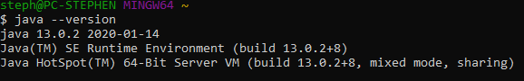

Successfully created JAVA_HOME variable.



Successfully created JAVAFX Variable.



Successfully executed JavaFX application

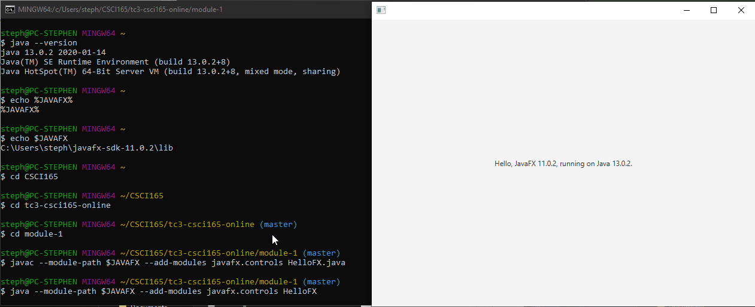

Successfully compiled and executed HelloWorld

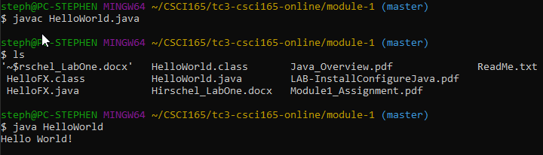

Successfully compiled and executed HelloWorld2