# 

**COVID-19 VACCINATION RECORD MANAGEMENT SYSTEM DOCUMENTATION**

**Phone : +254798355947**

# Email [stiveckamash@gmail.com](mailto:stiveckamash@gmail.com)

# 

# 

# 

# 

# 

# 

### **TABLE OF CONTENTS**

**ASSIGNMENT. 1**

**INTRODUCTION. 2**

ASSUMPTIONS . 3

PROGRAM DESIGN . 3

Components of the System. 3

PSEUDOCODE. 4

Modules Description and Explanation 8

Registration 8

Vaccination module. 8

Search By ID module 8

Display Statistics 8

Sample System Output for Each module. 8

Conclusion. 10

# 

# 

# 

# 

# INTRODUCTION.

Coronavirus or severe acute respiratory syndrome coronavirus 2 (SARS-CoV-2) is a deadly virus that has caused global pandemic. The virus causes respiratory tract infections that can range from mild to lethal. The World Health Organization (WHO) has named the disease caused by coronavirus as coronavirus disease (COVID-19).

As of now, there is no specific medication available nor drugs discovered for treating COVID-19 patients. Thus, hospitals usually provide supportive care to COVID-19 patients as part of their treatment procedure. This includes treatment to relieve symptoms, fluid therapy, oxygen support and prone positioning as needed, and medications or devices to support other affected vital organs. The COVID-19 vaccination is found to be a safer way to help build protection against the virus and end the pandemic. This has made many countries to quickly vaccinate their people, and in order to vaccinate the mass population of their people as quickly as possible, the COVID-19 vaccination process is simultaneously done in many vaccination centres in the country.

In order to be able to managed well individual being vaccinated and keep track their records , a more favourable method which involves use of a simple management system that allows registration and vaccinations of different patients in each center was necessary .This method will be much better as opposed to the previous method of keeping paper records . Paper work seems more tiring and time consuming as it is difficult to search various records . The system developed was mainly aimed at keeping records of individual patients at each center and making search easier . It had the following assumption while being developed.

### ASSUMPTIONS .

* The range of age for patients will range from 0 - 150 years old and no one is assumed to be aged more than 150.
* A single patient cannot repeat his or her details .Once he/she has registration will not try to register again.
* Dosage period can be administered after dose one is done hence the time is not real but just a simulation of what could happen in a real working system.
* Files being used are shared among the two center and each center will have up to date data at each time
* Patient Id is a sequence of Integers starting with 1 , 2 , 3 etc
* The patient is trusted and he/she will always enter the correct details that he can be reached with.

### PROGRAM DESIGN .

#### Components of the System.

1. Registration
2. Vaccination
3. Search By ID
4. Display Statistics

A high level diagrammatic design for the vaccination system which show how the above modules interact with the data storage is as shown in the figure below .

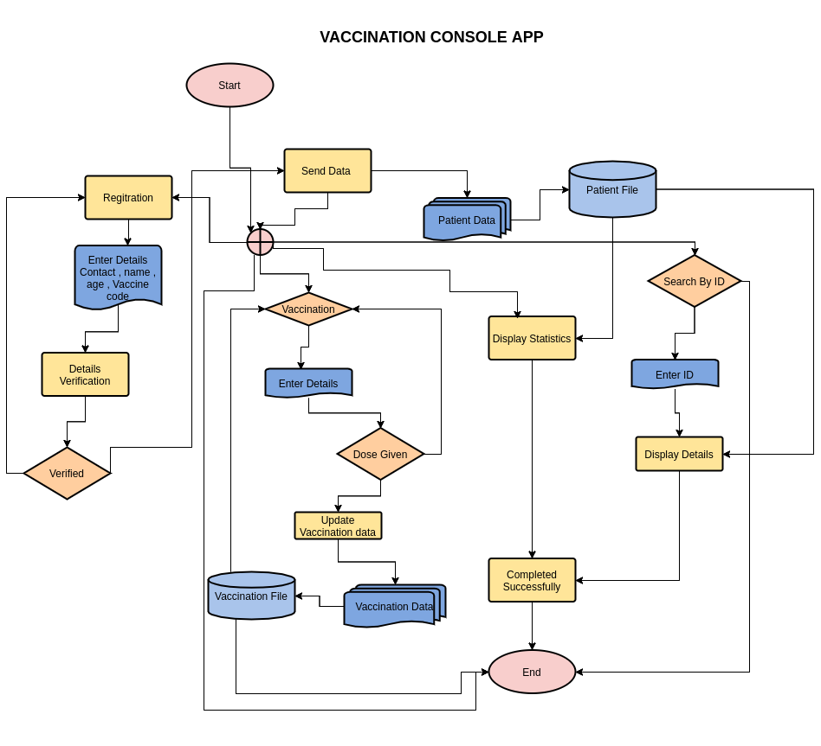

### PSEUDOCODE.

The modules above were implemented with the following logic shown by the pseudocode . For a certain module to be started , a certain code from 1 - 4 needed to be selected as show below.

*START APPLICATION.*

*OUTPUT "DISPLAY MENU OPTION*

*1. Registration*

*2. VAccination*

*3. Search by ID*

*4. Statistics*

*5. Exit*

*"*

*choice <-- INPUT ASK user for choice*

*WHILE choice in ["1" , "2" , "3" , "4" , "5"]*

*if choice is "1"*

*OUTPUT "Ask for user Details"*

*vaccine_center <-- INPUT from user*

*age <-- INPUT from user*

*if age < 12*

*EXIT*

*else*

*if age >=12 and age <=45*

*SELECT AND DISPLAY option for vaccine codes 'BV' , "EC" , 'AF' , "CZ" , "DM"*

*else:*

*SELECT AND DISPLAY option for vaccine codes 'AF' , "CZ" , "DM"*

*endif*

*endif*

*vaccine_code <-- INPUT from user vaccine code selection*

*name <-- INPUT for user's name*

*contact <-- INPUT for user's contact details*

*patient_id <-- generate ID for user*

*APPEND vaccine_center , vaccine_type , name , contact ,age to the file patient.txt*

*OUTPUT "Registration is Successful"*

*else if choice is "2"*

*patient_id <-- INPUT ask for patient id given*

*if patient_id not in the patient.txt*

*Call Registration function*

*else*

*if patient_id is in vaccination.txt file*

*check Dosage to be administered and Update accordingly in vaccination.txt file*

*else*

*Open vaccination.txt file and append Patient details*

*vaccinate dose 1 must be checked*

*OUTPUT "THE next dose date and whether completed*

*endif*

*endif*

*else if choice is "3"*

*patient_id <-- INPUT Ask for patient id to be searched for.*

*patient_data <-- READ ALL DATA FROM patient.txt file*

*vaccine_data <-- READ ALL DATA FROM vaccination.tx file*

*for each line in vaccine_data*

*if patient_id is in the line*

*OUTPUT --> CONTENT OF THE LINE in table form*

*else*

*for each_line in patient_data*

*if patient_id is in the each_line*

*OUTPUT --> CONTENT OF THE LINE in table form*

*else*

*OUTPUT "NO record with such ID is found in the system"*

*endif*

*endfor*

*endif*

*endfor*

*else if choice is "4"*

*vaccine_data <-- READ ALL DATA FROM vaccination.tx file*

*vaccine_center1 <-- []*

*vaccine_center2 <-- []*

*vaccine_center1_completed <-- 0*

*vaccine_center2_completed <-- 0*

*for each_line in vaccine_data*

*if "VC1" in each_line*

*append to vaccine_center1 list*

*if dose1 in each_line is "True" and dose2 in each_lien is 'True'*

*incremented vaccine_center1_completed by 1*

*endif*

*else*

*append to vaccine_center2 list*

*if dose1 in each_line is "True" and dose2 in each_lien is 'True'*

*incremented vaccine_center2_completed by 1*

*endif*

*endif*

*endfor*

*OUTPUT "HERE IS THE STATS FOR VACCINATION"*

*OUTPUT "CENTER 1 STATS"*

*for each_line in vaccine_center1*

*OUTPUT each line in table format*

*endfor*

*OUTPUT "Total Vaccinated completely are vaccine_center1_completed*

*OUTPUT "Total Waiting for dose 2 are COUNT(vaccine_center1)-1 -vaccine_center1_completed*

*OUTPUT "CENTER 2 STATS"*

*for each_line in vaccine_center2*

*OUTPUT each line in table format*

*endfor*

*OUTPUT "Total Vaccinated completely are vaccine_center2_completed*

*OUTPUT "Total Waiting for dose 2 are COUNT(vaccine_center2)-1 -vaccine_center2_completed*

*else if choice is "5"*

*EXIT()*

*Endif;*

### Modules Description and Explanation

##### Registration

An Individual inputs his/her details . He starts by selecting the center in which he opt to be vaccinated . He will then select the type of vaccine to be administered depending on the age in which he entered . After a success details input , user details are saved in a ***patient.txt*** file, the program notifies him he has done registration with his *Patient_ID* and can start his vaccination

##### Vaccination module.

This is the main component of the system . It allows individuals to update their records whether he has completed any of the dosage . Details for each individual are retrieved from ***patient.txt*** using his Patient_id . In case his record does not exist in patient.txt , he is asked to Redo registration . In case the record is in the patient.txt and not in the vaccination.txt , It is assumed he is on his first dose and his details are saved to vaccination.txt else the details are updated for the second dose if not completed.

##### Search By ID module

Allows a user to enter his Patient ID and his details will be displayed from the two file storage .

##### Display Statistics

Used to compute and get statistics for completed and uncompleted dosage in each vaccination center and displayed to the user in tabular form.

#### **Sample System Output for Each module.**

Screenshot below show how the Registration module works

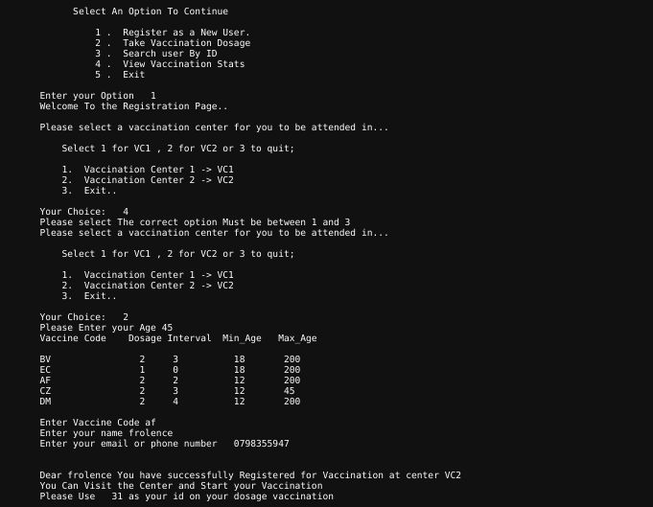

Below is how Vaccination module works

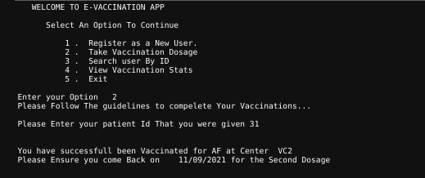

Below screenshot shows sample output for search by Id module.

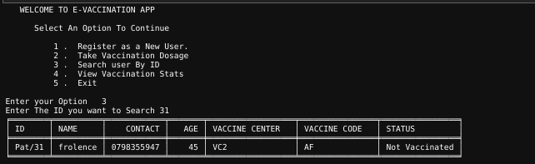

Below is a screenshot for the record stats display module.

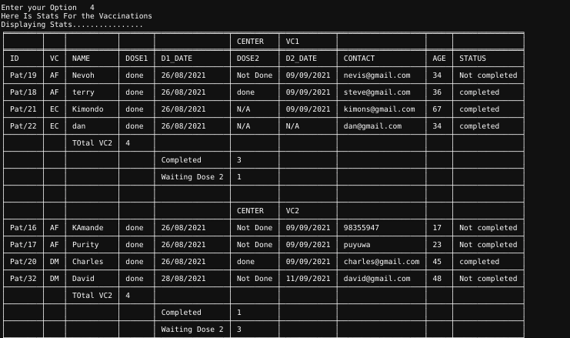

Files data for the system are stored as a comma separated entries as show in the screenshot below.

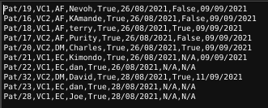

### Conclusion.

From the above system description developed ,

The major goal was achieved although not 100% with the main hindrance being able to make sure that users do not repeat registration for the vaccine because of using Ids auto generated. In order to improve the system for the future the following improvements might be done to the system.

1. Using a more advanced method for uniquely identifying a particular user maybe each has his id number as that given by the government.
2. A GUI to be developed which will make it easier for user usage
3. Using a database instead of file systems.