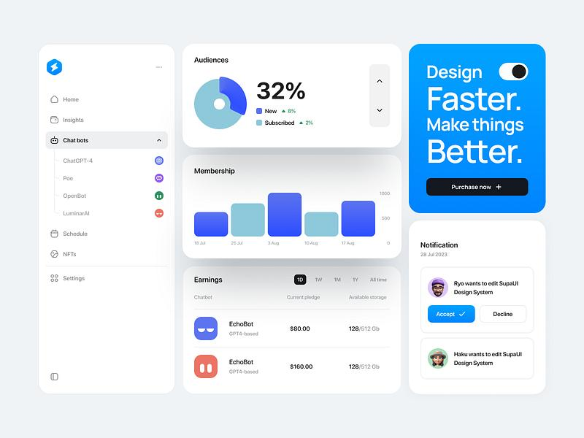

Solocorn Color Palette
1. Foundation (Page Structure)
Role | Color | RGB | Hex
Primary Background |  | 237, 237, 237 | #EDEDED
Section Background |  | 223, 223, 223 | #DFDFDF
Card / Surface |  | 212, 212, 211 | #D4D4D3

2. Structural Elements
Role | Color | RGB | Hex
Warm Accent |  | 202, 189, 180 | #CABDB4
Divider / Border |  | 176, 174, 171 | #B0AEAB

3. Typography Hierarchy
Role | Color | RGB | Hex
Primary Text |  | 63, 61, 57 | #3F3D39
Secondary Text |  | 127, 124, 119 | #7F7C77

4. Brand Accents
Role | Color | RGB | Hex
Soft Teal Accent |  | 79, 209, 197 | #4FD1C5
Blue Accent |  | 29, 78, 216 | #1D4ED8

Quick Visual Palette
#EDEDED #DFDFDF #D4D4D3
#CABDB4 #B0AEAB
#7F7C77 #3F3D39
#4FD1C5 #1D4ED8

Design Philosophy of This Palette
- Soft neutral greys → calm, modern UI foundation
- Warm neutral → prevents the interface from feeling cold
- Deep charcoal text → strong readability
- Teal accent (#4FD1C5) → primary brand identity
- Blue accent (#1D4ED8) → links and secondary actions

