
Mate all good dworry

Accred_2024_3star.pngX2


Tactical Threat Scenario Analysis

{{ customer_name }}

Prepared by {{ consultant_name }}

Month YYYY

INSERT CUSTOMER LOGO

{{ customer_name }} have undergone a Tactical Threat Scenario assessment completed by Planet IT. This assessment pits a real world but simulated and hypothetical threat against the current security implementation of {{ customer_name }}. The goal of this assessment is to assess the current ability of the security systems in place at stopping a novel threat and providing actionable advice; as well as indicating where there may be weaknesses in {{ customer_name }}’s security environment.
Although this is a theoretical assessment of {{ customer_name }}’s estate it is based on industry leading threat intelligence from multiple sources and utilises information and IOCs based on true threats that have penetrated businesses. The simulation focused on assessing defensive capabilities across the following stages of the attack chain:

- Threat Surface & Initial Access: An evaluation of the perimeter, identity controls, and email gateways against targeted intrusion techniques (e.g., phishing, credential theft, vulnerability exploitation).
- Endpoint Defence & Execution: An assessment of the deployed endpoint security to block malicious payloads, prevent execution, and restrict local privilege escalation.
- Lateral Movement & Network Resilience: An analysis of internal access controls and network segmentation to determine an adversary's ability to pivot toward critical infrastructure or databases.
- Data Protection & Exfiltration: A review of the safeguards surrounding sensitive data and the mechanisms in place to detect or prevent unauthorised data extraction.
- Detection, Response & Recovery (MDR/SOC): A measurement of the organisation’s capability to actively detect the intrusion, orchestrate an effective incident response, and recover operational stability with minimal downtime.

This report details the theoretical progression of the simulated attack against {{ customer_name }}, highlights the specific points of failure or 'capability gaps' within the current environment, and provides tactical recommendations to sever the attack path and fortify the estate.

The main findings and recommendations of the report are:

{% for rec in recommendations %}
- {{ rec }}
{% endfor %}

Overview of Current Environment
Organisational Profile | Details
Industry | {{ industry }}
Headcount | {{ users }}
Endpoints / Servers | {{ endpoints }} / {{ servers }}
Operating Systems | {{ operating_systems }}
Cloud Infrastructure | {{ cloud_env }}
Microsoft Licensing | {{ m365_license }}
In-House Security Coverage | {{ in_house_team }}
Target Compliance | {{ compliance }}
Crown Jewels | {{ critical_infra }}

Current Technology | Details
MDR / SOC Provider | {{ mdr_provider }}
Endpoint Security | {{ endpoint }}
Endpoint Technology | {{ endpoint_posture }}
Network Firewall | {{ firewall }}
Identity & Access | {{ identity }}
Email Security | {{ email }}
Security Culture | {{ savviness }}
Internal SOC Team | {{ in_house_team }}
Penetration Testing | {{ pentest_status }}
Vulnerability Scanning | {{ vuln_scanning }}

Risk, Compliance and Posture | Details
Backups Structure | {{ backups }}
SaaS Backups | {{ saas_backup }}
Remote Access Strategy | {{ remote_access }}
Incident Response Readiness | {{ ir_readiness }}
MFA Status | {{ mfa_status }}
Patching Strategy | {{ patching }}
Cyber Insurance Status | {{ insurance }}
Outage Tolerence | {{ rto }}

Threat Simulation Timeline
{% for event in threat_timeline %}
- [{{ event.timestamp }}] {{ event.event_description }}
{% endfor %}

Threat Simulation Narrative

{{ threat_narrative }}

Simulated Sophos MDR Case

The below case notes outline how Sophos MDR, Planet IT’s primary Managed Detection and Response vendor would have interrupted the flow of attack, responded on your behalf and reported the threat back to you.

{{ mdr_case_log }}

Why Planet IT
Planet IT is a leading IT company offering complete outsourced IT solutions to organisations across the UK and Europe. Based in Milton Park, Oxford, we provide comprehensive support services to suit your needs and deliver business transformation.

Our expert team has an extensive record of delivering software and hardware solutions to major blue-chip clients. Our technicians are highly skilled in planning, implementing and troubleshooting.

At Planet IT, we always take time to assess your IT needs and existing infrastructure, make recommendations, and implement improvements quickly and efficiently. In addition, we are highly experienced in planning and installing entire new IT systems in large organisations.
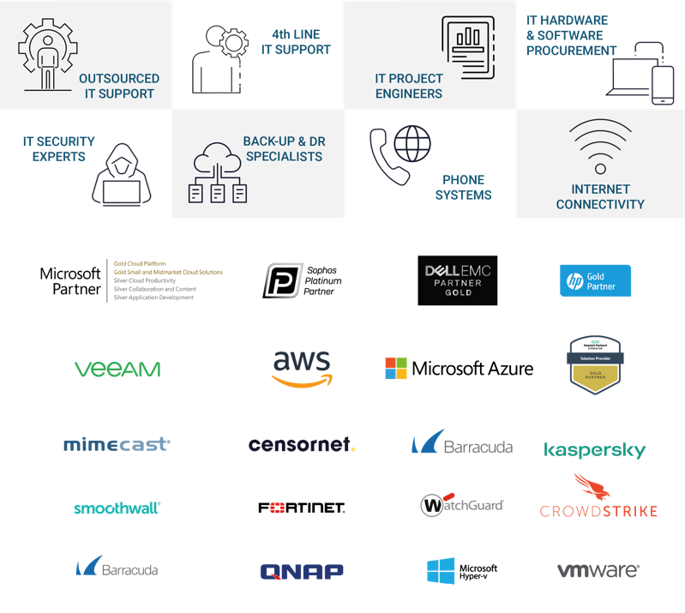

Our Pedigree
Since we started in 2003, Planet IT has supported over 2,000 clients in the UK, US and Europe. We are trusted by businesses across multiple industries, delivering various projects across Security, Backup & Disaster Recovery, Cloud migration, Fully Managed Support, Device as a Service and software licencing.

Since the beginning, we have built our business on first-class customer service and employing the best people available. We continue that ethos today, constantly building and maintaining our



client relationships. Here's a snapshot of some of the customers we work with today.

Assumptions and Client Responsibilities
This agreement is between;
- [{{ customer_name }} ] (“The Client”)
- Planet IT (“The Provider”)

Project Assumptions Client Responsibilities
These following items are responsibilities that The Client needs to fulfil as part of the project:
- Documentation/deliverables provided as part of the project will go through a maximum of two The Client reviews unless mutually agreed.
- In order to avoid delays to the project, The Client must review the documentation/deliverables within two business days of receipt of the document, except where mutually agreed.
- The Client is responsible for the supply of all infrastructure (hardware, software licences, network and environments) requirements to successfully deliver the project.
- The Client will be responsible for all aspects of data quality, availability, backups and restores required to successfully deliver the project.
- The Client will be responsible for raising all necessary change control requests.
- The Client will provide site access and a suitable work area to the project team.
- The Client will provide internal staff as per the schedule or as reasonably required including, but not limited to:
  - Project Manager to liaise with Planet IT Technical Design Authority to assist with scheduling The Client deliverables, resources and activity as per the agreed schedule.
  - Availability of appropriate The Client representatives at necessary requirements, design and planning workshops, testing and validation activities.
  - Provide access to network information, diagrams, site floor plans or site assistance, indicating outlet location, station number, username, and station type for each site where applicable.
  - Third party vendor coordination excluded from the scope of this proposal unless directly included in scope.
  - Supplying third party resources to assist in interfacing with third party equipment.
  - The successful execution and completion of User Acceptance Testing.
- The Client will inform Planet IT of any health and safety requirements.
- Ensure that Planet IT personnel who attend The Client site are instructed on all relevant health and safety regulations and criteria.
- Ensuring all dependencies that this engagement may have on other The Client projects is planned and met.
- The Client is to provide a minimum of ten working days’ notice prior to agreed resource schedule commencement.
- The Client cannot cancel planned activities on this schedule during the three working days prior to starting those activities. If so, The Client will incur the full cost of the cancelled activities during that three-day period.

This Statement of Work is offered by Planet IT based on the assumptions outlined below:
- The project will be delivered using the resources outlined within the document. Any delays to the project caused by The Client will result in additional days required to complete the project, these additional days will be at cost to The Client.
- Should the scale of the project transpire to be greater than initially expected, The Client are responsible for any additional time required to complete the project.
- The project will be delivered without interruption or suspension by The Client.
- Tasks assigned to The Client resources as part of detailed resource planning will be completed on time.
- Information and documentation requested by Planet IT for this project will be accurate, complete and provided in soft copy within two days.
- Reasonable requests from Planet IT to The Client for functional or technical clarification will be responded to within one business day. Failure to respond during the allocated time frame could have an impact on timelines and associated cost.
- The Client accepts that Planet IT’s professional services team members will perform their duties through a combination of on-site and off-site activity.
- The Client accepts non-exclusive access to the Planet IT’s professional services team members during the project.
- Planet IT documentation deliverables will be provided in editable formats such as Microsoft Word or Excel as applicable.
- Where applicable installation and/or configuration of The Client owned application software will be the responsibility of The Client.
- Any representatives of The Client (or their associates) that are involved at the various steps in the project are available as planned, adequately skilled and competent to execute the tasks required of them.
- Any The Client nominated decision-making representative is duly empowered.
- Planet IT will receive a minimum of five working days’ notice of any rescheduling of work resulting from delays caused by The Client, or their contractors.
- The Client will provide single point of contact for all aspects relating to project delivery.
- Network connectivity IP addresses and naming conventions will be provided by The Client where applicable.
- Business hours are standard UK business hours, 7.5 hour working day.
- The project will operate as a gated system. The project will be placed on hold and resources suspended until gate controls are met.
- The Client will be responsible for undertaking any appropriate user acceptance testing and sign off as accepted based on the outlined test schedule.
- If The Client opts out of user acceptance testing, Planet IT will not assume accountability for any project failures. It is the responsibility of The Client to address any necessary remediation work.

Authors
Name | Role
[TA NAME] | Technical Architect
[AM NAME] | Account Manager
Justin Towle | Head of Professional Services
James Dell | Technical Architecture Director
Nick Johns | Chief Technical Officer
Adrian Sweeney | Chief Commercial Officer

Planet IT Contact Details
Method | Details | Method | Details
Telephone | 01235 433900 | Fax | +44 (0) 1235 433901
Email | architecture@planet-it.net | Address | Planet IT Ltd  85f Park Drive  Milton Park  Abingdon  Oxfordshire  OX14 4RY

Revision Details
Revision | Date | Author | Comments
1.1 | 28/03/2025 | J.Dell / A.Sweeney / J.Towle / R. McClafferty | Updated for 2025
2.0 |  | [TA NAME]
2.1 |  | [APPROVER NAME] | Internal Approval

Distribution List
Name | Company
 | [CUSTOMER NAME]

Disclaimer

Whilst every precaution has been taken in the preparation of this document, no responsibility is assumed for errors or omissions, nor is any liability assumed for loss or damage resulting from the use of the information it contains, to the extent such error or omission is a result of any information, data or documents provided to Planet IT by the Customer and relied on by Planet IT in the preparation of this document.






01235 433 900
enquiries@planet-it.net
85F Park Drive
Milton Park
Abingdon
OX14 4RY

www.planet-it.net

Terms and Conditions

Confidentiality

All information within this document is given in the strictest confidence and is considered as Confidential Information and genuine commercially sensitive information. With regards to this all parties shall treat information detailed in the strictest confidence and shall not, without the prior consent of the other party, disclose any information with regards to this proposal to any other organisations, whosoever they may be. In the event the customer is compelled by law or by any applicable regulatory agency (including a request to disclose information in accordance with the Freedom of Information Act 2000) to disclose any Confidential Information the customer shall immediately consult with Planet IT Limited prior to any such pending disclosure so that the parties may discuss whether the Confidential Information is exempt from disclosure or so that a protective order or other appropriate remedy may be obtained. If such an order or other remedy is not available, the customer shall disclose only that minimum portion of Confidential Information that it is legally compelled to disclose, consistent with the advice of its counsel.

Disclaimer

Planet IT Limited makes no representations or warranties with respect to the contents or use of this document, and specifically disclaims any express or implied warranties of merchantability or fitness for any purpose.

Intellectual Property

Nothing in this document is intended to grant any rights under any patent, copyright or other intellectual property right of Planet IT Limited.

