









Security Maturity Assessment

Branded

Prepared by Consultant

October 2026

• Q1
• Q2
• Q3
• Q4
• Q5

Branded – Executive Summary
Executive summary text for client.

Issue | Ruling | Rationale | Suggested Remediations | Aligned Solutions
1. Legacy VPN exposes management plane | Not observed amongst the top three risks; may be context‑specific or lower priority. | No strong token overlap with top risks derived from consultation and domain ratings. | • Assign ownership, define acceptance criteria, and plan remediation into the phased roadmap. | • Consultation to validate exposure and, if confirmed, align to relevant workstream.
2. Backups fail monthly; not immutable | Not observed amongst the top three risks; may be context‑specific or lower priority. | No strong token overlap with top risks derived from consultation and domain ratings. | • Assign ownership, define acceptance criteria, and plan remediation into the phased roadmap. | • Consultation to validate exposure and, if confirmed, align to relevant workstream.
3. Out-of-hours escalation unclear | Not observed amongst the top three risks; may be context‑specific or lower priority. | No strong token overlap with top risks derived from consultation and domain ratings. | • Assign ownership, define acceptance criteria, and plan remediation into the phased roadmap. | • Consultation to validate exposure and, if confirmed, align to relevant workstream.

Security Rating

Overall: Assessment Incomplete (Evidence Pending).
Scoring withheld pending validation of required domain evidence.

Security Rating Snapshot
Executive measure | Assessment
Overall score | /100
Maturity rating | Assessment Incomplete (Evidence Pending)
Direction of travel | Stable
Primary strengths | Action 1, Action 2, Action 3
Primary gaps | Risk 1, Risk 2, Risk 3
Board-level takeaway | Validation of evidence required before numeric scoring can be issued.

Weighted Maturity Table
Area | Weighting % | Indicative score | Weighted Contribution | Rationale

Maturity Band Legend
Range | Rating | Meaning
0–39 | High Risk | Foundational gaps and reactive posture
40–59 | Needs Attention | Proactive improvement underway
60–79 | Moderate | Controls maturing; governance stabilising
80–100 | Strong | Adaptive and evidence-led resilience

Scoring withheld due to incomplete evidence across foundational domains.

Findings
Overall Assessment
Moderate (67/100). The organisation’s cyber resilience reflects this position across core domains.
Priority Actions
1. Action 1
2. Action 2
3. Action 3
Recommended Follow-Up Exercise
Schedule a governance‑focused tabletop to validate incident declaration thresholds, authority pathways, and containment runbooks.
- Action 1
- Action 2
- Action 3
Executive summary text for client.

Severity | Issue | Business Exposure | Priority Action
AMBER 35% | Heading 1 | Risk 1 | Action 1
AMBER 35% | Heading 2 | Risk 2 | Action 1
AMBER 35% | Heading 3 | Risk 3 | Action 1

Programme Options (indicative)
Indicative solution | Why this fits Branded | Cost band
Action 1 | Risk 1 | TBC following discovery

Simulated attack of current infrastructure
Disclaimer: this is a fictional breach scenario leveraging threat intelligence and known threat actor activity mapped to the current technology stack and perceived security maturity of Branded – this is meant as an illustration of potential risks only

Current domain alignment

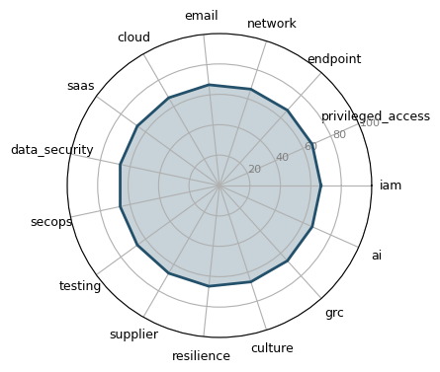

Cyber Maturity Matrix Alignment
Pillar 2: Proactive Cybersecurity

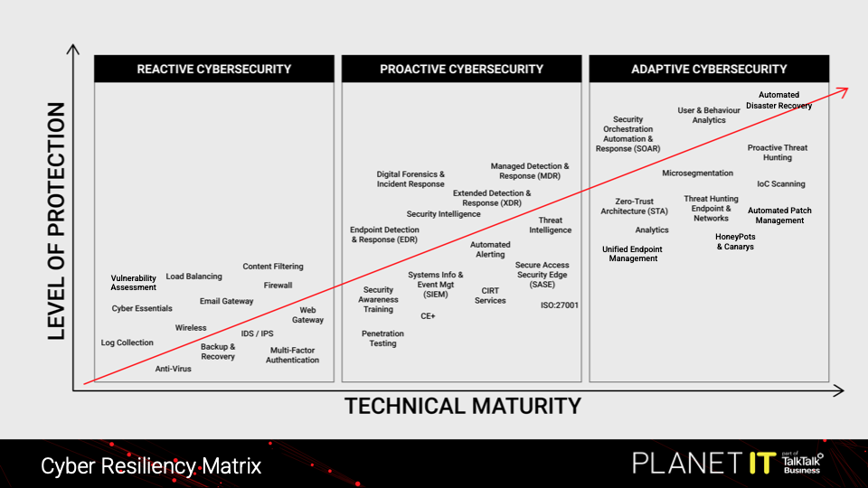
Current Maturity

Compliance and Framework Alignment

Standard: No compliance alignment generated Gaps: • Compliance alignment data was not provided during generation

The Cost of Inaction
Cost of inaction narrative.

Overview of Current Environment
Organisational Profile | Details
Industry | Technology
Headcount | 250
Endpoints / Servers | 300 / 20
Operating Systems | Windows 11, Windows Server 2022
Cloud Infrastructure | Microsoft Azure
Microsoft Licensing | M365 Business Premium
In-House Security Coverage | Yes (9-to-5)
Target Compliance | ISO 27001
Critical Asset Profile | Business services: Finance and payroll; Microsoft 365 collaboration  Systems/platforms: Dynamics 365; SharePoint; Teams  Sensitive data: Personal data; Financial data  Regional operations across two sites

Current Technology | Details
MDR / SOC Provider | None (Adlumin under evaluation; working-hours IT monitoring via Webroot/Freshdesk)
Endpoint Security | Webroot EDR
Endpoint Technology | EDR Deployed (Endpoint Detection Response)
Network Firewall | Fortinet
Identity Access | Microsoft Entra ID cloud-only
Email Security | Microsoft Defender
Security Culture | Pillar 2: Proactive security culture
Internal SOC Team | Yes (9-to-5)
Penetration Testing | Annual
Vulnerability Scanning | Monthly Authenticated

Risk, Compliance and Posture | Details
Backups Structure | Immutable / Air-Gapped
SaaS Backups | Dedicated Third-Party SaaS Backup
Remote Access Strategy | Zero Trust Network Access (ZTNA) / SASE
Incident Response Readiness | Tested IR Plan with Active Retainer
MFA Status | Universal / Conditional Access
Patching Strategy | Automated (OS Third-Party)
Cyber Insurance Status | Active Policy
Outage Tolerence | 12-24 Hours

Detailed Assessment

Domain: Identity Access Management
Pillar 2: Proactive Cybersecurity (67/100)
Remediation rationale for Identity & Access Management.

Field | Details
Current Maturity | Pillar 2: Proactive Cybersecurity (67/100)
Technical Analysis | Authoritative technical analysis for Identity Access Management.
Business Impact Risk | Specific business impact analysis for Identity Access Management.
Critical Gaps | • Gap 1 for Identity Access Management  • Gap 2 for Identity Access Management
Zero-Cost Quick Wins | • Quick win 1 for Identity Access Management  • Quick win 2 for Identity Access Management
Recommended Solutions | • Solution 1 for Identity Access Management  • Solution 2 for Identity Access Management  • Solution 3 for Identity Access Management
Strategic Remediation Rationale | Remediation rationale for Identity Access Management.
Partnership Recommendations | Shared responsibility model for Identity Access Management.

Domain: Endpoint Security

Remediation rationale for Endpoint Security.
Field | Details
Current Maturity | Pillar 2: Proactive Cybersecurity
Technical Analysis | Authoritative technical analysis for Endpoint Security.
Business Impact Risk | Specific business impact analysis for Endpoint Security.
Critical Gaps | • Gap 1 for Endpoint Security  • Gap 2 for Endpoint Security
Zero-Cost Quick Wins | • Quick win 1 for Endpoint Security  • Quick win 2 for Endpoint Security
Recommended Solutions | • Solution 1 for Endpoint Security  • Solution 2 for Endpoint Security  • Solution 3 for Endpoint Security
Strategic Remediation Rationale | Remediation rationale for Endpoint Security.
Partnership Recommendations | Shared responsibility model for Endpoint Security.

Remediation rationale for Network & Edge Security.

Domain: Network Edge Security

Field | Details
Current Maturity | Pillar 2: Proactive Cybersecurity
Technical Analysis | Authoritative technical analysis for Network Edge Security.
Business Impact Risk | Specific business impact analysis for Network Edge Security.
Critical Gaps | • Gap 1 for Network Edge Security  • Gap 2 for Network Edge Security
Zero-Cost Quick Wins | • Quick win 1 for Network Edge Security  • Quick win 2 for Network Edge Security
Recommended Solutions | • Solution 1 for Network Edge Security  • Solution 2 for Network Edge Security  • Solution 3 for Network Edge Security
Strategic Remediation Rationale | Remediation rationale for Network Edge Security.
Partnership Recommendations | Shared responsibility model for Network Edge Security.

Domain: Cloud Security

Remediation rationale for Cloud Security.
Field | Details
Current Maturity | Pillar 2: Proactive Cybersecurity
Technical Analysis | Authoritative technical analysis for Cloud Security.
Business Impact Risk | Specific business impact analysis for Cloud Security.
Critical Gaps | • Gap 1 for Cloud Security  • Gap 2 for Cloud Security
Zero-Cost Quick Wins | • Quick win 1 for Cloud Security  • Quick win 2 for Cloud Security
Recommended Solutions | • Solution 1 for Cloud Security  • Solution 2 for Cloud Security  • Solution 3 for Cloud Security
Strategic Remediation Rationale | Remediation rationale for Cloud Security.
Partnership Recommendations | Shared responsibility model for Cloud Security.

Remediation rationale for Email & Collaboration.

Domain: Email Collaboration
Remediation rationale for Backup & Recovery Assurance.

Remediation rationale for Monitoring & Threat Detection.
Field | Details
Current Maturity | Pillar 2: Proactive Cybersecurity
Technical Analysis | Authoritative technical analysis for Email Collaboration.
Business Impact Risk | Specific business impact analysis for Email Collaboration.
Critical Gaps | • Gap 1 for Email Collaboration  • Gap 2 for Email Collaboration
Zero-Cost Quick Wins | • Quick win 1 for Email Collaboration  • Quick win 2 for Email Collaboration
Recommended Solutions | • Solution 1 for Email Collaboration  • Solution 2 for Email Collaboration  • Solution 3 for Email Collaboration
Strategic Remediation Rationale | Remediation rationale for Email Collaboration.
Partnership Recommendations | Shared responsibility model for Email Collaboration.

Remediation rationale for Incident Response & Preparedness.

Domain: Backup Recovery Assurance
Remediation rationale for Supply Chain & Third-Party Assurance.

Remediation rationale for SaaS Security & Shadow IT.
Field | Details
Current Maturity | Pillar 2: Proactive Cybersecurity
Technical Analysis | Authoritative technical analysis for Backup Recovery Assurance.
Business Impact Risk | Specific business impact analysis for Backup Recovery Assurance.
Critical Gaps | • Gap 1 for Backup Recovery Assurance  • Gap 2 for Backup Recovery Assurance
Zero-Cost Quick Wins | • Quick win 1 for Backup Recovery Assurance  • Quick win 2 for Backup Recovery Assurance
Recommended Solutions | • Solution 1 for Backup Recovery Assurance  • Solution 2 for Backup Recovery Assurance  • Solution 3 for Backup Recovery Assurance
Strategic Remediation Rationale | Remediation rationale for Backup Recovery Assurance.
Partnership Recommendations | Shared responsibility model for Backup Recovery Assurance.

Remediation rationale for Information Protection & Data Governance.

Domain: Monitoring Threat Detection
Remediation rationale for Application Security & SDLC.

Remediation rationale for AI Governance & Acceptable Use.
Field | Details
Current Maturity | Pillar 2: Proactive Cybersecurity
Technical Analysis | Authoritative technical analysis for Monitoring Threat Detection.
Business Impact Risk | Specific business impact analysis for Monitoring Threat Detection.
Critical Gaps | • Gap 1 for Monitoring Threat Detection  • Gap 2 for Monitoring Threat Detection
Zero-Cost Quick Wins | • Quick win 1 for Monitoring Threat Detection  • Quick win 2 for Monitoring Threat Detection
Recommended Solutions | • Solution 1 for Monitoring Threat Detection  • Solution 2 for Monitoring Threat Detection  • Solution 3 for Monitoring Threat Detection
Strategic Remediation Rationale | Remediation rationale for Monitoring Threat Detection.
Partnership Recommendations | Shared responsibility model for Monitoring Threat Detection.

Remediation rationale for Vulnerability Management & Security Testing.

Domain: Incident Response Preparedness
Remediation rationale for Asset Management & Assurance.

Field | Details
Current Maturity | Pillar 2: Proactive Cybersecurity
Technical Analysis | Authoritative technical analysis for Incident Response Preparedness.
Business Impact Risk | Specific business impact analysis for Incident Response Preparedness.
Critical Gaps | • Gap 1 for Incident Response Preparedness  • Gap 2 for Incident Response Preparedness
Zero-Cost Quick Wins | • Quick win 1 for Incident Response Preparedness  • Quick win 2 for Incident Response Preparedness
Recommended Solutions | • Solution 1 for Incident Response Preparedness  • Solution 2 for Incident Response Preparedness  • Solution 3 for Incident Response Preparedness
Strategic Remediation Rationale | Remediation rationale for Incident Response Preparedness.
Partnership Recommendations | Shared responsibility model for Incident Response Preparedness.

Domain: Supply Chain Third-Party Assurance

Field | Details
Current Maturity | Pillar 2: Proactive Cybersecurity
Technical Analysis | Authoritative technical analysis for Supply Chain Third-Party Assurance.
Business Impact Risk | Specific business impact analysis for Supply Chain Third-Party Assurance.
Critical Gaps | • Gap 1 for Supply Chain Third-Party Assurance  • Gap 2 for Supply Chain Third-Party Assurance
Zero-Cost Quick Wins | • Quick win 1 for Supply Chain Third-Party Assurance  • Quick win 2 for Supply Chain Third-Party Assurance
Recommended Solutions | • Solution 1 for Supply Chain Third-Party Assurance  • Solution 2 for Supply Chain Third-Party Assurance  • Solution 3 for Supply Chain Third-Party Assurance
Strategic Remediation Rationale | Remediation rationale for Supply Chain Third-Party Assurance.
Partnership Recommendations | Shared responsibility model for Supply Chain Third-Party Assurance.

Domain: SaaS Security Shadow IT

Field | Details
Current Maturity | Pillar 2: Proactive Cybersecurity
Technical Analysis | Authoritative technical analysis for SaaS Security Shadow IT.
Business Impact Risk | Specific business impact analysis for SaaS Security Shadow IT.
Critical Gaps | • Gap 1 for SaaS Security Shadow IT  • Gap 2 for SaaS Security Shadow IT
Zero-Cost Quick Wins | • Quick win 1 for SaaS Security Shadow IT  • Quick win 2 for SaaS Security Shadow IT
Recommended Solutions | • Solution 1 for SaaS Security Shadow IT  • Solution 2 for SaaS Security Shadow IT  • Solution 3 for SaaS Security Shadow IT
Strategic Remediation Rationale | Remediation rationale for SaaS Security Shadow IT.
Partnership Recommendations | Shared responsibility model for SaaS Security Shadow IT.

Domain: Information Protection Data Governance

Field | Details
Current Maturity | Pillar 2: Proactive Cybersecurity
Technical Analysis | Authoritative technical analysis for Information Protection Data Governance.
Business Impact Risk | Specific business impact analysis for Information Protection Data Governance.
Critical Gaps | • Gap 1 for Information Protection Data Governance  • Gap 2 for Information Protection Data Governance
Zero-Cost Quick Wins | • Quick win 1 for Information Protection Data Governance  • Quick win 2 for Information Protection Data Governance
Recommended Solutions | • Solution 1 for Information Protection Data Governance  • Solution 2 for Information Protection Data Governance  • Solution 3 for Information Protection Data Governance
Strategic Remediation Rationale | Remediation rationale for Information Protection Data Governance.
Partnership Recommendations | Shared responsibility model for Information Protection Data Governance.

Domain: Application Security SDLC

Field | Details
Current Maturity | Pillar 2: Proactive Cybersecurity
Technical Analysis | Authoritative technical analysis for Application Security SDLC.
Business Impact Risk | Specific business impact analysis for Application Security SDLC.
Critical Gaps | • Gap 1 for Application Security SDLC  • Gap 2 for Application Security SDLC
Zero-Cost Quick Wins | • Quick win 1 for Application Security SDLC  • Quick win 2 for Application Security SDLC
Recommended Solutions | • Solution 1 for Application Security SDLC  • Solution 2 for Application Security SDLC  • Solution 3 for Application Security SDLC
Strategic Remediation Rationale | Remediation rationale for Application Security SDLC.
Partnership Recommendations | Shared responsibility model for Application Security SDLC.

Domain: AI Governance Acceptable Use

Field | Details
Current Maturity | Pillar 2: Proactive Cybersecurity
Technical Analysis | Authoritative technical analysis for AI Governance Acceptable Use.
Business Impact Risk | Specific business impact analysis for AI Governance Acceptable Use.
Critical Gaps | • Gap 1 for AI Governance Acceptable Use  • Gap 2 for AI Governance Acceptable Use
Zero-Cost Quick Wins | • Quick win 1 for AI Governance Acceptable Use  • Quick win 2 for AI Governance Acceptable Use
Recommended Solutions | • Solution 1 for AI Governance Acceptable Use  • Solution 2 for AI Governance Acceptable Use  • Solution 3 for AI Governance Acceptable Use
Strategic Remediation Rationale | Remediation rationale for AI Governance Acceptable Use.
Partnership Recommendations | Shared responsibility model for AI Governance Acceptable Use.

Domain: Vulnerability Management Security Testing

Field | Details
Current Maturity | Pillar 2: Proactive Cybersecurity
Technical Analysis | Authoritative technical analysis for Vulnerability Management Security Testing.
Business Impact Risk | Specific business impact analysis for Vulnerability Management Security Testing.
Critical Gaps | • Gap 1 for Vulnerability Management Security Testing  • Gap 2 for Vulnerability Management Security Testing
Zero-Cost Quick Wins | • Quick win 1 for Vulnerability Management Security Testing  • Quick win 2 for Vulnerability Management Security Testing
Recommended Solutions | • Solution 1 for Vulnerability Management Security Testing  • Solution 2 for Vulnerability Management Security Testing  • Solution 3 for Vulnerability Management Security Testing
Strategic Remediation Rationale | Remediation rationale for Vulnerability Management Security Testing.
Partnership Recommendations | Shared responsibility model for Vulnerability Management Security Testing.

Domain: Asset Management Assurance

Field | Details
Current Maturity | Pillar 2: Proactive Cybersecurity
Technical Analysis | Authoritative technical analysis for Asset Management Assurance.
Business Impact Risk | Specific business impact analysis for Asset Management Assurance.
Critical Gaps | • Gap 1 for Asset Management Assurance  • Gap 2 for Asset Management Assurance
Zero-Cost Quick Wins | • Quick win 1 for Asset Management Assurance  • Quick win 2 for Asset Management Assurance
Recommended Solutions | • Solution 1 for Asset Management Assurance  • Solution 2 for Asset Management Assurance  • Solution 3 for Asset Management Assurance
Strategic Remediation Rationale | Remediation rationale for Asset Management Assurance.
Partnership Recommendations | Shared responsibility model for Asset Management Assurance.

Security Testing and Planning

Proactive Security Testing

Incident Response Planning

Disaster Recovery Planning

Suggested Implementation Roadmap

At Planet IT we map our suggested and prospective implementation roadmaps to three distinct phases:

- Foundational Hygiene: Establishes the essential technical controls and baseline configuration practices required to eliminate common vulnerabilities and protect core corporate assets from opportunistic cyber threats.
- Active Managed Defence: Implements continuous security monitoring, real-time threat detection, and proactive incident response workflows to actively contest, isolate, and mitigate live attacks.
- Adaptive Governance: Integrates dynamic risk management, regulatory compliance, and continuous policy evolution to align security strategy with shifting business goals and the broader threat landscape.

These phases delineate the strategies required to implement a robust security, goveneance and compliance solution to effectively defend Branded moving forward. The phases are made up as such:

Phase Timeline | Primary Strategic Objective | Strategic Capability Overview
Phase 1: Foundational Hygiene  (0-3 Months) | Stabilisation, perimeter hardening, and the elimination of baseline technical debt. | Establishing identity authentication enforcement, baseline network and endpoint hardening, fundamental data recoverability assurance, and initial risk visibility aligned to introductory compliance standards.
Phase 2: Active Managed Defence  (3-9 Months) | Transitioning from passive protective tools to active, 24/7 threat hunting and validated defence. | Deploying continuous threat telemetry and incident response capabilities, offensive security validation, human risk mitigation programmes, and centralising security intelligence for broader framework alignment.
Phase 3: Adaptive Governance Resilience  (10-18+ Months) | Driving the long tail of the roadmap to achieve sustainable enterprise resilience, advanced automation, and board-level assurance. | Implementing zero-trust architectural principles, automated incident orchestration and response workflows, behavioural anomaly detection, and proactive threat deception and hunting capabilities.
Please find below a bespoke roadmap of suggested improvements tailored for Branded:

Partnership Success Criteria

Planet IT provides co-managed cyber defence and continuous assurance partnership.

Field | Details
Phase | Phase 1: Foundational Hygiene
Timeline | 0-3 Months
Strategic Objective | Objective 1
Key Deliverables | • Deliverable 1  • Deliverable 2  • Deliverable 3
Estimated Effort | Medium
Key Milestones | • Milestone 1  • Milestone 2  • Milestone 3
Business Value Delivered | Value 1
Resource Requirements | Internal Team Planet IT

Field | Details
Phase | Phase 2: Active Managed Defence
Timeline | 3-6 Months
Strategic Objective | Objective 2
Key Deliverables | • Deliverable 1  • Deliverable 2  • Deliverable 3
Estimated Effort | Medium
Key Milestones | • Milestone 1  • Milestone 2  • Milestone 3
Business Value Delivered | Value 2
Resource Requirements | Internal Team Planet IT

Field | Details
Phase | Phase 3: Adaptive Governance Resilience
Timeline | 6-9 Months
Strategic Objective | Objective 3
Key Deliverables | • Deliverable 1  • Deliverable 2  • Deliverable 3
Estimated Effort | Medium
Key Milestones | • Milestone 1  • Milestone 2  • Milestone 3
Business Value Delivered | Value 3
Resource Requirements | Internal Team Planet IT

Why Planet IT

Planet IT is a leading IT company offering complete outsourced IT solutions to organisations across the UK and Europe. Based in Milton Park, Oxford, we provide comprehensive support services to suit your needs and deliver business transformation.

Our expert team has an extensive record of delivering software and hardware solutions to major blue-chip clients. Our technicians are highly skilled in planning, implementing and troubleshooting.

At Planet IT, we always take time to assess your IT needs and existing infrastructure, make recommendations, and implement improvements quickly and efficiently. In addition, we are highly experienced in planning and installing entire new IT systems in large organisations.
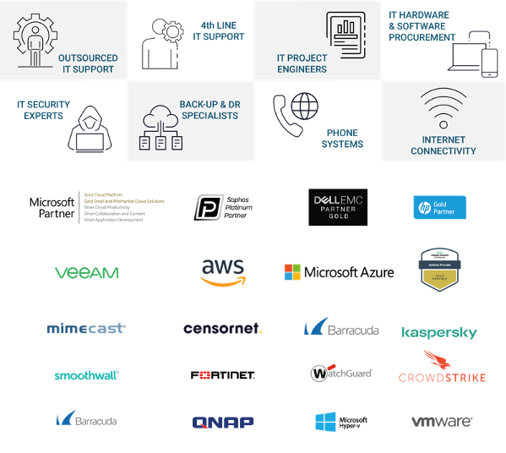

Our Pedigree
Since we started in 2003, Planet IT has supported over 2,000 clients in the UK, US and Europe. We are trusted by businesses across multiple industries, delivering various projects across Security, Backup Disaster Recovery, Cloud migration, Fully Managed Support, Device as a Service and software licencing.

Since the beginning, we have built our business on first-class customer service and employing the best people available. We continue that ethos today, constantly building and maintaining our



client relationships. Here's a snapshot of some of the customers we work with today.

Assumptions and Client Responsibilities
This agreement is between;
- [Branded ] (“The Client”)
- Planet IT (“The Provider”)

Project Assumptions Client Responsibilities
These following items are responsibilities that The Client needs to fulfil as part of the project:
- Documentation/deliverables provided as part of the project will go through a maximum of two The Client reviews unless mutually agreed.
- In order to avoid delays to the project, The Client must review the documentation/deliverables within two business days of receipt of the document, except where mutually agreed.
- The Client is responsible for the supply of all infrastructure (hardware, software licences, network and environments) requirements to successfully deliver the project.
- The Client will be responsible for all aspects of data quality, availability, backups and restores required to successfully deliver the project.
- The Client will be responsible for raising all necessary change control requests.
- The Client will provide site access and a suitable work area to the project team.
- The Client will provide internal staff as per the schedule or as reasonably required including, but not limited to:
  - Project Manager to liaise with Planet IT Technical Design Authority to assist with scheduling The Client deliverables, resources and activity as per the agreed schedule.
  - Availability of appropriate The Client representatives at necessary requirements, design and planning workshops, testing and validation activities.
  - Provide access to network information, diagrams, site floor plans or site assistance, indicating outlet location, station number, username, and station type for each site where applicable.
  - Third party vendor coordination excluded from the scope of this proposal unless directly included in scope.
  - Supplying third party resources to assist in interfacing with third party equipment.
  - The successful execution and completion of User Acceptance Testing.
- The Client will inform Planet IT of any health and safety requirements.
- Ensure that Planet IT personnel who attend The Client site are instructed on all relevant health and safety regulations and criteria.
- Ensuring all dependencies that this engagement may have on other The Client projects is planned and met.
- The Client is to provide a minimum of ten working days’ notice prior to agreed resource schedule commencement.
- The Client cannot cancel planned activities on this schedule during the three working days prior to starting those activities. If so, The Client will incur the full cost of the cancelled activities during that three-day period.

This Statement of Work is offered by Planet IT based on the assumptions outlined below:
- The project will be delivered using the resources outlined within the document. Any delays to the project caused by The Client will result in additional days required to complete the project, these additional days will be at cost to The Client.
- Should the scale of the project transpire to be greater than initially expected, The Client are responsible for any additional time required to complete the project.
- The project will be delivered without interruption or suspension by The Client.
- Tasks assigned to The Client resources as part of detailed resource planning will be completed on time.
- Information and documentation requested by Planet IT for this project will be accurate, complete and provided in soft copy within two days.
- Reasonable requests from Planet IT to The Client for functional or technical clarification will be responded to within one business day. Failure to respond during the allocated time frame could have an impact on timelines and associated cost.
- The Client accepts that Planet IT’s professional services team members will perform their duties through a combination of on-site and off-site activity.
- The Client accepts non-exclusive access to the Planet IT’s professional services team members during the project.
- Planet IT documentation deliverables will be provided in editable formats such as Microsoft Word or Excel as applicable.
- Where applicable installation and/or configuration of The Client owned application software will be the responsibility of The Client.
- Any representatives of The Client (or their associates) that are involved at the various steps in the project are available as planned, adequately skilled and competent to execute the tasks required of them.
- Any The Client nominated decision-making representative is duly empowered.
- Planet IT will receive a minimum of five working days’ notice of any rescheduling of work resulting from delays caused by The Client, or their contractors.
- The Client will provide single point of contact for all aspects relating to project delivery.
- Network connectivity IP addresses and naming conventions will be provided by The Client where applicable.
- Business hours are standard UK business hours, 7.5 hour working day.
- The project will operate as a gated system. The project will be placed on hold and resources suspended until gate controls are met.
- The Client will be responsible for undertaking any appropriate user acceptance testing and sign off as accepted based on the outlined test schedule.
- If The Client opts out of user acceptance testing, Planet IT will not assume accountability for any project failures. It is the responsibility of The Client to address any necessary remediation work.

Authors
Name | Role
Consultant | Technical Architect
 | Account Manager
Justin Towle | Head of Professional Services
Mike Bellido | Technical Architecture Director
Nick Johns | Chief Technical Officer
Adrian Sweeney | Chief Commercial Officer

Planet IT Contact Details
Method | Details | Method | Details
Telephone | 01235 433900 | Fax | +44 (0) 1235 433901
Email | architecture@planet-it.net | Address | Planet IT Ltd  85f Park Drive  Milton Park  Abingdon  Oxfordshire  OX14 4RY

Revision Details
Revision | Date | Author | Comments
1.1 | 28/03/2025 | J.Dell / A.Sweeney / J.Towle / R. McClafferty | Updated for 2025
2.0 |  | Consultant
2.1 |  |  | Internal Approval

Distribution List
Name | Company
 | Branded

Disclaimer

Whilst every precaution has been taken in the preparation of this document, no responsibility is assumed for errors or omissions, nor is any liability assumed for loss or damage resulting from the use of the information it contains, to the extent such error or omission is a result of any information, data or documents provided to Planet IT by the Customer and relied on by Planet IT in the preparation of this document.







01235 433 900
enquiries@planet-it.net
85F Park Drive
Milton Park
Abingdon
OX14 4RY

www.planet-it.net

Terms and Conditions

Confidentiality

All information within this document is given in the strictest confidence and is considered as Confidential Information and genuine commercially sensitive information. With regards to this all parties shall treat information detailed in the strictest confidence and shall not, without the prior consent of the other party, disclose any information with regards to this proposal to any other organisations, whosoever they may be. In the event the customer is compelled by law or by any applicable regulatory agency (including a request to disclose information in accordance with the Freedom of Information Act 2000) to disclose any Confidential Information the customer shall immediately consult with Planet IT Limited prior to any such pending disclosure so that the parties may discuss whether the Confidential Information is exempt from disclosure or so that a protective order or other appropriate remedy may be obtained. If such an order or other remedy is not available, the customer shall disclose only that minimum portion of Confidential Information that it is legally compelled to disclose, consistent with the advice of its counsel.

Disclaimer

Planet IT Limited makes no representations or warranties with respect to the contents or use of this document, and specifically disclaims any express or implied warranties of merchantability or fitness for any purpose.

Intellectual Property

Nothing in this document is intended to grant any rights under any patent, copyright or other intellectual property right of Planet IT Limited.

Current Maturity — Identity & Access Management: Pillar 2: Proactive Cybersecurity (67/100)

