









Security Maturity Assessment

Smoke Co

Prepared by Tester

Month YYYY

INSERT CUSTOMER LOGO

Internal Discovery Guide (Consultant Only - Remove Before Sending):
• N
• /
• A

Smoke Co – Executive Summary

Smoke Co have undergone a Security Maturity Assessment completed by Planet IT. This comprehensive assessment of the current security implementation of Smoke Co focused on assessing the security maturity of the systems, solutions and culture in place at Smoke Co. Namely focusing in the following areas:

- Identity & Access Management (IAM): An evaluation of authentication controls, MFA enforcement, and alignment with zero-trust principles to protect user credentials.
- Endpoint Protection: The posture of device-level security, malware defence, and the restriction of local administrator privileges across the estate.
- Network & Perimeter Security: An assessment of firewall architectures, network segmentation, and secure remote access controls for physical and virtual locations.
- Email & Collaboration Security: Defences against phishing, business email compromise (BEC), and malicious payloads within core productivity suites (e.g., Microsoft 365).
- Cloud & Infrastructure Security: The security configuration and workload protection mechanisms applied to public cloud environments and on-premises server infrastructure.
- Security Monitoring & Response (MDR/SOC): The organisation’s capability to actively detect, investigate, and remediate threats on a 24/7 basis using cross-domain telemetry.
- Security Validation & Testing: The frequency and efficacy of proactive offensive testing, including vulnerability scanning and internal/external penetration testing.
- Security Culture & Awareness: An analysis of human-centric risk, evaluating the maturity of user coaching, phishing simulations, and general security behaviour.
- AI Governance & Control: The strategies and controls in place to identify, govern and control access to approved AI systems as well as identification and control of shadow AI usage.
- Governance, Risk & Compliance (GRC): The strategic alignment of current controls with target compliance frameworks (e.g., ISO 27001, Cyber Essentials) and the overarching protection of critical business assets.

The report provides an overview of the current estimated security maturity in place at Smoke Co, identifies potential risks and issues, and recommends best practices and remediation actions to improve the security posture and culture at Smoke Co.

Identified Known Issues

The below items were self-identified by Smoke Co during the assessment consultation:

Known Issues (Customer-Stated) — Adjudication
1. Issue: Legacy VPN exposes management plane
Ruling: Pending adjudication
Rationale: Pending adjudication by consultant.
2. Issue: MFA not enforced for all users
Ruling: Pending adjudication
Rationale: Pending adjudication by consultant.

Security Rating

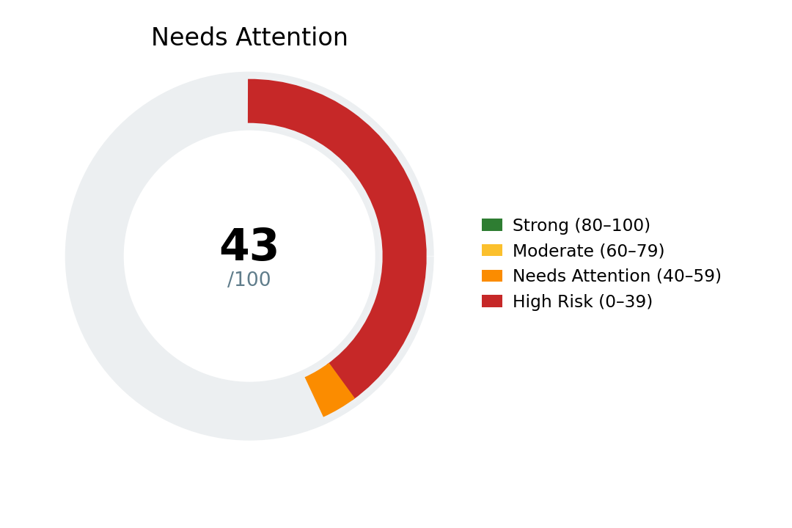 43/100
Overall: Needs Attention (43/100) — approx. Pillar 1 weighted across core domains

Domains by Pillar — Pillar 1: 2, Pillar 2: 2, Pillar 3: 0
- iam: High Risk (33/100)
- endpoint: Needs Attention (50/100)
- secops: Moderate (67/100)
- resilience: Strong (83/100)
[{'domain': 'iam', 'percent': 33, 'category': 'High Risk'}, {'domain': 'endpoint', 'percent': 50, 'category': 'Needs Attention'}, {'domain': 'secops', 'percent': 67, 'category': 'Moderate'}, {'domain': 'resilience', 'percent': 83, 'category': 'Strong'}]

Critical Findings

Critical issues — RAG summary
Indicative Costs

Main Findings

The main findings and recommendations of the report are:

N/A

Executive Commentary
The organisation operates within an unidentified sector, with approximately unknown user numbers. The current technology stack lacks MDR or SOC capabilities, and details regarding email security, firewall configurations, and identity management remain unspecified.
The business model is critically reliant on the availability and integrity of essential systems. With downtime tolerance (RTO) currently undefined, it is challenging to establish precise recovery objectives or quantify residual risk. This ambiguity underscores the need for robust measures to safeguard operational continuity.
Core services and data flows are heavily dependent on these critical systems. Any disruption would have cascading effects on customer fulfilment, regulatory compliance, and sustained revenue generation. The absence of foundational controls amplifies exposure to operational and financial risks, necessitating immediate remediation.
To stabilise the organisation’s risk profile, priority improvements should focus on implementing universal multi-factor authentication, automated patching processes, and immutable backup solutions. These measures will address baseline vulnerabilities and provide a foundation for enhanced resilience.
The strategic trajectory should aim to evolve from reactive security practices to an actively managed defence posture. Ultimately, the organisation should aspire to achieve an adaptive security framework, leveraging automation and verified recovery capabilities to ensure long-term protection and operational reliability.

Simulated attack of current infrastructure
Disclaimer: this is a fictional breach scenario leveraging threat intelligence and known threat actor activity mapped to the current technology stack and perceived security maturity of Smoke Co – this is meant as an illustration of potential risks only

N/A

Current domain alignment

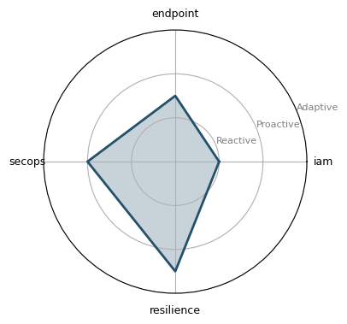

Cyber Maturity Matrix Alignment
N/A

Current Maturity

Compliance and Framework Alignment

N/A

Standard: Standard: Standard:

The Cost of Inaction
N/A

N/A

N/A

Overview of Current Environment
Organisational Profile | Details
Industry | Unknown
Headcount | 0
Endpoints / Servers | 0 / 0
Operating Systems | Unknown
Cloud Infrastructure | Unknown
Microsoft Licensing | Unknown
In-House Security Coverage | Unknown
Target Compliance
Critical Asset Profile | N/A

Current Technology | Details
MDR / SOC Provider
Endpoint Security | Unknown
Endpoint Technology | Unknown
Network Firewall | Unknown
Identity & Access | Unknown
Email Security | Unknown
Security Culture | Unknown
Internal SOC Team | Unknown
Penetration Testing | Unknown
Vulnerability Scanning | Unknown

Risk, Compliance and Posture | Details
Backups Structure | On-Premise Only
SaaS Backups | Unknown
Remote Access Strategy | Unknown
Incident Response Readiness | Unknown
MFA Status
Patching Strategy | Manual / Ad-hoc
Cyber Insurance Status | Unknown
Outage Tolerence | Unknown

Detailed Assessment

Domain:

Field | Details
Current Maturity
Technical Analysis
Business Impact & Risk
Critical Gaps
Zero-Cost Quick Wins
Recommended Solutions
Strategic Remediation Rationale
Partnership Recommendations

Domain:

Field | Details
Current Maturity
Technical Analysis
Business Impact & Risk
Critical Gaps
Zero-Cost Quick Wins
Recommended Solutions
Strategic Remediation Rationale
Partnership Recommendations

Domain:

Field | Details
Current Maturity
Technical Analysis
Business Impact & Risk
Critical Gaps
Zero-Cost Quick Wins
Recommended Solutions
Strategic Remediation Rationale
Partnership Recommendations

Security Testing and Planning

Proactive Security Testing
N/A

Incident Response Planning
N/A

Disaster Recovery Planning
N/A

Suggested Implementation Roadmap

At Planet IT we map our suggested and prospective implementation roadmaps to three distinct phases:

- Foundational Hygiene: Establishes the essential technical controls and baseline configuration practices required to eliminate common vulnerabilities and protect core corporate assets from opportunistic cyber threats.
- Active Managed Defence: Implements continuous security monitoring, real-time threat detection, and proactive incident response workflows to actively contest, isolate, and mitigate live attacks.
- Adaptive Governance: Integrates dynamic risk management, regulatory compliance, and continuous policy evolution to align security strategy with shifting business goals and the broader threat landscape.

These phases delineate the strategies required to implement a robust security, goveneance and compliance solution to effectively defend Smoke Co moving forward. The phases are made up as such:

Phase & Timeline | Primary Strategic Objective | Strategic Capability Overview
Phase 1: Foundational Hygiene  (0-3 Months) | Stabilisation, perimeter hardening, and the elimination of baseline technical debt. | Establishing identity authentication enforcement, baseline network and endpoint hardening, fundamental data recoverability assurance, and initial risk visibility aligned to introductory compliance standards.
Phase 2: Active Managed Defence  (3-9 Months) | Transitioning from passive protective tools to active, 24/7 threat hunting and validated defence. | Deploying continuous threat telemetry and incident response capabilities, offensive security validation, human risk mitigation programmes, and centralising security intelligence for broader framework alignment.
Phase 3: Adaptive Governance & Resilience  (10-18+ Months) | Driving the long tail of the roadmap to achieve sustainable enterprise resilience, advanced automation, and board-level assurance. | Implementing zero-trust architectural principles, automated incident orchestration and response workflows, behavioural anomaly detection, and proactive threat deception and hunting capabilities.
Please find below a bespoke roadmap of suggested improvements tailored for Smoke Co:

Partnership & Success Criteria

N/A

Field | Details
Phase
Timeline
Strategic Objective
Key Deliverables
Estimated Effort
Key Milestones
Business Value Delivered
Resource Requirements

Field | Details
Phase
Timeline
Strategic Objective
Key Deliverables
Estimated Effort
Key Milestones
Business Value Delivered
Resource Requirements

Field | Details
Phase
Timeline
Strategic Objective
Key Deliverables
Estimated Effort
Key Milestones
Business Value Delivered
Resource Requirements

Why Planet IT

Planet IT is a leading IT company offering complete outsourced IT solutions to organisations across the UK and Europe. Based in Milton Park, Oxford, we provide comprehensive support services to suit your needs and deliver business transformation.

Our expert team has an extensive record of delivering software and hardware solutions to major blue-chip clients. Our technicians are highly skilled in planning, implementing and troubleshooting.

At Planet IT, we always take time to assess your IT needs and existing infrastructure, make recommendations, and implement improvements quickly and efficiently. In addition, we are highly experienced in planning and installing entire new IT systems in large organisations.
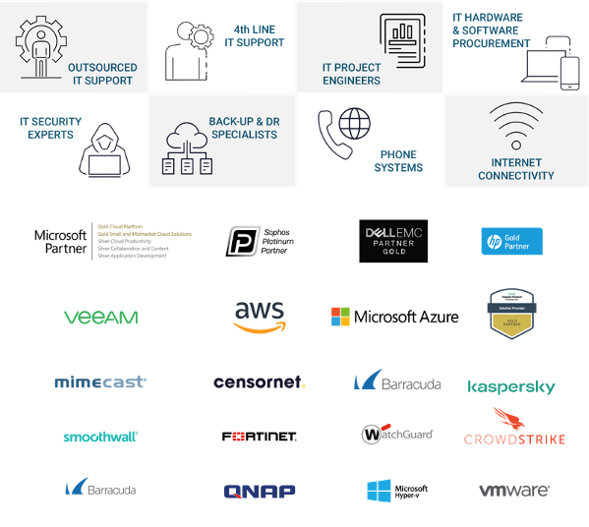

Our Pedigree
Since we started in 2003, Planet IT has supported over 2,000 clients in the UK, US and Europe. We are trusted by businesses across multiple industries, delivering various projects across Security, Backup & Disaster Recovery, Cloud migration, Fully Managed Support, Device as a Service and software licencing.

Since the beginning, we have built our business on first-class customer service and employing the best people available. We continue that ethos today, constantly building and maintaining our



client relationships. Here's a snapshot of some of the customers we work with today.

Assumptions and Client Responsibilities
This agreement is between;
- [Smoke Co ] (“The Client”)
- Planet IT (“The Provider”)

Project Assumptions Client Responsibilities
These following items are responsibilities that The Client needs to fulfil as part of the project:
- Documentation/deliverables provided as part of the project will go through a maximum of two The Client reviews unless mutually agreed.
- In order to avoid delays to the project, The Client must review the documentation/deliverables within two business days of receipt of the document, except where mutually agreed.
- The Client is responsible for the supply of all infrastructure (hardware, software licences, network and environments) requirements to successfully deliver the project.
- The Client will be responsible for all aspects of data quality, availability, backups and restores required to successfully deliver the project.
- The Client will be responsible for raising all necessary change control requests.
- The Client will provide site access and a suitable work area to the project team.
- The Client will provide internal staff as per the schedule or as reasonably required including, but not limited to:
  - Project Manager to liaise with Planet IT Technical Design Authority to assist with scheduling The Client deliverables, resources and activity as per the agreed schedule.
  - Availability of appropriate The Client representatives at necessary requirements, design and planning workshops, testing and validation activities.
  - Provide access to network information, diagrams, site floor plans or site assistance, indicating outlet location, station number, username, and station type for each site where applicable.
  - Third party vendor coordination excluded from the scope of this proposal unless directly included in scope.
  - Supplying third party resources to assist in interfacing with third party equipment.
  - The successful execution and completion of User Acceptance Testing.
- The Client will inform Planet IT of any health and safety requirements.
- Ensure that Planet IT personnel who attend The Client site are instructed on all relevant health and safety regulations and criteria.
- Ensuring all dependencies that this engagement may have on other The Client projects is planned and met.
- The Client is to provide a minimum of ten working days’ notice prior to agreed resource schedule commencement.
- The Client cannot cancel planned activities on this schedule during the three working days prior to starting those activities. If so, The Client will incur the full cost of the cancelled activities during that three-day period.

This Statement of Work is offered by Planet IT based on the assumptions outlined below:
- The project will be delivered using the resources outlined within the document. Any delays to the project caused by The Client will result in additional days required to complete the project, these additional days will be at cost to The Client.
- Should the scale of the project transpire to be greater than initially expected, The Client are responsible for any additional time required to complete the project.
- The project will be delivered without interruption or suspension by The Client.
- Tasks assigned to The Client resources as part of detailed resource planning will be completed on time.
- Information and documentation requested by Planet IT for this project will be accurate, complete and provided in soft copy within two days.
- Reasonable requests from Planet IT to The Client for functional or technical clarification will be responded to within one business day. Failure to respond during the allocated time frame could have an impact on timelines and associated cost.
- The Client accepts that Planet IT’s professional services team members will perform their duties through a combination of on-site and off-site activity.
- The Client accepts non-exclusive access to the Planet IT’s professional services team members during the project.
- Planet IT documentation deliverables will be provided in editable formats such as Microsoft Word or Excel as applicable.
- Where applicable installation and/or configuration of The Client owned application software will be the responsibility of The Client.
- Any representatives of The Client (or their associates) that are involved at the various steps in the project are available as planned, adequately skilled and competent to execute the tasks required of them.
- Any The Client nominated decision-making representative is duly empowered.
- Planet IT will receive a minimum of five working days’ notice of any rescheduling of work resulting from delays caused by The Client, or their contractors.
- The Client will provide single point of contact for all aspects relating to project delivery.
- Network connectivity IP addresses and naming conventions will be provided by The Client where applicable.
- Business hours are standard UK business hours, 7.5 hour working day.
- The project will operate as a gated system. The project will be placed on hold and resources suspended until gate controls are met.
- The Client will be responsible for undertaking any appropriate user acceptance testing and sign off as accepted based on the outlined test schedule.
- If The Client opts out of user acceptance testing, Planet IT will not assume accountability for any project failures. It is the responsibility of The Client to address any necessary remediation work.

Authors
Name | Role
Tester | Technical Architect
[AM NAME] | Account Manager
Justin Towle | Head of Professional Services
Mike Bellido | Technical Architecture Director
Nick Johns | Chief Technical Officer
Adrian Sweeney | Chief Commercial Officer

Planet IT Contact Details
Method | Details | Method | Details
Telephone | 01235 433900 | Fax | +44 (0) 1235 433901
Email | architecture@planet-it.net | Address | Planet IT Ltd  85f Park Drive  Milton Park  Abingdon  Oxfordshire  OX14 4RY

Revision Details
Revision | Date | Author | Comments
1.1 | 28/03/2025 | J.Dell / A.Sweeney / J.Towle / R. McClafferty | Updated for 2025
2.0 |  | Tester
2.1 |  | [APPROVER NAME] | Internal Approval

Distribution List
Name | Company
 | Smoke Co

Disclaimer

Whilst every precaution has been taken in the preparation of this document, no responsibility is assumed for errors or omissions, nor is any liability assumed for loss or damage resulting from the use of the information it contains, to the extent such error or omission is a result of any information, data or documents provided to Planet IT by the Customer and relied on by Planet IT in the preparation of this document.







01235 433 900
enquiries@planet-it.net
85F Park Drive
Milton Park
Abingdon
OX14 4RY

www.planet-it.net

Terms and Conditions

Confidentiality

All information within this document is given in the strictest confidence and is considered as Confidential Information and genuine commercially sensitive information. With regards to this all parties shall treat information detailed in the strictest confidence and shall not, without the prior consent of the other party, disclose any information with regards to this proposal to any other organisations, whosoever they may be. In the event the customer is compelled by law or by any applicable regulatory agency (including a request to disclose information in accordance with the Freedom of Information Act 2000) to disclose any Confidential Information the customer shall immediately consult with Planet IT Limited prior to any such pending disclosure so that the parties may discuss whether the Confidential Information is exempt from disclosure or so that a protective order or other appropriate remedy may be obtained. If such an order or other remedy is not available, the customer shall disclose only that minimum portion of Confidential Information that it is legally compelled to disclose, consistent with the advice of its counsel.

Disclaimer

Planet IT Limited makes no representations or warranties with respect to the contents or use of this document, and specifically disclaims any express or implied warranties of merchantability or fitness for any purpose.

Intellectual Property

Nothing in this document is intended to grant any rights under any patent, copyright or other intellectual property right of Planet IT Limited.

Severity | Issue | Business exposure | Priority action
RED 40% | Domain: iam in High Risk | Low maturity in this domain materially increases exposure until controls are improved. | Execute the domain’s top remediation actions with owners and evidence.
Workstream | Indicative Scope | Estimate
Combined package | Coordinated delivery with governance check‑ins and consolidated executive reporting. | £[x] – £[y]
Recommended next step: approve a scoped discovery and remediation planning exercise for the identified workstreams. This should confirm costs, delivery sequencing, ownership and decision points for funded change.

