EXECUTIVE SECURITY PRIORITIES SNAPSHOT
  - Board-level summary template aligned to the full Cybersecurity Maturity Assessment report.
Client | Northbridge Trading Ltd | Status | Executive Summary Extract | Prepared by | Bradley Collis

Executive Summary
Northbridge Trading Ltd has a credible security baseline, supported by Fortinet-managed perimeter controls, Webroot EDR, Kanji/Iru patching, Veeam and QNAP recovery foundations, annual penetration testing, Cyber Essentials Plus activity and broad Google SSO adoption. The assessment identifies three executive priorities that now require focused action: out-of-hours monitoring and response, incident and recovery readiness, and FTP and privileged-access controls. These gaps do not indicate a need for wholesale replacement, but they do create avoidable uncertainty around containment speed, recovery sequencing and customer-data protection during a material incident.
Executive decision required: approve a scoped discovery and remediation planning exercise covering MDR readiness, incident-response rehearsal, FTP remediation, vulnerability visibility and Google Workspace recovery assurance. This will confirm costs, sequencing, ownership and decision points for funded change.

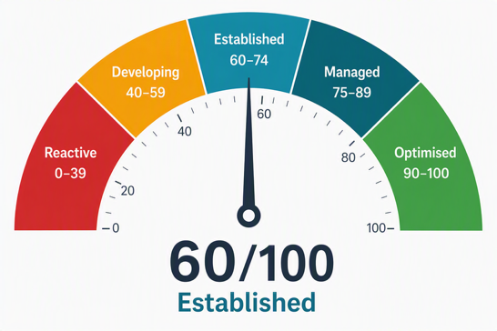
Overall indicative weighted score: 60/100 – Established, with targeted gaps requiring validation
This score is a consultant-led, point-in-time maturity judgement based on the assessment discussion and supporting notes. It is not a certification score or an independently tested technical rating. The weighting gives greater emphasis to controls that affect operational continuity, incident response, identity compromise and client-data exposure; individual domain scores should therefore be used to prioritise assurance work rather than as precise measures of control effectiveness.

Top Three Risks: RAG Prioritisation
RAG | Weight | Risk | Current Position / Impact | Recommended Solution
RED | 40% | Out-of-hours monitoring and response | Working-hours review is in place through Freshdesk, Webroot and Google Workspace, but there is no dedicated 24/7 SOC or MDR coverage. Overnight or weekend incidents may therefore take longer to identify, investigate and contain. | Validate endpoint, firewall, Google Workspace, Freshdesk, email and cloud telemetry; define escalation and containment authority; and compare internal, retained-response and MDR options.
AMBER | 35% | Incident and recovery readiness | Incident-response documentation is in progress, but it has not yet been validated with directors and business decision-makers. Recovery order, supplier escalation, insurer engagement and customer communication decisions need to be rehearsed before a live incident. | Run an executive tabletop exercise, agree decision owners and recovery priorities, create practical playbooks and use downtime-cost modelling to support the MDR business case.
AMBER | 25% | FTP and privileged-access controls | Google SSO and MFA cover many supported services, but the internal FTP server remains a material MFA exception and local administrator-password renewal is not yet formalised. Compromised credentials could expose customer files and production data. | Secure or replace the FTP route, formalise administrator-password renewal, document SaaS MFA exceptions and include privileged-access review within the security improvement register.

RED | Immediate executive attention required; risk could materially affect containment, recovery or customer confidence. | AMBER | Prioritised improvement required; risk is manageable but needs ownership, evidence or validation. | GREEN | Control is broadly established; monitoring or periodic assurance should continue.

Weighting methodology: weighting reflects business criticality, likelihood, incident-containment value, customer-data exposure, recovery uncertainty and current assurance. The total weighting is 100% and is used to sequence executive attention where change is required.

Board Decision Summary
Decision required | Approve a scoped discovery and remediation planning exercise for MDR readiness, incident-response rehearsal, FTP remediation, vulnerability visibility and Google Workspace recovery assurance.
Why now | Current controls provide a credible baseline, but out-of-hours response, FTP authentication, incident rehearsal and recovery assurance remain the areas most likely to affect containment speed and customer confidence.
Approval enables | Confirmed scope, costs, owners, sequencing, supplier dependencies and evidence required for budget approval and phased delivery.

Expected Business Benefits
Faster containment through clearer monitoring coverage, escalation routes and response authority. | Stronger recovery decisions through tested incident roles, supplier escalation and agreed system recovery priorities.
Reduced customer-data exposure by closing FTP and privileged-access gaps and strengthening file-sharing governance. | Defensible investment case with evidence-led cost, scope and sequencing for MDR, vulnerability scanning and recovery assurance.

Indicative Costs
Workstream | Indicative Scope | Cost Range
MDR readiness and out-of-hours response | Telemetry review across Webroot, Fortinet, Google Workspace, Freshdesk, email and cloud services; escalation model; containment authority; MDR options comparison. | High / TBC
Incident and recovery readiness | Executive tabletop exercise, response-plan review, recovery-priority workshop and representative Google Workspace recovery test. | Medium initially; High if backup licensing is added
Vulnerability visibility and FTP remediation | Dedicated vulnerability scanning across endpoints, servers, ESXi hosts and external services; FTP access decision; remediation tracking and evidence register. | Medium to High / TBC
Combined discovery and remediation plan | Coordinated delivery covering MDR readiness, tabletop exercise, FTP decision, vulnerability scanning scope, Google Workspace recovery requirements and ISO-aligned improvement tracking. | TBC following discovery
Recommended next step: approve a scoped discovery and remediation planning exercise for the identified workstreams. This should confirm costs, sequencing, ownership, telemetry readiness, supplier dependencies and decision points for funded change.
Assumptions: Cost bands are indicative planning categories rather than quotations. Final costs depend on asset scope, user count, telemetry availability, supplier pricing, licensing, response model and delivery sequencing. This snapshot summarises the full Northbridge Trading Ltd Cybersecurity Maturity Assessment and does not replace the supporting evidence base.
Confidential | Executive Summary Extract | Planet IT

