Internship Report
B.Eng. in Software Engineering, Academic Year 20XX
International College, King Mongkut’s Institute of Technology Ladkrabang
By
65011693 Soe Moe Htet
Internship period : 22 April – 22 June 2024

Company outline

Company name and address
Name - FrontwareInternational.co.ltd.
Address - 1213/390, Town in Town, ซอย ลาดพร้าว 94 Plubpla, Wang Thonglang, Bangkok 10310, Thailand

Main activities
Main products – The company focus on building Web3 products that hevily rely on cryptocurrency (Flux) that proposes multiple type of services to customer.
Goals – The company provides solutions to customers around the world, works on the projects based on the requirements, and supports cutting edge technology to the customers.

Organization structure
Based on my experience, the company has a CEO (ex-software developer), a secretary and two software dev teams i.e, frontend dev team and backend dev team. The company CEO along with his secretary handles the customer relationshps and company management, CEO also write the codes on backend team himself. There are two teams, frontend dev team and backend dev team. They used Flutter to develop UI based softwares and as for backend, they used Golang, C, Rust. Front end team focus on building UI and backend team manges handling server-side logic development and there is a server administrator team that handles the deployment and live server condition checking. There are approximately 10 employees in the office where I worked.
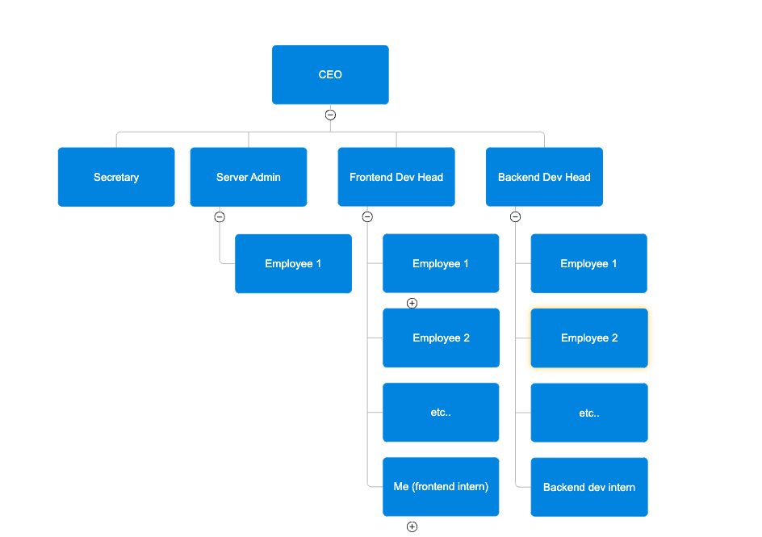

Department and supervision
My department is Frontend dev team. My supervisor is called – Mr. Florian Sabate
. He never provided me his contact information as in email or linked-in, but I have his phone number +66835684452.
Project Team Leader – Mr. Florian Sabate
Software Development Team
Fluxcore Application Development

Internship

Original description and objectives
Give a clear and concise description of your internship and its objectives which is given to you at the beginning of your internship.
My mentor gives me specific tasks and objectives that I need to finish within the appropriate time-frame. Mostly, it’s on peer to peer communication through telegram and he gave me tasks as in word document and sometimes instructions and steps that I need to do on the codebase of the company. Mostly, I have to work along with him on developing UI based features like dialogs, datatime picker, and some random tasks that the customers asked.

Software Development

Background

There are two main projects, FluxCore and FluxEdge (market place). I worked on FluxEdge UI website which allows user to interact with.
- FluxCore is an application aiming to share a computer resources to perform decentralized tasks. The person that download FluxCore will be able to first of all administrate his machine, and his remotely added machines, to put them on the FluxEdge network for customer to rent the machine and use them similarly to a VPS on cloud computing, to run AI model, applications, host server, database, and so on. There is also a mining part, where FluxCore make mining very intuitive and accessible to everyone with a nice looking interface. The application run on both Linux and Windows. In the backend part, the clients who decide to put their machine to be leasable, will have his machine placed into a kubernetes cluster. FluxCore is therefore for the administrator of the machine.
- FluxEdge the marketplace where people will find in realtime machine that are rentable.
The client Flux is a business based on cryptocurrency (FLUX) that proposes multiple type of services to their customer. After working a lot on the mining part, The company was focusing on the goal to make a decentralized system to use resources from around the world to do stuff as AI training.
They launched the ALPHA december:

https://fluxofficial.medium.com/unlocking-fluxcore-participating-in-the-public-alpha-release-3765adedee8e

The projects are still on BETA because the projects being very big, They are adding new features progressively. Started from running benchmarks on the local machine, and then ended up implementing service rental, mining and all of this both locally and remotely. The application use multiple technologies, for the call to the server, mostly to get DB data we use gRPC, MQTT is used for live hardware monitoring, and WebSocket for streaming (mostly for the shell used in FluxEdge to access the container of the application the client is renting on its rented machine).
This website is where they are showing some stats about the different machines that installed FluxCore. When I was working on FluxEdge or pouwmarketplace (project renamed by the client), I was on the dev environment. Because they have multiple servers. One for development that is mostly having Flux team members, testers and developers. I experienced some gRPC errors sometimes, this is due to server restart because they are all working in this environment (backend and frontend).

The production environment is available to the public but its still an alpha and only whitelisted user can join it.
People who wants to share their machine, need to install FluxCore, register an account. Have supported hardware, and need to subscribe to a service (AI, Rendering, Mining...). They will then have to choose a cluster. They are using Rancher to manage kubernetes clusters. So once the machine has joined a cluster, it will then be possible to run application on it inside containers.

Software requirement specification
SSH Terminal UI
User Requirements
Functional Requirements
- The system shall provide UI for user to put host, port, username and passwords to connect to his pc through ssh connection.
- The system shall allow user to use terminal commands upon successful login to his pc through ssh conection.
- The system shall provide the ability to close the terminal.
- The system shall provide the ability to open the terminal.
Non-Functional Requirements
- The system must respond to the user within 3 seconds when the user clicks any button in the application.
- The system must be able to run in these operating systems. There are MAC, Windows, and Linux operating systems.

System Requirements
Functional Requirements
- The system shall provide connection errors upon unsuccessful login to his pc.
- The system shall provide invalid credential errors if his host, port, username, and password are incorrect.
- The system shall provide history of terminal commands for the user to see.
- The system shall provide results of terminal commands after the user typed the commands.
- The system shall uses remote host information to initiate the connection through the program. If the credentials are verified, the program establishes an encrypted connectionNon-Functional Requirements
Non-Functional Requirements
- The system must be developed by using the Dart programming language
    - Dart is an OOP programming language
    - Dart has advanced features that support async programming.
- The system must use Github as the online version control system.

Company animated logo
User Requirements
Functional Requirements
- The system shall allow user (programmer) to control two hexagons movement (clockwise or counterclockwise) inside the logo.
- The system shall allow user (programmer) to control positions of both hexagons inside the logo.
- The system shall allow user (programmer) to control width, height, ratio of two hexagons inside the logo.
- The system shall allow user (programmer) to control positions of both hexagons inside the logo.
Non-Functional Requirements
- The system must start the logo animation within 1000 milliseconds.
- The system must be able to put as a UI component anywhere in the dart source code files compatible with any OS.

System Requirements
Functional Requirements
- The system shall use animation tween to ease the transition animation between animations.
- The system shall have a controller object that controls the animation of the logo and use this controller object to facilitate the animation transition.
- The system shall use geometry formulas using sines,cosines,tangent, and cotangent to make the movement consistent throughout the animation.
- The system shall use flutter pixel-perfect custom painter class to implement animation.
Non-Functional Requirements
- The system must have a delay of 4000 milliseconds between the animation to make the transition from one animation to other smoother
- The system must have lower speed in animation for the users to see animation.

Dialog page for machine information
User Requirements
Functional Requirements
- The system shall allow user to click on each machine text to open a dialog page on the current page.
- The system shall allow user to close the dialog when clicked on the close button.
Non-Functional Requirements

- The system must be able to reopen a dialog page after closing the dialog page.
- The system must have the same appearance for every machine.
- The system must respond to the user within 1000 miiliseconds.

System Requirements
Functional Requirements

- The system shall use Row and Column widget to implement the layout of the dialog page.
- The system shall use Text, Font, Icon, Image widgets to display information of the machine.
- The system shall use each machine information to fill the data in the text widgets in sync .
Non-Functional Requirements

- The system must allow the dialog page to pop up within 1000 milliseconds after clicked on the machine text in the page.
- The system must be developed using widgets from Flutter.

Refactored date feature
User Requirements
Functional Requirements

- The system shall provide date range box to show the datepicker dialog under the box.
- The system shall provide month panel to show the selected month
  - Today
  - Tomorrow
  - This week, Next week,
  - This month, Next month
  - This year, Next year
  - All Time
- The system shall provide the ability to choose the date range in day, month and year.
- The system shall provide the ability to switch between months and see available days (in black) and unavailable days (in gray).
- The system shall update the date in the datetime box after closing the dialog.

Non-Functional Requirements

- The system must be able to reopen a datepicker dialog after closing the dialog.
- The system must have the same appearance for every time the box is clicked.
- The system must respond to the user within 1000 miiliseconds.

System Requirements
Functional Requirements

- The system shall use Row and Column widget to implement the layout of the datepicker dialog.
- The system shall restrict the selection of the days that have passed and they must be colored in gray.
- The system shall restrict the confirm button to be available until the user has chosen the start date and end date .
- The system shall have the default date range even if the use has not chosen any date time for the first time.

Non-Functional Requirements

- The system must allow the dialog to pop up within 1000 milliseconds after clicked on the datetime box.
- The system must be developed using widgets from Flutter.

Yaml editor to write yaml file
User Requirements
Functional Requirements

- The system shall provide an edit box to allow user to type Yaml format commands.
- The system shall provide line numbers to detect how many lines the user has typed
- The system shall provide Error detection UI to display what errors there are for the commands.
- The system shall provide scrollbar to scroll up or down if there are more lines and the space becomes larger than the edit area.
- The system shall have autocomplete feature for the users to type available yaml commands

Non-Functional Requirements

- The system must be able to reopen a editor after closing the the editor.
- The system must have the same appearance for every time the editor is opened.
- The system must respond to the user within 1000 miiliseconds.

System Requirements
Functional Requirements

- The system shall allow programmers to implement the editor into different components of the projects.
- The system shall be made standalone as a different package to be used as a library for the programmers to
- The system shall restrict invalid Yaml commands based on the spacing and sequence of the characters.
- The system shall detect invalid YAML commands and display the errors in the Error detection UI.

Non-Functional Requirements

- The system must be developed using reeditor package from pub.dev.
- The system must be developed using widgets from Flutter.

Development team
As far as I know, there are ten people in my office that are involved in development of the software. My mentor, Florian leads the Frontend UI development. With his supervision, I am tasked to work on the existing UI to modify, update and remove some features. There are other people called Alex, and Eric who worked on backend development using Golang. One other guy, server administrator handles everything related to server, for example, if the server the company is using gets down, he is the one to ask for what is happening. The rest of the team, I didn’t have to communicate with them since they are not on my team and they are busy with their work.

Project plan
Since my work is task-based, I cannot give exact Gantt chart of the project. I have no full knowledge of the whole project my team was developing.

Software design
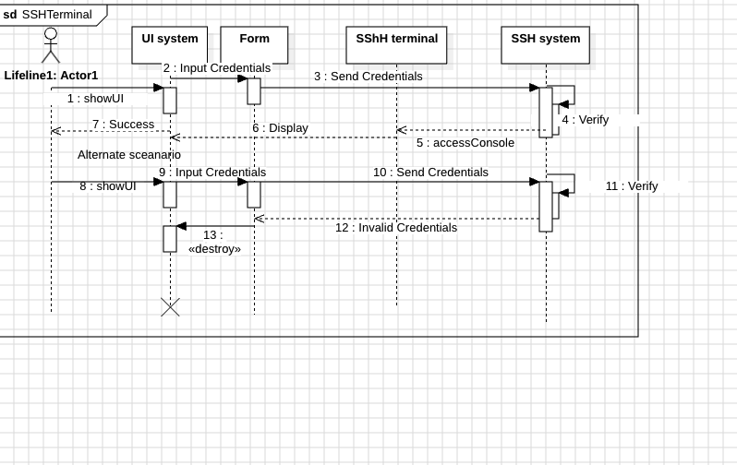
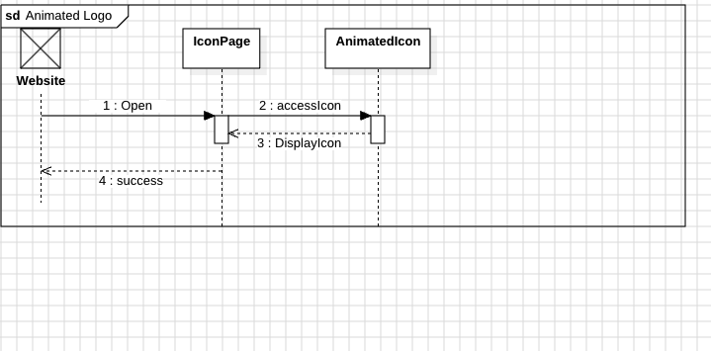
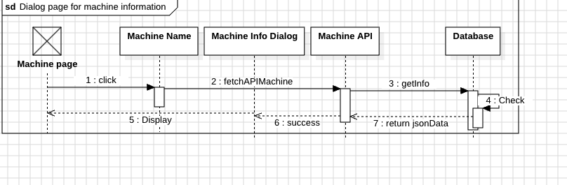
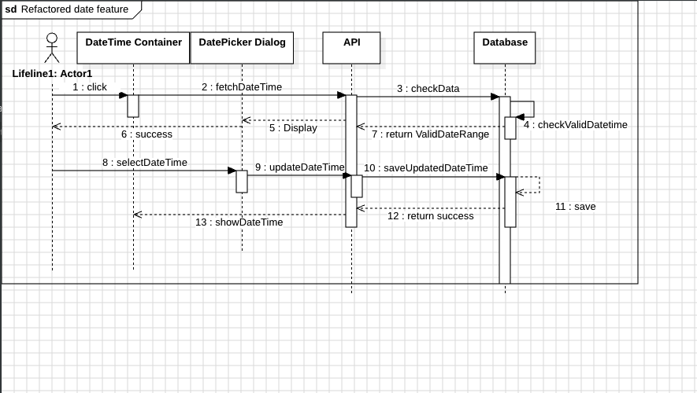
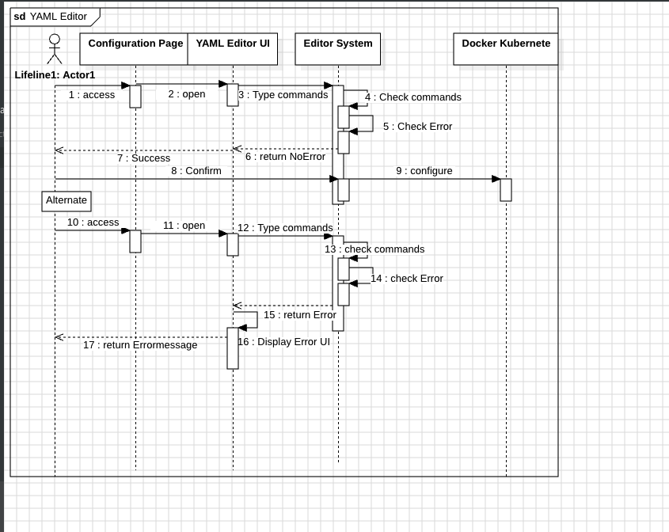

Implementation

Development tools
Tools:
- Dart
- Golang
- Python 3.6
- Flutter Framework
- GitLab
Libraries, Frameworks, and IDE
- Flutter
- UI packages from pub.dev
- TensorFlow
- Visual Studio Code
- CUDA
- cuDNN
- Pytorch
- Numpy
- Scipy
- Pandas

Techniques
State Management:

Provider Pattern: Used to manage the state across different widgets, ensuring a clean separation of concerns and efficient state updates.
Bloc: For more advanced state management, allowing predictable state transitions and easier debugging.
Asynchronous Programming:

Future and Stream: Handle asynchronous operations such as establishing SSH connections, executing commands, and streaming real-time data from the terminal.
async/await: Simplifies writing and reading asynchronous code, making it more maintainable.
UI Design Patterns:
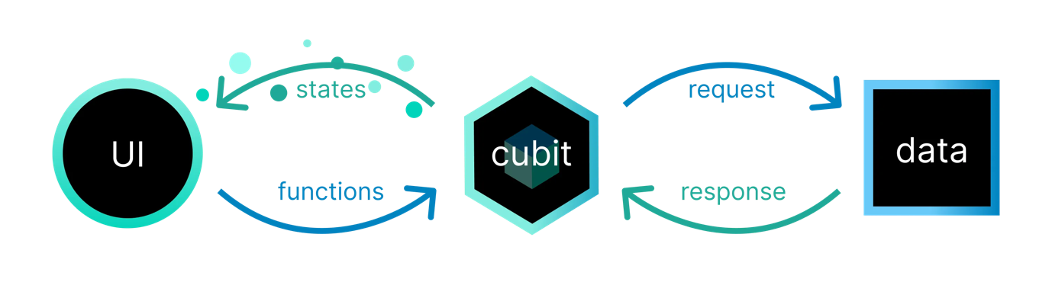
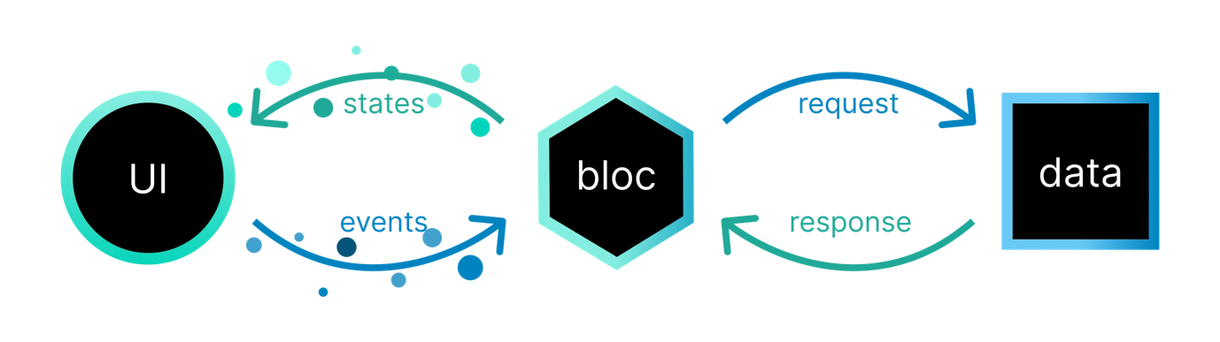
Error Handling:

Try-Catch Blocks: Used extensively to catch and handle exceptions, particularly for network operations and user input validation.
Error Boundaries: Ensure the application remains responsive and functional by catching and displaying user-friendly error messages.
Dependency Injection:

GetIt or Provider: Facilitates injecting dependencies and managing their lifecycle, promoting modularity and ease of testing.
Connection Management:

Connection Pooling: Reuses existing SSH connections to minimize the overhead of establishing new connections.
Command Execution:

Command Queueing: Ensures commands are executed in the order they are received and manages concurrent command execution.
Command History: Stores and retrieves command history, enabling users to re-execute previous commands easily.

Testing
Test Data Design
Valid Data:

Description: Data that represents valid input scenarios.
Example:
Host: 192.168.1.1
Port: 22
Username: user
Password: password
Invalid Data:

Description: Data that represents invalid input scenarios to test error handling.
Example:
Host: invalid_host
Port: 9999
Username: ``
Password: wrong_password
Boundary Data:

Description: Data that tests the boundaries of input constraints.
Example:
Host: 256.256.256.256 (invalid IP address)
Port: 0 (invalid port)
Username: a (minimum length)
Password: a (minimum length)

Screenshots
- SSH Terminal UI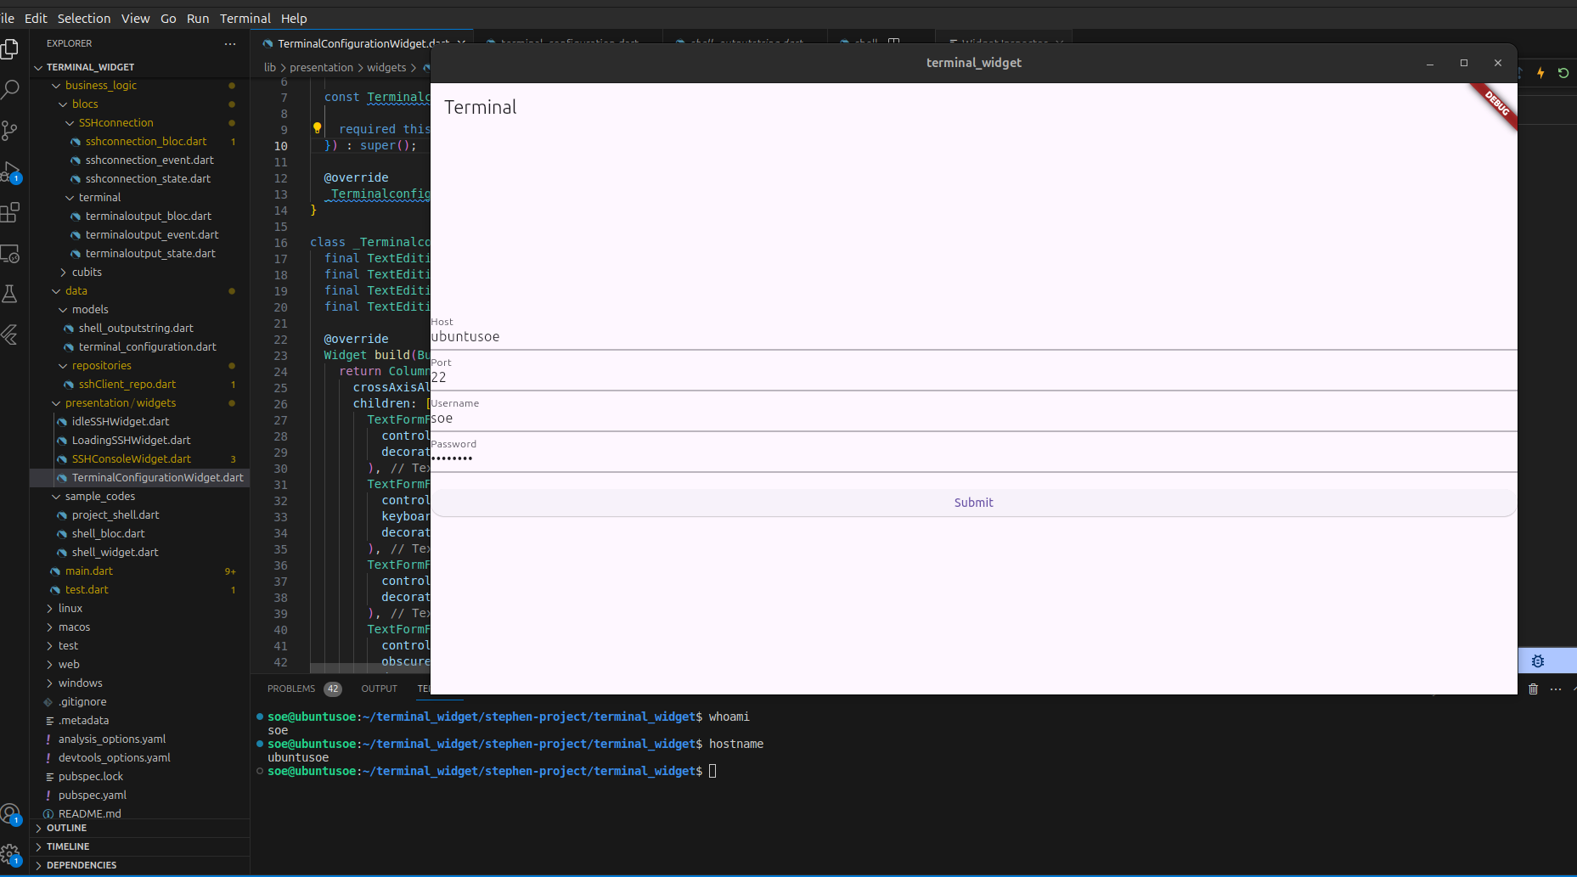 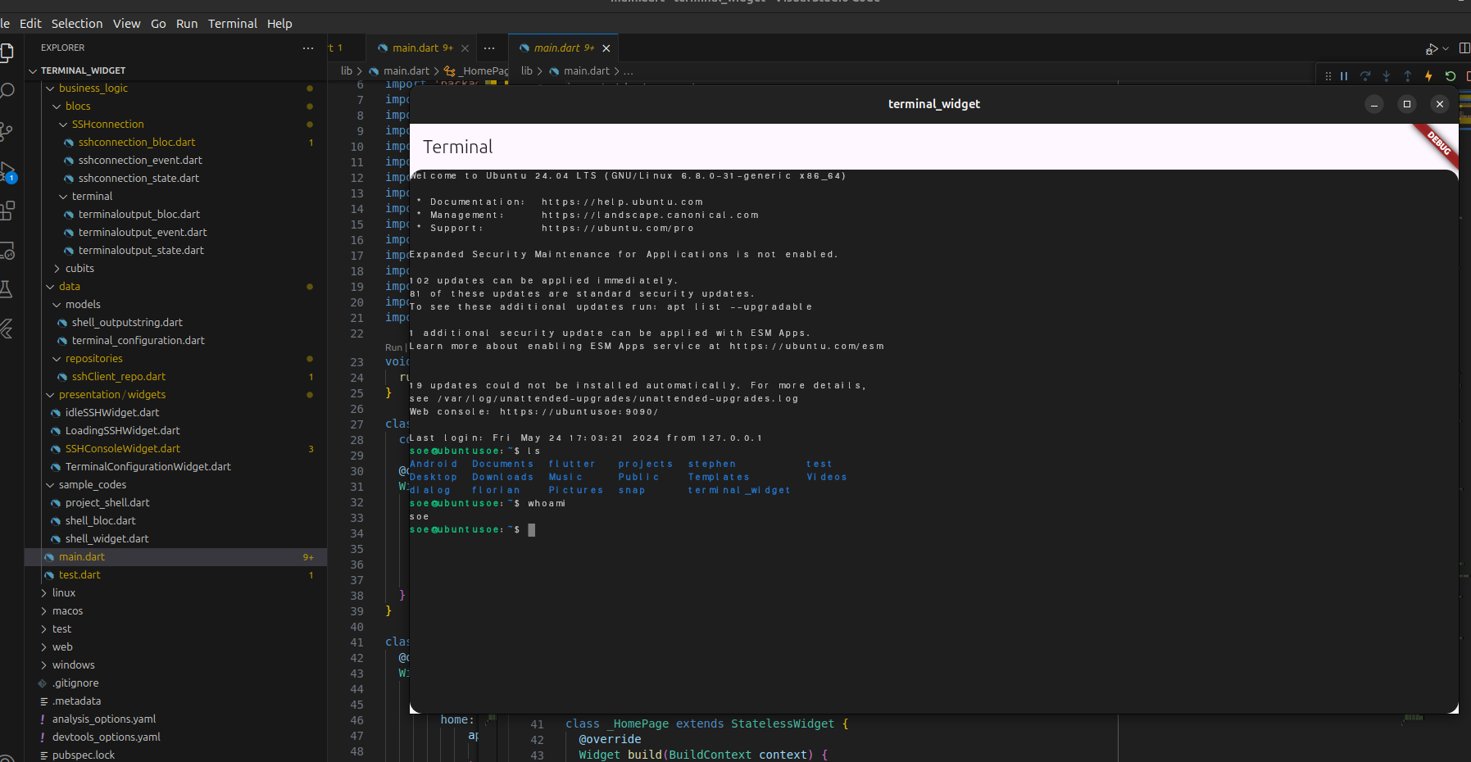
- Company animated logo
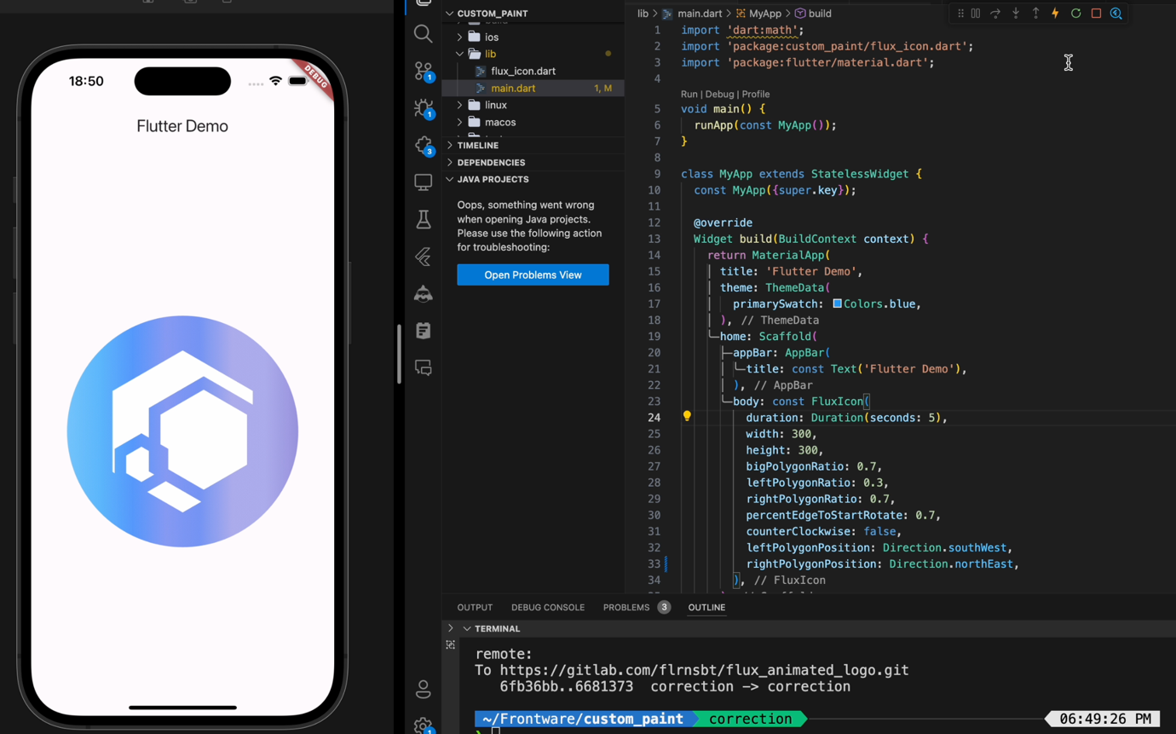
- Dialog page for machine information
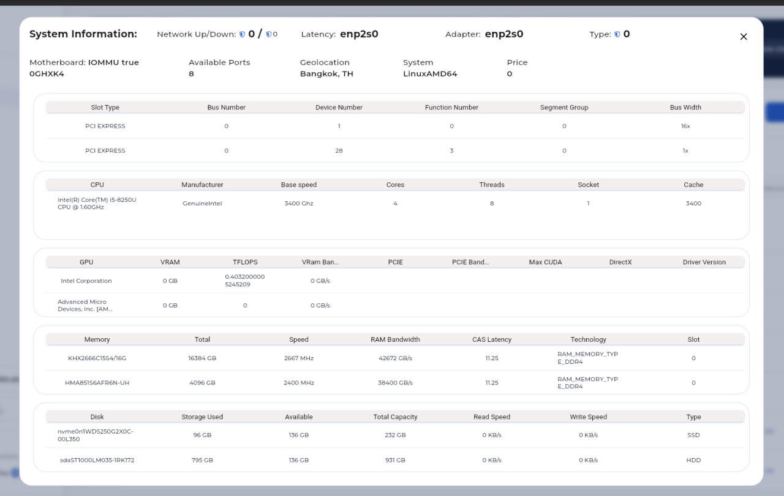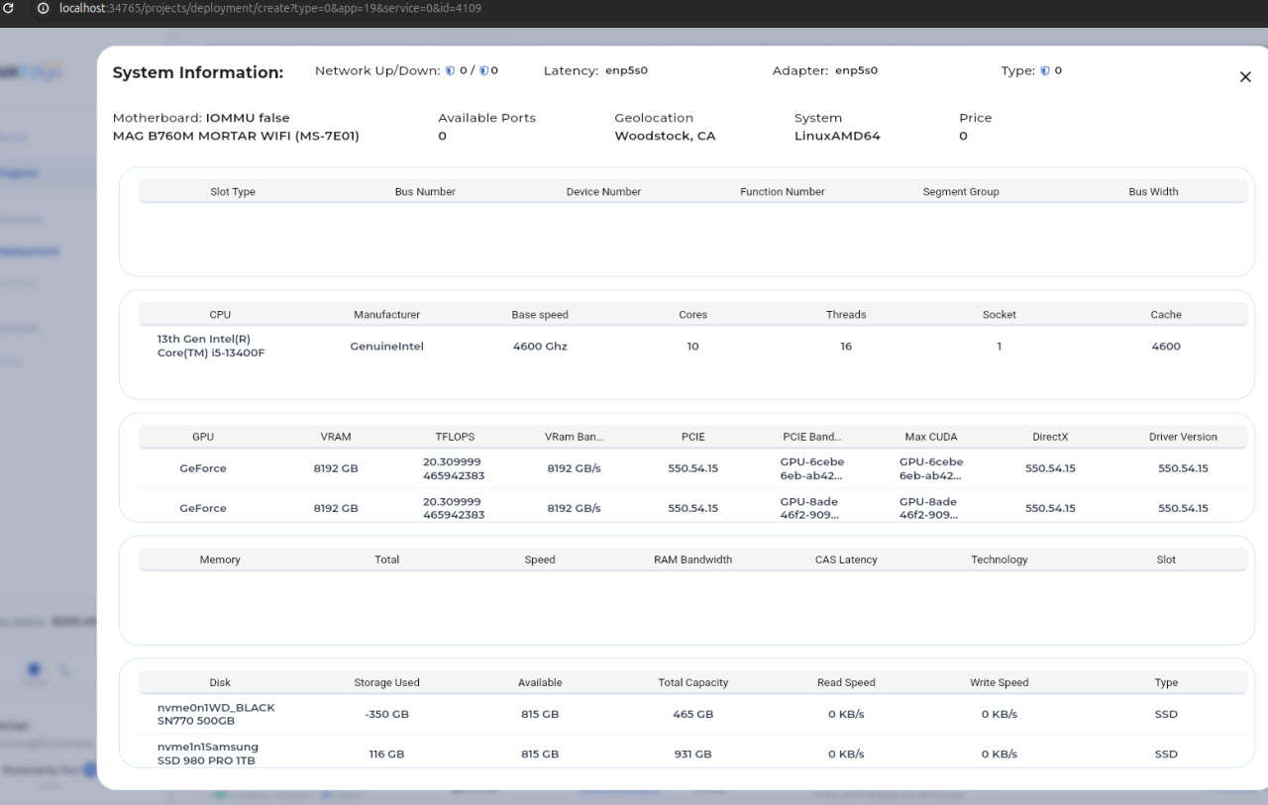
- Refactored date feature
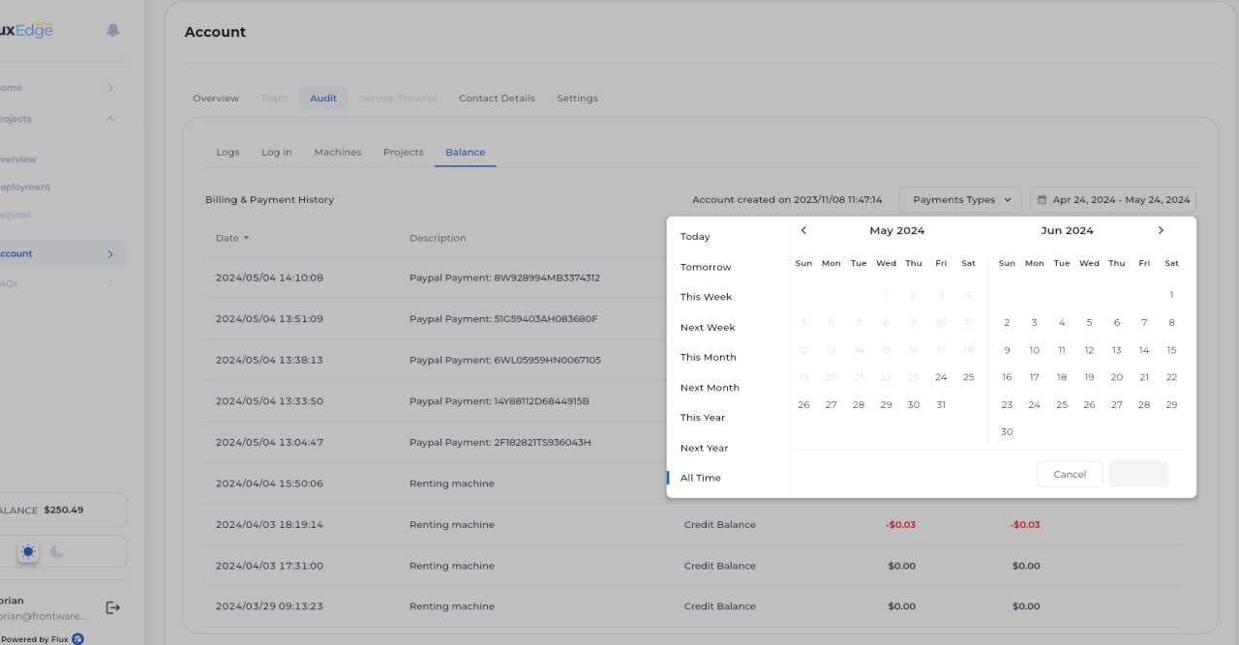
- Yaml editor to write yaml file
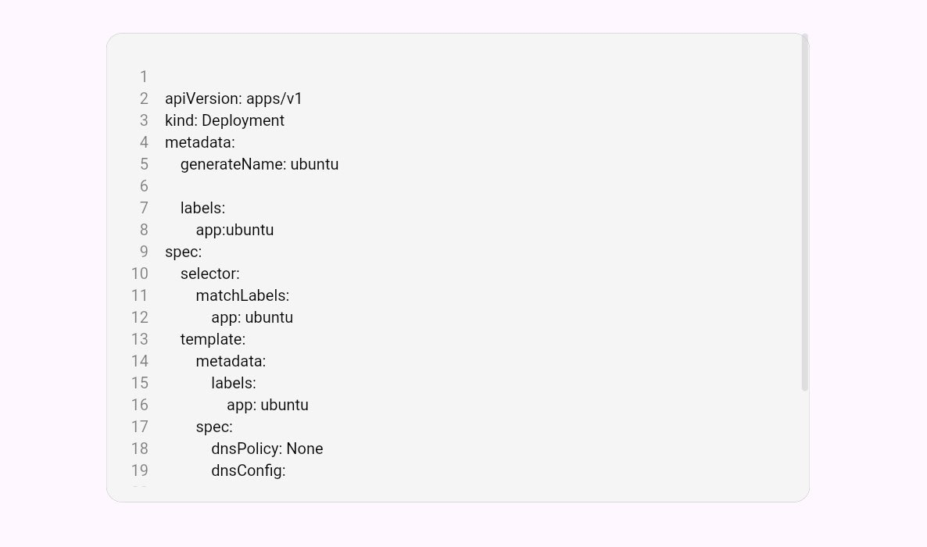
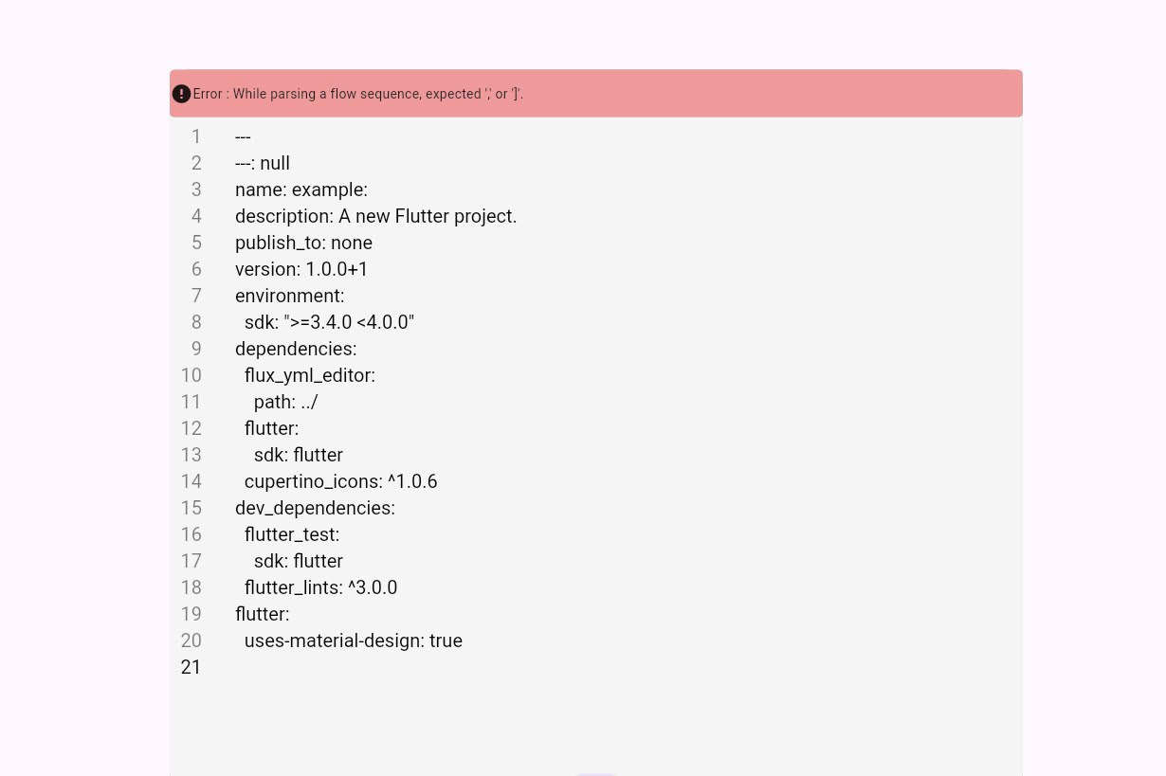
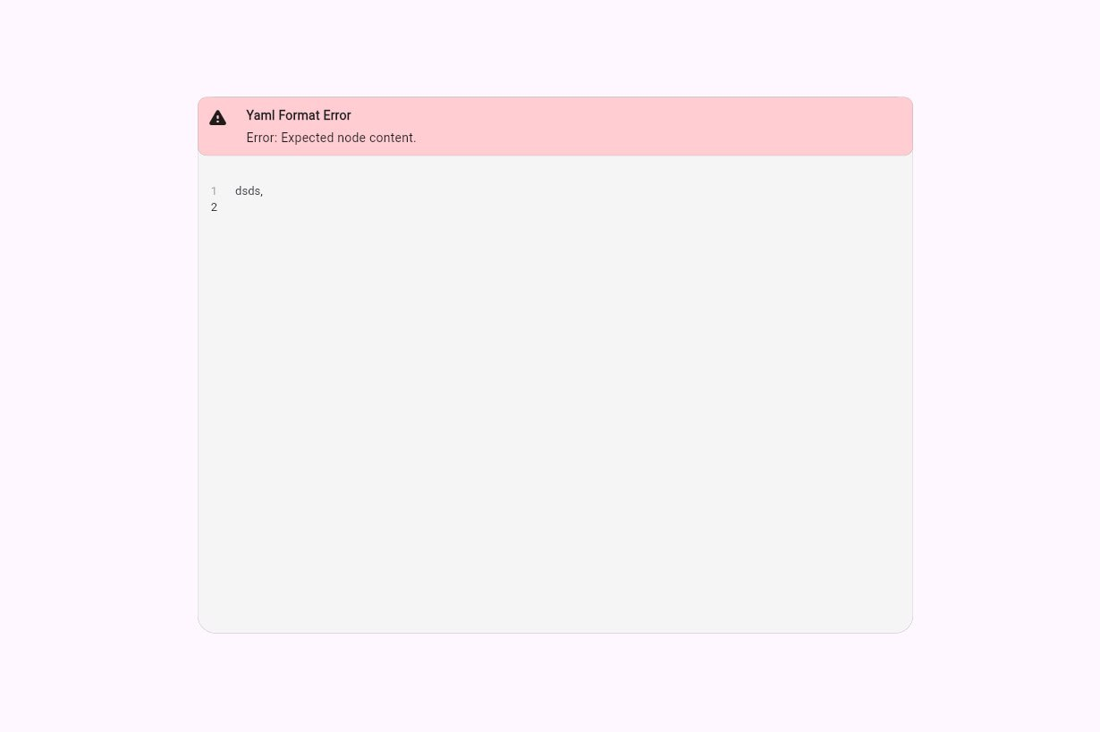
- Excel data format column
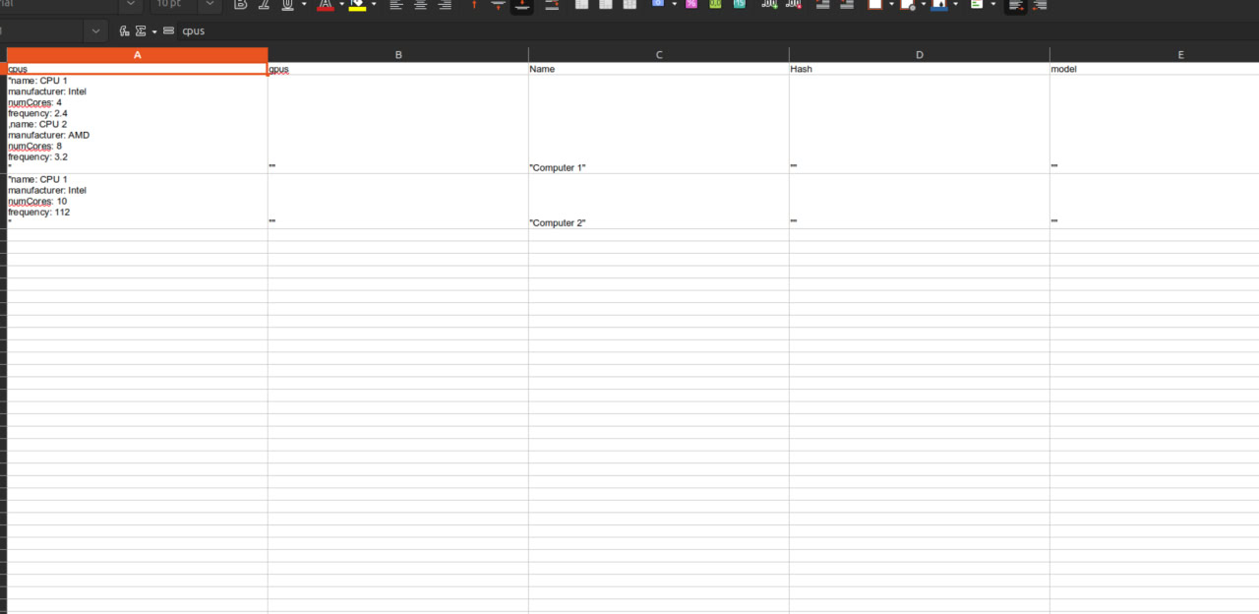
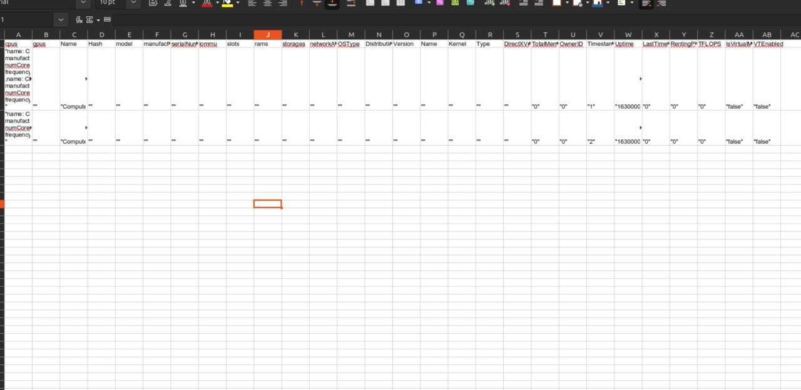

Achievement

Summary of work done
As you can see, my tasks are mostly UI features, and the requirements for each task are different from each other. I approximately wrote about 1500 lines of codes.

Evaluation
I spent most of my time studying and researching open source tutorials and reading documentations to tackle my objectives. Tasks can seem vaguely defined in my tasks. For example, “Implement a datetime picker” looks simple, but there is a big code base for the software the company is developing. I had to look for where I can put my date time picker and tried to understand how the big code base worked, which part is what, how they are developed. It was not easy to configure and figure out where to modify and change the code base. However, I took my time and had to be patient when doing my objectives. Sometimes, it feels stressful because all the employees are working full-time and there is lack of proper communication between employees and me as an intern, so I wasted some time myself just for figuring out what I should do clearly instead of asking them directly which I did later after two weeks. I needed to be direct, on-point when I communicated, reported my progress what I had done without wasting their time either.

Conclusion

Skills and knowledge learned
Especially, OOP concepts that I studied from the university helped me a lot in the tasks, which makes it so much easier to understand the source codes because the UI is developed in dart programming language which is similar to java and C#, focusing heavily on object-oriented development. I improved my communication skills, and learned UI development in flutter, and also stress-time management. The most important lessons would be “Time is money” in workplace and self-efficiency. For example, I should not rely on my mentor that much and I need to be responsible for what I have done, what I have failed, and be honest about it and direct about it without misleading comprehension.
I read Flutter documentation from Google developer team, OOP dart features from dart official website which was documented by Google developer team as well.

Problems and possible improvement
There is a big skill-gap between me and my mentor. He didn’t have a clear understanding of my skills level and couldn’t access my knowledge well. He didn’t have enough time to do it too because he was working full-time on the otherhand but he didn’t ignore me that’s is a really good thing, When he gave me some tasks for the projects he was leading, I feel overwhelmed since I have no prior knowledge about the business domain, the core philosophy behind the team, for example,in this one task he asked me to change a part of UI. Even though it’s easy, I had no idea where that part of UI needs to be changed 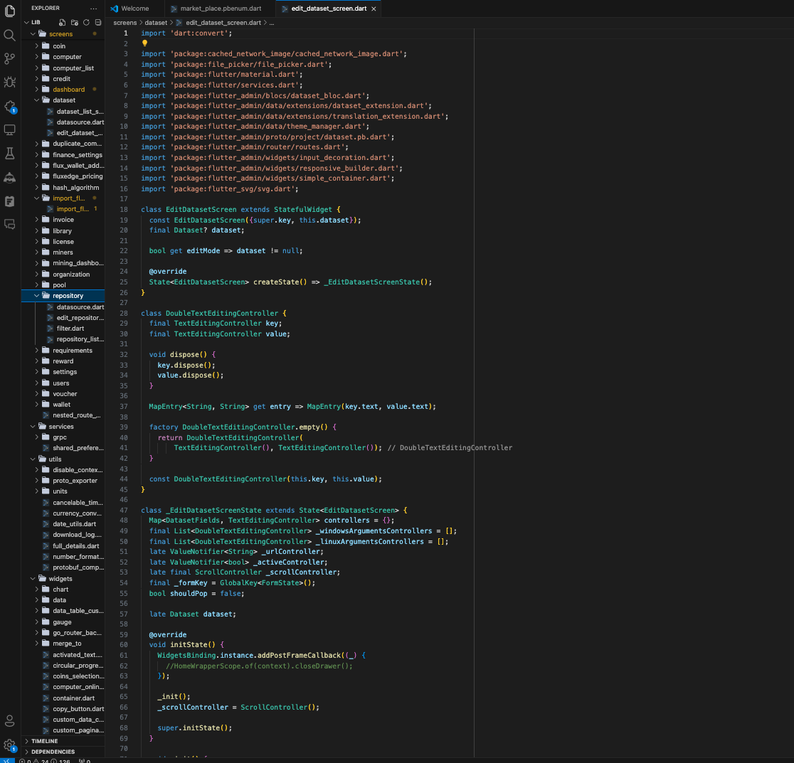
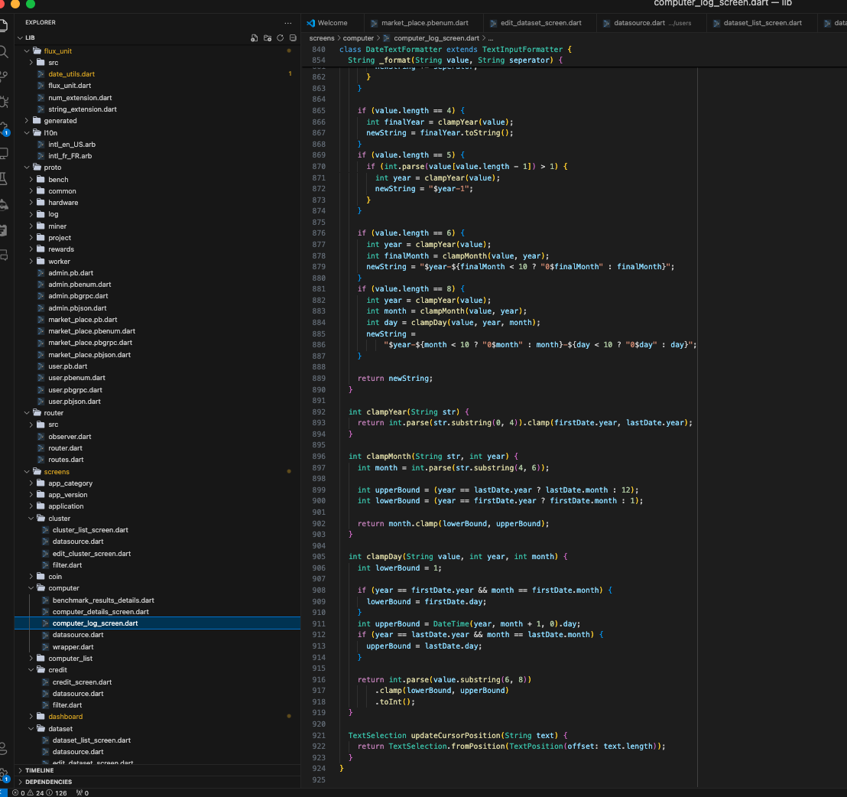
This is one small preview of the source code
There are more than 30 files and folders (maybe more) in each project (each file has more than 800 line numbers) and every other software developer has done their tasks in these projects.So, I had no idea where to start. It was too much stressful. So, I started reading every file and part and spent some great amount of time just for knowing where to start. After when I figure out where to do my work, I needed deep understanding of the dart syntax and flutter framework, so yet again I restudied and researched about the syntax and framework by reading documentation, other people’s projects from github, and then started implementing my tasks.

Before internship, I thought my knowledge would be sufficient and misunderstood myself that I could do everything, but in reality, there are things that I know what I know,that I know what I don’t know , that I don’t know what I know, and that I don’t know what I don’t know. This internship makes me realized that I need to know what I really know and communicated well about these thing that I can do. I wished I could have a senior who can guide me before I do my internship. For example, he could tell me what concepts I need to know before doing Flutter internship.

Acknowledgement
I really enjoyed my two months internship at this company, because everyone was cool and kind to me even though I am an intern. I feel really grateful for that supvervision and mentoring by my supervisor, Florian. He is of French Nationality and couldn’t speak English that well, but I understood easily what he meant though there were some miscommunication, he was patient and caring. I also thank the secretary and CEO of the company who are willing to give great opportunites to the new interns to be working on the projects.

Reference
https://flutter.dev/learn
https://pub.dev/

