Internship Report
B.Eng. in Software Engineering, Academic Year 20XX
International College, King Mongkut’s Institute of Technology Ladkrabang
By
65011693 Soe Moe Htet
Internship period : 22 April – 22 June 2024

Company outline

Company name and address
Provide the official name of the company, the physical locations of the headquarter, the offices, the manufacturing sites, and other sites of the company, as well as its website.
Name - FrontwareInternational.co.ltd.
Address - 1213/390, Town in Town, ซอย ลาดพร้าว 94 Plubpla, Wang Thonglang, Bangkok 10310, Thailand

Main activities
Describe the main activities and/or main products of the company. You may include the company’s vision, philosophy, mission statements, objectives, goals, etc. here.
Main products – The company focus on building Web3 products that hevily rely on cryptocurrency (Flux) that proposes multiple type of services to customer.
Goals – The company provides solutions to customers around the world, works on the projects based on the requirements, and supports cutting edge technology to the customers.

Organization structure
Describe the organization structure of the company. Provide an organization chart. Provide a brief description of the responsibility of each department in the company. Give an estimate of the total number of employees and the number of employees in each department.
Based on my experience, the company has a CEO (ex-software developer), a secretary and two software dev teams i.e, frontend dev team and backend dev team. The company CEO along with his secretary handles the customer relationshps and company management, CEO also write the codes on backend team himself. There are two teams, frontend dev team and backend dev team. They used Flutter to develop UI based softwares and as for backend, they used Golang, C, Rust. Front end team focus on building UI and backend team manges handling server-side logic development and there is a server administrator team that handles the deployment and live server condition checking. There are approximately 10 employees in the office where I worked.
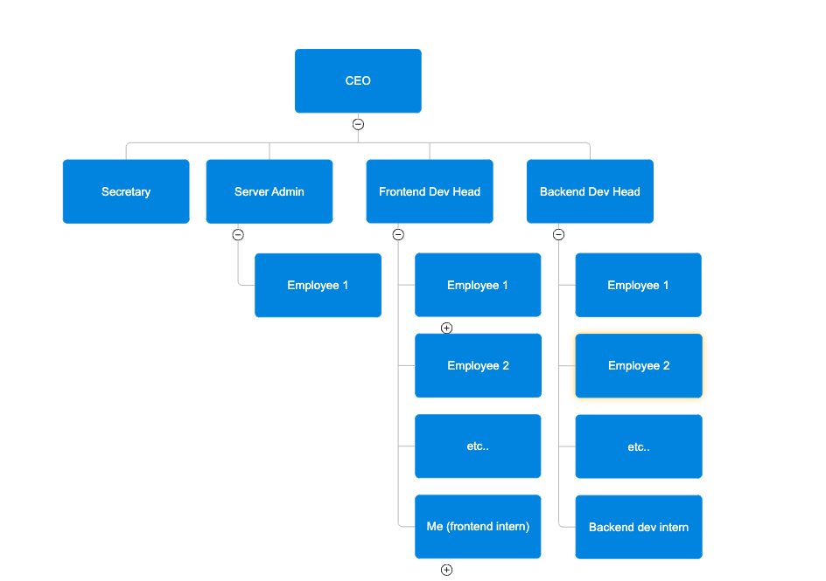

Department and supervision
Provide the name of the department (or division) in the company in which you are doing your internship. Provide the name(s) of your supervisor(s) in the company and their contact information.
My department is Frontend dev team. My supervisor is called – Mr. Florian Sabate
. He never provided me his contact information as in email or linked-in, but I have his phone number +66835684452.
Project Team Leader – Mr. Florian Sabate
Software Development Team
Fluxcore Application Development

Internship

Original description and objectives
Give a clear and concise description of your internship and its objectives which is given to you at the beginning of your internship.
My mentor gives me specific tasks and objectives that I need to finish within the time-frame. Mostly, it’s on peer to peer communication through telegram and he gave me tasks as in word document and sometimes instructions and steps that I need to do on the codebase of the company. Mostly, I have to work along with him on developing UI based features like dialogs, datatime picker, and some random tasks that the customers asked.

Revised description and objectives
If there is any revision to the description and objectives of your internship, summarize the revision here and explain the reasons for revision.

Software Development
Your internship should involve the development of a piece of software, either as an individual project or as part of a larger software system. This section is for you to summarize the software development process in your internship.

Background
Provide a summary of the background of the software you developed. This may include:
- Why the software should be developed?
- If the software is an improvement of an existing system, what are the problems and deficiencies of the existing system?
- If the software is part of a larger system, describe the whole software system and describe which parts of the system your software will interact with.
- Review of similar software in the market
- Who will be the user of the software?
- Summary of technical detail required to understand the requirements of the software
- Concise explanation of the software development environment and essential software libraries used in the development

There are two main projects, FluxCore and FluxEdge (market place). I worked on FluxEdge UI website which allows user to interact with.
- FluxCore is an application aiming to share a computer resources to perform decentralized tasks. The person that download FluxCore will be able to first of all administrate his machine, and his remotely added machines, to put them on the FluxEdge network for customer to rent the machine and use them similarly to a VPS on cloud computing, to run AI model, applications, host server, database, and so on. There is also a mining part, where FluxCore make mining very intuitive and accessible to everyone with a nice looking interface. The application run on both Linux and Windows. In the backend part, the clients who decide to put their machine to be leasable, will have his machine placed into a kubernetes cluster. FluxCore is therefore for the administrator of the machine.
- FluxEdge the marketplace where people will find in realtime machine that are rentable.
The client Flux is a business based on cryptocurrency (FLUX) that proposes multiple type of services to their customer. After working a lot on the mining part, The company was focusing on the goal to make a decentralized system to use resources from around the world to do stuff as AI training.
They launched the ALPHA december:

https://fluxofficial.medium.com/unlocking-fluxcore-participating-in-the-public-alpha-release-3765adedee8e

The projects are still on BETA because the projects being very big, They are adding new features progressively. Started from running benchmarks on the local machine, and then ended up implementing service rental, mining and all of this both locally and remotely. The application use multiple technologies, for the call to the server, mostly to get DB data we use gRPC, MQTT is used for live hardware monitoring, and WebSocket for streaming (mostly for the shell used in FluxEdge to access the container of the application the client is renting on its rented machine).
This website is where they are showing some stats about the different machines that installed FluxCore. When I was working on FluxEdge or pouwmarketplace (project renamed by the client), I was on the dev environment. Because they have multiple servers. One for development that is mostly having Flux team members, testers and developers. I experienced some gRPC errors sometimes, this is due to server restart because they are all working in this environment (backend and frontend).

The production environment is available to the public but its still an alpha and only whitelisted user can join it.
People who wants to share their machine, need to install FluxCore, register an account. Have supported hardware, and need to subscribe to a service (AI, Rendering, Mining...). They will then have to choose a cluster. They are using Rancher to manage kubernetes clusters. So once the machine has joined a cluster, it will then be possible to run application on it inside containers.

Software requirement specification
Provide a clear and concise specification of the requirements of your software. This may include the functional/non-functional requirements of the software, use cases, scenarios, mock-ups, etc.

Development team
Provide the list of the people involved in the development of the software. Describe key responsibility of each person and, if possible, the names of the source code files that each team member implements.
As far as I know, there are ten people in my office that are involved in development of the software. My mentor, Florian leads the Frontend UI development. With his supervision, I am tasked to work on the existing UI to modify, update and remove some features. There are other people called Alex, and Eric who worked on backend development using Golang. One other guy, server administrator handles everything related to server, for example, if the server the company is using gets down, he is the one to ask for what is happening. The rest of the team, I didn’t have to communicate with them since they are not on my team and they are busy with their work.

Project plan
Provide the initial project plan and the final revision of the plan. You may include Gantt charts of the project. For each task in the project, give the names of the team members who carried out the task.

Software design
Describe the final design of the software. You should explain the overview of the design of the software (include diagrams describing the architecture of your software and its context), the decomposition of your software, and then give detailed descriptions of key components of the software. If possible, include the name of the source code file that contains the implementation of each component. You may want to include the following diagrams: package diagrams, component diagrams, class diagrams, sequence diagrams, activity diagrams, E/R diagrams, etc.

Implementation

Development tools
Describe the software tools (including programming languages, IDE, software libraries, etc.) used in your implementation of the software.
Tools:
- Dart
- Golang
- Python 3.6
- Flutter Framework
- GitLab
Libraries, Frameworks, and IDE
- Flutter
- UI packages from pub.dev
- TensorFlow
- Visual Studio Code
- CUDA
- cuDNN
- Pytorch
- Numpy
- Scipy
- Pandas

Techniques
Describe important programming techniques and algorithms in your implementation of the software.

Testing
Describe how you test your software. Describe how you design your test data and any test script you used. Give examples of test data.

Screenshots
If the company allows, provide some screenshots depicting key features of your software.
- SSH Terminal UI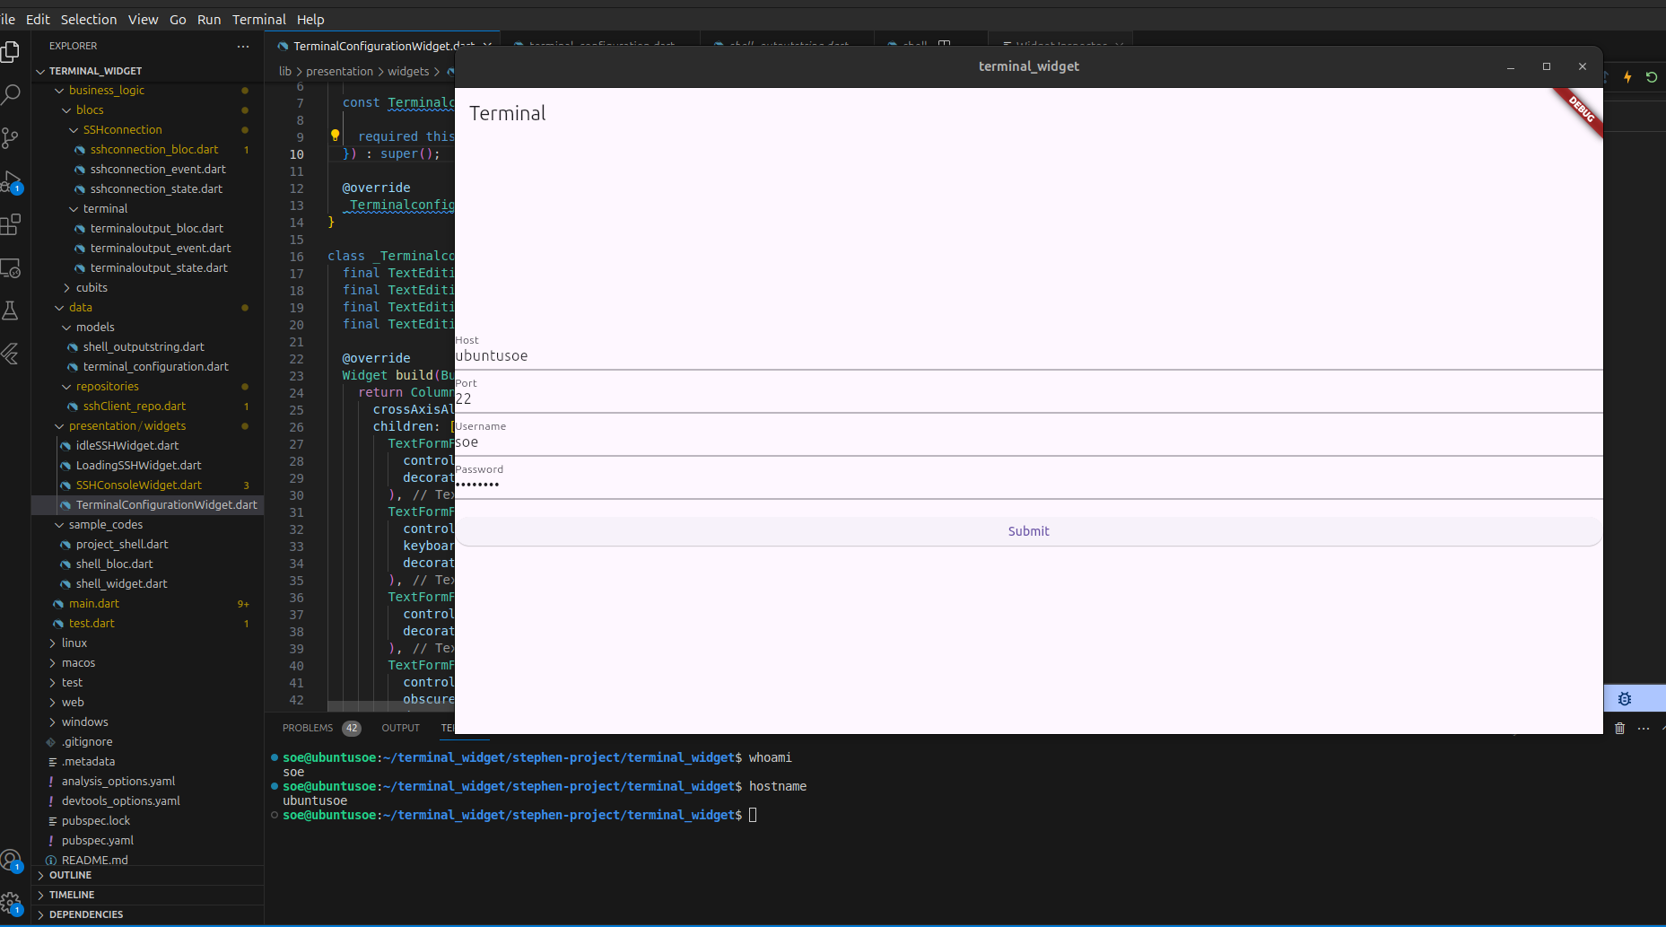 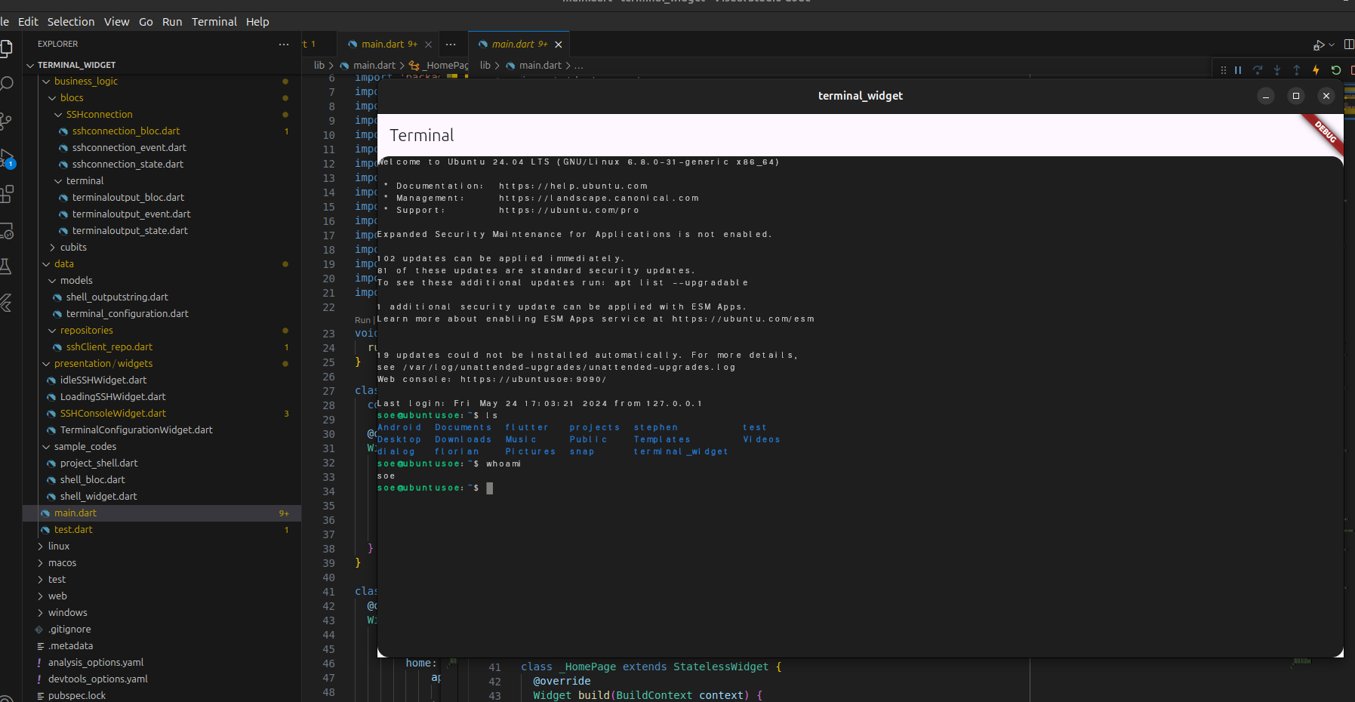
- Company animated logo
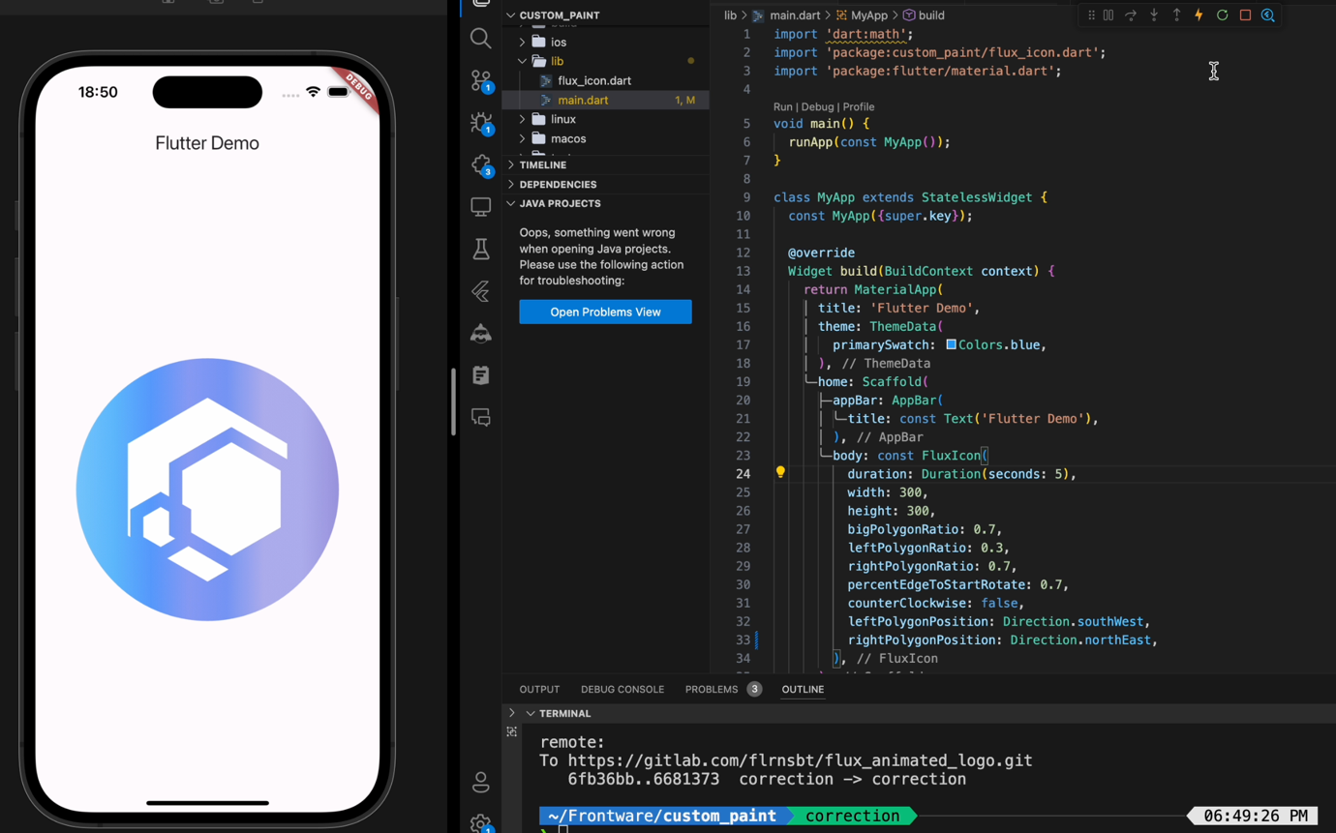
- Dialog page for machine information
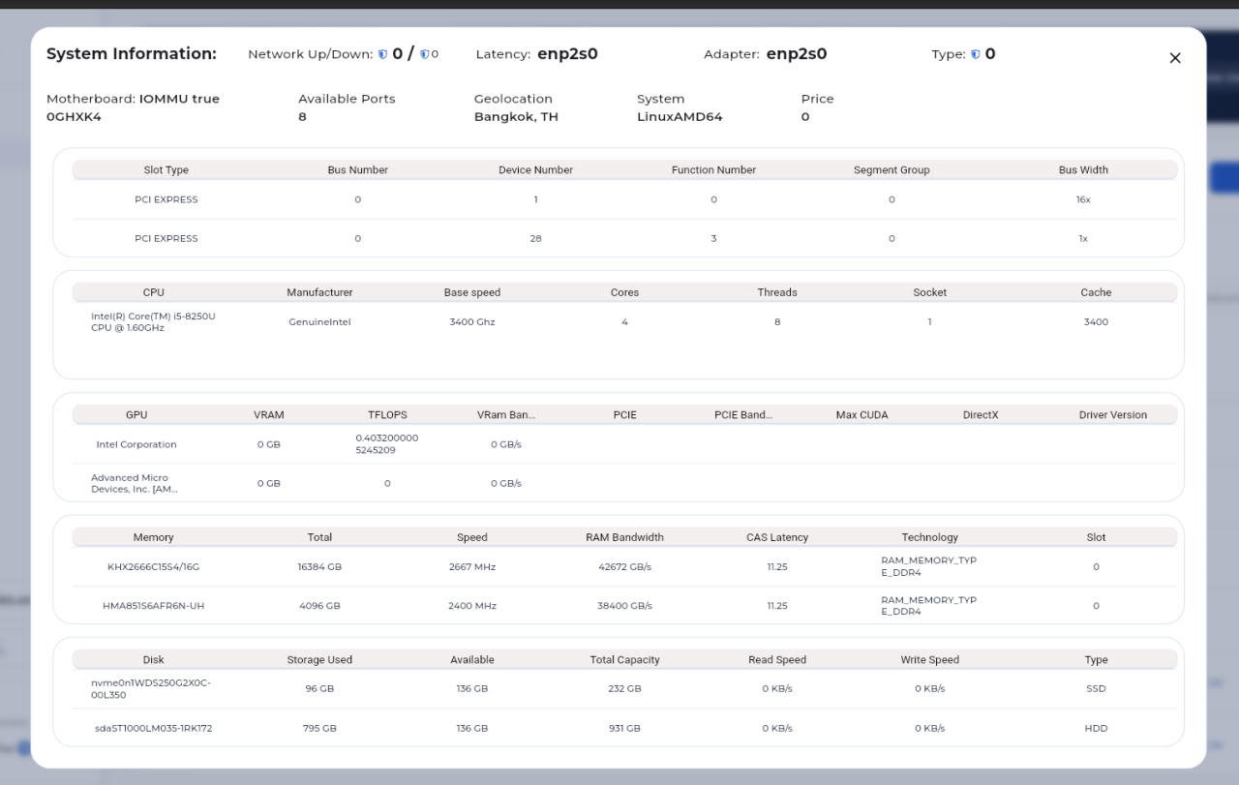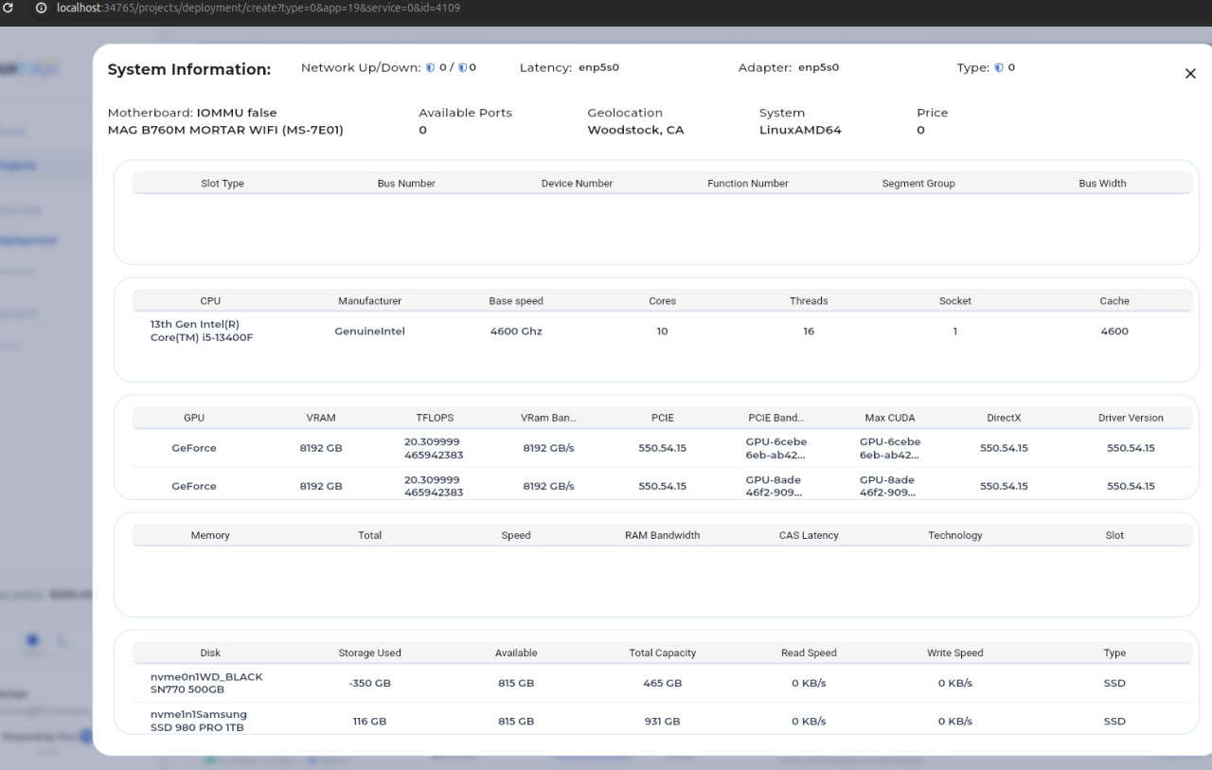
- Refactored date feature
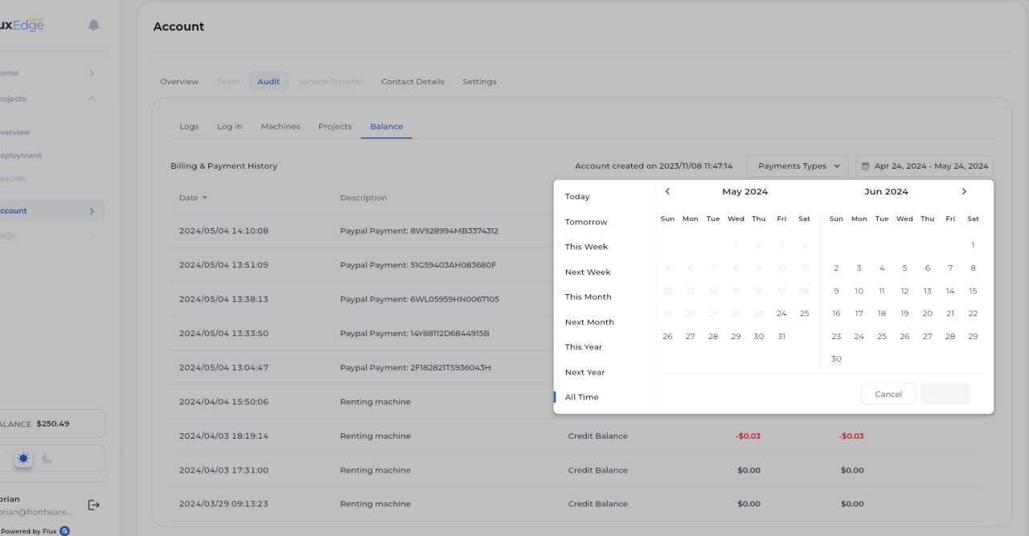
- Yaml editor to write yaml file
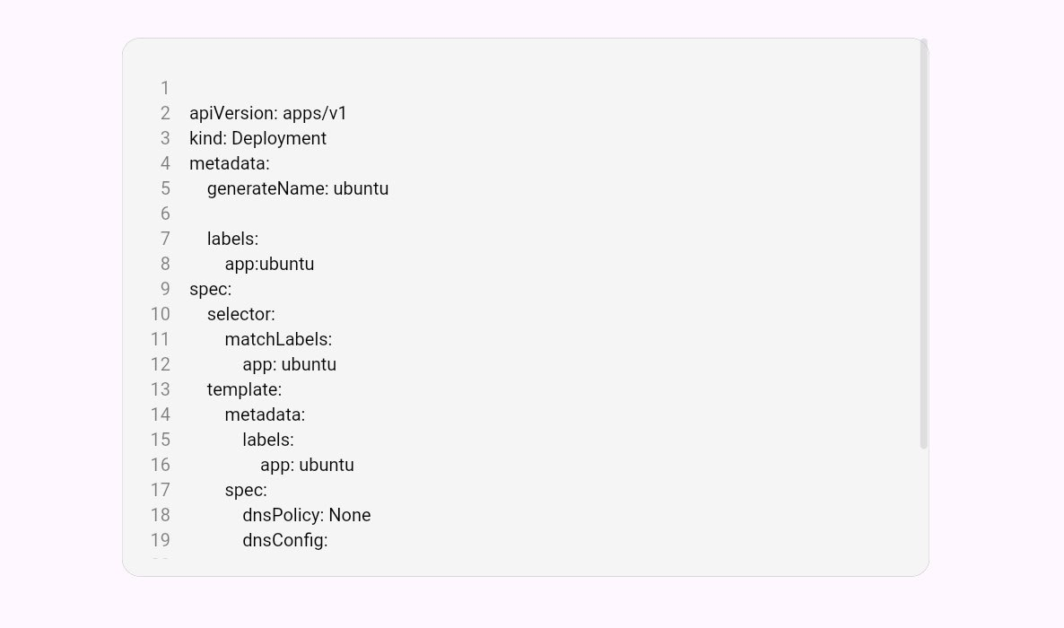
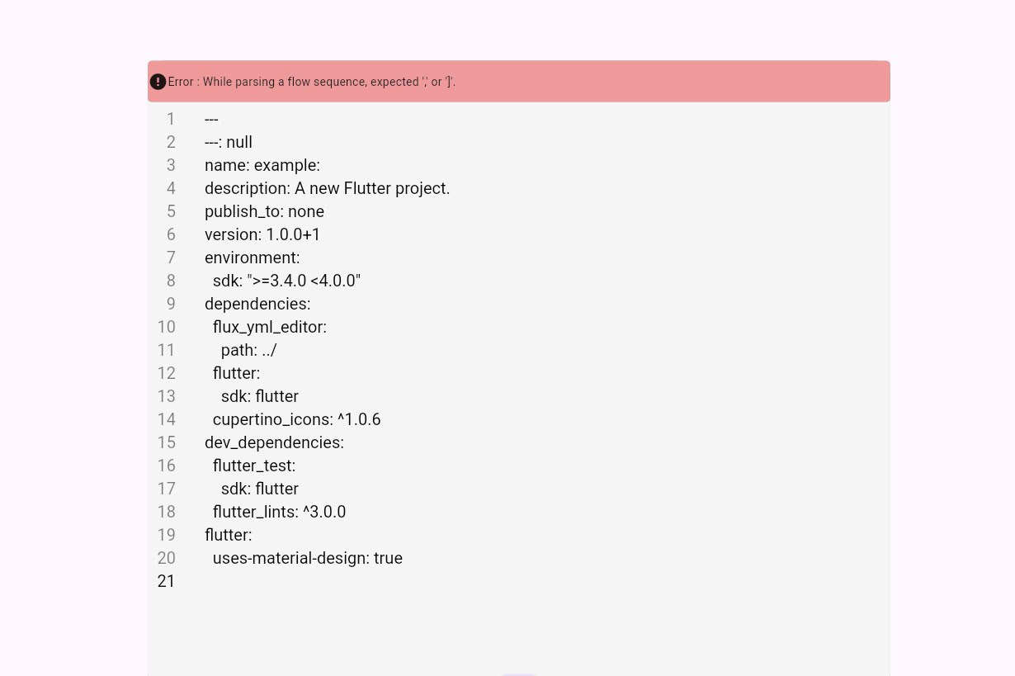
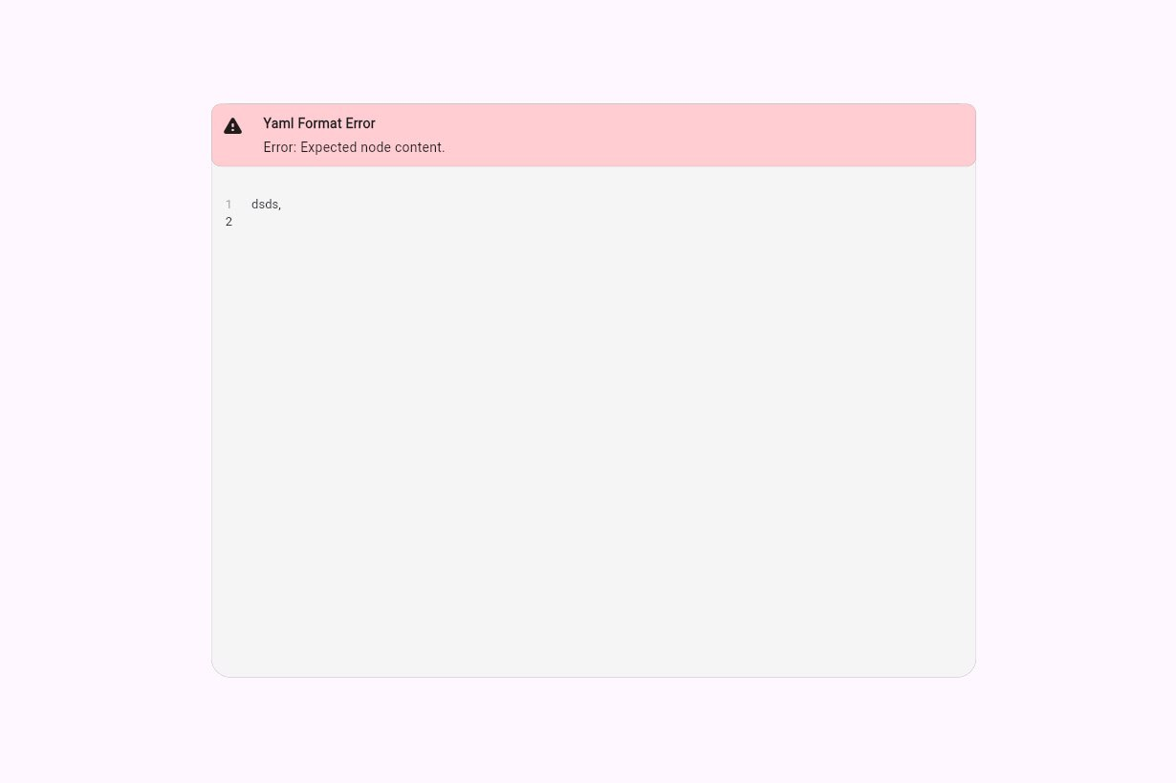
- Excel data format column
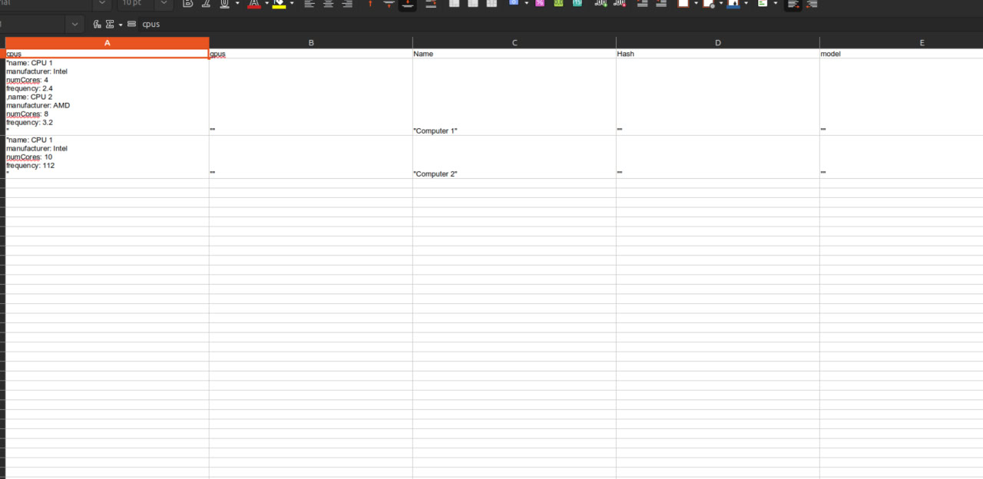
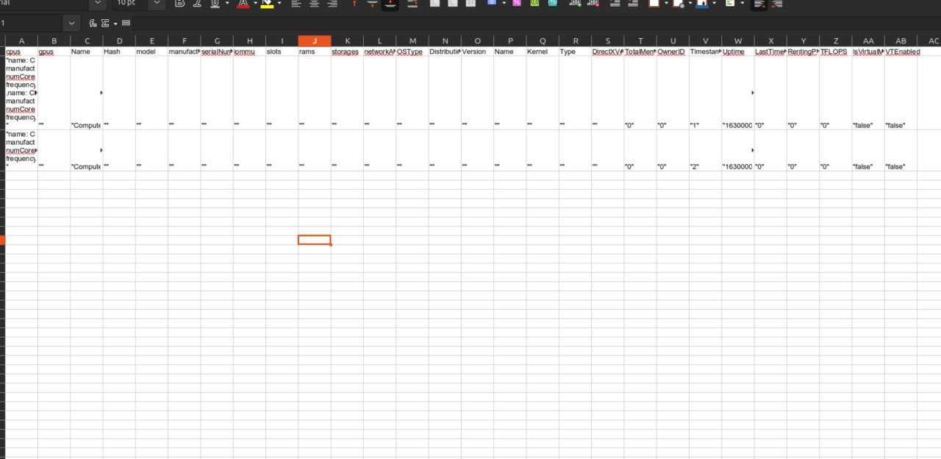

Achievement

Summary of work done
Provide a summary of the work you carried out during the internship. If a piece of work is carried out by more than one team members, please explicitly state so. Also give an estimate of the number of lines of code you wrote (not including commented code and, for web pages, not including the content of the web pages).
As you can see, my tasks are mostly UI features, and the requirements for each task are different from each other. I approximately wrote about 1500 lines of codes.

Evaluation
Give an honest evaluation of how successfully you achieved your objectives
I spent most of my time studying and researching open source tutorials and reading documentations to tackle my objectives. Tasks can seem vaguely defined in my tasks. For example, “Implement a datetime picker” looks simple, but there is a big code base for the software the company is developing. I had to look for where I can put my date time picker and tried to understand how the big code base worked, which part is what, how they are developed. It was not easy to configure and figure out where to modify and change the code base. However, I took my time and had to be patient when doing my objectives. Sometimes, it feels stressful because all the employees are working full-time and there is lack of proper communication between employees and me as an intern, so I wasted some time myself just for figuring out what I should do clearly instead of asking them directly which I did later after two weeks. I needed to be direct, on-point when I communicated, reported my progress what I had done without wasting their time either.

Conclusion

Skills and knowledge learned
Explain what skills and knowledge that you studied in the International College are applied on your work during the internship and how useful are those skills and knowledge. Explain whether you have improved any existing skill and whether you have learned any new skill and knowledge during your internship. What knowledge and experience will you take forward as the most important lessons from your internship?
Explain what publications (books, articles, etc.) and other materials you have studied during the internship and what you learned from those materials.
Especially, OOP concepts that I studied from the university helped me a lot in the tasks, which makes it so much easier to understand the source codes because the UI is developed in dart programming language which is similar to java and C#, focusing heavily on object-oriented development. I improved my communication skills, and learned UI development in flutter, and also stress-time management. The most important lessons would be “Time is money” in workplace and self-efficiency. For example, I should not rely on my mentor that much and I need to be responsible for what I have done, what I have failed, and be honest about it and direct about it without misleading comprehension.
I read Flutter documentation from Google developer team, OOP dart features from dart official website which was documented by Google developer team as well.

Problems and possible improvement
Describe the problems you experienced during your internship. Were there any techniques that you would like to have known before undertaking the internship? Explain how your internship experience could have been improved.
There is a big skill-gap between me and my mentor. He didn’t have a clear understanding of my skills level and couldn’t access my knowledge well. He didn’t have enough time to do it too because he was working full-time on the otherhand but he didn’t ignore me that’s is a really good thing, When he gave me some tasks for the projects he was leading, I feel overwhelmed since I have no prior knowledge about the business domain, the core philosophy behind the team, for example,in this one task he asked me to change a part of UI. Even though it’s easy, I had no idea where that part of UI needs to be changed 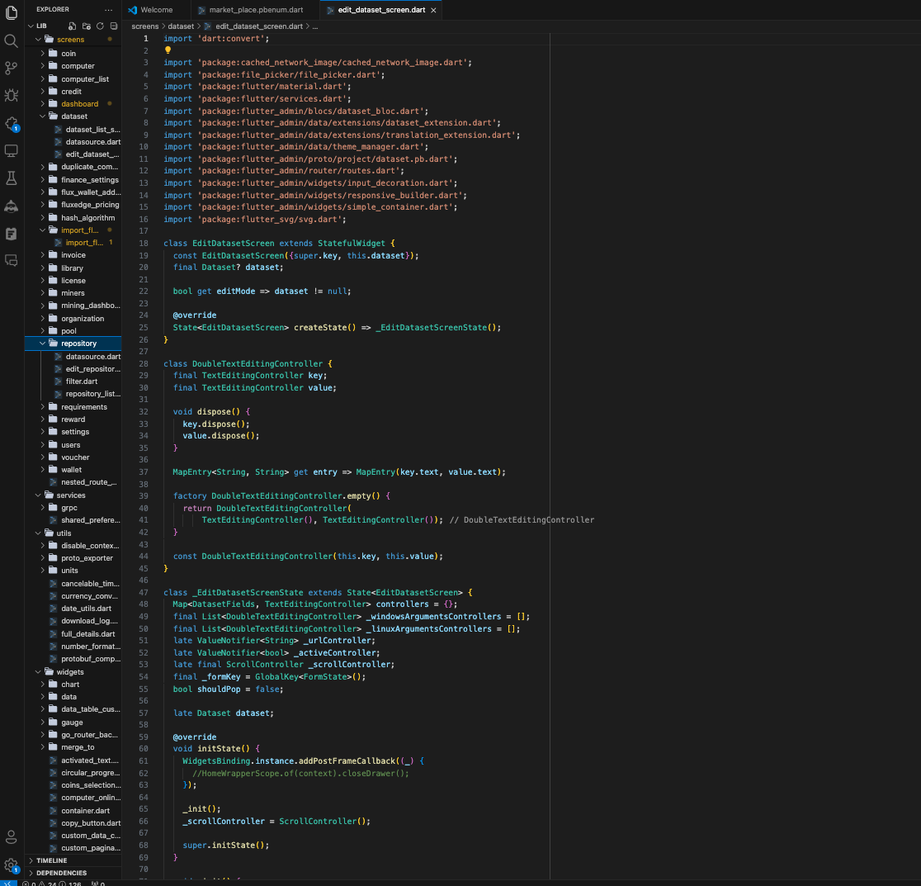
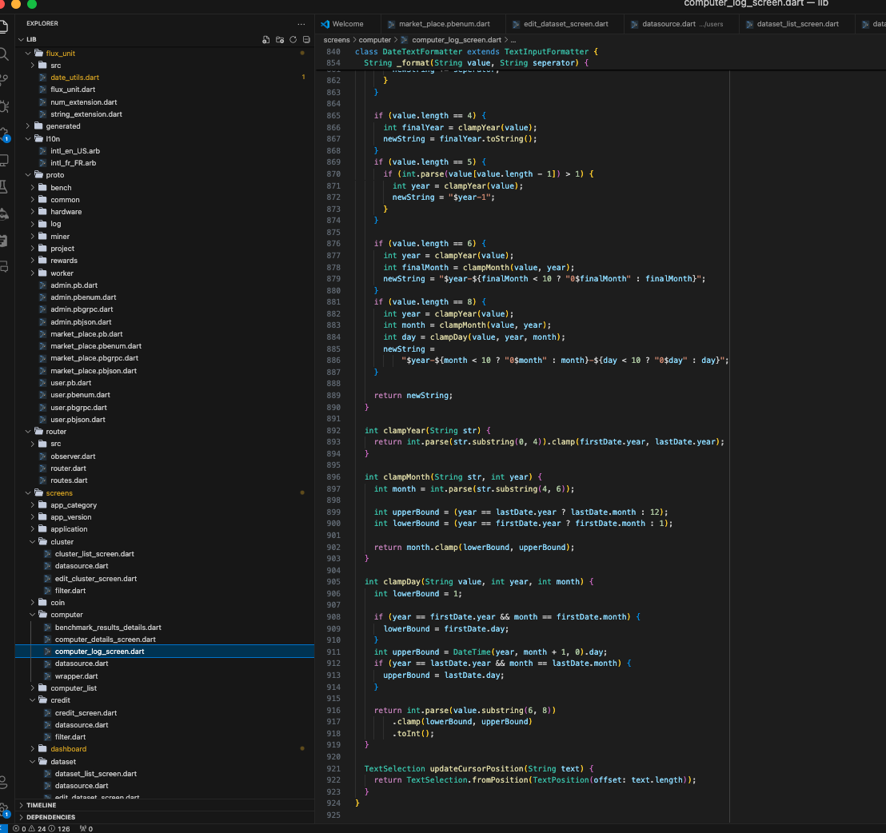
This is one small preview of the source code
There are more than 30 files and folders (maybe more) in each project (each file has more than 800 line numbers) and every other software developer has done their tasks in these projects.So, I had no idea where to start. It was too much stressful. So, I started reading every file and part and spent some great amount of time just for knowing where to start. After when I figure out where to do my work, I needed deep understanding of the dart syntax and flutter framework, so yet again I restudied and researched about the syntax and framework by reading documentation, other people’s projects from github, and then started implementing my tasks.

Before internship, I thought my knowledge would be sufficient and misunderstood myself that I could do everything, but in reality, there are things that I know what I know,that I know what I don’t know , that I don’t know what I know, and that I don’t know what I don’t know. This internship makes me realized that I need to know what I really know and communicated well about these thing that I can do. I wished I could have a senior who can guide me before I do my internship. For example, he could tell me what concepts I need to know before doing Flutter internship.

Acknowledgement
A brief “Thank you” message for the people who helped you during your internship
I really enjoyed my two months internship at this company, because everyone was cool and kind to me even though I am an intern. I feel really grateful for that supvervision and mentoring by my supervisor, Florian. He is of French Nationality and couldn’t speak English that well, but I understood easily what he meant though there were some miscommunication, he was patient and caring. I also thank the secretary and CEO of the company who are willing to give great opportunites to the new interns to be working on the projects.

Reference
List of publications and other materials referred to in the report

