SOFTWARE REQUIREMENTS SPECIFICATION

**For**

**BLOG WEBSITE**

**Prepared by:**

*AJITH.X*

*BRIGHTLIN ANGEL.S*

*KARTHIKA.K*

*DEIVANAYAGI.N*

**Academic Year:** *2020-2024*

Introduction

## Purpose

The main objective of this document is to illustrate the requirements of the project Library Management system. The document gives the detailed description of the both functional and non-functional requirements proposed by the client. The purpose of this project is to provide a friendly environment to maintain the details of books and library members. The main purpose of this project is to maintain easy circulation system using computers and to provide different reports. This project describes the hardware and software interface requirements using ER diagrams and UML diagrams.

## Document Conventions

* + - Entire document should be justified.
    - Convention for Main title

Font face: Times New Roman Font style: Bold

Font Size: 14

* + - Convention for Sub title

Font face: Times New Roman Font style: Bold

Font Size: 12

* + - Convention for body

Font face: Times New Roman Font Size: 12

## Scope of Development Project

Creating a blog website involves a multifaceted scope encompassing numerous vital elements. Begin by determining the blog's purpose and niche, defining the content strategy, and selecting an appropriate domain name and hosting. Crafting an appealing design and branding identity is crucial for a memorable online presence. Choosing a Content Management System (CMS) streamlines website management, while including essential features like comments, social sharing, and subscription forms enhances user engagement. Monetization strategies can help sustain your blog's growth. Effective SEO and promotion methods boost visibility, and a structured content creation workflow ensures regular, quality posts. Prioritize user experience with responsive design and fast load times, while addressing legal concerns and safeguarding your content. Analytics provide valuable insights, and community building fosters audience engagement. Consider future growth prospects, and prioritize security measures to safeguard your blog's integrity.

## Definitions, Acronyms and Abbreviations

REACT -> platform independence SQL-> Structured query Language ER-> Entity Relationship

UML -> Unified Modeling Language

IDE-> Integrated Development Environment SRS-> Software Requirement Specification

IEEE ->Institute of Electrical and Electronics Engineers

## References

* + - Books
* "ProBlogger: Secrets for Blogging Your Way to a Six-Figure Income" by Darren Rowse and Chris Garrett.
* "Content Strategy for the Web" by Kristina Halvorson and Melissa Rach:
  + - Websites
    - [**https://www.girlmuseum.org/blog**](https://www.girlmuseum.org/blog)
    - [**https://www.blogger.com/**](https://www.blogger.com/)

# Overall Descriptions

## Product Perspective

Use Case Diagram of Blog website

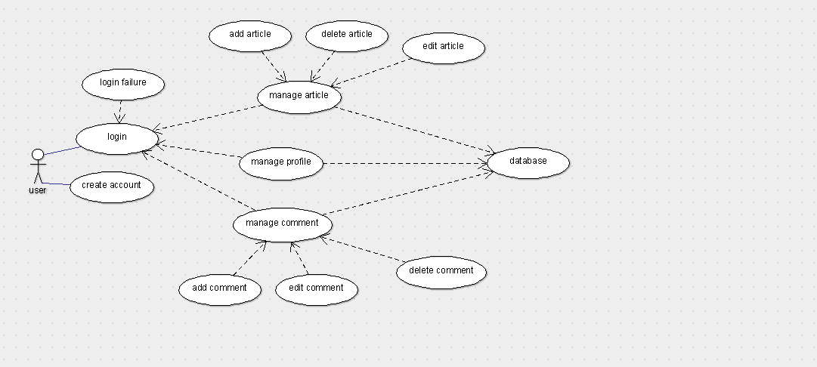

The above diagram shows the simple blog website the user can login to the site and he can able to add blogs and edit blogs. All the blogs and the information is stored in the database for future usage.

## Product Function

Entity Relationship Diagram of Blog website.

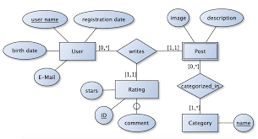

The blogging site which gives a valid information to the user and the user can add the blog and they can update it. There will be two types of users in the blog website. One is the reader and the other one is blogger (post some content on the internet). Both the user have an different login details. And the each user can do both the jobs. The content which the blogger post on the internet the another person can comment it, like it. These actions are take place in the website.

## 2.3 User Classes and Characteristics

In the blogging website many users are using it. In this there will be many members with different scope because each user have different need. So for the users we needs to create the website for all type of users.

1. Visitor

Characteristics

- Anonymous user.

- Can view public content.

- Cannot create or interact with posts or comments.

- Limited access to features.

2. Registered User:

Characteristics

- Has created an account.

- Can create, edit, and delete their own posts.

- Can comment on posts.

- May have a profile with customizable settings.

- Can subscribe to newsletters or notifications.

3. Moderator:

Characteristics:

- Trusted user with elevated privileges.

- Can review, edit, and remove inappropriate content.

- May have access to moderation tools.

- Can warn or ban users who violate community guidelines.

4. Administrator:

- Characteristics:

- Highest level of access.

- Can manage user accounts, including creating, modifying, or deleting them.

- Can manage content, including posts, comments, and categories.

- Can configure website settings and permissions.

5. Author:

- Characteristics:

- Specialized user with writing privileges.

- Can create, edit, and delete their own posts.

- May have access to additional writing tools or features.

- May have a public author profile page.

## Operating Environment

The product will be operating in windows environment. The Blogging website shall operate in all famous browsers, for a model we are taking Microsoft Internet Explorer, Google Chrome, and Mozilla Firefox. Also it will be compatible with the IE 6.0. Most of the features will be compatible with the Mozilla Firefox & Opera 7.0 or higher version. The only requirement to use this online product would be the internet connection.

The hardware configuration include Hard Disk: 40 GB, Monitor: 15” Color monitor, Keyboard: 122 keys. The basic input devices required are keyboard, mouse and output devices are monitor, printer etc.

## Assumptions and Dependencies

## Assumptions:

## 1. User Engagement:

## - Assumption: Users will actively engage with the website by reading, commenting on, and potentially contributing their own content.

## 2. Content Moderation:

## - Assumption: There will be a need for content moderation to ensure that posts and comments adhere to community guidelines and policies.

## 3. Scalability:

## - Assumption: The website may need to handle a growing number of users, posts, and comments over time.

## 4. Security:

## - Assumption: Security measures, such as encryption, user authentication, and secure storage of sensitive data, will be in place to protect user information.

## 5. Responsive Design:

## - Assumption: The website will be designed to be accessible and user-friendly on various devices, including desktops, tablets, and mobile phones.

## 6. SEO Considerations:

## - Assumption: The website will be optimized for search engines to improve its visibility in search results.

## 7. User Authentication:

## - Assumption: Users will need to create accounts and log in to access certain features, such as creating posts and comments.

## 8. Database Management:

## - Assumption: A database management system will be used to store and retrieve user information, posts, comments, etc.

## Requirement

Software Configuration:-

This software package is developed using java as front end which is supported by sun micro system. Microsoft SQL Server as the back end to store the database.

Operating System: Windows 7 and above

Language: react JS, HTML, CSS

Database: MS SQL Server (back end)

Hardware Configuration :- Processor: Pentium(R)Dual-core CPU Hard Disk: 40GB

RAM: 256 MB or more

## Data Requirement

The inputs consist of the query to the database and the output consists of the solutions for the query. The output also includes the user receiving the details of their accounts. In this project the inputs will be the queries as fired by the users like create an account, selecting books and putting into account. Now the output will be visible when the user requests the server to get details of their account in the form of time, date and which books are currently in the account.

# External Interface Requirement

## GUI

## Desktop Blogging Software:

## Description: Specialized software that allows users to create and manage their blog posts offline before publishing them on the website.

## Features:

## Offline drafting and editing of posts.

## Supports various formatting options.

## Synchronization with the website for publishing.

## Mobile App for Blogging:

## Description: A mobile application that allows users to create and manage their blog posts on the go.

## Features:

## User-friendly interface optimized for mobile devices.

## Easy uploading of images and multimedia.

## Push notifications for comments and interactions.

## Admin Dashboard:

## Description: A specialized interface for administrators and moderators to manage the content and users on the website.

## Features:

## Content moderation tools.

## User management capabilities.

## Analytics and reporting features.

## Content Curation Tool:

## Description: A tool that helps users curate and organize content from different sources to be shared on their blog.

## Features:

## Content discovery and aggregation.

## Scheduling and planning posts.

## Integration with social media platforms.

## Comment Moderation Panel:

## Description: An interface for moderators to review and manage comments on blog posts.

## Features:

## Filters for identifying and handling spam comments.

## Tools for flagging and removing inappropriate content.

## Notification system for new comments.

## Social Media Scheduler:

## Description: A tool that allows users to schedule and automate the sharing of their blog posts on social media platforms.

## Features:

## Integration with popular social media platforms.

## Scheduling options for optimal posting times.

## Analytics to track social media engagement.

## Analytics Dashboard:

## Description: A separate interface for users to view and analyze the performance of their blog posts.

## Features:

## Traffic statistics (page views, unique visitors).

## Engagement metrics (likes, comments, shares).

## User behavior insights.

## Customized Visual Editor:

## Description: A specialized editor that allows for the creation of visually appealing blog posts with unique layouts and designs.

## Features:

## Drag-and-drop elements for easy design.

## Customizable templates and themes.

## Integration with multimedia elements.

# System Features

The users of the system should be provided the surety that their account is secure. This is possible by providing:-

* User authentication and validation of members using their unique member ID
* Proper monitoring by the administrator which includes updating account status, showing a popup if the member attempts to issue number of books that exceed the limit provided by the library policy, assigning fine to members who skip the date of return
* Proper accountability which includes not allowing a member to see other member’s account. Only administrator will see and manage all member accounts

# Other Non-functional Requirements

## Performance Requirement

**Page Load Time:**

Requirement: The website should load in a maximum of X seconds.

Justification: Fast page load times enhance user experience and reduce bounce rates.

**Response Time:**

Requirement: The server should respond to user interactions (e.g., clicks, form submissions) within X milliseconds.

Justification: Quick response times contribute to a smooth and interactive user experience.

**Concurrent User Handling:**

Requirement: The website should support a minimum of X concurrent users without significant performance degradation.

Justification: Ensures the website can handle traffic spikes without slowdowns or crashes.

**Peak Traffic Handling:**

Requirement: The website should be able to handle X% more traffic than the average daily peak without degradation in performance.

Justification: Accounts for traffic spikes during peak usage times or special events.

**Database Query Performance:**

Requirement: Database queries should execute within X milliseconds.

Justification: Ensures efficient retrieval and manipulation of data for dynamic content.

**Image and Multimedia Loading:**

Requirement: Images and multimedia elements should load within X seconds, optimizing for different connection speeds.

Justification: Ensures multimedia content does not significantly impact page load times.

## Safety Requirement

The database may get crashed at any certain time due to virus or operating system failure. Therefore, it is required to take the database backup so that the database is not lost. Proper UPS/inverter facility should be there in case of power supply failure.

## Security Requirement

* + 1. System will use secured database
    2. Normal users can just read information but they cannot edit or modify anything except their personal and some other information.
    3. System will have different types of users and every user has access constraints
    4. Proper user authentication should be provided
    5. No one should be able to hack users’ password
    6. There should be separate accounts for admin and members such that no member can access the database and only admin has the rights to update the database.

## Requirement attributes

* + 1. There may be multiple admins creating the project, all of them will have the right to create changes to the system. But the members or other users cannot do changes
    2. The project should be open source
    3. The Quality of the database is maintained in such a way so that it can be very user friendly to all the users of the database
    4. The user be able to easily download and install the system

## Business Rules

A business rule is anything that captures and implements business policies and practices. A rule can enforce business policy, make a decision, or infer new data from existing data.This includes the rules and regulations that the System users should abide by. This includes the cost of the project and the discount offers provided. The users should avoid illegal rules and protocols. Neither admin nor member should cross the rules and regulations.

## User Requirement

User requirements are statements that describe the functionalities or features that users expect from a system or product. In the context of a blog website, these requirements reflect what users need and want in order to effectively use and engage with the platform. Here are some common user requirements for a blog website:

**User Registration and Authentication:**

Users should be able to create accounts with a unique username and password.

Users should be able to log in and log out securely.

**Profile Management:**

Users should have the ability to edit and update their profile information, including username, email, and profile picture.

Users should be able to reset their password if they forget it.

**Creating and Editing Posts:**

Users should be able to create new blog posts, including adding a title, content, and attaching images or multimedia.

Users should be able to edit or delete their own posts.

**Category and Tagging:**

Users should be able to assign categories and tags to their posts for easy organization and search.

# Other Requirements

## Data and Category Requirement

## User Data: This includes information about registered users like usernames, email addresses, passwords (usually encrypted), profile pictures, and any additional profile information.

## Post Data: This includes information about individual blog posts, such as the title, content, author, publication date, categories, tags, and any associated comments.

## Category Data: This includes information about different topic categories under which blog posts are organized, such as category names, descriptions, and unique identifiers.

## Tag Data: This includes information about tags associated with blog posts, which help in organizing and classifying content based on specific topics or themes.

## Comment Data: This includes information about comments made by users on blog posts, including the content of the comment, the commenter's username, and the date and time of the comment.

## Metadata and System Logs: This could include information used for system management and monitoring, such as access logs, error logs, and information related to system performance.

## Categories:

## Categories in a blog website are organizational structures used to group similar posts together. They help users navigate and find content that is of interest to them. For example, on a travel blog, categories might include "Destinations", "Travel Tips", and "Adventure Activities". Each post can be assigned to one or more categories.

## Category Name: The name or label of the category (e.g., "Technology", "Cooking Tips").

## Category ID: A unique identifier for each category, often used for database management.

## Category Description: A brief description or summary of what the category encompasses.

## Appendix

A: Admin, Abbreviation, Acronym, Assumptions; B: Books, Business rules; C: Class, Client, Conventions; D: Data requirement, Dependencies; G: GUI; K: Key; L: Library, Librarian; M: Member; N: Non-functional Requirement; O: Operating environment; P: Performance, Perspective, Purpose; R: Requirement, Requirement attributes; S: Safety, Scope, Security, System features; U: User, User class and characteristics, User requirement;

## Glossary

The following are the list of conventions and acronyms used in this document and the project as well:

* + 1. Administrator: A login id representing a user with user administration privileges to the software
    2. User: A general login id assigned to most users
    3. Client: Intended users for the software
    4. SQL: Structured Query Language; used to retrieve information from a database
    5. SQL Server: A server used to store data in an organized format
    6. Layer: Represents a section of the project
    7. User Interface Layer: The section of the assignment referring to what the user interacts with directly
    8. Application Logic Layer: The section of the assignment referring to the Web Server. This is where all computations are completed
    9. Data Storage Layer: The section of the assignment referring to where all data is recorded
    10. Use Case: A broad level diagram of the project showing a basic overview
    11. Class diagram: It is a type of static structure diagram that describes the structure of a system by showing the system’s cases, their attributes, and the relationships between the classes
    12. Interface: Something used to communicate across different mediums
    13. Unique Key: Used to differentiate entries in a database

## Class Diagram

A class is an abstract, user-defined description of a type of data. It identifies the attributes of the data and the operations that can be performed on instances (i.e. objects) of the data. A class of data has a name, a set of attributes that describes its characteristics, and a set of operations that can be performed on the objects of that class. The classes’ structure and their relationships to each other frozen in time represent the static model. In this project there are certain main classes

which are related to other classes required for their working. There are different kinds of relationships between the classes as shown in the diagram like normal association, aggregation, and generalization.

