For this project I will be working on a Scene from Buck Rogers in the 25th Century.

In this scene, the main character buck rogers has just returned to the Draconian flagship, where it is attacked seemingly by pirate marauders which have caused trouble for earth recently.

Because of the lack of trust Colonel Wilma Deering has in Bucks story he isn’t allowed to control his ship during the battle and was forced to come along due to him being suspected of being a spy.

Buck makes comments throughout the scene when earths pilots are blown up for relying too heavily on their ships AI.

Buck is finally allowed to fly his ship and takes out the remaining enemy ships, gaining the trust of Deering and returning to earth.



Intro will be played to the players camera, possible extras of prefabs used to make a sort of 3D effect

**1.**

Start of movie scene, ships scramble as pirate attack alert is sounded, will either be played as a clip, or be replace by a reconstructed take-off scene + initial attack run.

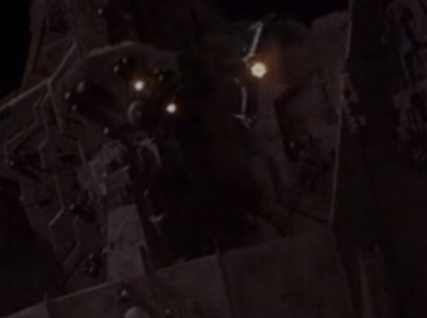

**2.**

Player is launched through colourful launch tube and follows flight path because AI is in control

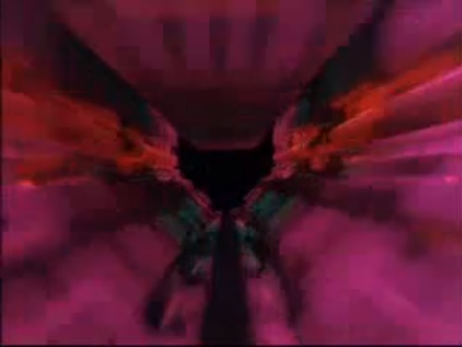

**3.**

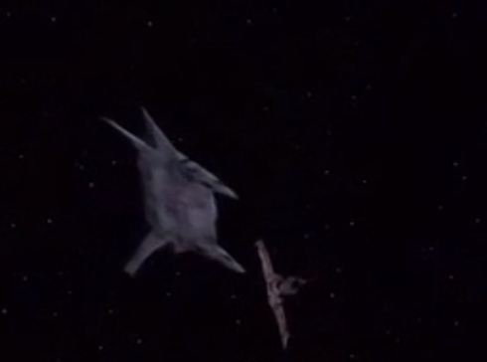

First ship lost by banking across enemies line of sight, buck and deering confrontation plays as audioclip continues

**4.**

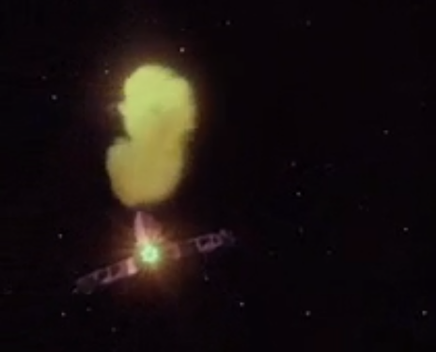

Ship comes from above and behind lieutenant Wesley and blows her up.

Followed by Thornberry against another ship.

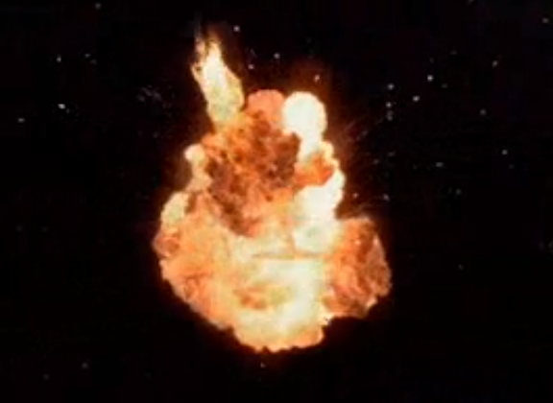

**5.**

**6.**

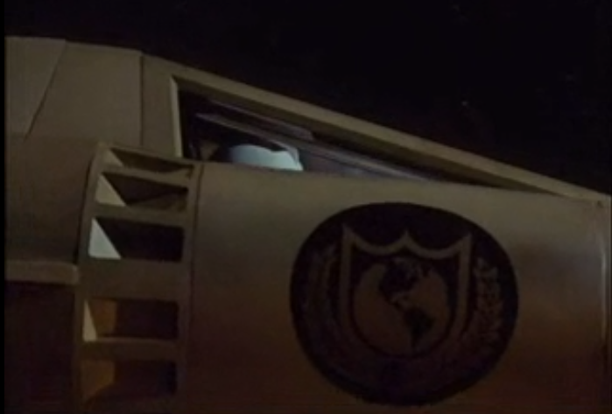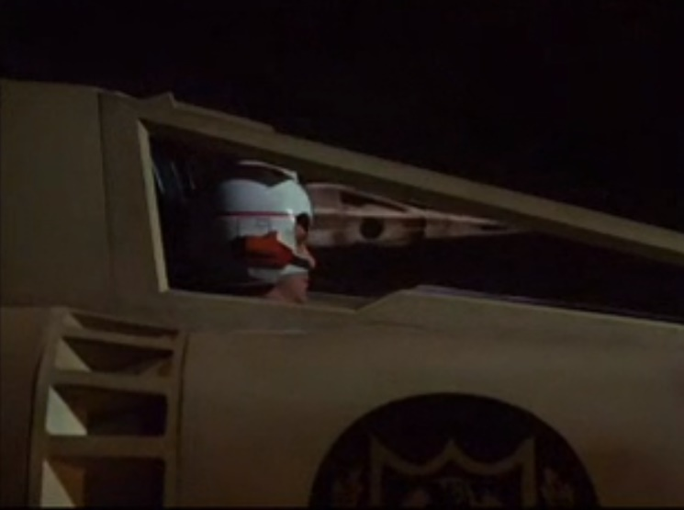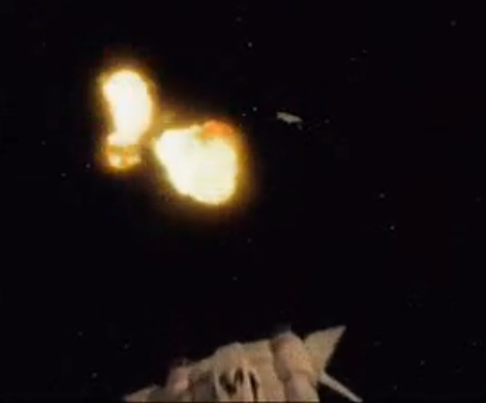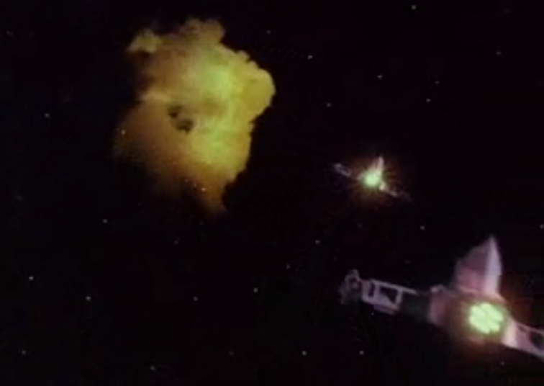

“My place or yours?”

**“Now Captain, Lets go home”**

**10.**

**9.**

Buck and Deering line up in formation, AI takes over flight for the player for this part, audio clip plays.

**8.**

Player Destroys enemies, each one causes a new Buck Rogers line to play, after the third buck sees that Deering is being tailed by 2 ships, player will destroy these

**7.**

Two pirates blow up another lieutenant, Buck switches to manual controls, I could possibly allow a player to take over here and delay the audio clips until Maurauders are destroyed, and keep the backing music playing to give the sense that the player is in the scene, all other ships will follow their predetermined paths or attack the player