CSCE 643 Project 2

We have learned DLT algorithm and different cost functions such as MLE. This project is designed for you to get familiar with these algorithms. We will use the two images below for this assignment.


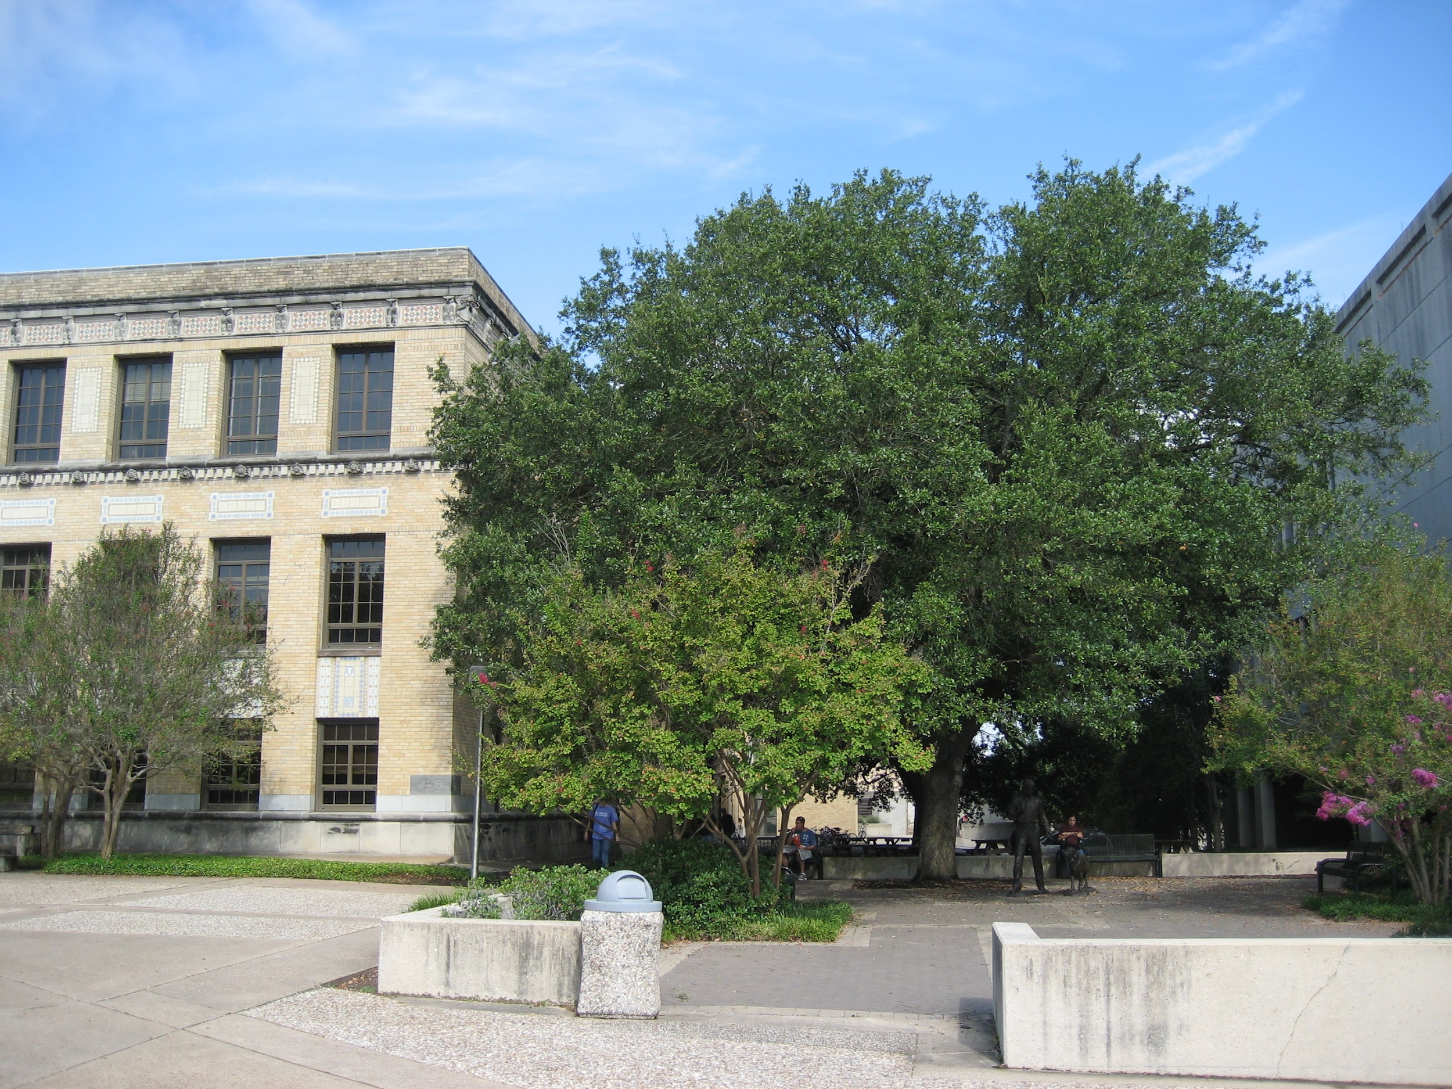

Please manually select corresponding 20 point pairs across these two images. Compute Homography matrix H using the following methods
- H matrix computed using DLT (20pts)
- H matrix computed using nomalized DLT. In your report, please tell me how do you normalize the images. (20pts)
- H matrix computed using MLE (modifying DLT's objective function to apply MLE,. Note: you can use Sampson Error instead of reprojection error) (40 pts)
Please compose panorama using the H you obtained for each cases. Again, you can use opencv or matlab functions to reproject image.

Peer Grading (20 pts).

Challenge 2: Implement RANSAC (Dot not using any existing RANSAC functions embedded in existing libraries). In you program, please make sure that you can randomly generate N false corresponding points for both images. Mix those points with the 20 points that you have in previous step. Using the N+20 points, repeatedly perform RANSAC on those points for increasing N size. For example, you can try N=20, 200, 1000, 2000, and 5000.... Report your findings on RANSAC time and inlier detection accuracy. Tell me when RANSAC would fail and provide probability analysis on your findings.

