

Computer Games Development CW208

Technical Design Document

Year IV

[Stephen Ennis]

[C00181305]

[24/04/2017]

[Oisin Cawley]

# 

**CRC Cards:** **3**

**Class Diagram** **3**

**Approaches:** **3**

Template 3

Template: 3

**Features:** **3**

Template 3

Template: 3

# 

# 

# CRC Cards:

|  |  |
| --- | --- |
|  | |
|  |  |

# 

# Class Diagram

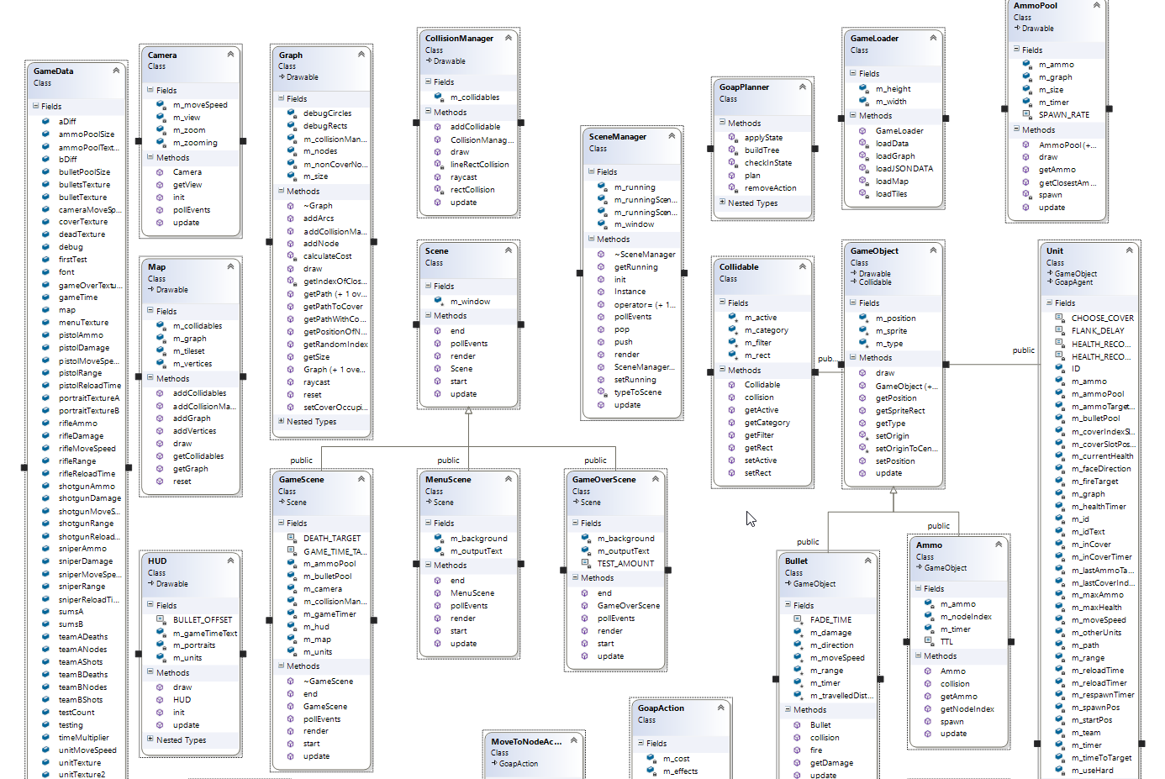

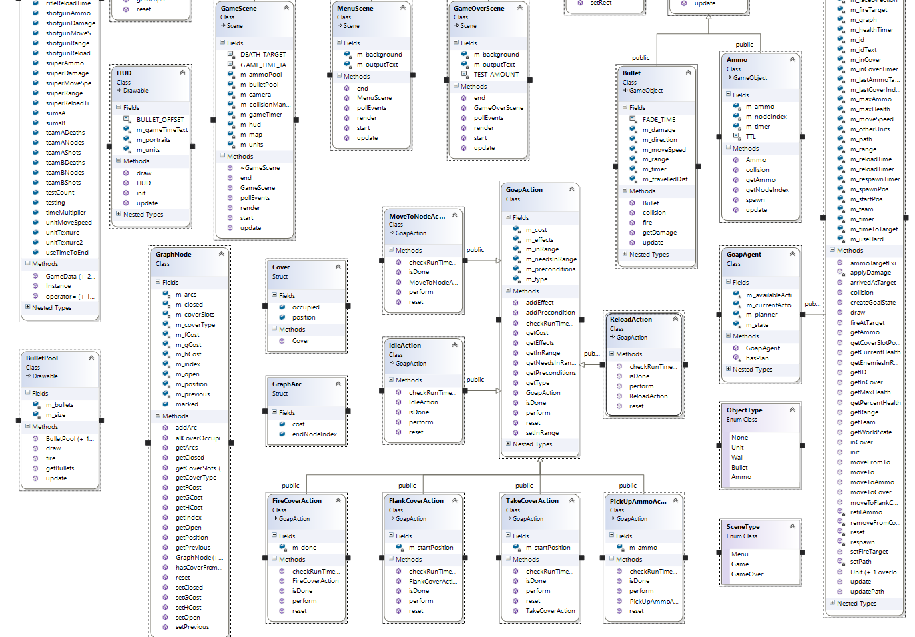

# Approaches:

## Template

### Template:

1. template.
   1. template.

# Features:

## Template

### Template:

template

* template::template()