Project Proposal

Stephen Aman | Peter Ballmer | Joachim Reiersen

**Description of the Product**

The product we are building is called MicSpot, an Android application designed to help stand up comedians find and sign up for open mics in an area, coordinate transportation with other comedians to and from open mics and discover new up and coming comedians. MicSpot will also allow the hosts of open mics to create their open mic within MicSpot so comedians around the area can perform at their open mic.

**Need for the Product**

‘Open mics‘ are a venue for beginning comedians to practice and hone their stand up comedy skills. It is from this venue that comedians will move on to book their own shows and launch their careers in standup comedy. However, the current state of open mic comedy is messy and disorganized and for comedians coming to a new area, it can be very difficult to navigate. Currently, the system for finding open mics is as follows: Each city’s comedy scene has a Facebook group, which will have within it (best case scenario) a Google calendar containing the schedule of open mics for the area (Bay Area calendar shown below):

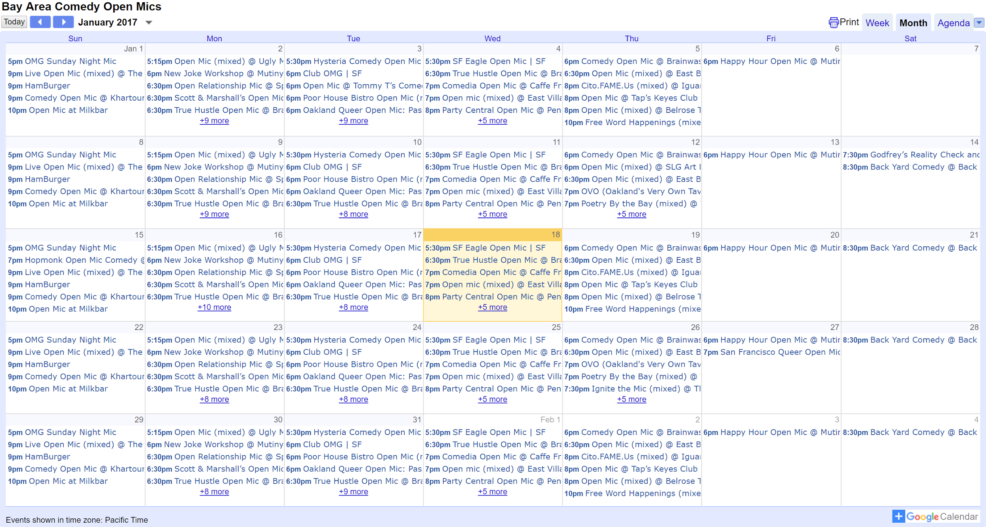

Worst case scenario, the Facebook group will have a text file containing the open mic information for each week.

**Finding open mics**

Comedians often travel to different cities to gain exposure and experience. However, find open mics to do so is often difficult. The information display is cluttered and tough to scan and gives no quick indication as to where any of these open mics are located. Another issue is the appointment of the Facebook group as the nexus of information for a comedy scene. These groups follow no standard naming convention and can be difficult to find. For example, in San Francisco, the Facebook group is titled “Bay Area Comedy Network”. In Seattle, the Facebook group is called “Northwest Comedians”, and in Denver, the Facebook group is called “Colorado Comedy Coop”. As one can imagine, coming to one of these cities and looking for the main Facebook group can be difficult when a comedian has no idea as to what the correct group is actually called. Additionally, one has to get approved to join the group after requesting to do so, and this can take anywhere from hours to weeks, depending on how diligent the group administrator happens to be (a completely voluntary job). MicSpot will address these issues by allowing hosts in an area to maintain and update their own mics (thus cutting out a host’s need to notify the group administrator to update the status of their mic). This will provide a consistent, open experience so comedians can go anywhere in the country and see the mic listings displayed on a map of that city, where mics that are happening that day are displayed as clickable green nodes and mics that are active but not happening that day are displayed as clickable yellow nodes.

Another issue with the current system is how up to date an open mic listing is. Looking at the Bay Area Comedy Open Mic calendar above, someone well versed in the scene can quickly pick out several mics from the list that have been discontinued or now meet on a bi-weekly basis as opposed to a weekly basis as listed. Even if a mic is correctly listed and up to date in the calendar, the mic will on occasion get canceled some weeks due to unforeseen circumstances (producer’s car broke down, trivia night at the bar replaced the mic that week, etc.). Currently, the only way comedian can be sure that the mic is happening that day is if the host posts to the Facebook group that day indicating that the mic is happening. However, this is problematic because any given comedian may not be Facebook friends with the host, and as a result not receive notification of whether the mic is happening or not, and either show up to a mic that got cancelled, or not show up to a mic that is in fact happening. In MicSpot, a host will have the ability to add their open mic to the map, and once added with the proper parameters (duration, location, set length given to each comedian, recurring basis, etc.), the host will be prompted by the app the morning of the day the mic will occur with a simple opt in of “Is the mic happening today? Y/N”. The host can respond to this with one tap, where comedians will then be able to see if the mic is running that day or not.

**Open mic signups**

Signing up for an open mic is also a problem. Some mics have in person sign ups, where comedians may have to get to the venue over an hour in advance to be guaranteed a spot. Other mics do online pre-signups, where the producer will post to the Facebook group the day of the mic to the Facebook group and allow comedians to sign up for slots via commenting with their desired slot number on the post. This can be problematic because the vast majority of open mic producers work day jobs, so the sign up post will not be consistently posted at the same time each week. This lack of consistency makes pre-signups tough for open mic comedians that work jobs without the flexibility to be constantly checking Facebook for mic postings. MicSpot addresses the sign up system by allowing mic producers to automate sign up postings, where a producer can opt to have sign ups open at a set time of day the day of the mic each week. Comedians then know when exactly pre-sign ups will be posted, and can plan ahead to sign up at that time. Comedians that consistently attend that mic can turn on sign-up notifications for the mic and get prompted by the app to sign up for a slot once signups open.

**Transportation Coordination**

For many comedians, it is not uncommon to do 2-3 open mics in a night, 4-5 nights a week. The transportation costs of doing this can add up over time, where sometimes taking a bus or train is too slow to make your spot, so one has to drive or Uber. Oftentimes, there will be multiple comedians doing the same set of mics on any given night, and theoretically this would be used by comedians to split transportation and save. However, in the current system there isn’t much visibility on this, and one would have to track down signup lists on individual Facebook posts to find out who exactly is going to be at each mic, then reach out. MicSpot will address this need by a allowing comedian to see which other comedians are present and attending a the same next open mic so that they can coordinate travel.

**Booking**

The reason stand up comedians go to open mics is two fold. The first reason is to try out new jokes and sharpen old jokes, and the second reason is to try to get noticed by hosts to other venues and get paid to do a show there. However, oftentimes the comedian at an open mic will not watch the other comedians’ sets and will instead choose to hang out outside the venue with other comedians and smoke cigarettes. This means that even if a relatively experienced comedian has been coming to the same open mic for months and consistently doing well, they still may be overlooked by producer-comedians at the open mic who hadn’t watched one of their sets yet. This is another area where MicSpot can offer a service, where comedians can check into a mic upon getting to the location during the time parameters of the mic. The mic’s page will display a “leaderboard” of sorts, where comedians that have come to the open mic the most times will be at the top. This will allow comedians who regularly attend certain open mics to be recognized for that experience and may make a host to another venue watch the comedian’s set. If the has a good set, they get the opportunity to be booked for paid work.

**Reviews**

Often, comedians have no idea what an open mic will be like prior to getting to the venue. It would be nice for comedians to be able to leave reviews on open mics to allow other comedians to get a feel for the open mic prior to going there. MicSpot would allow users to write comments on open mics and display these comments on the open mic page.

**Potential Audience**

The audience for MicSpot will be stand up comedians across the country. This isn’t a particularly large or wealthy group of people and the lack of a legitimate business opportunity in the field explains as to why virtually zero technical innovations have been made. Stand up comedians tend to be largely non-technical; therefore, such user-centered design will be emphasized in the development of the project.

**Discussion of Competing Products​**

As previously noted in the paper, all of the functionality provided in MicSpot is currently manufactured through a series of google calendars, Facebook groups, text files, and physical pieces of paper. There is currently no other mobile application that serves the needs outlined that has gained any traction among comedians.

**High-level Technical Design**

The project will consist of an Android application (frontend) responsible for displaying information to the user and fetching user input, as well as a backend, which handles business logic and data storage. The Android app will be programmed in Java and will rely on standard Google APIs for displaying the necessary information. For instance, the Google Maps API will be used to display the location of the various open mics, and the Firebase Cloud Messaging API will be used to deliver push notifications.  
 For the backend, we will use Node.js and Express to create a REST API, which will serve as the communication link between the frontend and the backend. We choose Node since all team members have previous experience with Javascript. All requests and responses to the REST API will be encrypted using SSL to protect user data. On the server, user data will be stored in a MongoDB database. Additionally, we will use the Facebook Login API to facilitate user signups. The backend service will be hosted on Heroku.

**Resource Requirements**

There are no unusual resource requirements for this project. We only need laptops for development and at least one physical Android phone to test the application. For the backend service, the free Heroku tier is likely to provide enough computational resources for our use case.

**Potential Approaches**

Alternative solutions we considered included:

1. A website based solution
2. A review site for open mics
3. An iOS app

However, with each of these alternatives, we found them to less suited to meet the needs of our audience--comedians. While a website based solution would be accessible from any device with connection to the internet, the ability to coordinate travel and booking would be greatly hindered and users would most likely have to sign in every time they used the site.

A review site for open mics would be helpful to both comedians and potential audience members; however, this approach wouldn’t provide comedians logistical information such as location, start time, organizer and who else is going to allow them to attend as many open mics as possible.

We found that we had more experience in Android than iOS so we felt our best work could be more fully realized in an Android app.

**Assessment of Risks**

One risk to MicSpot is that not enough hosts or comedians sign up for the app and thus the app contains too few events and/or not enough comedians to perform at them. Similarly, while the need to contact the Facebook group administrator has been eliminated, hosts may still not keep their open mics up to date – thus continuing the original problem.

There are also possible privacy issues with regards to any comedian being able to see any other comedians attendance at an open mic. Given that most comedians want visibility, this intuitively seems a minor concern; however, we must be careful regardless.

**Next Steps**

Our next steps will be to interview potential test users and prioritize features based on insight we gather. Then, we will design the app, build the MVP and, if time allows, commence testing.