All of the glyphs in this range should have zero width, with all glyphs registered so that they overlay correctly (see examples below).

To construct a fingering chart, first use fingeringBsnChart to produce an empty chart. To add the vertical and horizontal separators for hands and thumbs, use fingeringBsnChartThumbsHands. To add closed, half-closed, quarter-closed or trill keys to the chart, simply add the relevant glyphs at the same position.

The following diagram shows the disposition of keys in the blank chart.

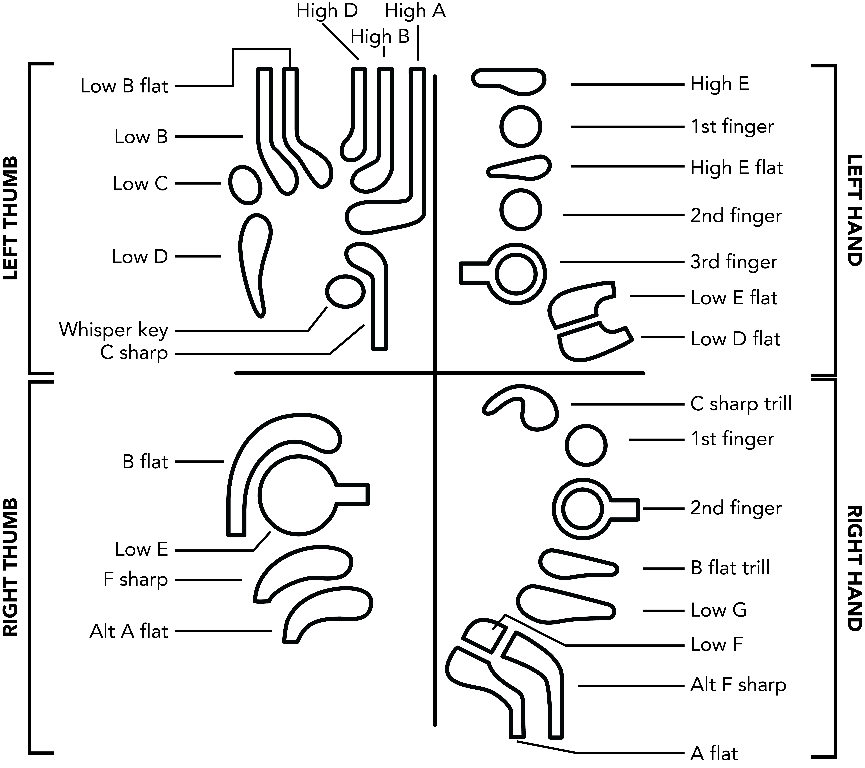

Here are a couple of examples of complete fingering charts. Note that they have been rotated counter-clockwise by 90 degrees:

|  |  |
| --- | --- |
| Macintosh HD:Users:DSpreadbury:Desktop:bassoon-c.png | C: fingeringBsnChart, fingeringBsnChartThumbsHands, fingeringBsnLH1stFingerClosed, fingeringBsnLH2ndFingerClosed, fingeringBsnLH3rdFingerClosed, fingeringBsnRH1stFingerClosed, fingeringBsnRH2ndFingerClosed, fingeringBsnRHLowGClosed, fingeringBsnLTLowCClosed, fingeringBsnLTLowDClosed, fingeringBsnRTLowEClosed |
| Macintosh HD:Users:DSpreadbury:Desktop:bassoon-high-g.png | High G: fingeringBsnChart, fingeringBsnChartThumbsHands, fingeringBsnLH1stFingerHalfClosed, fingeringBsnLH2ndFingerClosed, fingeringBsnLH3rdFingerClosed, fingeringBsnLHLowEFlatClosed, fingeringBsnRH1stFingerClosed, fingeringBsnRHLowFClosed, fingeringBsnLTWhisperKeyClosed |