All of the glyphs in this range should have zero width, with all glyphs registered so that they overlay correctly (see examples below).

To construct a fingering chart, first use fingeringClarChart to produce an empty chart for clarinet. To add the low E flat key found on the bass clarinet, next use fingeringClarBassEFlatOpen. To add closed, half-closed, quarter-closed or trill keys to the chart, simply add the relevant glyphs at the same position.

The following diagram shows the disposition of keys in the blank chart.

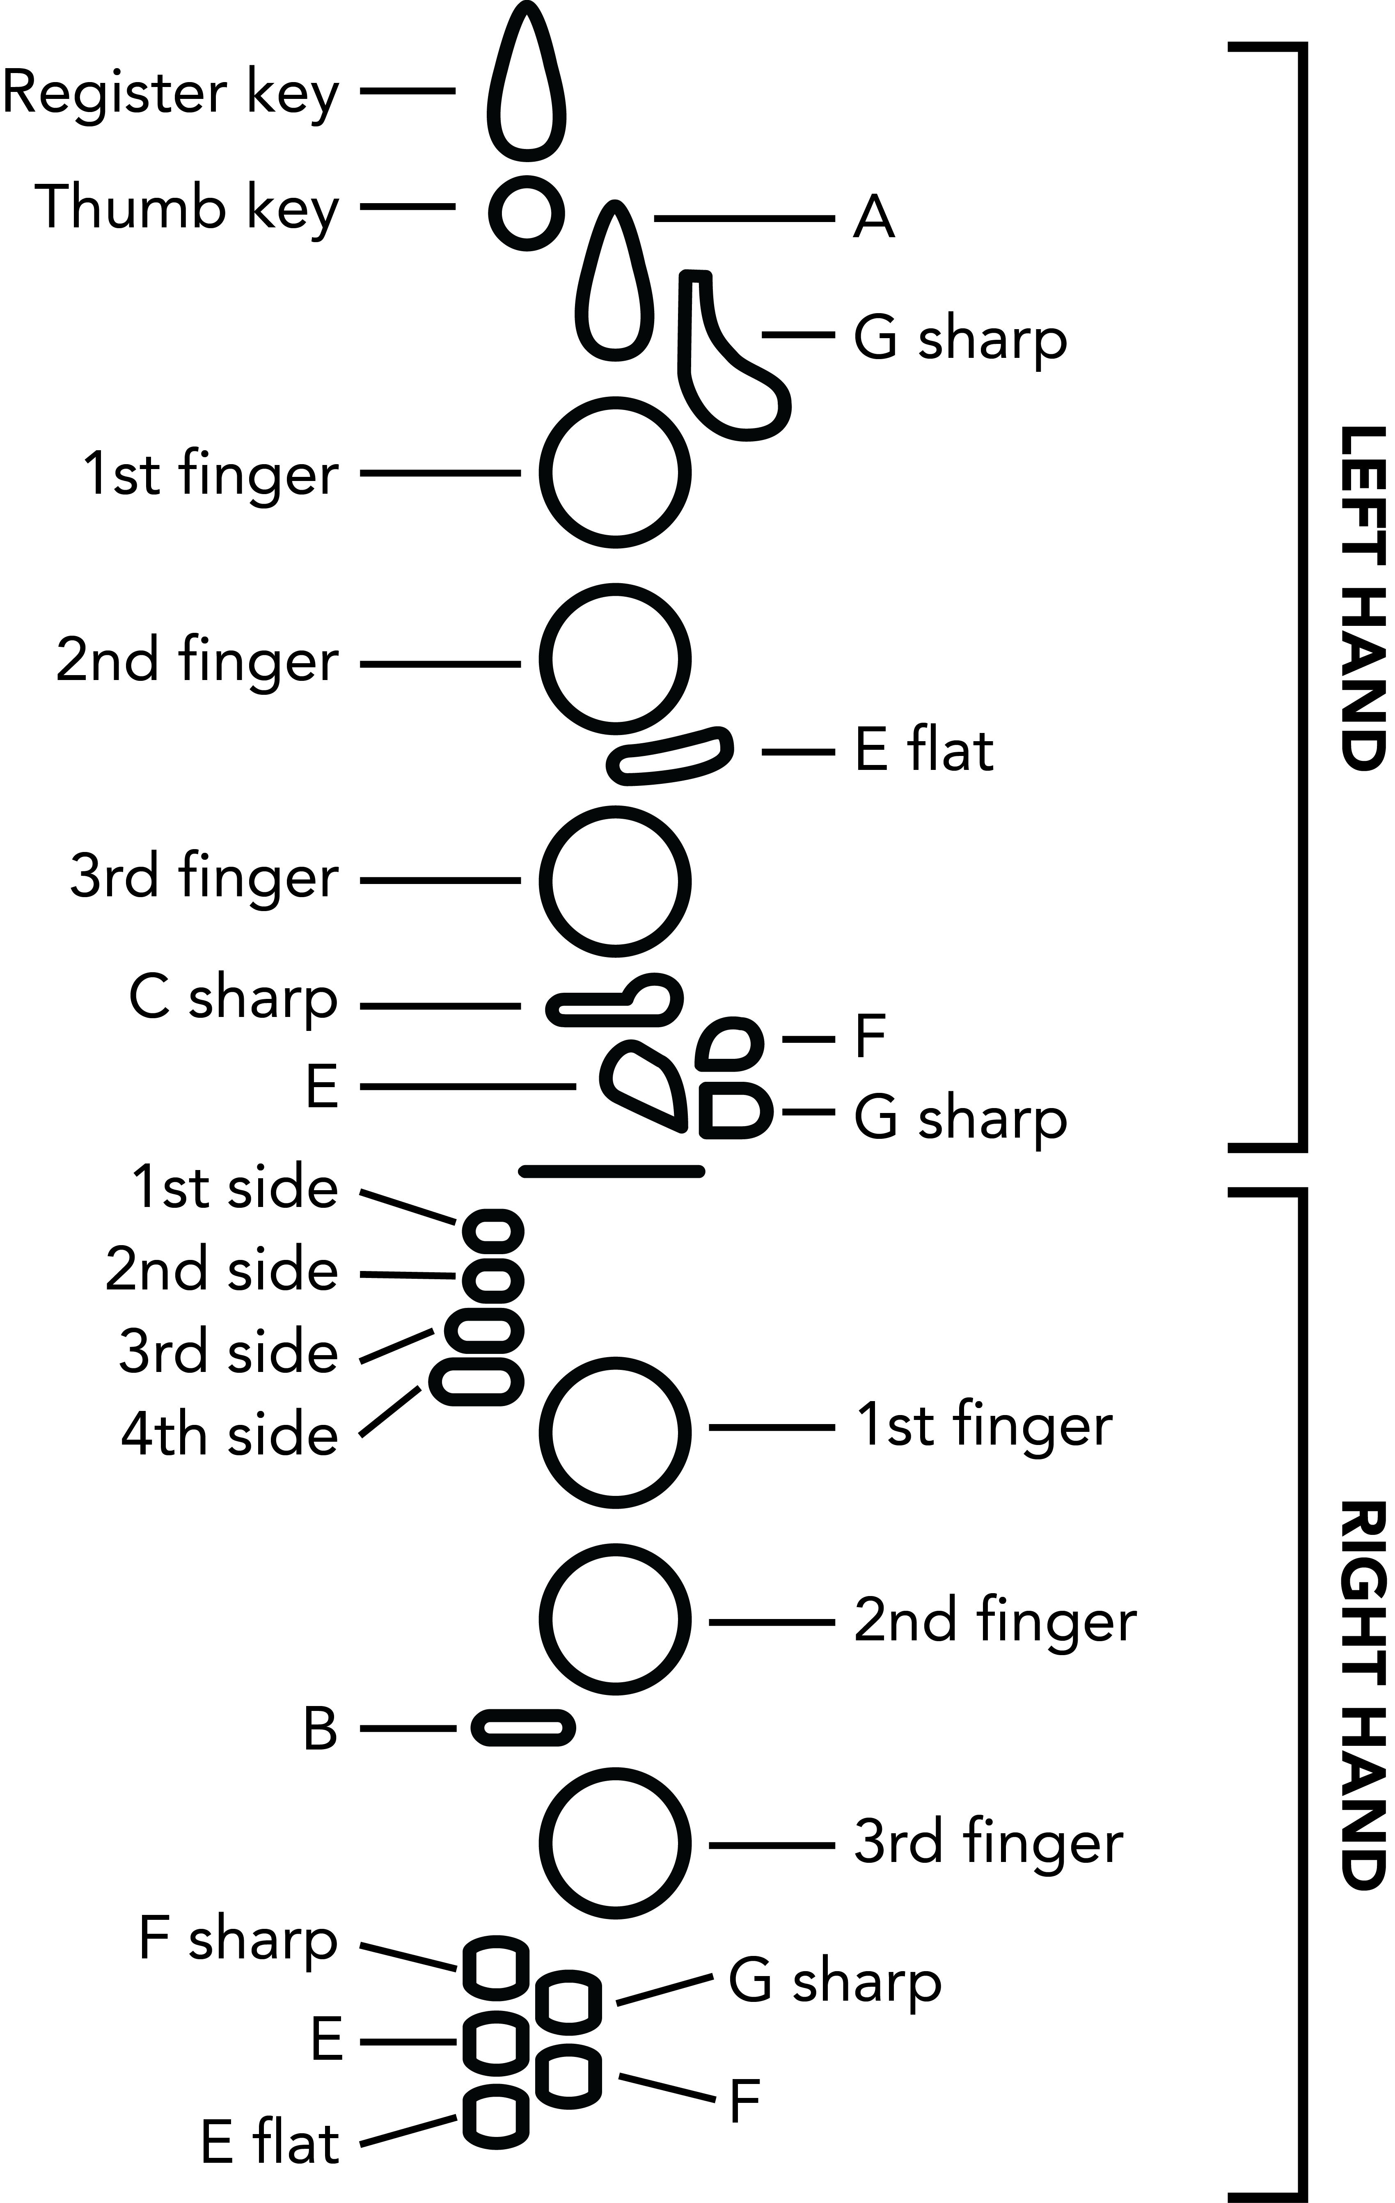

Here are a couple of examples of complete fingering charts. Note that they have been rotated counter-clockwise by 90 degrees:

|  |  |
| --- | --- |
|  | C: fingeringClarChart, fingeringClarLHRegisterClosed, fingeringClarLH1stFingerClosed, fingeringClarLH2ndFingerClosed, fingeringClarLH3rdFingerClosed |
|  | High E: fingeringClarChart, fingeringClarLHThumbClosed, fingeringClarLHRegisterClosed, fingeringClarLH2ndFingerClosed, fingeringClarLH3rdFingerClosed, fingeringClarRHGSharpClosed |