All of the glyphs in this range should have zero width, with all glyphs registered so that they overlay correctly (see examples below).

To construct a fingering chart, first use fingeringFluteChart to produce an empty chart for piccolo with all keys open; add fingeringFluteCFoot to add the low keys from a C foot flute, and add fingeringFluteBFoot to add the additional low B key if necessary.

To add closed, half-closed, quarter-closed or trill keys to the chart, simply add the relevant glyphs at the same position.

The following diagram shows the disposition of keys in the blank chart.

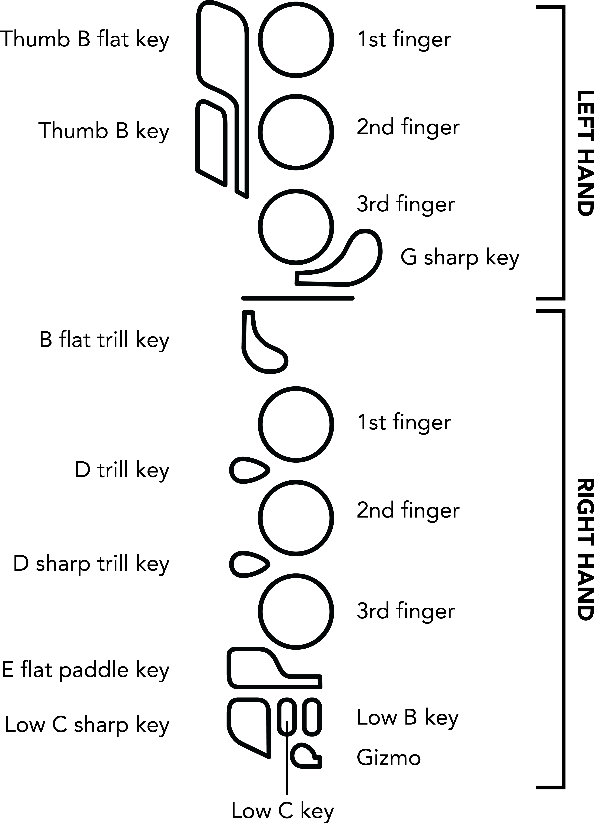

Here are a couple of examples of complete fingering charts. Note that they have been rotated counter-clockwise by 90 degrees:

|  |  |
| --- | --- |
| Macintosh HD:Users:DSpreadbury:Desktop:flute-c.png | C: fingeringFluteChart, fingeringFluteCFoot, fingeringFluteBFoot, fingeringFluteLHThumbBClosed, fingeringFluteLH1stFingerClosed, fingeringFluteLH2ndFingerClosed, fingeringFluteLH3rdFingerClosed, fingeringFluteRH1stFingerClosed, fingeringFluteRH2ndFingerClosed, fingeringFluteRH3rdFingerClosed, fingeringFluteRHCSharpClosed, fingeringFluteRHLowCClosed |
|  | E: fingeringFluteChart, fingeringFluteCFoot, fingeringFluteBFoot, fingeringFluteLHThumbBClosed, fingeringFluteLH1stFingerClosed, fingeringFluteLH2ndFingerClosed, fingeringFluteLH3rdFingerClosed, fingeringFluteRH1stFingerClosed, fingeringFluteRH2ndFingerClosed, fingeringFluteRHEFlatPaddleClosed |