All of the glyphs in this range should have zero width, with all glyphs registered so that they overlay correctly (see examples below).

To construct a fingering chart, first use fingeringRecChart to produce an empty chart. To add closed, half-closed, quarter-closed or trill keys to the chart, simply add the relevant glyphs at the same position.

The following diagram shows the disposition of keys in the blank chart.

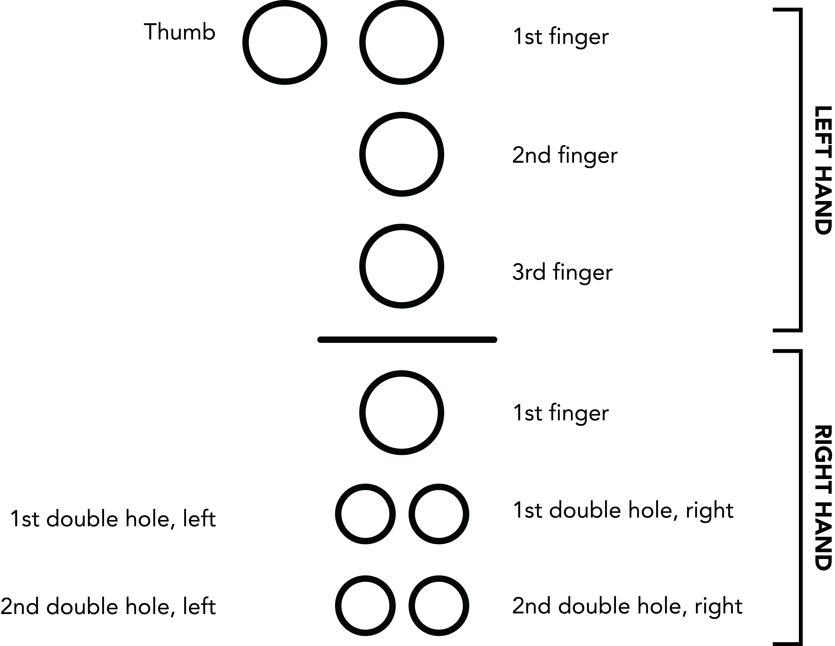

Here are a couple of examples of complete fingering charts. Note that they have been rotated counter-clockwise by 90 degrees:

|  |  |
| --- | --- |
| Macintosh HD:Users:DSpreadbury:Desktop:recorder-c.png | C: fingeringRecChart, fingeringRecLHThumbClosed, fingeringRecLH2ndFingerClosed |
| Macintosh HD:Users:DSpreadbury:Desktop:recorder-g.png | G: fingeringRecChart, fingeringRecLHThumbClosed, fingeringRecLH1stFingerClosed, fingeringRecLH2ndFingerClosed, fingeringRecLH3rdFingerClosed |