**Stephen Yang Project 1: Traffic Collision Rates in Los Angeles**

**Andrea Rosenberger**

**Zoey Charif**

Using Mapping, can we determine ‘hot spots’ or intersections or areas where traffic accidents are statistically frequent?

Are some MO Codes more prevalent than others in collisions? If so, which MO Codes are more common?

Are there Time Periods (days of the weeks, holidays, times of day) where collisions are more prevalent?

One of our missions is to determine whether some collision types are more prevalent than others in North Hollywood’s top ten hotspots. We tracked the frequency of six Collision Types from 2015 – 20

**Vehicle v. Pedestrian Vehicle v. Bike Vehicle v. Vehicle**

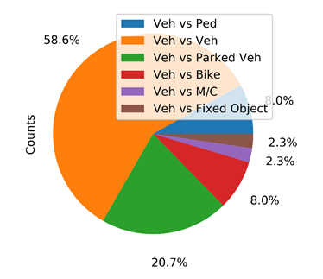**Vehicle v. M/C** (‘motorcycle’) **Vehicle v. Parked Vehicle** **Vehicle v. Fixed Object**

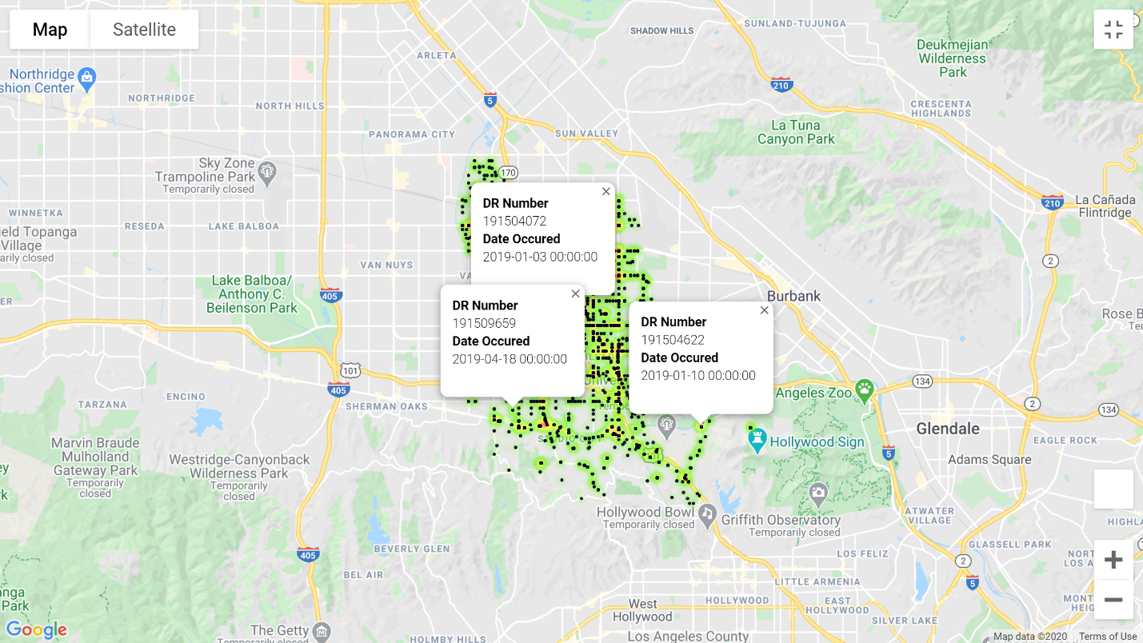

**Figure 2 - MAP** (Stephen)

**Figure 1- PIE CHART** (Zoey)

Based on our analysis, we determined:

* Vehicle vs. Vehicle collisions are the most frequent type.
* The Top 10 hotspots identified by mapping indicate very high percentages, ranging from 58% to 85%.
* The second most prevalent collision is Vehicle vs. Parked Vehicle. In some cases, the percentage was as high as 20%.

The reasons for these accidents are unknown based on the provided data. Additional data and input from the stakeholders will be required.

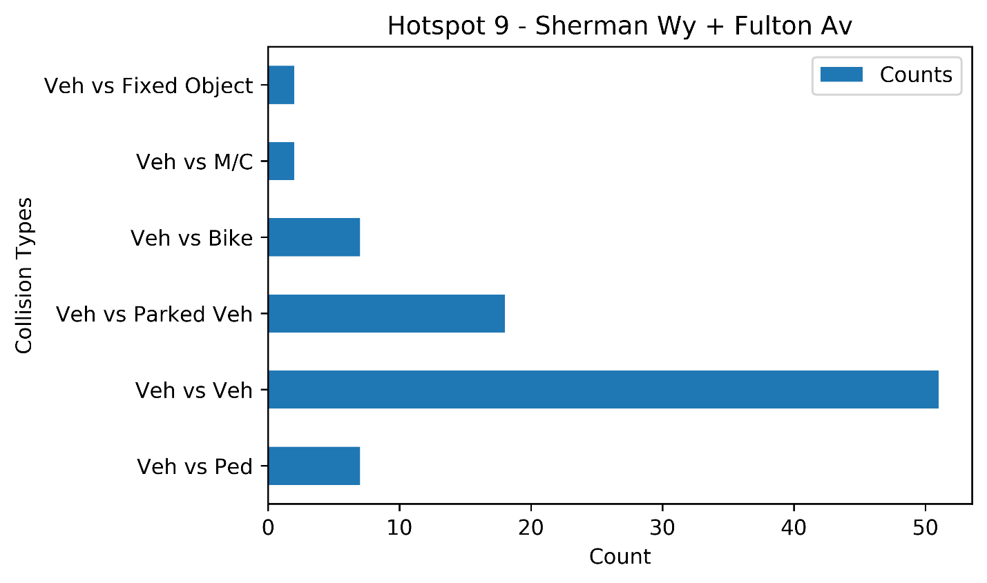

Periods of Time proved difficult to code as the original dataset was not formatted to a transferable timestamp. The times of days were entered as whole numbers from 0 – 2400. The formulas to address this proved difficult to work with and time was short. More work is needed.

We successfully tested for the number of collisions that occurred on Federally recognized or/and popular holidays. We also included some holiday-adjacent days, where we expected more vehicle traffic to occur and, potentially, the collision rates to be higher.

|  |  |  |  |  |  |
| --- | --- | --- | --- | --- | --- |
| **HOLIDAY** | **2015** | **2016** | **2017** | **2018** | **2019** |
| New Year's | 2015-01-01 | 2016-01-01 | 2017-01-02 | 2018-01-01 | 2019-01-01 |
| Martin Luther King Jr. | 2015-01-19 | 2016-01-18 | 2017-01-16 | 2018-01-15 | 2019-01-21 |
| President's | 2015-02-16 | 2016-02-15 | 2017-02-20 | 2018-02-19 | 2019-02-18 |
| St. Patrick’s* | 2015-03-17 | 2016-03-17 | 2017-03-17 | 2018-03-17 | 2019-03-17 |
| Cinco De Mayo* | 2015-05-05 | 2016-05-05 | 2017-05-05 | 2018-05-05 | 2019-05-05 |
| Memorial | 2015-05-25 | 2016-05-30 | 2017-05-09 | 2018-05-28 | 2019-05-27 |
| Independence | 2015-07-03 | 2016-07-04 | 2017-07-04 | 2018-07-04 | 2016-07-04 |
| Labor Day | 2015-09-07 | 2016-09-05 | 2017-09-04 | 2018-09-03 | 2019-09-02 |
| Columbus | 2015-10-12 | 2016-10-10 | 2017-10-09 | 2018-10-08 | 2019-10-14 |
| Veterans | 2015-11-11 | 2016-11-11 | 2017-11-10 | 2018-11-12 | 2019-11-11 |
| Thanksgiving | 2015-11-26 | 2016-11-24 | 2017-11-23 | 2018-11-22 | 2019-11-28 |
| Thanksgiving Day After* | 2015-11-27 | 2016-11-25 | 2017-11-24 | 2018-11-23 | 2019-11-29 |
| Christmas Eve* | 2015-12-24 | 2016-12-24 | 2017-12-24 | 2018-12-24 | 2019-12-24 |
| Christmas | 2015-12-25 | 2016-12-26 | 2017-12-25 | 2018-12-25 | 2019-12-25 |
| Christmas Day After* | 2015-12-26 | 2016-12-27 | 2017-12-26 | 2018-12-26 | 2019-12-26 |
| * not a Federally recognized holiday | | | | | |

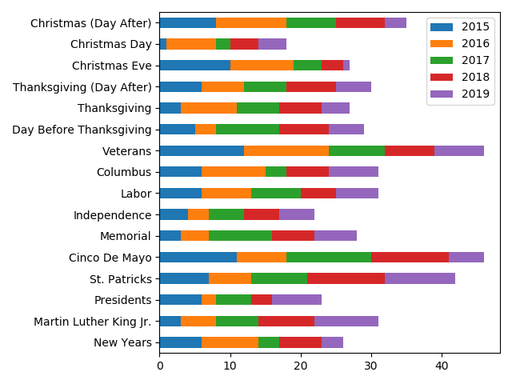Among the selected holidays and holiday-adjacent days, Veteran’s Day, Cinco de Mayo and St. Patrick’s Day experienced the most traffic collisions between 2015 – 2019. Although one could immediately hypothesize the potential factors surrounding these holidays, these elements are not included in this data set and further analysis is required.