ForNextDay(7)

Stephen Cole

twodee.c

#include<stdio.h>

#define LENGTH 5

#define WIDTH 3

int main(void)

{

int iArr[LENGTH][WIDTH];

int i;

int j;

for(i=0;i<LENGTH;i++){

for(j=0;j<WIDTH;j++){

iArr[i][j] = 0;

}

}

printf("iArr[4][2] = %d\n", iArr[4][2]);

return 0;

}

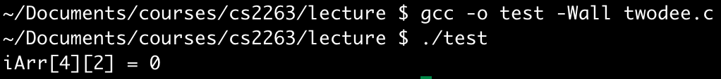

makefile

