# Design of a Portable Speaker Box

In this project we will be designing and building a portable speaker box. The following are the requirements of the system:

1. Must support Bluetooth connectivity
2. System should use a battery pack with a playtime of 4-5 hours
3. System’s battery pack should be charged using the mains power
4. System should be able to switch between battery power and mains power for operation.
5. Must achieved 45-50 Hz
6. Must fit in a backpack with dimensions approximately 17 by 11 by 5.5 inches.
7. Can connect an external speaker

These requirements will be achieved in a systematic manner. Therefore, let us start by observing the amplifier of choice.

## Speakers

In order to choose the amplifier, we need to determine the number of speakers the system will require. After some research two speakers, the tang bang W5 and Dayton audio PS95 speakers were chosen by examining the frequency spectrum of each (which is shown in the appendix). Each of the spectrums were loaded into VituixCad after which it was observed that the cross over point was approximately 122Hz leading to the spectrum (black) in figure 1.

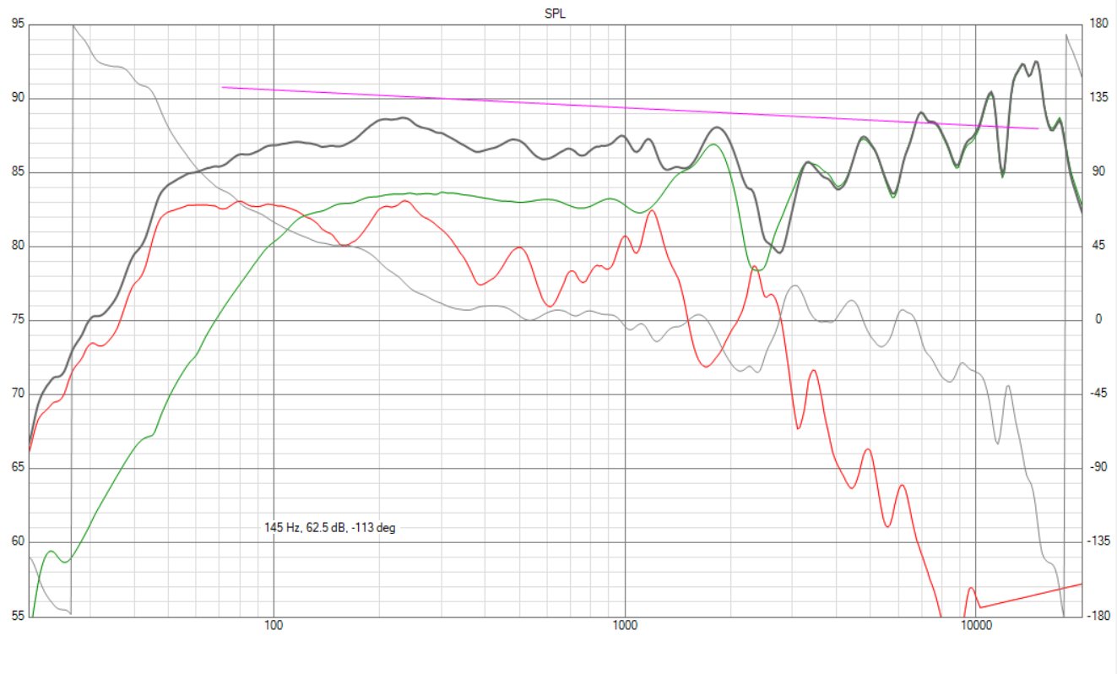

Figure : Showing the Frequency Spectrums of the Speakers

From figure 1, it is observed that the system will be able to produce audible sound at 45-50Hz thus, requirement 5) will be accomplished. From the speaker specifications, the RMS power are 10 and 40 watts for the full-range and woofer, respectively. The amplifier chosen should be able to deliver at least twice the RMS power.

## Amplifier Choice

In this design we are using two speakers therefore we will need a two-channel amplifier. After research, the TPS3116D2 amplifier seems suitable and the specs are in the appendix. This amplifier has 3 channels one of which is “bridged” which will be used to power the woofer. One of the other channels will be used to power the full-range driver and the external speaker. From the appendix, to achieve the maximum power from the amp it must be powered using 24V. This will lead to two channels outputting 50 watts and one channel outputting 100-watts thus; the amp can deliver twice the RMS power of the speakers.

## Power

The speaker system will be using a battery pack to power the amplifier. To create the battery pack, we will be using li-ion batteries as they have a higher power density than Ni-MH.

|  |  |  |  |  |  |
| --- | --- | --- | --- | --- | --- |
| Battery | Voltage | Current Capacity | Quantity | Specs | Cost |
| PrettyW Lithium | 3.7V | 3400mAh | 8 | 14.8V @ 6800mAh – 2.25 hr | $360 |
| Flashlight - li | 3.7V | 3000mAh | 16 | 14.8V @ 12000mAh – 4hr  18.5V @ 9000mAh – 3hr | $352 |

From the spec sheet of a Li-ion battery it has a voltage of 3.7V and a current rating of 3000mAh. This current rating implies that the battery can supply 3A for one hour at 3.7V. Using option B seems most feasible as it will cost less and we will get better performance from the battery pack.

To ensure that the batteries are charged and discharges properly, we will need to use a battery management system, BMS. This device ensures that all battery cells are within safe voltage ranges i.e. they are not overcharged etc. After some research, Daier 5S 50A BMS board seem most suitable for board it price and characteristics (it has short circuit protection, temperature cut-off and power failure protection). This device is capable of charging the Li-ion batteries to 4.2V which will lead to an input of 21V. However, to minimize the cost of the build, we can use an 20V laptop charger as these already have an AC to DC converter. It is important to note, that we must exam the charge current of the laptop charger as we do not want it to exceed the charging current of the BMS. In this case the charging current of the BMS is 20A or 50A which is much higher than any laptop charger.

Now to connect the laptop charger an adaptor will be need for the specific charging pin. In this case we are using the Lenovo yoga 720

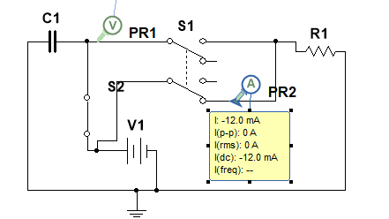

## Box Design

In the designing of the enclosure a simulation software, WINISD will be used. For the box design we will be looking at a ported design or a passive radiator. Based on the requirements, the maximum volume of the box will be 16.8 liters however, only a fraction of this will be usable due to speakers, battery, and PCB modules taking up space. Let us leave 5.8 liters or 415-inch cube of space for the components which leaves 11 Liters.

|  |  |  |  |
| --- | --- | --- | --- |
| PARAMETER | PORTED | PASSIVE | |
| DSA215-PR 8" | DSA270-PR 10" |
| Box | 11 | 11 | 11 |
| Tuning freq | 35.95 | 45.44 | 64.43 |
| Vent – diameter  - length  - Rear port velocity | 2.1 inches |  |  |
| 44 cm |  |  |
|  |  |  |
| Passive Radiator – mass   * Fs(with kg) |  | 0.02 | 0.25 |
|  | 22.45 | 11.19 |
| -3db | 31.46 | 40.68 | 32.39 |
| Cone Excursion | 29.38 | 33.76 | 30 |

From the results above, in order to keep the box small, we will use a passive radiator. Either of the passive radiators can work as they can be tuned using weights to achieve similar results. Using the following formula, we can calculate the maximum spacing between drivers:

Therefore, we can place the speaker any distance apart on the box since the length is 17 inches. However, since we will like the woofer to compliment the full-range driver at 2628 Hz using the formula above we can place the drivers a maximum of 5.1 inches (from center to center). The total volume now is 15.86 liters and is reduce to 15.19 liters after considering the size of the drivers. So the final box dimensions will be 17 by 12 by 6.5 inches.

## Cone excursion

This is where the speaker may vibrate more than the XMAX which can lead to damaging of the speaker/s. Therefore, we can use a high pass filter to allow the frequencies that would not cause any damage. The following is the graph before any filter is added where the red line is the XMAX and yellow cone excursion.

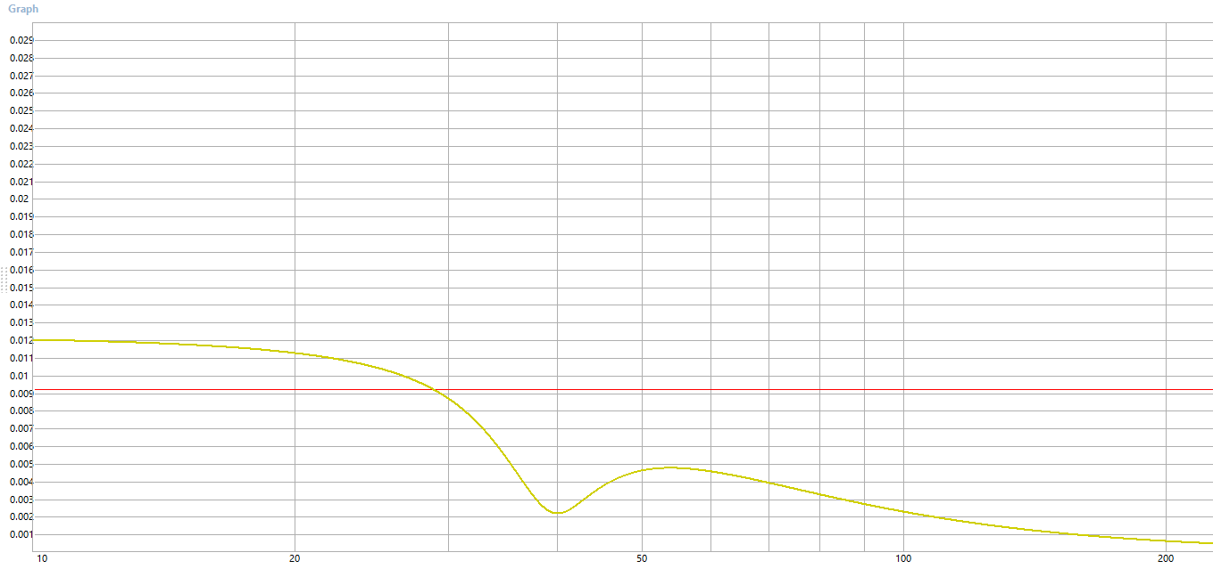

The following is the graph after the high pass filter is added.

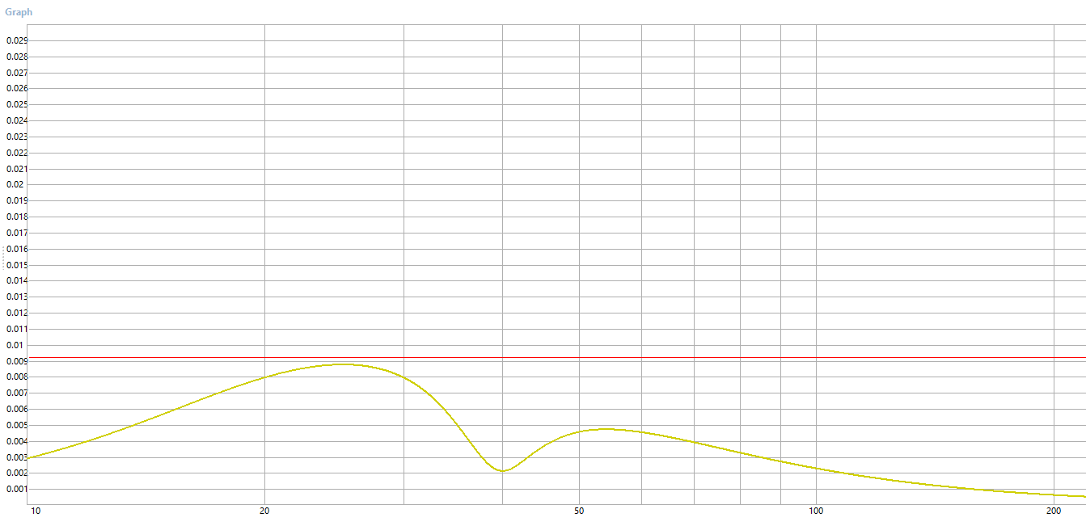

From the above graph we can see that the cone excursion is below the Xmax which is what we desire. The high pass filter used was second order Butterworth with a center frequency of 20Hz. So now, we need to design this filter. A simple second order high pass filter circuit is as follows:

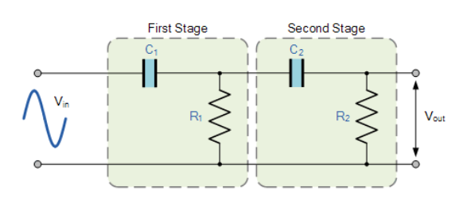

Using the simulation software, Vituix cad we can get some values. The following will be the circuit cross-over circuit and high pass circuit for the sub-woofer.

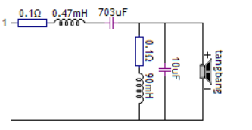

## Added Protection

After some research, I discovered resettable fuse or polyswitch. This is a passive electronic component used to protect against overcurrent faults in electronic circuits. They are relatively inexpensive and will protect the speakers from any faults. Before we size this fuse we need to determine using power equation maximum current and voltage of the speakers.

*Tang bang*

The tang bang speaker is rated for 40W @ 4ohms. Therefore,

*RS100*

This speaker is rated 30W @ 4ohms. Therefore,

Therefore, we need to limit the current to 3.16 A and 2.73 A.

Cross-over @ 198Hz

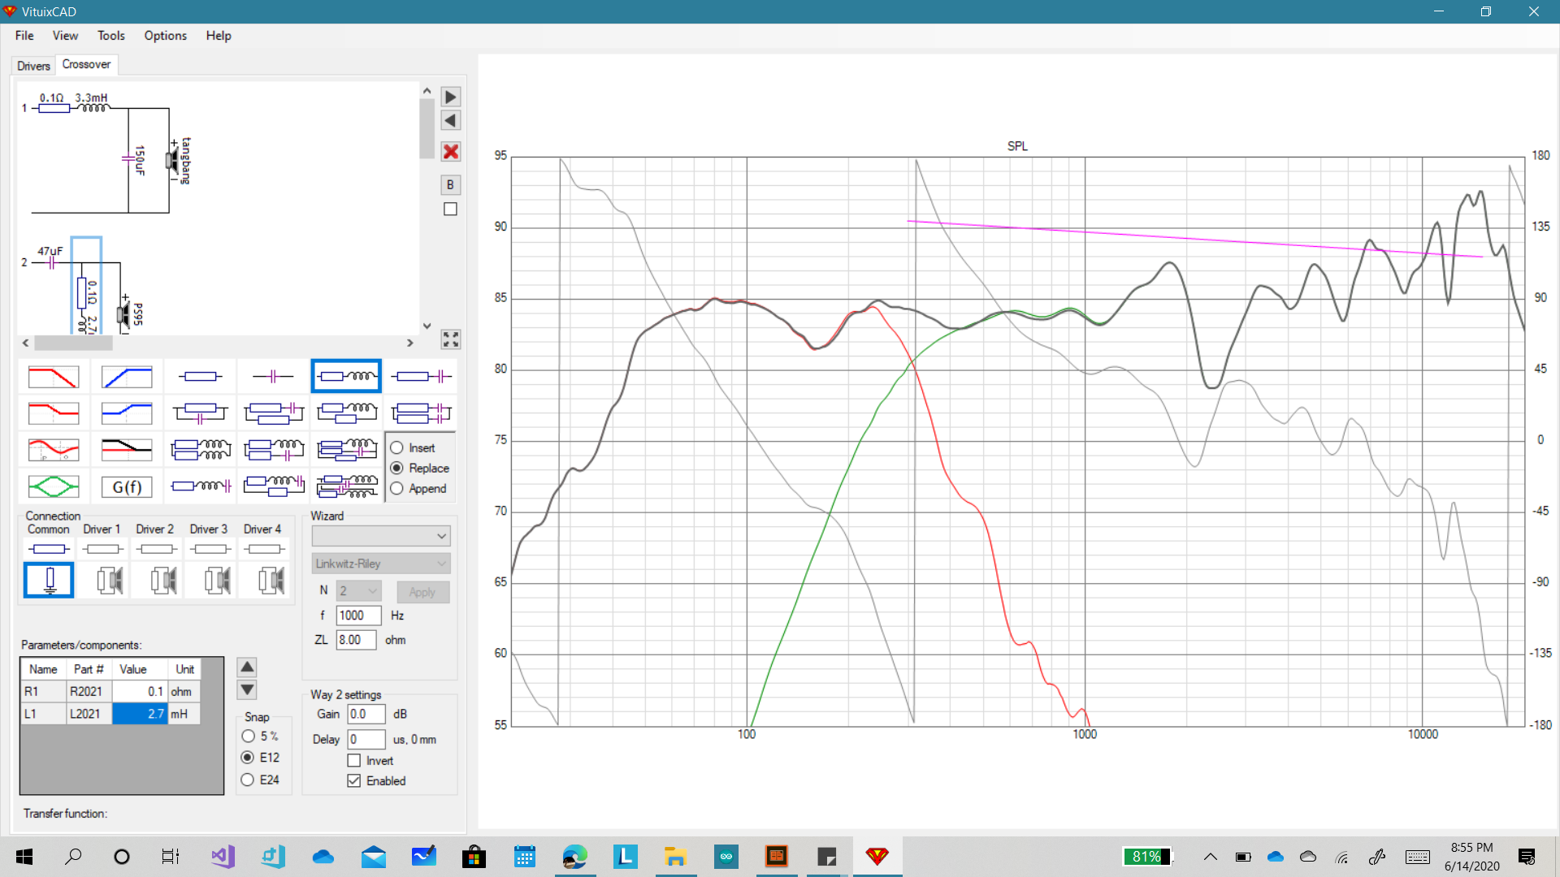

Cross-over @ 116Hz

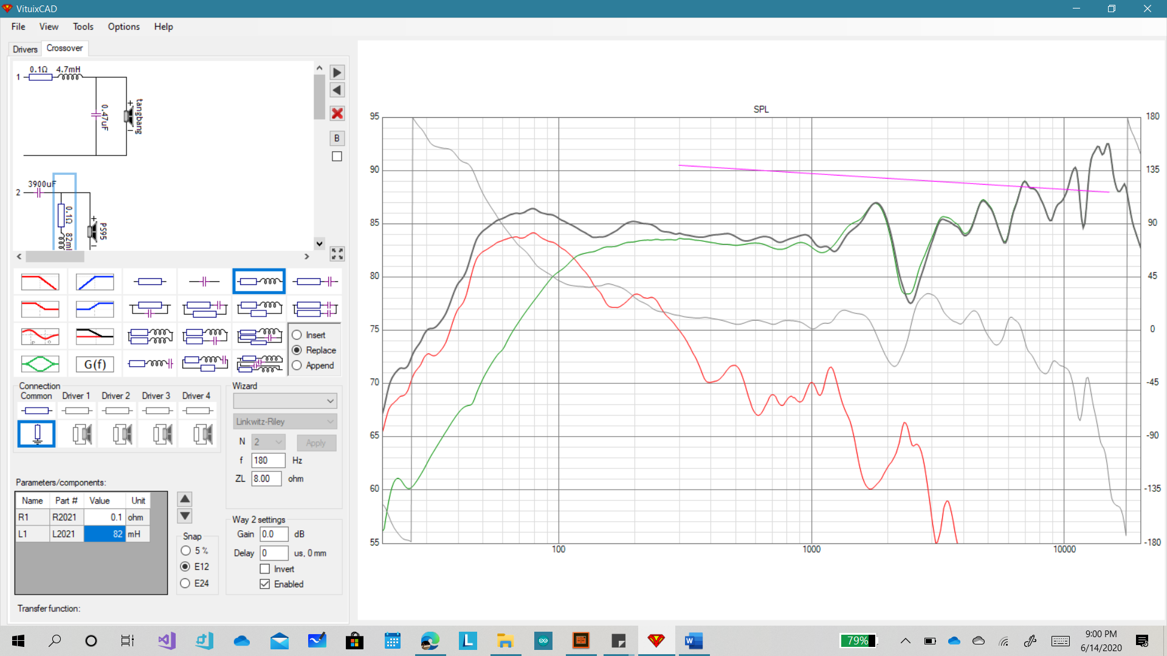

Crossover @ 123Hz – could include a notch filter for at the higher frequencies to get a more even frequency response.

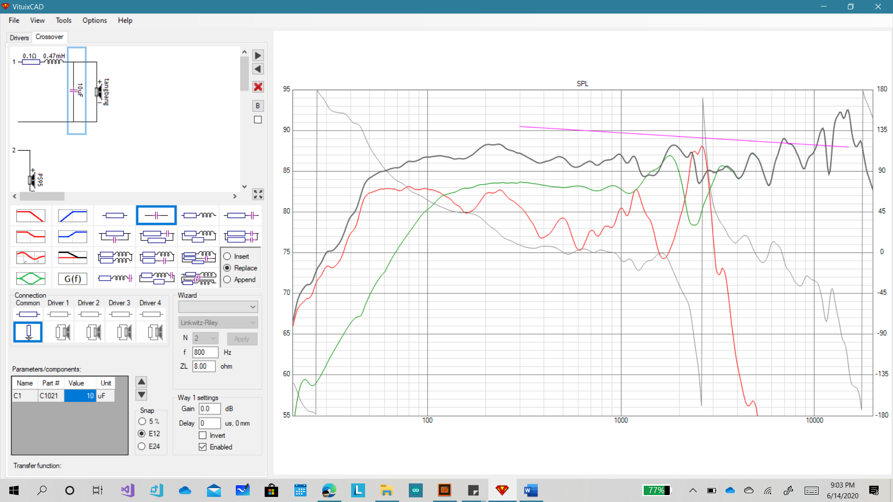

Power Specs of the amplifier

What we could do is make it portable by having a switch to change it from “wall power” to battery power. The battery power will underpower the speakers and will not sound as loud. The wall power should achieve the 100- and 50-watts output using the following AC to DC converter:

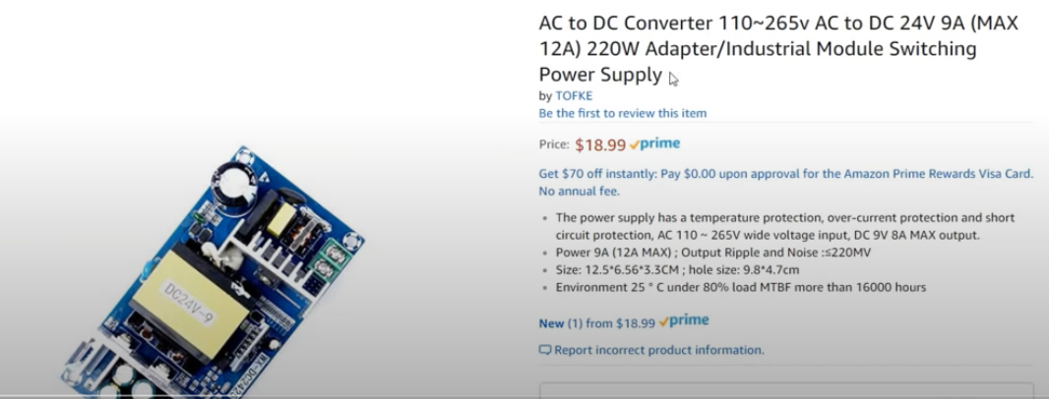

Parts needed:

1. Tang bang W5 speaker
2. Dayton PS95

# Appendix 1

Frequency Response for Dayton Audio (PS95 point source speaker)

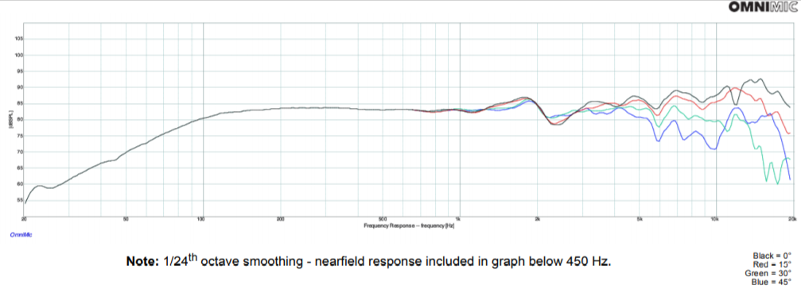

Frequency Response for Dayton Audio (PS95 point source speaker)

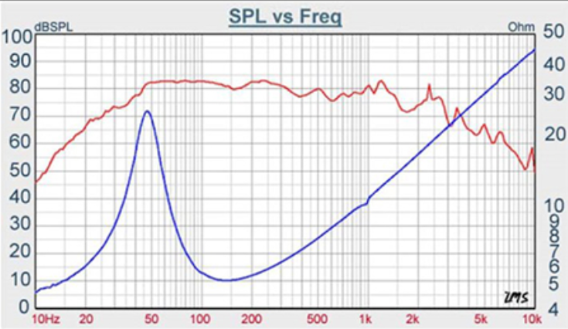

**Amplifier Chosen**

Make your own 2.1 multimedia wireless Bluetooth amplifier or portable speaker with this 2 x 50W + 100W amplifier board. The board accepts 12 VDC to 24 VDC which makes it perfect for making home or mobile audio projects. Make your audio project truly portable by adding three to five 18650 Li-Ion batteries.

These boards are pre-tested and pre-assembled, which makes your project easy to complete. The on-board jacks, potentiometer, and screw terminals let you get this board powered up and playing music in minutes. Just connect your power source using a 2.1 x 5.5 mm DC power plug, a 3.5 mm stereo audio source, and run speaker wire from the six screw terminals to you speakers and you're done. For the most wattage output use [120-055](https://www.parts-express.com/--120-055)24 VDC power adapter. If you don't want to use the 3.5 mm jack, an optional 3-pin connector for internal line-in audio is available (wiring harnesses not included). Push and hold in the master volume control for three seconds to switch from Bluetooth to line-in source. Push in master volume control to switch back to Bluetooth. Use the built-in 150 Hz high pass filter switch on the board to protect your satellite speakers.

**Specifications:** • Power output: 2 x 50W + 1 x 100W @ 4 ohms • Impedance: 4Ω for satellites and 3-4Ω for subwoofer • Chip: TPA3116*2 • SNR: 100 dB • Frequency response: 20-20,000 Hz • Signal input: 3.5 mm stereo jack or 3-pin socket • Signal output: 6 screw terminals • Power requirements: 12-24 VDC • Maximum current draw 3A • Quiescent current: 60 mA • Power input: 2.1 mm x 5.5 mm DC jack • Dimensions (not including potentiometer): 3.94" W x 0.9" H x 3.94" D • Potentiometer shaft length: 0.6" and master volume 0.64" without knobs.

