**Port Scanner**

It is a powerful networking enumeration tool for scanning open and closed ports.

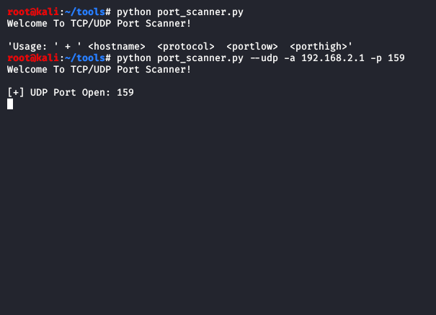

**Modules**

UDP- Scanning ports using UDP protocols

TCP- Scanning ports using TCP protocols

**Commands**

**python portscanner.py -a 192.168.43.224 -p 21,22,80 --udp**

**-a:** Specifies the host address

**-p:** Specifies the port

**--udp**: UDP protocol

**--tcp**: TCP protocol

**Installing**

$ sudo apt-get update && sudo apt-get install python3 python3-pip -y

$ git clone [“github URL repository”]

$ cd portScanner/

$ chmod +x portscanner.py

**Usage**

Python3 portscanner.py

**Disclaimer**

I will not be held responsible for any misuse of the program in violation of the laws. Program to be used for education purposes only