PM ‘always willing to engage’ with MEPs

Keith Schembri silent on whether he would be willing to meet delegation
Saturday, November 25, 2017, 08:50
PATH: https://www.timesofmalta.com/articles/view/20171125/local/pm-always-willing-to-engage-with-meps.663969
INDEX: MEPs, EU, Muscat, Schembri, international oversight

by Claire Caruana

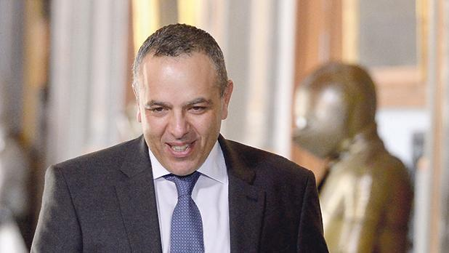
Keith Schembri
Prime Minister Joseph Muscat was “always willing to engage” with members of the European Parliament, a government spokesman said ahead of a fact-finding mission to Malta by MEPs next week.
The Times of Malta reported earlier this week that during their visit, when they would be evaluating the prevailing situation with regard to the rule of law, the MEPs would ask to meet with Dr Muscat and his chief of staff, Keith Schembri.
When approached about this, the spokesman said the government had not yet been officially informed when the delegation would be arriving. Invitations for meetings had still to be received, he added.
The spokesman said Dr Muscat was “always ready to engage”. However, no reply was forthcoming on whether Mr Schembri would be willing to meet the delegation as well.
Mr Schembri has repeatedly refused to appear before any European committees despite his name featuring in the Panama Papers leaks and the MEPs urging the Prime Minister to ask Mr Schembri to meet with them.
During their two-day visit, the Euro-parliamentarians also plan to meet the Police Commissioner, the Attorney General, the Chief Justice, the Malta Financial Services Authority, the Financial Intelligence Analysis Unit, Pilatus Bank and Nexia BT.
The MEPs also intend to speak to Maltese journalists, activists and NGOs.
The visit by the MEPs was triggered by Daphne Caruana Galizia’s murder on October 16, which provoked a debate on the rule of law on the island.
A 90-minute debate on the rule of law in Malta took place at the European Parliament last week, when members of the European Parliament voted in favour of a resolution asking the European Commission to initiate a dialogue with the Maltese government on the matter.

