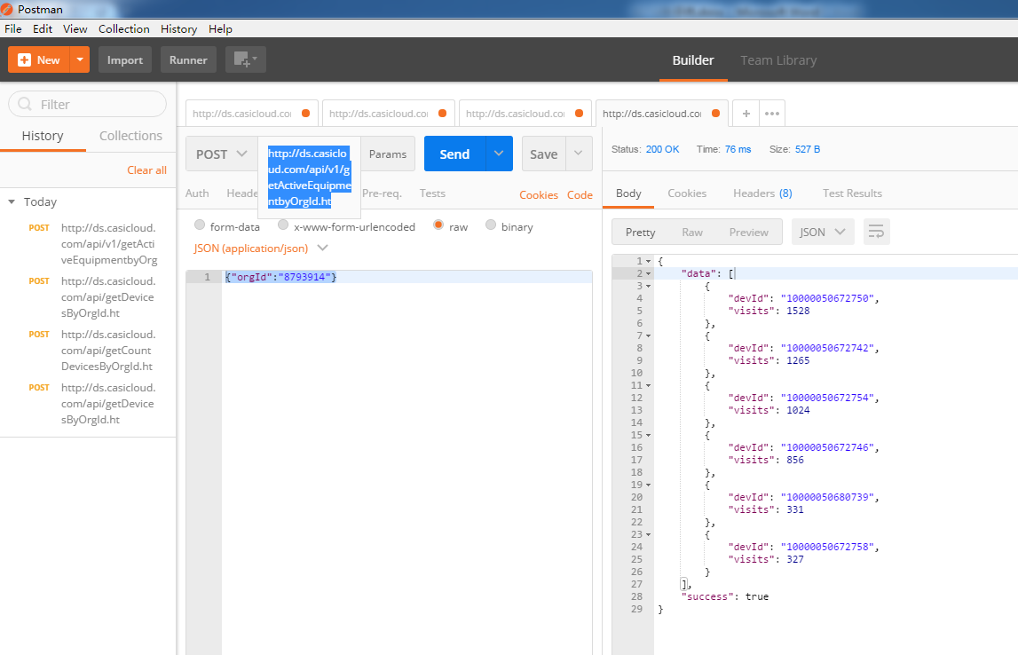

以上示例为postman调用接口的展示，以下为java代码获取数据

String url = "http://ds.casicloud.com/api/v1/getActiveEquipmentbyOrgId.ht";

Map<String,Object> param = **new** HashMap<String,Object>();

param.put("orgId", "8793914");

String result = HttpClientUtils.*sendPost*(url, JSON.*toJSONString*(param));

Gson gson = **new** Gson();

DeviceForGson deviceForGson = gson.fromJson(result, DeviceForGson.**class**);

**boolean** success = deviceForGson.isSuccess();

List<DeviceActive> data = deviceForGson.getData();

以下为根据接口构建的实体类用来接数据

**public** **class** DeviceForGson {

**private** List<DeviceActive> data;

**private** **boolean** success;

**public** DeviceForGson(List<DeviceActive> data, **boolean** success) {

**super**();

**this**.data = data;

**this**.success = success;

}

**public** DeviceForGson() {

**super**();

}

**public** List<DeviceActive> getData() {

**return** data;

}

**public** **void** setData(List<DeviceActive> data) {

**this**.data = data;

}

**public** **boolean** isSuccess() {

**return** success;

}

**public** **void** setSuccess(**boolean** success) {

**this**.success = success;

}

@Override

**public** String toString() {

**return** "DeviceForGson [data=" + data + ", success=" + success + "]";

}

}

以下为根据接口返回数据构建对象

**public** **class** DeviceActive {

**private** String devId;

**private** Integer visits;

**public** DeviceActive(String devId, Integer visits) {

**super**();

**this**.devId = devId;

**this**.visits = visits;

}

**public** DeviceActive() {

**super**();

}

**public** String getDevId() {

**return** devId;

}

**public** **void** setDevId(String devId) {

**this**.devId = devId;

}

**public** Integer getVisits() {

**return** visits;

}

**public** **void** setVisits(Integer visits) {

**this**.visits = visits;

}

@Override

**public** String toString() {

**return** "DeviceActive [devId=" + devId + ", visits=" + visits + "]";

}

}