CNS HIAA

KPI Notifications & Alerts
  - End-User Guide and Microsoft 365 / Power Automate Administration Manual
FOR USERS  Choose KPI subscriptions, thresholds and delivery channels. | FOR IT  Configure Entra ID, Outlook, Teams, Power Automate and monitoring. | FOR OPERATIONS  Deliver consistent, auditable alerts from KPI status changes.
Version 1.0 | July 2026
Implementation status The in-dashboard inbox, subscriptions, profile, snapshot comparison, deduplication and manual evaluation are implemented. Outlook email, Teams delivery and production scheduling require the Phase 3 configuration described in Part 2.

How to use this manual
This manual is divided into two practical parts. Application users should begin with Part 1. IT administrators and solution owners should use Part 2 to enable Microsoft 365 delivery and production operations.
Part | Audience | Purpose
Part 1 | All dashboard users | Set personal notifications, review alerts and manage subscriptions.
Part 2 | IT administrators / developers | Configure Entra ID, Outlook, Teams, Power Automate, security and support.
Appendices | IT / audit / support | Payload examples, test cases, operational checklist and references.

Power Automate compatibility Yes. The current design can integrate with Power Automate because alert evaluation and delivery are already separated and protected behind interfaces. The recommended production pattern is to keep alert creation in the application, then let Power Automate process queued delivery records or receive a server-to-server webhook. Do not expose a reusable flow URL or shared secret in browser code.

  - PART 1

User Guide: Set and Manage Your Notifications

1. What notifications do
The Notifications area lets each signed-in user decide which KPI changes they want to follow. A notification is created when a monitored KPI or the overall portfolio changes status, worsens, recovers, or moves between configured alert bands. The dashboard inbox is the authoritative record of alerts generated by the application.
- Dashboard notifications are available immediately in the application.
- Email and Microsoft Teams options become available after IT enables those channels.
- Your choices are stored against your signed-in Entra ID profile when production identity is enabled.
- A first evaluation creates a silent baseline so users are not flooded with historical alerts.
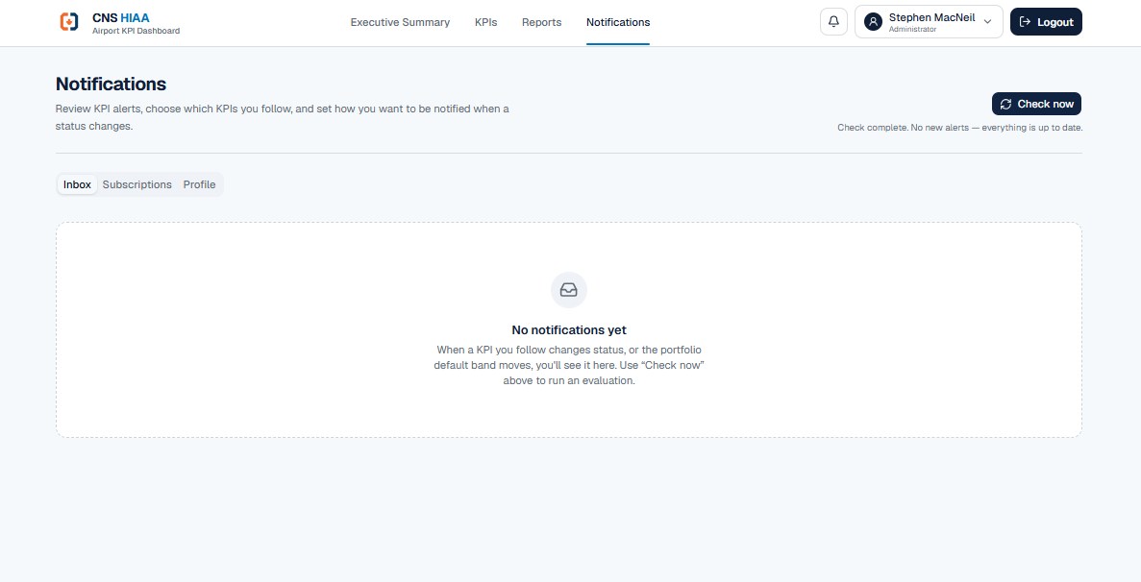
Figure 1. Notifications inbox with manual “Check now” evaluation and no new alerts.

2. Open Notifications
1 | Sign in: Open the CNS HIAA Airport KPI Dashboard using your normal organizational account.

2 | Open Notifications: Select Notifications in the top navigation, or select the bell icon and then View all notifications.

3 | Choose a tab: Use Inbox to review alerts, Subscriptions to choose what you follow, and Profile to verify your account and role.

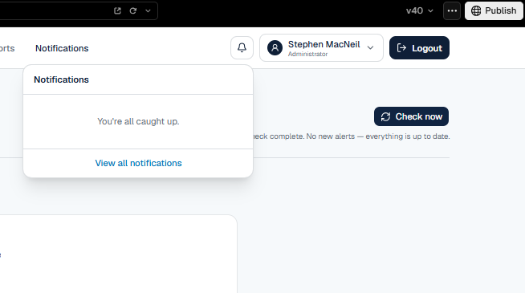
Figure 2. Header notification bell and quick notification panel.

3. Configure your subscriptions
1 | Open Subscriptions: Select the Subscriptions tab.

2 | Choose portfolio alerts: Enable Dashboard under Overall portfolio status to follow the combined KPI status.

3 | Choose individual KPIs: Enable Dashboard beside each KPI you are responsible for or need to monitor.

4 | Choose a minimum severity: Select Info, Warning or Critical. The system should deliver only alerts at or above your selected threshold.

5 | Choose delivery channels: Use Dashboard now. Enable Email and Teams after IT activates the associated feature flags and Microsoft 365 connections.

6 | Save and confirm: Save the subscription changes and revisit the page to confirm the selections persisted.

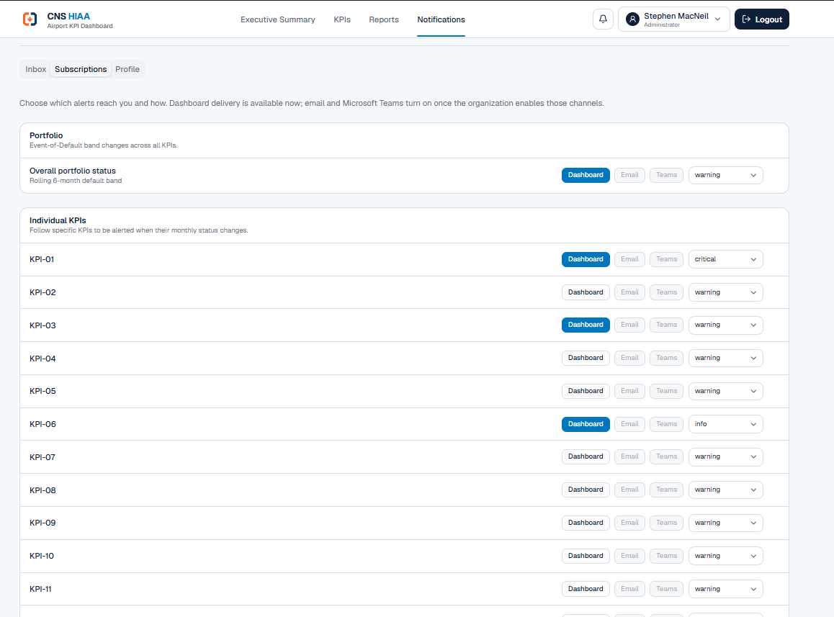
Figure 3. Subscription controls for portfolio status and individual KPI-01 through KPI-21.
Threshold | Use it when | Typical result
Info | You need visibility into all status changes, including low-impact changes. | Highest message volume.
Warning | You need operational exceptions and worsening performance. | Recommended default for most KPI owners.
Critical | You only need urgent or damage-point-level conditions. | Lowest volume; highest urgency.

Recommended user setting KPI owners should subscribe to Dashboard alerts for their assigned KPIs at Warning. Operational managers may also subscribe to Overall portfolio status. Critical-only is best for executives who want urgent exceptions rather than routine changes.

4. Review and manage alerts
- Unread alerts appear in the inbox and increase the bell badge count.
- Open an alert to review the KPI, status transition, severity, timestamp and message.
- Use Mark as read after reviewing an alert, or Mark all as read when the inbox has been triaged.
- Use Check now only when you need an immediate evaluation. Production scheduling will normally run automatically.
- A recovery alert confirms that a KPI has improved from a worse band to a better band.
No notification appears? Confirm that the KPI is enabled under Subscriptions, the severity threshold includes the event, and the status actually changed after the baseline was created. Contact IT if the dashboard channel is enabled but no delivery is recorded.

5. Verify your profile
The Profile tab shows the identity and role currently used by the application. In development, this may be a test identity. In production, the profile should be populated from Microsoft Entra ID and mapped to the dashboard role model.
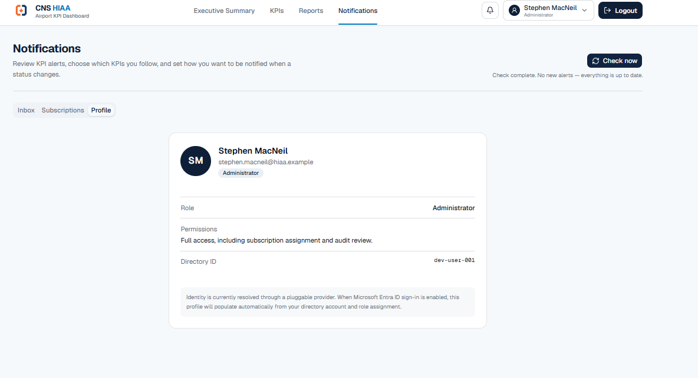
Figure 4. Profile view showing user identity, application role and directory identifier.
Role | Expected access
Viewer | Read dashboards and manage personal notification preferences.
KPI Owner | Viewer access plus responsibility for assigned KPIs and related alerts.
Manager | Broader portfolio visibility and operational reporting access.
Administrator | Full access, user/role support, subscription assignment and audit review.

6. User responsibilities
- Keep subscriptions limited to KPIs relevant to your responsibilities.
- Do not rely on email alone; the dashboard inbox remains the source of record for application alerts.
- Review warning and critical notifications promptly and follow the applicable operational process.
- Report incorrect KPI status or duplicate notifications to IT with the KPI number, time and screenshot.

  - PART 2

IT Administration: Microsoft 365 and Power Automate

7. Current foundation and production readiness
The notification foundation is sound: the evaluation engine reuses the Executive Summary as its single source of truth, compares current KPI bands with stored snapshots, deduplicates events, creates per-user deliveries, and begins with a silent baseline. The transport interface and channel feature flags make Microsoft 365 delivery an additive change rather than a redesign.
Component | Current state | Production action
KPI evaluation | Implemented | Schedule securely and monitor run results.
Dashboard inbox | Implemented | Retain as the authoritative user-facing record.
Subscriptions | Implemented | Bind to Entra ID user object and enforce RBAC.
Email transport | Stubbed | Enable Graph or Power Automate Outlook delivery.
Teams transport | Stubbed | Enable Power Automate Teams connector / adaptive cards.
Identity | Pluggable development identity | Enable MSAL / Entra ID and validate claims.
Database | Neon + Drizzle | Retain or migrate to Azure Database for PostgreSQL / Azure SQL.
Scheduling | Manual / endpoint | Use Azure Function timer, Logic Apps, or Power Automate recurrence.

Decision Power Automate can be used with this build. It should serve as a delivery/orchestration layer, not as the system that recalculates KPI status or independently decides whether an alert exists. This avoids mismatches between the dashboard and Microsoft 365 messages.

8. Recommended target architecture
1 | Evaluate in the application: A scheduled server-side process calls evaluateAndDispatch(), reads getExecutiveSummary(), stores the new snapshot, creates deduplicated alert_event records and creates pending delivery records.

2 | Claim pending deliveries: A server-side worker or secure Power Automate flow retrieves only pending delivery records using an authenticated API or receives a signed webhook payload.

3 | Deliver through Microsoft 365: Power Automate sends Outlook email, posts a Teams message or adaptive card, then records the provider result.

4 | Update delivery status: The integration marks delivery as sent, failed or retrying and stores the provider message/run identifier.

5 | Audit and monitor: Application Insights, Power Platform run history and the audit_log provide traceability without logging secrets or unnecessary personal data.

Pattern | Assessment | Recommendation
Application calls a Power Automate HTTP trigger | Simple and fast, but the callback URL is a secret and must never be exposed to the browser. | Acceptable server-to-server pattern behind Key Vault / managed configuration.
Power Automate polls an authenticated pending-deliveries API | Strong separation and easy retries; may require a custom connector or premium HTTP capability. | Preferred where licensing and API authentication are available.
Application sends email directly with Microsoft Graph | Fewer moving parts and precise control; requires app registration and mail permissions. | Preferred for high-volume or mission-critical email delivery.
Power Automate owns KPI evaluation logic | Duplicates business rules and risks inconsistent status results. | Do not use.

9. Microsoft Entra ID configuration
1 | Register the application: Create or update the Entra app registration for the dashboard. Configure the production redirect URI and supported account type for the CNS tenant.

2 | Configure authentication: Use Authorization Code flow with PKCE for interactive users. Keep client secrets and certificates server-side only.

3 | Define application roles: Create roles such as Viewer, KPI Owner, Manager and Administrator, then assign users or groups.

4 | Validate token claims: Validate issuer, audience, signature, expiry and tenant. Resolve the user from immutable directory object ID rather than email alone.

5 | Use least privilege: Request only the Graph permissions needed for the chosen delivery method. Separate interactive sign-in permissions from background application permissions.

Identity mapping Use the Entra object ID as the stable external identity key in app_user. Email addresses and display names may change; the directory object ID is the durable link for subscriptions and audit records.

10. Outlook email integration options
Option | How it works | Best fit
Power Automate Outlook connector | The flow uses Send an email (V2) from a controlled service account or shared mailbox connection. | Low-to-moderate volume, operational ownership by Microsoft 365 administrators.
Microsoft Graph sendMail | The application or Azure Function posts to /users/{id}/sendMail using Mail.Send. | Higher control, direct telemetry and reduced flow dependency.

- Use a dedicated notification mailbox such as a controlled shared mailbox; do not send from a personal administrator account.
- For application Mail.Send, admin consent is required and access should be constrained to the intended mailbox using Exchange application access controls where applicable.
- Include the KPI number, old band, new band, severity, event time, dashboard link and event ID in every message.
- Treat a Graph 202 Accepted response as accepted for processing, not as proof of final mailbox delivery.
- Do not include sensitive operational details beyond what recipients are authorized to view in the dashboard.

11. Microsoft Teams integration
Power Automate can deliver Teams notifications using the Microsoft Teams connector. A concise adaptive card can display the KPI, severity, status change and an Open dashboard action. Use response-enabled cards only when an acknowledgement workflow is intentionally introduced.
Card field | Recommended content
Title | KPI-## status changed
Severity | Info / Warning / Critical
Transition | Previous band → Current band
Detected | UTC timestamp plus user-friendly local display
Action | Open the relevant dashboard or notification record
Correlation | Alert event ID for support and audit

Teams limit Keep cards compact. The Teams connector documents an approximate 28 KB message-size limit for posting messages and cards. Avoid embedding large data tables or images.

12. Build the Power Automate flow
1 | Create a solution: Create the flow inside a Power Platform Solution so connections, environment variables and deployment can be managed across development, test and production.

2 | Choose the trigger: Preferred: Recurrence plus an authenticated API action to claim pending deliveries. Alternative: When an HTTP request is received, called only from the application server.

3 | Validate the request: Require a strong authentication method. Validate event ID, delivery ID, channel, recipient, severity and payload version before sending.

4 | Apply idempotency: Before sending, confirm the delivery is still pending and use delivery_id as the idempotency/correlation key.

5 | Send the message: Use Outlook Send an email (V2) or Teams Post card/message. Keep the connection owned by a service account and protected by DLP policies.

6 | Record the result: Call the application callback endpoint to store sent/failed state, provider run ID, attempt count and sanitized error details.

7 | Configure failure handling: Use scopes for Try, Catch and Finally; retry transient failures with exponential backoff; move permanent failures to an administrator review queue.

Environment variable | Purpose | Example / rule
DASHBOARD_BASE_URL | Link back to the application | Production HTTPS URL only
NOTIFICATION_API_BASE_URL | Authenticated delivery API | Server-side endpoint
NOTIFICATION_API_AUDIENCE | Entra resource / API audience | Use OAuth rather than reusable query-string secrets
OUTLOOK_SENDER | Approved sender mailbox | Dedicated shared/service mailbox
TEAMS_TARGET | Approved chat, user or channel destination | Store IDs, not display names
PAYLOAD_VERSION | Contract version | Start with 1.0 and reject unsupported versions

13. Secure the evaluation endpoint
The current secret-protected POST endpoint is suitable for development and controlled testing, but production should use stronger platform controls.
- Require Microsoft Entra ID application authentication or place the endpoint behind Azure API Management / an Azure Function with Entra authentication.
- Store secrets in Azure Key Vault or managed application settings; never commit them to source control or expose them in client-side JavaScript.
- Reject GET requests and enforce POST with a small, versioned request body.
- Rate-limit manual Check now requests and restrict them by role.
- Use a database or distributed lock so two evaluations cannot create competing snapshots.
- Attach a correlation ID to evaluation, alert_event, delivery and Power Automate run records.
- Return a summary (evaluated, created, deduplicated, failed) without returning sensitive recipient data.

14. Scheduling recommendation
Scheduler | Advantages | Cautions | Use
Azure Function timer | Reliable server-side execution, code-based telemetry, managed identity. | Requires Azure hosting and operations. | Recommended production evaluator.
Azure Logic Apps | Azure-native workflow and monitoring. | Consumption and connector costs; another workflow layer. | Good alternative.
Power Automate recurrence | Easy for Microsoft 365 administrators. | Licensing/connectors and flow ownership must be governed. | Suitable for moderate-frequency schedules.
Manual Check now only | Useful for testing. | Not reliable as the production schedule. | Do not use as the sole production method.

Suggested cadence Evaluate after each approved data refresh and at least once before the weekly reporting deadline. Avoid running more frequently than the KPI source data changes. Add a separate weekly reminder process for owners whose KPI data is incomplete or stale.

15. Changes I would make before production
Priority | Change | Why
1 | Replace shared-secret-only endpoint security with Entra ID / managed identity. | Reduces secret leakage risk and improves auditable service-to-service access.
2 | Add an outbox/claim model for pending deliveries. | Prevents lost messages and supports safe retries without duplicate sends.
3 | Separate evaluation schedule from delivery processing. | A temporary Outlook or Teams outage should not block KPI status evaluation.
4 | Add acknowledgement and escalation only for selected Critical events. | Avoids turning every alert into a workflow while supporting urgent operational response.
5 | Add quiet hours, digest mode and temporary mute. | Reduces alert fatigue and supports shift-based operations.
6 | Add data freshness and weekly reporting reminders as distinct event types. | A stale or missing report is different from a KPI performance-band change.
7 | Implement role/group-based default subscriptions. | New KPI owners receive required alerts without manually selecting every KPI.
8 | Add retention, privacy and purge rules. | Limits unnecessary storage of personal delivery history and audit data.
9 | Add health metrics and an administrator delivery dashboard. | Shows evaluator health, pending queue, failures, retries and channel status.

16. Weekly reporting reminders
Weekly reporting reminders should be implemented as a separate notification event type rather than as a KPI band-change alert. This keeps operational performance alerts distinct from data-governance reminders.
1 | Define reporting due dates: Store the expected reporting day/time and time zone for each KPI or portfolio.

2 | Assess data freshness: Compare the workbook/data source timestamp and required reporting period with the due date.

3 | Notify the responsible owner: Send a reminder before the deadline and an overdue notice only when the required data is not ready.

4 | Escalate selectively: Escalate to a manager after an agreed grace period, not immediately.

5 | Close automatically: Stop reminders when the current reporting period is detected and validated.

17. Testing and acceptance
Test | Expected result
First production evaluation | Snapshots are recorded; no historical alert flood is generated.
Green to warning/critical | One alert_event is created; subscribed users receive eligible deliveries.
Repeated evaluation with no change | No duplicate event or duplicate Microsoft 365 message.
Recovery transition | Recovery alert is created and delivered according to subscriptions.
Threshold filtering | Critical-only subscriber does not receive Info or Warning delivery.
Channel disabled | Dashboard delivery remains; email/Teams is not attempted.
Outlook/Teams transient failure | Delivery retries; event is not recreated.
Unauthorized endpoint call | Request is rejected and logged without running evaluation.
Concurrent evaluation calls | Only one snapshot transition is committed.
User deactivated in Entra ID | New delivery is prevented or routed according to the offboarding policy.

18. Operations and support
Operational check | Owner | Frequency
Evaluation job success and duration | IT application owner | Daily / after scheduled runs
Pending and failed delivery count | IT / Microsoft 365 administrator | Daily
Power Automate connection health | Power Platform administrator | Weekly and after credential changes
Service account and app permission review | Security / Entra administrator | Quarterly
Subscription and role audit | Application administrator | Monthly
Retention / purge verification | IT / privacy owner | Quarterly

Support evidence For an incident, capture the KPI number, alert_event ID, delivery ID, timestamp, recipient/channel, application correlation ID and Power Automate run ID. Do not place access tokens, callback URLs or full secret values in tickets.

Appendix A - Recommended payload contract
Use a small, versioned payload. The following field set is sufficient for delivery and support while keeping business logic inside the application.
Field | Required | Description
version | Yes | Payload contract version, for example 1.0.
deliveryId | Yes | Unique delivery record and idempotency key.
alertEventId | Yes | Unique source event identifier.
recipient | Yes | Authorized user email or Entra object reference.
channel | Yes | email or teams.
severity | Yes | info, warning or critical.
scope | Yes | portfolio or KPI-##.
previousBand | No | Previous status band when applicable.
currentBand | Yes | Current status band.
title | Yes | Short user-facing title.
message | Yes | Concise user-facing explanation.
dashboardUrl | Yes | HTTPS deep link to the relevant application page.
occurredAtUtc | Yes | ISO 8601 UTC timestamp.

Appendix B - Go-live checklist
☐ Production Entra app registration and redirect URI configured.
☐ Application roles and group assignments approved.
☐ Development identity disabled in production.
☐ Evaluation and callback APIs use Entra authentication or an equivalent protected gateway.
☐ Secrets stored in Key Vault / secure environment configuration.
☐ Outlook sender mailbox and Teams destinations approved.
☐ Power Automate flows placed in a Solution with service-owned connections.
☐ DLP policy and connector licensing reviewed.
☐ Retries, dead-letter handling and administrator alerts tested.
☐ Data retention, privacy and audit requirements approved.
☐ First-run silent baseline verified.
☐ User guide distributed and KPI owners trained.

Appendix C - Microsoft references
The following Microsoft Learn resources should be used by IT when implementing and validating the Microsoft 365 integration. Confirm current licensing and connector availability in the CNS tenant before deployment.
- Microsoft Graph permissions reference: https://learn.microsoft.com/graph/permissions-reference
- Microsoft Graph - user: sendMail: https://learn.microsoft.com/graph/api/user-sendmail
- Power Automate - Overview of HTTP connectors: https://learn.microsoft.com/training/modules/http-connectors/
- Power Platform custom connectors - OpenAPI definition: https://learn.microsoft.com/connectors/custom-connectors/define-openapi-definition
- Microsoft Teams connector reference: https://learn.microsoft.com/connectors/teams/
- Power Automate - Adaptive cards for Teams: https://learn.microsoft.com/power-automate/overview-adaptive-cards

Document control Review this manual after material changes to notification thresholds, identity roles, Microsoft 365 connectors, the KPI data model or the production hosting architecture.

