CNS HIAA
Airport KPI Dashboard
User Guide
Using the KPI Dashboard & Notifications
For all dashboard users
Version 1.0 | July 2026

Welcome
The CNS HIAA Airport KPI Dashboard gives you a single, always-current view of 21 key performance indicators (KPI-01 through KPI-21) and an overall portfolio status. This guide explains how to read the dashboards, follow the KPIs that matter to you, and manage the notifications you receive when something changes. No technical knowledge is required.
Works on every device
The dashboard runs in any modern web browser on Windows PC, Mac, iPhone, iPad, and Android phones and tablets. There is nothing to install — just open the web address your organization provides and sign in. The layout adapts automatically to your screen size.

1. How this guide is organized
Section | What you will learn
Getting around | Signing in and moving between the four areas on any device.
Reading the dashboards | How the Executive Summary and KPI pages present your data.
Notifications | Following KPIs and choosing how you are alerted.
On your phone or tablet | Using the same features on a smaller screen.
Troubleshooting | What to check if something does not look right.

2. Getting around

2.1 Sign in
- Open the dashboard web address supplied by your organization in any browser.
- Sign in with your normal organizational account when prompted.
- You arrive on the Executive Summary — the portfolio roll-up of all KPIs.

2.2 The four areas
Area | Purpose
Executive Summary | One-page portfolio status: overall band, rolling damage points, and each KPI's status.
KPIs | Detailed dashboard for each KPI (KPI-01 to KPI-21) with charts and the numbers behind them.
Reports | Printable / exportable summaries for contract and management reporting.
Notifications | Your alert inbox, the KPIs you follow, and your profile.

On a phone or tablet
If you do not see the menu across the top, tap the menu button (three lines) in the top-right corner to open the navigation. Tap any item to jump to that area; the menu closes automatically.

3. Reading the dashboards
Every number you see is calculated live from the source spreadsheets maintained for each KPI. When the underlying spreadsheet is updated, the dashboard reflects the new values on the next refresh — there is no separate data entry in the app.

3.1 Executive Summary
- The overall portfolio band (for example, Event-of-Default Threshold Reached) summarizes all KPIs together.
- Rolling 6-month damage points and the default threshold show how close the portfolio is to a breach.
- Each KPI shows a green / amber / red status so you can spot problem areas at a glance.

3.2 KPI pages
- Open the KPIs area and choose a KPI (KPI-01 to KPI-21).
- Each page shows the headline status, the counts behind it, damage points, and trend charts.
- Charts and tables are driven entirely by that KPI's spreadsheet, so they always match the source of record.
Status colors
Green = on target. Amber (warning) = attention needed. Red (critical) = target missed / damage incurred. The same colors are used in notifications so the two always agree.

4. Notifications
The Notifications area lets you decide which KPI changes you want to follow and how you want to hear about them. A notification is created when a KPI or the overall portfolio changes status, worsens, recovers, or crosses an alert band. The dashboard inbox is the authoritative record of every alert the application generates.
- Dashboard notifications are available immediately.
- Email and Microsoft Teams delivery become available after IT enables those channels.
- The first evaluation records a silent baseline, so you are not flooded with historical alerts.

4.1 Open Notifications
- Select Notifications in the top navigation, or select the bell icon and then View all notifications.
- Use the Inbox tab to review alerts, Subscriptions to choose what you follow, and Profile to check your account and role.
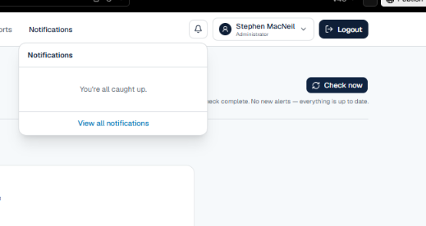
Figure 1. The header bell shows unread alerts and a quick panel with a link to all notifications.

4.2 Review your alerts (Inbox)
- Unread alerts appear in the inbox and increase the bell badge count.
- Open an alert to see the KPI, the status change, severity, timestamp, and message.
- Use Mark as read after reviewing, or Mark all as read once you have triaged the inbox.
- Use Check now only when you want an immediate evaluation — normally this runs automatically.
- A recovery alert confirms a KPI has improved from a worse band to a better one.
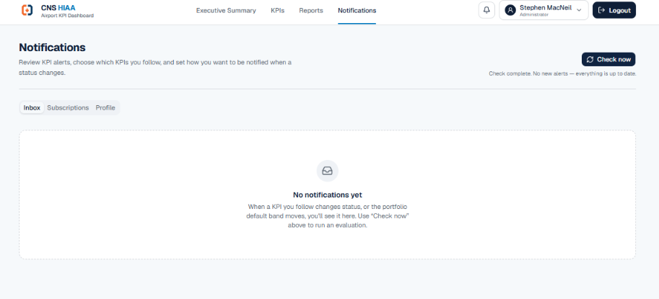
Figure 2. The Notifications inbox with the manual "Check now" evaluation.

4.3 Choose what you follow (Subscriptions)
- Select the Subscriptions tab.
- Enable Dashboard under Overall portfolio status to follow the combined KPI status.
- Enable Dashboard beside each KPI you are responsible for or need to monitor.
- Choose a minimum severity — Info, Warning, or Critical. You receive only alerts at or above that level.
- Leave Email and Teams for later; enable them once IT activates those channels.
- Changes save automatically; a check mark confirms each save.
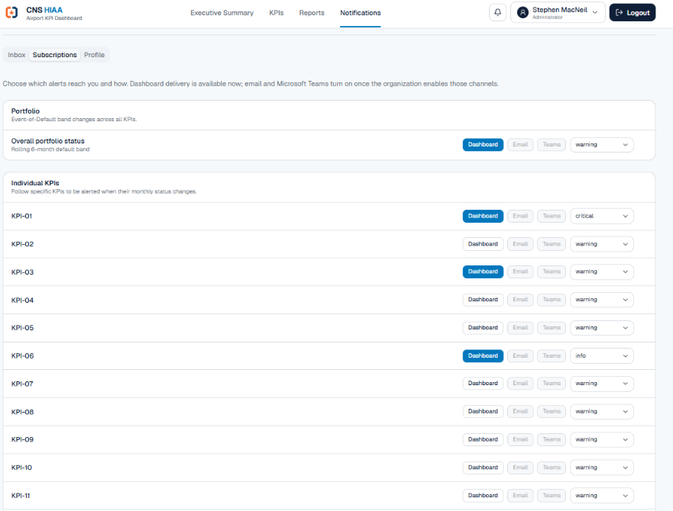
Figure 3. Subscription controls for the portfolio and for individual KPI-01 through KPI-21.
Severity | Use when | Typical result
Info | You want visibility into all status changes, including minor ones. | Highest message volume.
Warning | You need operational exceptions and worsening performance. | Recommended default for KPI owners.
Critical | You only need urgent, damage-point-level conditions. | Lowest volume; highest urgency.

Recommended setup
KPI owners: follow your assigned KPIs on Dashboard at Warning. Operational managers: also follow Overall portfolio status. Executives: Critical-only for urgent exceptions rather than routine changes.

4.4 Verify your profile
The Profile tab shows the identity and role the application is using for you. In production this comes from your Microsoft Entra ID account; in a preview it may be a test identity.
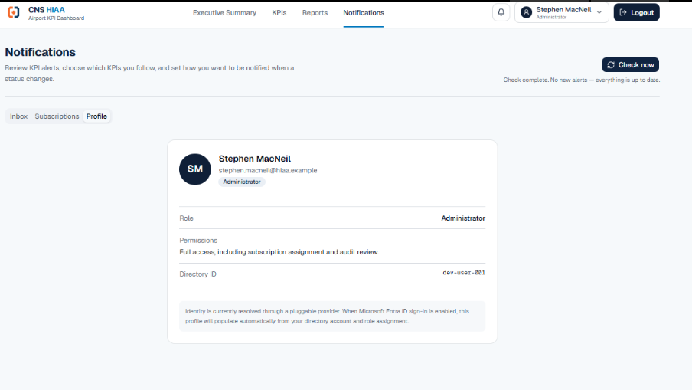
Figure 4. Profile view showing your identity, application role, and directory identifier.
Role | What you can do
Viewer | Read dashboards and manage your own notification preferences.
KPI Owner | Viewer access plus responsibility for assigned KPIs and their alerts.
Manager | Broader portfolio visibility and operational reporting access.
Administrator | Full access, including subscription assignment and audit review.

5. Using the dashboard on your phone or tablet
The dashboard is designed to work the same way on small screens as on a computer.
- iPhone / Android phone: open the web address in Safari or Chrome and sign in as usual.
- Use the menu button (three lines, top-right) to move between areas.
- KPI cards and charts stack into a single column so they stay readable — scroll to see more.
- The Subscriptions controls wrap to fit; tap a channel button to turn it on or off.
- Add the site to your Home Screen (Share → "Add to Home Screen") for quick, app-like access.
Tip
Everything is saved to your account, not the device. Preferences you set on your computer show up on your phone and vice-versa.

6. Troubleshooting
Situation | What to check
I expected an alert but none appeared | Confirm the KPI is enabled under Subscriptions, your severity threshold includes the event, and the status actually changed after the baseline.
The menu is missing on my phone | Tap the menu button (three lines) in the top-right corner.
Numbers look out of date | Data refreshes periodically from the source spreadsheets; check the 'Data refreshed' time and try again shortly.
Email / Teams options are greyed out | Those channels are enabled by IT. Use Dashboard alerts until then.
I cannot sign in | Use your normal organizational account; contact IT if the problem persists.

Your responsibilities
Keep subscriptions limited to KPIs relevant to your role, and remember the dashboard inbox — not email — is the official record of alerts.

