Assignment

CSCU9N5

Multimedia and HCI

Student ID 2628030

25/10/2019

**Design objective:**

For this assignment I will create a web based multimedia application related to sorting algorithms, designed for students and people interested in computer science and mathematics.

The main objective will be to show each sorting algorithm, with its complexity, related to both speed and space utilization. Furthermore to compare each of these algorithms in comparison to one another, and why certain algorithms are better in certain situations. Each algorithm will need a graphical representation of the complexity, its space usage, and its efficiency. Furthermore an interactive animation or pictorial representation of the process of searching and sorting would be ideal. This application will be mainly aimed at students doing/studying computer science, however will also be aimed at people who have a genuine interest I.e a hobbyist or someone trying to understand more about the field, in relation to work or some other personal reason.

My personal reasons for picking sorting algorithms as my focus is two fold, first and quite possibly the most apparent reason. Being a computer scientist, the complexity of all the different sorting algorithms is extremely important to consider whenever and where-ever we decide to use one, I.e application, memory, size of list, on a pc, on a phone, and so on. There are many different algorithms, each with its own advantages and disadvantages. Having them all in one place, or in this instance in one web based multimedia application is an ideal way to view them, and brings ease to the learning process. Secondly knowing and being able to justify choices of sorting algorithms is a very common question to be asked either in an interview question or when regarding them for any program, and then, by using such a multimedia application before an interview or selection would be most helpful. It would also likely end in a better response if asked in an interview, or better efficiency.

For people that aren’t myself I also find that sorting and searching is often a well utilized tool, it occurs in many different applications and games, and is used by many different types of users. For those with a genuine interest whatever age they may be, I think a multimedia application explaining each in details would be highly useful. Whether for professional or personal reasons. Following this are two persona’s for the design of this multimedia application, I.e possible users, and their personal objectives, reasons for using the application, like and dislikes, their desired platform, hobbies, and a scenario relating to why they will want to use this application.

**Name:** Brian (Deaf/requires a hearing aid) **Age:** 23

**Occupation:** Computer science student

**Platform:** Desktop computer (Self built)

**Goals/objectives:**

* Revising for a computer science exam where he is aiming for a first
* Studying a computer science degree
* Seeking knowledge and in depth information on sorting algorithms
* Wants a deeper knowledge for his future goal of working in the games industry

**Likes:**

* Playing games especially role playing games like final fantasy
* Mainly a pc gamer but also owns a ps4 console

**Dislikes:**

* First person shooter games
* Fish and shellfish

**Hobbies:**

* Currently working on a roll playing game in his spare time
* Plays the piano

**Scenario:**

Brian needs to know about and study each sorting algorithm for an examination. He especially wants to know more about the differences between bubble sort and Quick sort, he currently can’t remember the other’s and desperately wants to do well in his exam. He needs to explain the mathematical complexity of algorithms in his exam as hinted to by his professor. He wants to know their advantages and disadvantages, and where they will need to be used I.e in what specific situation you may pick one over another, so that he can explain it well in an exam setting and also for personal interest to implement it into his own game for sorting inventory items. He will want to see detailed explanations and graphical representations of how each of these algorithms work and the code behind their implementation.

**Name:** Ashley **Age:** 30

**Occupation:** Financial organisation project manager

**Platform:** IOS, I-mac and I-phone

**Goals/objectives:**

* She has to manage a team of programmers and has little CS knowledge, she has therefore taken an interest in the subject
* In a meeting someone mentioned sorting algorithms and she wants to understand more about them to better communicate with her team
* She really wants to do well in this project, so that it leads to greater opportunities in her workplace

**Likes:**

* Being organized in life I.e making lists and spreadsheets especially for finances
* Extreme sports but in particular loves bungee jumping

**Dislikes:**

* Meat and dairy, Ashley is a vegan after watching “*Earthlings*”
* The current impact on the environment and inefficiency

**Hobbies:**

* Yoga and martial arts (Tae kwon do)
* Watching films on Netflix

**Scenario:**

Ashley really wants an overview of what sorting algorithms are, how they work so that she better communicate with her staff, and specifically so that she can make an informed decision about which one to use. From what her staff have told her there are various sorting algorithms with advantages and disadvantages, so she wants to research each and find out their merits. She has good knowledge of mathematics but wants to learn more about how these algorithms run on computers I.e their speed and efficiency. She would much prefer to see some types of mathematical graphs explaining each, with an explanation of how they work. She is determined to learn as much as possible, so the more information the better.

**Design:**

For the main homepage of my multimedia application I want the main features to be spread in front of you as you enter the web based multimedia application, a basic example of which is below, first desktop then mobile:

**PC: (figure 1; a,b,c)**

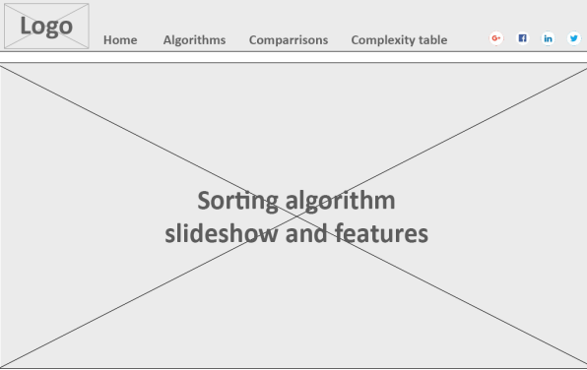 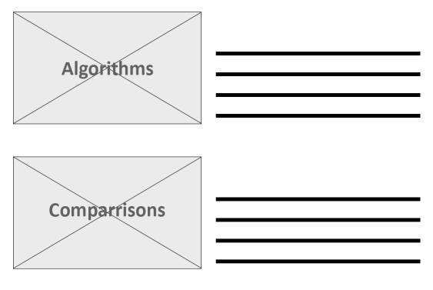

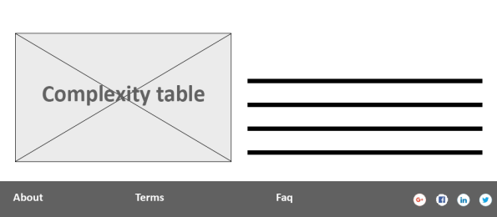

**Mobile: (figure 2; a, b)**

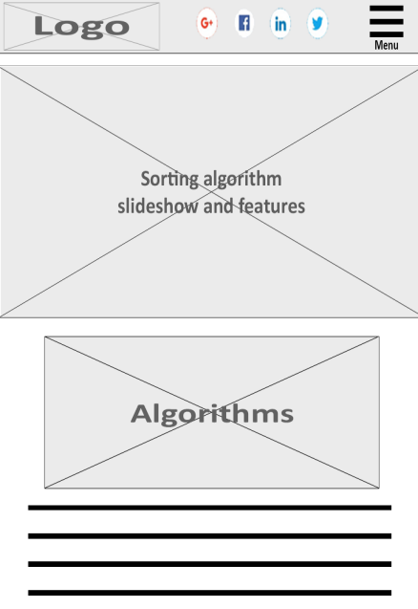 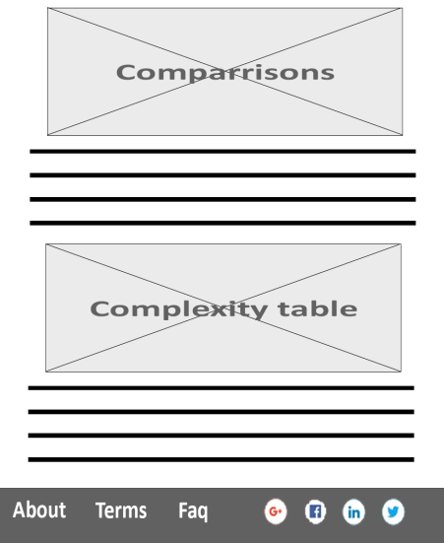

This is to be the basic layout of the home page, if not obvious from the dimensions these are elongated, the first being on a wide screen pc or laptop monitor. The second being on a mobile phone. Both of these are elongated due to the fact that the user will be able to scroll down I.e. each box is a screen full of information.

The following is the wire frame for the other pages on the website; main algorithm page, algorithm individual pages, comparison pages, and complexity table page:

**Algorithm main page:**

**PC: (figure 3; a,b,c)**

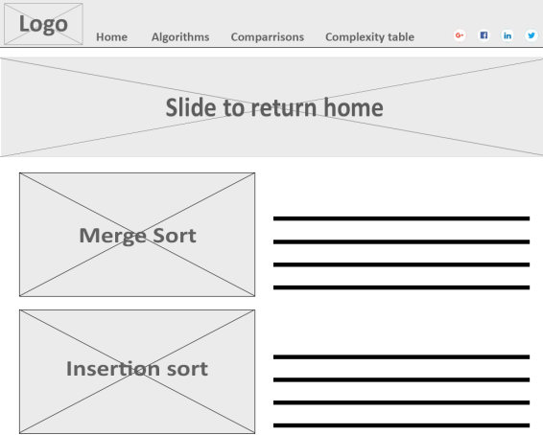 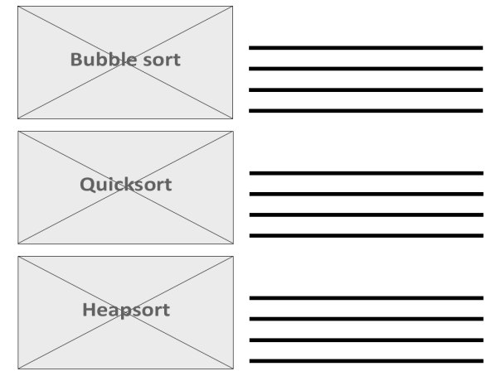

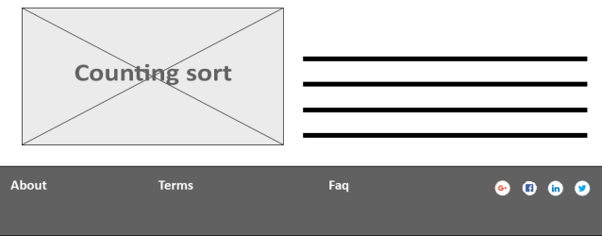

**Mobile: (figure 4; a, b)**

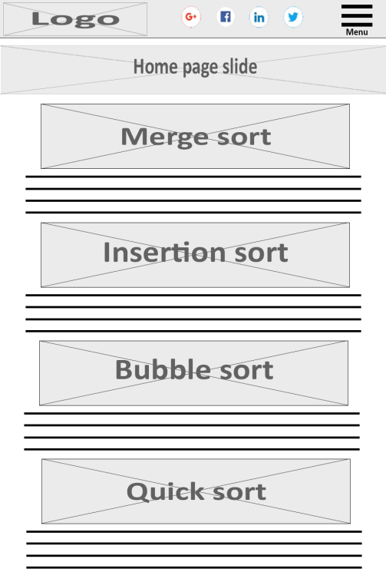 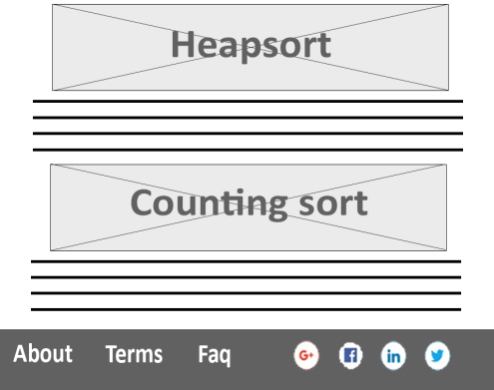

**Specific algorithm and comparison pages:**

**PC: (figure 5; a,b,c)**

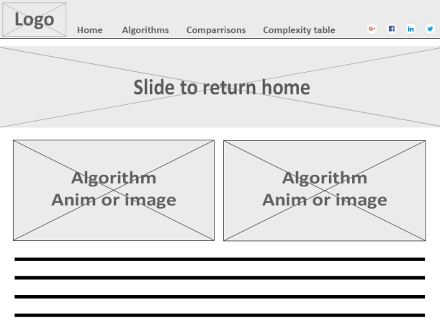 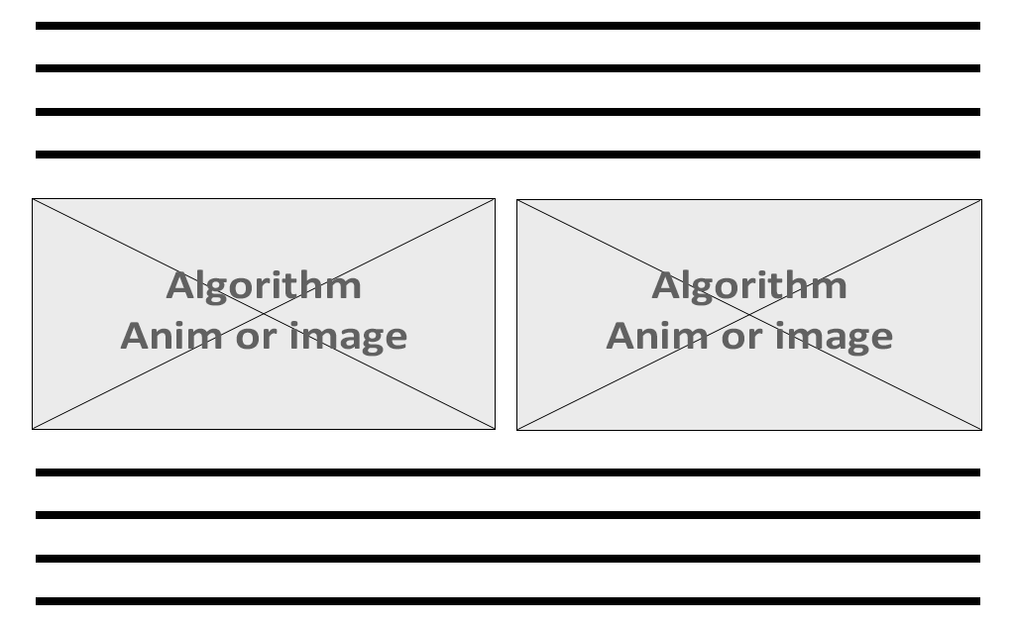



**Mobile: (figure 6; a,b)**

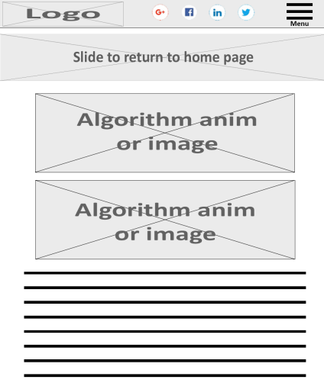 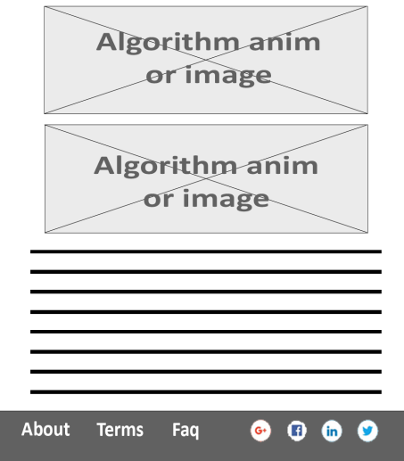

Most of these pages will be quite closely styled to keep the site consistent however an important point of note is in the comparisons page. In a finished product the algorithm animation or image box in the comparisons page would also include a drop down menu to pick which algorithm I.e. pick to compare which one to which other one. This may not be apparent from the wire frames so I think it is important to note at this point. Now I will explain why I have made these decisions.

**Complexity table page:**

**PC: (figure 7; a,b)**

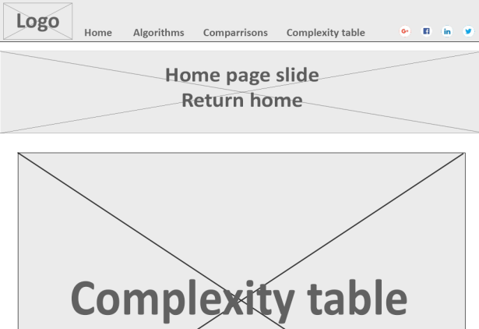 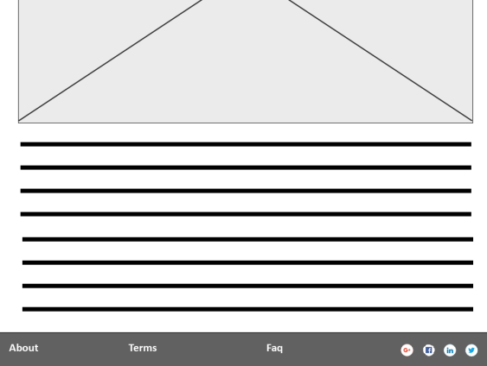

**Mobile: (figure 8; a,b)**

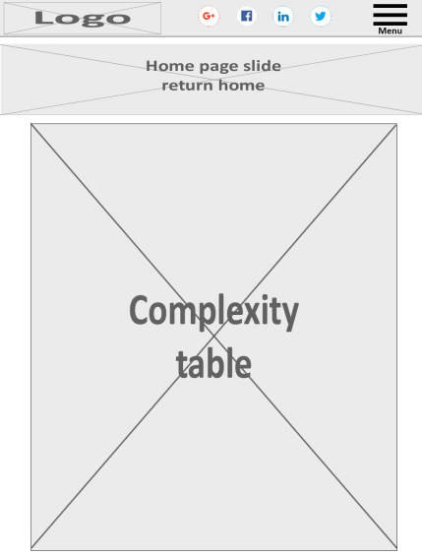 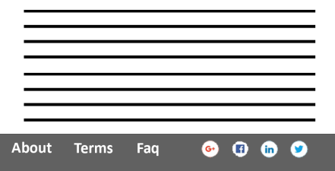

**Navigation map using navigation bar: (figure 9)**

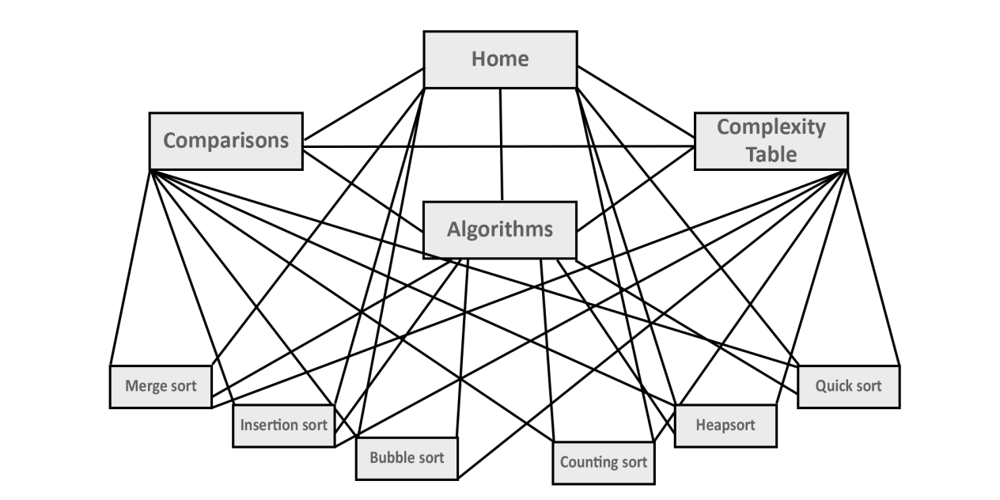

As shown in the navigation map of these pages (figure 9), we can effectively navigate from any page to any other page via the drop down menu at the top of the screen, or menu button if using mobile.

**Navigation map page view: (Figure 10)**

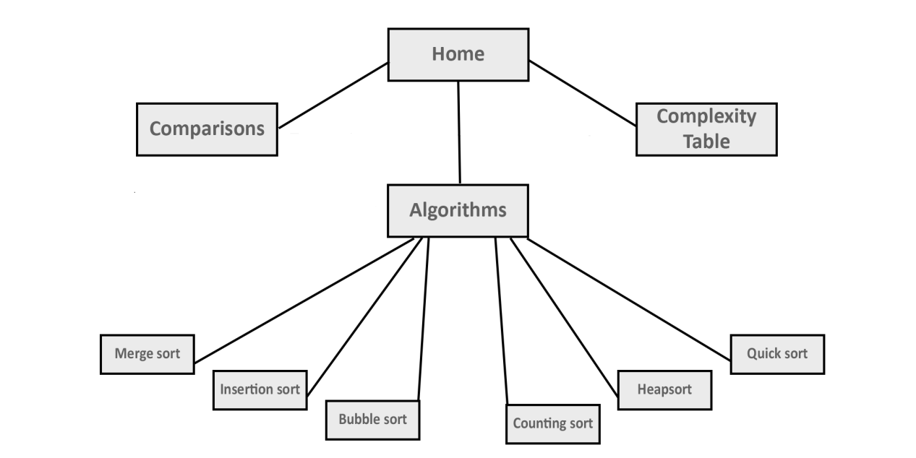

We see above (figure 10) a more simplified version of this which is to represent each page of the application, should we not use the navigation bar, we would be lead through the application as shown above. It should be noted also that even though comparisons has only one point on the navigation map, due to this being an interactive section of the multimedia application it contains 15 instances of comparison i.e. comparing each of the sorting algorithms to one another. These however would all be contained within the one page as shown below:

**Comparison page: (Figure 11)**

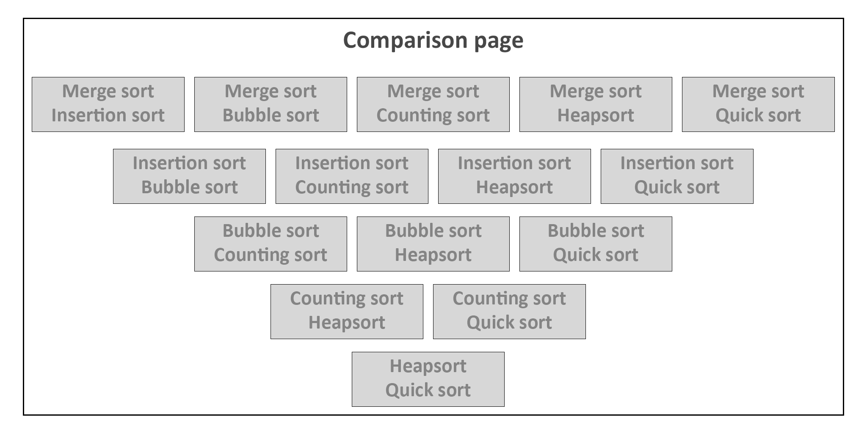In a sense this would give 24 unique pages of information, 15 nested in comparisons.

**Design decisions:**

Now I will talk about the home page design (figure 1 and 2), and the main features present through all of the pages (figure 1 - 8). As is very common these days I have added the page logo in the top left, the navigation bar beside, and a main banner in the centre of the screen. These will typically be the first things the user sees, and therefore take up the entire screen. The banner of course being the main eye catching image/information that is viewed upon entrance to the application.

The lower three images and text (figure 1) will be main points of navigation, with some flare to make them attractive, and including some text information about them. These will also be accessible via the navigation tab at the top of the screen/site.

Finally the terms, frequently asked questions, and about section, will be right at the bottom as is commonplace in modern day web design. I haven’t added this to the navigation map as these features will also be accessible from any page of the website.

In both the header and footer I added share links to social media. The design for mobile is almost identical, with a few changes which are due to the screen dimensions and size of image. The navigation bar has been removed and instead a menu button is placed in the header, this however will contain the same functionality as the desktop navigation bar.

The main points of navigation instead of having text beside them, now have the text underneath the image, so that we can maintain a readable text size, and the functionality and features remain the same in both, thereby not discriminating against a device or platform.

Now I will explain why I have made these decisions and will refer to individual instances of each from the wire frames above. Firstly lets address the most common features, header and footer containing; navigation bar, share links, about, terms, FAQ, logo, main points of navigation, and for mobile the menu. All of these are used in such a familiar way due to striking for consistency, meaning for a well versed through to new user on the web will have no issue navigating the website. Consistency is key in reducing memory load also meaning the user can focus on the content, not on navigating the application.

I have kept this navigation through each and every page whether it is on desktop or mobile, which allows for multiple platforms opening to more users, also since our target users will be spread across platforms even as we see in our persona’s.

The page information will remain consistent across all devices and platforms also.

Secondly lets address more style orientated decisions such as the banner, image and text, and the comparison page. The ‘hero banner’ is one of the most popular and commonly used items in modern design, this is due to a few factors, first and most obviously its captivating appearing right in the eye as soon as entering the website, this allows us to show perhaps main content or suggest the way the user should navigate our site. Giving us more control over what information they are seeing next. The banner is more practical than using a carousel, a case study from both Beaconfire RED and Notre Dame university both confirm the fact that the click through rate of carousels (shown in figure 12) is not very effective bar the first image, therefore confirming that the ‘hero banner’ is a much better choice. In the home page(figure 1 and 2) the banner will be much larger than individual pages (figure 3-8) as for the home page it will link to the first most logical choice I.e. algorithms page whereas in the other pages(figure 3-8) it will lead generally either up a level, or to the home page, which we would prefer not to encourage hence make it smaller. Which will mean the eye is less attracted to it, meaning the user will follow through the application in a semi-directed way.

**CTR: (Figure: 12; a,b)**

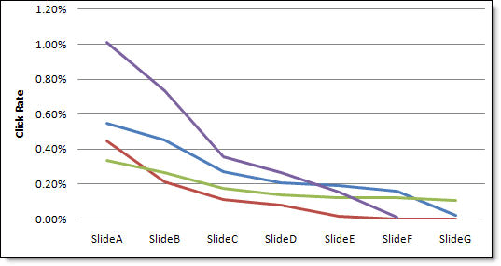 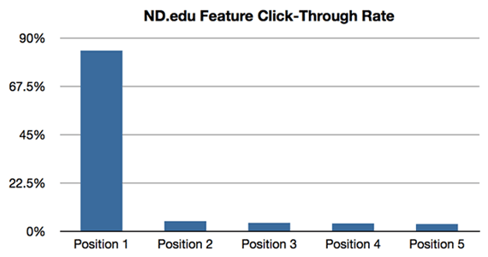

For the image and text these were more logical approaches designed for the users, the images will contain graphs, charts and demonstrations of how the algorithms work, given the user the most essential information in the form of an image or animation, where the text is really just for further explanation and detail. Also the text itself especially in the individual algorithm pages will contain code example of the sorting algorithm for implementation use. These were deemed logical choices due to our persona needs and likely users.

Finally regarding the comparison page, this is to be interactive allowing the user to pick any algorithm an any other algorithm on the page. The information that will change here will be the data represented in the image I.e. whichever algorithm you picked and the written detail underneath in the text. Obviously the text will be the same disregarding order, so if you pick merge sort and insertion sort, or insertion sort and merge sort. The only difference will be which side the image is on. The information below remains the same in both instances.

**Prototype description:**

Regarding the prototype I have kept extremely close to my design phase and wire frames. Rather than comment on all the features that exist across both of them as I have already spoke on earlier in this report with regards to figures 1 through 8, I will instead speak on the differences between the two and what is perhaps lacking in the prototype which will exist in the full version.

The main points to take away are first I removed the share links to social media as since this is a prototype I feel there would be no need or even no reason to share an unpublished web application as first It wouldn’t work correctly and secondly it is an unfinished piece of work. For these reasons I removed this feature from all pages.

The navigability works exactly as stated in figures 9,10 and 11, however from figure 11 this multiple output approach where any comparisons are nested in the comparison page, has not been implemented at all however a basic overview of what this would look like and has been included. Further to navigability I have added breadcrumbs to all pages as I feel this feature actually adds ease to the navigation of the multimedia application.

Also the footer that is shown in all wire frames in figure 1 through 8 has slightly changed. Instead of about, contact us and FAQ pages, I felt these were far to similar to an actual web page rather than in interactive multimedia web application that I instead replaced it with a space for a name and email address which has also been left open as not to give away who this report and application has been made by.

Finally the specific algorithm page has become slightly different from the comparisons page in that now the specific algorithm page will include two multimedia elements(one animation and one video respectively), text, one large image of code, then text again. Rather than in the comparisons page, two images, text, two images, and text. As I have not altered the specific algorithm page, bar the one for merge sort, these pages still follow the original design schematic however in the final version would be much more similar to the merge sort page than the comparisons page.

The main part that is missing from the prototype is an interactive comparisons page, which once completed would allow the user to pick any two algorithms and get information back in the 15 possible combinations mentioned above in figure 11 and briefly touched on above. I believe that it was a large undertaking for the time allowed and as it is a prototype and not a full version, thought the example provided would be ample.

**Usability testing plan:**

* Can you access the algorithms page?
* Are there any dead links in the algorithms page?
* Is the merge sort animation at an acceptable speed?
* Can you get to home from the merge sort page?
* Do you know where you are in the application at all times?
* Can you find the heap sort page?
* Can you easily access the comparison page from the home screen?
* Can you easily access the complexity page from the home screen?
* Can you play the video in the merge sort page?
* Can you access the features above from mobile?
* Is the mobile layout suitable?
* Did you feel the application was easy to navigate?

___________________________________________________________________________________________________________________________________________________________________________________________________________________________________________________________________________________________________________________________________________________________________________________________________________________________________________________________________________________________________________________________________________________________________________________________________________________________________________________________________________________________________________________________________________________________________________________________________________________________________________________________________________________________________________________________________________________________________________________________________________________________________________

**Sources**

**Images:**

Ashley photograph, Free stock images, by Heitor Verdi:

<https://www.pexels.com/photo/woman-wearing-blue-top-2169434/>

Brian photograph, Free stock images, by Konstantin V:

<https://www.pexels.com/photo/photo-of-man-s-face-3027175/>

CTR graphs:

<http://www.websiteoptimizers.com/blog/home-page-carousels-good-ultimate-guide-existing-studies-real-data/>

**Prototype construction:**

Technical sources:

<https://maxcdn.bootstrapcdn.com/bootstrap/3.4.0/css/bootstrap.min.css>

<https://cdnjs.cloudflare.com/ajax/libs/font-awesome/4.7.0/css/font-awesome.min.css>

<https://ajax.googleapis.com/ajax/libs/jquery/3.4.1/jquery.min.js>

<https://maxcdn.bootstrapcdn.com/bootstrap/3.4.0/js/bootstrap.min.js>

Banner, free stock image, Pixabay:

<https://www.pexels.com/photo/cards-casino-chance-close-up-278961/>

Algorithms link, free stock image, Pixabay:

<https://www.pexels.com/photo/abstract-business-code-coder-270348/>

Comparisons link, free stock image, Pixabay:

<https://www.pexels.com/photo/view-of-airport-247791/>

Complexity link, free stock image, jeshoots.com:

<https://www.pexels.com/photo/person-holding-a-chalk-in-front-of-the-chalk-board-714699/>

Merge sort video:

<https://www.youtube.com/embed/JSceec-wEyw>