Vive Experiment Equipment Setup

Document created: 4September 2017.

Document last updated: 20 September 2017, by Stephen Pritchard

# Equipment

|  |  |  |  |
| --- | --- | --- | --- |
| Device | Quantity | Details |  |
| Head-mounted display (HMD) | 1 | HDMI, USB, DC(power), female audio jack (optional) | C:\Users\scpri\AppData\Local\Microsoft\Windows\INetCache\Content.Word\2017-09-04 11.44.14.jpg |
| Link Box | 1 | Orange to HMD: HDMI, USB, DC(power). To PC (unseen in picture): HDMI, USB. DC(power). | Link Box with connections to HMD |
| Hand Controller | 2 | Wireless. Micro-USB for firmware update or charging | C:\Users\scpri\AppData\Local\Microsoft\Windows\INetCache\Content.Word\2017-09-04 11.40.08.jpg |
| Tracker | 6 | Wireless (via dongle). Micro-USB for firmware update or charging | A picture containing indoor, table, sitting, black  Description generated with very high confidence |
| Tracker wireless dongle | 6 | USB – plugs into the dongle dock | A hand holding a cellphone  Description generated with very high confidence |
| Tracker dongle dock | 6 | USB(female) – plug in dongle; micro-USB for wired connection to PC | A hand holding a cellphone  Description generated with very high confidence |
| USB-micro-USB cable | 8 | For connecting dongle docks to PC, or wired connection of device to PC (for firmware update), or to small power transformer for charging | A hand holding a cellphone  Description generated with very high confidence |
| Larger power transformer | 3 | For power to lighthouse sensors, link box | A close up of a device  Description generated with high confidence |
| Smaller power transformer | 2 | For charging wireless devices (hand controllers, trackers) using USB-microUSB cables. |  |
| “Lighthouse” | 2 | No connection required. MicroUSB for firmware update. RCA jack for connecting the two sensors for synchronisation. DC(power) | A picture containing jack, indoor, electronics, sitting  Description generated with high confidence |
| 2.6m collapsible tripod stand | 2 | Standard ¼” camera mount (fits lighthouse sensors, or gimballed mount) | A room with white walls  Description generated with very high confidence |
| Ball head mount | 2 | Standard ¼” camera mount (sits on top of lighting stand, with lighthouse on top, allowing lighthouse to be oriented in any direction | A traffic light  Description generated with high confidence |
| Wall mount | 2 | Ball/socket mount, comes with screws, included with Vive purchase | A picture containing indoor, wall, stationary, table  Description generated with very high confidence |
| Tracker belt clips | 4 | These come with a nut and a bolt each, and can be attached to the rear of a tracker, allowing it to be attached to a belt of strap for positioning on a body | A picture containing indoor, table, sitting, electronics  Description generated with high confidence |
| Luggage straps with easy clips | 4 | Two longer straps, for attaching around torso, and two shorter lengths for around arm/shoulder | A picture containing indoor, table  Description generated with very high confidence |
| USB 3.0 hub | 2 | Each hub can accommodate 4 USB devices |  |

# Hardware Setup

## Lighthouses

### Option 1: Tripod mount lighthouses

Unfold the tripod stands and position them on either side of the room. Try and position them where they will not be bumped, and will either never (or infrequently) need to be moved. When they have been positioned, mark the location of the tripod feet with masking tape on the ground, so that it can be repositioned correctly if moved.

Screw a ballhead mount into the bottom of each lighthouse.

Attach the ballhead mount to the top of the tripod stand.

### Tricky and important:

Position the lighthouse so that it is high, and gives the best view over the experiment area. You don’t need to be extremely fussy – the lighthouse has a very wide field of view. However, you don’t want to move this once its set, so it shouldn’t be completely off either. Once you are confident of the position, you will need to tighten the screws on the ballhead mount, and on the tripod, so that the tripod height and the orientation of the lighthouse atop the ballhead mount will not shift. *The ballhead mount is tricky to get in a stable position due to the weight of the lighthouse with the added pull from its power cable.* (SteveP: Regine you might consider buying more expensive ballhead mounts that do a better job – the one’s I purchased were bargain basement price, even though they work with some fiddling).

*The lighthouses should be positioned high (over 2.5m) and looking downwards into the experiment area. They should as far apart as the room could manage (to at least allow 4m of walking distance, with some buffer for walls. Aim for at least 5m apart.). The lighthouses are ideally placed at opposite corners of a rectangular play space.*

Each lighthouse requires its own connection to power using a large power transformer, so try and position them with power outlet in mind to avoid unnecessary extension cable use.

When each ligthhouse is positioned, provide power. One lighthouse should feature the letter ‘b’, in its channel display, and the other the letter ‘c’. If necessary, you can change the ‘channel’ of a lighthouse by pressing the button on the back.

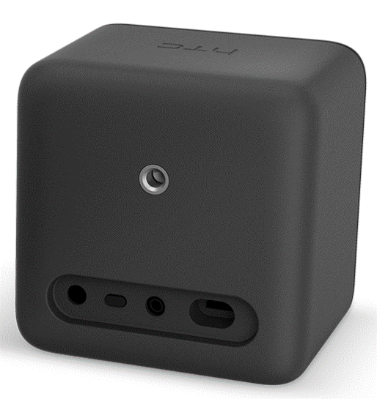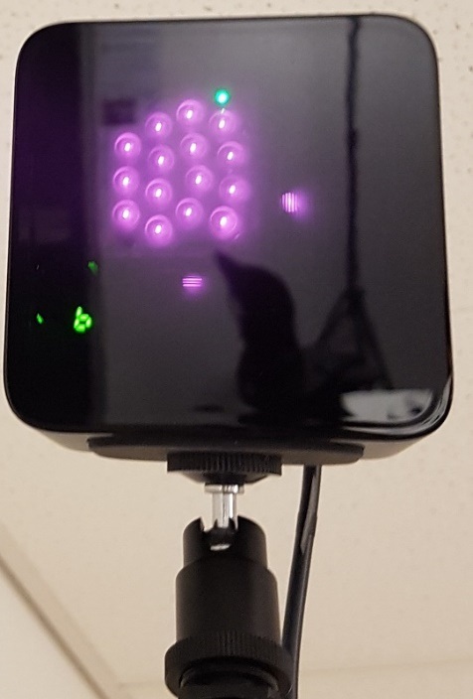

Ballhead mount

Status LED (green is good)

Channel selection button

Channel

### Option 2: Wall mount lighthouses

The Vive comes with wall-mounts, screws and screw inserts for attaching to a plasterboard wall. This is ideal in that it will minimise the chance of lighthouse sensor movement and increase consistency of conditions from participant to participant. However, it might be difficult or not permitted to screw anything into the walls. It might be possible to adhere a piece of wood to the walls and then screw the mount into that. Consult Marcus/Craig. The wall mount can be attached to either the bottom screw slot on the lighthouse sensor, or the rear screw slot.

## Recharge trackers and controllers

The wireless devices used with the Vive (trackers and hand controllers) use rechargeable batteries. Ensure that all devices are charged prior to use. It is difficult to find the time to discharge under use from a full charge, but it seems to be at least 4 hours for both the hand controllers and trackers. It might even be longer for experiments that make no use of the hand controller vibration/haptic feedback capability. Hopefully should last for a full day of testing, with an overnight recharge. To charge a device, plug a USB/microUSB cable into a small power transformer at the USB end, and plug the microUSB end into the tracker/controller. (The tracker microUSB slot is on one side, not the bottom). SP note: extra small power transformers might be needed to allow all trackers/controllers to be simultaneously recharged. Consult Marcus/Craig on options. At present, there are only two small power transformers, and 8 USB/microUSB cables.

A picture containing indoor, electronics, person, wall

Description generated with high confidenceA picture containing indoor, table, wall

Description generated with high confidence

## HMD and Linkbox connection

The HMD connects to the PC via the linkbox. Connect the HDMI, USB and power cables from the HMD into the orange-marked slots on one side of the link box. Short HDMI and USB cables then connect the other side of the link box to the PC, and a large power transformer attaches to the power slot on this side of the link box too.

A close up of a device

Description generated with high confidenceA black computer mouse on a desk

Description generated with high confidence

NOTE: If using the laptop, connect the HDMI/USB from the linkbox to the ports on the LEFT side of the laptop (just for neatness).

## Tracker setup

For the wireless trackers to communicate with the PC, the wireless dongle needs to be connected to the PC, via a USB port. The hand controllers don’t need this, since they communicate with the HMD, which relays the hand controller data to the PC through its connection.

Since there are six trackers, six USB ports re required, but the laptop (and probably not the PC) does not have sufficient available ports. The right side of the laptop has only two USB ports. So 2x USB hubs are required.

Plug each of the USB hubs into one of the ports on the right side of the laptop (or spare USB ports on a desktop). This will split those two USB ports into eight USB ports, sufficient for the six trackers and a mouse.

To connect the wireless dongle to a USB port on the hub: a) plug the dongle into its dock, b) plug the microUSB end of a USB/microUSB cable into the dock, c) plug the USB end of this cable into the hub.

A close up of a phone

Description generated with high confidenceA hand holding a cellphone

Description generated with very high confidenceA close up of electronics

Description generated with very high confidence

The dongles should be placed upright and spread them apart as reasonable (i.e., not all touching in a big bunch).

## Dodgy tracker

[update] This tracker has been returned to HTC for fixing, and a replacement tracker acquired.

The dongle for one of the trackers is faulty. Note: each tracker is paired with a dongle and they cannot be interchanged. Until this tracker is updated, the tracker may be connected via USB/microUSB cable to the computer, via one of the USB hubs. The tracker will still be tracked, but will not have freedom of movement, and this tracker is ideally used to track one of the poles. If necessary, a longer USB/microUSB cable could be purchased to allow more freedom. To setup the wired tracker, plug the microUSB end of the cable into the tracker (port on side of the tracker), and plug the USB end into a free USB port (e.g., on a USB hub, or on the computer itself).

## Connecting a belt clip to tracker

The belt clips are designed to be used specifically with the HTC Vive tracker, and there is an obvious and easy way that they should be placed. When bolting it on, use a nut on the bolt, because the bolt is too long for the screw hole on the tracker. Don’t over tighten and risk damage to the tracker.

A picture containing indoor, wall, table, sitting

Description generated with high confidenceA picture containing indoor, table, wall, person

Description generated with very high confidenceA hand holding a remote control

Description generated with high confidence

A picture containing indoor

Description generated with high confidenceA hand holding a cell phone

Description generated with high confidenceA picture containing indoor

Description generated with very high confidence

A picture containing indoor, table, sitting, electronics

Description generated with high confidenceA picture containing indoor, table, sitting

Description generated with very high confidenceA picture containing indoor, person, table, red

Description generated with very high confidence

A desk with a computer mouse

Description generated with high confidence Note: You need to remove the belt clip to put the trackers on the belt.

## Attaching trackers to poles

<to be determined> For testing, you should be able to rest a tracker on the top of a pole. They seem to sit in the top without falling. You don’t need to worry about the angle, currently only grabbing positional data from the pole trackers, not rotation data.

# Software Setup

Run steam.

Run steam VR (click the little VR icon on the top-right of the steam window).



A small SteamVR status window will pop-up towards the bottom of the screen. This is your primary means of ensuring that all devices (including the lighthouses) are on and are being tracked correctly. (The lighthouses are also known as “base stations”).

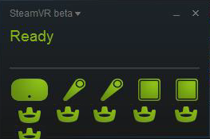

# Firmware update

From time to time, you might see a small exclamation mark badge appear over one of the devices depicted in the SteamVR status window. This means that a firmware update is available for that device. To update firmware, the device needs to be connected directly via USB-microUSB cable to the computer (or to the computer via the USB hub). This applies for any device – the HMD is already cabled to the computer, but you will need to specifically use the USB-microUSB cable for a base station, a hand controller or a tracker.

To update firmware. Click on the drop-down menu at the top of the window (it currently has the label “SteamVR beta˅”, but that might change to just “SteamVR˅”. From the drop-down, select the sub-menu “Devices, and then “update firmware”.

# Prepare for the experiment

Before executing ViveExperiment.exe, make sure:

1. Everything is connected
2. All trackers/controllers/HMD to be used in the experiment are active and detected and “green” in the steamVR status window. You might need to ‘turn on’ the hand controllers and the trackers.
3. To turn on a hand controller, press once the small button indicated below (the one just above the Vive logo on the front of the controller, adjacent to the LED). The light below it will flash and then turn solid green when the controller is activated and properly detected in SteamVR.

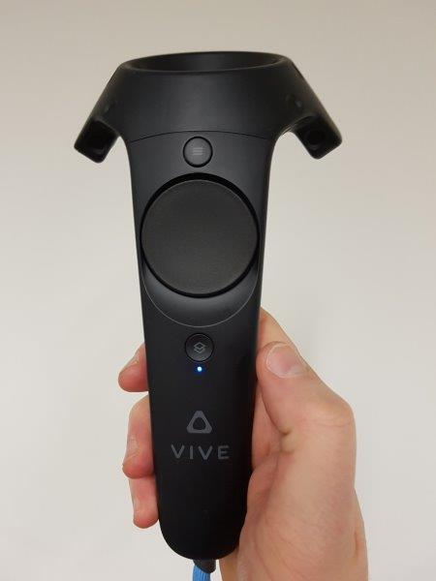

1. To turn on a tracker, press once the button in the top/centre of the trackpad (it’s a triangle shape, like the vive logo). It’s status LED will flash blue, and turn green when the tracker is properly detected in steamVR. A red LED indicates flat battery.

A picture containing indoor, table, sitting, black

Description generated with very high confidence

Vive Experiment Running

# Startup

* Attach desired trackers to the participant and to any real-world poles in use.P
* Edit parameters.txt file as appropriate.
* Edit instructions.txt file as appropriate.
* Make sure all equipment is active/detected as described above.
* Double click ViveExperiment.exe to commence the experiment.
* Verify that the HMD screen has activated (can see the glow of the screens through the eye-lenses.
* Verify the laptop/PC screen shows a 2D view of what the HMD displays, but with an experimenter’s-eyes-only UI overlaid on top.
* Put the HMD on the participant, and adjust for appropriate fit.