Stephen Re – Activity 17_1

1

2



3

4

5

6

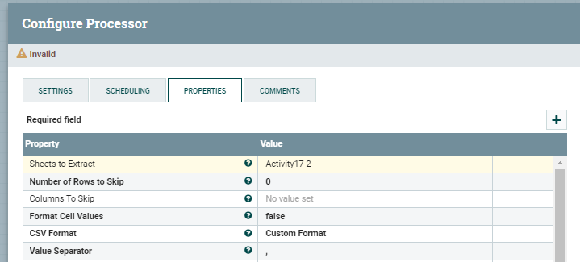

7

8a

8b

9

10a

10b

11

12

13a

13b

14

15

16

