Stephen Re – Activity 17.5: Using NiFi to Create a Pipeline in Cassandra

1. Create the NifiNetwork A screenshot of a computer

   Description automatically generated
2. Run the cqlsh command A screenshot of a computer

   Description automatically generated
3. create and populate cassandra table A computer screen shot of a black screen

   Description automatically generated
4. start the NiFi UI   
   A screenshot of a computer

   Description automatically generated
5. Create aprocess **group** and name it Cassandra-test  
   A screenshot of a computer

   Description automatically generated
6. configure the Cassandra-test  
   A screenshot of a service

   Description automatically generated
7. Enable the CassandraSessionProvider *controller*A screenshot of a service

   Description automatically generated
8. Create Cassandra processor and configure  
   A screenshot of a computer

   Description automatically generated  
   
9. Start mysql container and create table  
   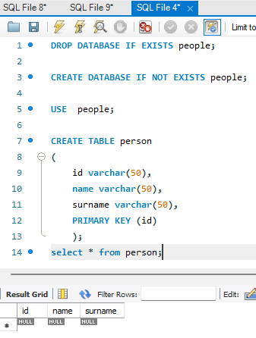
10. Create DBCPConnectionPool controller in process group  
    A screenshot of a computer

    Description automatically generated
11. Add a SplitJSON *processor connected to the QueryCassandra and configure*
12. Settings tab  
    A screenshot of a computer

    Description automatically generated
13. Properties tab  
    A screenshot of a computer

    Description automatically generated
14. Add a ConvertJSONToSQL *processor* and connect it to the SplitJSON *processor* and configure  
    A screenshot of a computer

    Description automatically generated
15. Connect processors and configure connections  
    A screenshot of a computer

    Description automatically generated
16. Add a PutSQL *processor and connect*A screenshot of a computer

    Description automatically generated
17. Run pipeline and query mysql  
    A screenshot of a computer

    Description automatically generated