Character Art Bible

# Biography

Full/True Name: Karlen Rofgon

Aliases/Titles: Karl

Date of birth: 15th February

Race: Reptalian

Gender: Male

Handedness: Right

Blood Type: RO+

Occupation: Theif/Adventurer

Birthplace: Torramel

Residence: Shack outside the walls Torramel

Talents/Skills: Pickpocket, Safecracking, Lockpicking, Sneaking

Weaknesses: The cold, his greed, wide open spaces

Languages: English, Reptalian

# Physical Description

Eyes: Orange

Hair: Black thin feathers

Skin: Dark green scales

Height/Weight: 175cm/55kg

Distinguishable Features: 2 small horns on the nose, Bumps around the face from the cheeks to the chin.

Common Poses/Movements: Running/fleeing, crouched looking at his surrounding, jumping with daggers

# Health/Status

Physically: Fine

Mentally: Mostly fine

Hygiene: Mostly fine… ish

# Appearance/Outfits

Casual: Black Hood, Grey Shirt, Dark Brown Pants, Leather Shoes, Leather Belt, Hidden Daggers on his belt

Work: Black Hood, Grey Shirt, Dark Brown Pants, Leather Shoes, Hidden Daggers on his belt, Leather armour (shoulder pads, elbow pads, knee pads wrist guards)

Formal: N/A

Accessories/jewellery: Stolen goods, coin bag

Example Pictures

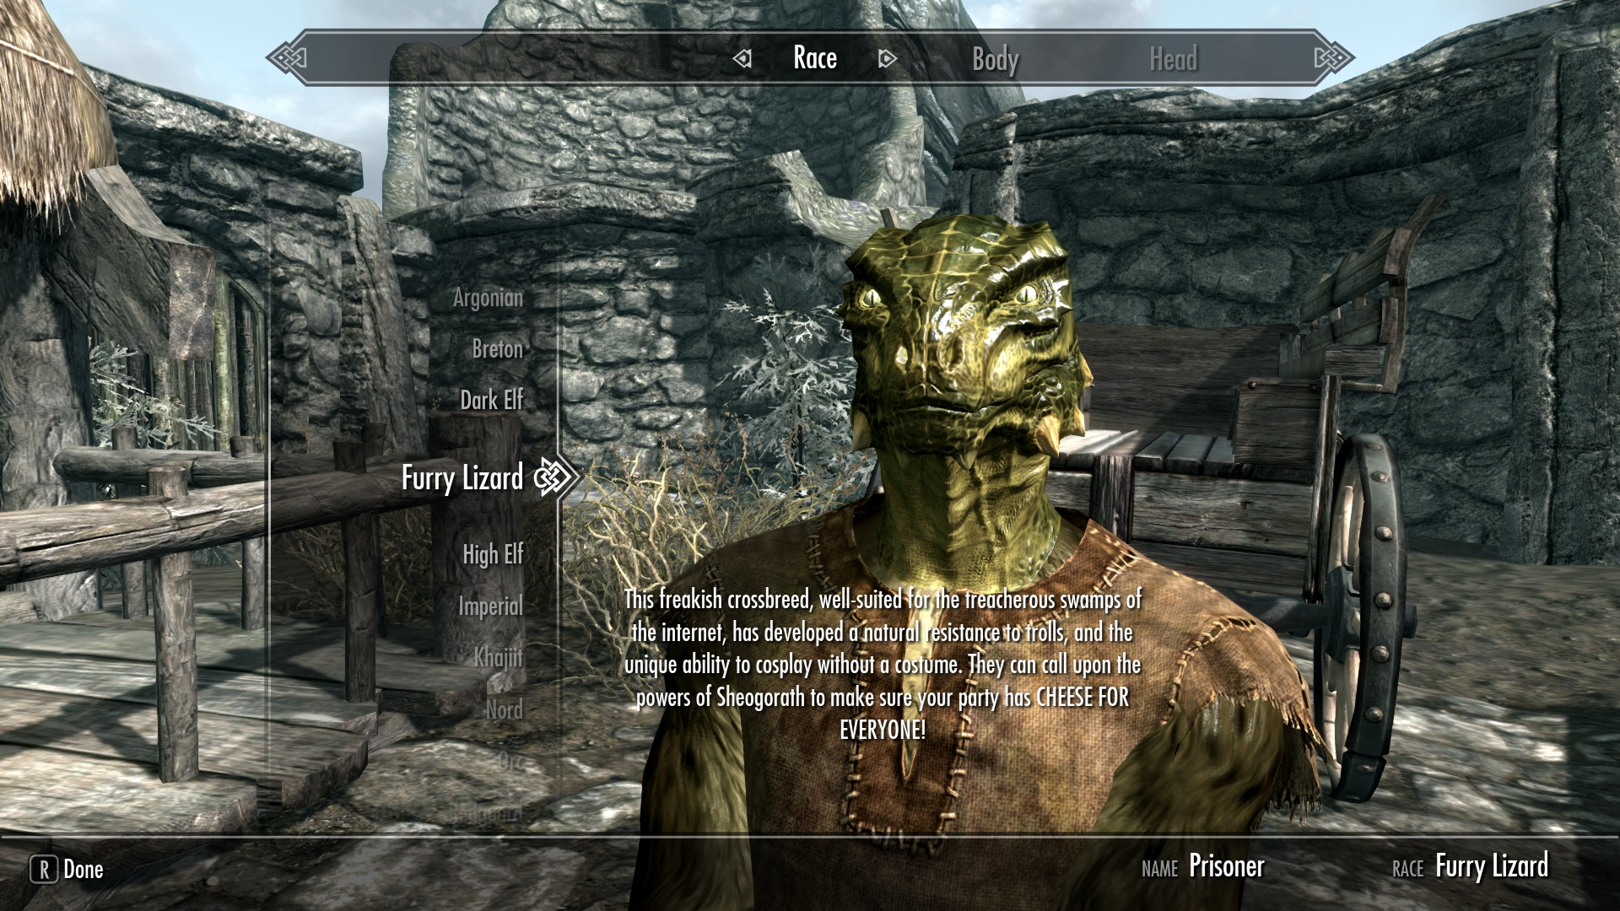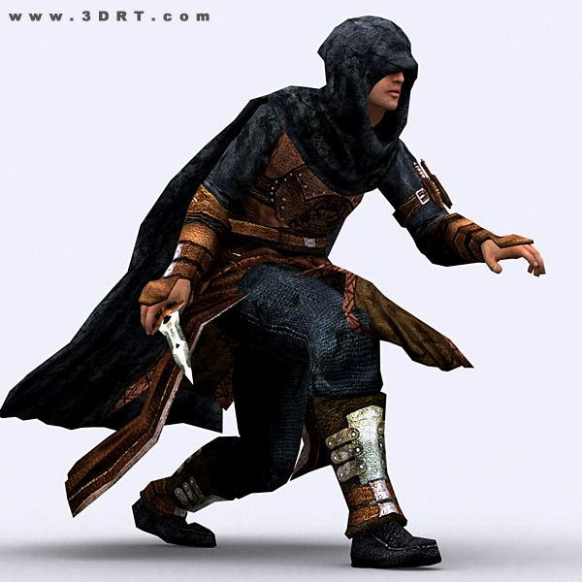

Reference Pictures

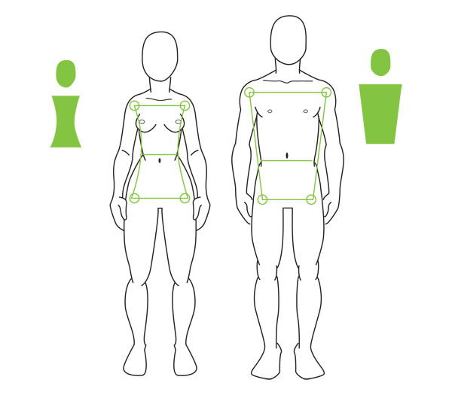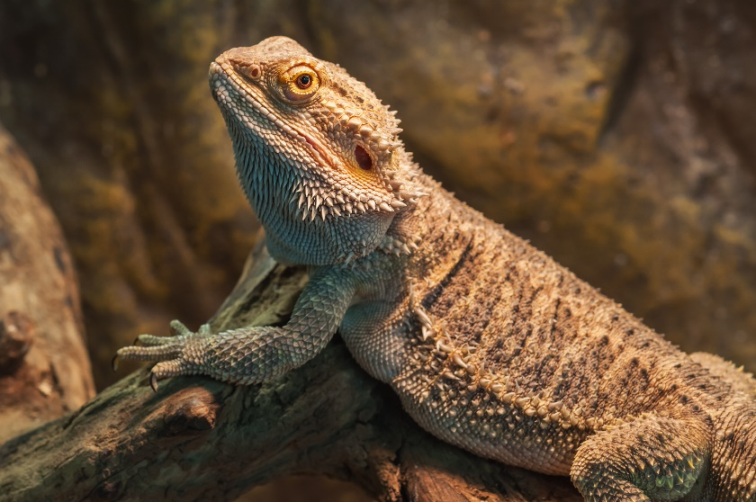

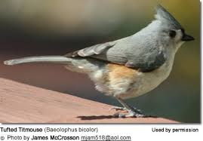

Clothing and Prop References

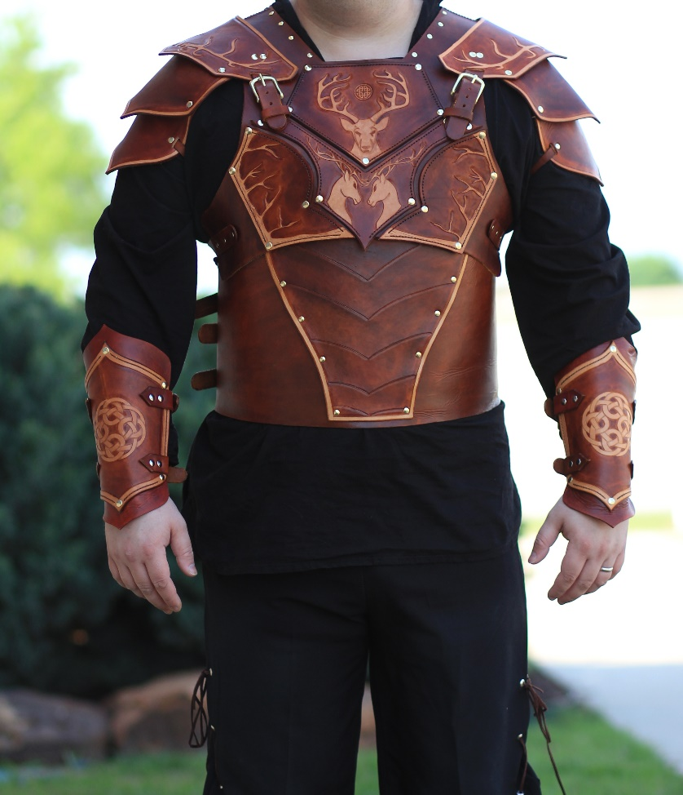

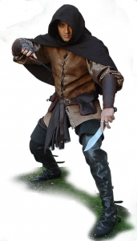

Design of your Character Sheet