Working with Git and SourceTree

# 开始新项目

## 1、Clone / New

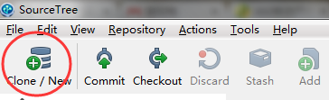

### 1.1 Clone Repository

从现有的remote中拉取

如果使用BitBucket或者Stash，在repo中有快捷键

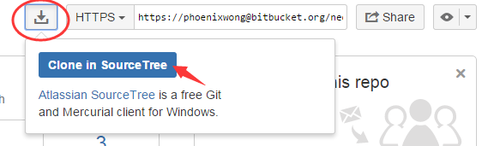

如果是别的类型的remote，例如我们本地的服务器，则需要手动复制git路径

https 或 ssh开头，通常是以 *.git结尾。



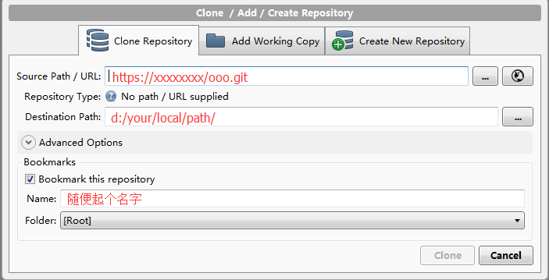

### 1.2. Add Working Copy

添加已经`git init`过的本地路径，即文件夹内已有隐藏的 .git 文件夹



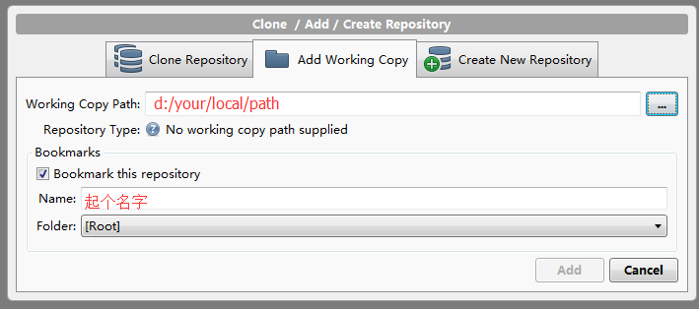

### 1.3 Create New Repository

从零开始创建项目

#### 第一步：添加本地路径，然后Create

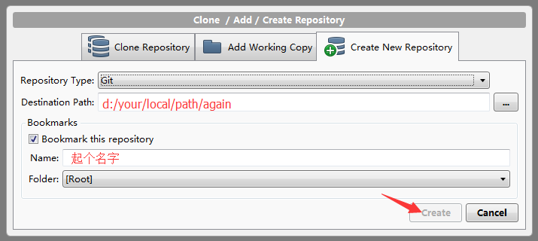

#### 第二步：添加remote（可选）

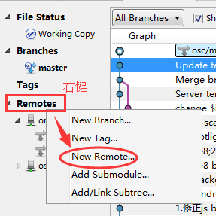

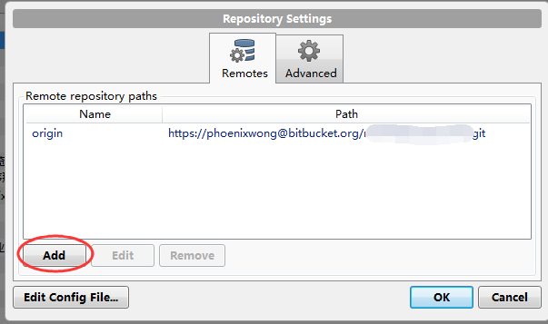

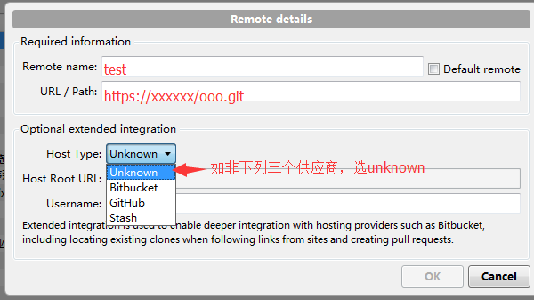

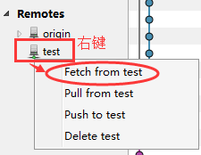

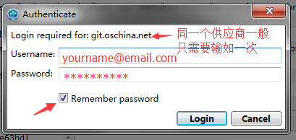

# 提交修改

1. Index/Stage your modified files

2. `Commit`

3. Write some comments

4. `Submit`

5. `Push`

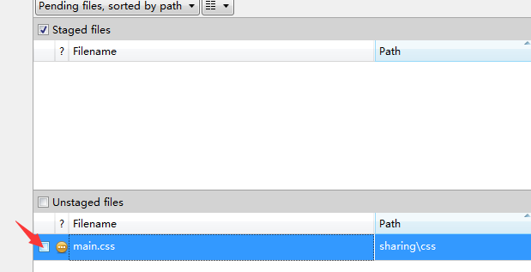

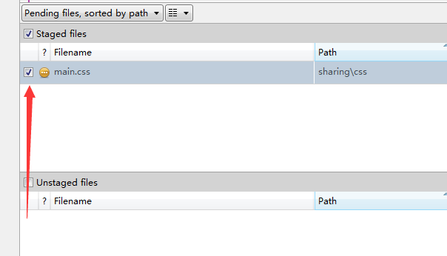

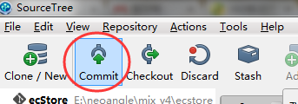

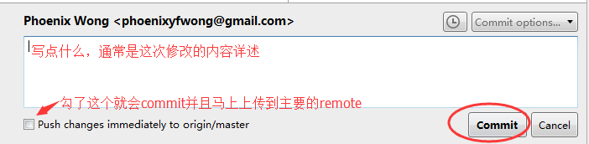

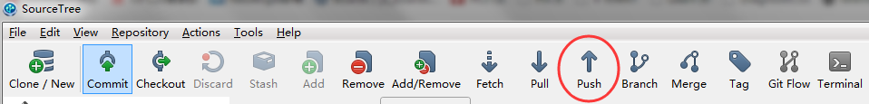

**Working with Branches**

There should be at least two active branches in practice

1. master (checked remote PROD)

2. develop (checked remote QA)

Meanwhile, create separate feature branches for individual issue. e.g.

* bugfix/ZYBAA-133-rework-login-flow
* hotfix/ZYBAA-75-overlay-adjustment
* feature/ZYBAA-68-new-login-form

Always make a Pull Request, usually against `develop`, after you close a ticket.

** If we can install the Stash and combining it with JIRA. That would be awesome! **

**Checkout New Branch Base on Any Commit, Anytime You Like**

Right click on any commit > Branch > Type a new name.

**Conflict!**

If we stick with branches + PR workflow, there will be almost zero conflict.

How to resolve (just in case):

1. Clean up you mess

- Stash changes (win and mac)

- Make a patch (mac only) and then discard your changes

- Copy all the conflicting files to another folder and then discard all your changes

2. Pull down the latest commit

3. Reverse your changes

- Apply stash

- Patch

- Modified your scripts manually