Trey: A New Beginning
Book One of the Trey Series

Stephen Marrero

Lifestyle Creations

Copyright
Trey: A New Beginning
Copyright © 2026 Stephen Marrero. All rights reserved.
No part of this publication may be reproduced, distributed, or transmitted in any form or by any means, including photocopying, recording, or other electronic or mechanical methods, without the prior written permission of the publisher, except in the case of brief quotations embodied in critical reviews and certain other noncommercial uses permitted by copyright law.
Published by Lifestyle Creations.
This is a work of fiction. Names, characters, places, and incidents are the product of the author’s imagination.
First Kindle eBook edition.

Dedication
For every child learning that love can grow again, and for the families who hold space for them.

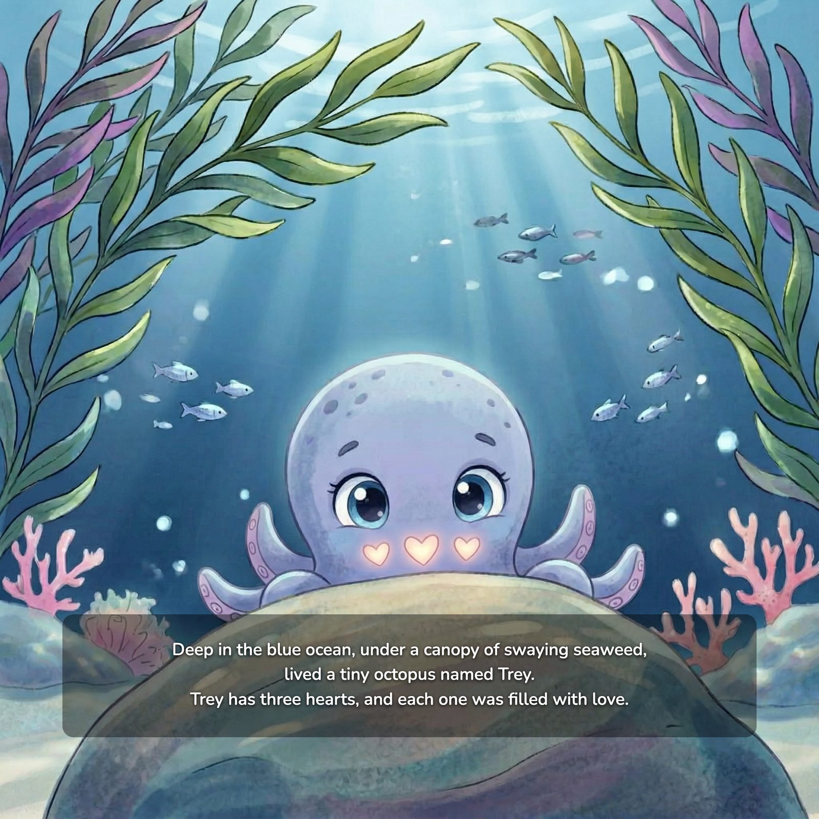
Deep in the blue ocean, under a canopy of swaying seaweed, lived a tiny octopus named Trey. Trey has three hearts, and each one was filled with love.
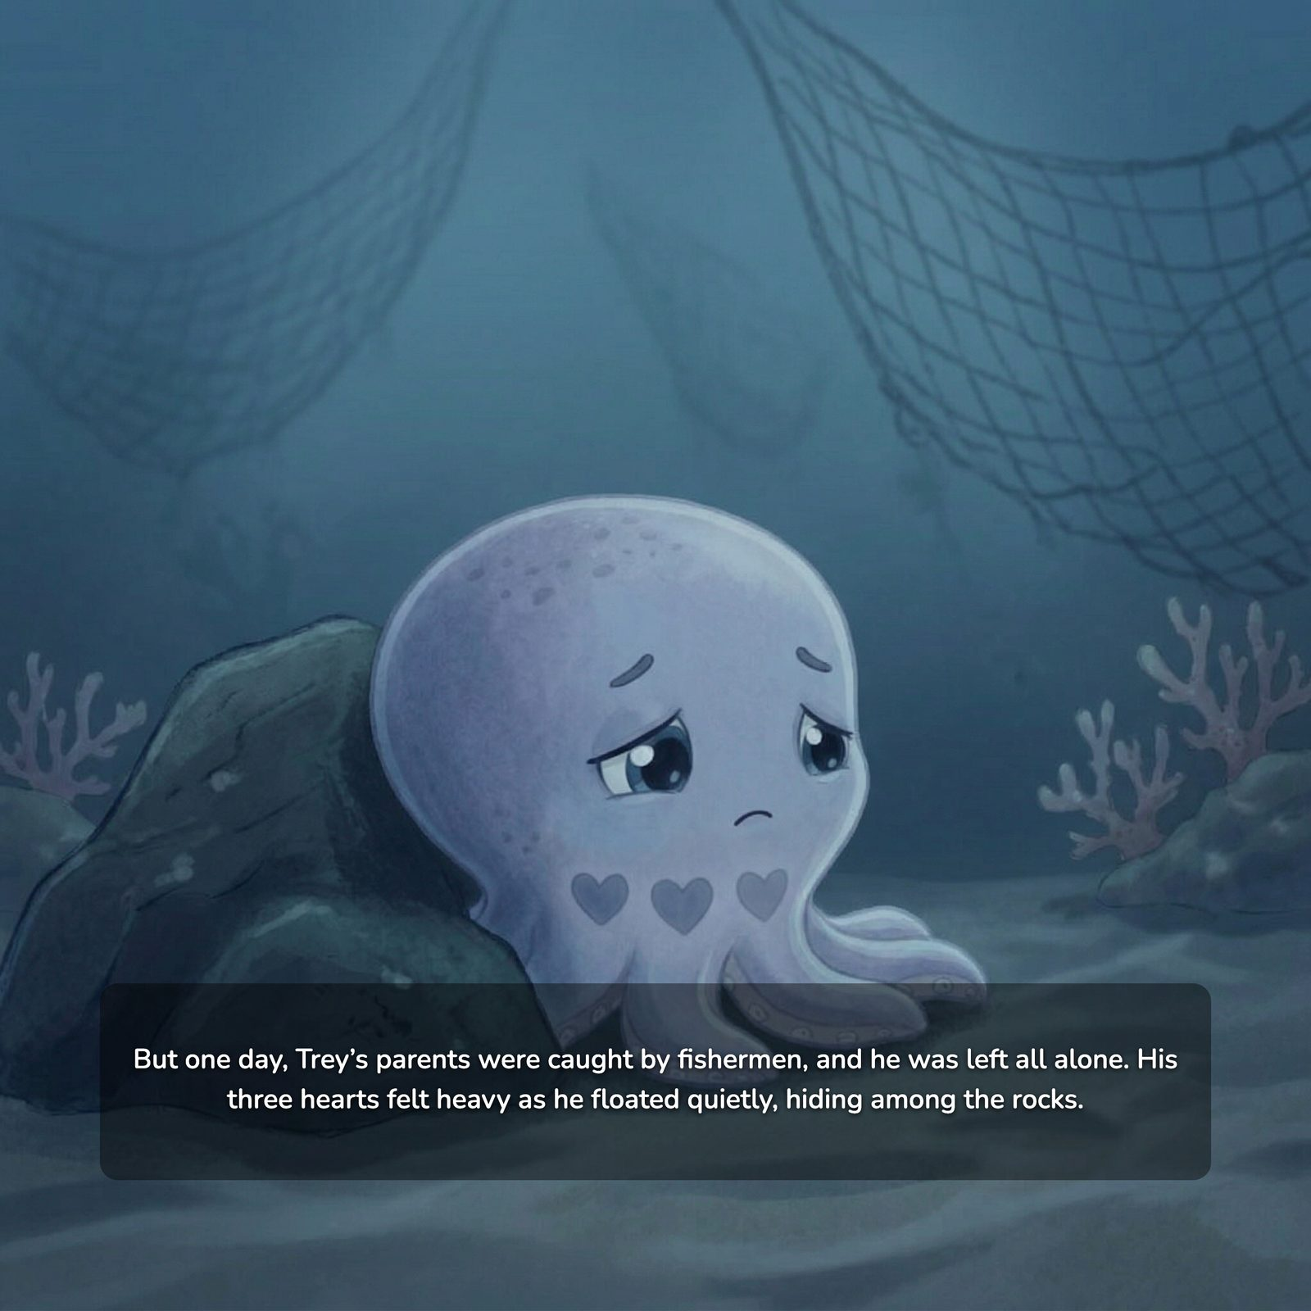
But one day, Trey’s parents were caught by fishermen, and he was left all alone. His three hearts felt heavy as he floated quietly, hiding among the rocks.
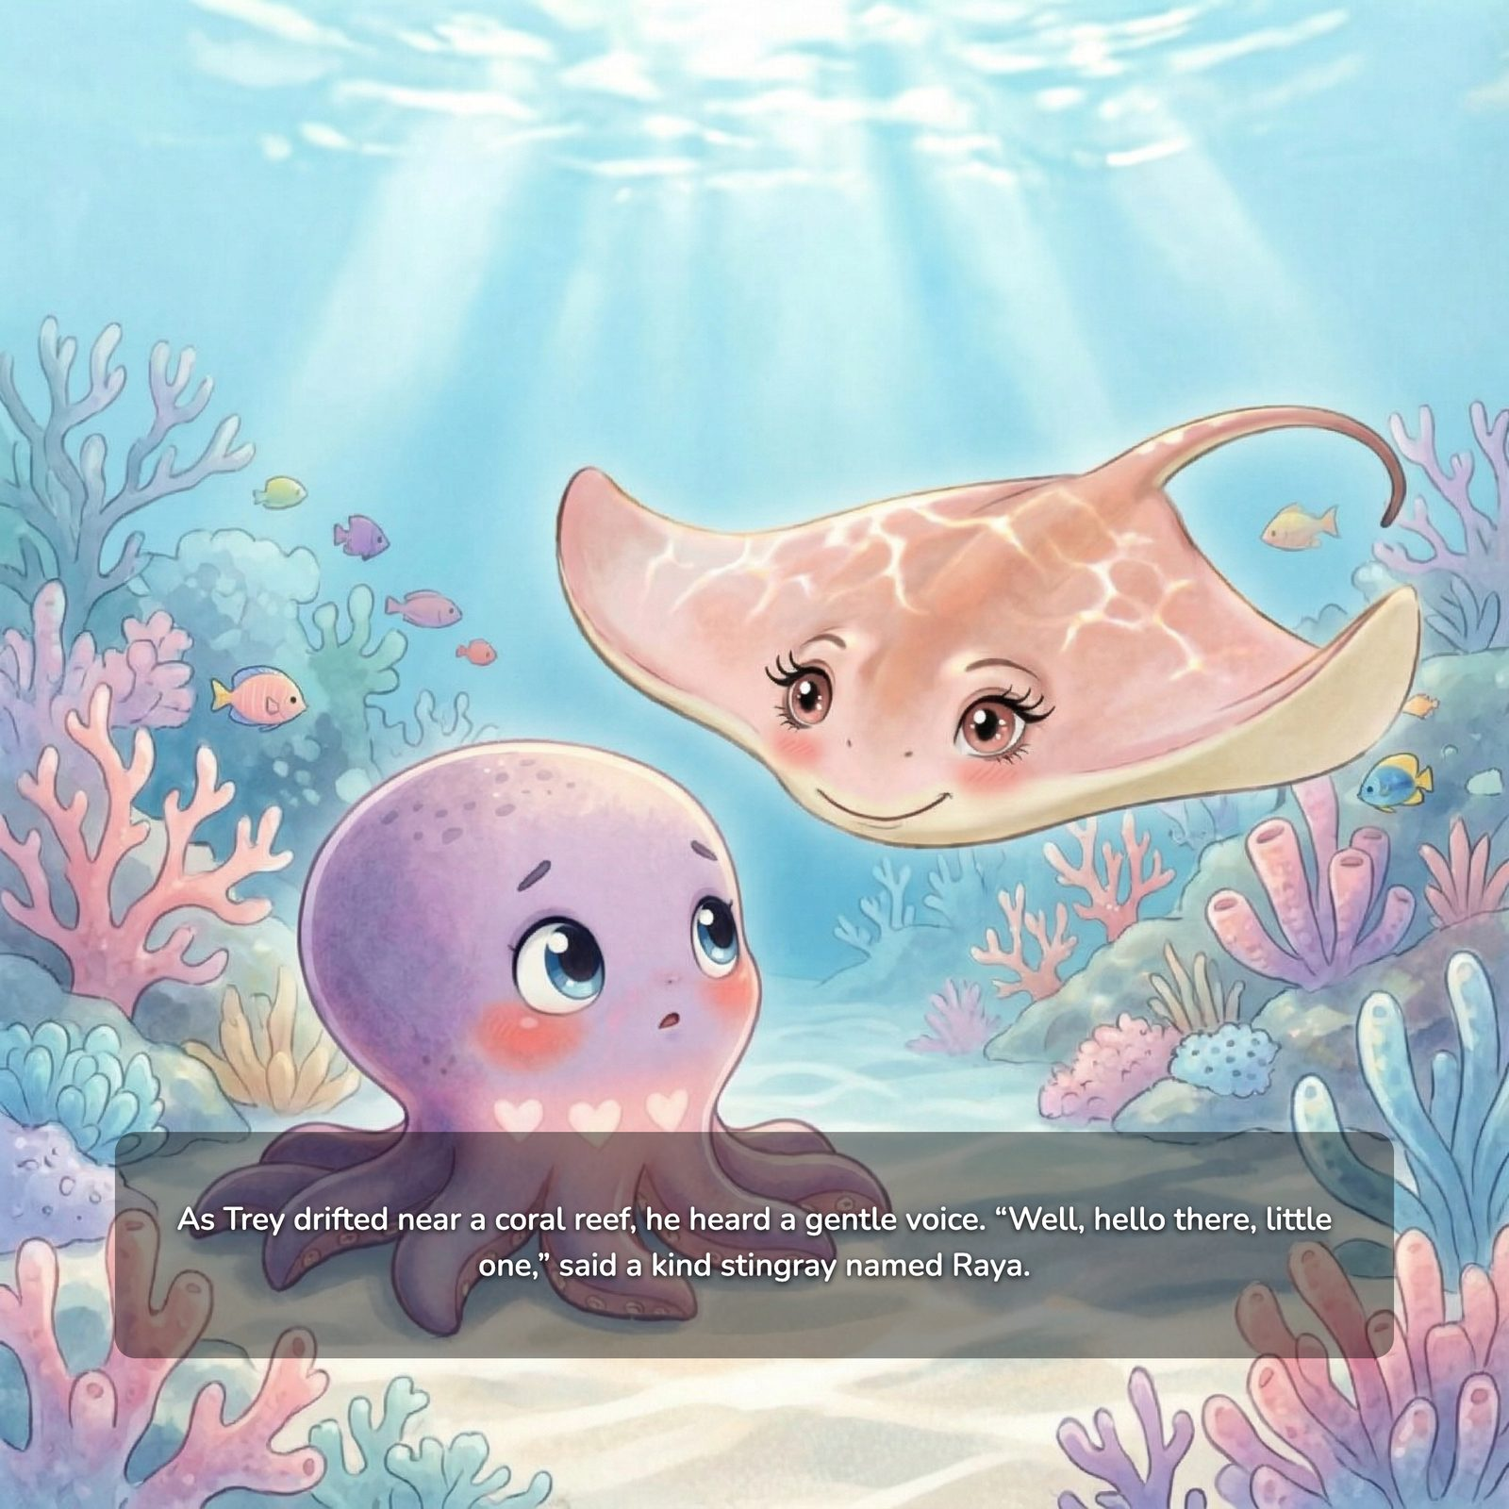
As Trey drifted near a coral reef, he heard a gentle voice. “Well, hello there, little one,” said a kind stingray named Raya.
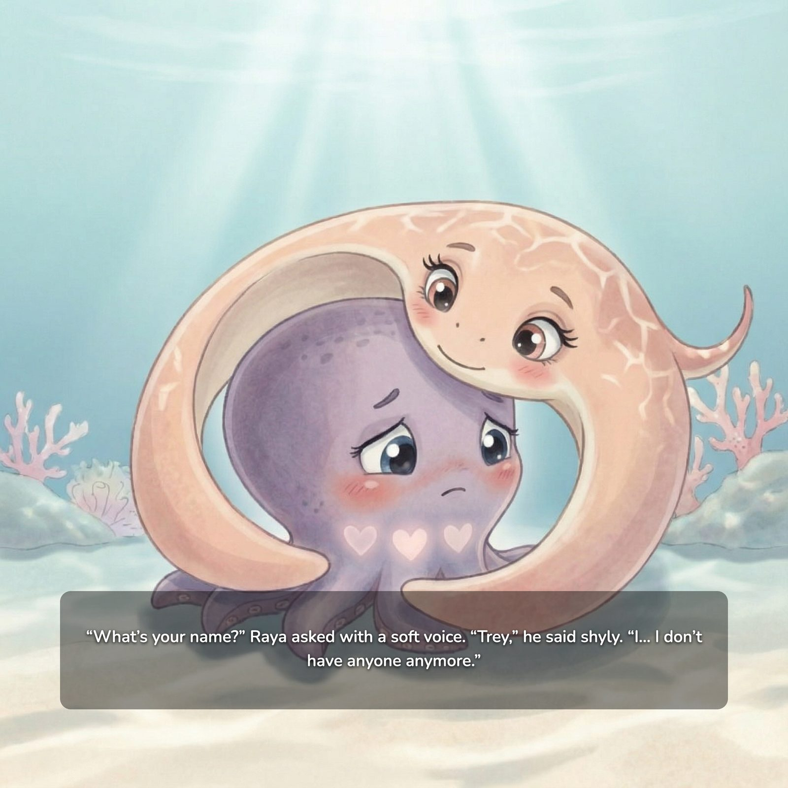
“What’s your name?” Raya asked with a soft voice. “Trey,” he said shyly. “I… I don’t have anyone anymore.”
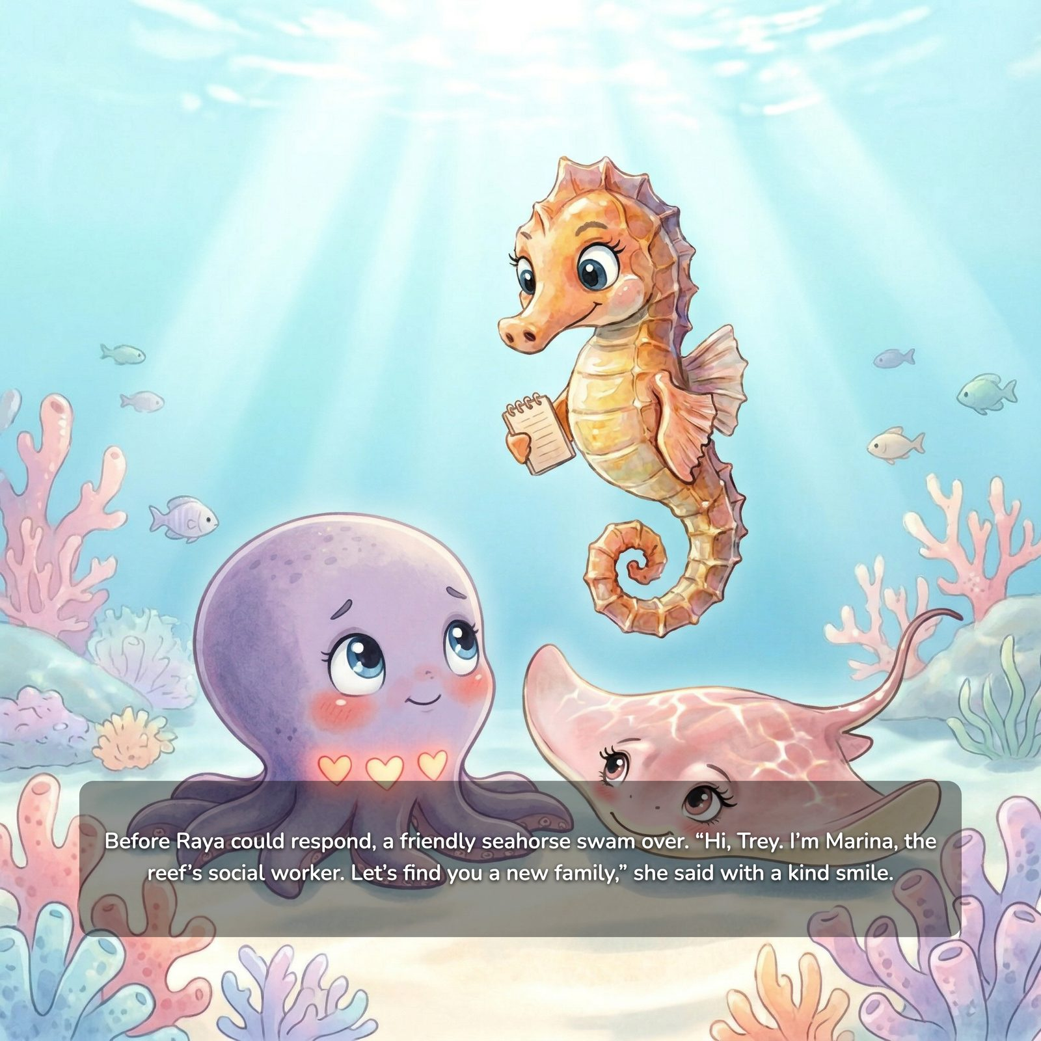
Before Raya could respond, a friendly seahorse swam over. “Hi, Trey. I’m Marina, the reef’s social worker. Let’s find you a new family,” she said with a kind smile.
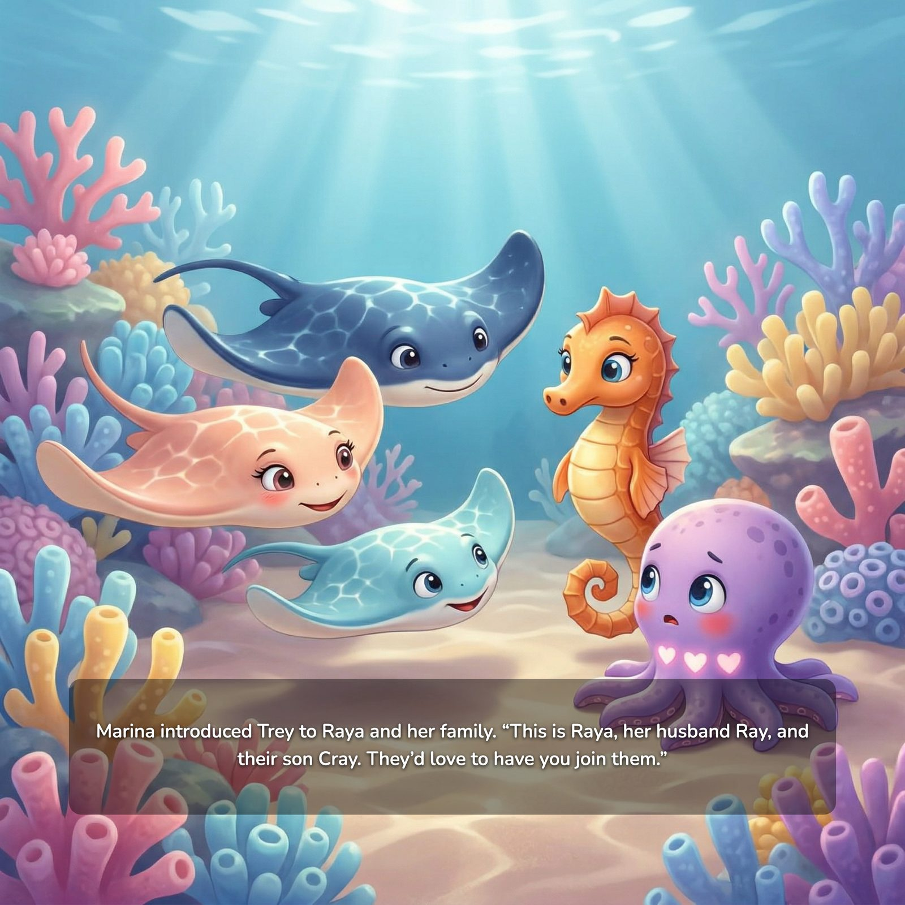
Marina introduced Trey to Raya and her family. “This is Raya, her husband Ray, and their son Cray. They’d love to have you join them.”
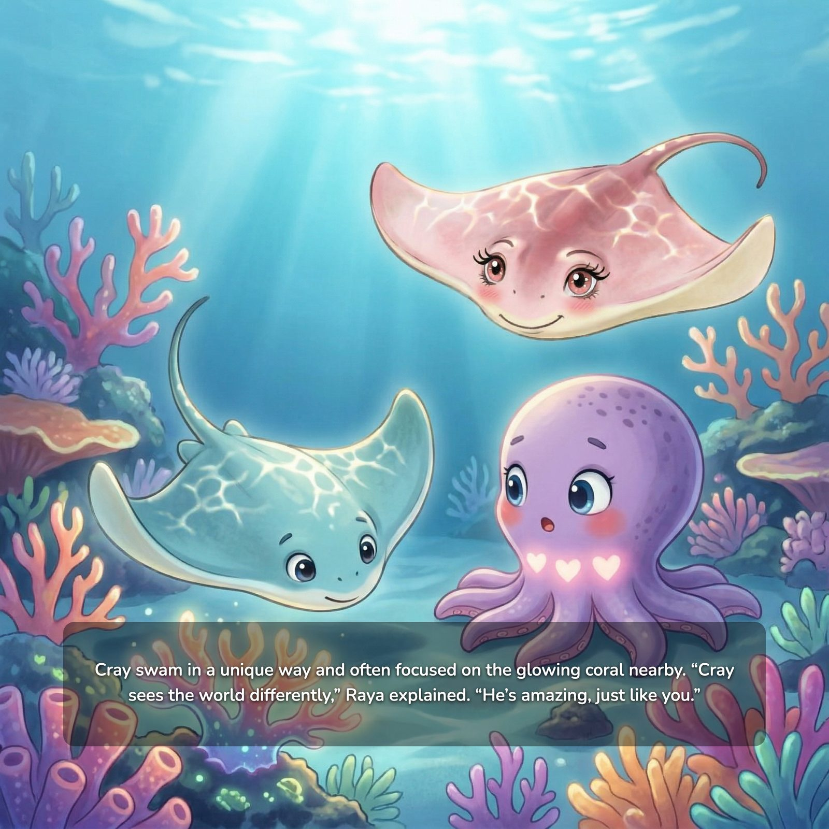
Cray swam in a unique way and often focused on the glowing coral nearby. “Cray sees the world differently,” Raya explained. “He’s amazing, just like you.”
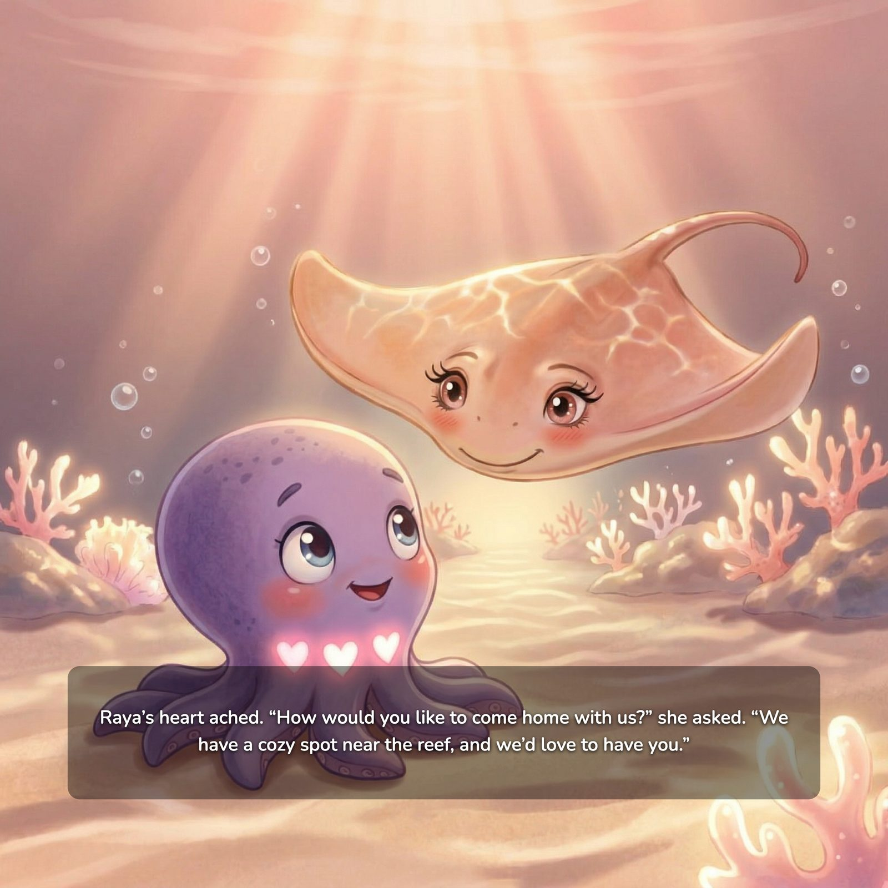
Raya’s heart ached. “How would you like to come home with us?” she asked. “We have a cozy spot near the reef, and we’d love to have you.”
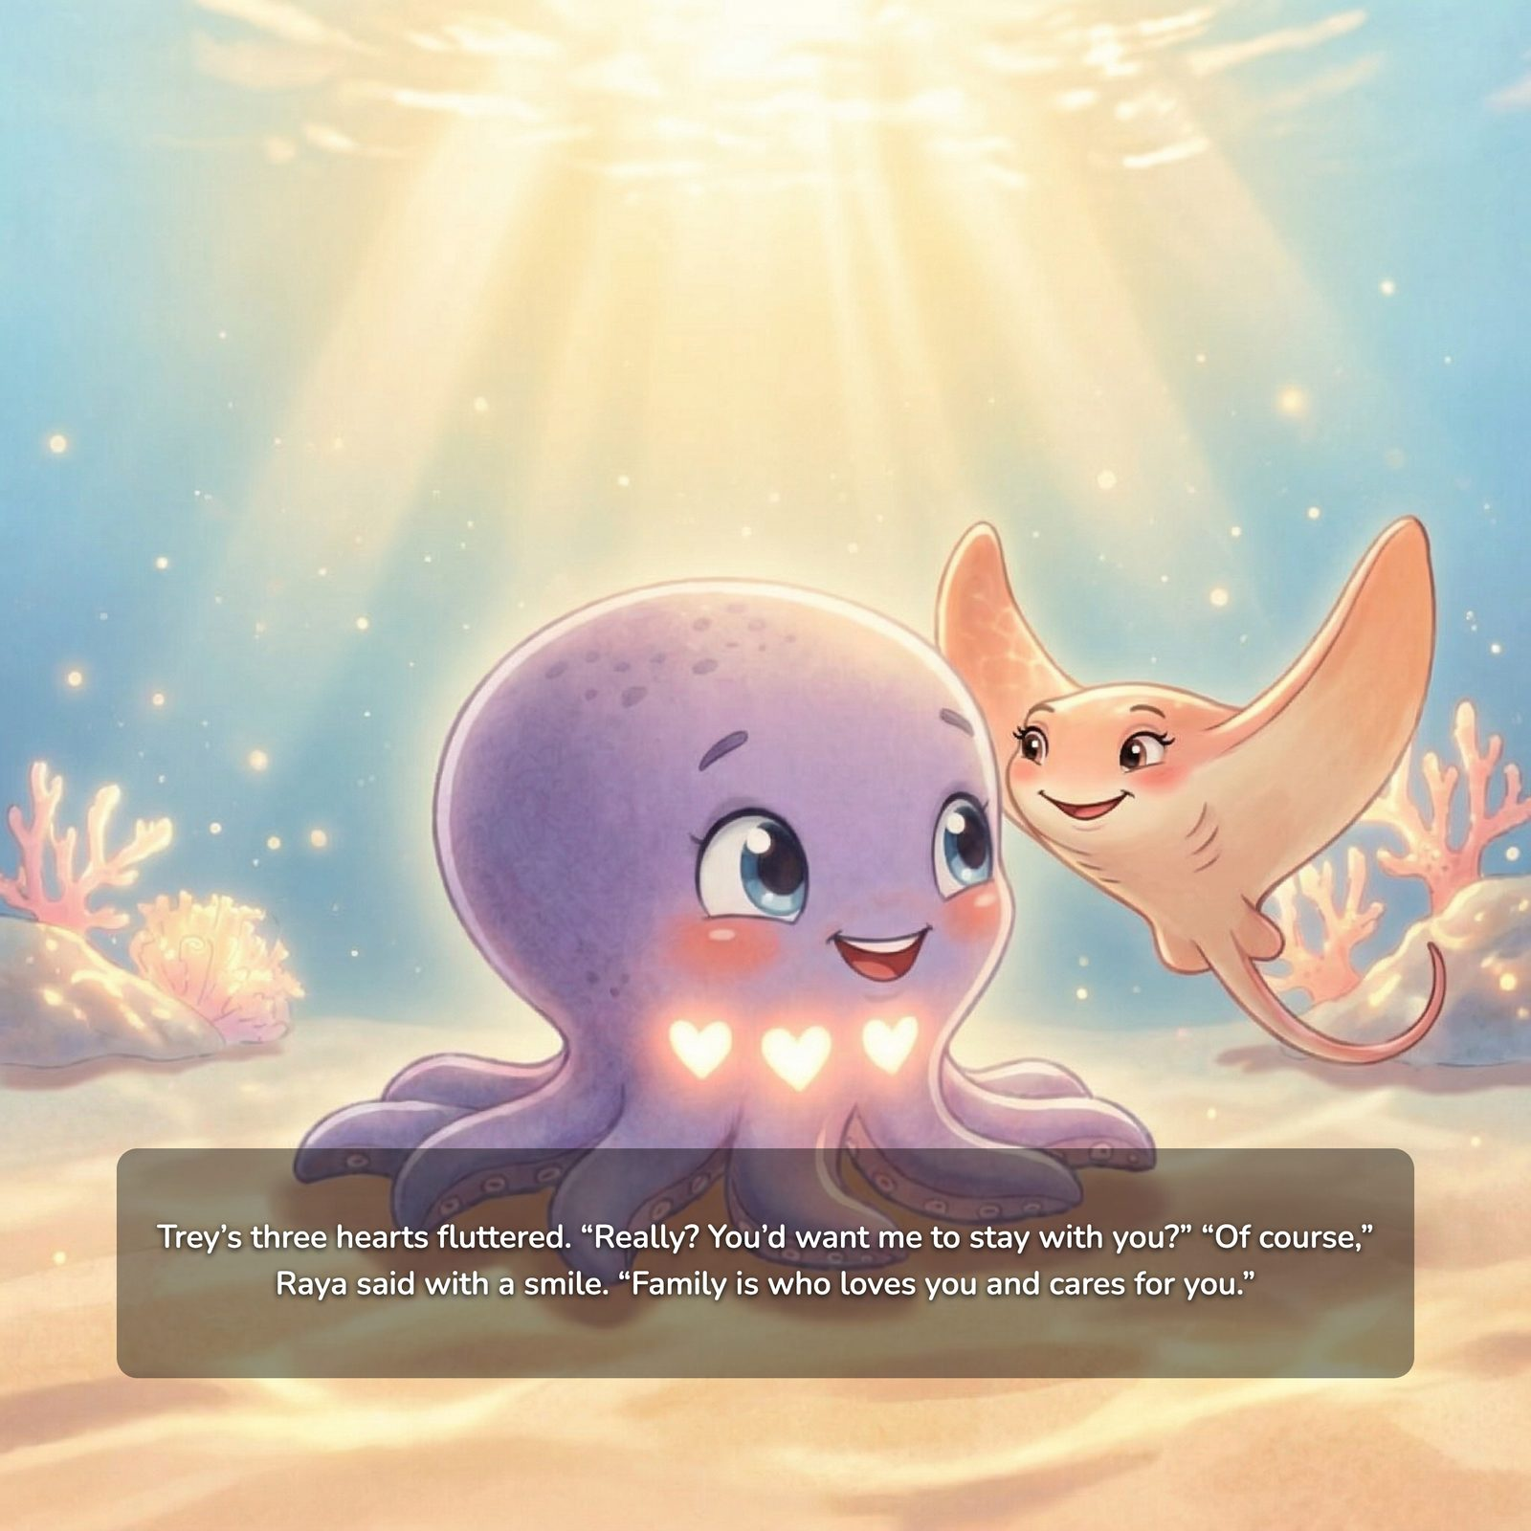
Trey’s three hearts fluttered. “Really? You’d want me to stay with you?” “Of course,” Raya said with a smile. “Family is who loves you and cares for you.”
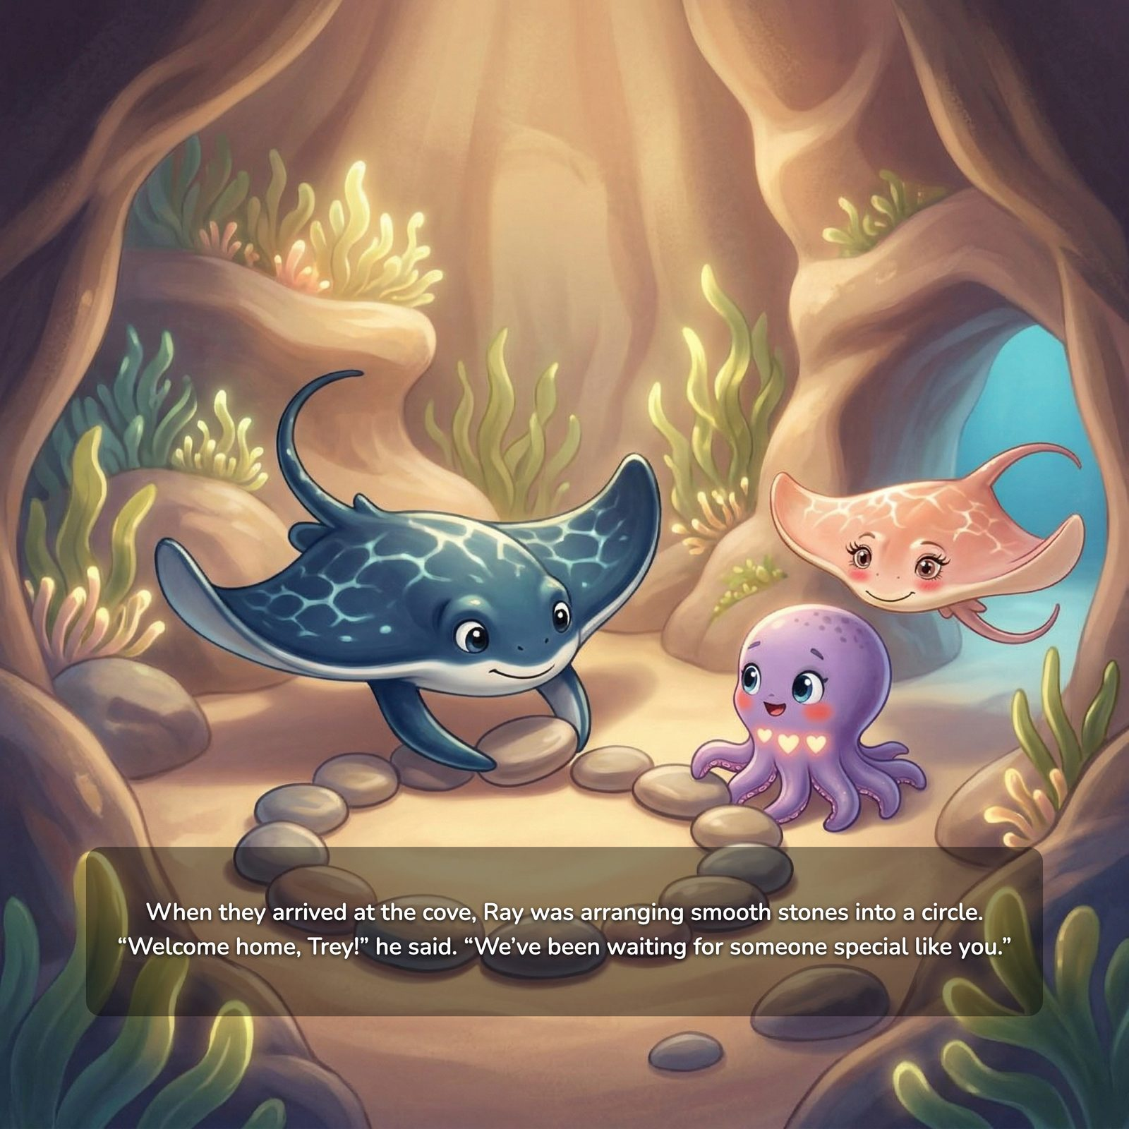
When they arrived at the cove, Ray was arranging smooth stones into a circle. “Welcome home, Trey!” he said. “We’ve been waiting for someone special like you.”
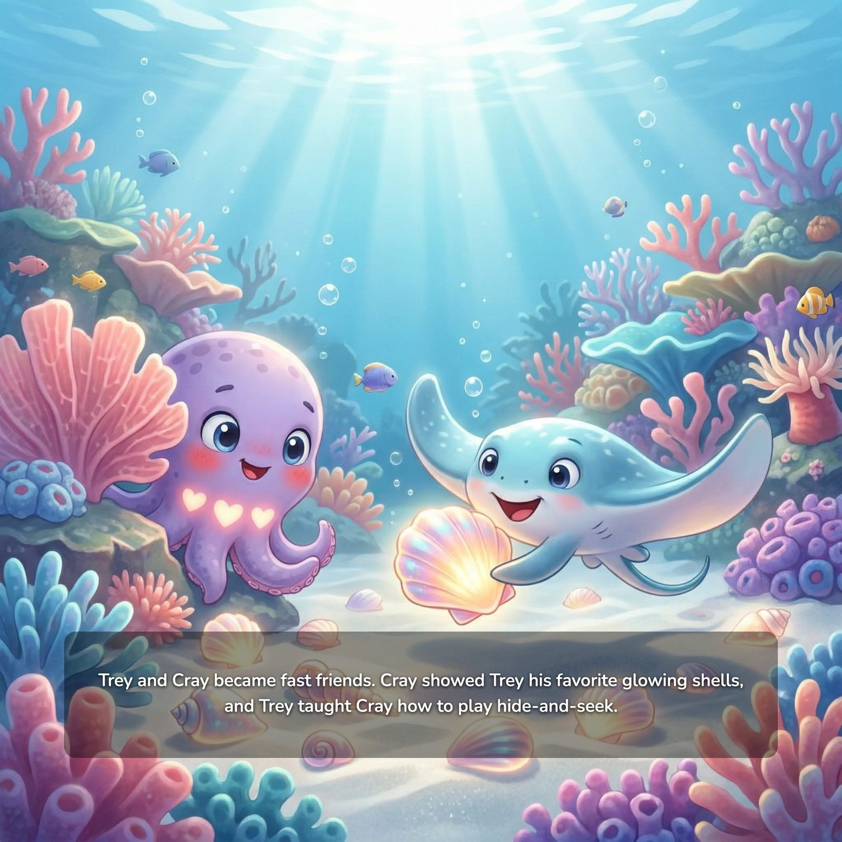
Trey and Cray became fast friends. Cray showed Trey his favorite glowing shells, and Trey taught Cray how to play hide-and-seek.
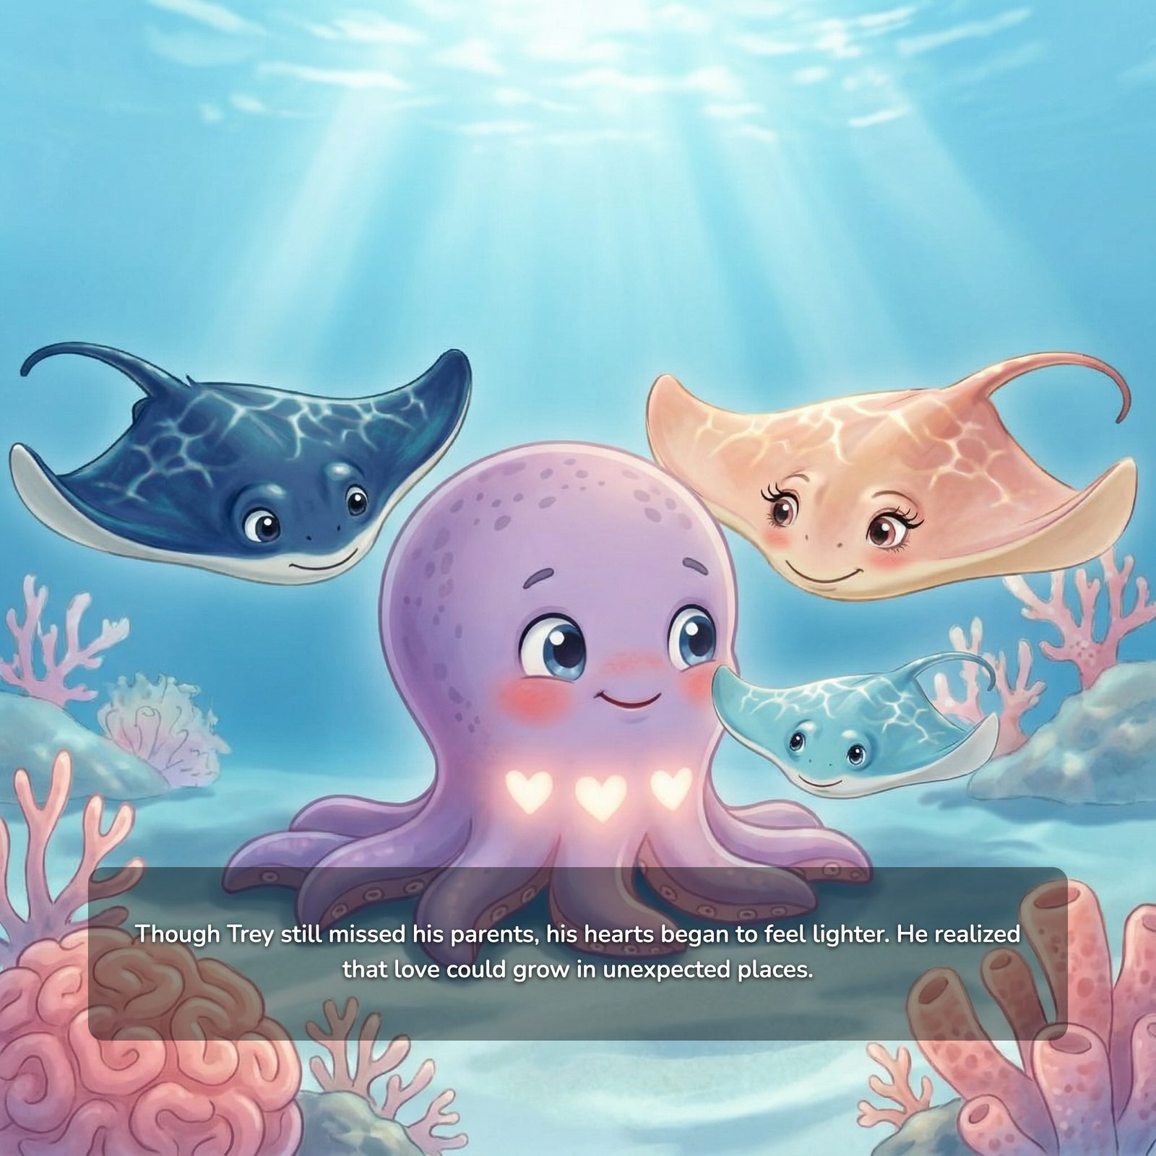
Though Trey still missed his parents, his hearts began to feel lighter. He realized that love could grow in unexpected places.
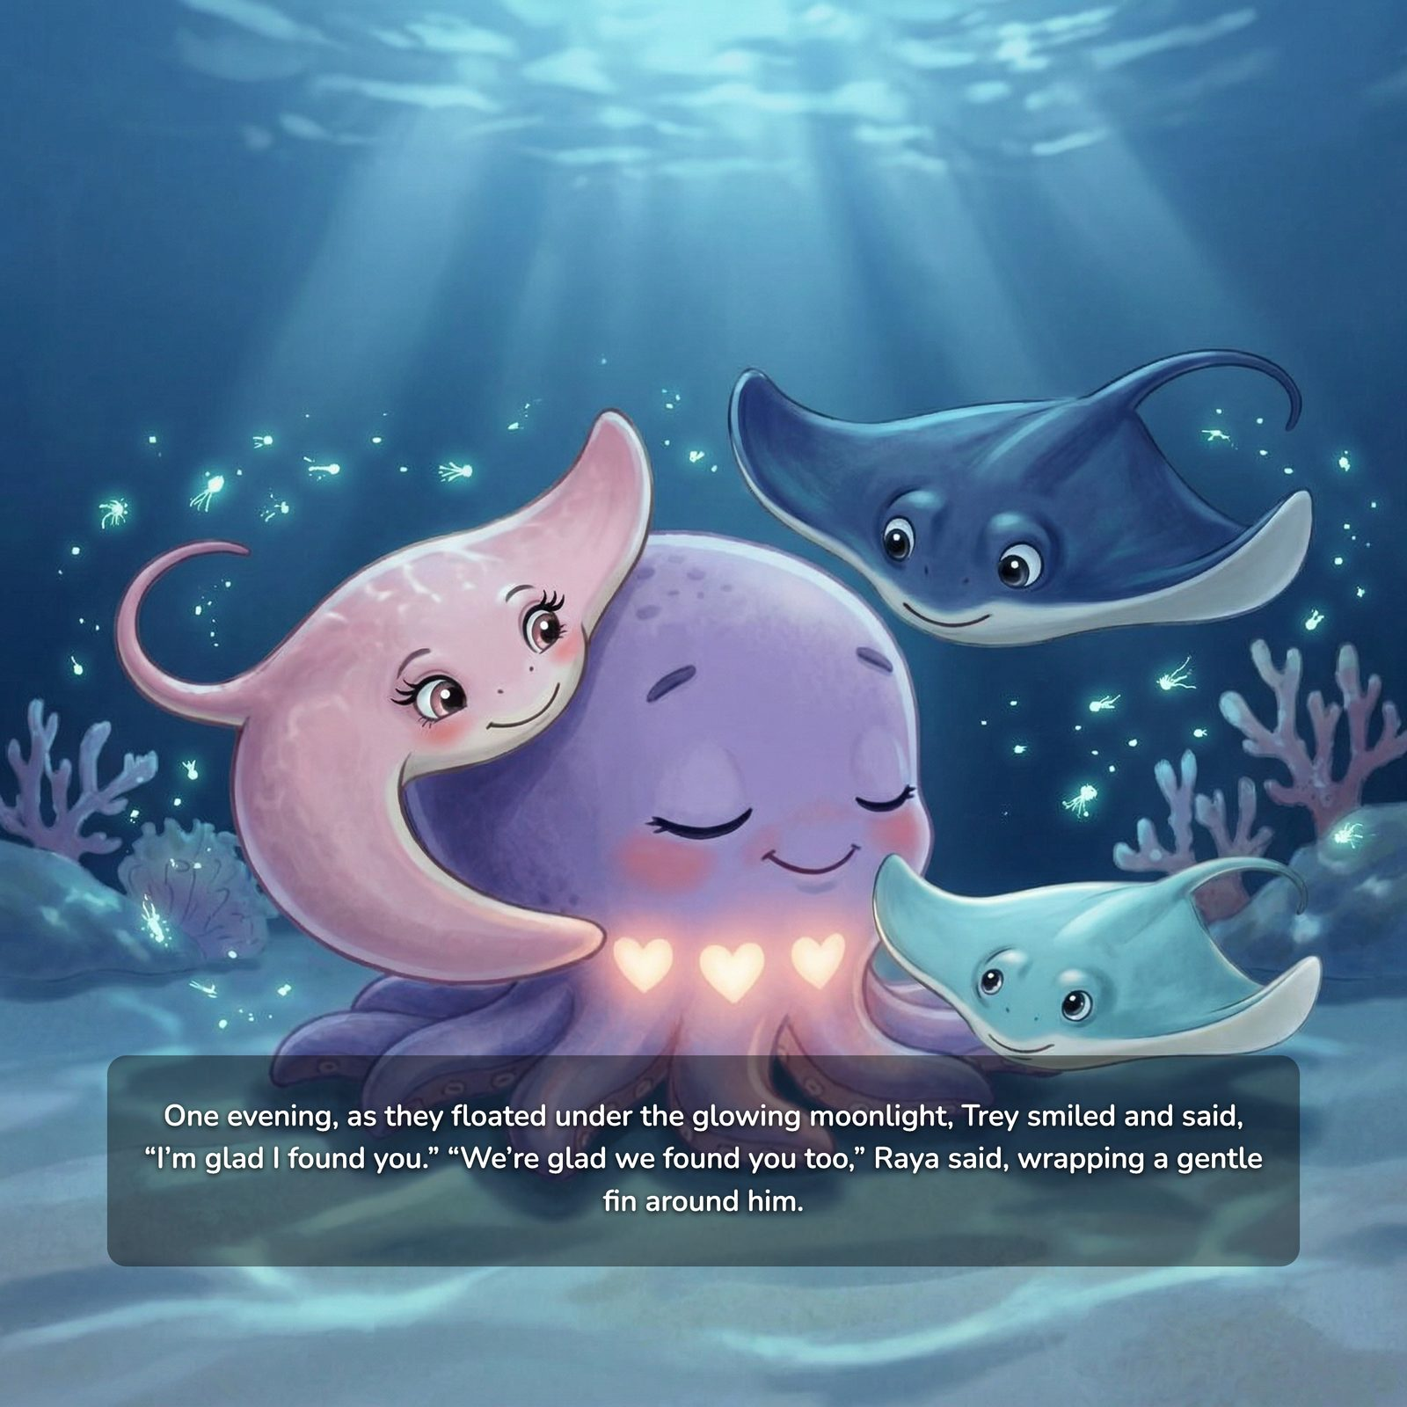
One evening, as they floated under the glowing moonlight, Trey smiled and said, “I’m glad I found you.” “We’re glad we found you too,” Raya said, wrapping a gentle fin around him.

For Parents and Caregivers
The following pages offer gentle guidance to support conversations about loss, adoption, and belonging as you read Trey’s story together.

A Note to Caregivers
Children may not always have the words to express grief, loss, or change — but they feel it deeply.
As you read Trey’s story together, your role is not to fix the feelings, but to stay present with them.
Your calm presence helps your child feel safe.
There are no perfect words — connection is what matters most.

How to Use This Book
- Read at your child’s pace
- Pause when emotions arise
- Allow repeated questions
- It’s okay if your child does not want to talk right away
Understanding happens gradually and often returns in layers.

Pages 1–2: Loss & Separation
Trey loses his parents and is suddenly alone.

Your child may feel:
- Sadness
- Fear
- Questions about safety

What to say:
- “Trey feels really sad.”
- “That is a really big change.”
- “It makes sense his heart feels heavy.”

Pages 3–5: Safe Adults & Support
Raya and Marina step in to help Trey.

Your child learns:
- Adults can care and protect
- Help exists after loss

What to say:
- “Raya wants Trey to feel safe.”
- “There are people who help children.”

Pages 6–10: A New Family & Belonging
Trey is invited into a new home.

Your child may feel:
- Excited
- Nervous
- Unsure

What to say:
- “New things can feel exciting and scary.”
- “It’s okay to take time to feel safe.”
- “Families grow together.”

Pages 7 & 11–13: Differences, Healing & Mixed Feelings
Cray experiences the world in his own way, and Trey learns that love can grow in unexpected places.

What your child learns:
- Differences are safe and valuable
- You can feel more than one thing at once
- New love does not replace old love

What to say:
- “Trey feels happy and sad.”
- “Both feelings are okay.”

Supporting Your Child

Helpful responses:
- “I’m here with you.”
- “That makes sense.”
- “You’re safe.”
- “You can always talk to me.”

Try to avoid:
- “Don’t be sad”
- “You’re fine”
- “Be strong”

Closing Message
Love can grow again, even after loss.
With your presence, your child can learn they are safe, cared for, and not alone.

