**ASSIGNMENT 8**

Please follow below notices:

1. Do it with your group
2. Submit a package of Power BI file and report (in MS Word format, show process of your work in step-by-step, and give your comments on those figures). Name of files follows the structure of “ex8_group1.pbix”, “ex8_group1.docx”.
3. Deadline of submission: before 23:00 October 07, 2022

**Questions:**

1. Load and transform all eight items from dataset “WideWorldImporters.xlsx” (Hint: press Transform Data)

1. Connect, combine, and transform new sources (Hint: New Source -> Folder -> Targets -> Combine & Transform Data)

1. Employee query: Remove null values or empty strings in Parent Employee Key column.

1. Customer query: Transform the Postal Code column type to Text to accommodate both numeric and text values.

1. Targets for 2020 query:

* Removes the Promoted Headers step and all subsequent steps.
* Remove the first three rows.
* Use the first row for the column names.
* Now you see that the last row is a total row, and the last column, Year Target, is a total column. Please remove them.
* Unpivot month columns (from January to December).
* From column “Attribute”, add a column “Start of Month” to transform month names into dates. Then, you get this:

* Change column type of “Start of Month” to Date.
* Move column “Start of Month” to the beginning.
* Rename column “Value” to “Target Excluding Tax”. The result is:

1. Target query:

* Add new column “Months” to get this:

* Extract the first four characters of column “Source.Name”, change column type to whole number type, and you get this:

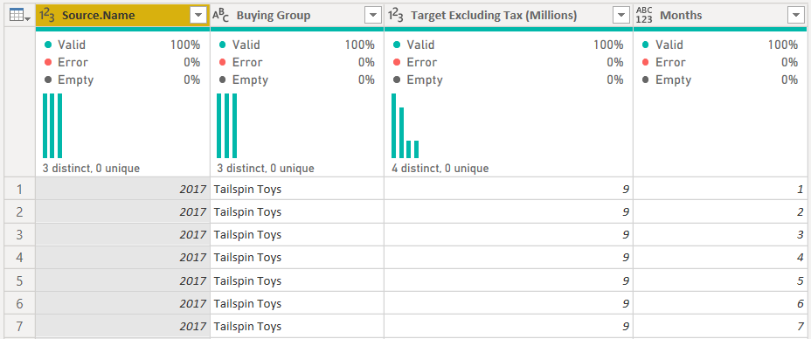

* From column “Source.Name”, add new column “Start of Month”, change column type to date type, and get this:

* Just keep three columns like this:

* According to business rules, it’s all right to divide the yearly target evenly across months for years. So, calculate Target Excluding Tax to get this:

1. Append queries:

* Append the Targets for 2020 (second) and Targets (first) queries.
* Transform the Start of Month to End of Month.

1. Merge queries:

* Merge the City (first) and State Province (second) queries with State Province Key -> Select the State Province and Sales Territory check boxes -> Rename the State Province.1 column to State Province -> Remove the State Province Key column. City query or result looks like:

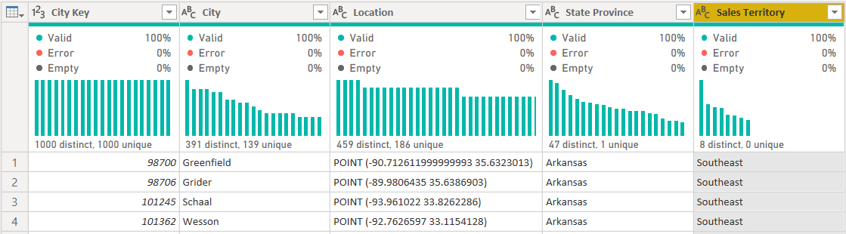

1. Disable load for State province and Targets for 2020 queries.
2. Create data model with the following relationships:

|  |  |
| --- | --- |
| **From: Data Table (Column)** | **To: Lookup Table (Column)** |
| Sale (City Key) | City (City Key) |
| Sale (Customer Key) | Customer (Customer Key) |
| Sale (Salesperson Key) | Employee (Employee Key) |
| Sale (Stock Item Key) | Stock Item (Stock Item Key) |
| Sale (Invoice Date Key) | Date (Date) |
| Sale (Deliver Date Key) | Date (Date) -> inactive |
| Targets (Buying Group) | Customer (Buying Group) -> many-to-many relationship, single (Customer filter Targets) |
| Targets (End of Month) | Date (Date) |

1. Cloning tables: Creates a table called Invoice Date by copying the Date table.
2. Calculate average profit per employee (name Profit average per Employee). (Hint: use Quick measure button)
3. Calculate total cost in a calculated column (name Total Cost) in the Sale table.
4. Add a calculated column (name Unit Price Difference) to the Sale table to calculate the price difference between the standard unit price and the price a product was sold.
5. Add a calculated column (name Sale Rows) to the Customer table to count the number of related rows in the Sale table for each customer. (Hint: use RELATEDTABLE function)
6. Add a measure (name Total Profit) to compute the total profit.
7. Add a measure (name Total Sales Excluding Tax) to compute total sales excluding tax.
8. Add a measure (name Profit %) to compute the profit margin percentage.
9. Add a measure (name Total Dry Items Units Sold) to compute total dry items was sold. Note that you need to avoid showing zeros in your visuals. (Hint: use operator <>)
10. Use Calculate measure to add a measure (name New England Profit) to calculate profit for the New England sales territory.
11. Use Calculate measure to add a measure (name New England, Far West, and Plains Profit) to calculate profit for New England, Far West, and Plains.
12. Use Calculate measure to add a measure (name New England Profit 2020) to calculate profit in New England in 2020.
13. Use Calculate measure to add a measure (name Profit All Sales Territories) to calculate profit for all sales territories regardless of any filters on the City[Sales Territory] column.
14. Create the following figures, each group of figures in one page:

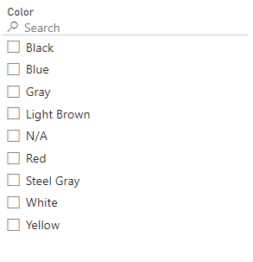

* **Hint:** 
  + **West**: Far West, Plains, and Rocky Mountain
  + **East**: Great Lakes, Mideast, and New England
  + **South**: Southeast, Southwest
  + **North:** the others

1. To reduce the load on the production environment, you connect to the development database and develop your reports. Once you publish your report, you need to use the production data instead. Because you’re developing your model iteratively, you need to switch between the environments back and forth. How can you minimize the time spent on changing data sources? The solution must allow for switching the source in the Power BI service.
2. Create a parameter for database location and use it in queries.
3. Change the data source in the Data Source settings.
4. Change the data source in the Source step in each query.
5. You get data from a table in an Azure SQL Database that contains hundreds of millions of rows. Loading the full table takes half an hour. You would like to load a sample of 1,000 rows from the table. How can you achieve this? Your solution must minimize time spent on loading data.
6. Use a report-level filter.
7. Keep top rows.
8. Provide your own SQL statement that has a TOP clause.
9. You get data from a CSV file with over 10,000 rows. You need to ensure one of the columns does not contain any missing values. Which Power Query features should you use?
10. Column distribution
11. Column quality
12. Column profiling based on top 1,000 rows
13. Column profiling based on the entire dataset
14. You are the only developer of Power BI reports in Contoso, and you’re creating the first sales report. Your report must show data no later than 10 minutes from its arrival in the production environment. Which connectivity mode suits best? Your solution must minimize the resources spent.
15. Import mode
16. Live Connection
17. DirectQuery
18. You need to combine the Customer and City tables, both of which have the CityKey column. Each row in the output table must contain a customer name and their city. Which Power Query feature should you use?
19. Group by
20. Merge
21. Transpose
22. Append
23. After you load data from an Excel file, you encounter the error shown in figure below:

Which Power Query feature can you use to resolve the error? Your solution must retain all data from Excel.

1. Replace errors
2. Remove rows
3. Change type (add new step)
4. Change type (replace current)
5. A data model has a fact table that has over 15 million rows. There is a date/time column called DateTime, which contains both date and time. You need to reduce the size of the data model. Your solution must preserve as much of the original data as possible. Which solution should you implement?
6. Change the data type of the DateTime column to Text.
7. Clean the DateTime column.
8. Split the DateTime column into two separate columns: one column that contains dates, and one column that contains the time portion.
9. Change the data type of the DateTime column to date.
10. You create a visual that is supposed to show revenue by year. You use the Year column from the Calendar table and the Revenue measure from the Sale table. The formula of the Revenue measure is as follows:

Revenue = SUM(Sale[Total Including Tax])

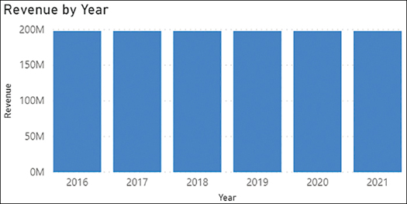

After checking data, you can see that in 2019, revenue was $50 million. How can you fix the visual? The solution must use minimum amount of DAX and ensure that the Calendar table can be used with other fact tables. The solution must also take into account that you may be interested in analyzing other measures based on the Sale table.

1. Use the TREATAS function in DAX.
2. Create a relationship between the Calendar and the Sale tables.
3. Merge the Sale and Calendar tables.
4. Create a calculated table that calculates revenue for each year.
5. Your Date table currently consists only of one column called Date, which contains dates. You need to add a column to the Date table that shows month and year in the MMMM YYYY format, such as May 2021. What should you do? Your solution must require the minimum amount of effort and storage, and the solution must ensure that the values are sorted chronologically.
6. Create a calculated column that uses the FORMAT function.
7. Create a calculated column that uses the EOMONTH function format as MMMM YYYY.
8. Duplicate the Date column and apply a custom format string.
9. Create a new calculated table called “Date – MMMM YYYY” and format as MMMM YYYY
10. You need to write a measure that calculates the monthly balance. Which formula should you use?
11. CALCULATE(SUM(Inventory[Balance]), ENDOFMONTH('Date'[Date]))
12. CALCULATE(SUM(Inventory[Balance]), MAX(Inventory[Date]))
13. CALCULATE(SUM(Inventory[Balance]), DATESMTD(Inventory[Date]))
14. CALCULATE(MAX(Inventory[Balance]), LASTDATE(Inventory[Date]))
15. You inherit a Power BI data model that contains several tables, one of which has many calculated columns that all use the RELATED function. You would like to reduce the size of the model. What should you do?
16. Append tables.
17. Merge tables.
18. Separate tables into several data models.
19. Hide unused columns.
20. Your department wants to see a single visual that explains the factors that contribute to revenue growth the most. Which visualization should you use?
21. Decomposition tree
22. Funnel chart
23. Key influencers
24. Stacked column chart
25. You’d like to create a navigation page in your report that will take users to different pages depending on their choice. Your solution must involve minimal effort, and you must be able to test it in Power BI Desktop. Which element(s) should you use?
26. Buttons with the Bookmark action
27. Buttons with the Page navigation action
28. Table
29. Text box with hyperlinks
30. You need to ensure that users can effectively navigate your reports by using the keyboard. Which property should you configure?
31. Bookmarks
32. Layer order
33. Mobile layout
34. Tab order
35. Your colleague already designed a report page that includes two visuals: a bar chart showing sales by client, and a column chart showing sales by product category. You need to ensure that whenever a user selects a client or product category, the other chart shows only the corresponding sales without showing overall sales. How should you configure interactions?
36. Filter
37. Highlight
38. None
39. You’ve created a bar chart that shows sales by client. You want users to see profit figures when they hover over a client. Which options would work in this case? Each answer presents a complete solution.
40. Add Profit as a visual-level filter.
41. Add Profit to drill-through fields.
42. Add Profit to tooltips.
43. Create a report page that shows Profit and add it as a tooltip.
44. You need to create a bar chart that shows the 10 products that generate the most revenue. Which action should you take? Your solution must involve minimal effort and consider that users may apply date filters.
45. In the Product table, create a calculated column called IsTop10 that uses the RANKX function; then use the column in a visual-level filter.
46. Create a calculated table called Top 10 Products that filters the Sales table.
47. Set a Top N visual-level filter.
48. Create a measure that uses the TOPN function.
49. You need to group the Brand values into Brand Group, which is not available in the model. How would you group the Brand values? Your solution must require minimal effort to maintain.
50. Create a data group of type List.
51. Create a data group of type Bin.
52. Create a calculated column in DAX.
53. Create a custom column in Power Query.
54. You have built a line chart that shows revenue by month. You need to show mean monthly revenue on the same visual. How should you add the value to the visual? Your solution must consider that users may apply product filters and involve minimal effort.
55. Create a measure that uses the AVERAGEX function.
56. Add an Average line from the Analytics pane.
57. Add a Median line from the Analytics pane.
58. Create a calculated column in the Product table that uses the AVERAGEX function.