Applied Econometrics

Lecture 16: Model Selection and the Use of F – Statistic

Say not “I have found the truth” but rather “I have found a truth”
KAHLIL GIBRAN, THE PROPHET

1) Introduction
The variance of the least squares estimator of the slope coefficient of a multiple regression is given by:
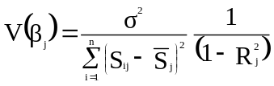
where R_{j}² is the coefficient of determination of the auxiliary regression of X_{j} with all the regressors included in the model. The variance of the estimator of the slope coefficient (V(β_{j})) depends on the three factors: (1) the error variance (σ²), (2) the total sum of squares of X_{j} (TSS=Σ(S_{ij} – 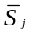)²), and its variance inflation factor (VIF = 1/(1-R_{j}²)).

(1) Since the simpler model features less regressor than the larger model, it follows that the VIF of the simpler model will be less than that of the larger model. The reason is that the more variables we include in the model, the greater multicollinearity, and, hence, the greater R_{j}², unless the omitted variables happen to be orthogonal to the regressors included in the simpler model. The simpler model, which omits relevant variables, produces bias estimates but with smaller variances. Consequently, there appears to be a tradeoff between bias and precision.

(2) We calculate the squared standard error of the regression (s²) as the proxy measurement of (σ²).
s² = RSS/(n – k)
As to the numerator, the RSS of the larger model will generally be less than that of the model which omits relevant variables. As to the denominator, given the sample size, smaller models have more degrees of freedom. In sum, whether the inclusion of omitted variables in the model leads to a reduction in s², depends on whether the RSS falls sufficiently to offset the loss in degrees of freedom.

There are two opposite tendencies when we include the relevant variables in the model: increase in VIF due to multicollinearity and reduction s².

2) The omitted variable bias: Example

Griffin (1971) gave the following model:
C = β₀ + β₁(Y + A) (1)

where C is consumption, Y is income and A is foreign aid. The identity of savings is given by:
S = Y – C (2)

Put (1) into (2) we obtain:
S = – β₀ + (1– β₁)Y – β₁A (3)

If we divide through by Y
S/Y = – β₀/Y + (1– β₁) – β₁A/Y (4)

Griffin ignores the constant term (β₀) of the equation (3) and, dividing through by Y, gets a model to be estimated of the form:
S/Y = α₀ + α₁A/Y (5)
where his theory would suggest that S/Y = α₀ + α₁A/Y
Griffin estimates the slope of coefficients ranged from – 0.67 to – 0.84.

The magnitude of the negative relationship between aid and savings (α₁) is very different when we estimate the correct model (S/Y = α₀ + α₁A/Y – α₂(1/Y)) and the incorrect model (S/Y = α₀ + α₁A/Y).

3) The F – test
The general formulae for the F – test is as follows:
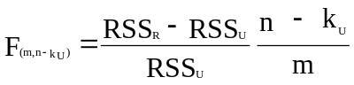

where RSS_{U} and RSS_{R} are the residual sum of squares of the unrestricted and restricted model respectively; n is the sample size; k_{U} is the number of estimated coefficients in the unrestricted model; and m is the number of linear restrictions imposed on the model.

4) F – test and t – test compared

If we want to impose two or more zero restrictions, we can no longer rely on separate t – tests, but we must use an F – test. The result for this is that the sample distributions of these coefficients are not independent.

If our restriction involves dropping only one variable, it does not matter whether we use the t – or F – tests: both tests are equivalent. In fact, it can be shown that t² = F.

5) Testing several zero restrictions at once

The unrestricted model can be written by:
Y = β₀ + β₁X₁ + β₂X₂ + β₃X₃ + β₄X₄ (U)

The restriction model can be written by:
Y = β₀ + β₁X₁ + β₂X₂ (R)

The restrictions are: β₃ = β₄ = 0. We may use an F – test to test whether or not both these restrictions are jointly valid.

6) The overall F – test: Restriction all slope coefficients to zero

We can also use the F – test to test whether all regressors can be jointly dropped from the regression.
The multiple regression model can be specified as follows:
Y = β₀ + β₁X₁ + β₂X₂ + … + β_{k}X_{k}
The hypothesis being testing is:
H₀: β₁ = β₂ = … = β_{k}
Against
H₁: at least β_{i} ≠ 0
The calculated F is given by:
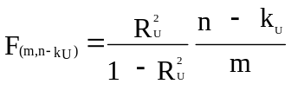
If the calculated F is greater than the F – critical value at desired level of significance, m is the degrees of freedom for denominator and (n – k_{U}) is the degrees of freedom for numerator, we reject the hypothesis H₀.

7) Testing non – zero linear restrictions
Suppose we have the following model:
lnQ = β₀ + β₁lnL + β₂lnK + ∈
where Q is output, K is capital and L is labor.

We want to test the hypothesis that there are indeed constant returns to scale (β₁+β₂=1). This is a non-zero linear restriction.

We substitute (β₁=1–β₂) into the unrestricted model:
lnQ = β₀ + (1 – β₂)lnL + β₂lnK + ∈
lnQ = β₀ + lnL + β₂(lnK – lnL) + ∈
ln(Q/L) = β₀ + β₂ln(K/L) + ∈

The restricted model has only two coefficients instead of three in the unrestricted model. So, the imposition of the linear restriction has reduced the number of model parameters by one. We must use the RSS variant to test because the dependent variable in the restricted model (ln(Q/L)) is different from that in the unrestricted model (lnQ).

8) Testing the stability of parameters
8.1) Pooling data

The restricted model can be specified as follows:
LE = β₀ + β₁lnY RSS_{R} = 3125.8
where LE is the life expectancy at birth and Y is the GNP per capita.

Looking the scatter suggests that the relationship between income and life expectancy is different for high and low income countries. So, the unrestricted model can be specified as follows:
For Y ≤ 2,500 LE = α₀ + α₁ln(Y) RSS₁ = 2217.6
For Y > 2,500 LE = γ₀ + γ₁ln(Y) RSS₂ = 529

The restricted model (pooling data) we assume an identical intercept and slope for the two sets of observations. So, the null hypothesis can be stated as follows:
H₀: α₀ = γ₀ and α₁ = γ₁

Figure 1:
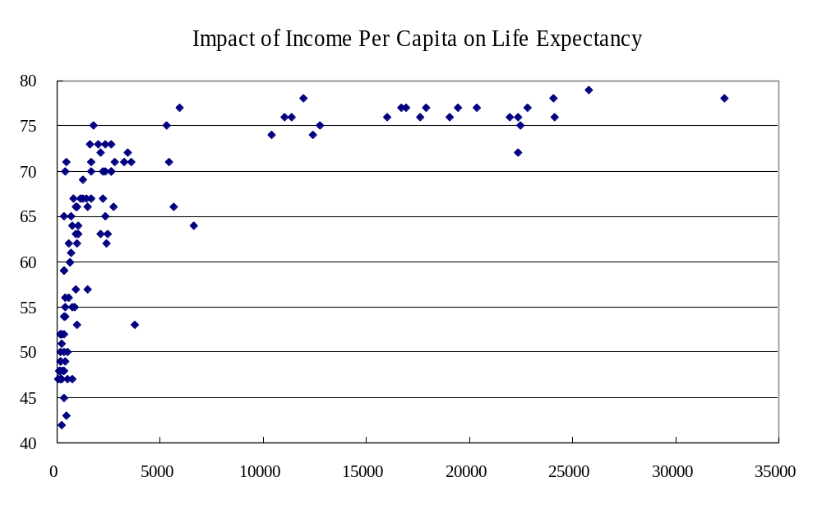
The general formulae for the F – test is used:
where RSS_{U} = RSS₁ + RSS₂; n = 111; k_{U} = 4 (total number of parameters in the two equations of the unrestricted model); and, m = 2 (number of restrictions).

We compare the calculated F with the critical value of F at 5% level of significance;
Because F_{calculated} = 7.39 > F_{critical value} (0.05, m, n–k_{U}) = 3.07, we reject the null hypothesis.

8.2) Parameter stability across time

If we estimate an equation using time-series data we assume that the parameters of the model remain constant over time. That is, we are pooling data from different time periods.

The restricted model can be specified as follows:
TOT = β₀ + β₁t RSS_{R} = 0.5383
where TOT is the terms of trade (ratios between export price index to import price index) and t=1950,1986.

Figure 2
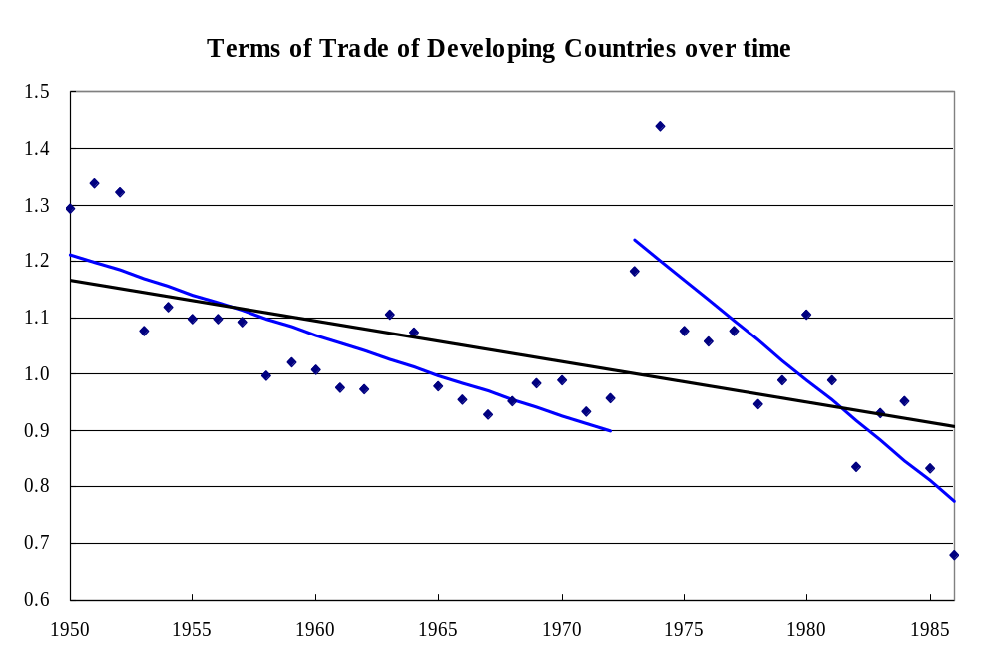

Looking the scatter suggests that the data appears to have a break in the year of 1972. So, the unrestricted model can be specified as follows:
For t = 1950, …, 1972 TOT = α₀ + α₁t RSS₁ = 0.1095
For t = 1973, …, 1986 TOT = γ₀ + γ₁t RSS₂ = 0.1327

The restricted model (pooling data) we assume an identical intercept and slope for the two sets of observations. So, the null hypothesis can be stated as follows:
H₀: α₀ = γ₀ and α₁ = γ₁

The general formulae for the F – test is used:
where RSS_{U} = RSS₁ + RSS₂ = 0.2422; RSS_{R} = 0.5383; n = 37; k_{U} = 4 (total number of parameters in the two equations of the unrestricted model); and, m = 2 (number of restrictions).

We compare the calculated F with the critical value of F at 5% level of significance. Because F_{calculated} = 20.17 > F_{critical value} (0.05, m, n–k_{U}) = 3.28, we reject the null hypothesis.

The use of F – test to test for parameter stability is often called the Chow test. Chow also provided an alternative specification of the F – test to apply in the case when one sub–sample has too few observations to be estimated.

9) Use of dummy variables

Dummy variables, both intercept and slope dummies, may also be used to model parameter instability.

The restricted model can be specified as follows:
S/Y = β₀ + β₁A/Y
where S/Y is the savings as per cent of GNP and A/Y is the foreign aid as per cent of GNP.
S/Y = 19.14 – 0.87 A/Y RSS_{R} = 10,358
(9.28) (-5.56)
The t – statistics are in brackets

The unrestricted model can be specified as follows:
S/Y = α₀ + α₁A/Y + α₂D
where D is the dummy variable: D = 1 if (S/Y = -73 and A/Y = 29.4) and D = 0 if others
S/Y = 18.27 – 0.64A/Y – 72.38D RSS_{U} = 5546
(11.10) (-5.36) (-7.39)
The t – statistics are in brackets
The general formulae for the F – test is used:
Because F_{calculated} = 54.66 (or 7.39²) > F_{critical value} (0.05, m, n–k_{U}) = 3.99, we reject the null hypothesis. The observation 26 is the outlier, which changes the slope of the coefficient.

Figure 3
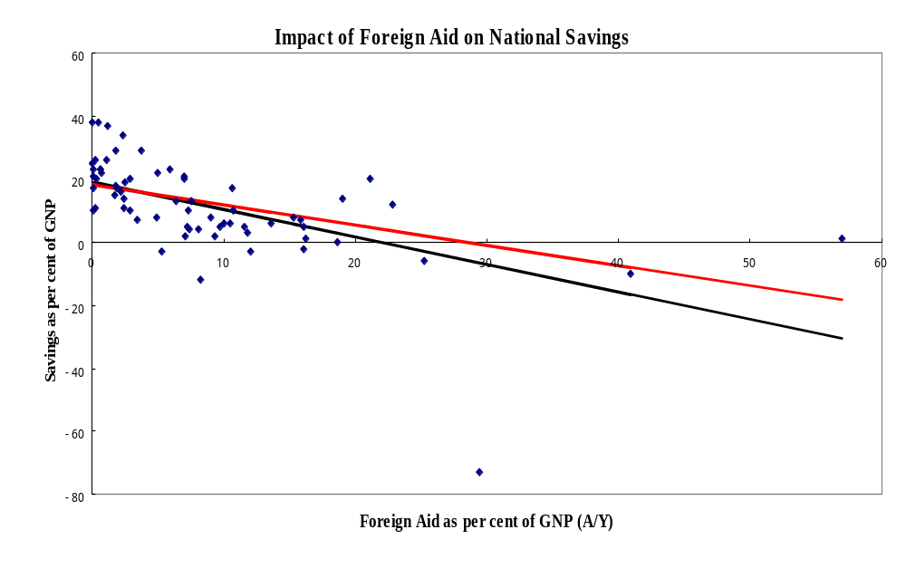

References

Bao, Nguyen Hoang (1995), ‘Applied Econometrics’, Lecture notes and Readings, Vietnam-Netherlands Project for MA Program in Economics of Development.

Maddala, G.S. (1992), ‘Introduction to Econometrics’, Macmillan Publishing Company, New York.

Mukherjee Chandan, Howard White and Marc Wuyts (1998), ‘Econometrics and Data Analysis for Developing Countries’ published by Routledge, London, UK.

White, Howard (1992), ‘What Do We Know About Aid’s Macroeconomic Impact?’, Journal of International Department 4: 121-137

Wonnacott, Thomas H. and Ronald J. Wonnacott (1990). ‘Introductory Statistics’, Published by John Wiley and Sons, Inc., Printed in the United States of America.

The F – test checks whether the imposition of a linear restriction on a model significantly increases its residual sum of squares. To do this, the F – statistic takes into account of the degrees of freedom of the unrestricted and restricted version of the model.

