ASSIGNMENT 4

Stephen Young

2022-04-24

options(knitr.duplicate.label = 'allow')

# Markdown Basics

## Favorite Foods

1. Pizza
2. Buttered Chicken
3. Ice Cream

## Images

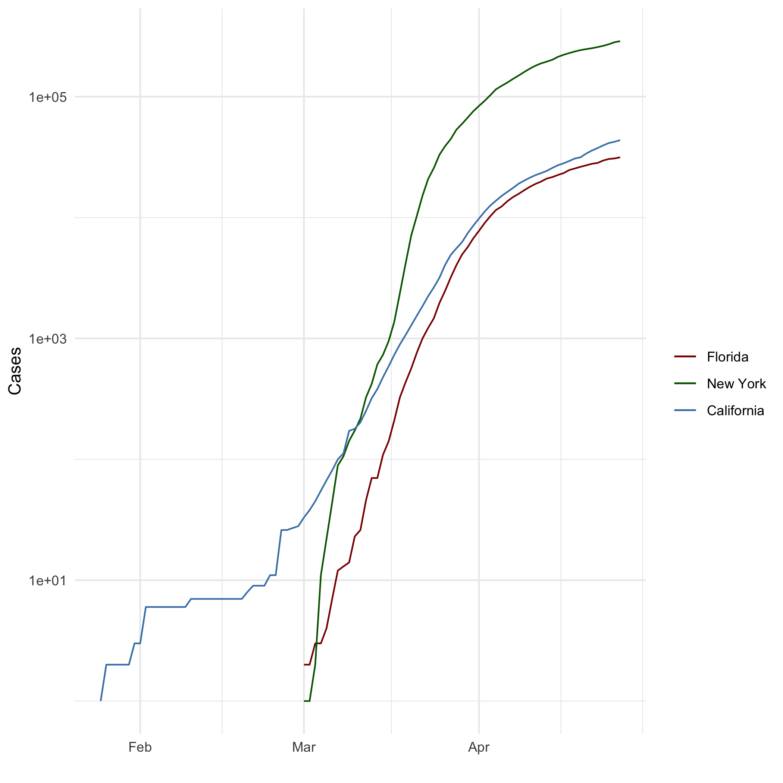

## Add a Quote

“And wow! Hey! What’s this thing suddenly coming towards me very fast? Very very fast. So big and flat and round, it needs a big wide sounding name like … ow … ound … round … ground! That’s it! That’s a good name – ground! I wonder if it will be friends with me? And the rest, after a sudden wet thud, was silence.” - Douglas Adams, Hitchhiker’s Guide to the Galaxy

## Add an Equation

$x−5=10$

## Add a Footnote

This is a footnote

## Add Citations

* R for Everyone (Lander 2014)
* Discovering Statistics Using R (Field, Miles, and Field 2012)

# Inline Code

## NY Times COVID-19 Data

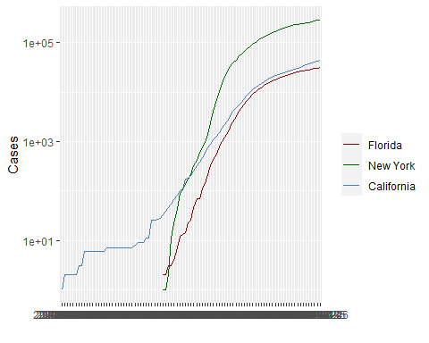

## R4DS Height vs Earnings

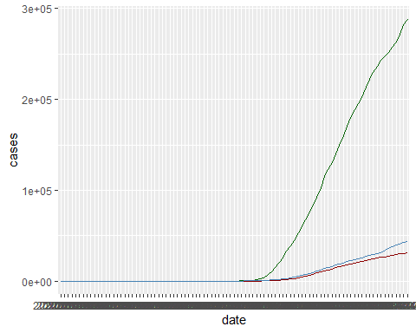

# Tables

name race in_fellowship ring_bearer age

1 Aragon Men TRUE FALSE 88 2 Bilbo Hobbit FALSE TRUE 129 3 Frodo Hobbit TRUE TRUE 51 4 Galadriel Elf FALSE FALSE 7000 5 Sam Hobbit TRUE TRUE 36 6 Gandalf Maia TRUE TRUE 2019 7 Legolas Elf TRUE FALSE 2931 8 Sauron Maia FALSE TRUE 7052 9 Gollum Hobbit FALSE TRUE 589

## Knitr Table with Kable

One Ring to Rule Them All

| name | race | in_fellowship | ring_bearer | age |
| --- | --- | --- | --- | --- |
| Aragon | Men | TRUE | FALSE | 88 |
| Bilbo | Hobbit | FALSE | TRUE | 129 |
| Frodo | Hobbit | TRUE | TRUE | 51 |
| Galadriel | Elf | FALSE | FALSE | 7000 |
| Sam | Hobbit | TRUE | TRUE | 36 |
| Gandalf | Maia | TRUE | TRUE | 2019 |
| ## Pandoc Ta | ble |  |  |  |

| name | race | in_fellowship | ring_bearer | age |
| --- | --- | --- | --- | --- |
| Aragon | Men | TRUE | FALSE | 88 |
| Bilbo | Hobbit | FALSE | TRUE | 129 |
| Frodo | Hobbit | TRUE | TRUE | 51 |
| Galadriel | Elf | FALSE | FALSE | 7000 |
| Sam | Hobbit | TRUE | TRUE | 36 |
| Gandalf | Maia | TRUE | TRUE | 2019 |
| Legolas | Elf | TRUE | FALSE | 2931 |
| Sauron | Maia | FALSE | TRUE | 7052 |
| Gollum | Hobbit | FALSE | TRUE | 589 |

# References

| name | race | in_fellowship | ring_bearer | age |
| --- | --- | --- | --- | --- |
| Aragon | Men | TRUE | FALSE | 88 |
| Bilbo | Hobbit | FALSE | TRUE | 129 |
| Frodo | Hobbit | TRUE | TRUE | 51 |
| Galadriel | Elf | FALSE | FALSE | 7000 |
| Sam | Hobbit | TRUE | TRUE | 36 |
| Gandalf | Maia | TRUE | TRUE | 2019 |
| Legolas | Elf | TRUE | FALSE | 2931 |
| Sauron | Maia | FALSE | TRUE | 7052 |
| Gollum | Hobbit | FALSE | TRUE | 589 |

Field, A., J. Miles, and Z. Field. 2012. *Discovering Statistics Using r*. SAGE Publications. <https://books.google.com/books?id=wd2K2zC3swIC>.

Lander, J. P. 2014. *R for Everyone: Advanced Analytics and Graphics*. Addison-Wesley Data and Analytics Series. Addison-Wesley. <https://books.google.com/books?id=3eBVAgAAQBAJ>.