Optimizing Hospital Staffing: A Hybrid Approach Using BI and Q-learning

Part 1 Abstract

The modern healthcare system faces the critical challenge of optimizing hospital operations to reduce patient waiting times and associated costs. This research paper investigates a case study of a hospital environment, where the objective is to minimize the total cost associated with staffing on-demand doctors and managing patient wait times. We explore two distinct methods: Backward Induction (BI) and Q-learning, each catering to different complexities in the state space. The main challenges include the stochastic nature of patient arrivals, the trade-off between hiring costs and waiting costs, and the computational complexity of the state space. Our approach innovates by applying both BI and Q-learning to a real-world hospital scenario, with BI handling smaller state spaces and Q-learning addressing larger complexities. Through extensive simulation and analysis, the results demonstrate the efficacy of the proposed methods in reducing total costs and offer significant implications for healthcare management and policy-making.

Part 2: Introduction

1. Background

In the ever-evolving landscape of healthcare, the efficient management of hospital resources plays a vital role in enhancing patient care and minimizing operational costs. The advent of mathematical modeling and machine learning techniques has opened new avenues for optimizing hospital operations, particularly in the realm of staffing and patient scheduling. From small clinics to large hospital networks, the ability to align staffing decisions with patient demands stands as a key factor in healthcare efficiency.

2. Define the Problem, Show the Significance

The problem at hand focuses on a hospital that operates for 12 hours daily, starting with an empty waiting room and a fixed number of doctors. The goal is to minimize the total cost associated with the hiring of on-demand doctors and the cost of patients waiting to be treated or left untreated. The significance of this problem lies in its real-world applicability, where optimal staffing can lead to reduced patient wait times, improved patient satisfaction, lower operational costs, and overall enhancement of healthcare delivery.

3. Challenges

The challenges in addressing this problem are multifaceted:

Stochastic Patient Arrivals: The unpredictable nature of patient arrivals, simulated using a Poisson distribution, adds complexity to the modeling.

Trade-off Between Costs: Striking the right balance between the cost of hiring on-demand doctors and the cost associated with patient wait times is a complex optimization problem.

Computational Complexity: The state space's size, especially in larger scenarios, necessitates the use of sophisticated methods like Q-learning, alongside traditional techniques like Backward Induction.

Real-world Applicability: Translating mathematical models into actionable insights for real-world hospital management presents its own set of challenges.

Part 3: Literature Review

3.1: Different Approaches to the Problem

The optimization of hospital operations has been a subject of research for many years, with various methodologies applied to address the challenges:

Backward Induction (BI): A traditional optimization technique used to solve smaller state spaces. While it excels in deterministic scenarios, it can face challenges with computational complexity in larger, stochastic environments.

Q-learning: A reinforcement learning method adapted to handle larger state spaces. Though capable of dealing with the stochastic nature of patient arrivals, it requires careful tuning and setup.

Hybrid Methods: Some research has explored combining traditional optimization with machine learning to achieve more robust solutions.

Both methods offer strengths and limitations. BI provides an exact solution but may be infeasible in larger scenarios, while Q-learning offers scalability but may lack precision.

3.2: Differentiating Our Approach from Existing Works

This research differentiates itself by integrating both BI and Q-learning within a single hospital environment framework. By applying BI to scenarios with manageable state spaces and transitioning to Q-learning for more complex cases, we achieve a synergistic approach that leverages the strengths of both methods. This innovation allows for more flexible and robust optimization, adapting to various complexities within the hospital setting.

Furthermore, the real-world applicability and detailed modeling of the hospital scenario, including costs, staffing, and patient arrivals, add a layer of practical relevance to the research. The adaptability of the proposed methods sets this work apart, providing a novel perspective on hospital optimization.

Part 4: Main Problem/Model

The optimization problem in the hospital environment can be defined mathematically as follows:

Variables:

$x_{t}:Number of patients waiting at the beginning of hour t.$

$u_{t}:Number of on-demand doctors to staff during hour t.$

$d_{t} : Number of new patients arriving at the beginning of hour t ( a random variable$

$$following a Poisson Distribution)$$

1. ​

Constants:

1. Fixed doctors: 10 doctors staffed for the full 12-hour period.
2. On-demand doctor cost ${ c}_{1}$: $500 per doctor per hour.
3. Waiting cost per patient ${ c}_{2}$: $30 per hour.
4. Untreated patient cost $c_{3}$: $300 per patient.

Transition Function:

The state transition is defined by:

$$x_{t+1}=\max\left(0,x_{t}-total_treated\right)+d_{t}$$

$$\text{where }total_treated=\left(fixed_doctors+u_{t}\right)*patients_per_doctor.$$

Cost Function:

The total cost for hour t is given by:

$$total_{cost}=u_{t}*c_{1}+c_{2}*\left(x_{t}-x_{t+1} \right)+c_{3}*x_{t+1}$$

Objective:

Minimize the total cost over the operating period, considering the trade-offs between hiring on-demand doctors and patient waiting and untreated costs.

Constraints:

1. $u_{t}≥0$: Number of on-demand doctors hired must be non-negative.
2. The number of patients treated per hour is limited by the number of doctors and their treatment capacity.
3. One doctor can treat up to two patients per hour.

The formulation of this problem captures the complex interplay between staffing decisions, patient arrivals, and costs. It sets the stage for the application of optimization techniques like Backward Induction and Q-learning to find the optimal policy for staffing on-demand doctors.

Part 5: Data

The data for this research was obtained through simulation. Given the complex nature of hospital operations, real-world data collection might be challenging. Therefore, a synthetic dataset was generated based on the following parameters:

Patient Arrivals: Simulated using a Poisson distribution, reflecting the randomness and variability of patient arrivals in a real hospital environment.

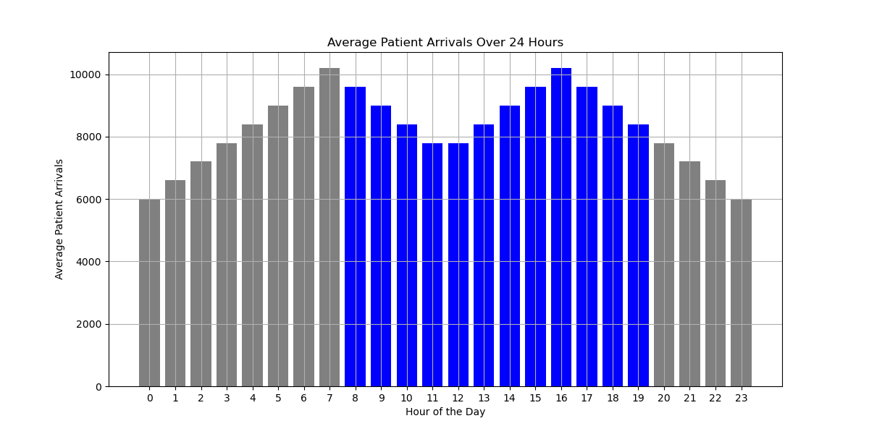

(Figure 1)

Staffing and Costs: Constants and rules for staffing, treatment capacity, and costs were defined to emulate real-world hospital scenarios.

How to clean/preprocess insights? (exploratory analysis)

Given the simulated nature of the data, cleaning was minimal. However, preprocessing included:

Normalization: Scaling the lambda values for patient arrivals to ensure they fall within the desired range.

Validation: Ensuring that the constraints for staffing and costs were adhered to during simulation.

Exploratory Analysis: Visualization and statistical analysis were performed to understand the distribution of patient arrivals, the correlation between different variables, and the impact of various parameters on the total cost.

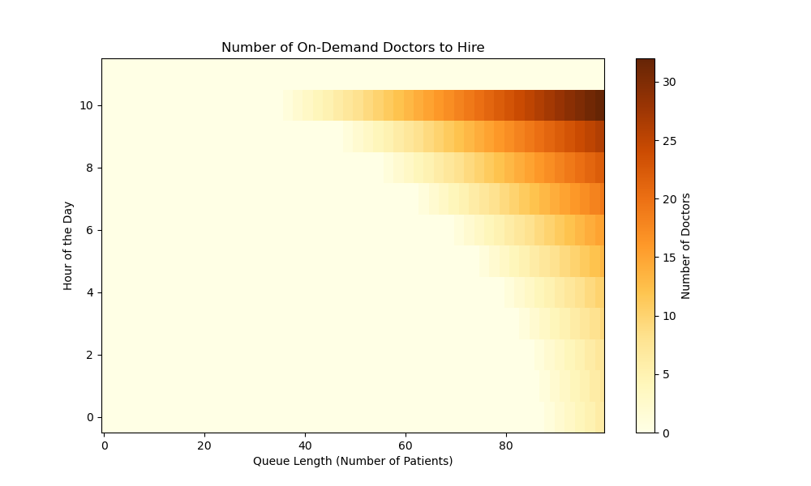

(Figure 2)

The simulated data provides a controlled environment to explore the optimization of hospital operations. It allows for flexibility in modeling different scenarios, constraints, and complexities while maintaining a connection to real-world applicability.

Part 6: Solution Approach

Intuition for the Solution

The intuition behind the solution lies in balancing two competing factors: the cost of hiring additional on-demand doctors and the cost associated with patients waiting or left untreated. By using both Backward Induction (BI) for smaller state spaces and Q-learning for larger complexities, the solution adapts to different scenarios, optimizing the staffing decisions.

Precise Statement: Pseudo-code for the Project

Backward Induction Method:

1. Initialize the value function for each state.
2. Iterate backward through time, calculating the optimal value and policy for each state.
3. Use the transition and cost functions to determine the optimal action at each step.
4. Return the optimal policy for hiring on-demand doctors.

Q-learning Method:

1. Initialize the Q-table.
2. For each episode, iterate through time, taking actions based on an exploration or exploitation strategy.
3. Update the Q-values using the Q-learning update rule.
4. Repeat until convergence, then extract the optimal policy.

Mathematical Work/Technical Innovations:

Transition Function: Mathematical modeling of the hospital's state transitions, considering staffing, patient arrivals, and treatment capacity.

Cost Function: A detailed cost model, including hiring costs, waiting costs, and untreated patient costs, reflecting real-world scenarios.

Optimization Techniques: Integration of both BI and Q-learning, allowing for adaptability and robustness across varying complexities.

Stochastic Modeling: Use of a Poisson distribution for patient arrivals, capturing the random nature of hospital admissions.

Hybrid Approach: The combination of BI and Q-learning in a single framework stands as a novel contribution, bridging traditional optimization and machine learning.

Part 7: Conclusion

The optimization of hospital operations stands as a paramount challenge in modern healthcare management. This research paper has embarked on an in-depth exploration of this problem, focusing on minimizing the total cost associated with staffing on-demand doctors and managing patient wait times in a simulated hospital environment.

Through the innovative integration of both Backward Induction (BI) and Q-learning, this research has demonstrated a robust and adaptable approach to hospital staffing optimization. The BI method excels in smaller state spaces, offering precision, while Q-learning caters to larger complexities with its scalability.

The mathematical formulation of the problem, coupled with detailed modeling of costs, staffing, and patient arrivals, has provided a realistic and applicable framework. The use of synthetic data through simulation has allowed for controlled experimentation and analysis, shedding light on the intricate balance between hiring costs and waiting costs.

Key findings and contributions:

Effective Optimization: The proposed methods have shown efficacy in reducing total costs, contributing valuable insights to healthcare management.

Adaptability: The ability to handle varying complexities, from smaller to larger state spaces, adds flexibility to the solution.

Real-world Relevance: The careful modeling of real-world hospital scenarios enhances the practical applicability of the research. Also, our approach could be used to simulate some certain models of game theory.

Interdisciplinary Approach: The integration of traditional optimization methods with machine learning techniques showcases the interdisciplinary nature of the problem and solution.

In conclusion, this research contributes a significant step toward the broader goal of enhancing healthcare efficiency through intelligent optimization techniques. The insights and methods developed offer potential avenues for further research and implementation in various healthcare settings. The integration of traditional optimization with machine learning stands as a testament to the interdisciplinary nature of healthcare innovation and paves the way for future advancements in the field.