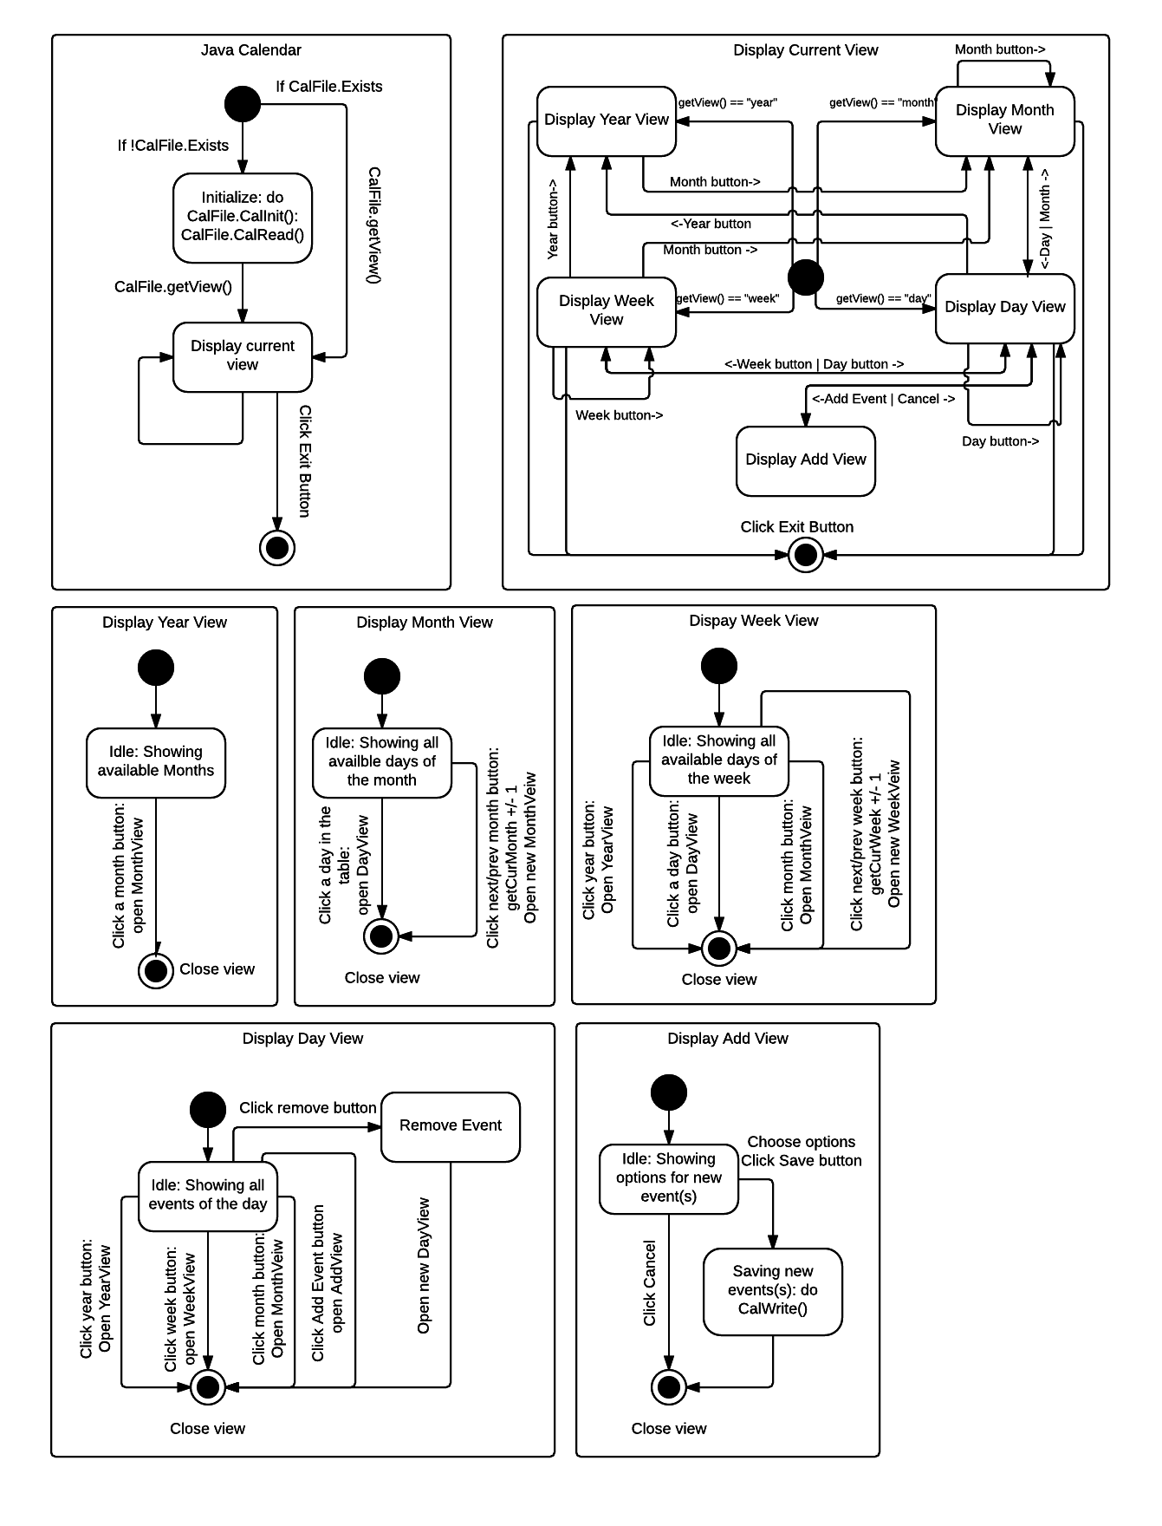Lucidchart - Diagrams Done RightLucidchart - Diagrams Done Right