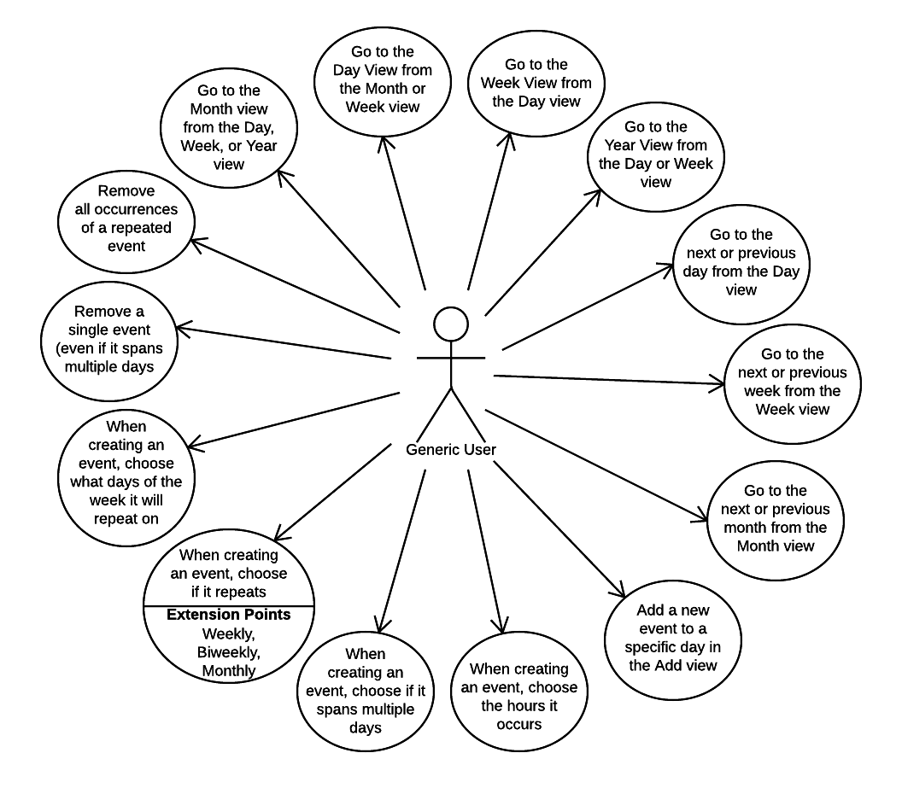Lucidchart - Diagrams Done Right