<https://www.zhihu.com/people/cromputer/posts>

## **[表面剔除透明与双面显示](https://zhuanlan.zhihu.com/p/385651024" \t "https://www.zhihu.com/people/cromputer/_blank)**

1. 剔除透明

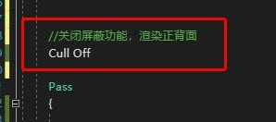



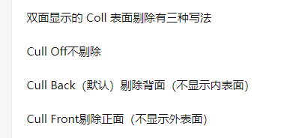

2.正面和背面显示不一样可以写两个通道，一个剔除背面，一个剔除背面

Shader "Unlit/CutTransparent"  
{  
 Properties  
 {  
 _MainTex ("Texture", 2D) = "white" {}  
 _BackCol("Back Color",Color) = (1,0,0,1)  
 _FrontCol("Front Color",Color) = (0,1,0,1)  
 }  
 SubShader  
 {  
 Tags { "RenderType"="Opaque" }  
 LOD 100  
   
   
 Pass  
 {  
 Cull Back  
 CGPROGRAM  
 #pragma vertex vert  
 #pragma fragment frag  
 *// make fog work* #pragma multi_compile_fog  
  
 #include "UnityCG.cginc"  
  
 struct appdata  
 {  
 float4 vertex : POSITION;  
 float2 uv : TEXCOORD0;  
 };  
  
 struct v2f  
 {  
 float2 uv : TEXCOORD0;  
 UNITY_FOG_COORDS(1)  
 float4 vertex : SV_POSITION;  
 };  
  
 sampler2D _MainTex;  
 float4 _MainTex_ST;  
  
 fixed4 _BackCol;  
  
 v2f vert (appdata v)  
 {  
 v2f o;  
 o.vertex = UnityObjectToClipPos(v.vertex);  
 o.uv = TRANSFORM_TEX(v.uv, _MainTex);  
 UNITY_TRANSFER_FOG(o,o.vertex);  
 return o;  
 }  
  
 fixed4 frag (v2f i) : SV_Target  
 {  
 *// sample the texture* fixed4 col = tex2D(_MainTex, i.uv);  
 *// apply fog* UNITY_APPLY_FOG(i.fogCoord, col);  
 col*= _BackCol;  
 clip(col.a-0.5);  
 return col;  
 }  
 ENDCG  
 }  
   
 Pass  
 {  
 Cull Front  
 CGPROGRAM  
 #pragma vertex vert  
 #pragma fragment frag  
 *// make fog work* #pragma multi_compile_fog  
  
 #include "UnityCG.cginc"  
  
 struct appdata  
 {  
 float4 vertex : POSITION;  
 float2 uv : TEXCOORD0;  
 };  
  
 struct v2f  
 {  
 float2 uv : TEXCOORD0;  
 UNITY_FOG_COORDS(1)  
 float4 vertex : SV_POSITION;  
 };  
  
 sampler2D _MainTex;  
 float4 _MainTex_ST;  
  
 fixed4 _FrontCol;  
  
 v2f vert (appdata v)  
 {  
 v2f o;  
 o.vertex = UnityObjectToClipPos(v.vertex);  
 o.uv = TRANSFORM_TEX(v.uv, _MainTex);  
 UNITY_TRANSFER_FOG(o,o.vertex);  
 return o;  
 }  
  
 fixed4 frag (v2f i) : SV_Target  
 {  
 *// sample the texture* fixed4 col = tex2D(_MainTex, i.uv);  
 *// apply fog* UNITY_APPLY_FOG(i.fogCoord, col);  
 col*= _FrontCol;  
 clip(col.a-0.5);  
 return col;  
 }  
 ENDCG  
 }  
 }  
}